Name of Business
Paige Alexandria Haus of Beauty

Business Owners
Paige Alexandria Wride

Mission statement
Paige Alexandria Haus of Beauty is an Aesthetics and beauty business, which will be providing aesthetic and cosmetics treatments to combat signs of aging, rejuvenate and refresh skin. Including providing treatments such as Lip filler injections, vitamin b12 injections, Semi-permanent make up, make up for all occasions, teeth whitening, eyelash treatments, eyebrow treatments and waxing. Our mission at Paige Alexandria haus of beauty is to provide a friendly, personalised service from our highly skilled founder Paige Wride. Each visitor or client is unique to us, and each treatment is a highly personalised experience. Our founder, Paige Wride is always aware of, attentive to and responsive to your every need. We use cutting-edge techniques and high-quality goods to help our clients feel more beautiful and confident.

Aim and objectives of business
According to (What are aims and objectives in business? - Business aims and objectives - Edexcel - GCSE Business Revision - Edexcel - BBC Bitesize, 2022) that every company has goals and objectives. These provide an organisation with direction and a reason to achieve what it is does every day. A business aim is the company’s target or goal, whereas business objectives are the measures the organization must follow to achieve its overall goals. A company may have a number of aims that will assist it achieve its goals. I have used the SMART acronym to find and explain my objectives and aims of my business plan

SPECIFIC: To expand the company by employing Hairdressers and beauticians, whilst growing the number of clients a month.
MEASURABLE: To increase the number of clients a month by advertising the business and its services on all social media platforms such as Facebook, Instagram and websites. To offer beauticians and hairdressers the chance to work for themselves but in a salon environment by renting a chair.
ACHIEVABLE: To increase the number of clients a month and to employ a beautician and hairdresser by offering rent a chair, by advertising job roles and services on social media platforms such as Facebook, Instagram and our website.
RELEVANT: To increase the number of clients a month and to employ a beautician and hairdresser by offering rent a chair, by advertising job roles and services on social media platforms such as Facebook, Instagram and our website. Because expanding the business will grow clientele and profitability.
TIME BOUND: To increase the number of clients a month and to employ a beautician and hairdresser by 2023. This will be achieved by advertising our business through social media platforms which will be Starting July 2022 which will be on 3 social media platforms, Facebook, Instagram and our website, since growing our clientele is our goal employing more staff on a self-employed basis will ultimately increase profit. According to (contributor, 2020) that profitable organization can go out of business if they don’t stay competitive or evolve with the times. As a result, profit strategies are just one of several objectives pursued by corporations. Customers returning, dealing with rivals, maintaining workers, risk management and completing legal responsibilities are all examples of these aims.

Introduction
I have chosen aesthetics and beauty to base my business plan on as I hope to open my own Aesthetics and Beauty Clinic into the near future. The business will be named after myself Paige Alexandria Haus of Beauty. The clinic will provide many treatments for all genders ranging from 16 to 65+. The aim is to help clients feel confident and comfortable in their own skin with a little help from aesthetics and beauty treatments. Our unique selling points are that we are the clinic will be run from an outbuilding on my property, which will only be appointment based only allowing the client to have more privacy, I will also be child friendly accommodating parents or carers with children who wouldn’t usually take children to regular salons, my treatments will be cheaper due to working from home and not having to pay the expenses of running a shop salon. I have over 10 years’ experience and continually taking refresher courses to keep up to date with current trends and new popular treatments.

2.0 Product and service
The range of salon services are expanding and changing all the time. We at Paige Alexandria Haus of beauty we keep our products and services up to date with the latest beauty trends. The services our clinic will be offering the following treatments:
Eyebrow treatments
- Microblading/ Ombre eyebrows (SPM) this treatment is a semi-permanent makeup used with a tattoo machine. And usually lasts from 12-18 months. This product will cost around £199 per client and that including the top up price at 6 weeks.
- Hybrid, henna and standard tint and wax is a wax tint and shaping of the eybrows giving the client definition and shape this treatment will cost from £15-£25 and the treatment will usually last from 4 to 7 weeks.
- Brow lamination where the eyebrows are permed and styled into the clients desired shape giving them a fuller fluffier look. treatments price will cost £30 per client and will last 6 to 8 weeks.
Eyelash Treatments
- LVL lash lift is where the lash is permed to give the eyelash a natural yet fuller look, this treatment will cost £25 per client and treatment will last from 6 to 8 weeks.
- Lash Extensions, this treatment will include individual lashes from classics, hybrids and Russians, price ranging from £40 to £50 per client.
Aesthetics
- Anti-wrinkle treatment, this treatment reduces the appearance of fine lines and reduces the movement of muscles on the forehead, eyebrows and smile lines, treatment usually last between 3 to 6 months and the cost of this price will range from £120 to £200 per client.
- Lip augmentation is a treatment that enhances the lips to add volume and shape, to make them appear bigger, treatment usually lasts between 6 to 9 months and costs from £90 to £150.
- Vitamin B12 injection is a treatment used by giving the client an injection in the arm to help with fatigue, improve metabolism, improve brain function, improve the symptoms of mental health, Treatment is usually needed every 1 to 3 months and costs £25 per client.
Facials
- Chemical Skin Peel is a treatment that causes the dead skin to peel to help the skin repair itself by boosting collagen, which will help reduce acne scaring and fine lines, treatment costs around £50 per client.
- Microneedling, is a treatment that causes trauma to the skin encouraging
the skin to boosting the collagen growth to help repair acne scars, stretch marks, dark markings this treatment usually costs £40 per client.
Dermaplaning, is a treatment where a surgical blade is used to remove dead skin cells, peach fuzz, and dirt and oils from the skin leaving it feeling fresh, rejuvenated and helps reduce the appearance of acne scars, treatment usually costs £30.
Other Services
- Makeup, for all occasions, strip lashes included cost price for this treatment is £30
- Teeth whitening this treatment is used to whiten the appearance of your teeth from 1 to 12 shades whiter, treatment costs £50

3.0 Financial resources
My financial resources will be coming from my own savings, due to currently working mobile I have had no fixed costs to pay out for, I will be using money I have already saved to convert an outhouse building into a clinic suitable to carry out my treatments.
After researching financial resources for businesses (Nixon, 2021) says that “if your new business or company requires more funding, you may be considering financing options. Debt and equity are the two most common way to fund a corporation. Borrowing money from another institution, such as a loan or mortgage, is referred to as debt. The money is subsequently repaid over time, together with any interest that has accrued. You might also opt to fund your company with your own money. This entails selling stock of your company based on their share size and may be eligible for dividends based on your profitability.” I have created a 12-month cash flow showing my earnings and outgoings for each month.
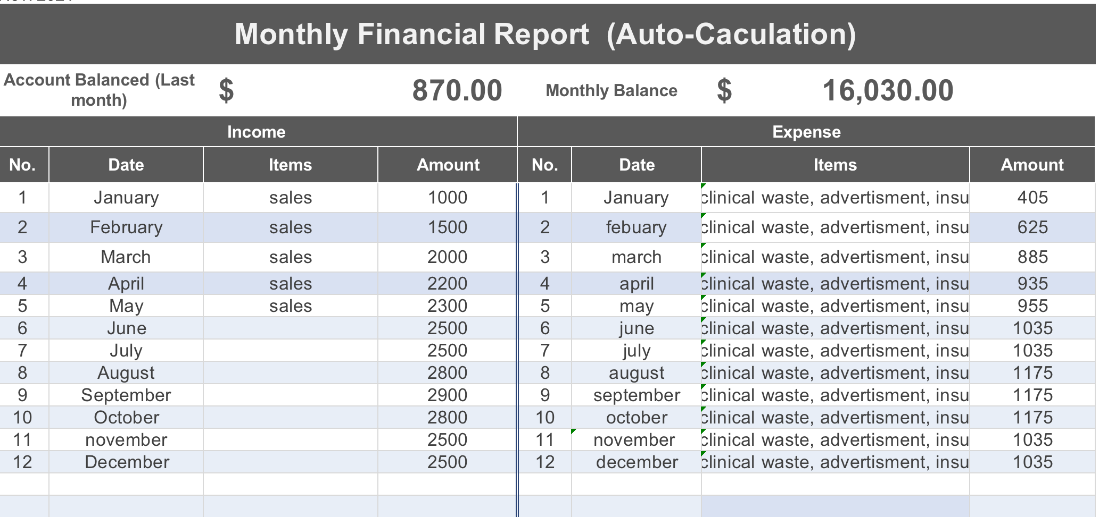

It is vital to create a cash flow chart when writing a business plan as it tells you when your expenses are too high or whether you need to make a short-term investment to deal with a cash flow excess. According to (ward, 2020) The cash flow chart will inform investors whether your company is a good credit risk and if you have enough cash on hand to qualify for a line of credit, a short-term loan or a longer-term investment.

4.0 Physical resources
Paige Alexandria haus of beauty’s Clinic will be based on my property as an outbuilding. I have accumulated many of my physical resources over the years from attending courses and being supplied equipment and machinery to carry out treatments, inventory control will need to be done every month. Stock take will be done by seeing how many products have been used and when restock would be needed. (Bhasin, 2019) Says that the keys resources are those that are crucial to business and help it establish a value position in service to its consumers and deliver the product to them. These sort of business resources are critical and necessary for your company’s success. It is frequently based on bath tangible and intangible assets.

5.0 Market Activities
To help my business stand out from the crowd I have come up with a marketing plan that will keep me ahead of the competition, such as questionnaire, competitions and loyalty cards. I will be using social media to market and promote my business using Facebook, Instagram and our company website. I have also taken the time to produce a questionnaire to get feedback from future clients. After looking at the results I have found that there is a high demand for the teeth whitening treatment, after taking the time to researching (smith, 2022) SWOT analysis I have also conducted a SWOT analysis on our clinic which will help us identify our strengths and weaknesses.
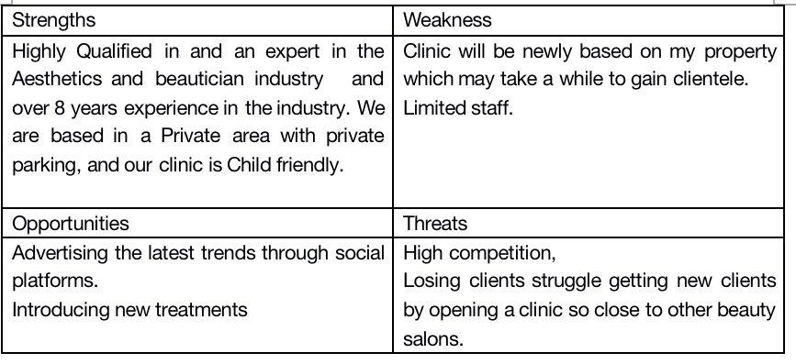
Our goal will be to turn our threats into opportunities to help our business grow and thrive. According to (Gregory, 2021) that the majority of marketing focuses on raising awareness of your company. However, once you have people’s attention, whether through email or social media, you must establish trust, this can be done by:
- Donating free treatments to charities
- Planning seasonal promotions
- Make referrals
- Ask for referrals
- Holiday gift vouchers

6.0 Human Resources
that employee performance, retention and loyalty, as well as devotion to their work function, will all suffer if your small business lacks effective human resources.
According to: (Regan, 2021) says that there are several facts that support the importance of human resources in small businesses here are a few examples:
- 75% of employess will stay with their firm that proactively listens to and acts on their issues and concerns
- Almost 80% of workers say that they prefer new benefits over a pay rise
Paige Alexandria haus of beauty currently has one employee the founder of the business, we will be looking to expand by employing two more employees at a self-employed basis. One job role will be for a beautician who will be required to hold a full NVQ level 2 in beauty therapy, great customer service skill and have a good work ethic, professional appearance and positive attitude and must also have excellent verbal and written communication.
Another Job role will be for a hairdresser/ barber who will be required to hold a full NVQ level 3 in hair dressing/ barbering qualification, great customer service skill and have a good work ethic, professional appearance and positive attitude and must also have excellent verbal and written communication. Before you start a business, you will need a variety of licenses and insurances, the amount of these will determined by the type of business you wish to operate, as a sole trader of a beauty salon (Writer, 2022) says you will need relevant health and safety laws, insurance, licenses and confidentiality and non-disclosure agreements. At Paige Alexandria haus of beauty i currently have liability and public insurance with INSYNC insurance company. And currently hold a license from my local council to be able to carry out treatments from my property. All consultation forms are stored currently in a locked cabinet.

8.0 Appendix
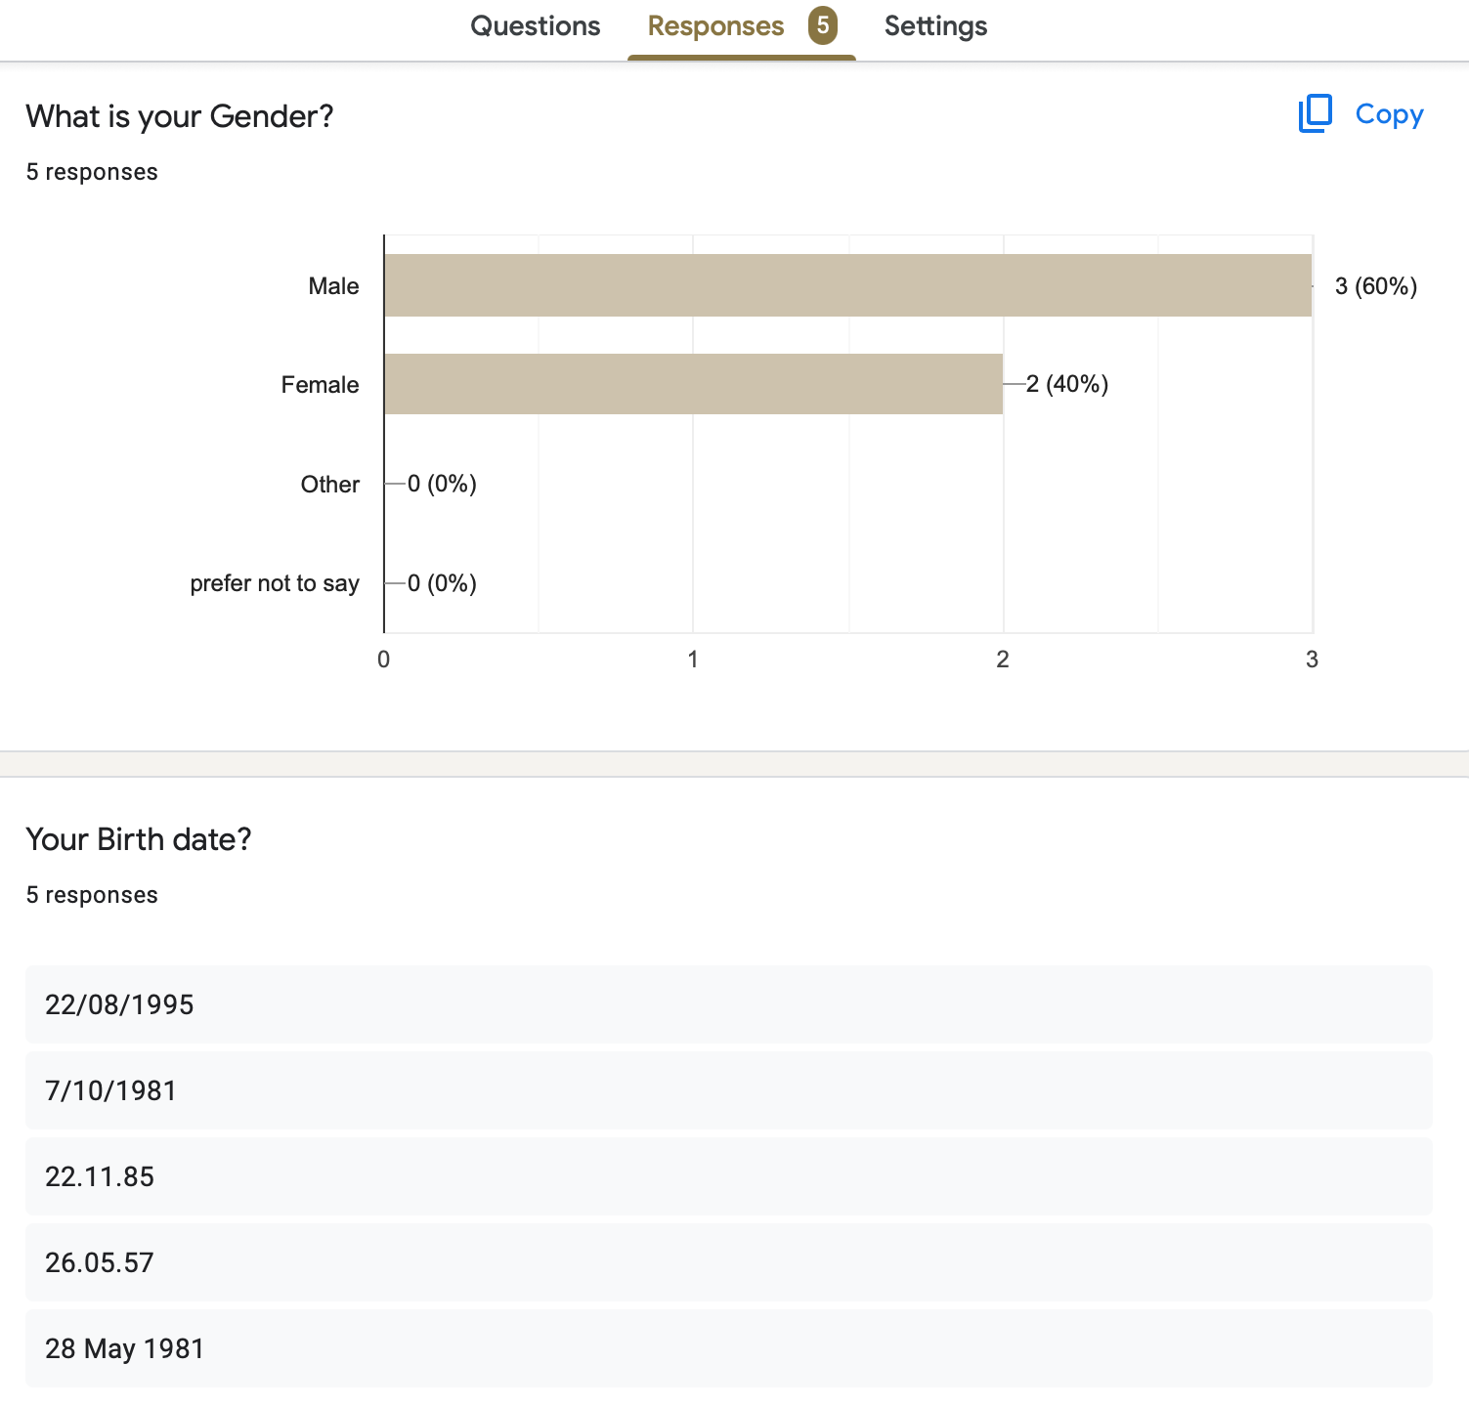
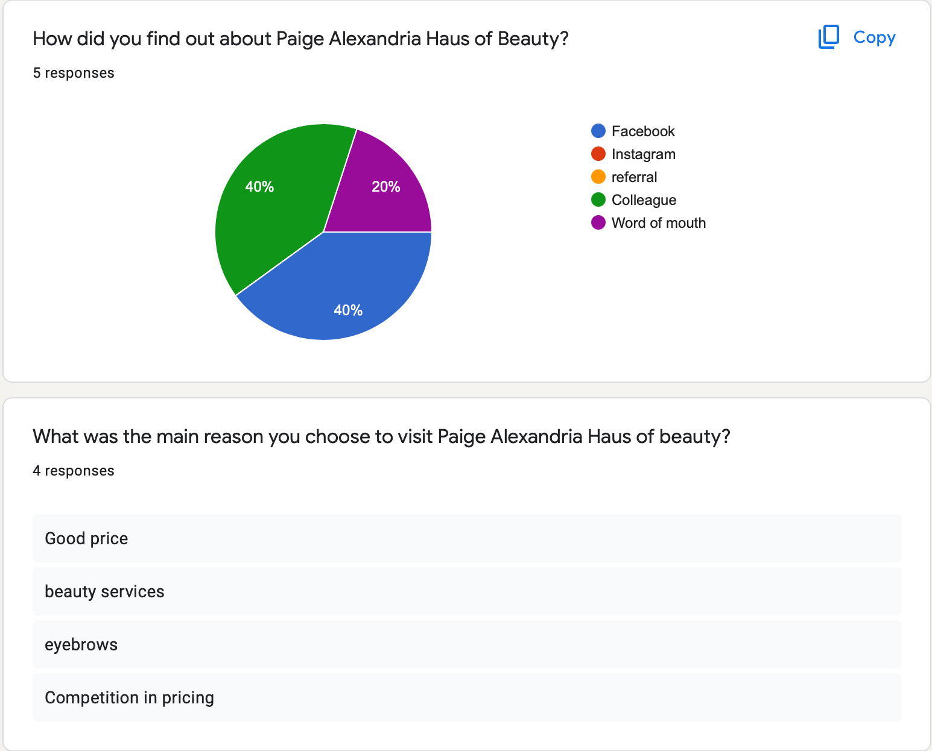
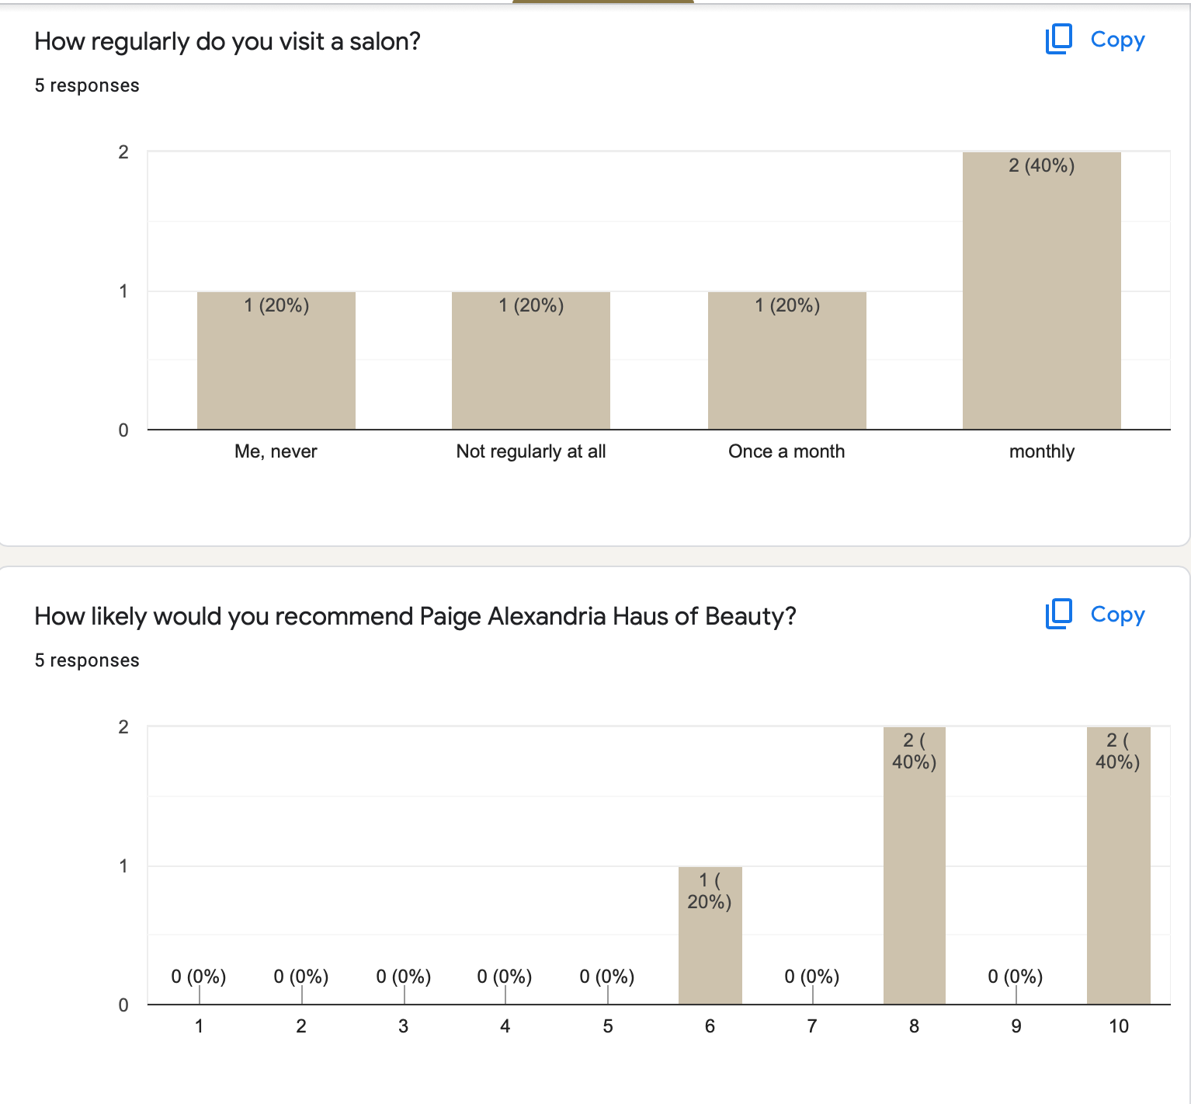
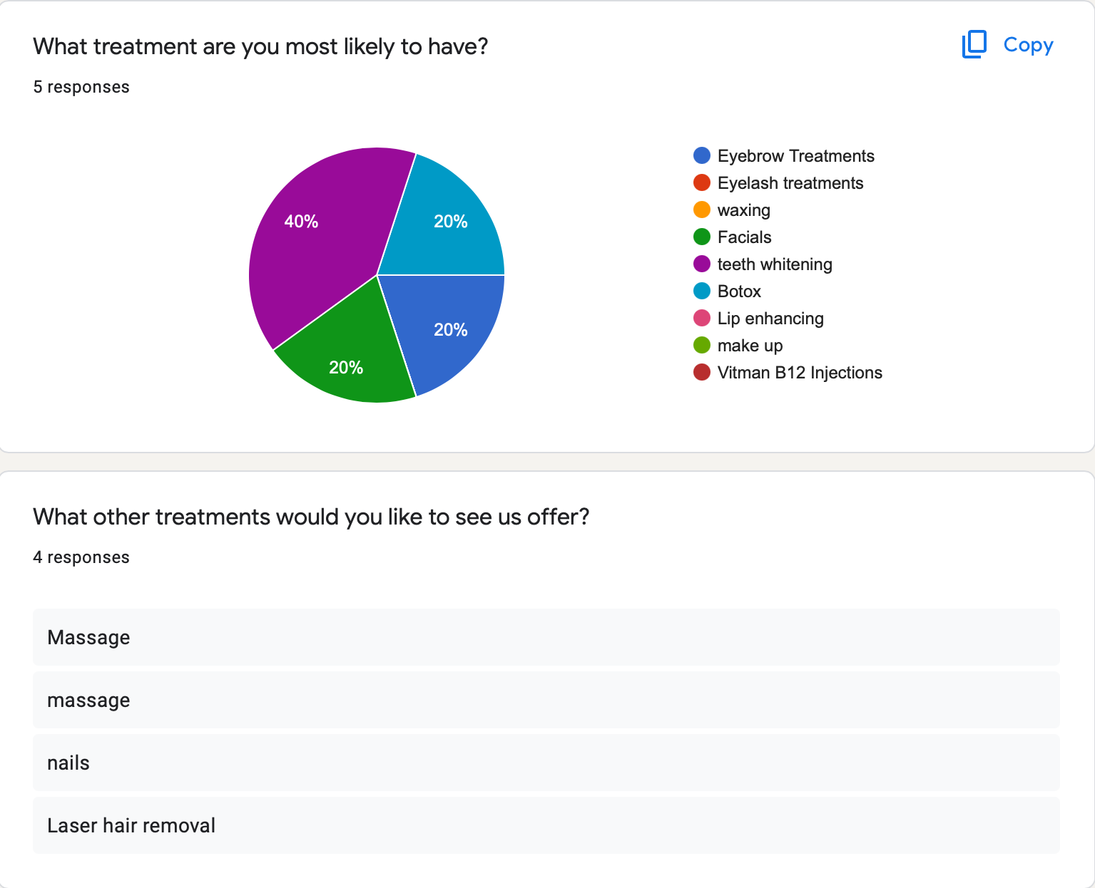
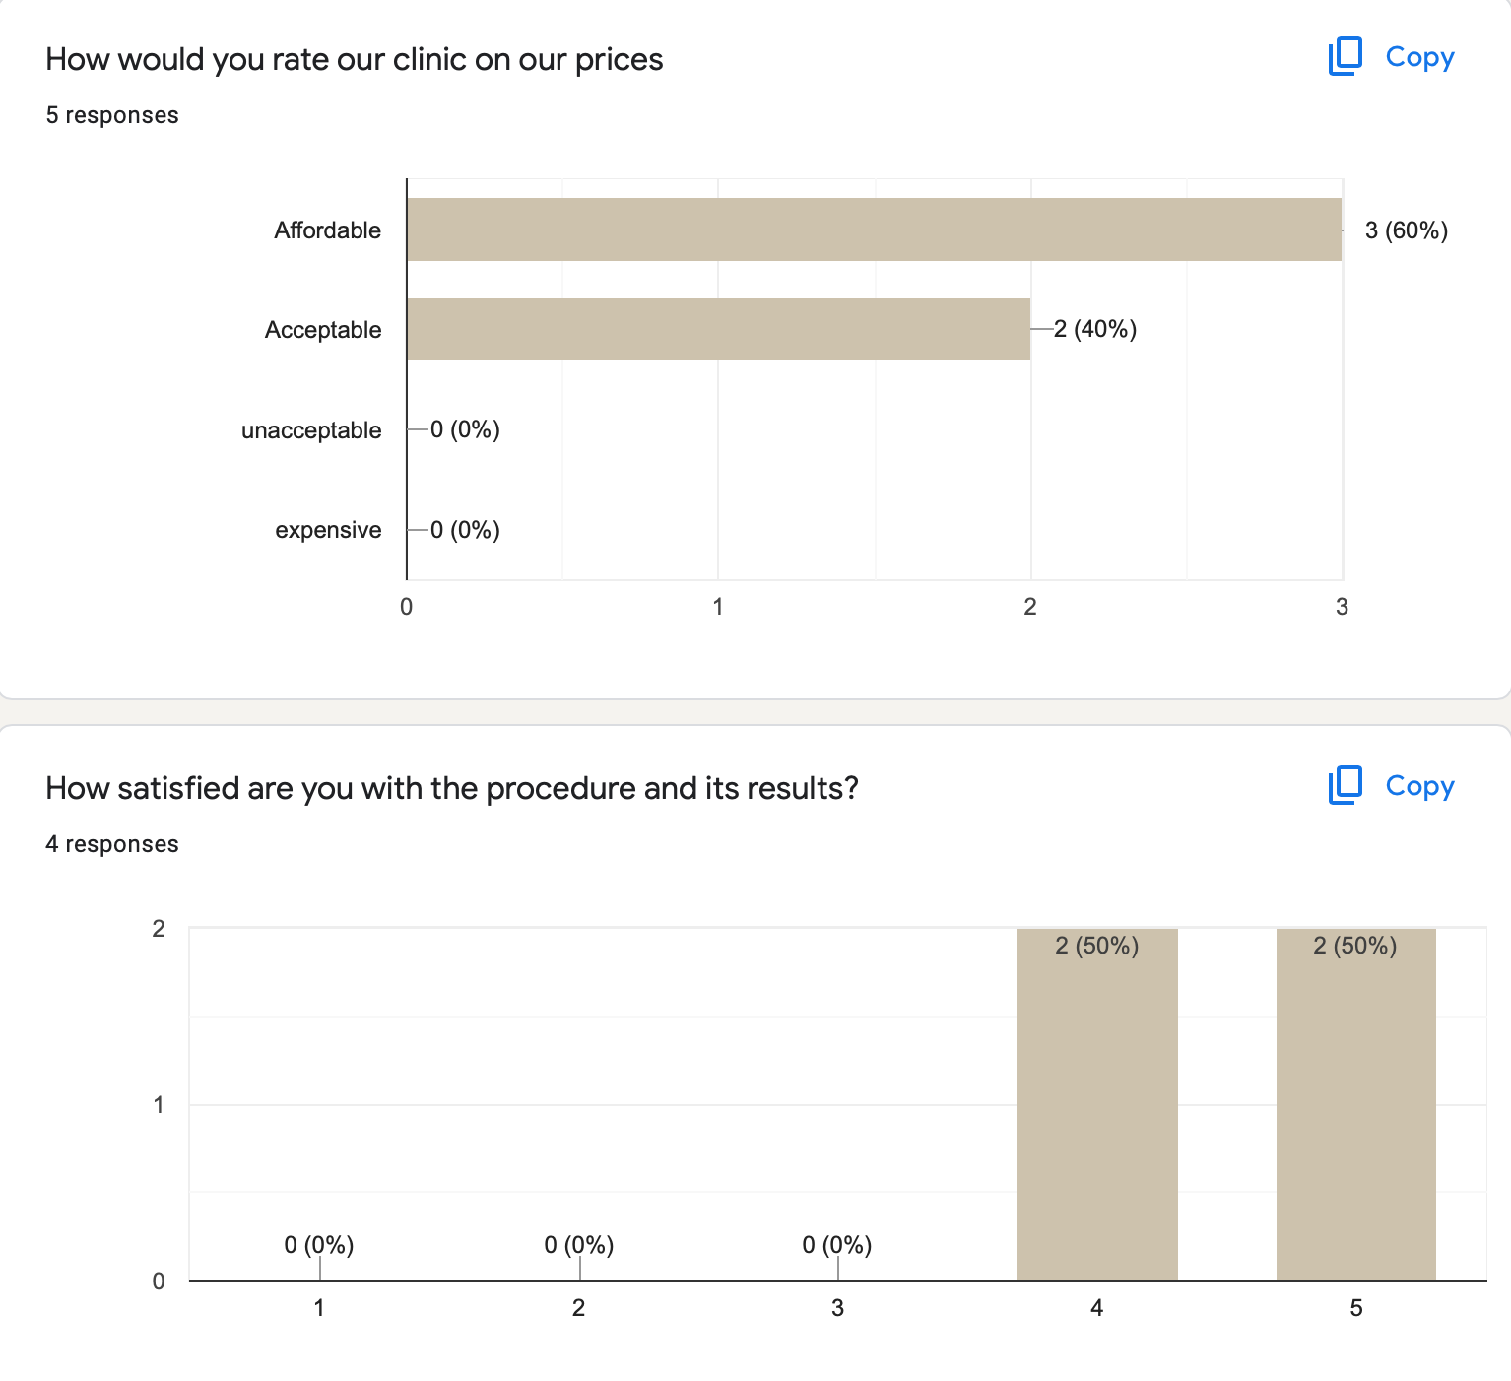

9.0 References

- BHASIN, H. Four Types of Business Resources In-text: (Bhasin, 2019) Your Bibliography: Bhasin, H., 2019. Four Types of Business Resources. [online] Marketing91. Available at: <https://www.marketing91.com/four-types-of-business-resources/> [Accessed 21 March 2022].
- Website CONTRIBUTOR, C. What Other Objectives, Besides Profit, Are Important to Businesses? In-text: (contributor, 2020) Your Bibliography: contributor, c., 2020. What Other Objectives, Besides Profit, Are Important to Businesses?. [online] Small Business - Chron.com. Available at: <https://smallbusiness.chron.com/other-objectives-besides-profit-important-businesses-25492.html> [Accessed 19 March 2022].
- GREGORY, A. 101 Small Business Marketing Ideas In-text: (Gregory, 2021) Your Bibliography: Gregory, A., 2021. 101 Small Business Marketing Ideas. [online] The Balance Small Business. Available at: <https://www.thebalancesmb.com/small-business-marketing-ideas-2951688> [Accessed 21 March 2022].
- NIXON, R. Why is finance important? Here’s what you need to know. In-text: (Nixon, 2021) Your Bibliography: Nixon, R., 2021. Why is finance important? Here’s what you need to know.. [online] Real Business. Available at: <https://realbusiness.co.uk/why-is-finance-important-heres-what-you-need-to-know> [Accessed 20 March 2022].
- REGAN, R. Guide to Human Resources for SMBs in 2022 | Connecteam In-text: (Regan, 2021) Your Bibliography: Regan, R., 2021. Guide to Human Resources for SMBs in 2022 | Connecteam. [online] Connecteam. Available at: <https://connecteam.com/guide-human-resources-for-small-businesses/> [Accessed 21 March 2022].
- Website SMITH, C. SWOT Analysis for Hair Salons In-text: (smith, 2022) Your Bibliography: smith, C., 2022. SWOT Analysis for Hair Salons. [online] Small Business - Chron.com. Available at: <https://smallbusiness.chron.com/swot-analysis-hair-salons-11715.html> [Accessed 21 March 2022].
- WARD, S. Business Plan Essentials: Writing a Cash Flow Projection In-text: (ward, 2020) Your Bibliography: ward, s., 2020. Business Plan Essentials: Writing a Cash Flow Projection. [online] The Balance Small Business. Available at: <https://www.thebalancesmb.com/writing-the-business-plan-section-8-2947026> [Accessed 20 March 2022].
- WHAT ARE AIMS AND OBJECTIVES IN BUSINESS? - BUSINESS AIMS AND OBJECTIVES - EDEXCEL - GCSE BUSINESS REVISION - EDEXCEL - BBC BITESIZE In-text: (What are aims and objectives in business? - Business aims and objectives - Edexcel - GCSE Business Revision - Edexcel - BBC Bitesize, 2022) Your Bibliography: BBC Bitesize. 2022. What are aims and objectives in business? - Business aims and objectives - Edexcel - GCSE Business Revision - Edexcel - BBC Bitesize. [online] Available at: <https://www.bbc.co.uk/bitesize/guides/zkhby9q/revision/1> [Accessed 18 March 2022].
- WRITER, S. 7 Legal Considerations to Prioritize When Starting a Business In-text: (Writer, 2022) Your Bibliography: Writer, S., 2022. 7 Legal Considerations to Prioritize When Starting a Business. [online] Smallbusinessrainmaker.com. Available at: <https://www.smallbusinessrainmaker.com/small-business-marketing-blog/7-legal-considerations-to-prioritize-when-starting-a-business> [Accessed 21 March 2022].

