NOTES FOR JULIA:
I’m not sure what it means by ‘’show it relationship to your ideas” so I have included some sentences on how the word relates to my own practice and also in the broader context of craft – this is in red as I am not sure if it’s correct or relevant

In preparation for the independent project, I will be researching the words touch, body and material. The words that I have chosen are of interest to my work as a maker and that have also impacted the discipline of craft. The essay explores the words in a historical context, with references to artists such as Constantin Brancusi, Karen Finley and Antony Gormley, and theorists such as Laura Mulvey, Ann-Sophie Lehmann and Geraldine Johson.

Touch is the first sense to develop in the embryo (Montagu, 1978, p.2) and it is a fundamental aspect of development (Davis, Petrella & Rovers, 2017, p.14). Touch greatly contributes to the “cognitive, brain and socio-emotional development” (Davis, Petrella & Rovers, 2017, p.14) and when touch is not present during development, ‘’long-lasting negative effects take place, in terms of attachment injuries and touch wounds’’ (Davis, Petrella & Rovers, 2017, p.15). In terms of art and sculpture, touch was a factor that was not greatly considered until early modern Italy (Johnson, 2002, p. 61). Artists began to consider the sense as an important way for three-dimensional objects to be confronted by the viewer (Johnson, 2002, p. 61) and it has continued to be of “growing importance in artistic production’’ (Gallace & Spence, 2016, p. 114).
Prior to the Italian Renaissance, vision was dominantly viewed as the most important out of all the senses (ocularcentrism). Philosophers Plato and Aristotle were prominent figures who held this view, and it was not until the Renaissance where philosophers and writers began to open the debate about the senses. Touch was considered as a “less cerebral” and “more carnal” sense than vision (Johson, 2016, p. 61) and this view persisted until the Middle Ages. Touch was an attribute that was seen as evidence for sculptures’ lower status in the paragone debate, which was a “theoretical discussion concerned with comparing and contrasting sculpture and painting in order to establish which art was more noble’’ (Johnson, 2002, p. 68), however it was also considered as a positive attribute for sculpture (Johnson, 2016, p. 92). In the context of craft, the artists eye is not capable to make the decisions that the touch of the hand can. Touch is therefore an important sense can as the eye is not able to dictate the tactility of the piece like the hand
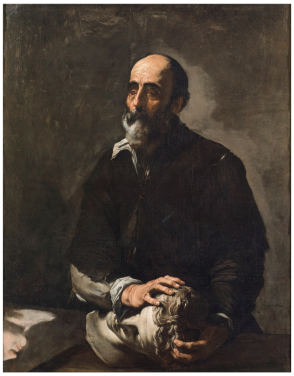

Fig 1: The Sence of Touch

The Sense of Touch (1632) (Figure 1) by Jusepe de Ribera depicts a blind man touching a sculpture of a head. It is the embodiment of the Niccolo Tribolo’s quote, which reads:
[S]culpture is… [the art] of using one's hands to show what is true. ... [I]f a blind man… happened to come upon a marble or wood or clay figure, he would claim that it was the figure of a [living person, but] … had it been a painting, he would have encountered nothing at all… [because] sculpture is the real thing, and painting is a lie (Barocchi, 1971, p. 518).
The painting reflects the importance of touch to a visibly impaired person, and it also can also indicate how important touch is to a sculptor, as when the sculptor considers the tactility of a piece, they are not using their eye but their hand. The painting additionally outlines the engagement between the artist/viewer and an object, something which is unattainable with a painting. We are able to touch a painting, but, as Keenan exclaims, the hand “remain[s] an outsider to the painted world” (2016, p. 54). Painting allows us to have an insight into a moment, but sculpture allows us to be present and exist in the same moment. In craft, the engagement between the object and maker is a crucial component of making from the starting point to the finish. Makers are constantly checking in with their pieces, touching and viewing from all angles to ensure that it is up their standard of making and it is an experience that cannot be applied to working in 2D. Touching our pieces is the proof that we have that it exists, and we are able to make choices on our next step based upon the multisensory aspect of craft/sculpture.
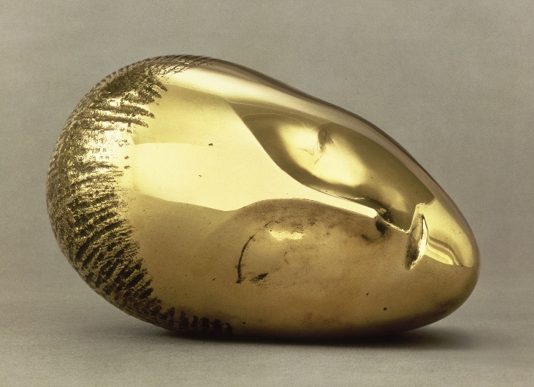
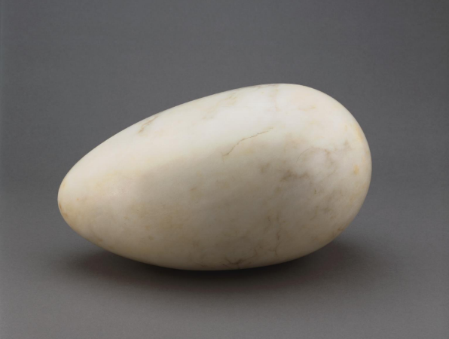
Fig 3: Sleeping Muse
Fig 2: A Sculpture for the Blind

As Brancusi once said, “sculpture must be lovely to touch, friendly to live with, not only well made’’ (Tacha, 1963, pp. 240, 241) which is reflected in his piece A Sculpture for the Blind, Fig 1 (c. 1920). The sculpture is made of veined marble, and it is the rough shape of an egg, measuring 17.5 x 29.5 x 18cm. The piece’s intention is to be touched, and Brancusi considered all elements of touch when creating the piece. Firstly, it is easily embraceable. Clayton described the object as fitting “easily on[to] your lap” and it would “take two hands to hold comfortably” (2017). Secondly, the piece is incredibly smooth. Brancusi was said to be “very fastidious about the finishing of his works” and he would personally smooth and polish the piece with “great care until he obtained the perfect surface quality’s he longed for” (Barassi, 2016, p. 174). Thirdly, due to the nature of marble and its high density, the object is heavy and lastly, again due to the nature of marble, the sculpture is cold to the touch.
Brancusi was known for his facial sculptures (Figure 3) which resembles Figure 2 due to the similarity of the shape. He was known to place his sculptures upon his knees and touch them with his eyes closed, which is reminiscent of Figure 1. It was not only his way of enjoying the finished piece, but “an integral part to its making’’ (Barassi, 2016, p. 174). He therefore viewed his artworks through touch, and through the eyes of someone who was visually impaired. The paradox of this piece is one that is interesting, as the piece is now displayed in a glass vitrine in the Museum of Art in Philadelphia, therefore a piece intended for the blind, is now for the sighted.
Word count for TOUCH: 916…

Link face to body… The body is defined as “the whole physical structure of a human or an animal” (Oxford Learner’s Dictionaries, 2022) and it is “central to how we understand facets of identity such as gender, sexuality, race, and ethnicity” (MOMA, 2022). How one presents their body can either align or rebel against social conventions (MOMA, 2022), signifying that the body is a powerful form of communication.
The body of a woman has been the object of male desires for centuries (Suleiman, 1986, p. 7). In addition, the ideals of the “female beauty has shifted from a symbol of fertility to one of mathematically calculated proportions”, which is evident through analysing depictions of female bodies by artists throughout history (Bonafini & Pozzilli, 2010). The artists who have documented these changed are a good indication of how society saw women.
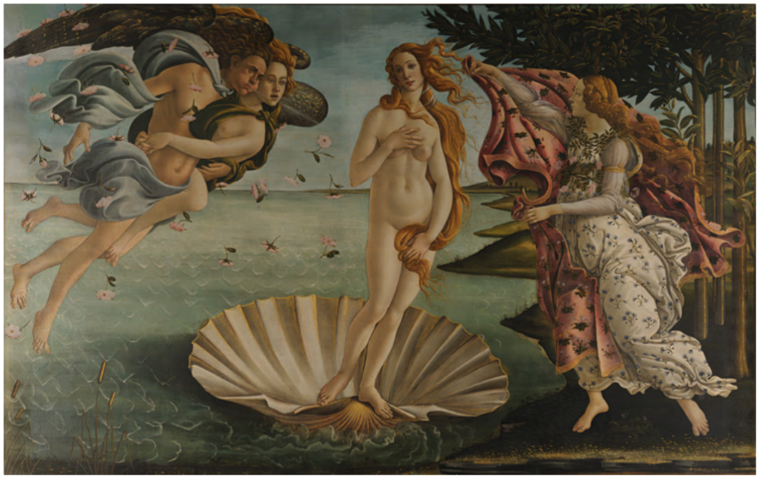
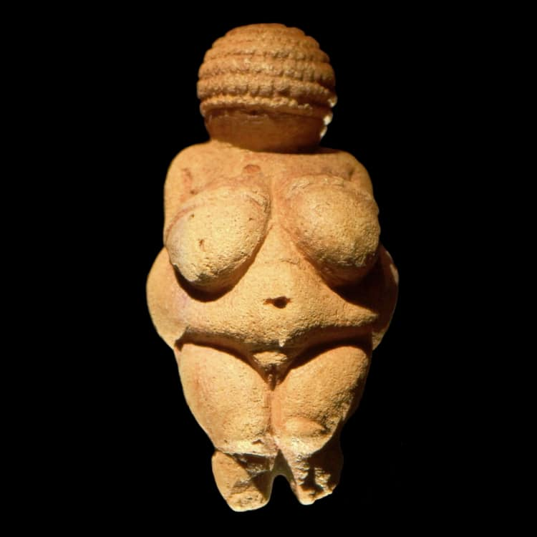
‌
Fig 5: The Birth of Venus
Fig 4: Venus of Willendorf

The Venus of Willendorf (30,000 – 25,000 BCE) (Figure 4) is one of the oldest portrayals of woman. The statue depicts a “bulging” stomach and “large breasts”, suggesting that the culture idolized a mother goddess (Bonafini & Pozzilli, 2011) and that the figure was a fertility symbol (Zygmont, 2022). This depiction of the female body, in comparison to Figure 4, documents the change from women being seen as a fertility symbol to one who is the object of the Male Gaze.
Figure 5, The Birth of Venus (1483 – 1485), painted by Sandro Botticelli, portrays Venus, the ancient goddess of beauty and love (Hoena, 2003, p. 5) nude and emerging from the water. The painting was created during the Renaissance and at this time an artist’s skill laid in their ability to “show perception in the body of the nude woman” (Zhoa, 2017, p. 106). The paintings of this period were mostly created by men, and as the paintings of the Renaissance reflected the ideals of beauty at the time (Zhoa, 2017, p. 110), men therefore dictated women’s beauty standards.
The fact that Venus is portrayed as nude, signifying “lust and erotic pleasure” (Zhoa, 2017, p. 106), implies that the painting was intended for the male audience. This demonstrates that the painting is the object of the Male Gaze (Mulvey, 1989) which is further emphasized by Venus’ strategically painted hands which cover her breasts. This is designed to titillate the man while conveying modesty.

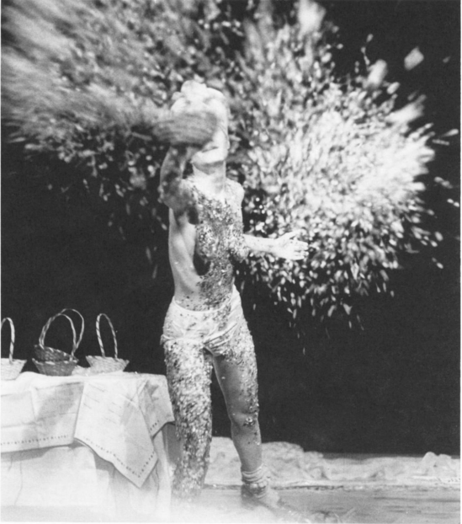

Fig 6: Karen Finley tossing candies at the audience in The Constant State of Desire

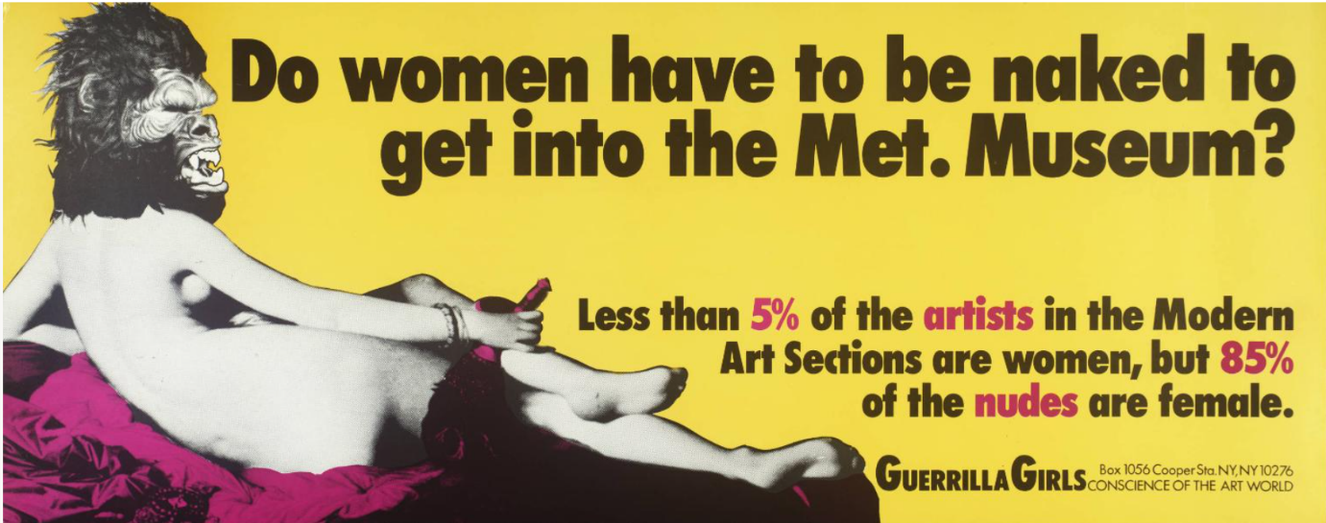
Karen Finley’s performances (Figure 6) outlines another change in attitude towards the female body. Finley was aware that a women’s body was typically seen as an “object of the gaze, an object of desire” when appearing on stage (Striff, 1997), and in The Constant State of Desire (1988) she presented her body in a way the subverted the Male Gaze by talking about her body in a graphic way and not displaying her body for the spectators’ approval (Striff, 1997) despite being almost nude. This greatly contrasts to how women’s bodies were received in the art sphere during this period and throughout history, which The Guerrilla Girls highlighted in their piece Do women have to be naked to get into the Met. Museum? (Figure 7 - 1989). The piece revealed that “less than 5% of the artists in the Modern Art Sections are women, but 85% of the nudes are female”, demonstrating that “women in the art world are therefore [exist for] exploration and objection only” (Cronje, 2001). Finley actively disengages with this narrative by purposely make the audience feel uncomfortable during her performances, by urging the view to question the “personal and public costs of sexism, homophobia, and racism” (Pellegrini, 2007). Her body is therefore present to communicate and to begin a narrative between the audience and herself rather than to be treated as a passive object which is reminiscent of Figure 5.
Fig 7: Do women have to be naked to get into the Met. Museum?

During a segment of her performance for The Constant State of Desire, Finley communicates a women’s experience of living in a patriarchal society. She exclaims, “I've never been treated equally my entire life… like I'm supposed to be so thankful cause a chick is on the Supreme Court…But nothing's changed. Nothing has changed’’ (1988). Her performances communicate her own experiences while also giving a voice to marginalised people and these experiences play a significant role in her performances. This relates to my own practice as I base a lot of my art using my own experiences.
Word count for BODY: 716
Materials are an integral part to our existence. As Ashby and Johnson state in Materials and Design, “we live in a world of materials; it is materials that give substance to everything we see and touch” (2013). The political developments, technical advancements, the wars, and economic and social changes of the late 19th century contributed to significant change in how people viewed the existing world in the 20th century, and it is within this century where artists were exploring the boundaries of artistic expression (Ruhrburg et al, 2000, p.7). Artists realised that a piece of art no longer had to be “be made in the spirit of the old aesthetics of imitation”, but as its’ “own independent dimension of existence” (Ruhrburg et al, 2000, p.7). This was greatly reflected in the change of how materials were used in art and the subject matter of the creations.
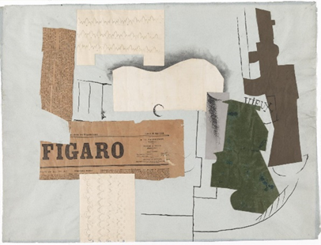
Materials are always required to be in contact with another (Lehmann, 2012) and it is within this connectivity where art is formed. Materials undergo numerous processes and interaction with other materials before they are able to be used as a medium, and the materials are still interacting with one another when a piece of work has been completed (Lehmann, 2012). Within craft the connectivity between material and material is an integral part of making. Craft greatly depends on numerous processes and these processes require materials, such as making a plaster cast, which, for example, clay, plaster, an object, a container, and something to securely hold the mould together is required.

Fig 6: Bottle of Vieux Marc, Glass, Guitar and Newspaper

Collage is an example of the importance of material connectivity and in Figure 6’s instance, this connectivity is also visual. Bottle of Vieux Marc, Glass, Guitar and Newspaper (Figure 6) is an example of Cubist collage and was created by Pablo Picasso in 1913. Picasso, alongside Braque, both created numerous paper collages between 1912 and 1913 (Kear, 2016) and their technique reflects the change in how materials were utilised and how artistic concepts were conveyed. Though the materials that Picasso used in this composition are traditional (paper, pen), the ideas that it represented were modern for the time. In craft, conveying modern concepts but with traditional materials are a regular thing and I carry this concept into my personal work.
Braque and Picasso are also credited with introducing everyday materials into art which they did so through Cubist collage (Evans, 2004 p. 185). This is a significant factor as their introduction of everyday materials into their art marks the beginning of how other artists introduced and experimented with unconventional materials during the 20th century (Tate, 2022). Minimalism (1960s) and Arte Povera (1960s – 1970s) both implemented found and unconventional materials into their art (Moma, 2022 and Tate, 2022), which I also do within my own practice by exploring concepts through casts of everyday and unconventional items. Antony Gormley also employed materials in a different manor, which is evident in Figure 7 as he used his own body as the prime material.
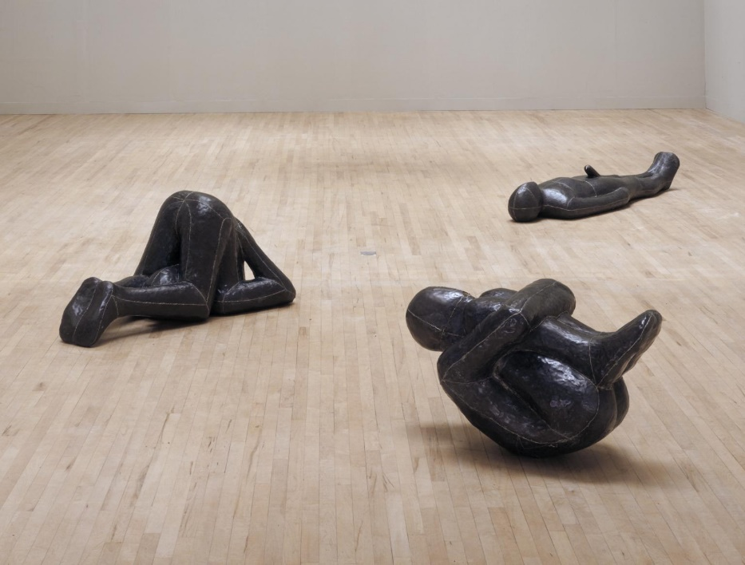

Figure 7: Three Ways: Mould, Hole and Passage

Figure 7, Three Ways: Mould, Hole and Passage (1981-82) is one of Gormley’s earliest pieces where he uses casts from his own body (Manchester, 2000). He took inspiration from Carl Ander’s and Donald Judd’s use of found objects and industrial materials in their art of the Minimalism movement which prompted Gormley to question if he could treat his body as a found object (Gormley, 2016). He then began to use it “as the tool, as the subject, as the material…” (Gormley, 2016) which relates to my personal work as my body and its experiences are a key part of my inspiration. In this piece he created casts from his body with plaster covered sheets and then the bodies were cast in lead and soldered together (Macpherson, 2019). This piece depended on the connection between Gormley and the plaster and Gormley participating as the critical material.
Word count MATERIAL – 614

- Analysis of the research areas you have defined around each keyword and art/design work selected.
- I’ve explained the history and the developments of the word within an art/craft context and my personal practice
- How are keywords different from each other? What distinguishes them?
- Differences: they all differently affect my work while all being important, the ‘body’ impacts my work in a conceptual way rather than a physical way, touch and material are both very physical
- Synthesis of the research areas you have defined around each keyword and art/design work selected.
- The art works that I have chosen reflect the context of the word within history
- How do they link together?
- All valuable words within the context of craft and my personal work -
- What happens to each keyword research area (as you have defined it in your writing) when they are placed together and considered in terms of relationships?
- Touch and material are very similar, the tactility of the picee is dependent on the material and finish. Body can be used as a material. Touching the body…
- Leading to a possible area(s) of study for next year
- Outline a research question (This is a question which will keep you focused when you are doing your reading over the summer. This will NOT be the title of your Level 6 Independent Project, rather it is aimed at helping you to guide your own research)
- How materials can change the meaning of a piece
- Materials and different processes
- More in depth look at how materials use have changed during the 20th and 21st century – people now use sound as a material…, into of plastic, 3D printing

Bibliography
Ashby, M.F., Johnson, K. (2013). Materials and design: the art and science of material selection in product design. Butterworth-Heinemann.
Barassi, S. (2016) ‘The sculpture is a blind man: Constantin Brancusi’s Sculpture for the Blind’, in Dent, P. (ed.) Sculpture and Touch. New York: Taylor & Francis
Barocchi, P. (ed.) (1971) Scritti d’Arte del Cinquecento. R. Ricciardi
Bonafini, B., Pozzilli, P. (2011) ‘Body weight and beauty: the changing face of the ideal female body weight’, Obesity Reviews, 12 (1), pp. 62-65
Cronje, K (2001) The Female Body as Spectacle in Nineteenth and Twentieth-Century Western Art
[paper] Available at: https://core.ac.uk/download/pdf/37374962.pdf (Accessed on: 2nd April 2022)
Clayton (2017). Lenka Clayton. [online] Available at: http://www.lenkaclayton.com/sculpture-for-the-blind-by-the-blind [Accessed 27 March 2022]
Davis, Petrella & Rovers (2018) ‘What is Touch’, in Rovers, M, Malette, J., Guirguis-Younger, M. (ed.) Touch in the Helping Professions: Research, Practice and Ethics. University of Ottawa Press / Les Presses de l’Université d’Ottawa.
Edwards, S (2004) ‘Cubist collage’, in Edwards, S. and Wood, P. (eds) Art of the avant-gardes (Vol. 2). Yale University Press.
Finley, K (1988) The Constant State of Desire. [Text from performance] Available at: https://www.jstor.org/stable/pdf/1145875.pdf?casa_token=DKms4Jr5c6gAAAAA:ogvfaeXa2u6zSKeH9ZSFbgdnH_aOz-_k7srOEDHnrcXrWk4chWK5M1fy_wd3kIfMhne1rlq3U24ZInwAuvNQhtaPHrBwaebnCB7wQZoVLnL0-Tcqtg (Accessed on: 10th April 2022)
Gallace, A., Spence, C. (2016) ‘The neglected power of touch: what the cognitive neurosciences can tell us about the importance of touch in artistic communication’, in Dent, P. (ed.) Sculpture and Touch. New York: Taylor & Francis
Google Arts & Culture. (n.d). The birth of Venus - Sandro Botticelli - Google Arts & Culture. [online] Available at: https://artsandculture.google.com/asset/the-birth-of-venus/MQEeq50LABEBVg?hl=en-GB [Accessed 10 Apr. 2022].
Gormley, A in Bloomberg Quicktake: Originals (2016). The Body as a Found Object: Antony Gormley | Brilliant Ideas Ep. 40. (Video) Available at: https://www.youtube.com/watch?v=yBK4RBRj1U8 [Accessed 18 Apr. 2022].‌
Johson, G. (2016) ‘A taxonomy of touch: tactile encounters in Renaissance Italy’, in Dent, P. (ed.) Sculpture and Touch. New York: Taylor & Francis
Johnson, G (2002) ‘Touch, Tactility, and the Reception of Sculpture in Early Modern Italy’, in Smith, P., Wilde, C. (ed.) A Companion to Art Theory. Black Publishers Ltd
Kear, J (2016) Bottle of Vieux Marc, Glass, Guitar and Newspaper [online] Available at: https://www.tate.org.uk/art/artworks/picasso-bottle-of-vieux-marc-glass-guitar-and-newspaper-t00414 [Accessed on: 16th April 2022]
Keenan, H. (2016) ‘Touching sculpture’, in Dent, P. (ed.) Sculpture and Touch. New York: Taylor & Francis
Knepp, R. (2017). Male Gaze in Contemporary Art [online] Available at: http://artulens.com/ph-692/2017/9/13/male-gaze-in-contemporary-art [Accessed 26 March 2022]
Lehmann, A. (2012). ‘How materials make meaning’, Netherlands Yearbook for History of Art / Nederlands Kunsthistorisch Jaarboek Online, 62(1), 6-27
Macpherson, A (2019). Antony Gormley: 10 works to know [online] Available at: https://www.royalacademy.org.uk/article/antony-gormley-10-works-to-know [Accessed 17 Apr. 2022].
Manchester, E (2000). ‘Three Ways: Mould, Hole and Passage’, Antony Gormley, 1981–2 | Tate. [online] Tate. Available at: https://www.tate.org.uk/art/artworks/gormley-three-ways-mould-hole-and-passage-t07015#:~:text=Summary-,Summary,simplified%20figure%2C%20cast%20in%20lead [Accessed 18 Apr. 2022].
MOMA (2022) The Body in Art. [online] Available at: https://www.moma.org/learn/moma_learning/themes/investigating-identity/the-body-in-art/ [Accessed 18 Apr. 2022].
MOMA (2022) The Materials of Minimalism. [online] Available at: https://www.moma.org/learn/moma_learning/themes/minimalism/the-materials-of-minimalism/ [Accessed 18 Apr. 2022].
Montagu, A (1978) Touching: The Human Significance of the Skin. 2nd edn. United Stated of America
Mulvey, L., 1989. Visual and other pleasures. Springer.
Oxford Learner’s Dictionaries (2022). Body definition. [online] Available at: https://www.oxfordlearnersdictionaries.com/definition/english/body [Accessed 5th Apr. 2022].
Pellegrini, A. (2007) ‘Art, Activism and Social Change: ‘A Hell of a lot of hard work’—An interview with Karen Finley’’ Women & Performance: a journal of feminist theory, 17(3), pp.331-337.
Ruhrberg, K. et al, (2000). Art of the 20th Century. Taschen.
Sessions College For Professional Design (2022). History of Art | Art and the Human Body. [online] Available at: https://documents.sessions.edu/eforms/courseware/coursedocuments/history_of_art/lesson3.html#:~:text=For%20artists%2C%20representing%20the%20human,%2C%20pity%2C%20or%20even%20adoration [Accessed 24 March 2022]
Striff, E. (1997) ‘Bodies of Evidence: Feminist Performance Art’, Critical Survey, 9(1), pp. 1-18
Suleiman, S.R. ed., (1986) The female body in Western culture: Contemporary perspectives (Vol. 6, No. 1-2). Harvard University Press.
Tacha, A. (1963) Brancusi: Legend, Reality and Impact, in Art Journal, 22
Tate (2022). Arte povera [online] Tate. Available at: https://www.tate.org.uk/art/art-terms/a/arte-povera [Accessed 17 Apr. 2022].
Tate (2022). Materials Coursework Guide [online] Tate. Available at: https://www.tate.org.uk/art/student-resource/exam-help/materials [Accessed 12 Apr. 2022].
Tate (2017). Minimalism [online] Tate. Available at: https://www.tate.org.uk/art/art-terms/m/minimalism [Accessed 18 Apr. 2022].
The Art Story. (2022). Body Art Movement Overview. [online] Available at: https://www.theartstory.org/movement/body-art/ [Accessed 23 March 2022]
Zygmont, B (2022). Venus of Willendorf [online] Available at: https://www.khanacademy.org/humanities/prehistoric-art/paleolithic/paleolithic-objects/a/venus-of-willendorf [Accessed 18 Apr. 2022].

Figures:

‌

