University of Wales Trinity Saint David
School of Engineering
Advanced Computational Methods
Ashley Morris
P149364
Mechanical engineering
31/01/2020

Motion Simulation and FEA

M6X00408


Contents
1 Introduction 1
2 Background research 1
2.1 Motion Simulation 1
2.2 FEA techniques and models 2
3 Modelling 2
4 Motion simulation 3
5 Analysis of FEA 4
5.1 Stress analysis 4
5.2 Displacement analysis 7
6 Improvements 8
7 Results after improvements 9
7.1 Stress analysis 9
7.2 Displacement 11
8 Conclusions 12
9 References 12

Figure 1 Figure 2 2
Figure 3 3
Figure 4 3
Figure 5 4
Figure 6 4
Figure 7 5
Figure 8 Figure 9 5
Figure 10 5
Figure 11 6
Figure 12 Figure 13 6
Figure 14 Figure 15 Figure 16 7
Figure 17 7
Figure 18 Figure 19 8
Figure 20 8
Figure 21 9
Figure 22 9
Figure 23 9
Figure 24 10
Figure 25 10

Introduction
The world becoming more and more efficient, there is a greater need to optimize a design of a product. Solidworks allows the creation, modifications, analysis and optimisations of a design. There are many features within solidworks that useful in industry and used on a daily basis. These features include motion simulation and Finite Element Analysis or FEA. The aim of this assignment is to create assembled part using the solidworks. The aims within the assignment is to first accurately measure a part that will be designed; second task is to create a model of the part that has been measured; the third task is assemble the parts together and then use the motion simulation on the part and a FEA, from this a new model will be made with changes to try and improve the design of the model. The two models will then be compared to see if the changes to the part have improved the part or hindered the part. Motion analysis and FEA will be looked at in detail and be explained throughout the assignment. This will include the improvements done for the model. There will be a section in the report to speak about the history of computer aided design, motion simulation and FEA. Explaining each of these in detail, a brief history on each, what they are and where they are used in industry. There will also be a section on recommended further work. The end of the report will include a conclusion discussing the overall assignment and irritating the results of the assignment.

Background research
In 1957 the first numerical control system was created by Dr Patrick Hanratty (Caudill, 2017). This would later become CAD: this allowed designers to draw their designs in CAD with precision, versatility and the ability to edit the designs quickly and easily on CAD. This changed the engineering industry forever (Caudill, 2017). In 1995, Solidworks was developed by Dassault Systemes, this software allowed an easier system for the user to use, this allowed engineers to easily take advantage of the 3D CAD technology (Caudill, 2017).

Motion Simulation
Motion simulation is what it says, a study on the motion on one or several bodies. This is also known Rigid Body Dynamics (RBD). It is most commonly used to give an approximation of a myriad range of mechanisms in motion. This form of motion study uses a body that is “Rigid”, while allowing a freedom of movement through around all axes. This creates a motion simulation that is no longer definite but an approximation due to the bodies having some sort of movement (Stewart, 2000). Its very useful in applications that don’t need a slight accuracy and is convenient enough for multiple applications.

FEA techniques and models
Finite element analysis or FEA is a tool used to analyse mechanical properties and mechanical factors. These mechanical properties are body under load, this is hard to obtain from a real-life prototype (Bender, et al., 2013). FEA models are split up into many elements, this creates a mesh on the model. Then by defining the material of the model, the program will solve all of the geometric elements individually, this is then combined to give an estimate of the mechanical properties of the structure (Yue, 2010).

Modelling
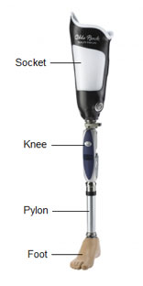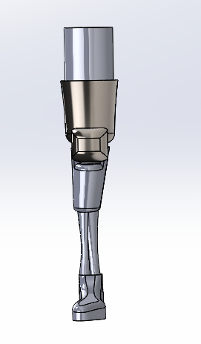
Figure 1 model prosthetic leg Figure 2 model made in solidworks
This prosthetic leg model was based off a simple model, shown opposite with a socket, knee, pylon connected to a foot. There are many other types of prosthetic legs, with all sorts of designs, many without the kneecap, however for the practicality aspect a knee cap needed to be added to look at the forces hitting the pylon. The part being looked at is the socket/holder at the joint. The material decided upon was aluminium as it was light and cheap to produce and make. This insures that the leg does not over extend past the upright, so that the person using the leg does not overextend and hurt themselves.
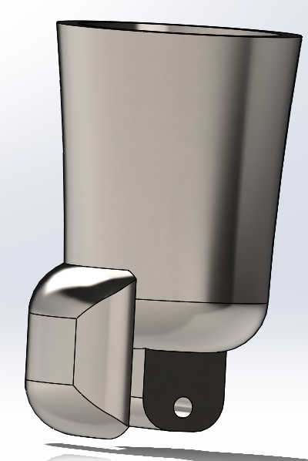
Figure 3 socket or holder
An analysis on the stress produced on the part as well as the displacement caused on the part. Once all these have been looked at the part will be remade with improvements, this will look to lower the displacement or lessen the stress on the part.

Motion simulation
First the motion conditions were decided among the part. so, a talk was inserted in with the joint of the leg, to create the upwards motion as if someone was coming from sitting in a seat to standing up. This is shown with image below;
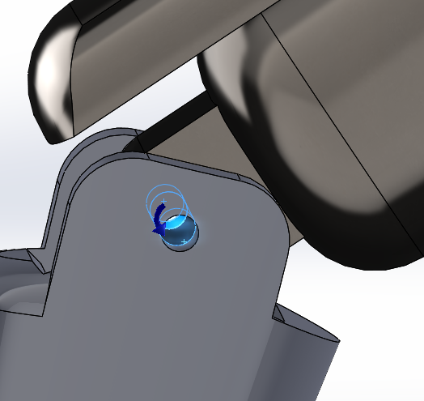
Figure 4 joint of the socket
The specifications of the torque force are shown below, the force function was decided upon trial and error, this compounded with measuring to from sitting to standing. The force chosen was constant as the movement coming up is constant. To create a fault within part I had the motion continue until it hits the leg with the cap, this was done through solid body contacts.
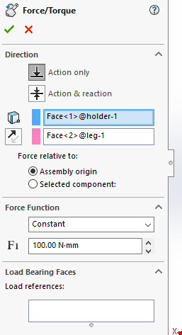
Figure 5 forces implemented
After the run of the motion simulation, motion loads were then imported on the holder at frames as the holder hits the leg. This will give a good indication of the stresses being applied onto the part.

Analysis of FEA

Stress analysis
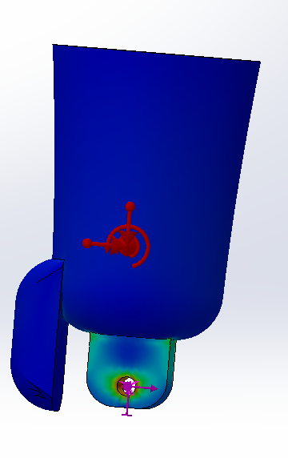
Figure 6 socket stress analysis
This first picture shows a side view of the holder and as you can see there are some stress around the hole for the joint, there are also some stress on the top right and left.
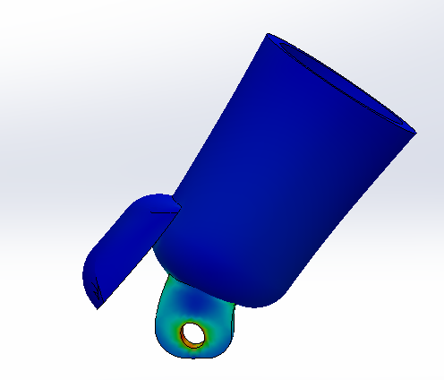
Figure 7 deformity from the stress
This second imagine shows the deformity that occurs due to the stress imported onto the part. This shows a great deal deformity on either side the stressed part, where the part is elongated on the left and shortened on right hand side. There is also some deformity within the hole where the highest stress is implied.
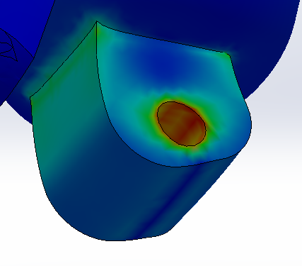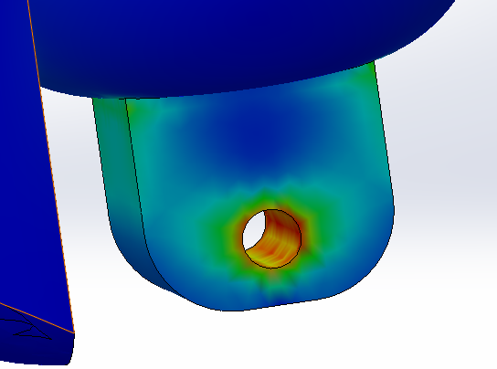
Figure 8 close up of the joint deformed Figure 9 inside look of the joint
The figures above show the stressed part of the piece closer up and as shown the stress in the corners direct across the part, this is also replicated on the other side of the part. This also shows how much stress is within the hole and the severity of it.

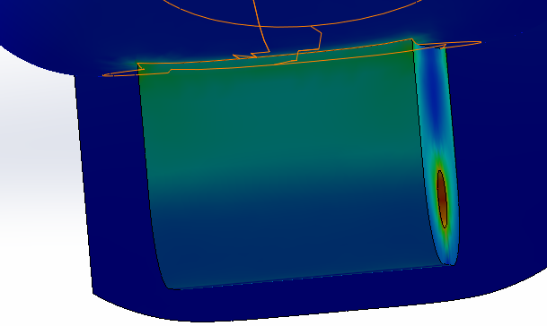
Figure 10 back view of the joint
This view shows the back of the joint of the holder showing the stress all the way around the top of the part. this shows the stress of the part is concentrated at the top of this section around and within the hole, these will be the areas that will need improving for the updated model.
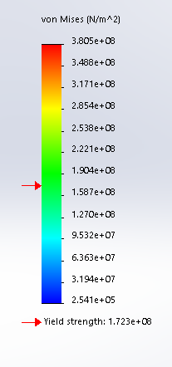
Figure 11 stress bar of the model
The picture showing stress on the piece in colour bar; the colours are indicated with blue being the least amount of stress and red being the highest amount of stress. The yield strength is given under the colour bar and the yield strength gives where the line is before deformities begin. The aim in the improvements will be to bring the yield strength below the whole bar. Another measure to look at is the factor of safety: a factor of safety is the load bearing capacity of a component or structure (Crative Mechanics Staff, 2016). This factor is measured by using the figure below;
$$Safty Factor= \frac{stength}{Stress Max}$$
Figure 12 safety factor measurement
This can be calculated by taking the taking the max stress on the part and dividing it by the yield point. If the answer of the equation is below one then the part has failed and will break, the higher the safety factor is the lower chance of the part failing. In the original model the part would have failed as the yield strength is smaller than max stress.

Displacement analysis
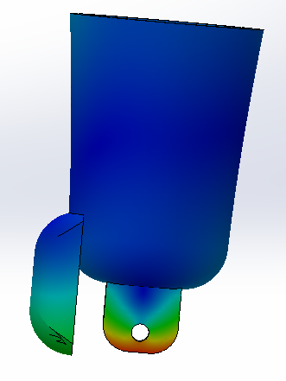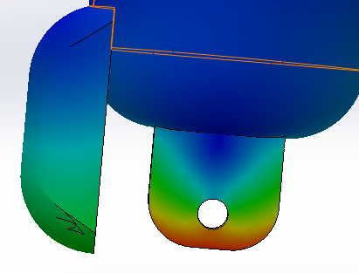
Figure 13 dissplacment Figure 14 dissplacment on joint
The displacement of the part is shown in the images above. As shown, there is a little bit of displacement on the cap as it hits the leg of the piece. The main part of the holder that has the most displacement is the bottom, where there are movement is within the red on the colour chart.

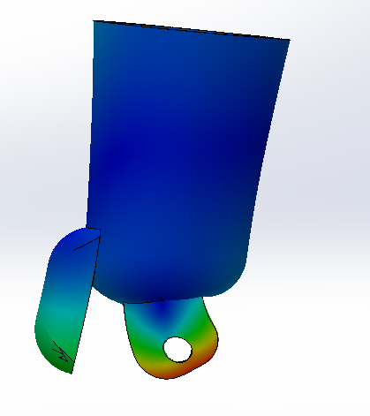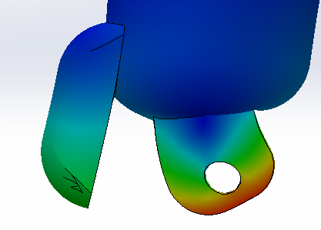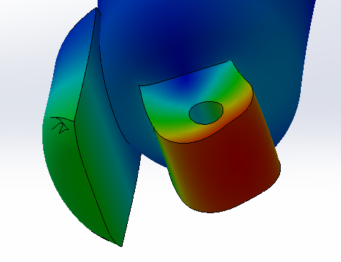
Figure 15 dissplacment deformity Figure 16 dissplacment around the joint Figure 17 dissplacment below joint
These three images show the displacement as a defect. As observed the cap comes out slightly where bottom of the holder pulls to the right, where there is an unbalanced created due to the force applied on the figure.
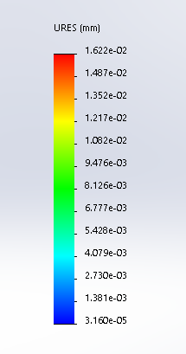
Figure 18 displacment bar
The bar for the displacement is shown above with 1.6×10⁻²mm being the largest displacement, the smallest displacement being 3.1×10⁻⁵mm which is tiny. With regards to the displacement there is not a great deal of movement, however, it’s worth trying to make the displacement as small as possible.

Improvements
The improvements that were made to the part were based on trying to solve the stress on the part that exceeded the yield point, the second part was to try and improve the displacement at the bottom of the part as shown in figures 12 to 16. This would hopefully lower the displacement around the socket. The stress within the hole joint will have to be improved this will be done through fillets around the hole, to elevate some of the stress. These fillets were 0.5mm with stress in the top corners of the holder, which were shown in figures 6 to 10, it was decided to fillet these with 1mm fillet around the holder, this should boost the strength of the part. If all of these improvements are implemented and the stress and displacement on the part is still too high then maybe moving the hole further up into space and making the hole bigger should elevate some of the displacement at the bottom of the piece as well as improve the stress inside of the joint.

Results after improvements

Stress analysis
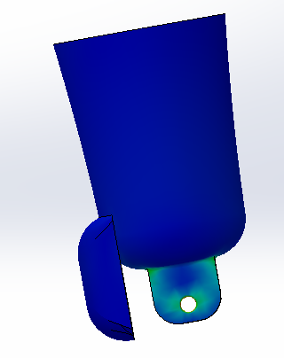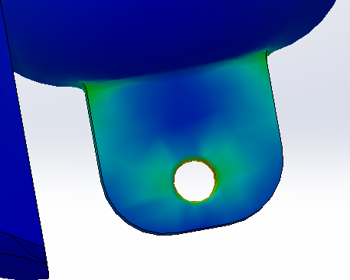
Figure 19 stress of new model Figure 20 stress around the joint
These were the results of the stress analysis after the improvements were implemented to the piece. As seen in these first two images that the stress around the hole have decreased and a decrease in stress around the top of the joint, due to the fillets implemented within the part.

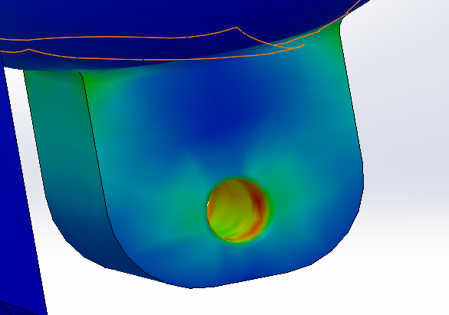
Figure 21 stress within the joint
From this angle it shows the inside of the part, where there are still a few red sections within the hole, this may have been solved by enlarging the hole; however, as will be shown later on the stress has been decreased on the bar chart all together, where the red values are below the yield value.
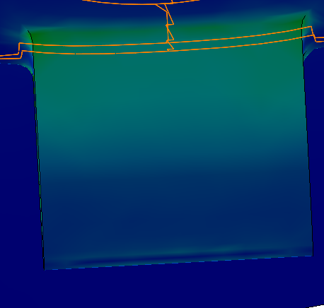
Figure 22 stress at the back of the joint
This image shows the improvement of the back of the holder, as shown the improvements have worked and the stress has decreased around the top of the holder. This is in line with the rest of the part.
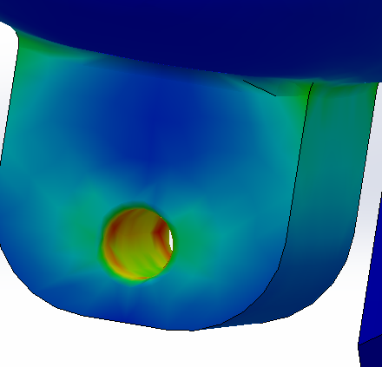
Figure 23 stress within joint
This shows the stress on the other side of the part and as shown, there is a decrease in stress around the part. This is what was expected with the changes that were implemented within the part.
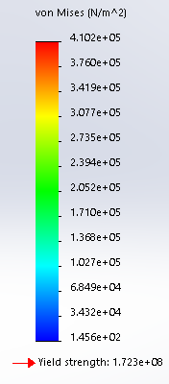
Figure 24 stress bar new model
This is the new bar stress bar from the improvements, as you can see the yield strength line is greatly above the stress in which the part will consume during the motion. This is a good improvement as the in the previous model most of the stresses were below the yield strength. This means that the part will not run to failure, the model is comfortably within the safety factor and therefore is more reliable.

Displacement
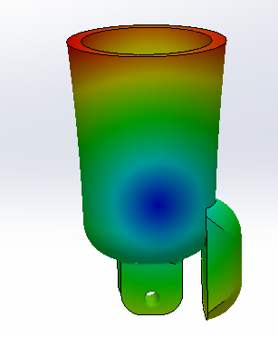
Figure 25 displacment new model
From the changes done to the part these were the changes in the displacement. As seen above all the highest displacement has moved from the joint of the socket up to the top part of the socket. This is preferable as there needs to be some sort of flex within the socket to make it comfortable for the person sitting within the socket.
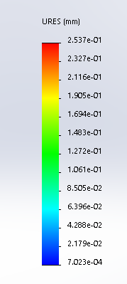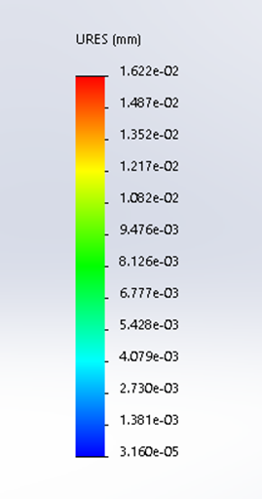
Figure 26 new bar displacment Figure 17 1 orginal bar
These two figures show the before and after in terms of displacement within the holder. On the left is the displacement of the improved piece and on the right is the changes of displacement for the old piece. As you can see from the changes in displacement: the overall displacement has actually increased, however the displacement in key areas has decreased such, as, around the hole and the below the hole. Whereas with the improved part the displacement has lowered slightly but increased towards the top of the piece. The movement within the piece is minimal at best and will not be noticed. However, this might be improved through more analysis of the part, but maybe at the risk of the stress within the part; a solution may be to change the material of the product to a stiffer material, change more of the design of the socket.

Conclusions
The objective of this assignment was to make a component of our choosing, modelling the component and assemble the component. From this a motion simulation was made with objective of the component being made, from the motion simulation a Finite Element Analysis can be made on the part chosen. These elements of the assignment are important as to add realistic motions that the component would undertake along with an FEA analysis. This can accurately predict the stress that the part would undertake, as well as the displacement that would happen within the part. Once the results were analysed improvements could be made to the part to help relief the stress on the part and lower the displacement from the part. The results of the improvements showed in the new FEA that stress was reduced below the yield point, which was the goal of the stress analysis, however, there was not a considerable change in the displacement on the part and in some areas the part had increased its displacement. Further improvements could be looked at in, regards to, lowering the displacement in the part, maybe look at the material and use a different material or edit parts of the material again. Overall this assignment has shown the use of motion simulation within solidworks and proved how this can be implemented into a FEA to help improve the part.

References
Bender, J., Erleben, K. & Trinkle, J., 2013. Interactive Simulation of Rigid Body Dynamics in Computer Graphics. 33(1).
Caudill, L., 2017. 60 Years of CAD Infographic: The History of CAD since 1957. [Online]
Available at: https://partsolutions.com/60-years-of-cad-infographic-the-history-of-cad-since-1957/
Crative Mechanics Staff, 2016. Factor of Safety in Design and Engineering: The Basics. [Online]
Available at: https://www.creativemechanisms.com/blog/factor-of-safety-in-design-and-engineering-the-basics
[Accessed 28 January 2020].
Stewart, D., 2000. Rigid-Body Dynamics with Friction and Impact. 1st ed. Iowa City: Society for industrialand applied mathemathics .
Yue, X., 2010. Finite Element Analysis on Strains of Viscoelastic Human Skull and Duramater, Beijing: University of science and technology Beijing.

One drive link
https://uowtsd-my.sharepoint.com/personal/amorris_149364_student_uwtsd_ac_uk/_layouts/15/onedrive.aspx?id=%2Fpersonal%2Famorris%5F149364%5Fstudent%5Fuwtsd%5Fac%5Fuk%2FDocuments%2FYear%203%2Fsolidworks%2FAshleys%20solidworks

