
UK Labor Market Overview & Changes in HR Strategies
2626 words
Noble Kuriakose Mathew | 9/8/22 | LCMB7000

Table of Contents
Part A: The current state of the labor market in the UK 2
Introduction 2
Tight Labor Market 2
Vacancies 3
Unemployment 4
Earnings 4
Part B: Emerging changes in Human Resourcing Strategies in the post Covid, post Brexit external environment. 5
Introduction 5
Hybrid Work Model 5
Changes in Recruitment 6
Furlough and Job Retention 6
References 8

Part A: The current state of the labor market in the UK

Introduction
The labor market, more commonly referred to as the “job market”, is where the supply and demand for jobs intersect. This is where employees and employers interact with each other, with the employees providing supply, and the employers providing demand. At a microeconomic level, the relationship between firms and their workforce is examined, such as how and when businesses hire and lay off employees, what employees working hours and salary structures are, and so on. On the other hand, from a macroeconomic lens, the effect on demand and supply of domestic and international factors is examined, including age of the population, immigration, literacy etc. (Joll, Shorey, McKenna and McNabb, 2020)
In this report, we will be examining the state of the labor market in the United Kingdom. With a population of 62.3 million (World Bank, 2021), the labor force in the UK stands at 34.6 million (World Bank, 2021). The UK economy was impacted by Britain’s exit from the EU in 2017, and subsequently by the Coronavirus pandemic in 2020. However, post the pandemic, the UK economy began to recover quickly as vaccine rollouts were rapid and effective, allowing for easing of restrictions, slowly restoring the economy to normalcy. While the economy was on the trajectory of a fast-paced recovery, labor shortages became a rising concern as global demand began to outweigh global supply. This was coupled with rising energy prices due to the Russia-Ukraine conflict, and growing barriers to migration and trade due to exiting the EU meant further labor supply shortages. All the above factors, coupled with rising inflation, began to slow down the growth of the UK economy (OECD, 2022)

Tight Labor Market
Between April to June 2022, approximately 32.79 million people were employed in the UK. The employment rate, which refers to the number of people in the population aged between 16-64 who are in work, stood at 75.5%. A low unemployment rate, along with a high number of vacancies in jobs, signifies that the labor market is “tight”, meaning that the economy is nearing full employment recruitment for jobs is becoming more and more difficult (Powell, Francis Devine and Clark, 2022)
As per the Bank of England, one major reason behind a tight labor market, is a rise in the number of economically inactive people in the UK post the pandemic. Economically inactive refers to those who are outside of the labor force, who are neither employed or unemployed, they are not currently working nor available to start work. This can include students, those who are retired, those who are ill and so on etc. (Barr, Magrini and Meghnagi, 2019) With reference to a post pandemic scenario, there have been two major reasons which have led to economic inactivity; one is of being a ‘student’ and the other is of ‘long term illness.’ Initially, this mix was skewed towards students, however recently there has been a decline in those who are economically inactive due to being students, and increase in those who are economically inactive due to a long-term illness. A study by Reuschke and Houston (2022) approximates that COVID caused 80,000 people from the workforce to leave employment as of March 2022. Furthermore, rise in economy inactivity has been higher for people in their 50s and 60s as opposed to those younger or older than them. Workers in this age usually move straight into retirement or economy inactivity and this was the case more so than usual in the pandemic. People in this age group were mostly also unable to work during COVID due to health issues, and may have chosen early retirement from their jobs to avoid exposure to COVID (Boileau and Cribb, 2022).
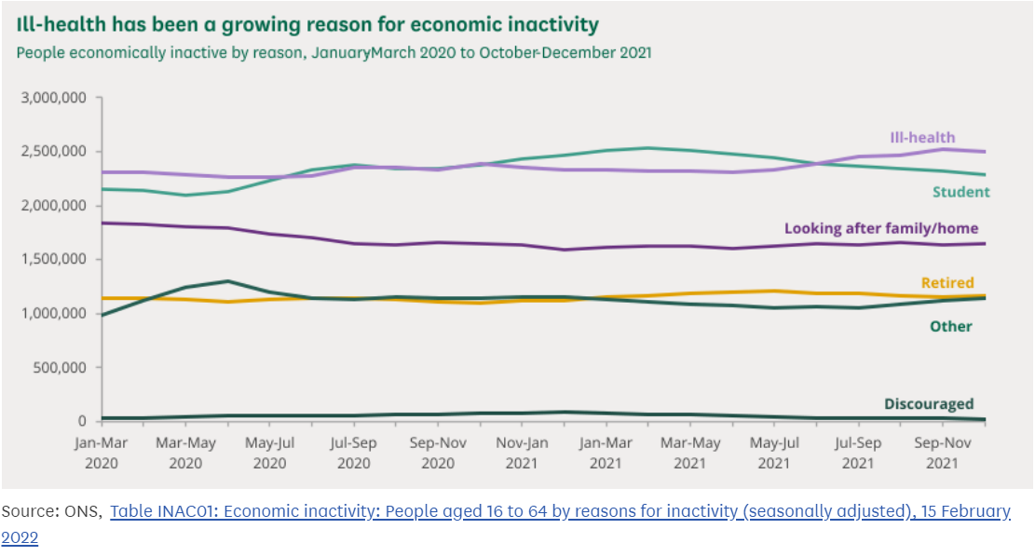
The second cause behind tightening of the labor market is due to Brexit, which has significantly reduced migration from the EU into the UK, and in turn, has reduced the available workforce. The UK Home Office constructed modelling which predicted a steep decline in the number of EU workers in the UK by 200,000-400,000 workers by 2025 (Portes, 2022). Following a reduced flow of potential workers from the EU into the UK, the proportion of the population who is willing and able to work in the market has shortened even more so. Research conducted by the Financial Times showed that sectors such as hospitality, security, corporate support services and warehouse staff had experienced a steep decline in the number of EU workers and an increase in vacancies as employers faced difficulty in recruiting from non-EU countries due to low wages. These sectors were heavily dependent on EU workers even before the pandemic. The report also found that employers had not responded to these shortages in workers by raising pay scales (Giles, 2022).

Vacancies
Following on from a tight labor market, the number of job vacancies in the UK labor market has also reached an all-time high this year. Logically speaking, when employment levels are high and there is a shortage in workforce, it becomes harder to recruit people for jobs, thus driving up job vacancies. Under this tight market, it becomes more and more difficult to recruit workers. When the pandemic started, job vacancies experienced a record low, however, in January to March 2022, these vacancies reached a record high of 1.29 million (Powell, Francis-Devine and Clark, 2022). At the start of the pandemic, most sectors experienced a fall in vacancies, however many sectors are now seeing a steep increase in vacancies, especially those such as the accommodation, hospitality and food services sector.
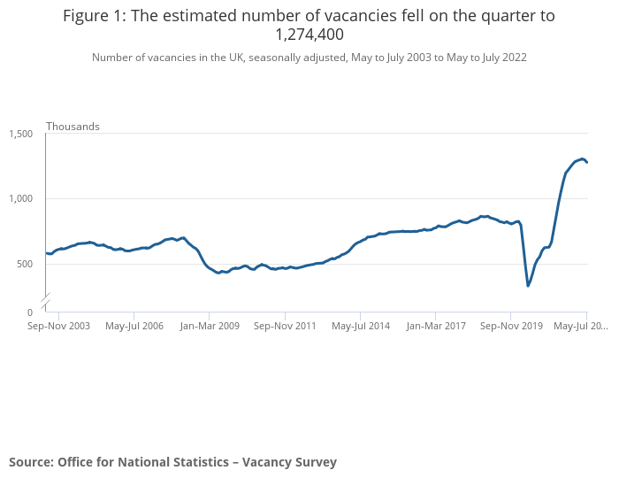

Unemployment
The unemployment rate in the UK, which refers to the percentage of the economically active population who are unemployed, stood at 3.8%. As per historical levels, this unemployment rate is quite low (Schomberg and Milliken, 2022). This can be linked to the fact that there is already a shortage of labor in the market, so UK firms are more likely to retain their existing labor than to let go of any employees to recruit new employees in an already difficult market. Initially, when the pandemic hit, it was expected that record unemployment would be experienced, however this did not turn out to be the case. Now, in a market with short labour supply, firms are increasing wages to attract and retain their existing employees. Data from the Office of National Statistics shows that wages in the second quarter of 2022 were up by 4.7% in comparison to last year. However, these efforts are dampened by factors such as rising inflation in the UK, which has hit a record high in 40 years, at 10.1% (Smith, 2022).
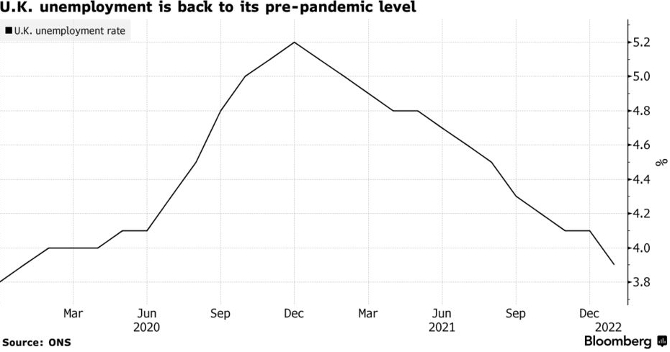

Earnings
Initially, COVID lockdowns impacted earnings negatively, as furloughed workers were receiving a lesser proportion of their total wages, and those who were working had to reduce their working hours. Shortly after, real wages began to experience growth as low paid faced a decline as a proportion of total jobs (Powell, Francis-Devine and Clark, 2022). “Real” wages represent the actual value of wages, once they are adjusted for inflation. They give insight into how much money a person makes once inflation is accounted for (Lavoie, 2022). Since 2020 ended, the growth of real wages has pretty much stagnated, and increasing inflation means real wages are effectively declining. As mentioned earlier, firms in both the private and public sector increased pay scales, however this was dwarfed by increasing prices of goods and services. Regular pay (which excludes bonuses) grew annually at 1.8% for the public and 5.4% for the private sector, however in comparison with Consumer Price Inflation, this translated into a decline in real wages by 4.1% (Giles, 2022). Although UK firms are increasing wages of employees, rising inflation means the cost of living is much higher, and even with these increased wages, the amount of goods and services that the workforce can purchase has declined.
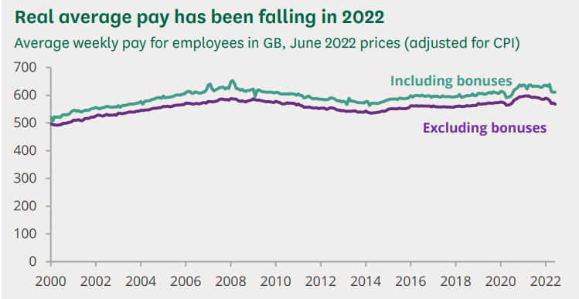

Part B: Emerging changes in Human Resourcing Strategies in the post Covid, post Brexit external environment.

Introduction
The UK labor market was still experiencing the impact of Brexit, when the COVID pandemic struck, and lockdowns were imposed. When the external political environment changes, organizations usually have to follow suit with their own internal changes, for example when Brexit occurred, free movement of labor to and from EU to the UK was restricted and organizations had to adapt their human resourcing strategies accordingly. Similarly, when the economic environment experiences a change or unforeseen circumstances, organizations and their human resource strategies must adapt. When the COVID-19 pandemic spread, organizations all around the world, including the UK had to alter their strategies for their workforce (Wilkinson and Dundon, 2021). Therefore, whenever political and economic changes such as COVID-19 and Brexit come about, the human resource strategies in organizations also experience change and adapt accordingly. In this section of the report, we will examine some of the changes that have emerged in Human Resourcing Strategies in the UK in the wake of Brexit and COVID-19.

Hybrid Work Model
The COVID pandemic brought about an unprecedented time for workplaces all around the world, including the UK. Initially, lockdowns meant people could not go into their offices and were working remotely from their homes due to fear of exposure to COVID. Even before the pandemic, the concept of remote working was picking up pace in the UK, however the number of people working remotely doubled after the pandemic. In the Spring of 2022, when work from home guidelines were lifted in the UK, 38% of adults reported that they had worked from home in the past 7 days (Is hybrid working here to stay? - Office for National Statistics, 2022). Emerging trends show that professionals now engage in a hybrid working model, which organizations human resources have allowed for their employees. A hybrid working model is whereby an individual divides their time between their workplace and their home. This model is facilitated by technologies such as Zoom, Microsoft Teams, Slack etc. Organizations facilitate their employees by purchasing licenses to this software, allowing for employees to sign in and join meetings and conduct office work on the go without being physically present in the office. Many companies all over the UK have begun to adopt a hybrid working model or flexible working hours post the pandemic. This Human Resource strategy seems to be one that is beneficial for both the employer and the employee. This has allowed employees to save up on time and money spent on commuting to the workplace, freeing up time for family and personal life, enhancing employee satisfaction (Jones, 2022). For the employer, this means saving up on large costs that they would normally incur for renting out or maintaining office space. This also translates into ease of accessibility of workforce when and where they need it without the requirement of having them physically present. Large UK firms like PwC, KPMG, Deloitte, EY and Salesforce, have all adopted a hybrid working model strategy for their employees. Firms have customized the extent to how flexible they want to keep their strategy, with some allowing employees full freedom not to come into the office at all if they choose to. There are 4 types of hybrid models that can be adopted:
- Week by Week: This alternates by offering work from home for one week and work from office for the week after
- Split-Week: This splits the week whereby some days employees come into office for meetings and the rest of the days they work from home
- Shift Work: In this, employees can work part of their shift from home and the other part of their shift from the office, for eg. The morning shift in the office and the evening shift at home
- At Will: This model allows employees full freedom to choose whether they want to work fully from home or fully from office, or to choose whichever structure between home and office that they prefer (Geada and Anunciação, 2021)

Changes in Recruitment
As discussed earlier, it is seen that migration restrictions resulting from Brexit have impacted the labor market by contracting the supply of overseas workers, resulting in labor shortages of both skilled and unskilled workers for many employers. Many employers have placed reliance on EU workers, such as those in sectors like hospitality and food processing. These employers, along with others, are facing adversity in recruiting workers due to a tight labor market. Businesses in the UK now need to focus on actively and more innovatively recruiting new talent (Wilton, 2022). Firstly, in order to overcome the shortage of workers in various sectors, firms are looking into diversifying their workforce. In order to tap into unused talent pools that are available in the UK at the moment, many firms are looking into restructuring some of their hiring requirements, and are looking to adopt a more agile approach to hiring, rather than being stringent. Other than this, the hiring process of many organizations was partially online even before the outbreak of COVID, however, virtual recruiting has increased exponentially post the pandemic, with companies hiring candidates without ever having met them in person. Furthermore, another innovation in the hiring process is that of social media recruitment and video resumes. Video resumes have gained popularity, whereby some candidates are asked to record their profile in a video and share it with the employer. They are becoming an alternative for a traditional cover letter. In terms of social media recruitment, firms extensively focus on building their social media presence online to attract talent, as applications such as Instagram can often given prospective employees a look into an organization’s work culture. Social media can be a useful tool to connect with potential talent, and firms now realize this and are hence building their presence (Machado and Davim, 2022). Organizations are aware that employees want more than just a good pay scale, they want a work life balance, flexible hours, and a good working culture, and this is the image that organizations can promote on social media to recruit potential talent

Furlough and Job Retention
Initially, when COVID-19 struck, it was expected that many people would lose their jobs. Although many did, there has been a shift in Human Resource Management, whereby governments in many countries have taken steps to protect the workforce via various job retention schemes. The UK government introduced such a scheme titled ‘Corona Virus Job Retention Scheme (CJRS)’ under which 11.5 million jobs were furloughed. Previously when crises struck the UK, employment levels faced decline, however furloughing has helped people keep their jobs and firms have retained their workers instead of letting them go. Under the CJRS, firms would furlough employees and the state would reimburse 80% of the employee’s wage, up to £2500 per month (Stuart, Spencer, McLachlan and Forde, 2021). Historically, there was no practice of furlough in the UK, and through the CJRS firms are now expected to adopt furlough schemes themselves along with planning for other schemes to retain their employees in times of uncertainty and global turmoil. Retention management is now being focused on an organization level at firms and is something that is being more actively factored into human resource strategies. The CJRS provided support during the pandemic, however firms must independently work on their labor retention and management strategies now. Practices that focus on retention are also expected to foster a positive impact on the efforts of workers, their morale and their overall job satisfaction. Work conducted by Maley (2019) puts forward a case that investing in employees during periods of economic uncertainty has a long- term effect improving motivation, productivity and performance. This can include things like retaining staff during uncertain times instead of letting them go, and investing in training them and improving and fostering their skillset.

References
- Joll, C., Shorey, J., McKenna, C. and McNabb, R., 2020. Developments In Labour Market Analysis. [Place of publication not identified]: Taylor & Francis Group.
- OECD, 2022. OECD Economic Surveys: United Kingdom 2022. [online] Paris: OECD Publishing. Available at: <https://books.google.com.pk/books?id=qRV_EAAAQBAJ&pg=PA23&dq=UK+labour+market+2021..2022&hl=en&sa=X&ved=2ahUKEwiOgPSY8eb5AhVGKuwKHUeoA7kQ6AF6BAgHEAI#v=onepage&q=UK%20labour%20market%202021..2022&f=false> [Accessed 27 August 2022].
- Powell, A., Francis Devine, B. and Clark, H., 2022. UK Labour Market Statistics. House of Commons Library.
- Barr, J., Magrini, E. and Meghnagi, M., 2019. Trends in Economic Inactivity Across the OECD: The Importance of the Local Dimension and a Spotlight on the United Kingdom. Paris: OECD Publishing.
- Boileau, B. and Cribb, J., 2022. The rise in economic inactivity among people in their 50s and 60s. [online] Institute for Fiscal Studies. Available at: <https://ifs.org.uk/uploads/BN345-the-rise-of-economic-inactivity-in-people-50s-60s.pdf> [Accessed 27 August 2022].
- Reuschke, D. and Houston, D., 2022. The impact of Long COVID on the UK workforce. Applied Economics Letters, pp.1-5.
- Portes, J., 2022. Immigration and the UK economy after Brexit. Oxford Review of Economic Policy, 38(1), pp.82-96.
- Giles, C., 2022. Brexit intensifies labour shortages as companies struggle to hire. [online] Ft.com. Available at: <https://www.ft.com/content/a9677ee4-281d-4d0d-8456-661982890304> [Accessed 28 August 2022].
- Powell, A., Francis-Devine, B. and Clark, H., 2022. Coronavirus: Impact on the labour market. [online] House of Commons Library. Available at: <https://researchbriefings.files.parliament.uk/documents/CBP-8898/CBP-8898.pdf> [Accessed 28 August 2022].
- Schomberg, W. and Milliken, D., 2022. UK's hot labour market cools and inflation eats pay. [online] Reuters. Available at: <https://www.reuters.com/world/uk/uk-unemployment-rate-holds-38-three-months-june-2022-08-16/> [Accessed 28 August 2022].
- Smith, E., 2022. UK inflation hits new 40-year high of 10.1% as food and energy price surge continues. [online] CNBC. Available at: <https://www.cnbc.com/2022/08/17/uk-cpi-inflation-july-2022.html> [Accessed 28 August 2022].
- Lavoie, M., 2022. Post-Keynesian Economics. Cheltenham: Edward Elgar Publishing Limited.
- Giles, C., 2022. Record wage drop signals more cost of living pain for UK households. [online] Ft.com. Available at: <https://www.ft.com/content/28f2b344-e2a6-4e10-bf4a-c924660eded0> [Accessed 28 August 2022].
- Wilkinson, A. and Dundon, T., 2021. Contemporary Human Resource Management. SAGE.
- Ons.gov.uk. 2022. Is hybrid working here to stay? - Office for National Statistics. [online] Available at: <https://www.ons.gov.uk/employmentandlabourmarket/peopleinwork/employmentandemployeetypes/articles/ishybridworkingheretostay/2022-05-23#:~:text=The%20proportion%20of%20people%20hybrid,over%20the%20past%20seven%20days.> [Accessed 29 August 2022].
- Jones, A., 2022. Hybrid work is here to stay: The shift helps young professionals focus on priorities & work-life balance. [online] The Economic Times. Available at: <https://economictimes.indiatimes.com/magazines/panache/hybrid-work-is-here-to-stay-the-shift-helps-young-professionals-focus-on-priorities-work-life-balance/articleshow/93271721.cms> [Accessed 29 August 2022].
- Geada, N. and Anunciação, P., 2021. Reviving businesses with new organizational change management strategies. IGI Global.
- Wilton, N., 2022. An Introduction to Human Resource Management. SAGE.
- Machado, C. and Davim, J., 2022. Organizational innovation in the digital age. Cham, Switzerland: Springer.
- Stuart, M., Spencer, D., McLachlan, C. and Forde, C., 2021. COVID‐19 and the uncertain future of HRM: Furlough, job retention and reform. Human Resource Management Journal, 31(4), pp.904-917.
- Maley, J., 2018. Preserving employee capabilities in economic turbulence. Human Resource Management Journal, 29(2), pp.147-161.

