Geo queries calculating distance.

Something we may wish to investigate are distances travelled by patients to GP practices. This is not so much a location-based service but location analysis. This could be used to help determine where to locate new facilities.

Stage 1
First have a look at the structure of all the map tables that we will use to investigate the
We have data from the following shape files:
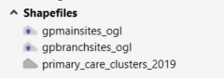

Select only GP sites in Swansea from branch and the brand and main
Run several queries to pull out only the Swansea bay data

Isolating Polygons
First, we need to isolate the cluster polygons for Swansea. This is a simple manual select.
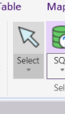
We can create a new table of polygons from this selection. Remember to rename the selection and save it to a suitable folder.

Now we can carry out some geographical selections:

Joining Tables Geographically (Using Geographic Operators) When two tables have graphic objects, MapInfo Professional can join the tables based on the spatial relationship between those objects. Thus, even if your tables do not share a common column, you may be able to join the tables.
Geographic operators allow you to select objects based on their spatial relationship to some other object. MapInfo Professional has a special column name you use with geographical operators: "obj" or "object". This column name refers to the graphic objects that are attached to your table. The geographic operators go between the objects being specified. Select the geographic operators from the Operators drop-down list.

The following table lists the geographic operators:

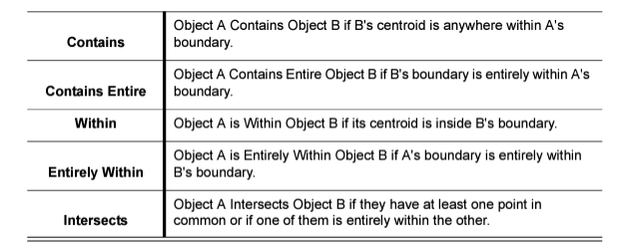

The difference between Contains and Within on the one hand, and Contains Entire and Entirely Within on the other, hinges on how the geographic comparison is made. For Contains and Within, the comparison is based on object centroids. For Contains Entirely and Entirely Within, the comparisons are based on the whole object.

The following graphic illustrates this point:

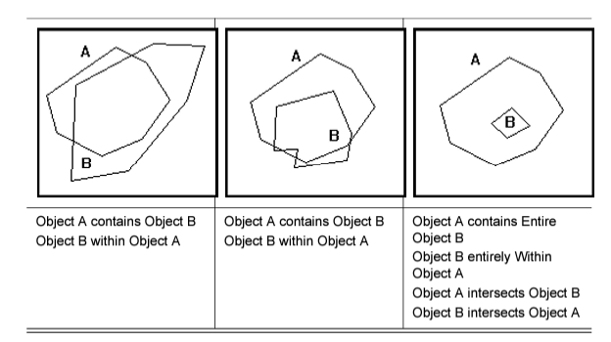

In each case, object A contains object B because the centroid of object B is inside the boundary of object A. However, in the cases at the left and in the middle, part of object B is outside the boundary of object A. Only in the case to the right is all of object B inside object A. Only in this case could we assert "object A Contains Entire Object B" or "Object B Entirely Within Object A." Further, if A contains entire B, then A contains B, and If A is entirely within B then A is within B.

Applying this to GP data
We are querying for point objects found within polygon objects.
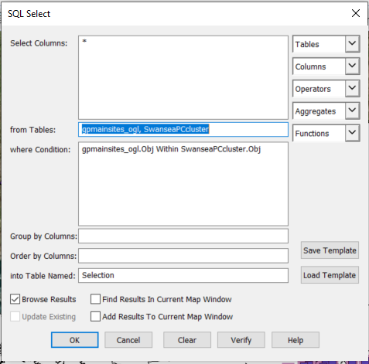

Cary out the same process for the branch sites, you should have a map that looks something like this

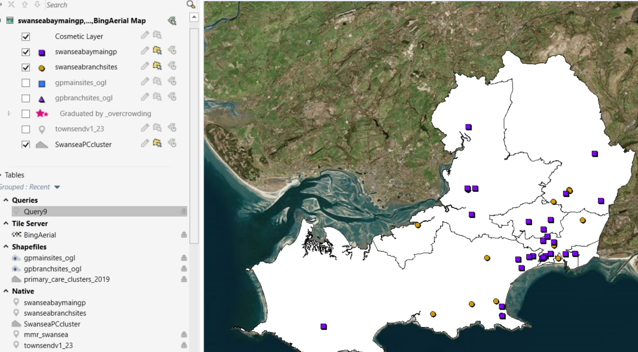

Calculating the Average distance to the GP surgery

Choose some fields from the swanseabaymaingp table to identify your selection and distance calculations e.g.
Wcode, Practicana, Ppclustern, pccs 2019,ppclusterc

Your query dialogue will need to look something like this:
swanseabaymaingp.Wcode, swanseabaymaingp.Practicena,swanseabaymaingp.Ppclusterc, swanseabaymaingp.Ppclustern, swanseabaymaingp.Pccs_2019, Round(Distance(CentroidX(obj),CentroidY(obj),CentroidX(swanseabaymaingp.obj),CentroidY(swanseabaymaingp.obj),"Km"),.1)"Kilometers"

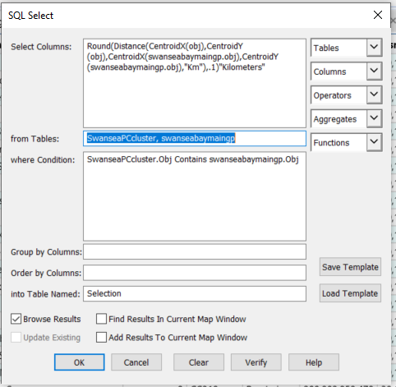

Because this will register as polygon, we need to export the data and reintroduce it as a point dataset so export and save as a CSV
You can then geocode this new data containing an average distance to a GP surgery to the swamseamainGP site data. This will allow you to add a thematic map to show the distances.



