‘Supporting pupil progress: a detailed analysis of one child’s holistic development, with justification for the next steps in learning.’

Ensuring Pupil Progress Assignment – Part 1/2

M6X02151 – Ensuring Pupil Progress
Group 5 – p123348
Word Count: 4052



Contents

Introduction Page 4
Data Collection Page 6
Analysis of learner and Next Steps Page 9
Conclusion Page 14
Appendix Page 16
References Page 22

Please note that the child’s name has been changed in line with British Education Research Association (BERA) guidelines. In no instance will the child or school be identifiable.

A note
At Aiming for Excellence, I emphasised the huge responsibility we have as educators to give children hope and vision they may not get otherwise. Thank you giving me the opportunity to do just that.

Introduction
‘Children speak a hundred languages’
(Malaguzzi,1998).

Political, theoretical context and overarching purpose
Children are the most incredible, complex beings whose potential to innovate and create are endless, if nurtured correctly. In a renowned TED talk, Robinson (2006) highlights the fact that we are preparing children for a world where their future employment does not yet exist, therefore subject knowledge is not enough. Donaldson (2018), emphasises that our current overcrowded curriculum needs purpose, and that those purposes should drive our decision making. Therefore, when considering pupil progress, looking at the whole child is essential.
The purpose of this assignment is to holistically capture Beau, a five year old reception child, in line with Foundation Phase pedagogy, and demonstrate how best progress can be made. The ‘Mosaic Approach’ was used to collect data, and the ASK Model (Attitudes, Skills and Knowledge) to analyse the data. The strengths and limitations of these choices will be discussed later.
The way in which children learn and develop has been contested since the 1944 Butler Act. So, it seems imperative to paint a picture of the current, turbulent curriculum in Wales. So how have ideas progressed? Historically, theorists, such as Paolo Friere and John Locke, viewed children as passive receivers of education. Friere (2006), in ‘The Banking Model of Education’, compared children to banks, where practitioners deposit information without challenge or voice. Similarly, John Locke, viewed children’s minds as blank slates, that educators ‘fill up’ (Pinker 2002). Despite a behaviourist ‘reactive’ pedagogy, Piaget described children as lone scientists - mini investigators who are active in their education. Donaldson (2015) apposes a didactic ideal of education, and promotes an environment where children can be critical thinkers, solve problems and become resilient, ethical members of society – always active in the process. This is imperative to note when looking at a child’s progress because ‘purposes must drive our decisions’ (Donaldson, 2018). Opportunities must be made for children to lead and construct their learning, and have a box of tools ready for when things do not go to plan.
The four purposes are highlighted below and are considered;
Ambitious, capable learners who are ready to learn throughout their lives.
Enterprising, creative contributors who are ready to play a full part in life and work.
Ethical, informed citizens who are ready to be citizens of Wales and the world.
Healthy, confident individuals who are ready to lead fulfilling lives as valued members of society. (Donaldson, 2015).

Curriculum and school context
The school is situated in an urban part of South Wales, that has religious undercurrent. With a population of 150 on role, 95% of children achieve the expected outcome in the Foundation Phase, with 100% achieving the expected outcome in KS2 (2017 data). 16.4% of children receive Free School Meals, 28% of children have English as an Additional Language and 17% have Additional Learning Needs (of which 6% are statemented).
The participant, Beau, is 5 years old and is in a one form entry Reception class. The class is predominantly Foundation Phase led, with a variety of opportunity for child led learning and child led AFL. The evidence suggests that Beau is a best fit Outcome 3 for Personal and Social Development, Mathematics and Physical Development and a best fit Outcome 2 for Language, Literacy and Communication. This will be explored later on on the assignment. Beau is selective with which friends he plays with, and tends to go to the same areas of the classroom (construction and sand). If Beau fails to complete a task, he can often get worried and become withdrawn with no real intervention. He attends breakfast clubs and after school clubs and really enjoys talking about Marvel, Minecraft and Fortnite. His favourite subject to learn is mathematics, because he finds it ‘fun’, interestingly he excels in this.

Data Collection

Justification of method
Clarke and Moss were responsible for the creation of the Mosaic approach. Despite the work of John Locke, Clarke and Moss (2005) view children as multifaceted and diverse who are influenced by a multitude of aspects, therefore we need different perspectives to build up the best picture, in order to make the most effective decisions. We are essentially expressing a childs story by putting together the different pieces of the mosaic. Bronfenbrenner (2013) supports this notion, suggesting that children are influenced by media, their likes and dislikes, home, school, community and political sphere. Having an array of perspectives, including the childs can only increase the validity of the research and avoid unintentional bias.
In addition to points raised in the introduction, the Mosaic Approach is rooted in a child active approach. Mulagazzi and Reggio Amelia thought processes view children as experts and agents in their learning and prioritises the child’s voice. The following principals can be viewed below. Other comparisons can be made to Rinaldi (2006), who’s ‘pedagogy of listening’ puts the child at the centre of .
‘Pieces of the Mosaic Approach’ (Clark, 2011)
Observation: Qualitative observation accounts
Child interviewing: A short structured interview conducted one to one or in a group
Photography and book making: Children’s photographs of ‘important things’ and books
Tours: Tours of the site directed and recorded by the children
Map making: 2D representations of the site using children’s own photographs and drawings
Interviews Informal interviews with practitioners and parents
Magic carpet: Slide show of familiar and different places
Figure 1
Synergising information that is initially child led, allows for different stakeholders to partake in the research. This is beneficial because it can bring to the surface differing perspectives and issues that may not have been visible otherwise. Additionally, it is noted that children express them selves in different ways also, therefore this approach allows us to capture this (Clark 2001). Clark also highlights that there are differing stages to the Mosaic Approach; stage one includes building the best possible image of the child in action; and stage two, collaborating child and adult perspectives in a critical, reflect discussion. The data collected is qualitative. Qualitative study has to be ‘exposed and adaptable enough for the enlightenment of fresh, unprecedented classifications of understanding and knowledge. The issue with qualitative data is that we can overgeneralise and draw conclusions that are bias. Also, we tend to apply our assumptions on a larger scale, which can be misleading, especially as in this case, the sample is so small (Willis, 2008).
From research, there are also several limitations to the Mosaic approach. Although the research is action led and inclusive, Blaisdall (2012) argues that for children who do not want to participate in the study, it can actually be excluding. Additionally, that there can be a divide between rhetorical speechmaking and what is effective in actual practice. However, with this considered, the Mosaic Approach seems an excellent choice when painting the best possible picture of a child.
The data collected will be analysed using the ASK model ‘attitudes, skills, knowledge’ as seen below.
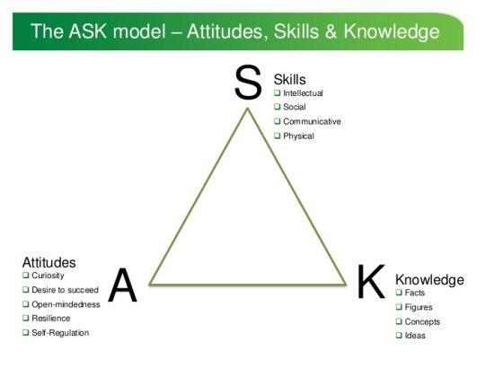
Figure 2 (Nottingham, 2013)
This method allows us to categorise the data into three ways, attitudes, skills and knowledge. Additionally, to raise essential problem-solving opportunities for critical analyses to take place. A concern is that as this study is child led, we may experience uncalled for digressions.
Awareness and application of ethics
As a member of this child’s Reception class, I understand the role as teacher that is a position of responsibility. No incentives were given that might manipulate the data. In accordance with UNCRC (1989), the right to feel safe, and to be treated as equal despite race, religion, gender or sexuality was respected. The University was also respected and care was taken to ensure that its good name was not brought into jeopardy.
In line with BERA (2011) procedures and recommendations, care was taken so that Beau understood he could cancel his assent at any time without concern. All data was kept on a password protected cloud, and all names were modified to retain confidentiality and anonymity. A consent form was signed by the class teacher (See Appendix A). Seeing the parent on the yard, I had an informal chat about the research and the Dad approved and was supportive.
I ensured that I was seated away form the child when I was observing, so that I did not intervene or influence with the lesson being taught. Also I made sure I was never on my own with Beau.

Analysis of learner and Next Steps

The purpose of this analysis is to capture an image of Beau, refereeing to attitudes, knowledge and skills. To begin our journey, Beau was keen to partake in the research, and seemed overly pleased that someone was taking so much interest in his interests. Firstly, a learning walk took place which will be explored throughout the analysis. A focus interview with both the teacher and the child helped to give differing perspectives. The following is in line with Foundation Phase (2015) pedagogy, which is responsive and informative to Successful Futures (2015). Note that with each area of the Foundation Phase curriculum, selected pieces of work are taken to capture where the child is currently at, in line with the suggested outcomes. The expected Outcome at the end of Year 2 would be Outcome 5, If there was enough words in this assignment, more evidence could have been provided.
Donaldson regards the current framework for the Foundation Phase overloaded or congested, however here are the seven statutory areas of learning practitioners should strive towards (highlighted are areas discussed):
Seven Areas of Learning:
- Language, Literacy and Communication Skills
- Mathematical Development
- Welsh Language Development
- Knowledge and Understanding of the World
- Physical Development
- Creative Development
- Personal and Social Development, Well-Being and Cultural Diversity

Language, literacy and communication: Best fit outcome 2
A core area of the National Curriculum (Donaldson, 2015).
Nearing the end of Reception, Beau is a keen communicator. As demonstrated in the learning walk, he was excited to share his opinion on his favourite parts of the classroom, such as the role play, construction and sand pit. Construction especially because he gets to build Superheros. When mapping his choice of location in the classroom, it seemed evident that the role play was a popular choice. Perhaps, this is because he has the opportunity to express himself verbally, which he feels more competent at. On the contrary, Beau expresses his discontent with writing down his work. As seen in Appendix B, he struggles to discriminate between letters and needs a highlighter pen as a guide. However, Appendix B demonstrates Beau’s ability to overwrite a sentence independently. During activities, he can respond to stimulus and interact with his peers. He lights up when you talk about his interests, though becomes withdrawn when he struggles to form a letter. Appendix C shows Beau expressing his views on the actions of a dragon, and could overwrite confidently, though struggled to write a word independently, but had a go. Interestingly in an interview about that piece of work, Beau expresses his love for Dragons, and stated that made him ‘want to try’, because he was interested in it. Beau hits elements of Outcome 3 for writing, however not a significant amount (see Appendix C).
Oracy is definitely one of Beau’s strengths, hitting all strands of Outcome 2. As seen in the learning walk, an in-depth recount was given about the places in the classroom he enjoyed the most. Appendix D1 demonstrates his ability to recount an experience and give reasons for this, which covers strands of the expected Outcome 3 (Welsh Government, 2015). Appendix D2, strengthens this point and provides further evidence, as Beau was able to explain a character he had made and express what he liked.
Next Steps for Language, Literacy and Communication
In relation to Appendix B, Beau needs to be encouraged to have a go at writing independently. As a practitioner, highlighting the words scaffolds the learning, in line with Vygotskian pedagogy. The practitioner gives the learner enough support to achieve the task (Mc Loed, 2012). More specifically, Beau needs to be given more opportunities to have a go at writing on his own, slowly lessening support – as though removing stabilisers from a bicycle. To assist with attitude, praise needs to given towards effort, as Nottingham (2016) implies that learning is difficult and causes doubt and confusion. Exposing Beau to the Learning Pit could help him understand that learning is a process that requires patience. A limitation of this is the childs age, such an abstract concept may not be accessible to Beau, therefore this may need to be adapted. Opportunities should be made for Beau to practise the writing skill in the writing area, enhancing provision to meet his interests, though monitering this could be a problem. For instance, encouraging him to write about Superhero’s and Fortnite. Robin (2009), states that child led learning increases confidence and the likelihood of increased engagement in activities, therefore, allowing Beau to choose what he writes about should inspire him to engage.
As part of an intervention for writing, led by Miss Lai the teaching assistant, involving Beau in a ten minute session each morning to practise spelling out his CVC words using a whiteboard. Repetition is a key element of transferring knowledge to the long-term memory (Ebbinghaus, 1913). In addition, another strand is to distinguish between upper and lower case letters. An already in place intervention is to have a letter of the week, however, this does not include the capital letter. Therefore, a simple change would be to include this in the letter of the week, showing both forms.

Mathematical development: Best fit outcome 3
Beau expresses his love for mathematics. When discussing this love with his teacher, she expressed that he loves maths because there is a single answer, though sometimes struggles to explain his thinking. From one observation, you can see Beau counting reliably to 20 and beyond (outcome 3), and on one occasion, partitioning these into groups (outcome 4), in the sand pit with plastic insects. Surprisingly, the maths area of the classroom isn’t Beau’s first choice when choosing an area.
There is solid best fit evidence for Outcome 2/3, for instance Appendix E. Appendix E sorting by observation activity, Beau was able to compare, sort and order simple measurements with confidence and on more than one occasion. Having assessed the maths work Beau had already completed and discussed this with his teacher, outcome 3 seems best fit.
As discussed earlier, from observation, when the work is too challenging for Beau, he becomes reluctant to have a go because he fears failure. On occasion, if a mistake is made he gets upset and becomes withdrawn.
Next Steps for Mathematical Development
Start from different points on a number line, encourage Beau to state one more or less from differing amounts. Beau demonstrates that can do this in Appendix F, with numbers under ten, therefore building upon prior knowledge should give him confidence with two digit numbers. Perhaps using a 100 square would scaffold the learning also. This will open the opportunity to begin working towards Outcome 4.
To achieve the measurement strand at Outcome 4, Beau will need to opportunities to measure using non-standard measurements. For instance, building a tower using a certain amount of cubes, or measuring heights of friends using big blocks, which would provide opportunity for comparison also.
As mentioned, Beau if the work is too difficult he becomes withdrawn. Low skill and high challenge is rooted in Flow Theory, stating that if a challenge is too much, a person can feel threatened (Csikszentmihalyi, 2016), therefore, selecting the right amount of challenge would be a next step for Beau, taking care to challenge, but not over challenge, making the work more accessible. The challenge here is finding the balance, and challenge enough to give the opportunity for significant progress to be made.
Specifically, Appendix F displays evidence of Outcome 3. A next step would be to introduce 1 more/less in relation to teen numbers, perhaps using numicon to visually show one more or less.. Additionally making use of the outdoors, by drawing a number line to twenty with chalk, and physically moving from number to number to see the difference. A possible Assessment for Learning strategy may be to use lollypop sticks to differentiate the one more/less questions on the carpet, keeping in mind the positive, resilient atmosphere.

Welsh Language Development
There is increased pressure on teachers to immerse children in the Welsh language and to celebrate welsh culture. Welsh Government (2017) announced that by 2050, it aims to have a million Welsh speakers in Wales. ‘Everyone has a part to play, and we want everyone to contribute to realising the ambition’.
From spending time with Beau, it is evident that incidental Welsh is a central part of his daily routine. Simple phrases such as ‘Ga I’ (can I have) , diolch (thank you) and dwi’n hapus (I’m happy) shows that he is exposed to language often. Appendix H shows aspects of Outcome 3 ‘to respond to questions’ however I do not feel there is enough evidence just yet. Beau really enjoys playing with Tedi Twt, and only speaking welsh when using the puppet. He communicates with other members of the class and is able to ask simple questions such as… ‘beth sy’n bod’ (whats the matter) and pwy wy ti? (who are you). One observation involved lollypop stick questioning, where Beau demonstrated his knowledge of welsh colours by locating the particular welsh dragon ‘draig’ when prompted.
Next steps for Welsh would be to increasingly use incidental welsh on a daily basis, and integrate Welsh into the displays. Also, to introduce Beau to additional sentence phrases such as, wyt ti’n hoffi? And ble wyt ti’n bwy.
After an interview with Beau, he stated that ‘I really like Welsh because my mum speaks it at home’. A next step could be involving mum (who has obvious influence), directly by giving a ‘sentence of the week’ would immerse Beau more in the language, which would hopefully raise positive attitudes. Harris (2009) highlights the importance of parental engagement, stating that research suggests that where parents are involved, children thrive. This is heightened when the ideal of ‘you can achieve despite your context’ is shared.

Personal and Social Development and next steps: best fit outcome 3
Donaldson (2015) highlights the increased challenge disadvantage has on a childs wellbeing. An exciting change in the proposal is that wellbeing will have equal as importance as literacy and numeracy. The name will alter to Health and Wellbeing. Building on principals of resilience and empathy encapsulates the meaning ‘Well-being’. Emotionally, Beau can play cooperatively with other children. One observation shows the following: Beau works with Charlie to build a shelter for the animals in the sand pit. They share materials and talk about best where to put certain objects. He listens and responds to ideas and shows resilience when the shelter falls over. Playing cooperatively demonstrates evidence towards a best fit Outcome 3. A next step would be too encourage independent play (outcome 4). A way of stimulating this could be to enhance the provision of shelter building to encourage independent play and observe how he performs over time.
At Christmas time, we took a visit to the local church. When asked why he had to ‘use a quiet voice’, he response because its ‘an important place’, showing an awareness of adopting behaviour to different situations (outcome 3).
When I approached the Head Teacher about this assignment and the child I chose, Beau had received a Head Teacher award the prior week for being caring towards his friends. He excels where it comes to self organisation and independence. For instance, at PE time, Beau requires no assistance getting changed and is often the first one ready, expressing the outcome: perform most care routines independently and show some awareness of hazards. During a lesson making potions, (under observation), he expressed that he wouldn’t actually drink the potion because it would make him sick. Demonstrating an awareness of hazards. Next steps to reach Outcome 4 strands would be to develop an understanding of eating healthily. This concept has had increased focus with Donaldson (2015) and the Healthy Schools Project. During circle time, children will be exposed to different types of food and we will discuss what healthy means, and why certain foods help us to be healthy, hopefully to develop positive attitudes.
Physical Development and next steps: Best fit outcome 3
Beau can hold a pencil using two fingers and thumb however when mark making is sometimes weak. To increase strength, a finger gym section activity will be added to the continuous provison. A favourite is spaghetti and playdough base, with an objective of adding cheerios. This would cross curricular with numeracy and hopefully increase strength over time. A pom pom could be used as a writing aid also. Another issue Beau has as well as his pencil grip is using scissors to cut out things. Providing differing fine motor skill activities should hopefully help to develop this skill.
As discussed previously, persistence is something that needs to be encouraged. Beau will often say ‘I can’t do it’ when presented with a new challenge (such as cutting out a star). An example of this can be found when trying to cross the beam during a gymnastics trip to the leisure centre. Success seems to be connected with action. Successful people keep moving. They make mistakes, but they never quit (Hilton, 2006), therefore, Beau needs to be encouraged that its perfectly normal to fail, as this only increases chances of succeeding – to achieve this, a whole class ethos needs to be built in child friendly terms. Such as: you can’t do it YET, or Wonderful Mistakes! Dweck (2014) argues that we should praise children for the effort they make rather than the results they produce as it’s the process of learning that matters. Addressing the idea that learning takes time, and that children are involved in learning process will help them become more resilient. Practically applied this could be visable through displays. Encouraging peer praise could be
The tour of the classroom consisted of an initial playground tour. Beau stated that he loves playing on the bikes and with the skipping rope, however dislikes the climbing frame because he fell over once. From a later observation, it showed that he avoided this area.

Conclusion
This experience has brought to the surface fundamental aspects that will assist me in my future career. For instance, I feel increased competence in identifying where a child is currently at and setting realistic targets, or next steps that are achievable through teacher led scaffolding and a growth mindset. Encouraging children to become aware of where they are at and how to improve will be part of my strategy. In St. Thomas Primary school, they display the skills as a display and the children are aware of where they are and the next steps they need to take to progress.
The importance of pedagogy, that didn’t seem to have value at the beginning of the PGCE, is now paramount. Fundamentally, the wellbeing, happiness and resilience of the children in my class will always be at the forefront of my mind. Additionally, when teaching a new skill, I will heed the words of Donaldson (2018) that ‘purposes should always drive our decisions’, because otherwise, what’s the point?

Appendix

Appendix A: consent form

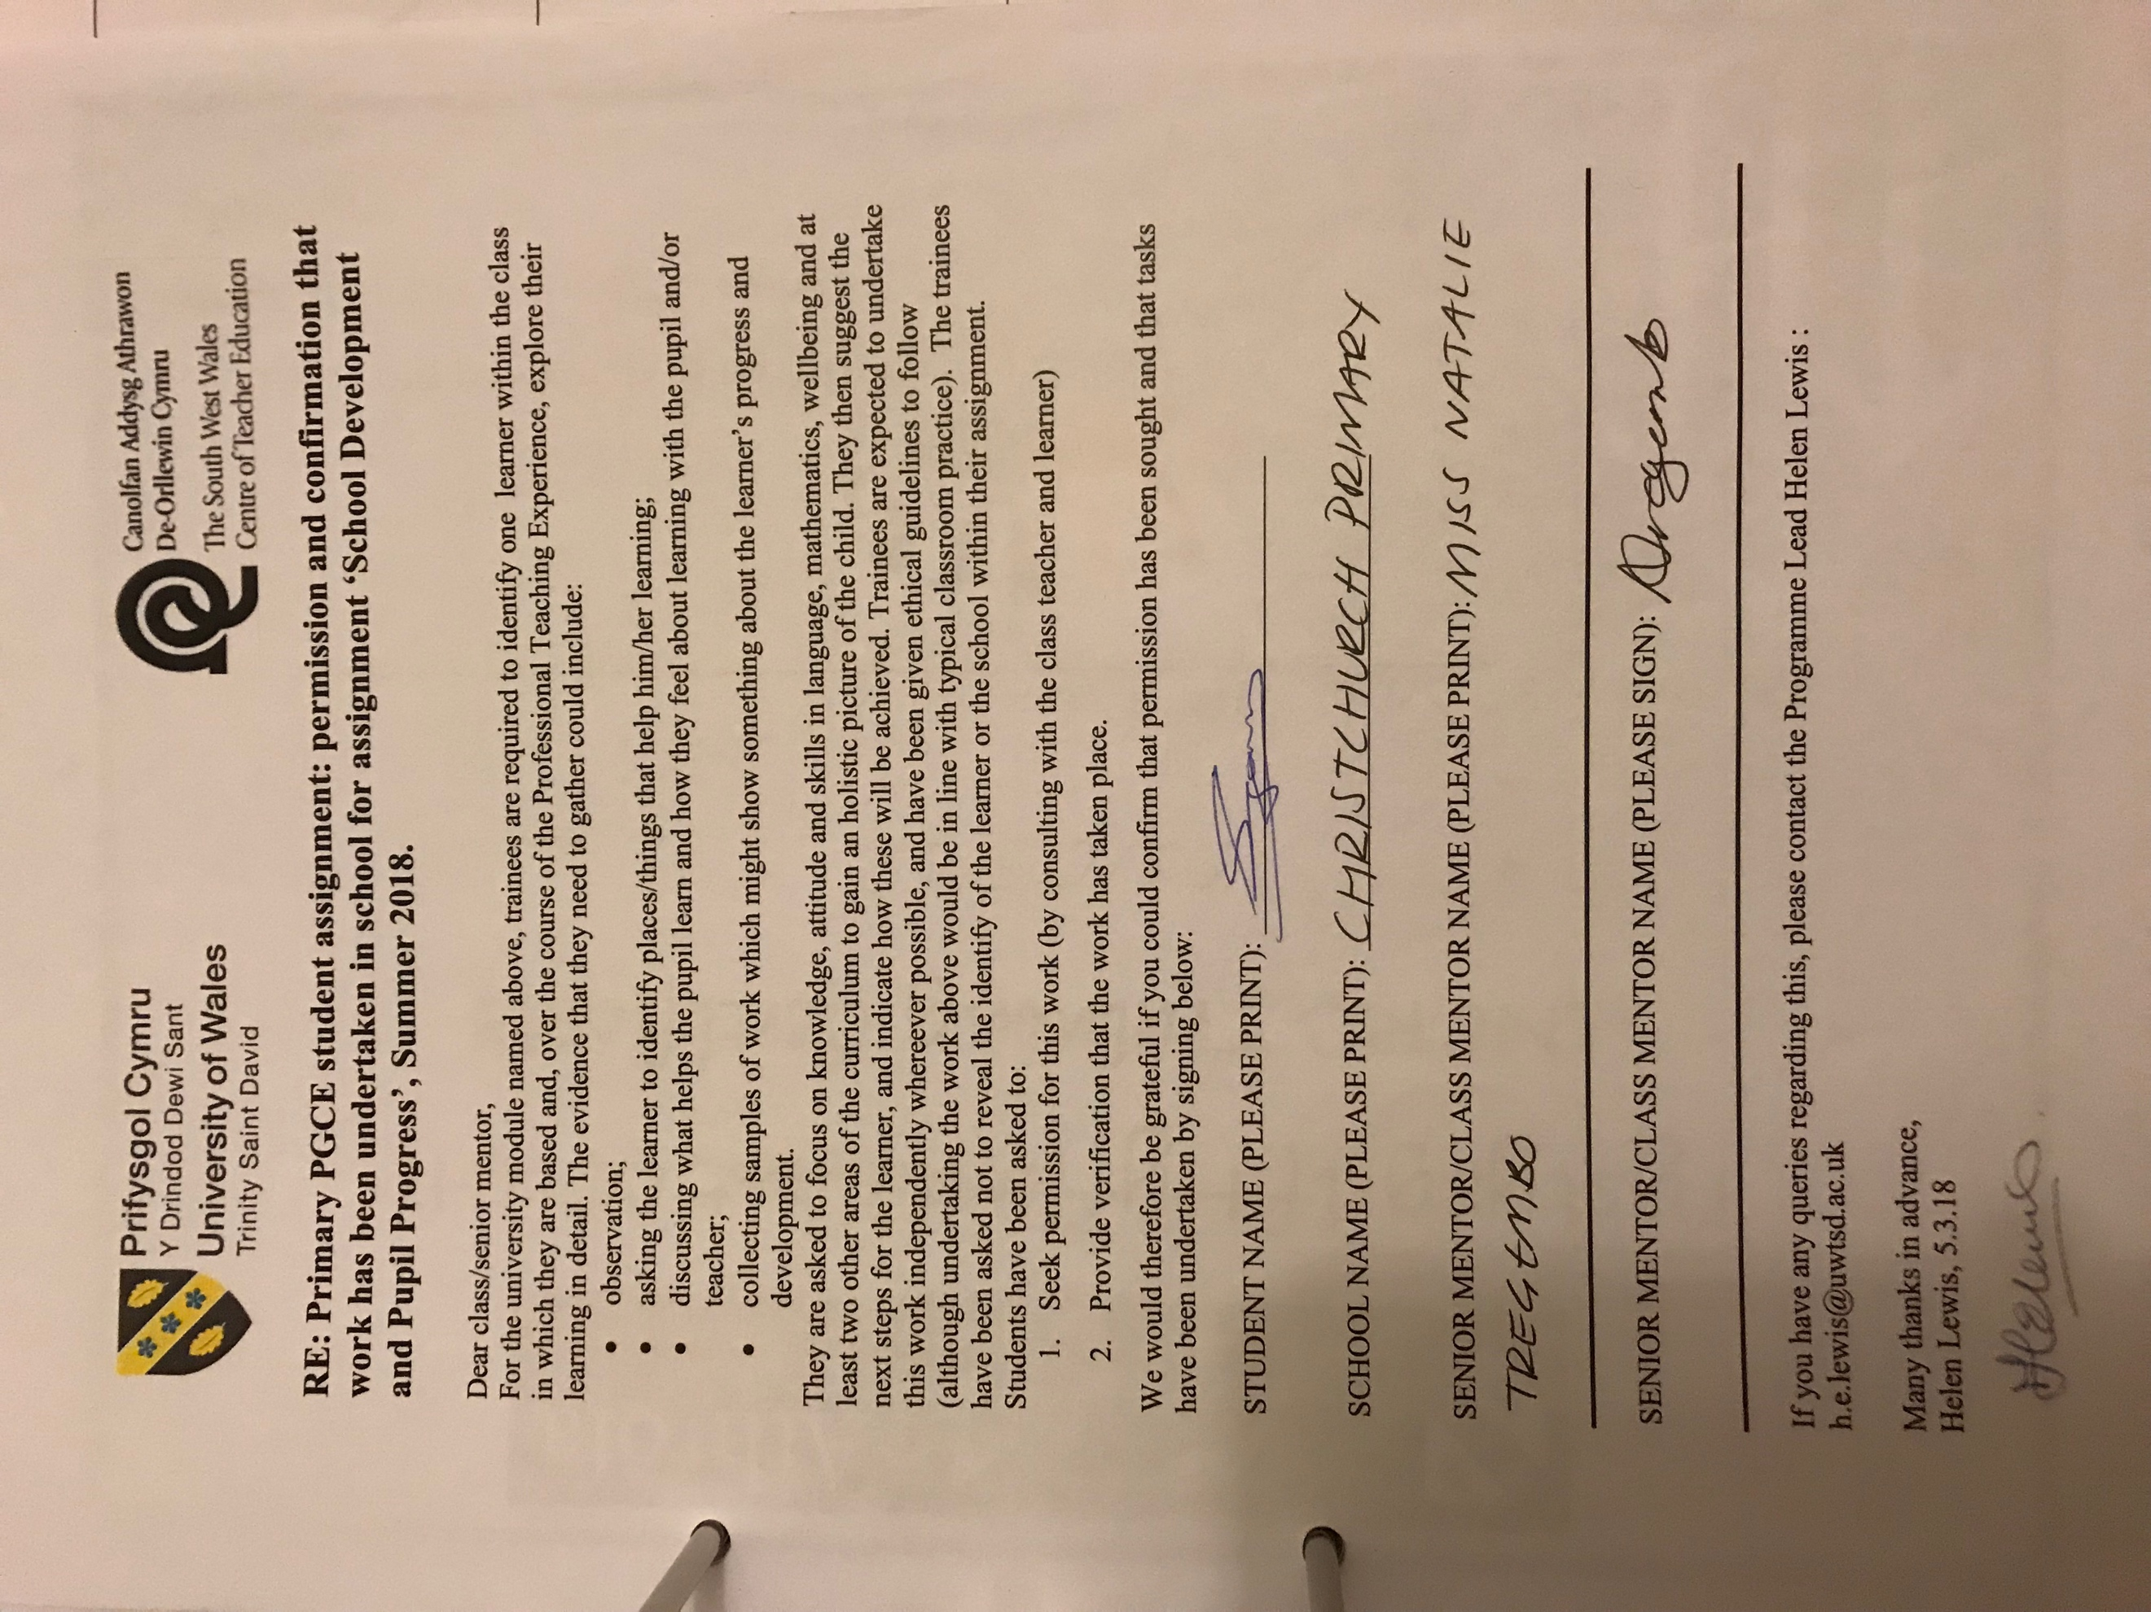

Appendix B: overwriting

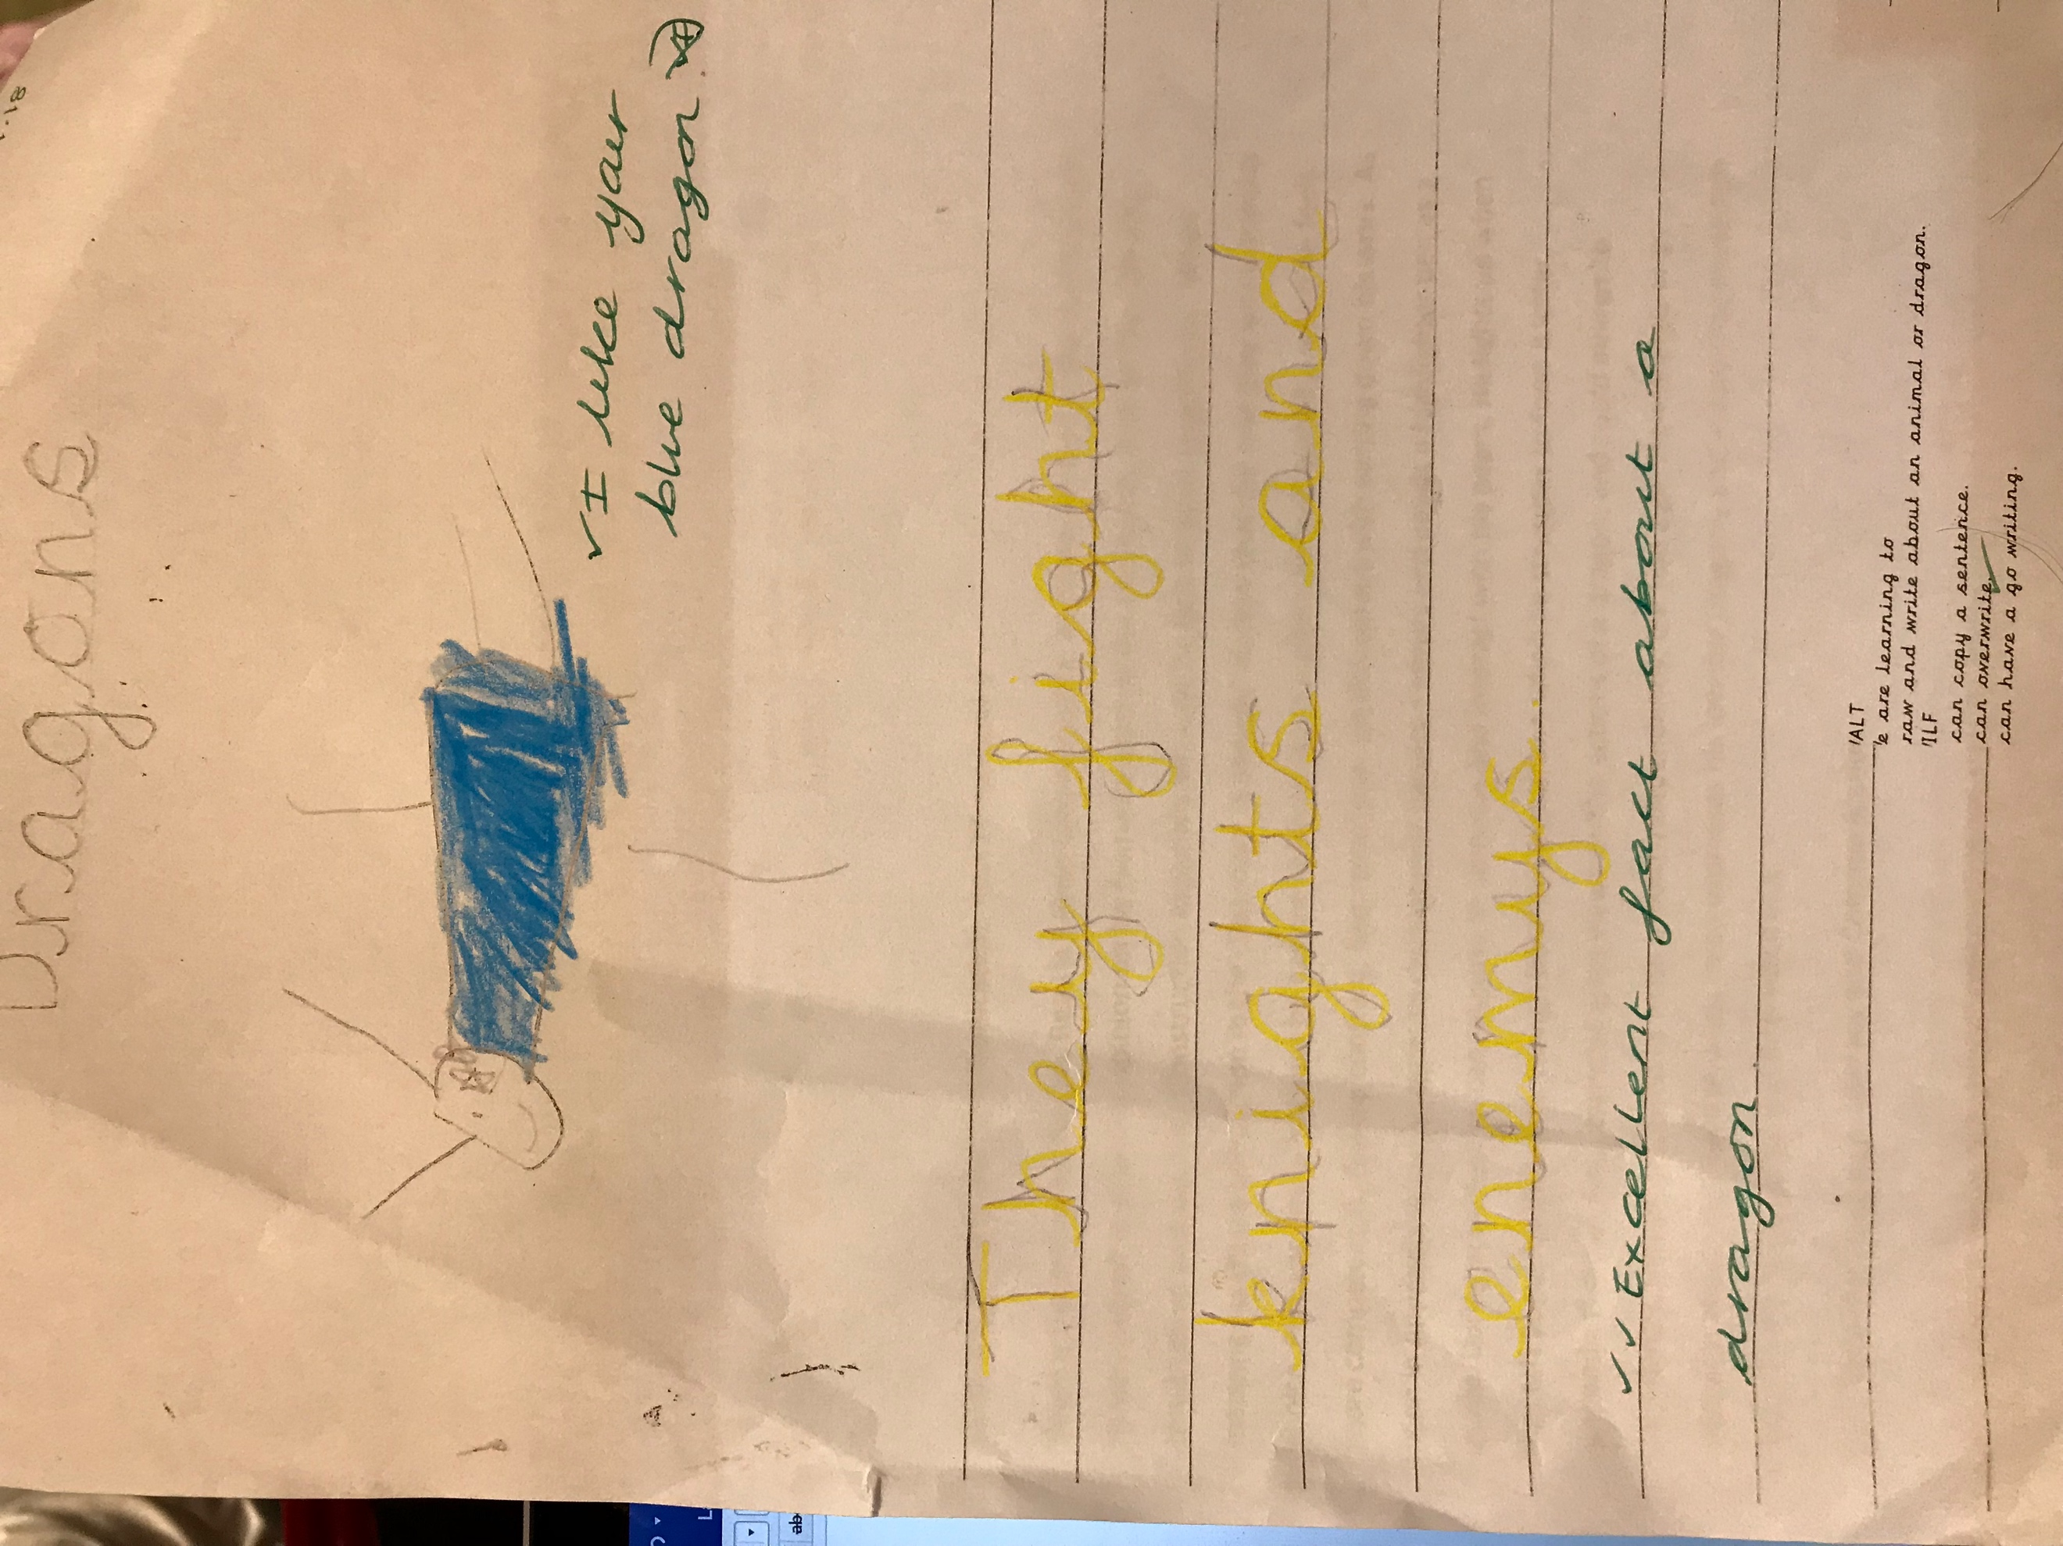

Appendix C Writing Outcome 3

Outcome 3 (Welsh Government, 2015).
Writing – Children recognise the alphabetic nature of writing and can form some letters and on occasion simple words and phrases, writing from left to right. They discriminate between letters, use correct initial consonants and begin to use spelling strategies to spell vowel-consonant, consonant-vowel-consonant and high-frequency words. They distinguish between upper- and lower-case letters and show an awareness of full stops and spaces between words. They contribute to a form modelled by an adult, showing developing understanding
of different formats and conveying meaning by sequencing words, symbols and pictures. They orally compose and dictate a sentence, describing events, experiences and pictures to communicate meaning.
Appendix D1
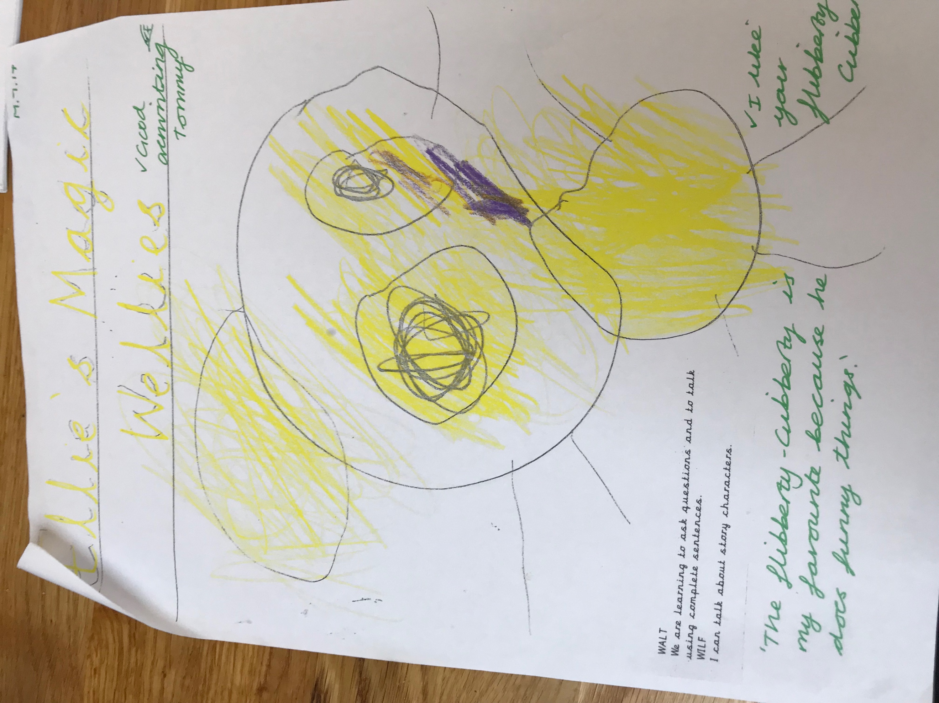
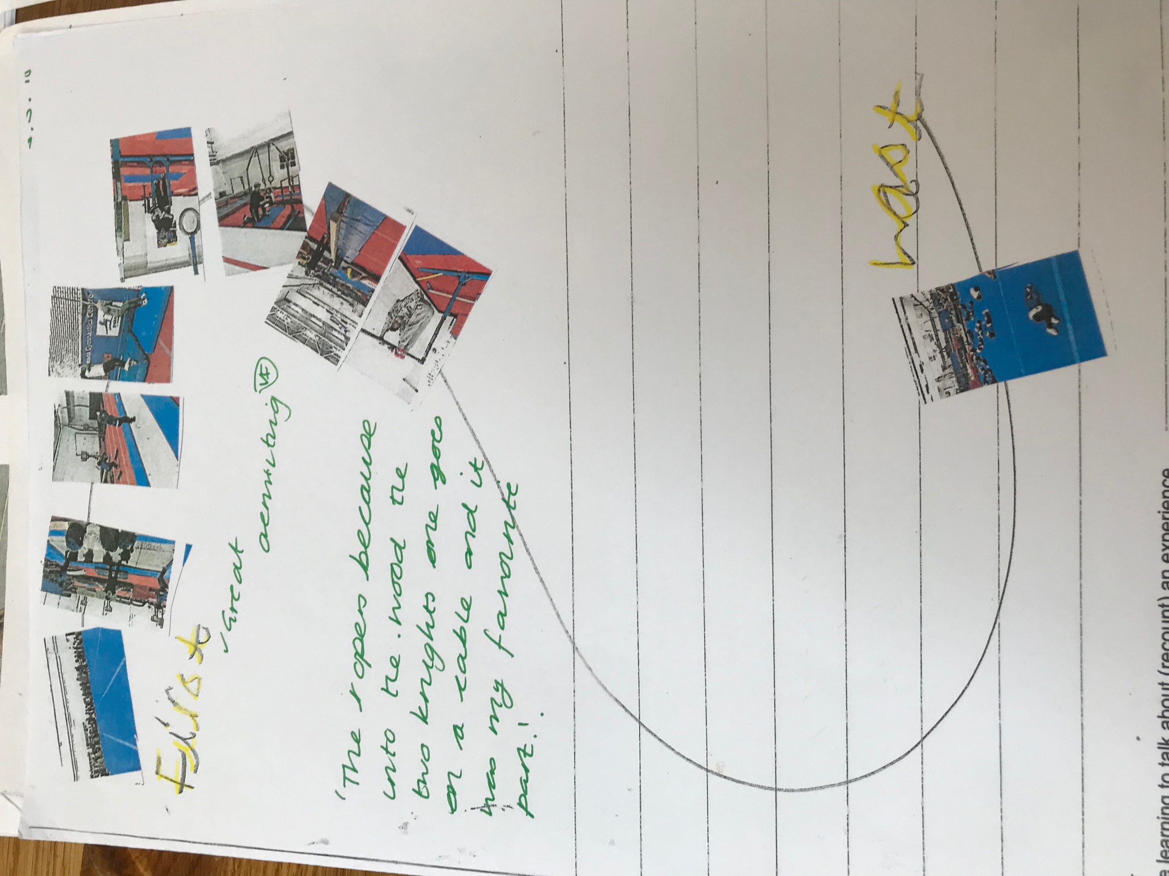
Appendix D2

Appendix E

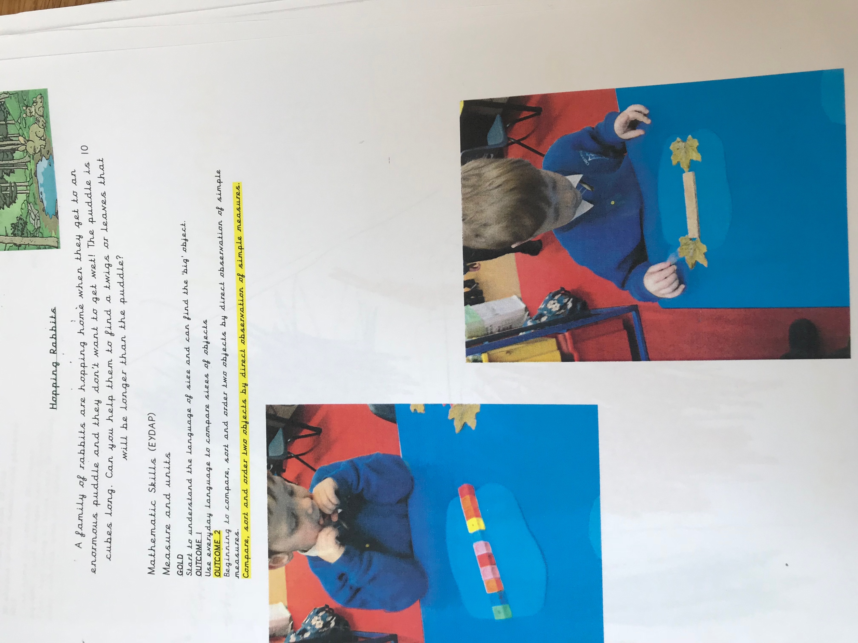

Appendix F

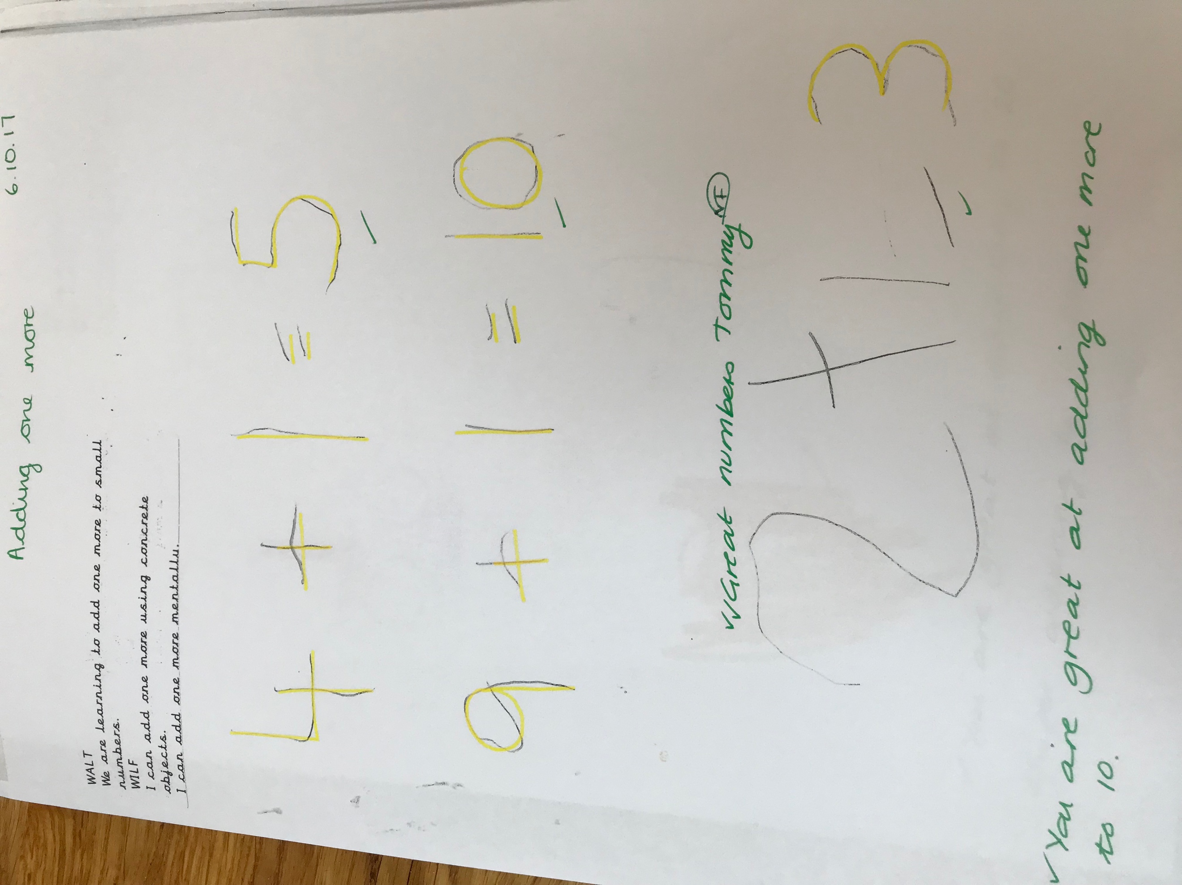

Appendix G

Outcome 3
Children recite up to 20 and in simple sequences and count up to 10 objects reliably. They read, write and compare and order numbers to 10 and understand that zero means none. They understand very simple addition and subtraction and mentally recall ‘one more’ and ‘one less’ within 10. They use 1p, 2p, 5p and 10p coins to ‘pay’ for items. They make a sensible estimate up to 10 and understand that this can be checked by counting. They use direct comparisons and simple terminology in terms of measure and temperature and understand that measurements must start at the same point. They use the concept of time in terms of daily events and demonstrate a sense of how long things take. They recognise simple 2D and 3D shapes, describe them in simple language and use them in their play. They recognise and repeat patterns of up to three visually and aurally. They sort and classify objects using one criterion and record collections using marks, numbers or pictures. They move in given directions.

Appendix H Welsh Language Development

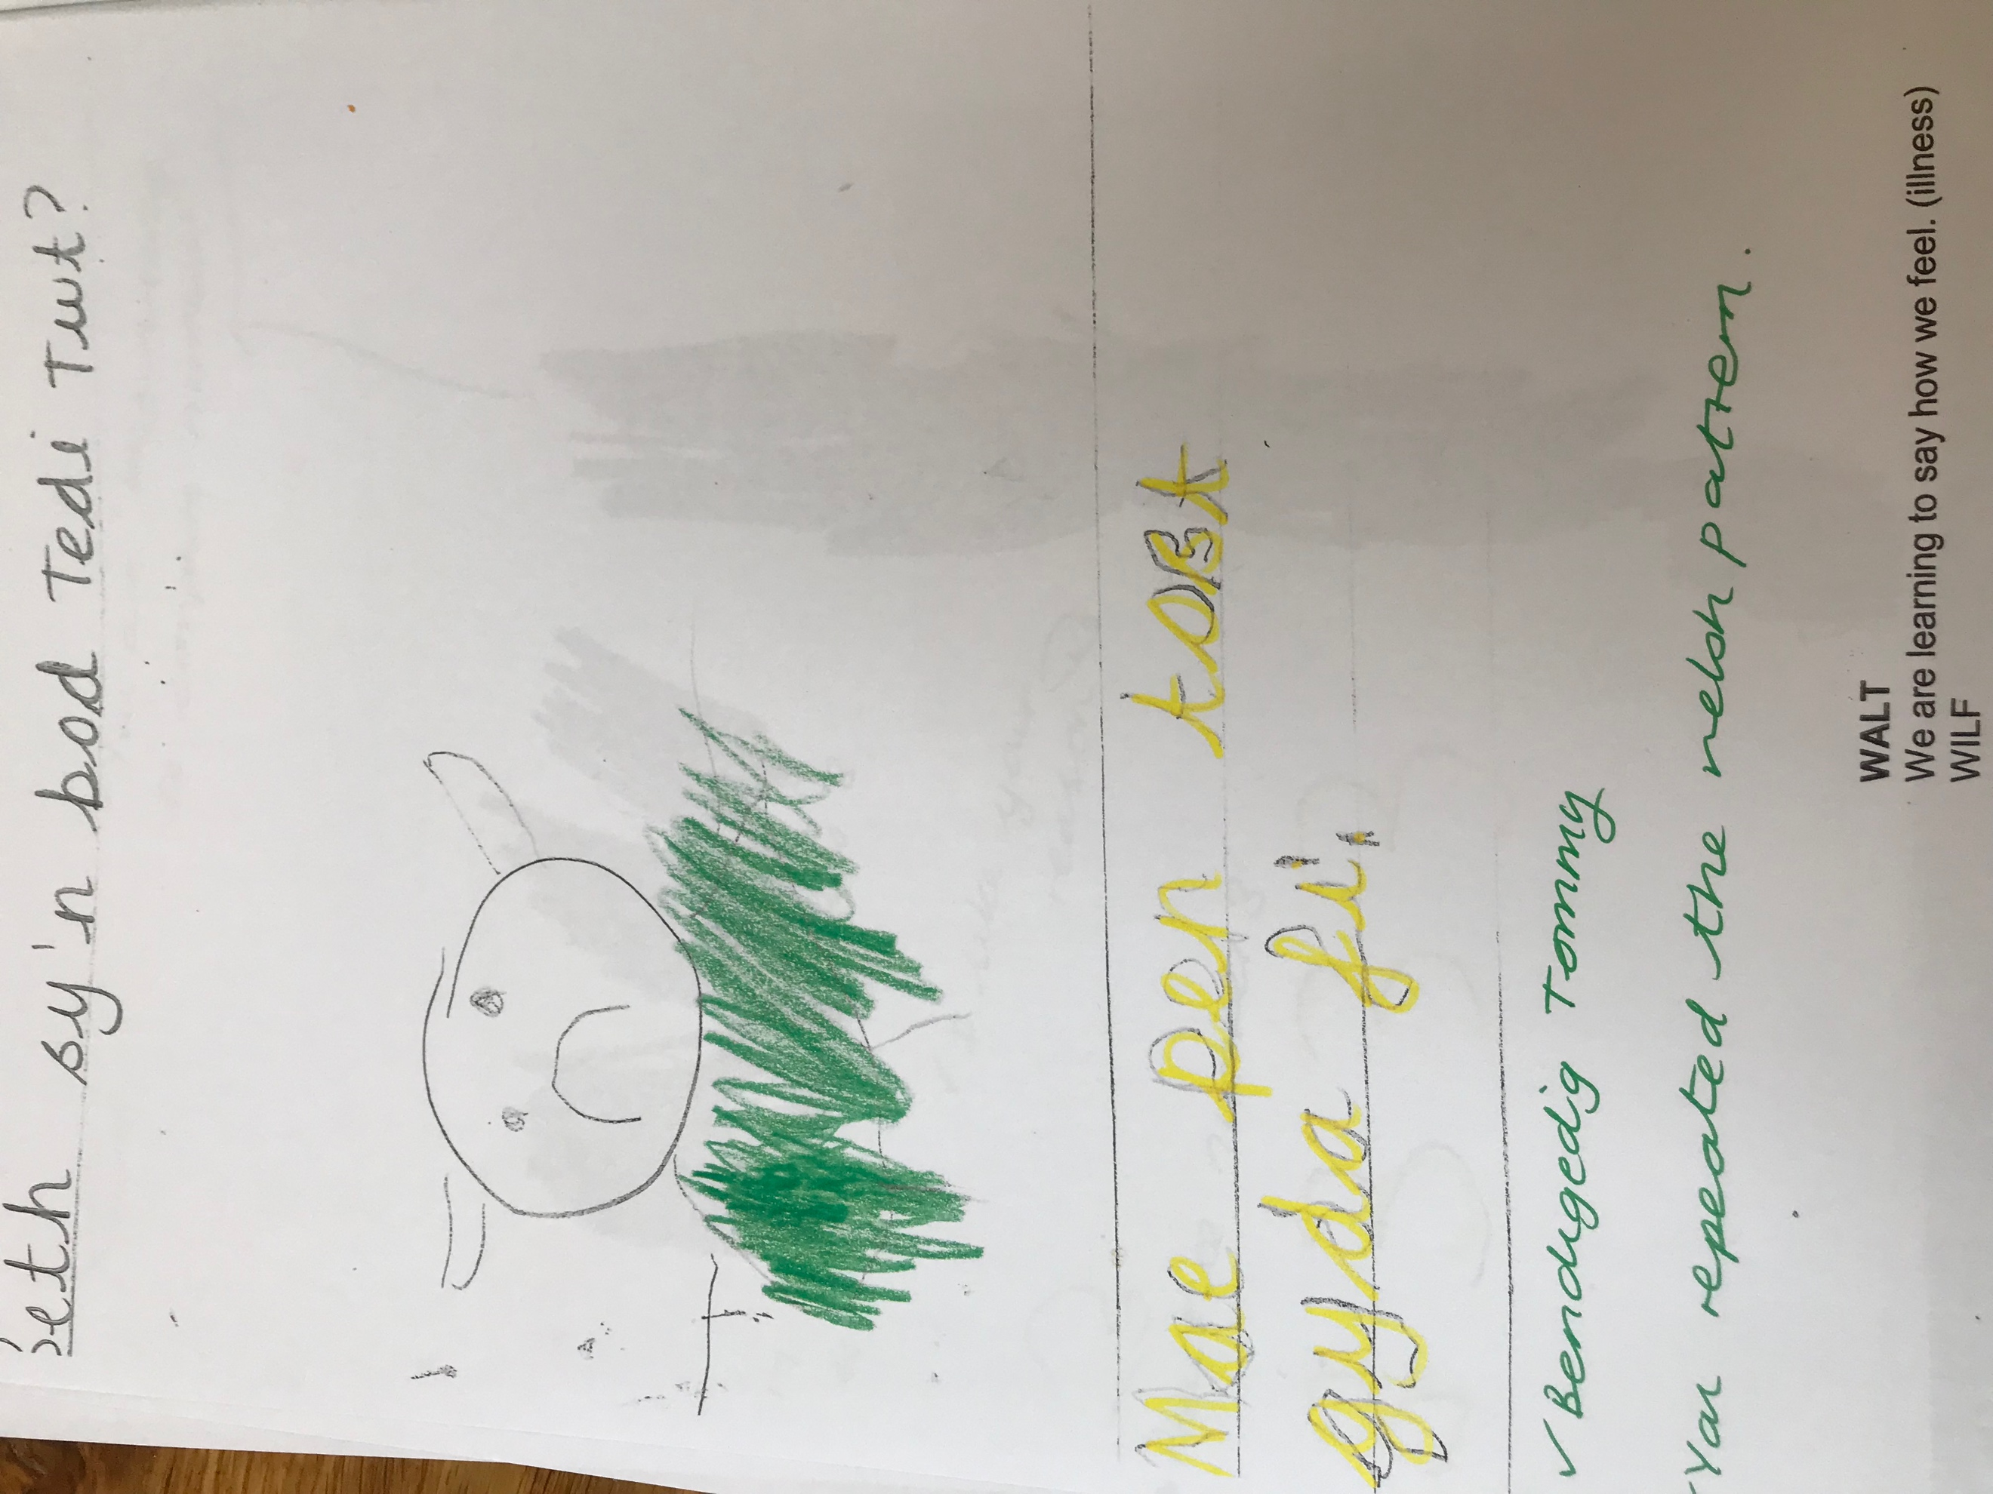
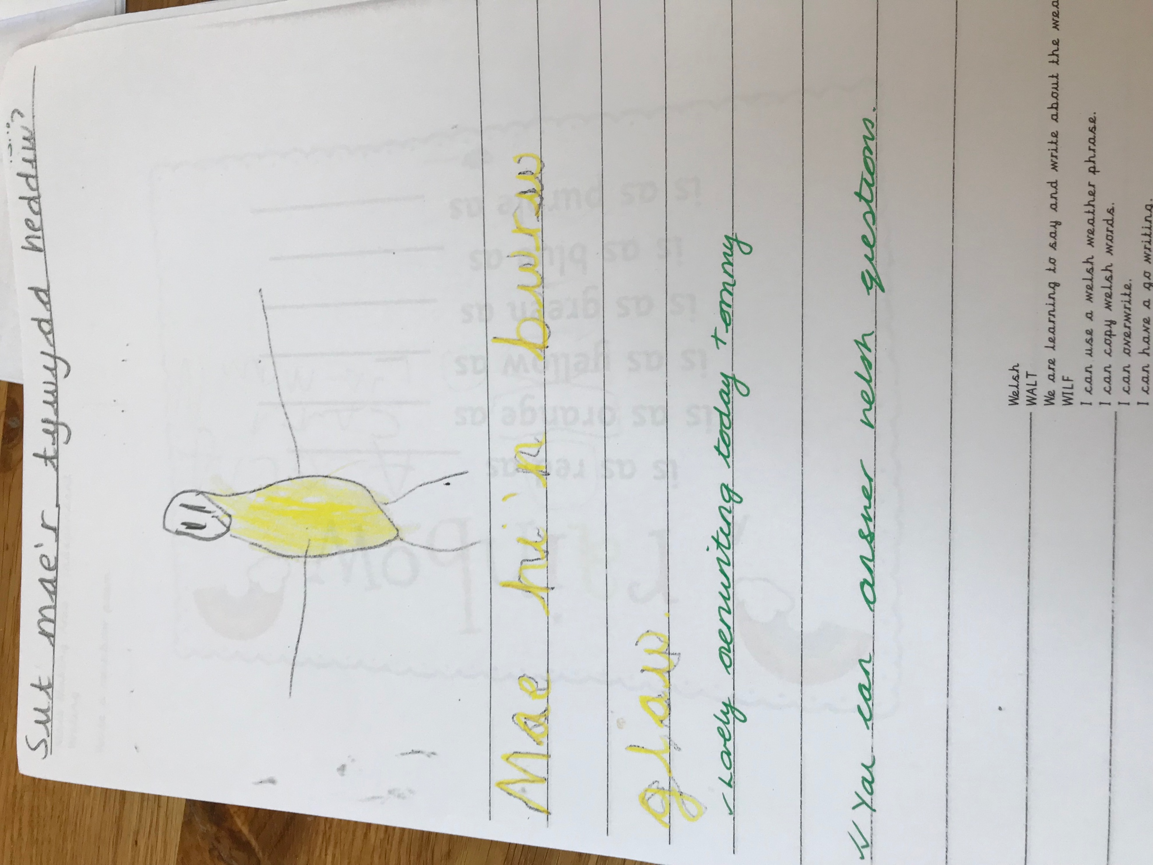

References

Alexander, R. et al. (2009). Children, their World, their Education. Final Report and Recommendations of the Cambridge Primary Review. Routledge.

Blaisdell, C. (2012) Inclusive or Exclusive Participation: Paradigmatic Tensions in the Mosaic Approach and Implications for Childhood Research. [ONLINE] Available at: http://www.childhoodstoday.org/download.php?id=68. [Accessed 14 May 2018].

Clark, A. (2001) Say Your Piece. [ONLINE] Available at: https://www.nurseryworld.co.uk/nursery-world/news/1087815/piece. [Accessed 9 May 2018].
Clark, A. (2005) ‘Ways of seeing: using the Mosaic approach to listen to young children’s per- spectives’, in Clark, A., Kjørholt and Moss, P. (eds.) Beyond Listening. Children’s perspectives on early childhood services. Bristol: Policy Press, pp. 29–49.
Clark, A. and Moss, P. (2001) Listening to Young Children: The Mosaic
Csikszentmihalyi, M. (2016) All about Flow and Positive Psychology. [ONLINE] Available at: https://positivepsychologyprogram.com/mihaly-csikszentmihalyi-father-of-flow/. [Accessed 13 May 2018].
Donaldson, G. (2015) Successful Futures: Independent Review of Curriculum and Assessment Arrangements in Wales Cardiff: Welsh Government

Donaldson, G. (2018) Aiming for Excellence Conference. Selwyn Centre Llanelli.
Dweck, C.(2014). Carol Dweck, "Developing a Growth Mindset". [Online Video]. Available from: https://www.youtube.com/watch?v=hiiEeMN7vbQ. [Accessed: 8 May 2018].

Ebbinghaus H. (1913). Memory: A Contribution to Experimental Psychology. New York: Columbia University.

Freire, P (2006). "The Banking Model of Education". In Provenzo, Eugene F. Critical issues in education: an anthology of readings. Thousand Oaks, CA: Sage Publications. pp. 105–117.
Hilton, C. (2006) Habits of Mind. Available at: http://www.ascd.org/publications/books/108008/chapters/Describing-the-Habits-of-Mind.aspx Accessed (14th May 2018).

Harris, H. (2009) Do Parents Know They Matter?: Raising Achievement Through Parental Engagement. HAMBLENDON PR.

Malaguzzi, L. (1998) The Hundred Languages of Children: The Reggio Emilia Approach—Advanced Reflections. 2nd ed. Greenwich:Ablex Publishing Corporation
Mc Loed. 2012. Zone of Proximal Development. [ONLINE] Available at: https://www.simplypsychology.org/Zone-of-Proximal-Development.html. [Accessed 8 May 2018].

Moss, P. (2006) Listening to Young Children: Beyond Rights to Ethics in Let’s Talk about Listening to Children Learning and Teaching Scotland: available at: http://www.educationscotland.gov.uk/Images/listeningtochildren_tcm4-324433.pdf

Pinker, S (2002). The Blank Slate. [ONLINE] Available at: https://www.nytimes.com/2002/10/13/books/chapters/the-blank-slate.html. [Accessed 4 May 2018].

Psychology Notes. (2013) What is Bronfenbrenner’s Ecological Systems Theory?. [ONLINE] Available at: https://www.psychologynoteshq.com/bronfenbrenner-ecological-theory/. [Accessed 9 April 2018].
UNCRC. (1989.) Convention on the Rights of the Child. [ONLINE] Available at: https://downloads.unicef.org.uk/wp-content/uploads/2010/05/UNCRC_united_nations_convention_on_the_rights_of_the_child.pdf?_ga=2.39104227.1742625317.1523286710-1030017664.1523286710. [Accessed 4 April 2018].
Welsh Government. (2015) Foundation Phase Framework. Cardiff.
Willig, C.(2008) Introducing qualitative research in psychology. Maidenhead: McGraw-Hill Open University Press.

