
Assignment I: The implementation strategy of adidas
1076507899g@gmail.com
1801050 | NIANMIN GUO

School：University of Wales Saint David
Lecturer: Gareth Hughes
Start date: 14 Nov 2017 - 14:28
Due date: 26 Nov 2018 - 23:59
Student Name: NAINMIN GUO OR FRED GUO
Student Number:1801050
E-mail: 1076507899@qq.com

contents
1.Executive summary 2
1.1 Remit of the report 2
1.2 Brief background of adidas 2
1.3 Summary of conclusion 2
1.4 Advantages and disadvantages of the strategy 2
1.5 Summary of recommendations 2
2.Introduction 3
2.1Background of the organization 3
2.1Definition of major concepts 3
2.2.1 Strategy 3
2.2.2 Business level strategy 3
2.2.3 Competitive advantage 4
2.2.4 Porter Generic Strategies 4
3.main body 5
3.1 Implementation of the strategy 6
3.1.1 Differentiation strategy 6
3.2 Advantages and disadvantages of the strategy 9
3.2.1 Advantages 9
3.2.2 Disadvantages 9
4.Conclusion 10
5. Recommendations 10
6.Reference list 12
7.Appendix 14
Appendix 1: background information of Adidas 14
Appendix 2: productions information about Adidas 16
Appendix 3: customer services information of Adidas 16
Appendix 4: the image of Adidas logo 18

1.Executive summary

1.1 Remit of the report
The main goal achieved in this report is four points. The first point is to use the strategic theory of learning to determine the strategy used by Adidas. The second point is to conduct a critical assessment based on Adidas' strategy. The third point is to draw some reasonable suggestions based on the conclusions drawn after the end of the assessment.

1.2 Brief background of adidas
Adidas was founded in 1949 and is a member of the German sportswear manufacturer Adidas AG. Named after its founder, Adolf Adi Dassler. It has two core brands, Adidas and reebok. Adidas has a successful corporate culture 3C, which includes Confidence, Collaboration and Creativity. Adidas is very focused on the development of talent and ROLE MODEL LEADERSHIP.

1.3 Summary of conclusion
Adidas uses its rich resources to design and develop sustainable materials to design a wide range of sports products. Adidas develops children's apparel design and personalization services to meet customer service needs. The logo design of different brands of Adidas is also very good. Adidas' commitment to employee care and social responsibility will enhance Adidas' reputation. However, propaganda and design products will be a burden for Adidas, and pressure from competitors will reduce the profitability of Adidas' differentiated strategy.

1.4 Advantages and disadvantages of the strategy
The advantages are that adidas using differentiation strategy improve the company's sales performance and increase profits, increase customer loyalty.
The disadvantages are that adidas is difficult to achieve true differentiation and making differentiation needs huge investment.

1.5 Summary of recommendations
1. Adidas should continue to implement the differentiation strategy
2. to increase investment in research continually to expand the gap with competitors.
3. Adidas can develop into a diverse range of companies.
4. to continue invest in the corporate social responsibility

2.Introduction
This report investigates the strategy adopted by adidas. The researches include a set of strategies methods. Firstly, the background of adidas and strategies of major concepts could be introduced. And then, the main body includes the implemented strategies of organization and evaluate the strengths and weaknesses of strategies. The final part is conclusion and recommendations.

2.1Background of the organization
Adidas was founded in 1949 and is a member of the German sportswear manufacturer Adidas AG. Named after its founder, Adolf Adi Dassler. It has two core brands, Adidas and reebok. Adidas has a successful corporate culture 3C, which includes Confidence, Collaboration and Creativity. Adidas is very focused on the development of talent and ROLE MODEL LEADERSHIP. In the 2018 Fortune Global 500 list, adidas ranked 480. Adidas mission is to be the best sport company in the wold. And it has approximately 56,888 employees and has seven locations in the world. (adidas group, 2015)
More details in the Appendix 1. (sources from adidas group website)

2.1Definition of major concepts

2.2.1 Strategy
Porter (1980, P35) defines strategy as a broad formula for how companies compete, what their goals should be, and what strategies are needed to achieve them. The company is working hard and its strategy to achieve its goals. And Rumelt and Richard (2011, P37) also stated the strategy usually involves the formulation and implementation of these two main components. Formulation a strategy involves analyzing the environment or situation, making a diagnosis, and then making a guiding policy that includes activities such as strategic planning and strategic thinking. Implementation refers to the action plan taken to achieve the goals set by the guiding policy.

Strategy is a series of methods and plans that companies take to achieve some long-term goals or gain benefits. The formulation and implementation of the company's strategy has a rigorous analysis and investigation to adapt to the company's future funding and the expected results.

2.2.2 Business level strategy
Business level strategy is the way strategy managers design a set of actions to use one company resources and unique competencies to obtain a competitive advantage outperforming other competitors in the market (Karami,2007). The business layer strategy focuses on how to achieve sustainable competitive advantage within a given scope and under defined resource allocation. It plays a key role in consolidating and enhancing the competitive position and competitive advantage of enterprises. (Wang Qiliang, 2007)
Through these theories, this can be summarized as a business layer strategy is a strategy in which companies use their own resources to gain a competitive advantage in a market segment or a single industry sector

2.2.3 Competitive advantage
Porter's competitive advantage (1985, P214) was the key to ensuring that a company leads other competitors and gets higher benefits. There is a another explains. Competitive advantage is that companies refer to higher abilities through attributes and resources than other competitors in the same industry or market. (Chacarbaghi and Lynch, 1999). And Powell and Thomas in 2001 (pp875) declared “resources held by a firm and the business strategy will have a profound impact on generating competitive advantage”. In addition, Superior performance outcomes and superiority in production resources reflect competitive advantage. (Lau, 2002)
Competitive advantage is the key to a company's use of its resources and strategies to get ahead of other competitors and get more benefits. Therefore, a company's competitive advantage can be reflected in the company's performance and productivity and the strategies adopted.

2.2.4 Porter Generic Strategies
Porter wrote (1980, PP46) that strategic targets are cost leadership, differential or focus these three. These are also known as Porter's three general strategies. And these strategies can be applied to any size or form of business.

Dess and Davis (1984, P27) made the definition for the three strategies.
Cost leadership refers the company using its business ability to produce a product or service with the lower cost than other competitors. The strategy involves gaining market share by attracting cost-conscious or price-sensitive customers. When the company wants to achieve a leading position in the competition, this strategy can minimize the company's investment and achieve its goals.
A differential advantage is when a business' products or services are different to its competitors. Companies generally gain a competitive advantage through differentiation strategies. Because customers can experience different experiences from the differentiation of company products and services, this will help them make the right decisions.
Focus strategy refers a company getting its business at a few or one target markets rather than all marketing. The focus strategy reflects the company's ability to adjust and plan for market segments. This requires a thorough study of the market, which allows the company to take targeted measures.

The figure 1 the chart of Porter Generic Strategies
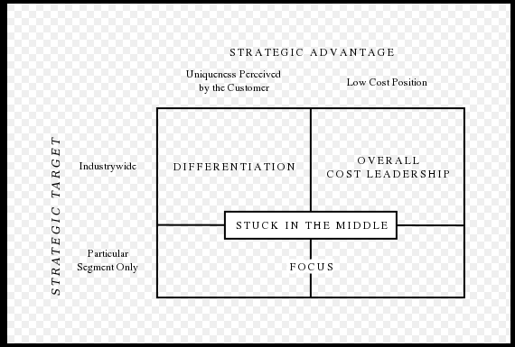
(sources from Porter (1980). Competitive Strategy )
Through Porter Generic Strategies, if a company belongs to the stuck in the middle, company can choose one or two strategies to develop according to their own situation. These theories are all conducive to the company to gain its own competitive advantage.

3.main body
This section mainly analyse some of the strategic approaches adopted by Adidas and the evaluation of these strategies.

Differentiation strategies are not suitable for small companies. It is more suitable for large companies. Because the company needs to provide one or several differentiations in the market, products, services, transportation, etc. to gain a competitive advantage. (Wright, 2004)
Adidas is a large international company with sufficient capital to develop and design its own differentiation.
Adidas is more concerned with a wide range of differentiation strategies. Adidas' corporate-level strategy focuses more on innovation, trying to produce new products, services and processes to gain competitive advantage. (Mahdi, Abbas, Mazar, & George, 2015)

3.1 Implementation of the strategy

3.1.1 Differentiation strategy
Differentiation is a strategy about the differentiation the product and service meeting customers demand and charging for the premium price (Pizam, 2010).

3.1.1.1 Products differentiation
Edward (1933, P33) Product differentiation refers to the process by which a company differentiates a product or service from a general product or service, making it more attractive to a target market and achieving higher profits.

Regarding the differentiation of Adidas products, its products can be divided into three main categories according to gender, including men, women and children. The first two are the original series of Adidas. On December 9, 2009, Adidas and Disney jointly announced that the two parties will jointly launch a new baby and children's wear series. (Kai, 2009) Since then, Adidas' products have been adapted to people of all ages. On the other hand, its products can also be divided into footwear, apparel and jewelry. These classifications reflect the clarity of Adidas' market segmentation. But the most prominent aspect of Adidas is the other two aspects. One of them is that Adidas designs products for customers that adapt to these sports, depending on the type of exercise. The design of these products includes almost all sports held at the Olympics. It also designed products for cycling. The diversity and differentiation of these products will allow Adidas to meet a wide range of customer needs and increase their sports experience. On the other hand, in order to win the loyalty of high consumption, Adidas began to implement a private customized strategy in October 2017 or named custom-design service. This strategy allows consumers to design the shoes they want based on their hobbies. These product strategies reflect Adidas' significant investment in product differentiation. More detail information will be shown in Appendix 2. (adidas in UK, 2017)

Adidas also uses product differentiation strategies to promote various products to promote sales. For example, Adidas released the first sports fragrance in 1990 to make athletes more attractive and spirited. Adidas perfumes are now very popular with many athletes, which makes consumers pay more attention to Adidas products. Its fragrance is now produced by the famous French perfume company COTY. When consumers experience the combined effects of perfume and other products, Adidas will attract more consumers to buy and increase consumer loyalty and satisfaction. (Adidas perfumes,2011)

3.1.1.2 Services differentiation
Customer service refers to the provision of services to customers before, during and after purchase. The satisfaction of the customer depends on the company's requirements for employees and related service regulations (Buchanan and Leigh, 2011).
Regarding Adidas' services, it can be divided into two aspects. One is the service to the company target customer. One is the service to society.

In terms of customer service for the company, due to advances in technology, Adidas mainly focuses on establishing online network services. In 2000, Adidas partnered with Sports, the world's leading Internet sports media company, to market the ADIDAS brand and its products through their websites cbs.sportsline.com and sports.com. This strategy has allowed Adidas to lead other companies to promote their products worldwide. Adidas has now established a comprehensive customer service center. The customer service center provides many ways to accept customer complaints and timely feedback. These include WhatsApp, Facebook, Twitter and mobile phones. Specific information will be shown in Appendix 3. On the other hand, Adidas' official website also provides auto-reply features and customer receipts for some common issues. Customers can log in to their own accounts to find their own order information and after-sales service information on the website. Certainly, Adidas has a good privacy statement. These features allow Adidas to achieve better customer satisfaction and increase customer loyalty. And these make Adidas have a good reputation around the world. (adidas group, 2015)

In terms of logistics, in 2001, ADIDAS rebuilt the original warehouse and established a modern large-scale distribution center in Germany to provide distribution services for sales in Europe and the Middle East and improve the efficiency of logistics distribution. This allows Adidas products to be shipped to European countries faster and to gain greater market share. (Xun, 2010)

Brand logo differentiation
Branding is a set of marketing and communication methods. It helps customers choose the company's products rather than competitors' products and is designed to create lasting impressions for their customers. （Ghodeswar and Bhimrao，2008)

Regarding the brand logo of Adidas, in its history, Adidas brand logo is divided into three series, namely sports performance series which is a three-striped logo, sports traditional series which is a shamrock logo and sports fashion series which is a spheroidal three-stripes Sign. The specific logo image will be shown in Appendix 4. The sports performance series is dedicated to the popular sports industry, and its positioning is a trend that is now popular. So, it uses the three logos of Adidas, which means that the price of the product is low, and it is easier for the public to accept. The sports tradition series is the classic series of Adidas, and its positioning is the classic trend of retro. This makes the traditional series more stylish and higher-end than the sports performance series. The sports fashion collection reflects Adidas' latest fashion style and is loved by young people.

These three different logos represent Adidas' different styles of products, which allows customers to more clearly distinguish Adidas products and quickly find the products they need. On the other hand, because Adidas has different logos, the company's research and development is more targeted, which further makes Adidas more widely available market.

CSR
Corporate Social Responsibility (CSR), also known as corporate sustainability, represents several sustainable businesses, corporate conscience, corporate citizenship or responsible business. And it is also a form of self-discipline of international private companies. (Wood and Donna, 1991)
Another discussion is to describe CSR as an internal organizational policy or a corporate ethics strategy. (Sheehy and Benedict ,2015)

In 2015, the Adidas Group developed a fair labor compensation strategy. This is also an attempt by Adidas to achieve fair labor compensation. In order to protect the welfare of workers, in 2010 Adidas began working with Hong Kong's Labor Education and Service Network to train workers representatives to understand how to ensure worker welfare. (adidas in china, 2015)

Adidas provides accident insurance, medical insurance, travel insurance, and term life insurance for full-time employees. For part-time personnel and contractors, the company also provides accident insurance and other medical insurance. In order to better train employees, in July 2014, Adidas established a corporate university called “adidas Group Learning Campus” in China. In 2015, Adidas invested more than RMB 1.2 million to protect the health and safety of Chinese employees, including basic safety equipment and 100% annual medical check-ups. (adidas in china, 2015)

To protect the environment, Adidas continues to increase the use of environmentally friendly materials in the manufacture of apparel and accessories. Environmentally friendly materials include high quality cotton, recycled polyester, recycled rubber and bio-based thermoplastic polyurethane. And as of the end of 2015, Adidas has achieved the achievement of all footwear products using environmentally friendly materials. In 2014, after the successful phase-out of all long-chain fluorochemicals, Adidas made significant progress on the phase-out of PFC-free. Adidas achieved 99% non-fluorination of the product by December 31, 2017. (adidas in china, 2015)

Adidas is actively responding to disaster relief operations. In the 2008 Wenchuan Earthquake, Adidas donated RMB 3 million to support China through the Shanghai Red Cross. At the same time, the employees of the Adidas Group in China donated a total of RMB 173,000. Adidas' Hong Kong and Taiwan regional headquarters donated a total of RMB 399,000. (adidas in china, 2008)

3.2 Advantages and disadvantages of the Differentiation strategy

3.2.1 Advantages
When the company implements the differentiation strategy most directly, it will help to improve the company's sales performance and increase profits. The differentiation of products and services helps to increase customer loyalty. (Wei, Yuchen & Leiming, 2005)
Sales performance is the sum of the benefits that a company or an individual gain over a period. To a certain extent, sales performance can assess how well a company or individual operates during this time. (Jiang & Chen ,2011)
A company's loyal customers are customers who have high trust or dependence on the company's products or services. Customer loyalty can be increased and lost. (Zhang & Chen, 2002)

Sales performance is the sum of the benefits that a company or an individual gain over a period. To a certain extent, sales performance can assess how well a company or individual operates during this time. A company's loyal customers are customers who have high trust or dependence on the company's products or services. Customer loyalty can be increased and lost.

When Adidas began selling children's products in 2009, it began to acquire the new market for children's apparel and the profits it brought. And from 2010 to 2015, Adidas' worldwide sales continued to increase. And in 2015 exceeded 2.5 billion euros. In addition, if Adidas customers accept the custom-made service and are satisfied with the products they design, they will become Adidas loyal customers or increase their loyalty to Adidas. These will help Adidas get a better reputation and increase its market share.
(adidas group,2015))

3.2.2 Disadvantages
The company's differentiation strategy means that the company needs to invest a lot of capital to investigate and research new products and markets. (Wang Hong,2007)
The implementation of the differentiation strategy is easily borrowed by competitors, which makes it difficult for companies to achieve true differentiation. (Zhang Song, & Wu Xianfeng. 2006)

The company's investment in any new products and services will be huge, which requires the company to have enough funds to support. And the company's differentiation strategy will be easily imitated by the opponent, which makes it difficult for the company to open the gap with competitors.

For Adidas' product diversification, Adidas spent a lot of time and resources to design and analyze the functionality and utility of various sports products. The use and design of some environmentally friendly materials also requires the company to invest a large amount of capital. Especially for private custom and perfume products, the employment fees of some famous designers and perfume adjusters. Products also need to have the cost of a well-known actor and star to promote. These will make the company cost a lot of money.

After Adidas achieved all products in 2015 with eco-friendly materials. Nike also used and produced renewable materials. As of FY2017, NIKE has transformed more than 4.6 billion plastic bottles into recycled polyester footwear and apparel. Adidas also achieved 99% non-fluorination in 2017. (The Nike of sustainable business report, 2017)

4.Conclusion
Adidas has used its vast resources to design and develop sustainable materials to design a wide range of sports products, which gives Adidas a huge competitive advantage. And in order to enter new markets and get good customer loyalty, Adidas conducts the design of children's apparel and personally customized services for customer service. Of course, these strategies have also made Adidas profitable. on the other hand. Adidas started designing and selling some affiliated fragrances. This has earned Adidas a greater reputation and advocacy. The design of the logos of different brands of Adidas is also very good. Each logo represents a different product type and corresponding target customer, which can improve the company's customer satisfaction and loyalty. Adidas' commitment to employee care and social responsibility will further enhance Adidas' reputation.

However, propaganda and design products will become a burden for Adidas, and pressure from competitors will reduce the profits of the Adidas differentiation strategy.
Adidas requires significant investments in the implementation of its product and service differentiation strategy, which increases the company's financial burden and risk. On the other hand, Adidas has the same level of competitor Nike, and the differentiation strategy is easily imitated or surpassed by competitors, which will make Adidas's differentiated profits be taken away.

5. Recommendations
1. Adidas should continue to implement the differentiation strategy, and the market survey should be more detailed to meet the deeper needs of customers.
2. The investment in research can continue to increase, and more talented technical talents can be introduced to further expand the gap with competitors.
3. Adidas can develop into a diverse range of companies to invest in related products and services such as the Adidas Stadium, the Adidas Sports Center and the adidas hotel to special athlete
4.to continue invest in the corporate social responsibility and concentrate on the serious social issues.

Words approximately: 2800

6.Reference list
- Buchanan, Leigh (1 March 2011). "A Customer Service Makeover". Inc. magazine. Retrieved 29 Oct 2012.
- Chacarbaghi; Lynch (1999), Competitive Advantage: Creating and Sustaining Superior Performance by Michael E. Porter 1980, p 45
- Chamberlin, Edward. The Theory of Monopolistic Competition: A Re-orientation of the Theory of Value. Harvard University Press. ISBN 978-0674881259.
- Dess, G. G., & Davis, P. S. (1984). Porter's (1980) generic strategies as determinants of strategic group membership and organizational performance. Academy of Management journal, 27(3), pp467-488.
- Ghodeswar, Bhimrao M (2008). "Building brand identity in competitive markets: A conceptual model". Journal of Product & Brand Management. 17: 4. doi:10.1108/10610420810856468
- Jiang R, & Chen H. (2011). Empirical Research on the Influencing Factors of Sales Performance. Business Economics and Management, 1(2), pp21-29.
- Lau, Ronald S (2002). "Competitive factors and their relative importance in the US electronics and computer industries". International Journal of Operations & Production Management. 22 (1):pp 125–135.
- Mintzberg, Henry and, Quinn, James Brian (1996). The Strategy Process: Concepts, Contexts, Cases. Prentice Hall. ISBN 978-0-132-340304.
- Mu W, Wang Y, & Li L. (2005). Research on Environmental Management and Enterprise Competitiveness Based on Differentiated Strategies. Systems Engineering Theory and Practice, 25(3), pp26-31
- Porter, Michael E. (1980). Competitive Strategy. PP35 -26 Free Press. ISBN 0-684-84148-7.
- Rumelt, Richard P. (2011). Good Strategy/Bad Strategy - The Difference and Why it Matters. Crown Business. ISBN 978-0-307-88623-1.
- Powell, Thomas C. (1 September 2001). "Competitive advantage: logical and philosophical considerations". Strategic Management Journal. 22 (9): pp875–888. doi:10.1002/smj.173
- Porter, M. E. (1985). Competitive advantage: creating and sustaining superior performance. 1985. New York: FreePress, 43, p214
- Wang Qiliang. (2007). Business layer strategy: basic connotation, characteristics and future research direction. Industrial Technology Economy, 26(6), pp133-134.
- Wright, P, () "A refinement of Porter's strategies."
- Mahdi, H. A. A., Abbas, M., Mazar, T. I., & George, S. (2015). A Comparative Analysis of Strategies and Business Models of Nike, Inc. and Adidas Group with special reference to Competitive Advantage in the context of a Dynamic and Competitive Environment. International Journal of Business Management and Economic Research, 6(3), pp167-177.
- Wood, Donna J. (1991). "Corporate Social Performance Revisited". The Academy of Management Review. 16 (4): pp691–718. doi:10.2307/258977. JSTOR 258977
- Sheehy, Benedict (2015-10-01). "Defining CSR: Problems and Solutions". Journal of Business Ethics. 131(3): pp625–648. doi:10.1007/s10551-014-2281-x. ISSN 0167-4544.
- Wang H. (2007). Research on Enterprise Implementation Differentiation Strategy. Productivity Research, (1), pp111-112.
- Zhang Z, & Chen H. (2002). Cultivation model of corporate loyal customers. Economic Management (9), pp40-43.
- Zhang S, & Wu X. (2006). Theoretical analysis and practical application of China Mobile's differentiated competition strategy. Jiangxi Communication Technology, (3), pp45-48.
The website of reference:
- Adidas in China,2008 [online]. Adidas CSR. Available at: https://www.adidas.com.cn/CSR/home?locale=zh_CN [accessed at 24/11/2018]
- Adidas in UK,2017 [online]. Adidas productions. Available at: https://www.adidas.com.cn/campaign/keyfranchise.uk [accessed at 22/11/2018]
- Adidas in China,2015 [online]. Adidas group. Available at: https://www.adidas-group.com/en/home/Welcome.aspx/ [accessed at 24/11/2018]
- Adidas group,2015 [online]. Adidas background. Available at: https://www.adidas-group.com/en/group/culture [accessed at 24/11/2018]
- Kai, Z,2009 [online]. Adidas development. Available at: Nike group,2017 [online]. The Nike of sustainable business report. Available at: https://sbi-stg-s3-media-bucket.s3.amazonaws.com/wp-content/uploads/2018/05/18175102/NIKE-FY1617-Sustainable-Business-Report_FINAL.pdf [accessed at 23/11/2018]
- http://www.qdaily.com/articles/45857.html [accessed at 22/11/2018]
- Word perdumes,2011 [online]. Adidas perfumes. Available at: https://site.douban.com/137239/widget/notes/6177161/note/190037681/ [accessed at 21/11/2018]
- Xun, L.2010 [online]. Adidas warehouse and transaction. Available at: https:// Adidas warehouse and transaction.sogou.com/skins/detail/view/info/308266 [accessed at 22/11/2018]

7.Appendix
Appendix 1: background information of Adidas (sources from adidas official website, https://www.adidas-group.com/en/group/strategy-overview/)
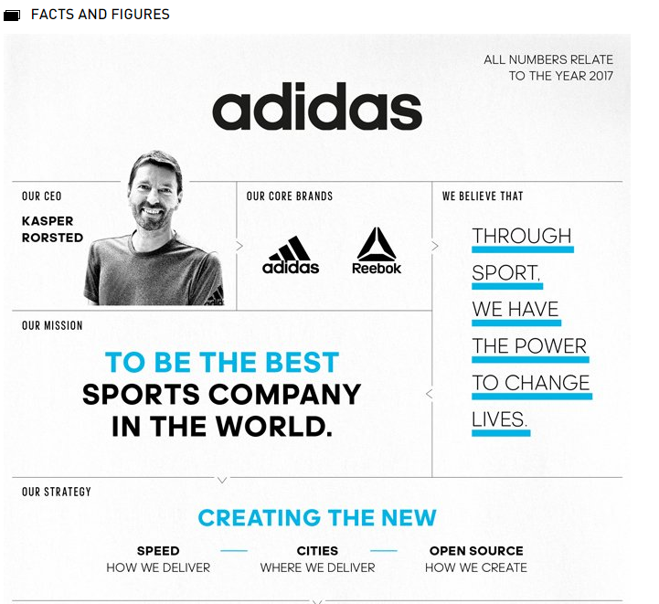
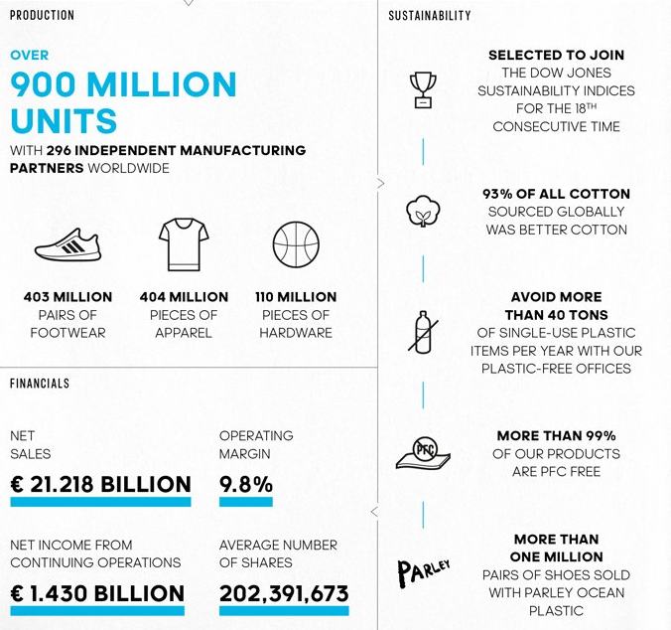
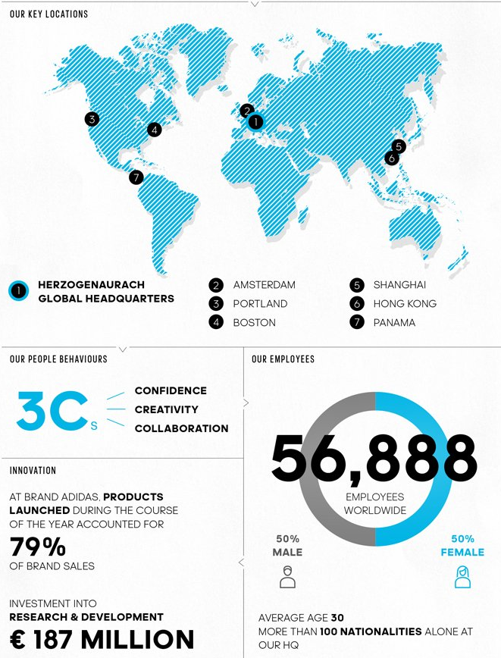
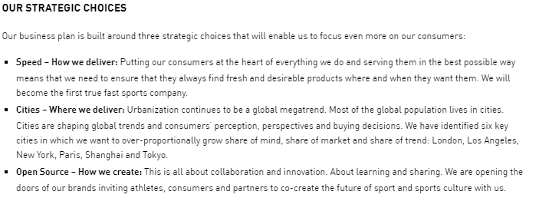
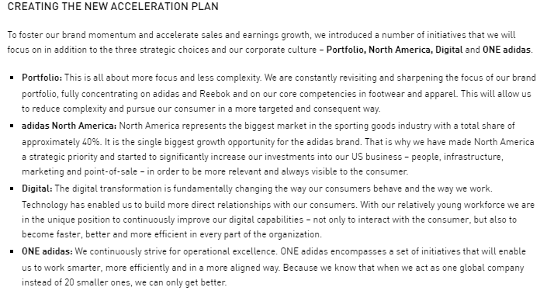

Appendix 2: productions information about Adidas (sources from adidas official website, https://www.adidas.co.uk//)


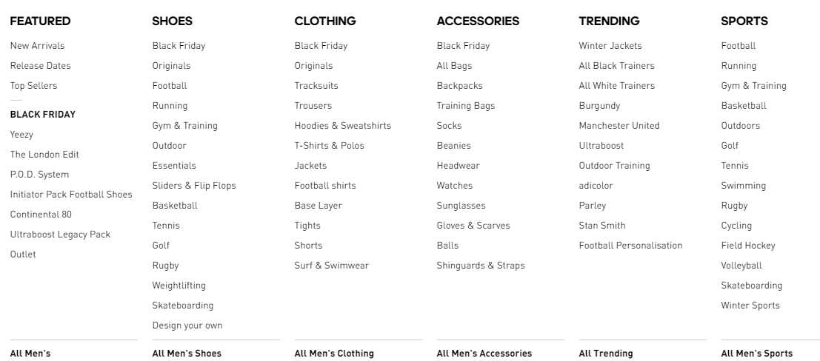

Appendix 3: customer services information of Adidas (sources from adidas official website, https://www.adidas.co.uk/help)
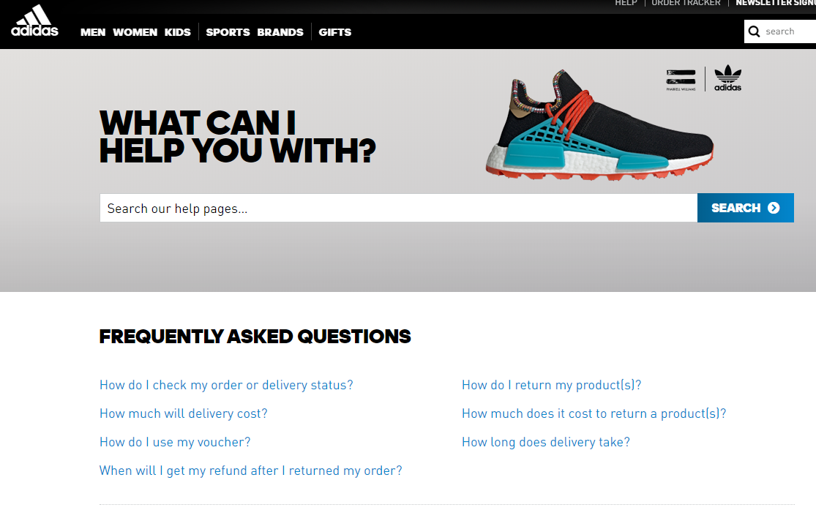
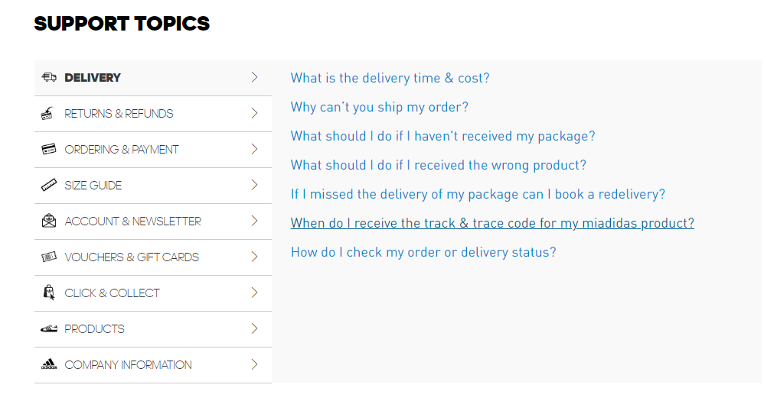
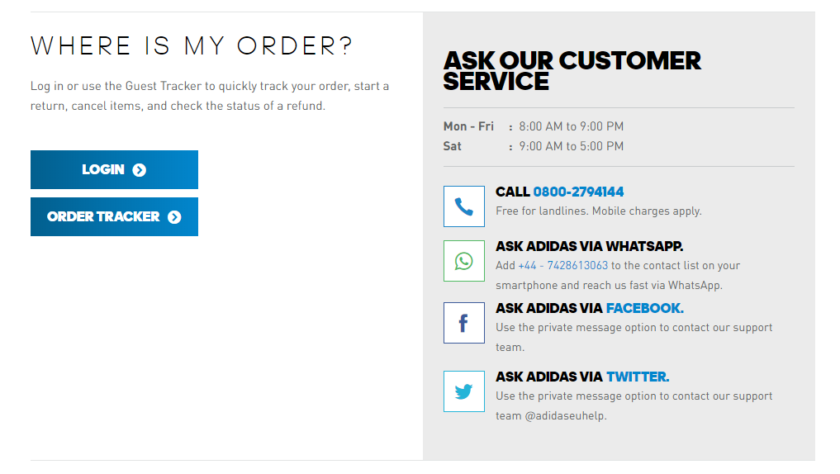
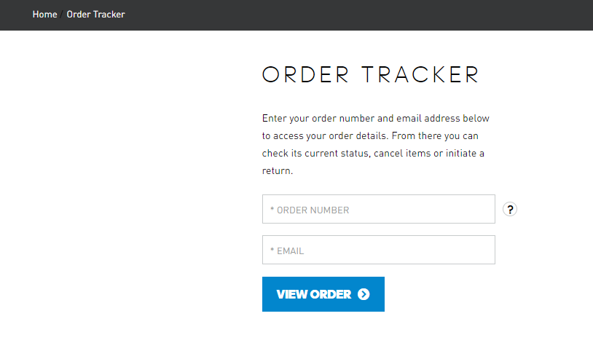
Appendix 4: the image of Adidas logo (sources from https://www.douban.com/group/topic/75758100/)


