  Component One:  “What are the key skills required when working in the housekeeping team?” | Student No: | 2011100
 | Module Title: | Operating Hotel Facilities
 | Module Code: | BMIH 4006
 | Lecturer: | Lola Villard

As per the brief evaluation of my student journal, I have been working in Delta hotel which is by Marriott Swindon. I worked there in the canteen area where I used to do various jobs which included serving food and drinks along with cleaning the table after guests left. Being a C&B member I also used to refill the containers for both lunch and dinners for guests to attend and continue having their dinner or lunch in the canteen. My major knowledge and experience in that work experience are to gain the knowledge and perspective of a receptionist and waiter. During my 1,2 and 3rd weeks, I evaluated my learning criteria in that department where I learned how to attend the guest along with completing various types of work relating to the business functions of serving food and preparing the table. Further, during weeks 4,5 and 6, I went and learned through the process of gaining experience in the section of both waiter and receptionist. It helped me in gaining a high and effective state of knowledge about the department and working job post at Delta hotels. The placement experience widely provided me with the ability and experience which helped me in attending the guest along with maintaining a high sense of service as per the needs and requirements of the hotel. It also helped me in acquiring and gaining a major set of knowledge through which the great service system along with mastering the process of guessing and dining the consumer experience gets developed. The placement at Delta Hotel provided me with a high set of knowledge and association which helps me in achieving high guest experience along with carefully providing services to the guest as accommodation and other guest experiences. I am now careful and effective enough in bartending and attending to different guests with highly attentive skills and functions through which managing and engaging transfer skills get related to a higher extent. During the working process and experience, I also developed the skill of conservation under which the hiring sense and process of business function and skills get practised to a higher extent and conservation. The hiring and placement process made me undergo various experiences and departments which helps me in developing and sharpening my skill sets and knowledge which helps in gaining high solutions and business determination. At times also helped in generating and experiencing emotional intelligence through other guests which positively related to the function and evaluative sources of hospitality and organisation in Delta Hotel. In nearly every source and evolution of business, the role of supervising has also been developed during the placement services and working period under enhanced sense and responsiveness. The skill of having patience also got generated in me to a higher extent through which the process of offering a high opportunity within managing the understanding process and evaluation of business function got developed. The working experience at Delta Hotel also provided me with high-profile guest services knowledge and how different services vary as per the segments of service and other confidentiality processes and focus. The work experience also provided me with high confidentiality and knowledge based on which the evaluative sources and other leading opportunities get connected under higher terms and focus. Moreover, the valuable range of network and business opportunities gets discussed and developed as per cultural development and focus which provides me with the chance of gaining knowledge abroad and other range of services. The work experience also helped me in gaining international experience and services under which the job of hospitality along with other eyes and language of culture knowledge got developed under higher aspects and functions. It also helped me in gaining a high set of knowledge under which the top role of manager gets related and experience under high hospitality development and factors whether it gets determined under high terms of knowledge through various range of opportunities. As a job person and placement staff in Delta Hotel I gained a sense of responsibility due to which I was highly capable of fragmenting and developing a high set of knowledge criteria and skills under which the hospitality workers and professionals get related under high manners and distribution of services. It helped me in varying and ageing major knowledge through which culture development and thriving get linked under higher terms and basis. Further, I also gained knowledge of event planning under which the hospitality experience and other systems got challenged and developed as per the benefits of the hospitality sector and career path speciality.

Word Count | 757

Component Two:
In this scenario– You have just been promoted to the team leader for a floor within the hotel. A guest complains that on their arrival, their room had not been properly cleaned. Create an action plan and answer the following questions.

Problem | Why did it happen? | What are you going to do? | How will you prevent this from happening in the future? | What measures would you introduce to improve team effectiveness?
Uncleaned rooms | The rooms were dirty because few of the staff were on leave and other staff had different shift timing. | I will make arrangements for a new and clean room for the guest. | In future, I will ensure that the staff are present at the right time so that if any such issues arise I can mitigate them on time. Also, I will make sure that as soon as the guest leaves the hotel room, it is cleaned at the same time. | I will establish metrics for each team project and communicate with them about their schedules and emergency shifts.
Noisy hotel | This is because, in the assembly hall of the hotel, the other guests booked for the reception party so the music and gathering of the customer's guests made the hotel noisy. | I will request the guest who booked for the reception party to play music till 1 at midnight so that people can sleep peacefully after that. | I will inform all the guests beforehand about the celebration or any party which has been booked by the other guests and will also make the policy of celebrating according to the timings laid down by the management. | I will talk to other managers of the hotel to ensure that each guest is provided with equal leisure and fun.
Temperature problem | This is due to the chill water system and the room's temperature generally set by a Thermostat. | I will make arrangements for the heater if the guests are feeling too cold and if the guest want their room temperature to be cool I will ensure that their need is fulfilled too. | The room temperature information will be informed to the guests during bookings so that they understand the reason behind the chill temperature. | I will communicate with the managers about the problems that the guests are facing due to room temperature so that they install automated temperature control systems.
The trouble with the Wi-fi | This is because the hotel has been using outdated and weak devices. | I will further have a conversation with the top management to make sure that they take steps to install the latest technologies within the hotel. | Together with the management of the hotel, I will install the latest technology to make sure that the guests are getting appropriate wifi services without any interruptions. | Regularly checking the system of the internet will help the hotel to provide proper wifi services, so I will ensure that the hotel hires a professional who keeps track of the performance of the system.
Lack of free services | This is because the hotel is undergoing losses currently. | I will ensure that the customers are getting quality services for what they have paid so that they do not feel the necessity of having free services. | Free services will only be provided to guests who have visited the hotel before. | To provide free services the hotel have to generate higher income or revenue and this can be enhanced only by gaining the confidence of the customer. I will make sure that the customers are getting timely services and that their wants are fulfilled on time without any delay so that they feel valued.

Component Three:
As the floor housekeeping manager and given the recent guest complaints you need to put together a basic training presentation for your colleagues within the housekeeping team to get the best out of them, ensure that brand standard is being achieved and that Health and Safety procedures are also being followed.

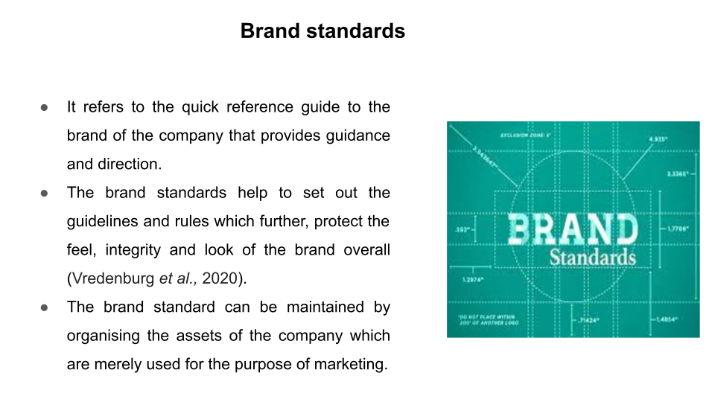
Training Notes: It refers to the quick reference guide to the brand of the company that provides guidance and direction which helps to ensure that the company's branding is consistent across the board. The brand standards help to set ut the guidelines and rules which further, protect the feel, integrity and look of the brand overall (Vredenburg et al., 2020). To maintain the standard of the brand the company had to create standards and rules for the written and visual materials as it helps to form the consistency of the brand for the long term. The brand standard can be maintained by organising the assets of the company which are merely used for marketing.
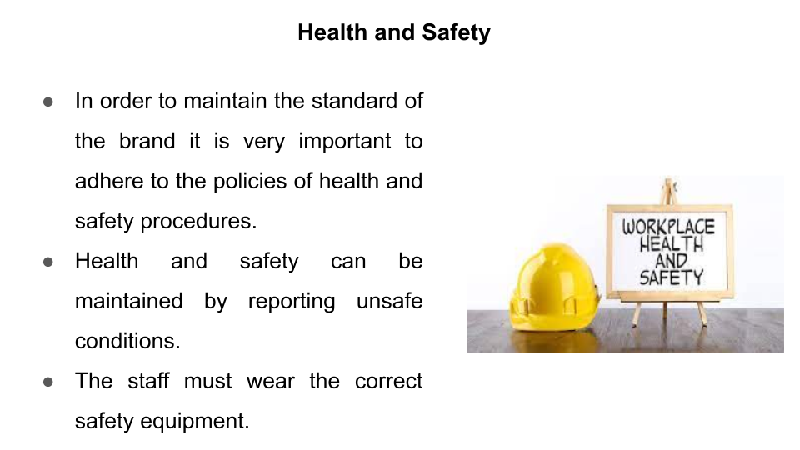
Training Notes: To maintain the standard of the brand it is very important to adhere to the policies of health and safety procedures as this helps to promote hygiene in terms of the services rendered by the management of the hotel (Lee et al., 2019). Health and safety can be maintained by reporting unsafe conditions so that steps can be taken to mitigate the issues underlying in the surroundings of the hotel area. The staff must wear the correct safety equipment so that they are safe and clean while operating various functions and also while rendering services to the customers.
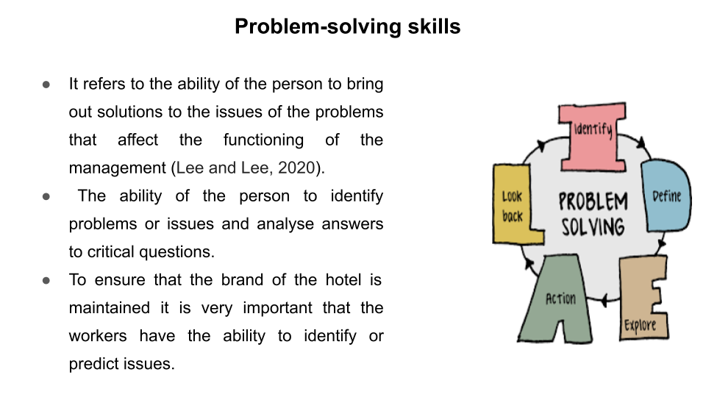
Training Notes: It refers to the ability of the person to bring out solutions to the issues the problems that affect the functioning of the management (Lee and Lee, 2020). The ability of the person to identify problems or issues and analyse answers to critical questions is referred to as problem-solving skills. To ensure that the brand of the hotel is maintained the workers must have the ability to identify or predict issues that might arise in future so that solutions can be ascertained to mitigate the uncertainties.
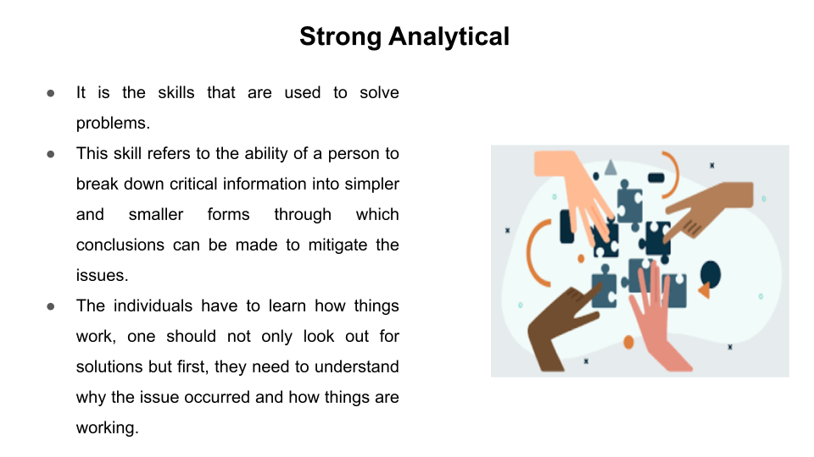
Training Notes: It is the skills that are used to solve problems. This skill refers to the ability of a person to break down critical information into simpler and smaller forms through which conclusions can be made to mitigate the issues. To improve analytical skills, one needs to be observant which means observing things closely so that it becomes easy to understand a certain situation and bring solutions beforehand with ease (Liu et al., 2019). The individuals have to learn how things work, one should not only look out for solutions but first, they need to understand why the issue occurred and how things are working.
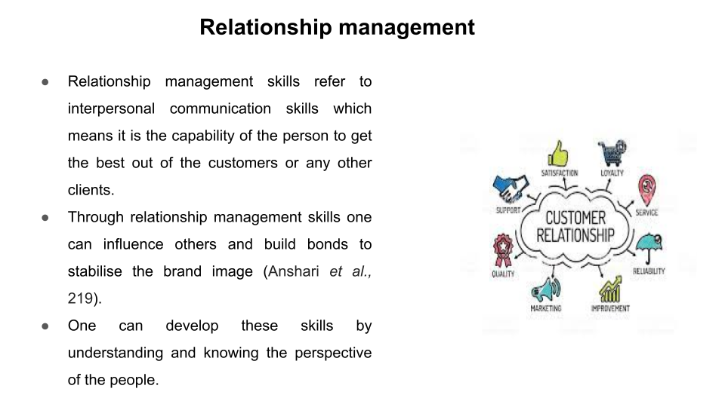
Training Notes: Relationship management skills refer to interpersonal communication skills which mean the person can get the best out of the customers or any other clients. Through relationship management skills one can influence others and build bonds to stabilise the brand image (Anshari et al., 219). One can develop these skills by understanding and knowing the perspective of the people and also by respecting the opinion of others and promoting inclusivity song the team. It is very important to learn how to communicate well then only one can enhance their relationship management skills and get the best outcomes to maintain the standard of the brand.

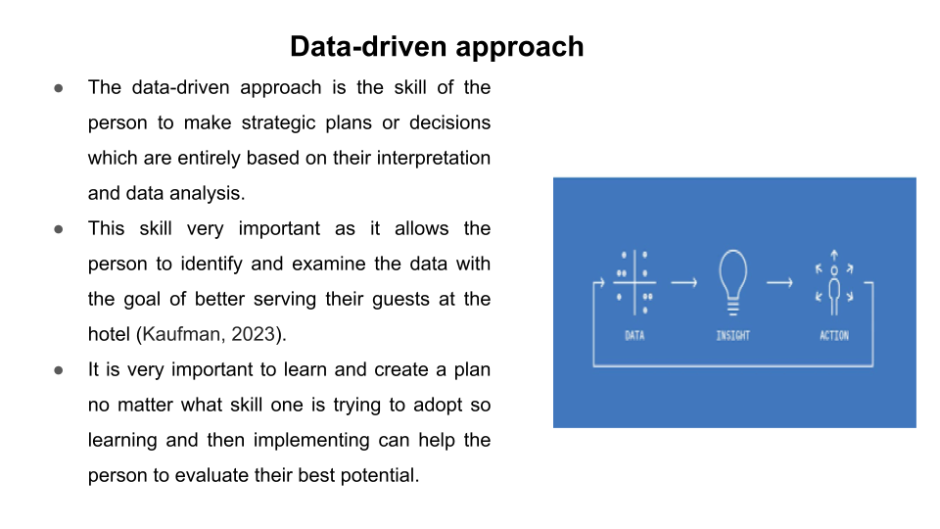
Training Notes: The data-driven approach is the skill of the person to make strategic plans or decisions which are entirely based on their interpretation and data analysis. This skill s very important as it allows the person to identify and examine the data with the goal of better serving their guests at the hotel (Kaufman, 2023). This skill can be improved by making and diagnosing the goals which mean that the persons need to analyse their strengths and weaknesses and look out for opportunities and then formulate their short-term goals. It is very important to learn and create a plan no matter what skill one is trying to adopt so learning and then implementing can help the person to evaluate their best potential.
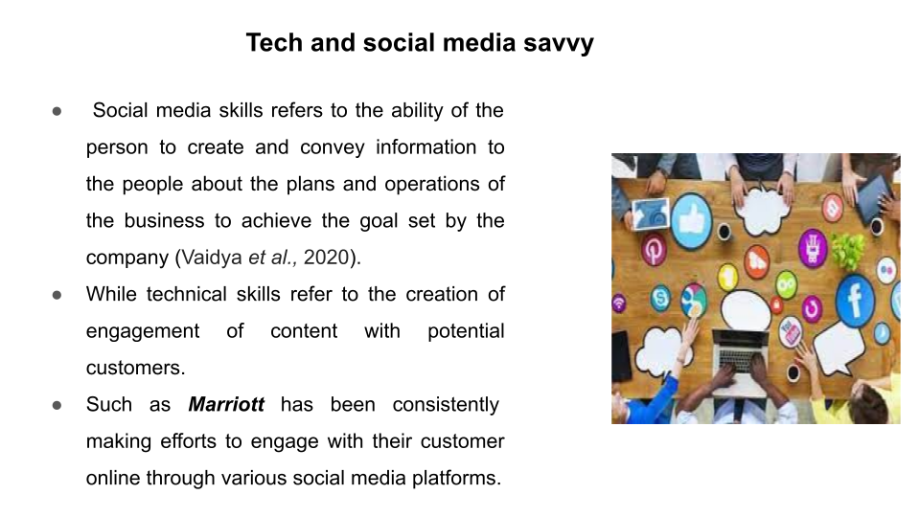
Training Notes: Social media skills refers to the ability of the person to create and convey information to the people about the plans and operations of the business to achieve the goal set by the company (Vaidya et al., 2020). While technical skills refer to the creation of engagement of content with potential customers such as delivering wider information about the company’s functional activities to its customers. Such as Marriott has been consistently making efforts to engage with their customer online through various social media platforms which have helped the hotel to gain a competitive advantage within the market.
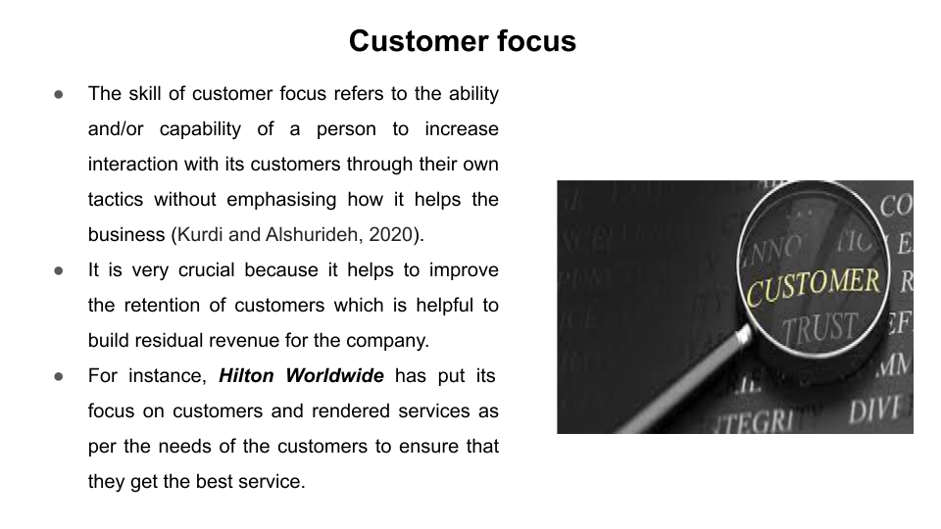
Training Notes: The skill of customer focus refers to the ability and/or capability of a person to increase interaction with its customers through their tactics without emphasising how it helps the business (Kurdi and Alshurideh, 2020). It is very crucial because it helps to improve the retention of customers which is helpful to build residual revenue for the company. Being a customer focus puts a person in a better position to understand the needs and preferences of the customers and thereby perform business operations with honesty. For instance, Hilton Worldwide has put its focus on customers and rendered services as per the needs of the customers to ensure that they get the best service.
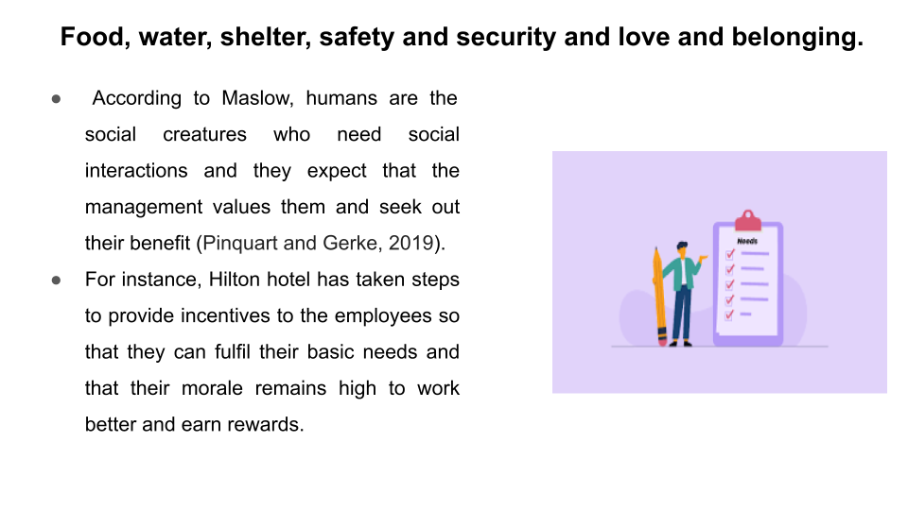
Training Notes: According to Maslow, humans are social creatures who need social interactions and they expect that the management values them and seek out their benefit (Pinquart and Gerke, 2019). For instance, Hilton Hotels has taken steps to provide incentives to the employees so that they can fulfil their basic needs and that their morale remains high to work better and earn rewards.
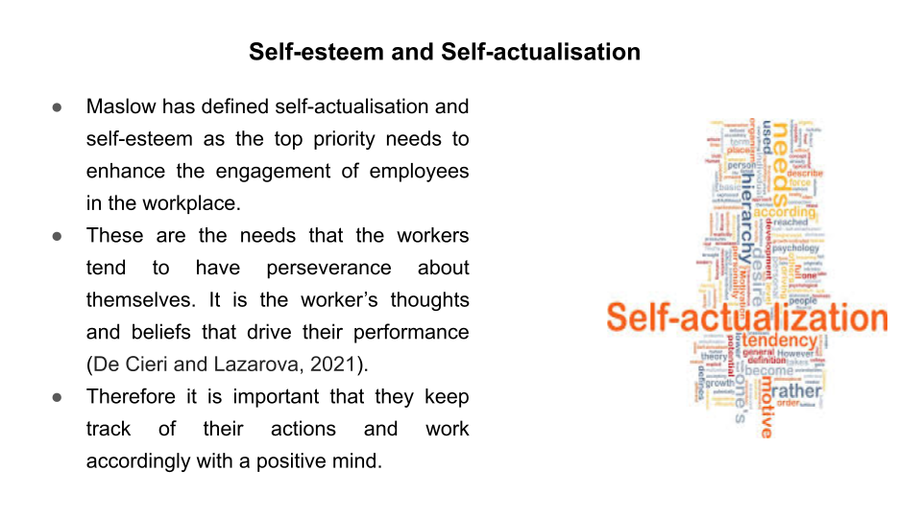
Training Notes: Maslow has defined self-actualisation and self-esteem as the top priority needs to enhance the engagement of employees in the workplace. These are the needs that the workers tend to have perseverance about themselves. It is the worker’s thoughts and beliefs that drive their performance (De Cieri and Lazarova, 2021). Therefore they must keep track of their actions and work accordingly with a positive mind.

References
Anshari, M., Almunawar, M.N., Lim, S.A. and Al-Mudimigh, A., 2019. Customer relationship management and big data enabled: Personalization & customization of services. Applied Computing and Informatics, 15(2), pp.94-101.
De Cieri, H. and Lazarova, M., 2021. “Your health and safety is of utmost importance to us”: A review of research on the occupational health and safety of international employees. Human Resource Management Review, 31(4), p.100790.
Kaufman, S.B., 2023. Self-actualizing people in the 21st century: Integration with contemporary theory and research on personality and well-being. Journal of Humanistic Psychology, 63(1), pp.51-83.
Kurdi, B. and Alshurideh, M., 2020. Employee retention and organizational performance: Evidence from banking industry. Management Science Letters, 10(16), pp.3981-3990.
Lee, E.K., Avgar, A.C., Park, W.W. and Choi, D., 2019. The dual effects of task conflict on team creativity: Focusing on the role of team-focused transformational leadership. International Journal of Conflict Management, 30(1), pp.132-154.
Lee, S.M. and Lee, D., 2020. “Untact”: a new customer service strategy in the digital age. Service Business, 14(1), pp.1-22.
Liu, H.Y., Beresin, E.V. and Chisolm, M.S., 2019. Social media skills for professional development in psychiatry and medicine. Psychiatric Clinics, 42(3), pp.483-492.
Pinquart, M. and Gerke, D.C., 2019. Associations of parenting styles with self-esteem in children and adolescents: A meta-analysis. Journal of Child and Family Studies, 28, pp.2017-2035.
Vaidya, A., Aydin, A., Ridgley, J., Raison, N., Dasgupta, P. and Ahmed, K., 2020. Current status of technical skills assessment tools in surgery: a systematic review. Journal of Surgical Research, 246, pp.342-378.
Vredenburg, J., Kapitan, S., Spry, A. and Kemper, J.A., 2020. Brands taking a stand: Authentic brand activism or woke washing?. Journal of public policy & marketing, 39(4), pp.444-460.

