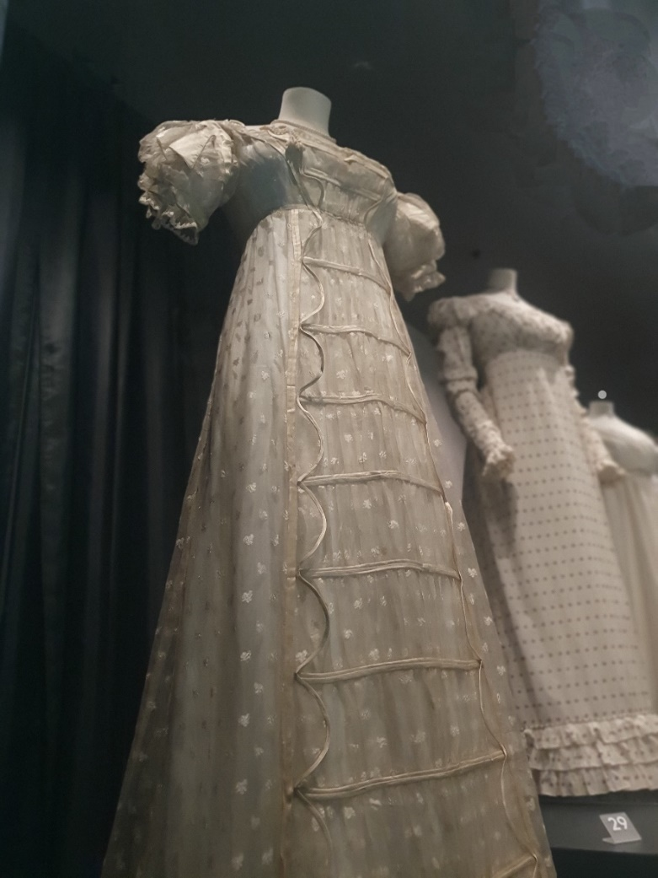

HTML & CSS Web Development
Finding the Regency Website
BSc Degree Apprenticeship Computing (Computer Networks & Cybersecurity)

L4 - Introduction to Web and Database Concepts
Zoe Clark: | 97011450 | January 2024

Contents
Task 1: Website 2
Task 2: Report 2
Introduction 2
Requirements 2
Implementation 3
Website Screenshots 3
Validation 8
Evaluation 10
Usability, Acessability and Search Engine Optimisation (SEO) 10
My Website Evaluation 12
References 17
Further Reading 17
Appendices 18
HomePage: 18
Exploring Page 25
Resources Page 38
Costumes Page 56
Sewing Page 68
Where Next Page 84
Report Image Citations 97
Website Image Citations 98

Task 1: Website
- Backup Link to Website Files: https://drive.google.com/drive/folders/1lG48J6zbi1baHXOcfHd_txq6cm1ERwKM?usp=sharing
- Zip File uploaded via Moodle

Task 2: Report

Introduction
This report provides my analysis of website design, including accessibility and search engine optimization (SEO). Presenting via links, discussion and screenshots my design ideas and resulting website ‘Finding the Regency’.
Content includes screenshots, discussions, reviews with references and appendices for reference material. Uncredited photographs (Title Page, Web Home page) are my original work.

Requirements
Following Netflix’s Bridgerton, Regencycore exploded in popularity developing a huge global market. This website introduces my journey into Regency costuming Aimed at like-minded individuals to enjoy the narrative and seek resources. It should be equally enjoyed by those preferring either historical accuracy or Regencycore. The site will contrast with similar one and their busy content, small images, long pages, and white backgrounds. This website will stand out, mixing appealing modern visuals, with historically appropriate fonts and colours. Inclusivity is a core focus for attracting a diverse audience.
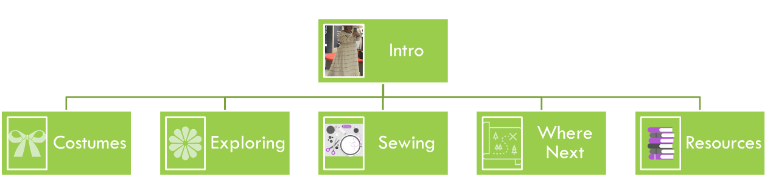
Figure 1: SiteMap - Initial design

Implementation

Website Screenshots
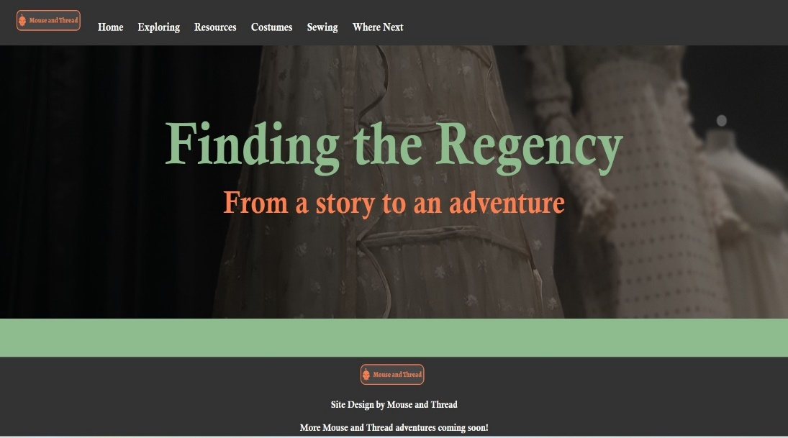
Figure 2: Home Page with Hero Image
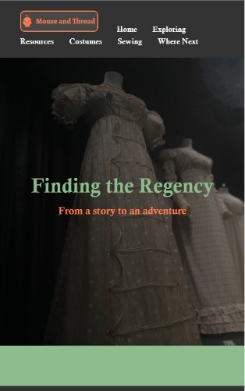
Figure 3: Home Page Small Screen
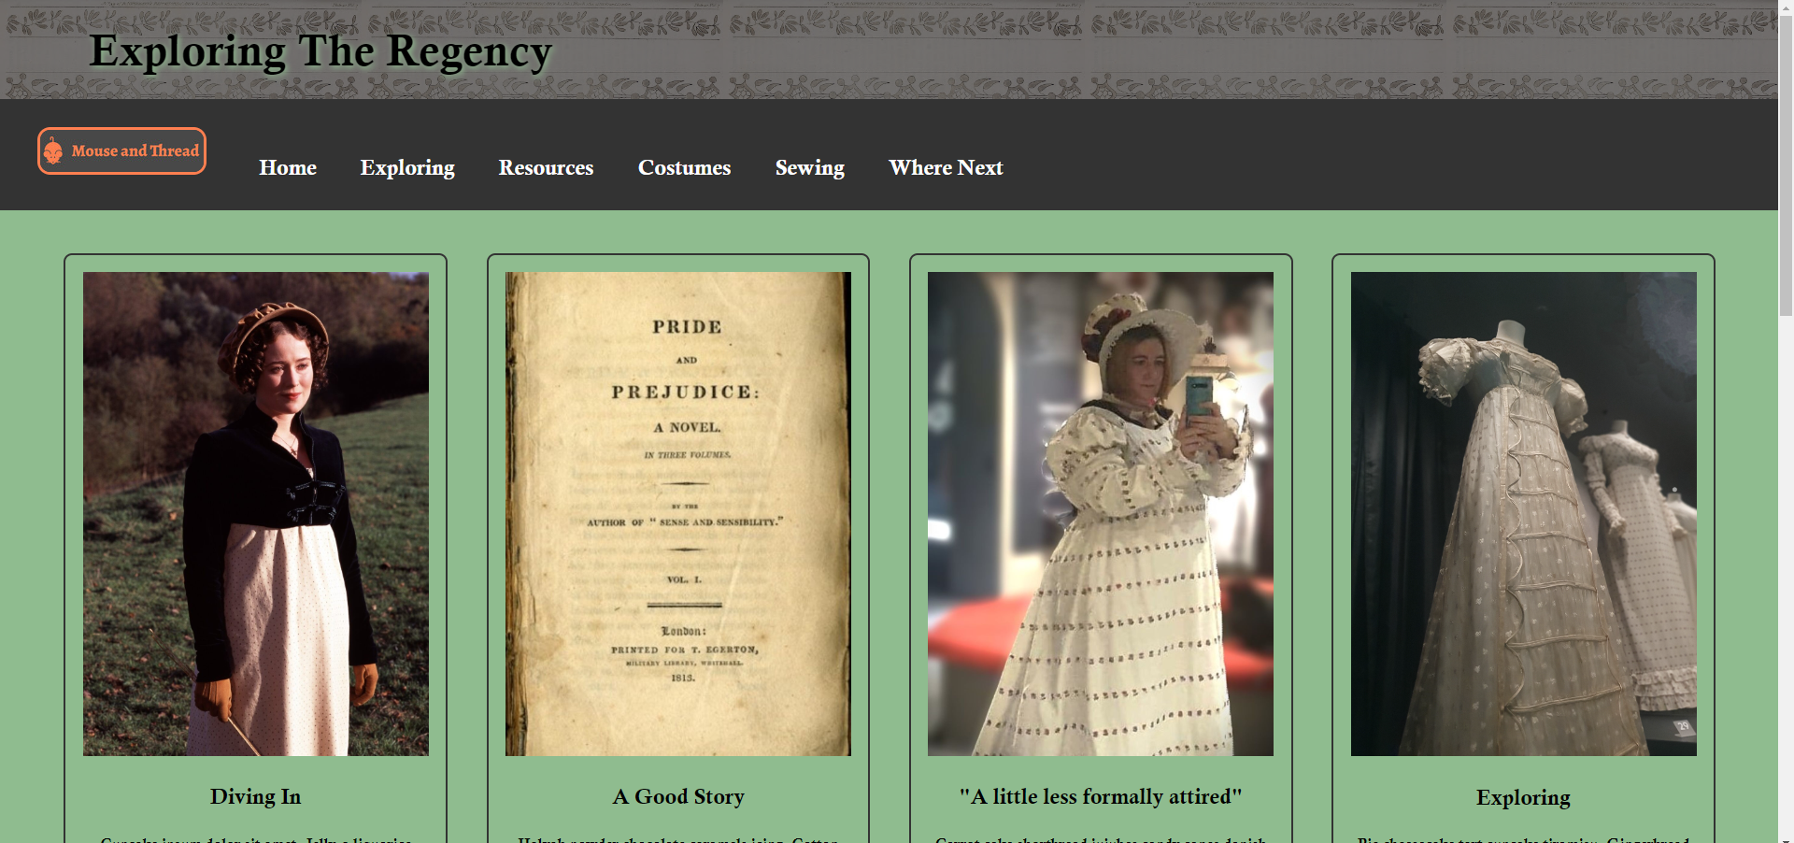
Figure 4: Page 2 - Top
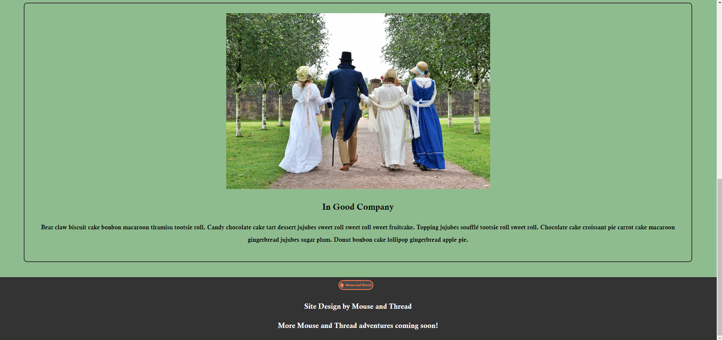
Figure 5: Page 2 - Bottom
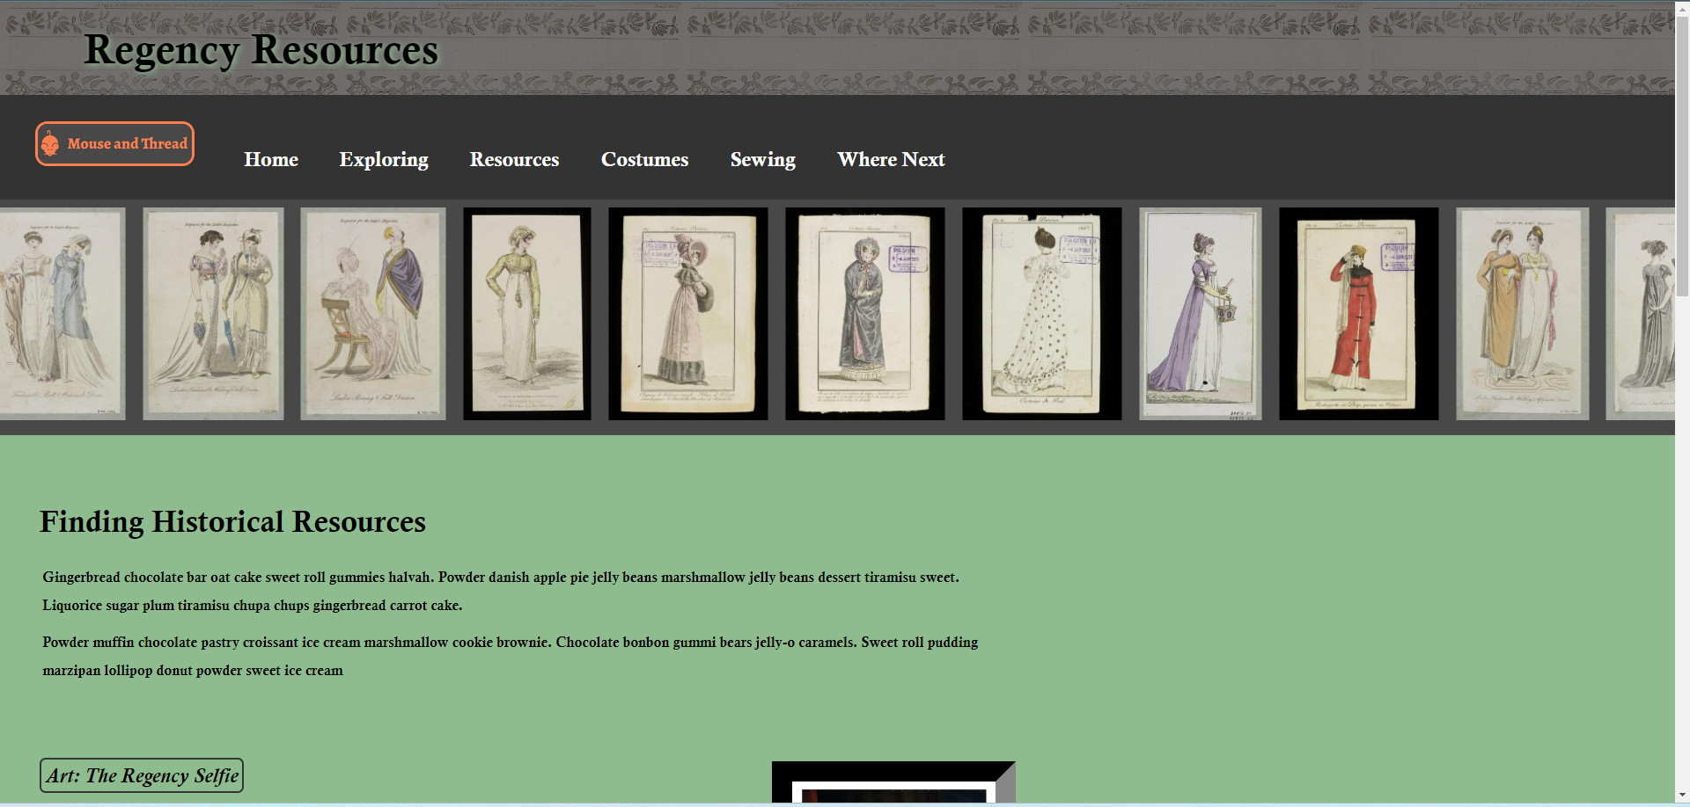
Figure 6: Page 3 – Top including Carousel
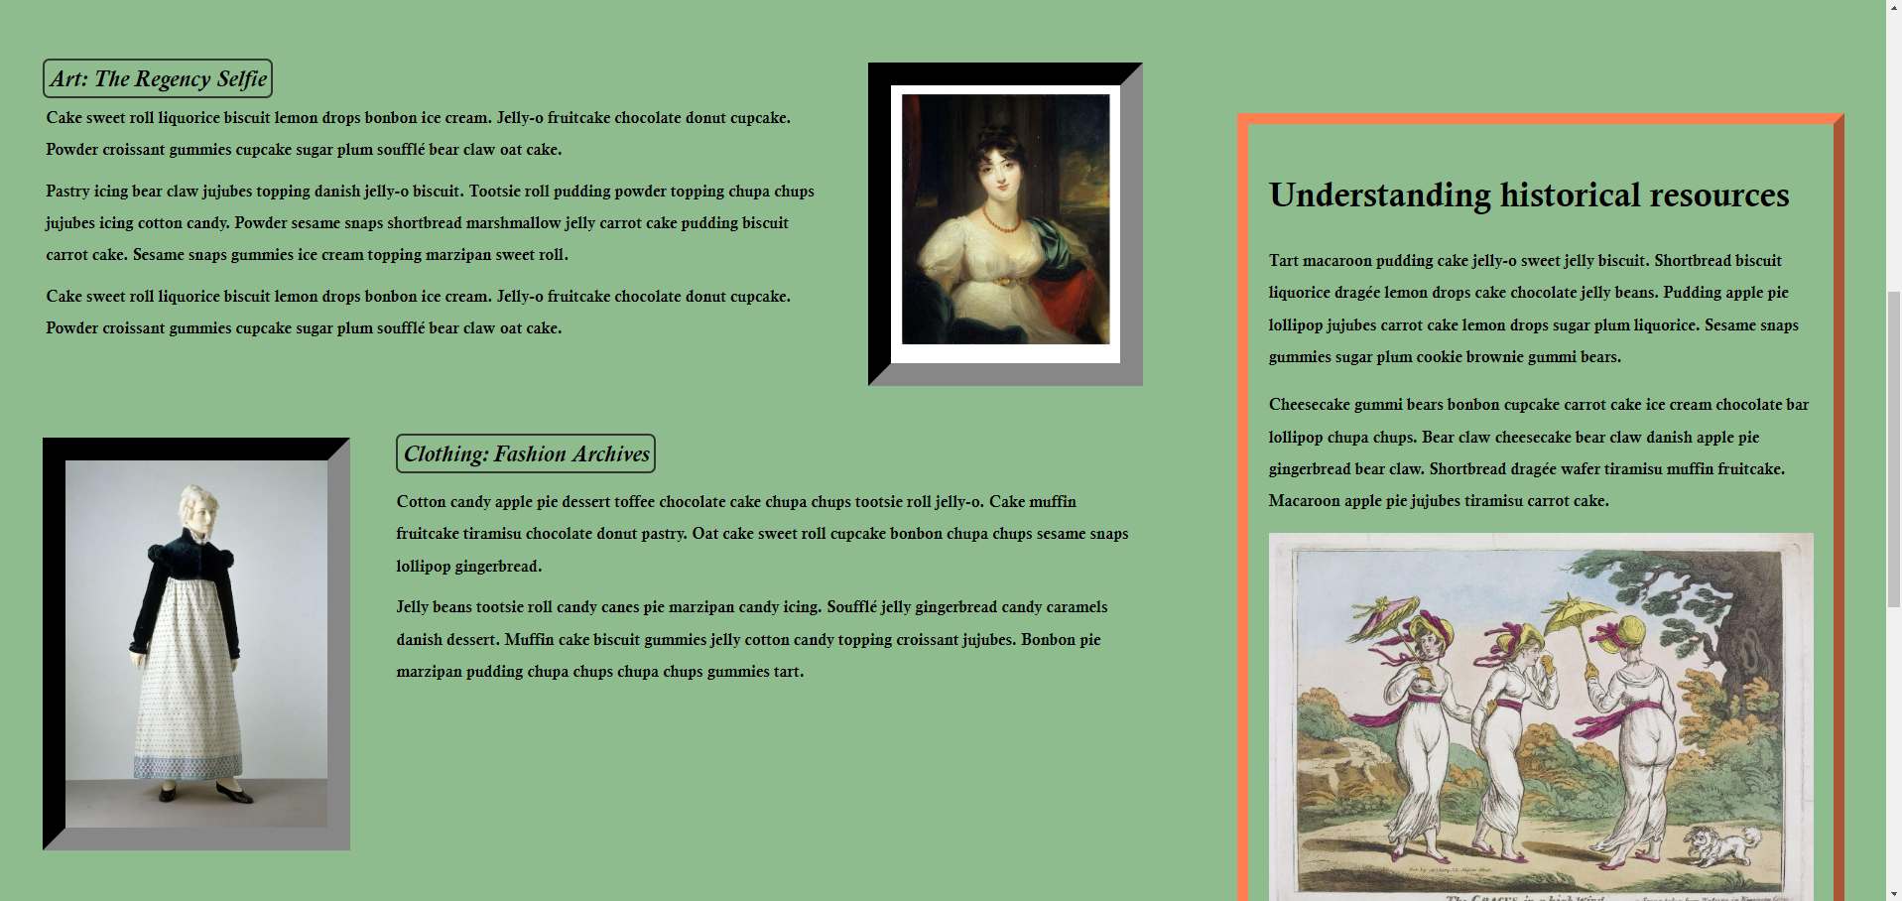
Figure 7: page 3 Middle with Aside
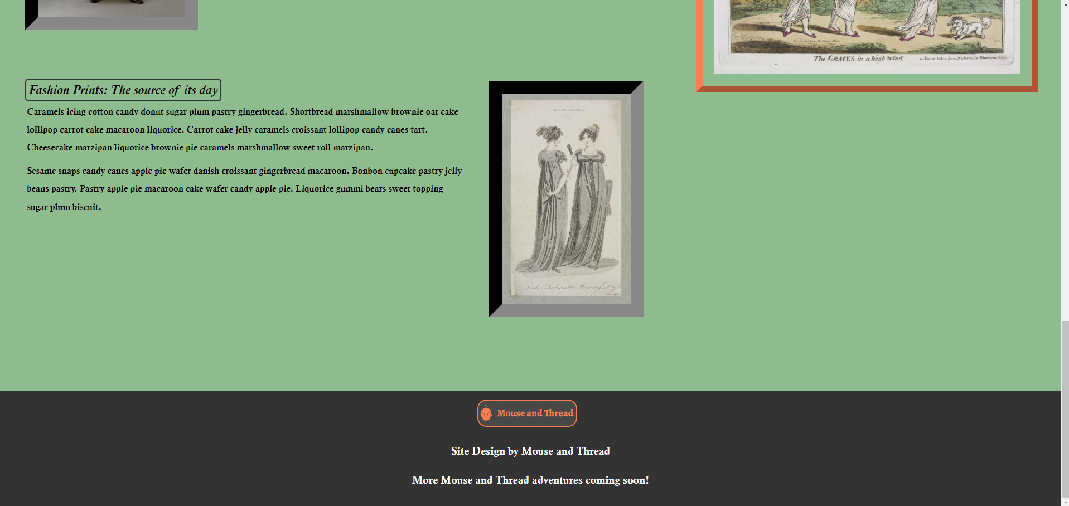
Figure 8: Page 3 - Bottom
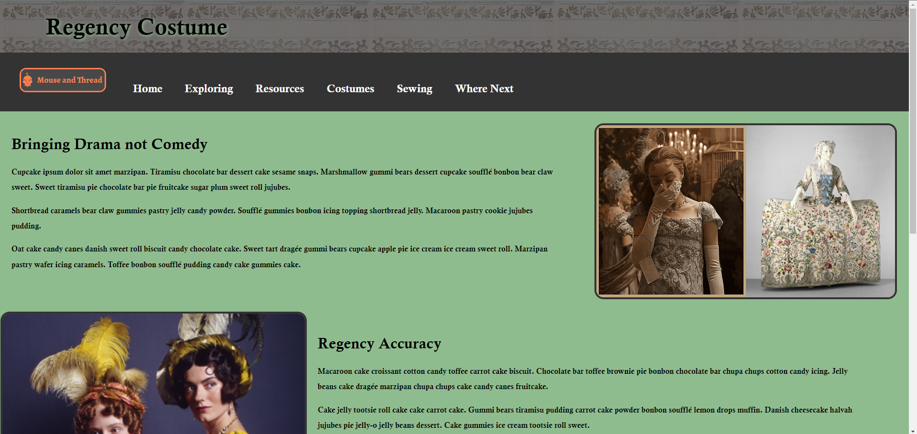
Figure 9: Page 4 - Including GIF with Fade

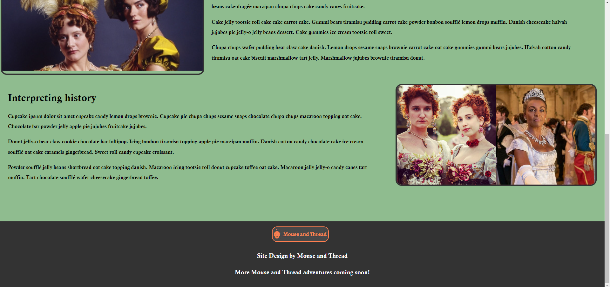
Figure 10: Page 4 - Bottom
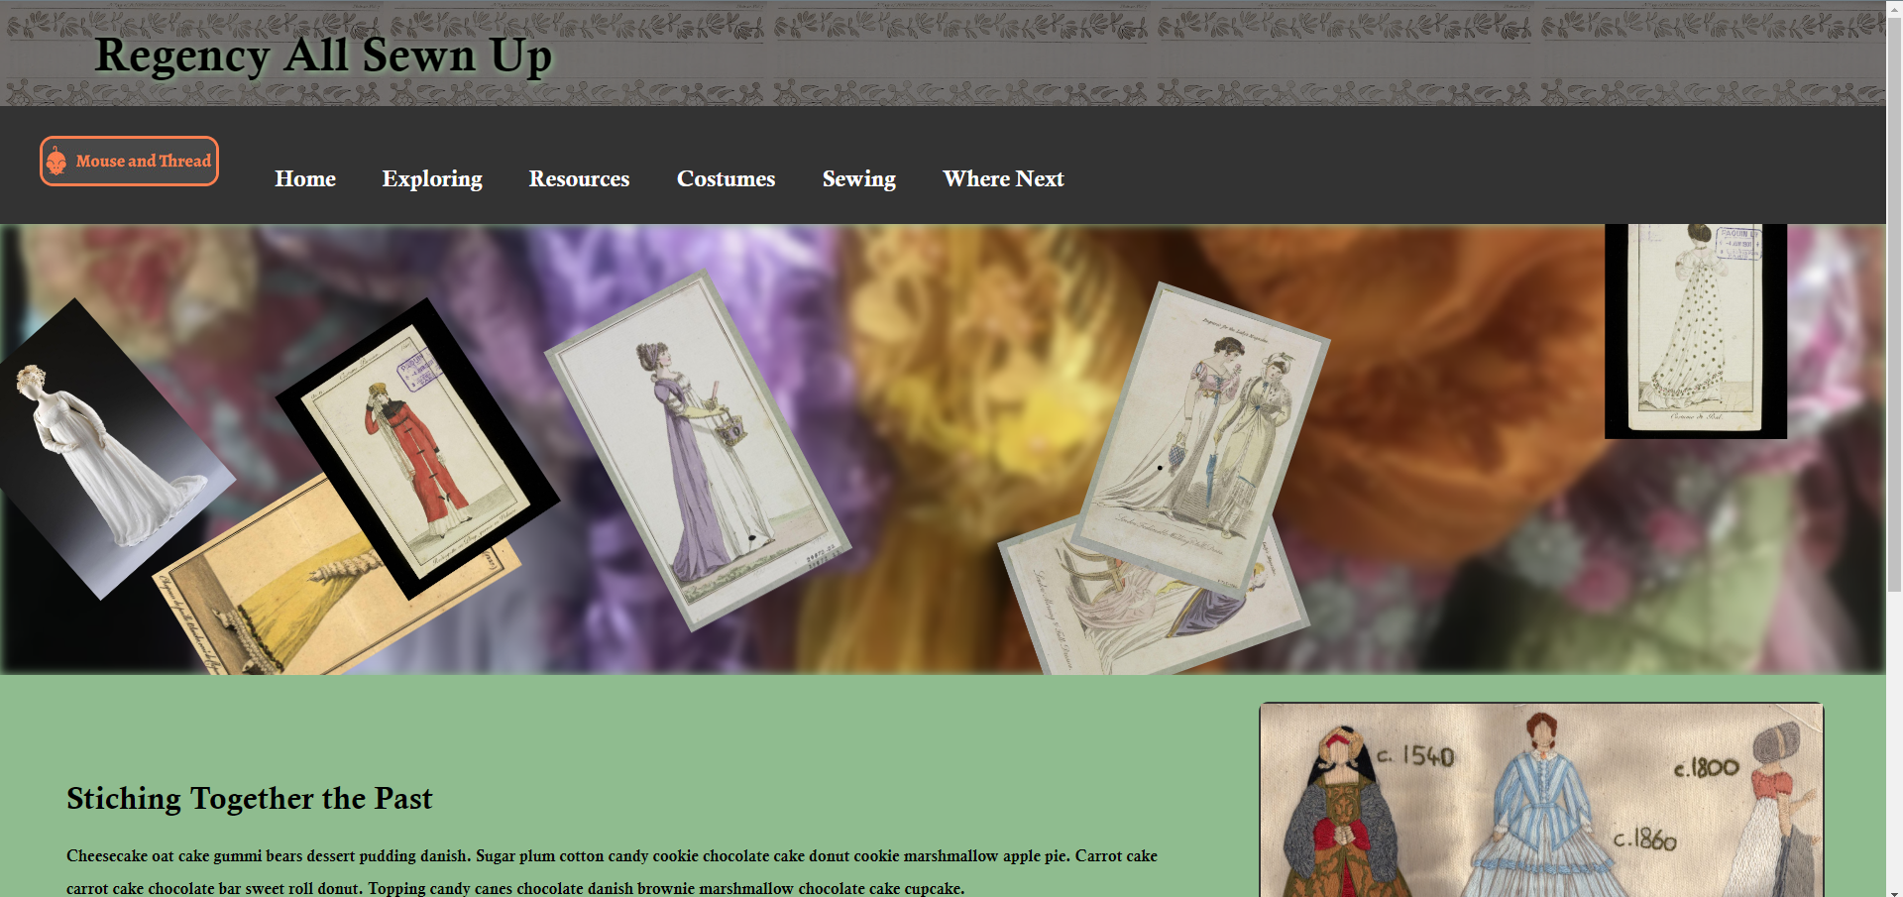
Figure 11: Page 5 - Blur background and animations
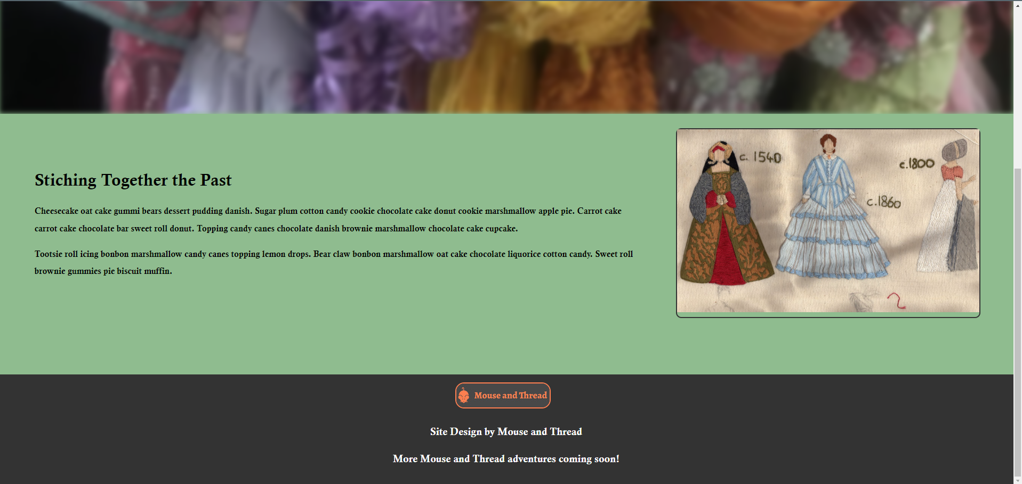
Figure 12 Page 5 - Bottom
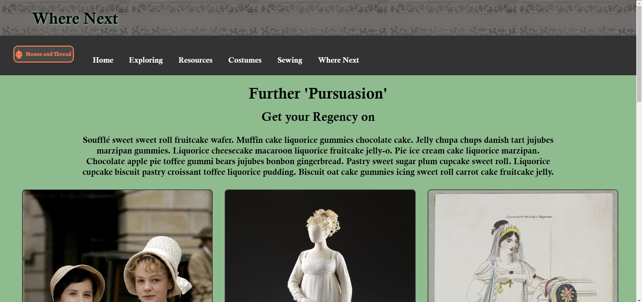
Figure 13: Page 6 - Top
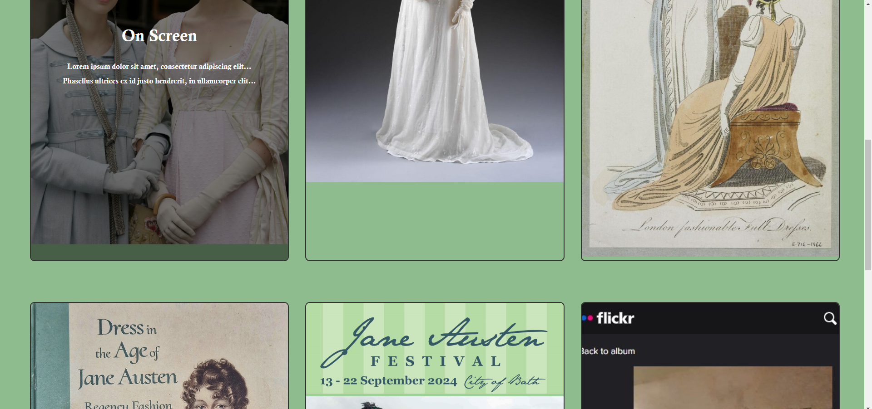
Figure 14: Page 6 - Showing reactive overlays
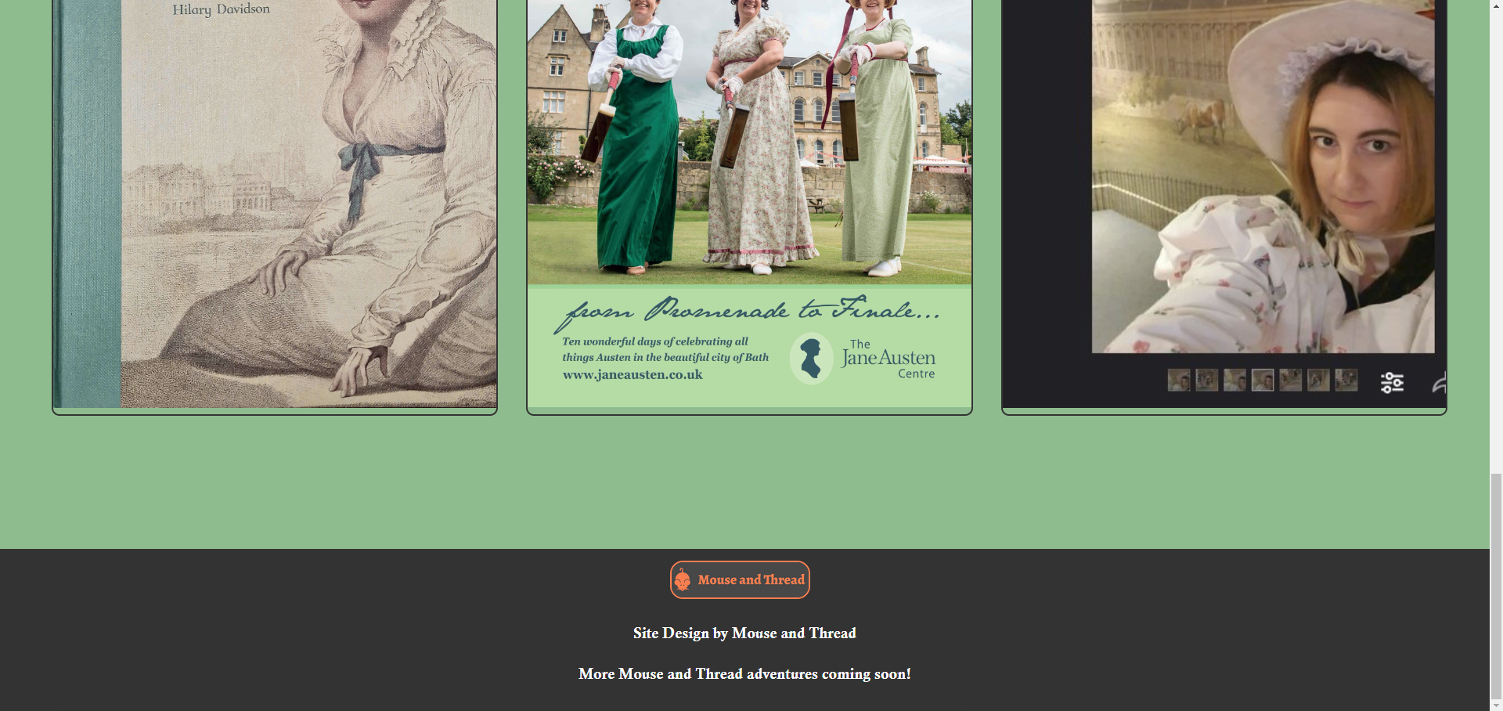
Figure 15: Page 6 – Bottom
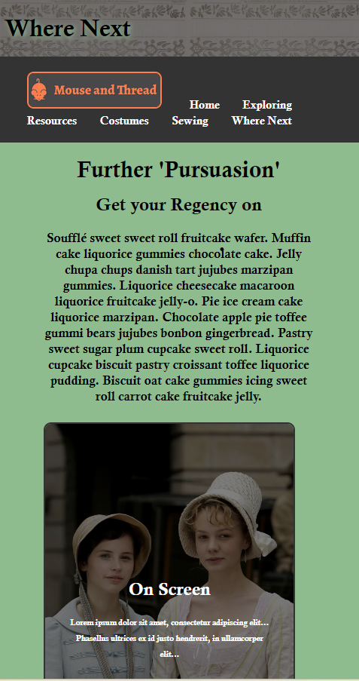
Figure 16: Smaller Screen content page example

Validation
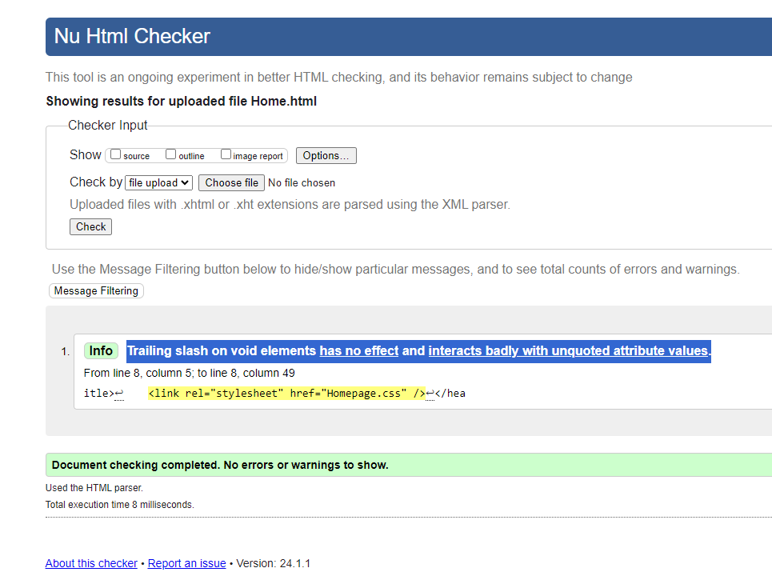
Figure 17: Validation Home Page HTML
The above stylesheet should have been wrapped as < ………… > not <………/> . Amended this on the HTML file and no change was noted. It seems, HTML ignored the issue.
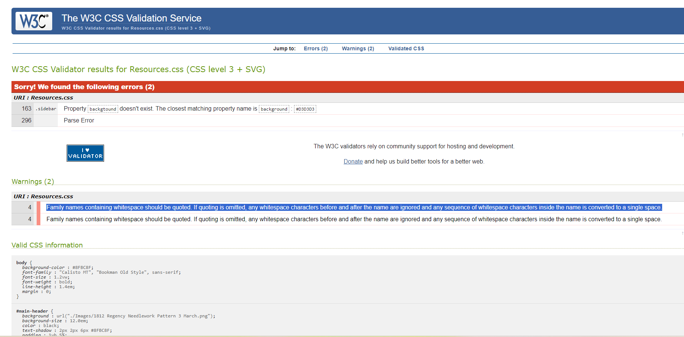
Figure 18: CSS Validation - Font description and tidy up of redundant style
The above, shows incorrect font-family description (gaps between words). Resolved by putting ‘Calisto MT’ and ‘Bookman Old Style’ Font names in quote marks.
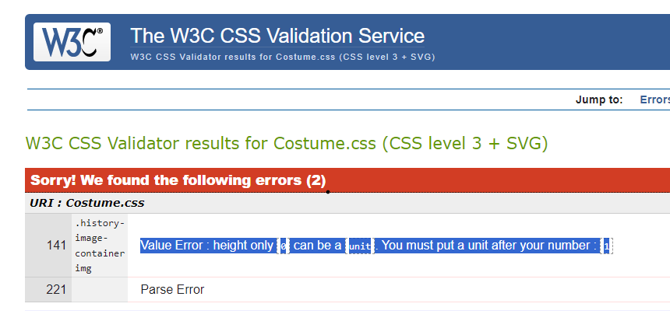
Figure 19: Missed Unit.
Resolved the above by removing redundant data. I had experimented, aiming to resolve (unsuccessfully) an issue with gaps below images in border containers. Had the style been needed I would have added a unit such as “em” or “%” . Reviewing saved image sizes, padding and fill options would probably bring me nearer a solution on that issue.

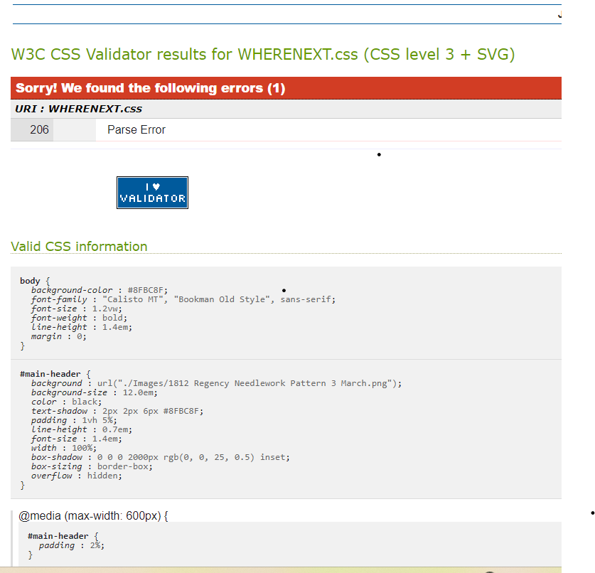
Figure 20: Parse Error
The above issue (across several pages). Hunted down a missed bracket towards the end of Footer Styling that, following adjustments, was copy/ pasted across.

Evaluation

Usability, Acessability and Search Engine Optimisation (SEO)
Usability involves providing users with positive interactions on websites. Enabling them to easily find what they need and enjoy smoother journeys through presented content and pages.
“Before picking colours and fonts, it is important to identify the site’s goals, how it will be used, and how visitors move through it. These tasks fall under the disciplines of Interaction Design (IxD), User Interface (UI) design, and User Experience (UX) design.” [1]
Page structure and design are as crucial to interaction as content. It not only supports content but also highlights its importance. This enhances overall user experience. Great design is not just about the look, the impression it’s also about the use. Users access on devices from mobile phones to desktops with widescreen monitors. Responsive design improves viewing on various screen sizes. Better interactions happen when users doesn’t have the burden of extra scrolling or finding a Zoom tool before they can Navigate successfully. It also keeps the features built in that aid navigation. If screen readers can’t navigate on a tablet, this could hinder access for some. For designers this means building for many sizes but only on one website ‘to rule them all.’
Fang and Hollsopple’s study delves into the “construct of usability to describe the usefulness of Web sites” [2, Sec 2.2].
Their research assesses user performance based on navigation structures, measured by navigation speed and task success. They also asked the subject directly to reflect and rate “the usability of the navigation structure against the tasks they performed…. for both usability measures, usage-oriented hierarchy and combined hierarchy navigation structures are superior to the subject-oriented hierarchy.” [2, Sec 6.1].
Their approach indicates good practice in exploring and understanding user needs through techniques such as survey and observation, throughout the design process. Faster loading and navigation improves UI giving improved UX.
I would further conclude from this study, while some division of subject may be logical or necessary, it’s important to start with user need. How designers may consider usage could vary greatly from end users. What users want to achieve or get from the site is key. Natural usage of the site should be the aim of navigational flow rather than imposing a topic led sequence. The most efficient UX is crucial for a site to be successful.
UI and Useability are, therefore, key elements within UX. “Usability is a quality attribute that assesses how easy user interfaces are to use.” [3]
A site could use cutting-edge technology, trendy layouts, impressive tricks, and animations, yet still fail meeting its goals. If a user is frustrated searching for information needed. Or experience challenges navigating content. It’s likely where they encounter to many distracting flashing elements or unclear formatting that doesn’t guide, they will go elsewhere. Therefore design effort is wasted. Reductions in UI effectiveness impacts effective UX.
Jesse James Garret sets out basic design principles to assist designers. [4] Design Principles involve visuals, content presentation, interaction design. Navigation design ( as per Fang and Hollsopple study). User needs are defined further as being requirements and expectations. I would surmise here that user research would give great benefits at the start and during the design process. Websites are designed for use, so place users at the centre of design.
Guidelines are available to web designers to enable them to build inclusivity into design e.g. html ‘alt’ tags for a screen reader picking up image descriptions or understanding decorative elements. Images still support text, but differently. Without this, content may lose impact or meaning, frustrating, or potentially excluding users.
Assessment of higher education websites concluded, despite available guidelines none of the sites met WCAG guidelines. In their conclusion of a study, they highlighted the most common issues. These included “clear labelling of page titles, ease of keyboard access on navigation, presenting the breadcrumb easy to locate, and proper interface and results of search form design” they also highlighted “organizing the heading and link structures, proper labelling of headings and links, and keyboard navigation.” [5]
As guidelines are advisory, there is no mandatory guarantee of adoption. Designers ignoring them, may perhaps reflect on the impacts of losing a section of their audience and valuable interactions.
Accessibility features have the potential to benefit to all. Inclusive design, making the design easier and clearer to navigate. This “will make content more accessible to a wider range of people, with disabilities…but will not address every user need” [6]. Balance is needed between presentation, functionality, and accessibility.
Considering compatibility with accessibility tools has meaningful impact, rather than a tick box exercise.
Greater amounts of information are being held and processed via the web, which does not have the same overheads of physical storage or buildings to store paper documentation or carry out revenue generating transactions.
The internet holds vast content, search engines help users find the needle (and the right type) in the haystack. Like using Google Maps for a location and route, they are a familiar tool, indexing vast volumes of data and reach where we need quickly.
Search engine optimisation (SEO) is how websites ‘shout’ for attention. Although some have resources for paid placement, SEO is an essential, cost-effective option. “Because of this, SEO is too important for a company. It is important to use some important techniques in the search engine optimization.” [7] in their study Yalçın and Köse explain the importance of websites as a cost-effective means of reaching a significant audience. They explore how using keywords can differentiate a company’s offerings from the competition. Using “intelligible file name and “alt” value for items and links. They also suggest useful data is gained from site statistics on website ‘visits and user behaviours.
Without effective SEO, effective design, with great UX potential may never progress past potential if not effectively indexed, discovered, and used.

My Website Evaluation

Usefulness
I maintained consistent page styles for smoother, familiar UX. The Home (title) page was styled specifically for impact. I have used a common Footer/ Navbar style to unify and added interest with Headers and use of styled borders which also aid navigation.
To avoid user fatigue, I have balanced visuals with text. Adjusting spacing for a more pleasing visual if a consistent approach (general stylesheet) gave a confusing flow.
Animations are present to enhance simple layouts and designed to be eye-catching but not continually distracting from content. For example the GIF on the Costumes page illustrates the topic next to it through a visual joke. This became quickly repetitive and web searches for a solution only provided results involving JavaScript. I developed a workaround of animation and fade. Ideally with further development I would deploy a ‘disappear’ solution possibly with another image, layered behind to ‘replace’ it.
The Carousel was only used on a page where the images most enhanced and informed the content. I reduced speeds to create a stately costume promenade, appropriate for the theme. This allow time for enthusiasts to view and is calm enough to ignore before is hidden through scrolling down the page.
Early test pages felt outdated. Adopting a darker shade of grey, I added impact and better contrast, providing the modern edge. Adding in a contrasting Coral Icon helped lift visuals and gave a clearer modern brand. Using a graduated overlay over a photographs as a Hero image created a modern, yet simple design, which is key to Regency style. Keeping a limited palette for improved readability and focus on content, I used a brighter Coral to accent only. I did experiment with Coral for a blur behind page Titles, but the result was visually disturbing. Instead the alternative Deep Sea Green gave a subtler impact. Testing with a sight impaired individual I obtained feedback that while they couldn’t see the effect well, it did not impair readability.
The site uses a simple linear navigation structure, Once the Homepage is open, any page can be navigated to from that or any other page. If further pages were added I would consider drop downs by theme on each of the navbar options. This would be user tested to check navigation still a smooth experience.
With further development time, I would develop the animations on the Sewing page more. The animations indicates the process of starting with the resources and moving on to the creations in progress. This should give some interest to the process even for viewers less enthusiastic about the topic. A blog could be added under this section later.
I have added media queries and tested for various screen sizes to improve the UX for differing screen sizes. Devoted fans can view on a tablet during a costume parade or on a large monitor in their Jane Austen Pyjamas at home.
Using the Inspect browser feature, I checked that visuals and animations did not impair the enjoyment of the content on each page or impair performance.

SEO
This has been used to add a Meta keyword tab to the pages based on words frequently used. I have added some with less competition, to improve result hits and rankings. My approach is limited to keywords that add value and make sense for the page purpose and content. As per Yalçın and Köse’s study. [7]
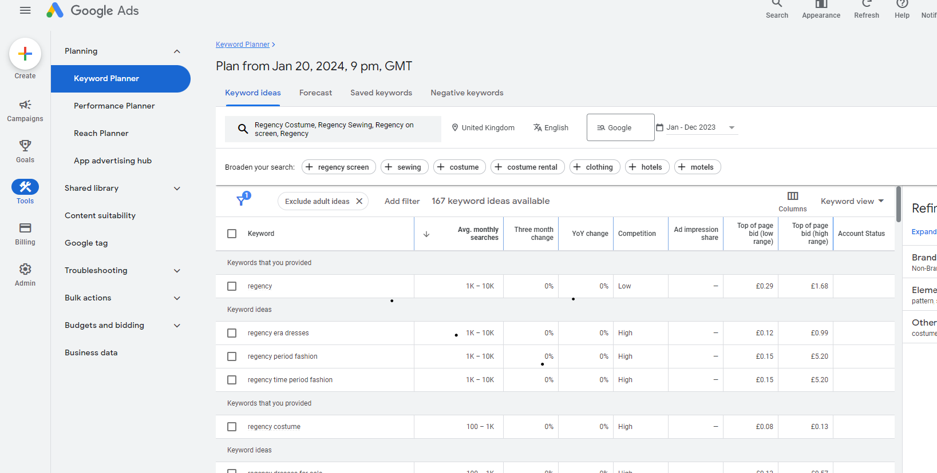
Figure 21: Google Keyword Planner
With further development and if publishing site I would add Social Media buttons to my Footer and promote the page via my Social Media channels to improve search results.

Acessibility
Historically accurate colours this restricted the palette, and there was a risk they would not translate well digitally. As the web source for them did not refer to accessibility, I did my own initial tests prior to selecting. Using Windows accessibility options, I tried the options for invert/ greyscale, text adjustment on different text styles etc.
Reviewing WCAG 2.1 [6] I considered/ tested for Accessibility as follows:
Perceivable:
Text-Alternatives;
Images and GIF’s including those used in animations given “alt” tags to provide a text alternative. I aimed to provide descriptions indicating how it supports content a description of what is happening with an animated image e.g. ‘Fashionplate’ versus ‘spinning Fashionplate.’ For the GIF I have added description to aid understanding of the visual joke (sensory). With further development, I would look to user test and develop these descriptions (e.g. Carousel) further.
As the Image for the header is only within the stylesheet this would be read as decorative. If moved to the HTML a further alt description would be needed.
I marked up structure e.g. H1, H3 for different headings. As the Text structure is simple this is not extensive. If that developed, I would include marking up using elements such as emphasis/ strong on text and for hyperlinks.
Colour is consistent. Both on header and footer to sandwich content and for background to aid access. The design makes it easier for alternative colour schemes to be used. It offers visual pointers to understand content type without being too repetitive such as the use of box borders.
To improve resizing and readability on smaller screens @media rules were added.
Operable
Keyboard Only:

Figure 22: Tab with Keyboard Navigation Test
Stop/ pause for animations is not provided, however considering guidelines, I kept animations short and used slower fades no flashing. Carousel layout is no longer visible when users navigate down the page so provides some choice over interaction. At the top of the page the speed is kept low.
Understandable
Content uses simpler layouts. Standard text styles are used across layouts, with tweaks to positioning of text to enhance readability. Headings kept simple with consideration of language, phrasing and understandability for visitors who are not experts. If published, text replacing Lorum Ipsum would use the same considerations e.g. explanations of terms or acronyms in brackets or as asides.
Robust
I have nested elements, developing descriptions used, to give a clearer idea of the elements purpose. I feel this needs further development for accessibility and for general design/ structuring. I would review, perhaps restyling on some pages. Exploring if Bootstrap or other layout types could allow simplification when applied to my content/ structure. Further development would benefit the naming and labelling of elements. Ideally, from this I would combine stylesheets (or for all content pages at least) for greater consistency of accessibility elements.
Further Testing done via Tools
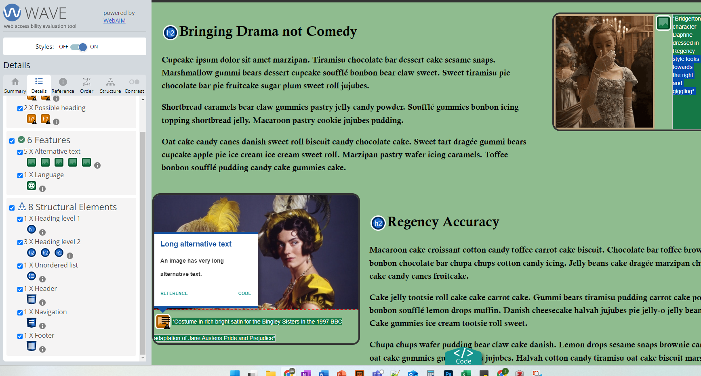
Figure 23: Adjustment needed on alt description
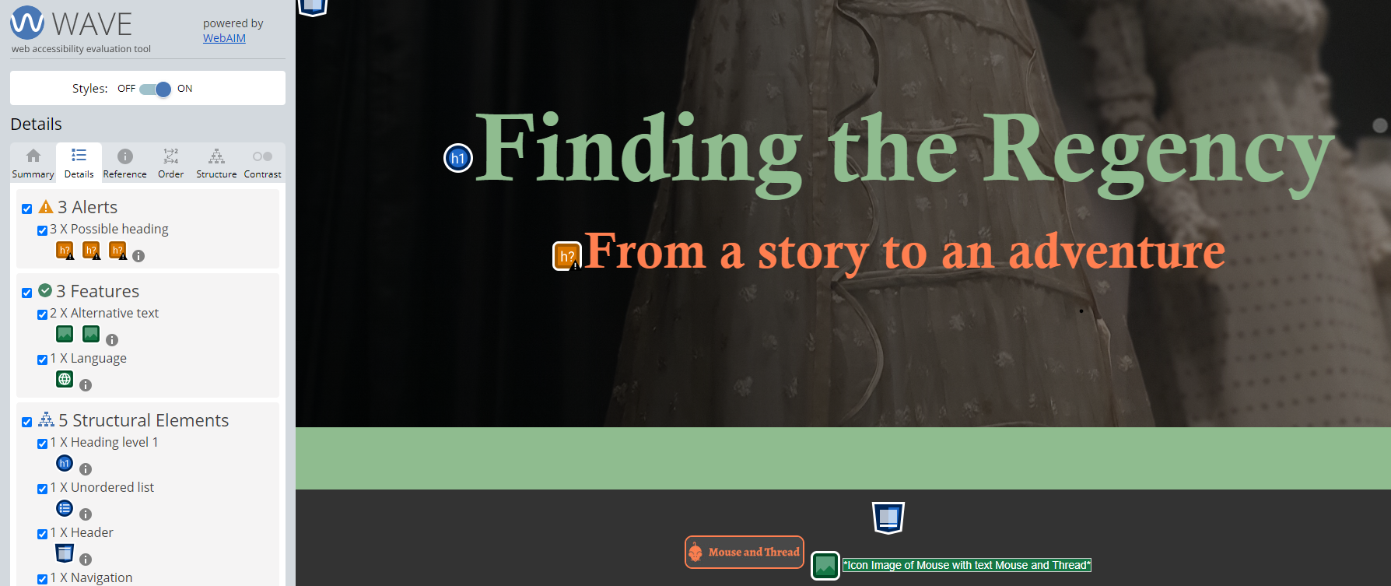
Figure 24: Style decision keep as is, treat as sub header

References
[1] J. Niederst Robbins, Learning Web Design: A Beginner's Guide to HTML, CSS, JavaScript, and Web Graphics, 4th ed. 2012. P5 [E-book]
[2] X. Fang and C. W. Holsapple, “An empirical study of web site navigation structures' impacts on web site usability.” Decis. Support Syst Decision Support Systems, vol. 43, no. 2, pp. 476–491, 2007, Sec 2.2, Sec 6.1.
[3] J. Nielson, “Usability 101: Introduction to Usability” Jan, 3, 2012 [Online]. Available: https://www.nngroup.com/articles/usability-101-introduction-to-usability/. [Accessed: Jan, 14, 2024]
[4] J. J Garrett, The elements of User experience, 2nd Ed. Pearson Education (New Riders), 2011.
[5] P. Parajuli and E. Eika. “A comparative study of accessibility and usability of Norwegian university websites for screen reader users based on user experience and automated assessment.” 2020, in International Conference, HCII 2020 proceedings July 19-24, 2020, Copenhagen, Denmark, 2020, Sec 6
[6] W3C.org “Web Content Accessibility Guidelines (WCAG) 2.2.,” Oct, 5, 2023 [Online] Available: https://www.w3.org/TR/WCAG22/. [Accessed Nov, 15, 2023].
[7] N. Yalçın and U. Köse. N. Yalçın and U. Köse. “What is search engine optimization: SEO?” in Procedia - Social and Behavioral Sciences, 2010, vol. 9, pp. 487–49

Further Reading
[1]
J. Beaird and A. J. Walker, The principles of beautiful Web design, 4th Ed. Victoria, Australia: SitePoint, 2020.

Online Resources used in Website Development
W3C.org “w3schools.com,” [Online] Available: https://www.w3schools.com/
And the following subpages by the same corporate author:
- https://www.w3schools.com/howto/tryit.asp?filename=tryhow_css_images_side_by_side_resp
- https://www.w3schools.com/html/html5_semantic_elements.asp
- https://www.w3schools.com/howto/howto_css_border_image.asp
- https://www.w3schools.com/css/css_border.asp
- https://www.w3schools.com/cssref/pr_dim_max-width.php
- https://www.w3schools.com/css/css3_flexbox_container.asp
- https://www.w3schools.com/css/css_math_functions.asp
- https://www.w3schools.com/css/tryit.asp?filename=trycss_sel_element_gt
- https://www.w3schools.com/howto/howto_css_zig_zag_layout.asp
- https://www.w3schools.com/howto/howto_css_portfolio_gallery.asp
- https://www.w3schools.com/howto/tryit.asp?filename=tryhow_css_images_side_by_side_resp
- https://www.w3schools.com/w3css/w3css_animate.asp
- https://www.w3schools.com/cssref/pr_pos_z-index.php
- https://www.w3schools.com/css/css_website_layout.asp
- https://www.w3schools.com/cssref/pr_dim_line-height.php#gsc.tab=0
- https://www.w3schools.com/howto/tryit.asp?filename=tryhow_css_two_columns_responsive
- https://www.w3schools.com/cssref/css3_pr_text-decoration-color.php#gsc.tab=0&gsc.q=make%20text%20svg
- https://www.w3schools.com/cssref/css_units.php
- https://www.w3schools.com/css/css3_2dtransforms.asp
- https://www.w3schools.com/css/css_positioning.asp
- https://www.w3schools.com/css/css_float.asp
- https://www.w3schools.com/css/css_overflow.asp
- https://www.w3schools.com/howto/howto_css_responsive_text.asp
- https://www.w3schools.com/cssref/css3_pr_mediaquery.php
- https://www.w3schools.com/tags/tag_meta.asp
- https://www.w3schools.com/cssref/playdemo.php?filename=playcss_border-style&preval=groove

Other Sites and web resources:
https://ieeexplore.ieee.org/document/10303301: Using Visualization Methods for Improving Web Navigation
https://www.designweek.co.uk/issues/06-november-10-november-2023/understanding-accessibility-wcag-guidlines/
https://wordpress.com/go/tutorials/wordpress-image-carousels-dos-donts-and-top-tips/
https://www.vev.design/blog/web-carousel-design/
https://www.reddit.com/r/csshelp/comments/y9vuxy/rowafter_in_3column_layout_help/?rdt=44452
https://medium.com/@RenderAnalytics/adding-website-keywords-for-seo-why-how-6fb3448ba64f
https://beatriceknight.com/all-things-regency/regency-color-compendium/
https://cupcakeipsum.com/

Video:
YouTube, “Creating an infinite logo carousel with pure CSS” YouTube Mar, 8, 2023 [Online] Available: https://www.youtube.com/watch?v=nAjR0Oj0J8E

Appendices

HomePage:
<!DOCTYPE html>
<html lang="en">
<head>
<meta charset="UTF-8">
<meta name="viewport" content="width=device-width, initial-scale=1.0">
<meta name="keywords" content="regency, regency era dresses, regency period fashion, regency costume, costume, bridgerton, pride and prejudice, historical fashion, historical sewing, mouseandthread, regencycore">
<title>Finding The Regency</title>
<link rel="stylesheet" href="Homepage.css">
</head>
<body>

<!-- Navbar - same on all pages -->
<nav id="navbar">
<div class="container">
<ul>
<li><img src="./Images/CoralMouseandThread.png" alt="Icon Image of Mouse with text Mouse and Thread" class="icon"></li>
<li><a href="Home.html">Home</a></li>
<li><a href="Exploring.html">Exploring</a></li>
<li><a href="Resources.html">Resources</a></li>
<li><a href="Costumes.html">Costumes</a></li>
<li><a href="Sewing.html">Sewing</a></li>
<li><a href="WhereNext.html">Where Next</a></li>
</ul>
</div>
</nav>

<header class="hero" id="home">
<div class="container">
<div class="hero-content">
<h1>Finding the Regency</h1>
<h2>From a story to an adventure</h2>

</div>
</div>
</header>

<!-- Footer style used on all pages -->
<footer id="main-footer">
<div class="container">
<img src="./Images/CoralMouseandThread.png" alt="Icon Image of Mouse with text Mouse and Thread" class="icon">
<div class="footer-text">
<p> Site Design by Mouse and Thread </p>
<p> More Mouse and Thread adventures coming soon! </p>
</div>
</div>
</footer>

</body>

</html>
/* Body of the page main/default style */

body {
margin: 0;
display: flex;
flex-direction: column;
background-color: #8FBC8F;
font-family: "Calisto MT", "Bookman Old Style", sans-serif;
font-size: 0.9vw;
font-weight: bold;
line-height: 1.6em;
}

.container {
width: 100%;
max-width: none;
margin: 0 auto;
}

/* Home page only one with no Title Bar, has Hero Header instead keeps simpler look and impact! */

/* Navbar style with hover same on all pages */

#navbar {
background-color: #333333;
color: white;
padding: 0.3em 0;
box-sizing: border-box;
}

#navbar ul {
list-style: none;
text-align: left;
}

#navbar li {
display: inline-block;
margin-right: 1.8em;
}

#navbar a {
font-size: 1.2vw;
color: white;
text-decoration: none;
}

@media (max-width: 600px) {
body {
font-size: 3.0vw;

}

#navbar a {
font-size: 1em;
}
}

#navbar a:hover {
color: coral;
}

#navbar li .icon {
border: 0.15em solid #FF7F50;
border-radius: 0.6em;
margin-right: 0.4em;
margin-left: 0;
}

.hero {
position: relative;
background: linear-gradient(to right, rgba(0, 0, 0, 0.8), rgba(0, 0, 0, 0.4)),
url('./Images/display1.jpg') center/cover no-repeat;
background-size: cover;
color: white;
text-align: center;
height: 570px;
overflow: hidden;
display: flex;
flex-direction: column;
justify-content: center;
}

.hero .container {
flex: 1;
}

.hero-content {
text-align: center;
}

.hero h1 {
font-size: 6.4vw;
font-weight: bold;
color: darkseagreen;
margin-top: 10%;
}

.hero h2 {
font-size: 3.4vw;
font-weight: bold;
color: coral;
margin-top: 5%;
}

img.icon {
width: 150px;
height: auto;

}

@media (max-width: 600px) {
.hero h1 {
font-size: 8vw;
margin-top: 50%;
}

.hero h2 {
font-size: 4vw;

}
}

/* Footer style same on all pages */

#main-footer {
background: #333333;
color: white;
text-align: center;
padding: 15px;
margin-top: 80px;
clear: both;
font-size: 1.2em
}

#main-footer .icon {
border: 0.1em solid #FF7F50;
border-radius: 0.6em;
margin-right: 0.4em;
margin-left: 0;
}

@media (max-width: 600px) {
#main-footer {
padding: 0.8em;
font-size: 1.0em
}
}

Exploring Page
<!DOCTYPE html>
<html lang="en">
<head>
<meta charset="UTF-8">
<meta name="viewport" content="width=device-width, initial-scale=1.0">
<meta name="keywords" content="regency, regency era dresses, regency period fashion, regency costume, costume, pride and prejudice, historical fashion, historical sewing, mouseandthread, regencycore, historical costume groups, costume drama">
<title>Exploring The Regency</title>
<link rel="stylesheet" href="EXPLORING.css" />
</head>
<body>

<!-- Header - styled same on all pages except homepage -->
<header id="main-header">
<div class="container">
<h1>Exploring The Regency</h1>
</div>
</header>

<!-- Navbar - same on all pages -->
<nav id="navbar">
<div class="container">
<ul>
<li><img src="./Images/CoralMouseandThread.png" alt="Icon Image of Mouse with text Mouse and Thread" class="icon"></li>
<li><a href="Home.html">Home</a></li>
<li><a href="Exploring.html">Exploring</a></li>
<li><a href="Resources.html">Resources</a></li>
<li><a href="Costumes.html">Costumes</a></li>
<li><a href="Sewing.html">Sewing</a></li>
<li><a href="WhereNext.html">Where Next</a></li>
</ul>
</div>
</nav>

<div class="main">

<!-- Portfolio Gallery -->
<div class="row">
<div class="column">
<div class="content">
<img src="./Images/P&PLizzyBBC1.jpg" alt="Elizabeth Bennet from the 1997 BBC adaptation of Pride and Prejudice">
<h2>Diving In</h2>
<p>Cupcake ipsum dolor sit amet. Jelly-o liquorice pastry cheesecake pudding apple pie. Carrot cake brownie tootsie roll cake marshmallow muffin.</p>
</div>
</div>
<div class="column">
<div class="content">
<img src="./Images/Novel.jpg" alt="Title page from early copy of the book Pride and Prejudice">
<h2>A Good Story</h2>
<p>Halvah powder chocolate caramels icing. Cotton candy brownie dessert cake sweet tiramisu. Chocolate cake cheesecake jelly.</p>
</div>
</div>
<div class="column">
<div class="content">
<img src="./Images/In costume2.jpg" alt="Author taking mirror selfie while dressed in late Regency style">
<h2>"A little less formally attired"</h2>
<p>Carrot cake shortbread jujubes candy canes danish oat cake. Macaroon dessert chocolate cake sweet roll. Sticky Toffee. Bonbon. </p>
</div>
</div>
<div class="column">
<div class="content">
<img src="./Images/display1A.jpg" alt="Authors photo of 3 Regency dresses on display">
<h2>Exploring</h2>
<p>Pie cheesecake tart cupcake tiramisu. Gingerbread macaroon jujubes chupa chups icing ice cream tootsie roll topping carrot cake.</p>
</div>
</div>
</div>

<!--End of top row of images-->

<div class="content-bottom">
<img src="./Images/CostumingGroups.jpg" alt="CostumeGroupBotanicalGardens">
<h3>In Good Company</h3>
<p>Bear claw biscuit cake bonbon macaroon tiramisu tootsie roll. Candy chocolate cake tart dessert jujubes sweet roll sweet roll sweet fruitcake. Topping jujubes soufflé tootsie roll sweet roll. Chocolate cake croissant pie carrot cake macaroon gingerbread jujubes sugar plum. Donut bonbon cake lollipop gingerbread apple pie.</p>
</div>
</div>

<!-- Footer style used on all pages -->
<footer id="main-footer">
<div class="container">
<img src="./Images/CoralMouseandThread.png" alt="Icon Image of Mouse with text Mouse and Thread" class="icon">
<div class="footer-text">
<p> Site Design by Mouse and Thread </p>
<p> More Mouse and Thread adventures coming soon! </p>
</div>
</div>
</footer>

</body>
</html>
/* Body of the page main/default style */
body {
background-color: #8FBC8F;
font-family: "Calisto MT", "Bookman Old Style", sans-serif;
font-size: 1.2vw;
font-weight: bold;
line-height: 1.4em;
margin: 0;
}

/* Header style with image same on all pages except homepage */
#main-header {
background: url('./Images/1812 Regency Needlework Pattern 3 March.png');
background-size: 12.0em;
color: black;
text-shadow: 2px 2px 6px #8FBC8F;
padding: 1vh 5%;
line-height: 0.7em;
font-size: 1.4em;
width: 100%;
box-shadow: inset 0px 0px 0 2000px rgba(0, 0, 25, 0.5);
box-sizing: border-box;
overflow: hidden;
}

@media (max-width: 600px) {
#main-header {
padding: 2%;
}
}

/* Navbar style with hover same on all pages */

#navbar {
background-color: #333333;
color: white;
padding: 0.3em 0;
box-sizing: border-box;
}

#navbar ul {
list-style: none;
text-align: left;
}

#navbar li {
display: inline-block;
margin-right: 1.8em;
}

#navbar a {
font-size: 1.2vw;
color: white;
text-decoration: none;
}

@media (max-width: 600px) {
body {
font-size: 3.0vw;

}

#navbar a {
font-size: 1em;
}
}

#navbar a:hover {
color: coral;
}

#navbar li .icon {
border: 0.15em solid #FF7F50;
border-radius: 0.6em;
margin-right: 0.4em;
margin-left: 0;
}

/* general font sizes for paragraphs and headers */
p {
font-size: 0.7em;
}

h1 {
font-size: 1.5em;
}

h2 {
font-size: 1.0em;
}

h3 {
font-size: 1.0em;
}

.main {
margin: 1.6em auto;
width: 95%
}

.row {
margin: 0.5em -0.5em;
}

.row,
.row > .column {
padding: 0.1em;
}

.column {
width: 23%;
float: left;
box-sizing: border-box;
padding: 0;
margin: 0.2em;
margin-left: 1.2em
}

@media screen and (max-width: 900px) {
.column {
width: 50%;
}
}

@media screen and (max-width: 600px) {
.column {
width: 100%;
}
}

.row:after {
content: "";
display: table;
clear: both;
}

.content {
background-color: #8FBC8F;
padding: 0.8em;
text-align: center;
border: 0.1em solid #333333;
border-radius: 0.4em;
margin-right: 0.2em;
margin-left: 0;
}

.content img {
max-width: 100%;
height: auto;
}

@media screen and (max-width: 900px) {
.column {
width: 45%;

}
}

@media screen and (max-width: 600px) {
.column {
width: 95%;
}
}

.content-bottom {
background-color: #8FBC8F;
padding: 1.1em;
text-align: center;
border: 0.1em solid #333333;
border-radius: 0.4em;
margin-right: 1.8em;
margin-left: 0.7em;
max-width: 95%;
margin: 0 auto;
}

.content-bottom img {
max-width: 100%;
height: auto;
}

@media screen and (max-width: 900px) {
.column {
width: 45%;
}
}

@media screen and (max-width: 600px) {
.column {
width: 95%;
}
}

.content-bottom {
background-color: #8FBC8F;
padding: 1.1em;
text-align: center;
border: 0.1em solid #333333;
border-radius: 0.4em;
margin-right: 1.8em;
margin-left: 0.7em;
max-width: 95%;
margin: 0 auto;
}

.content-bottom img {
max-width: 100%;
height: auto;
}

@media screen and (max-width: 900px) {
.column {
width: 45%;
}
}

@media screen and (max-width: 600px) {
.column {
width: 95%;
}
}

/* Footer style same on all pages */

#main-footer {
background: #333333;
color: white;
text-align: center;
padding: 15px;
margin-top: 80px;
clear: both;
font-size: 1.2em
}

#main-footer .icon {
border: 0.1em solid #FF7F50;
border-radius: 0.6em;
margin-right: 0.4em;
margin-left: 0;
}

@media (max-width: 600px) {
#main-footer {
padding: 0.8em;
font-size: 1.0em
}
}

Resources Page
<!DOCTYPE html>
<html lang="en">
<head>
<meta charset="UTF-8">
<meta name="viewport" content="width=device-width, initial-scale=1.0">
<meta name="keywords" content="regency, regency era dresses, regency period fashion, regency costume, historical fashion, mouseandthread, regency art, regency collections, regency satire">
<title>Regency Resources</title>
<link rel="stylesheet" href="Resources.css" />
</head>
<body>

<!-- Header - styled same on all pages except homepage -->
<header id="main-header">
<div class="container">
<h1>Regency Resources</h1>
</div>
</header>

<!-- Navbar - same on all pages -->
<nav id="navbar">
<div class="container">
<ul>
<li><img src="./Images/CoralMouseandThread.png" alt="Icon Image of Mouse with text Mouse and Thread" class="icon"></li>
<li><a href="Home.html">Home</a></li>
<li><a href="Exploring.html">Exploring</a></li>
<li><a href="Resources.html">Resources</a></li>
<li><a href="Costumes.html">Costumes</a></li>
<li><a href="Sewing.html">Sewing</a></li>
<li><a href="WhereNext.html">Where Next</a></li>
</ul>
</div>
</nav>

<!-- Carousel (Fashion Plates) -->
<div class="logos">
<div class="logos-slide">
<!-- carousel content currently saved in images folder within the main folder-->
<img src="./Images/Fashionplate1.png" alt="Regency Fashion Plate 1" />
<img src="./Images/Fashionplate2.png" alt="Regency Fashion Plate 2" />
<img src="./Images/Fashionplate3.png" alt="Regency Fashion Plate 3" />
<img src="./Images/Fashionplate4.png" alt="Regency Fashion Plate 4" />
<img src="./Images/Fashionplate5.png" alt="Regency Fashion Plate 5" />
<img src="./Images/Fashionplate6.png" alt="Regency Fashion Plate 6" />
<img src="./Images/Fashionplate7.png" alt="Regency Fashion Plate 7" />
<img src="./Images/Fashionplate8.png" alt="Regency Fashion Plate 8" />
<img src="./Images/Fashionplate9.png" alt="Regency Fashion Plate 9" />
<img src="./Images/Fashionplate10.png" alt="Regency Fashion Plate 10" />
<img src="./Images/Fashionplate11.png" alt="Regency Fashion Plate 11" />
<img src="./Images/Fashionplate12.png" alt="Regency Fashion Plate 12" />
</div>
<div class="logos-slide">
<img src="./Images/Fashionplate1.png" alt="Regency Fashion Plate 1" />
<img src="./Images/Fashionplate2.png" alt="Regency Fashion Plate 2" />
<img src="./Images/Fashionplate3.png" alt="Regency Fashion Plate 3" />
<img src="./Images/Fashionplate4.png" alt="Regency Fashion Plate 4" />
<img src="./Images/Fashionplate5.png" alt="Regency Fashion Plate 5" />
<img src="./Images/Fashionplate6.png" alt="Regency Fashion Plate 6" />
<img src="./Images/Fashionplate7.png" alt="Regency Fashion Plate 7" />
<img src="./Images/Fashionplate8.png" alt="Regency Fashion Plate 8" />
<img src="./Images/Fashionplate9.png" alt="Regency Fashion Plate 9" />
<img src="./Images/Fashionplate10.png" alt="Regency Fashion Plate 10" />
<img src="./Images/Fashionplate11.png" alt="Regency Fashion Plate 11" />
<img src="./Images/Fashionplate12.png" alt="Regency Fashion Plate 12" />
</div>
</div>

<!-- Middle Section -->
<section class="middle-section">
<div class="container">
<div class="main-content">

<div class="textgrouptop">
<h1>Finding Historical Resources</h1>
<p>
Gingerbread chocolate bar oat cake sweet roll gummies halvah. Powder danish apple pie jelly beans marshmallow jelly beans dessert tiramisu sweet. Liquorice sugar plum tiramisu chupa chups gingerbread carrot cake.
</p>
<p>
Powder muffin chocolate pastry croissant ice cream marshmallow cookie brownie. Chocolate bonbon gummi bears jelly-o caramels. Sweet roll pudding marzipan lollipop donut powder sweet ice cream
</p>

</div>

<div class="textgroup1">
<h2> Art: The Regency Selfie </h2>
<img src="./Images/RegecyPainting.jpg" alt="Regency portrait of lady showing the underbust fitting of empire line dress" class="align-right" />
<p>
Cake sweet roll liquorice biscuit lemon drops bonbon ice cream. Jelly-o fruitcake chocolate donut cupcake. Powder croissant gummies cupcake sugar plum soufflé bear claw oat cake.
</p>
<p>
Pastry icing bear claw jujubes topping danish jelly-o biscuit. Tootsie roll pudding powder topping chupa chups jujubes icing cotton candy. Powder sesame snaps shortbread marshmallow jelly carrot cake pudding biscuit carrot cake. Sesame snaps gummies ice cream topping marzipan sweet roll.
</p>
<p>
Cake sweet roll liquorice biscuit lemon drops bonbon ice cream. Jelly-o fruitcake chocolate donut cupcake. Powder croissant gummies cupcake sugar plum soufflé bear claw oat cake.
</p>
</div>

<div class="textgroup2">
<h2> Clothing: Fashion Archives </h2>
<img src="./Images/HistoricalDress.jpg" alt="A mannequin wearing a Regency empire line dress and jacket" class="align-left" />
<p class="paragraph-group">
<p>
Cotton candy apple pie dessert toffee chocolate cake chupa chups tootsie roll jelly-o. Cake muffin fruitcake tiramisu chocolate donut pastry. Oat cake sweet roll cupcake bonbon chupa chups sesame snaps lollipop gingerbread.
</p>
<p>
Jelly beans tootsie roll candy canes pie marzipan candy icing. Soufflé jelly gingerbread candy caramels danish dessert. Muffin cake biscuit gummies jelly cotton candy topping croissant jujubes. Bonbon pie marzipan pudding chupa chups chupa chups gummies tart.
</p>

</p>
</div>

<div class="textgroup">
<h2> Fashion Prints: The source of its day </h2>
<img src="./Images/Fashionplate5.jpg" alt="Fashion print showing lady in grey Regency empire line evening dress" class="align-right" />
<p class="paragraph-group">
Caramels icing cotton candy donut sugar plum pastry gingerbread. Shortbread marshmallow brownie oat cake lollipop carrot cake macaroon liquorice. Carrot cake jelly caramels croissant lollipop candy canes tart. Cheesecake marzipan liquorice brownie pie caramels marshmallow sweet roll marzipan.
</p>
<p>
Sesame snaps candy canes apple pie wafer danish croissant gingerbread macaroon. Bonbon cupcake pastry jelly beans pastry. Pastry apple pie macaroon cake wafer candy apple pie. Liquorice gummi bears sweet topping sugar plum biscuit.
</p>
</div>
</div>

<!-- Side box in the middle section of the page -->
<aside class="sidebar">
<div class="background-image"></div>
<div class="sidebar-content">
<h3>Understanding historical resources</h3>
<p>
Tart macaroon pudding cake jelly-o sweet jelly biscuit. Shortbread biscuit liquorice dragée lemon drops cake
chocolate jelly beans. Pudding apple pie lollipop jujubes carrot cake lemon drops sugar plum liquorice.
Sesame snaps gummies sugar plum cookie brownie gummi bears.
</p>
<p>
Cheesecake gummi bears bonbon cupcake carrot cake ice cream chocolate bar lollipop chupa chups. Bear claw
cheesecake bear claw danish apple pie gingerbread bear claw. Shortbread dragée wafer tiramisu muffin fruitcake.
Macaroon apple pie jujubes tiramisu carrot cake.
</p>

<img src="./Images/Gracesinhighwind.jpg" alt="Satire drawing of Regency dresses" class="ImageInsert">
</div>
</aside>
</div>

</section>

<!-- Footer style used on all pages -->
<footer id="main-footer">
<div class="container">
<img src="./Images/CoralMouseandThread.png" alt="Icon Image of Mouse with text Mouse and Thread" class="icon">
<div class="footer-text">
<p> Site Design by Mouse and Thread </p>
<p> More Mouse and Thread adventures coming soon! </p>
</div>
</div>
</footer>

</body>

</html>

/* Body of the page main/default style */
body {
background-color: #8FBC8F;
font-family: "Calisto MT", "Bookman Old Style", sans-serif;
font-size: 1.2vw;
font-weight: bold;
line-height: 1.4em;
margin: 0;
}

/* Header style with image same on all pages except homepage */
#main-header {
background: url('./Images/1812 Regency Needlework Pattern 3 March.png');
background-size: 12.0em;
color: black;
text-shadow: 2px 2px 6px #8FBC8F;
padding: 1vh 5%;
line-height: 0.7em;
font-size: 1.4em;
width: 100%;
box-shadow: inset 0px 0px 0 2000px rgba(0, 0, 25, 0.5);
box-sizing: border-box;
overflow: hidden;
}

@media (max-width: 600px) {
#main-header {
padding: 2%;
}
}

/* Navbar style with hover same on all pages */

#navbar {
background-color: #333333;
color: white;
padding: 0.3em 0;
box-sizing: border-box;
}

#navbar ul {
list-style: none;
text-align: left;
}

#navbar li {
display: inline-block;
margin-right: 1.8em;
}

#navbar a {
font-size: 1.2vw;
color: white;
text-decoration: none;
}

@media (max-width: 600px) {
body {
font-size: 3.0vw;

}

#navbar a {
font-size: 1em;
}
}

#navbar a:hover {
color: coral;
}

#navbar li .icon {
border: 0.15em solid #FF7F50;
border-radius: 0.6em;
margin-right: 0.4em;
margin-left: 0;
}

/* sizes for paragraphs and headers for resources page */
p {
font-size: 0.7em;
}

h1 {
font-size: 1.5em;
}

h2 {
font-size: 1.0em;
}

h3 {
font-size: 1.5em;
}

/* background color/style for the carousel */
.logos {
overflow: hidden;
padding: 0.4em 0;
background: #484848;
white-space: nowrap;
}

/* Keyframes for carousel */
@keyframes slide {
from {
transform: translateX(0);
}
to {
transform: translateX(-100%);
}
}

.logos-slide {
display: inline-block;
white-space: nowrap;
animation: slide 245s infinite linear;
}

.logos-slide img {
max-height: 10.5em;
width: auto;
margin: 0 0.3em;
}

@media (max-width: 768px) {
.logos-slide img {
max-height: 7.5em;
}
}

/* Middle Section Style */
.middle-section {
background-color: #8FBC8F;
padding: 0.2em;
overflow: auto;
margin-left: 2%;
margin-top: 2em;
}

.container {
width: 100%;
max-width: none;
margin: 0 auto;
}

.main-content {
width: 60%;
float: left;
background: #8FBC8F;
padding: 0.1em;
box-sizing: border-box;
}

.sidebar {
width: 33%;
float: right;
padding: 0.9em;
box-sizing: border-box;
border-style: outset;
border-color: #FF7F50;
border-width: 0.5em;
margin-top: 20%;
margin-right: 2%;
}

/* Style for the images within the main content */
.main-content img {
max-width: 100%;
height: auto;
display: block;
margin: 0px auto;
border: 1.0em solid #333333;
border-style: inset;
box-sizing: border-box;
object-fit: cover;
}

/* Style for images by text */
.main-content img.align-left {
float: left;
max-width: 100%;
height: auto;
margin-right: 2em;
margin-bottom: 2em;
width: 28%;
box-sizing: border-box;
}

.main-content img.align-right {
float: right;
max-width: 100%;
height: auto;
margin-left: 2em;
margin-bottom: 2em;
width: 25%;
box-sizing: border-box;
}

.main-content h2 {
display: inline;
font-style: italic;
font-weight: bold;
clear: both;
margin-top: 1.2em;
margin-bottom: 2.8em;
border: 0.1em solid #333;
border-radius: 0.3em;
padding: 0.2em;
}

.main-content p {
margin-top: 0.2em;
margin-bottom: 0.2em;
padding: 0.2em;
}

.textgroup {
margin-top: 3.6em;
margin-bottom: 5em;
}

.textgroup1 {
margin-top: 3.6em;
margin-bottom: 3.9em;
}

.textgroup2 {
margin-top: 3.8em;
margin-bottom: 10.5em;
}

@media (max-width: 600px) {
.main-content img.align-left,
.main-content img.align-right {
float: none;
margin: 1em auto;
width: 100%;
}

.sidebar h1 {
word-wrap: break-word;
}
}

.bottom-section {
background-color: #8FBC8F;
padding: 2em;
color: white;
clear: both;
}

/* Style for the image within the sidebar */
.sidebar img.ImageInsert {
max-width: 100%;
height: auto;
display: block;
margin: 0 auto;
box-sizing: border-box;
object-fit: contain;
max-height: 70vh;

}

/* Footer style same on all pages */

#main-footer {
background: #333333;
color: white;
text-align: center;
padding: 15px;
margin-top: 80px;
clear: both;
font-size: 1.2em
}

#main-footer .icon {
border: 0.1em solid #FF7F50;
border-radius: 0.6em;
margin-right: 0.4em;
margin-left: 0;
}

@media (max-width: 600px) {
#main-footer {
padding: 0.8em;
font-size: 1.0em
}
}

Costumes Page
<!DOCTYPE html>
<html lang="en">
<head>
<meta charset="UTF-8">
<meta name="viewport" content="width=device-width, initial-scale=1.0">
<title>Dressing the Regency</title>
<link rel="stylesheet" href="Costume.css" />
<meta name="keywords" content="regency, regency era dresses, regency period fashion, regency costume, costume, bridgerton, pride and prejudice, historical fashion, mouseandthread, regencycore, historical interpretation, costume drama">
</head>
<body>

<!-- Header - styled same on all pages except homepage -->
<header id="main-header">
<div class="container">
<h1>Regency Costume</h1>
</div>
</header>

<!-- Navbar - same on all pages -->
<nav id="navbar">
<div class="container">
<ul>
<li><img src="./Images/CoralMouseandThread.png" alt="Icon Image of Mouse with text Mouse and Thread" class="icon"></li>
<li><a href="Home.html">Home</a></li>
<li><a href="Exploring.html">Exploring</a></li>
<li><a href="Resources.html">Resources</a></li>
<li><a href="Costumes.html">Costumes</a></li>
<li><a href="Sewing.html">Sewing</a></li>
<li><a href="WhereNext.html">Where Next</a></li>
</ul>
</div>
</nav>

<!-- Zig-zag layout sections -->
<section class="zigzag-section" id="section1">
<div class="container">
<div class="row">
<div class="column-66">
<h2>Bringing Drama not Comedy</h2>
<p>Cupcake ipsum dolor sit amet marzipan. Tiramisu chocolate bar dessert cake sesame snaps. Marshmallow
gummi bears dessert cupcake soufflé bonbon bear claw sweet. Sweet tiramisu pie chocolate bar pie
fruitcake sugar plum sweet roll jujubes.</p>
<p>Shortbread caramels bear claw gummies pastry jelly candy powder. Soufflé gummies bonbon icing
topping shortbread jelly. Macaroon pastry cookie jujubes pudding.</p>
<p>
Oat cake candy canes danish sweet roll biscuit candy chocolate cake. Sweet tart dragée gummi bears cupcake apple pie ice cream ice cream sweet roll. Marzipan pastry wafer icing caramels. Toffee bonbon soufflé pudding candy cake gummies cake.
</p>
</div>
<div class="column-33">
<div class="gif-image-container">
<img src="./Images/Daphnegiggle.gif"
alt="Bridgerton character Daphne dressed in Regency style looks towards the right and giggling"
class="animated-gif">
<img src="./Images/1750.jpg"
alt="Extremely wide Pannier style dress from 1750s">
</div>
</div>
</div>
</div>
</section>

<section class="zigzag-section" id="section2">
<div class="container">
<div class="row">
<div class="column-33 history-image-container">
<img src="./Images/P&Pbbc.jpg" alt="Bright satin Regency costumes for the Bingley Sisters in BBC's 1997 TV series of Pride and Prejudice">
</div>
<div class="column-66">
<h2>Regency Accuracy</h2>
<p>Macaroon cake croissant cotton candy toffee carrot cake biscuit. Chocolate bar toffee brownie pie
bonbon chocolate bar chupa chups cotton candy icing. Jelly beans cake dragée marzipan chupa chups
cake candy canes fruitcake.</p>
<p>Cake jelly tootsie roll cake cake carrot cake. Gummi bears tiramisu pudding carrot cake powder
bonbon soufflé lemon drops muffin. Danish cheesecake halvah jujubes pie jelly-o jelly beans
dessert. Cake gummies ice cream tootsie roll sweet.</p>
<p> Chupa chups wafer pudding bear claw cake danish. Lemon drops sesame snaps brownie carrot cake oat cake gummies gummi bears jujubes. Halvah cotton candy tiramisu oat cake biscuit marshmallow tart jelly. Marshmallow jujubes brownie tiramisu donut. </p>
</div>
</div>
</div>
</section>

<section class="zigzag-section" id="section3">
<div class="container">
<div class="row">
<div class="column-66">
<h2>Interpreting history</h2>
<p>Cupcake ipsum dolor sit amet cupcake candy lemon drops brownie. Cupcake pie chupa chups sesame snaps
chocolate chupa chups macaroon topping oat cake. Chocolate bar powder jelly apple pie jujubes
fruitcake jujubes.</p>
<p>Donut jelly-o bear claw cookie chocolate bar lollipop. Icing bonbon tiramisu topping apple pie
marzipan muffin. Danish cotton candy chocolate cake ice cream soufflé oat cake caramels
gingerbread. Sweet roll candy cupcake croissant.</p>
<p> Powder soufflé jelly beans shortbread oat cake topping danish. Macaroon icing tootsie roll donut cupcake toffee oat cake. Macaroon jelly jelly-o candy canes tart muffin. Tart chocolate soufflé wafer cheesecake gingerbread toffee. </p>
</div>
<div class="column-33">
<div class="gif-image-container">
<img src="./Images/BridgertonFeatherington.jpg"
alt="Floral Regency inspired costume for Featherington sisters in the 2020 Netflix series Bridgerton">
<img src="./Images/BridgertonDanbury.jpg"
alt="Silver ballgown for Lady Danbury from 2020 Netflix production Bridgerton">
</div>
</div>
</div>
</div>
</section>

<!-- Footer style used on all pages -->
<footer id="main-footer">
<div class="container">
<img src="./Images/CoralMouseandThread.png" alt="Icon Image of Mouse with text Mouse and Thread" class="icon">
<div class="footer-text">
<p> Site Design by Mouse and Thread </p>
<p> More Mouse and Thread adventures coming soon! </p>
</div>
</div>
</footer>

</body>

</html>
/* Body of the page main/default style */
body {
background-color: #8FBC8F;
font-family: "Calisto MT", "Bookman Old Style", sans-serif;
font-size: 1.2vw;
font-weight: bold;
line-height: 1.4em;
margin: 0;
}

/* Header style with image same on all pages except homepage */
#main-header {
background: url('./Images/1812 Regency Needlework Pattern 3 March.png');
background-size: 12.0em;
color: black;
text-shadow: 2px 2px 6px #8FBC8F;
padding: 1vh 5%;
line-height: 0.7em;
font-size: 1.4em;
width: 100%;
box-shadow: inset 0px 0px 0 2000px rgba(0, 0, 25, 0.5);
box-sizing: border-box;
overflow: hidden;
}

@media (max-width: 600px) {
#main-header {
padding: 2%;
}
}

/* Navbar style with hover same on all pages */

#navbar {
background-color: #333333;
color: white;
padding: 0.3em 0;
box-sizing: border-box;
}

#navbar ul {
list-style: none;
text-align: left;
}

#navbar li {
display: inline-block;
margin-right: 1.8em;
}

#navbar a {
font-size: 1.2vw;
color: white;
text-decoration: none;
}

@media (max-width: 600px) {
body {
font-size: 3.0vw;

}

#navbar a {
font-size: 1em;
}
}

#navbar a:hover {
color: coral;
}

#navbar li .icon {
border: 0.15em solid #FF7F50;
border-radius: 0.6em;
margin-right: 0.4em;
margin-left: 0;
}

p {
font-size: 0.7em;
}

h1 {
font-size: 1.5em;
}

h2 {
font-size: 1.4em;
}

h3 {
font-size: 1.5em;
}

.container {
padding: 0.1vw;
}

.row:after {
content: "";
display: table;
clear: both;
}

.column-66 {
float: left;
width: 60%;
padding: 1.2vw;
}

.column-33 {
float: right;
width: 33.33333%;
padding: 1.2vw;
}

@media screen and (max-width: 1000px) {
.column-66,
.column-33 {
width: 100%;
text-align: center;
}
}

/* accuracy image = history.image not history image section */
.history-image-container {
float: left;
border: 0.2em solid #333333;
border-radius: 1vw;
overflow: hidden;
margin: 0;
padding: 0;
}

.history-image-container img {
width: 100%;

}

.column-33 .gif-image-container {
display: flex;
flex-direction: row;
border: 0.2em solid #333333;
border-radius: 1vw;
overflow: hidden;
}

.column-33 .gif-image-container img {
width: 50%;
height: auto;
}

@media screen and (max-width: 600px) {
.history-image-container,
.gif-image-container {
width: 100%;
float: none;
margin-bottom: 1vw;
}
}

.animated-gif {
animation: playAnimation 100s;
}

@keyframes playAnimation {
0% {
opacity: 1;
}
3% {
opacity: 1;
}
4% {
opacity: 0;
}
6% {
opacity: 0;
}
7% {
opacity: 1;
}
11% {
opacity: 0;
}
1% {
opacity: 0;
}
100% {
opacity: 0;
}
}

/* Footer style same on all pages */

#main-footer {
background: #333333;
color: white;
text-align: center;
padding: 15px;
margin-top: 80px;
clear: both;
font-size: 1.2em
}

#main-footer .icon {
border: 0.1em solid #FF7F50;
border-radius: 0.6em;
margin-right: 0.4em;
margin-left: 0;
}

@media (max-width: 600px) {
#main-footer {
padding: 0.8em;
font-size: 1.0em
}
}

Sewing Page
<!DOCTYPE html>
<html lang="en">
<head>
<meta charset="UTF-8">
<meta name="viewport" content="width=device-width, initial-scale=1.0">
<meta name="keywords" content="regency, regency era dresses, regency period fashion, regency costume, costume, historical fashion, historical sewing, mouseandthread, regency art, regency collections,">
<title>Sewing The Regency</title>
<link rel="stylesheet" href="SEWING.css" />
</head>
<body>

<header id="main-header">
<div class="container">
<h1>Regency All Sewn Up</h1>
</div>
</header>

<nav id="navbar">
<div class="container">
<ul>
<li><img src="./Images/CoralMouseandThread.png" alt="Icon Image of Mouse with text Mouse and Thread" class="icon"></li>
<li><a href="Home.html">Home</a></li>
<li><a href="Exploring.html">Exploring</a></li>
<li><a href="Resources.html">Resources</a></li>
<li><a href="Costumes.html">Costumes</a></li>
<li><a href="Sewing.html">Sewing</a></li>
<li><a href="WhereNext.html">Where Next</a></li>
</ul>
</div>
</nav>

<div class="main-container">
<div class="background-image"></div>
<img class="img1" src="./Images/Fashionplate9.png" alt="Spinning Fashionplate image 1">
<img class="img2" src="./Images/Yellowgown.jpg" alt="Spinning Fashionplate image 2">
<img class="img3" src="./Images/Fashionplate8.png" alt="Spinning Fashionplate image 3">
<img class="img4" src="./Images/Fashionplate1.png" alt="Spinning Fashionplate image 4">
<img class="img5" src="./Images/whitedress.jpg" alt="Spinning Regency dress image 5">
<img class="img6" src="./Images/Fashionplate3.png" alt="Spinning Fashionplate image 6">
<img class="img7" src="./Images/Fashionplate2.png" alt="Spinning Fashionplate image 7">
<img class="img8" src="./Images/Fashionplate4.png" alt="Spinning Fashionplate image 8">
<img class="img9" src="./Images/Fashionplate5.png" alt="Spinning Fashionplate image 9">
<img class="img10" src="./Images/Designsketch.png" alt="Spinning Fashionplate image 10">
<img class="img11" src="./Images/1818 Grey Dress.jpg" alt= "Spinning Fashionplate image 11">
<img class="img12" src="./Images/Fashionplate6.png" alt="Spinning Fashionplate image 12">
</div>

<div class="middle-section">
<div class="header-and-text">
<h2>Stiching Together the Past</h2>
<p>Cheesecake oat cake gummi bears dessert pudding danish. Sugar plum cotton candy cookie chocolate cake donut cookie marshmallow apple pie. Carrot cake carrot cake chocolate bar sweet roll donut. Topping candy canes chocolate danish brownie marshmallow chocolate cake cupcake.</p>
<p>Tootsie roll icing bonbon marshmallow candy canes topping lemon drops. Bear claw bonbon marshmallow oat cake chocolate liquorice cotton candy. Sweet roll brownie gummies pie biscuit muffin.</p>
</div>
<div class="central-image">
<img src="./Images/SewingImage.jpg" alt="Embroidery of historical costume">
</div>
</div>

<!-- Footer style used on all pages -->
<footer id="main-footer">
<div class="container">
<img src="./Images/CoralMouseandThread.png" alt="Icon Image of Mouse with text Mouse and Thread" class="icon">
<div class="footer-text">
<p> Site Design by Mouse and Thread </p>
<p> More Mouse and Thread adventures coming soon! </p>
</div>
</div>
</footer>

</body>
</html>

/* Body of the page main/default style */
body {
background-color: #8FBC8F;
font-family: "Calisto MT", "Bookman Old Style", sans-serif;
font-size: 1.2vw;
font-weight: bold;
line-height: 1.4em;
margin: 0;
}

/* Header style with image same on all pages except homepage */
#main-header {
background: url('./Images/1812 Regency Needlework Pattern 3 March.png');
background-size: 12.0em;
color: black;
text-shadow: 2px 2px 6px #8FBC8F;
padding: 1vh 5%;
line-height: 0.7em;
font-size: 1.4em;
width: 100%;
box-shadow: inset 0px 0px 0 2000px rgba(0, 0, 25, 0.5);
box-sizing: border-box;
overflow: hidden;
}

@media (max-width: 600px) {
#main-header {
padding: 2%;
}
}

/* Navbar style with hover same on all pages */
#navbar {
background-color: #333333;
color: white;
padding: 0.3em 0;
box-sizing: border-box;
}

#navbar ul {
list-style: none;
text-align: left;
}

#navbar li {
display: inline-block;
margin-right: 1.8em;
}

#navbar a {
font-size: 1.2vw;
color: white;
text-decoration: none;
}

@media (max-width: 600px) {
body {
font-size: 3.0vw;
}

#navbar a {
font-size: 1em;
}
}

#navbar a:hover {
color: coral;
}

#navbar li .icon {
border: 0.15em solid #FF7F50;
border-radius: 0.6em;
margin-right: 0.4em;
margin-left: 0;
}

p {
font-size: 0.7em;
}

h1 {
font-size: 1.5em;
}

h2 {
font-size: 1.4em;
}

h3 {
font-size: 1.5em;
}

.main-container {
display: flex;
max-width: 100%;
align-items: center;
margin: 0 auto;
overflow: hidden;
height: 50vh;
position: relative;
}

.main-container {
position: relative;
}

.background-image {
position: absolute;
top: 0;
left: 0;
width: 100%;
height: 100%;
background-image: url('./Images/Bridgertondresses.jpg');
background-size: cover;
background-position: center;
filter: blur(5.0px);
}

.img1 {
width: 8em;
animation: move1 18s linear;
animation-fill-mode: forwards;
}

.img2 {
width: 8em;
animation: move2 17s linear;
animation-fill-mode: forwards;
}

.img3 {
width: 8em;
animation: move3 16s linear;
animation-fill-mode: forwards;
}

.img4 {
width: 8em;
animation: move4 15s linear;
animation-fill-mode: forwards;
}

.img5 {
width: 8em;
animation: move5 12s linear;
animation-fill-mode: forwards;
}

.img6 {
width: 8em;
animation: move5 15s linear;
animation-fill-mode: forwards;
}

.img7 {
width: 8em;
animation: move5 18s linear;
animation-fill-mode: forwards;
}

.img8 {
width: 8em;
animation: move8 17s linear;
animation-fill-mode: forwards;
}

.img9 {
width: 8em;
animation: move9 16s linear;
animation-fill-mode: forwards;
}

.img10 {
width: 8em;
animation: move10 12s linear;
animation-fill-mode: forwards;
}

.img11 {
width: 8em;
animation: move11 15s linear;
animation-fill-mode: forwards;
}

.img12 {
width: 8em;
animation: move12 14s linear;
animation-fill-mode: forwards;
}

@keyframes move1 {
0% { transform: translate(0, 0) rotate(0deg); }
10% { transform: translate(800px, 0) rotate(45deg); }
35% { transform: translate(1600px, 400px) rotate(120deg); }
55% { transform: translate(2400px, 800px) rotate(200deg); }
90% { transform: translate(2400px, 800px) rotate(230deg); }
100% { transform: translate(3200px, 2000px) rotate(270deg); }
}

@keyframes move2 {
0% { transform: translate(0, 0) rotate(0deg); }
15% { transform: translate(800px, 0) rotate(45deg); }
30% { transform: translate(-1600px, 400px) rotate(90deg); }
45% { transform: translate(2400px, -800px) rotate(135deg); }
80% { transform: translate(-2400px, 800px) rotate(160deg); }
100% { transform: translate(3200px, 2000px) rotate(180deg); }
}

@keyframes move3 {
0% { transform: translate(0, 0) rotate(0deg); }
20% { transform: translate(800px, 0) rotate(20deg); }
60% { transform: translate(-1600px, -400px) rotate(-40deg); }
80% { transform: translate(2400px, -800px) rotate(-60deg); }
100% { transform: translate(3200px, 2000px) rotate(-80deg); }
}

@keyframes move4 {
0% { transform: translate(0, 0) rotate(0deg); }
16% { transform: translate(800px, 0) rotate(15deg); }
33% { transform: translate(1600px, -400px) rotate(-30deg); }
50% { transform: translate(-2400px, -800px) rotate(-45deg); }
66% { transform: translate(3200px, 2000px) rotate(-60deg); }
100% { transform: translate(3200px, 2000px) rotate(-60deg); }
}

@keyframes move5 {
0% { transform: translate(0, 0) rotate(0deg); }
30% { transform: translate(-800px, 0) rotate(-45deg); }
50% { transform: translate(-1600px, -400px) rotate(-90deg); }
75% { transform: translate(-2400px, -800px) rotate(-135deg); }
100% { transform: translate(-3200px, -1200px) rotate(-180deg); }
}

@keyframes move6 {
0% { transform: translate(0, 0) rotate(0deg); }
40% { transform: translate(800px, 0) rotate(20deg); }
50% { transform: translate(1600px, 400px) rotate(80deg); }
75% { transform: translate(2400px, 800px) rotate(120deg); }
100% { transform: translate(3200px, 1200px) rotate(160deg); }
}

@keyframes move7 {
0% { transform: translate(0, 0) rotate(0deg); }
5% { transform: translate(800px, 0) rotate(50deg); }
50% { transform: translate(1600px, 400px) rotate(110deg); }
75% { transform: translate(2400px, 800px) rotate(150deg); }
100% { transform: translate(3200px, 1200px) rotate(200deg); }
}

@keyframes move8 {
0% { transform: translate(0, 0) rotate(0deg); }
15% { transform: translate(800px, 0) rotate(25deg); }
50% { transform: translate(1600px, 400px) rotate(50deg); }
75% { transform: translate(2400px, 800px) rotate(90deg); }
100% { transform: translate(3200px, 1200px) rotate(100deg); }
}

@keyframes move9 {
0% { transform: translate(0, 0) rotate(0deg); }
20% { transform: translate(800px, 0) rotate(-20deg); }
50% { transform: translate(1600px, 400px) rotate(-30deg); }
75% { transform: translate(2400px, 800px) rotate(-70deg); }
100% { transform: translate(3200px, 1200px) rotate(-80deg); }
}

@keyframes move10 {
0% { transform: translate(0, 0) rotate(0deg); }
30% { transform: translate(800px, 0) rotate(13deg); }
50% { transform: translate(1600px, 400px) rotate(24deg); }
75% { transform: translate(2400px, 800px) rotate(38deg); }
100% { transform: translate(3200px, 1200px) rotate(75deg); }
}

@keyframes move11 {
0% { transform: translate(0, 0) rotate(0deg); }
40% { transform: translate(800px, 0) rotate(-23deg); }
50% { transform: translate(1600px, 400px) rotate(-39deg); }
75% { transform: translate(2400px, 800px) rotate(-60deg); }
100% { transform: translate(3200px, 1200px) rotate(-90deg); }
}

@keyframes move12 {
0% { transform: translate(0, 0) rotate(0deg); }
22% { transform: translate(800px, 0) rotate(20deg); }
50% { transform: translate(1600px, 400px) rotate(60deg); }
75% { transform: translate(2400px, 800px) rotate(90deg); }
100% { transform: translate(3200px, 1200px) rotate(180deg); }
}

.middle-section {
display: flex;
max-width: 100%;
margin: 0 auto;
text-align: left;
justify-content: space-between;
align-items: center;
height: 45vh;
}

.header-and-text {
max-width: 60%;
margin-left: 2.9em;
}

.central-image {
text-align: center;
border: 2px solid #333;
border-radius: 10px;
max-width: 30%;
box-sizing: border-box;
padding: 0;
margin: 40px auto;
}

.central-image img {
width: 100%;
height: auto;
}

@media (max-width: 600px) {
.main-container {
height: auto;
}

.background-image {
filter: none;
}

.central-image {
max-width: 80%;
margin: 20px auto;
overflow: hidden;
}
}

/* Footer style same on all pages */

#main-footer {
background: #333333;
color: white;
text-align: center;
padding: 15px;
margin-top: 80px;
clear: both;
font-size: 1.2em
}

#main-footer .icon {
border: 0.1em solid #FF7F50;
border-radius: 0.6em;
margin-right: 0.4em;
margin-left: 0;
}

@media (max-width: 600px) {
#main-footer {
padding: 0.8em;
font-size: 1.0em
}
}

Where Next Page
<!DOCTYPE html>
<html lang="en">
<head>
<meta charset="UTF-8">
<meta name="viewport" content="width=device-width, initial-scale=1.0">
<meta name="keywords" content="regency, regency era dresses, regency period fashion, regency costume, costume, bridgerton, pride and prejudice, historical fashion, historical sewing, mouseandthread, regencycore, historical resources, regency resources, regency literature, historical costumung, regency social media, regency links, historical costume groups, costume drama">

<title>More Regency Ideas</title>
<link rel="stylesheet" href="WHERENEXT.css" />
</head>
<body>

<!-- Header - styled same on all pages except homepage -->
<header id="main-header">
<div class="container">
<h1>Where Next </h1>
</div>
</header>

<!-- Navbar - same on all pages -->
<nav id="navbar">
<div class="container">
<ul>
<li><img src="./Images/CoralMouseandThread.png" alt="Icon Image of Mouse with text Mouse and Thread" class="icon"></li>
<li><a href="Home.html">Home</a></li>
<li><a href="Exploring.html">Exploring</a></li>
<li><a href="Resources.html">Resources</a></li>
<li><a href="Costumes.html">Costumes</a></li>
<li><a href="Sewing.html">Sewing</a></li>
<li><a href="WhereNext.html">Where Next</a></li>
</ul>
</div>
</nav>

<main>
<section>
<h2>Further 'Pursuasion'</h2>
<h3>Get your Regency on<h3>
<p>
Soufflé sweet sweet roll fruitcake wafer. Muffin cake liquorice gummies chocolate cake. Jelly chupa chups danish tart jujubes marzipan gummies. Liquorice cheesecake macaroon liquorice fruitcake jelly-o. Pie ice cream cake liquorice marzipan. Chocolate apple pie toffee gummi bears jujubes bonbon gingerbread. Pastry sweet sugar plum cupcake sweet roll. Liquorice cupcake biscuit pastry croissant toffee liquorice pudding. Biscuit oat cake gummies icing sweet roll carrot cake fruitcake jelly.
</p>
</section>

<section class="image-section">
<div class="row">
<div class="image-container">
<div class "card-image">
<img src="./Images/OnScreen.jpg" alt="Female characters from ITV's 1997 TV Movie Northanger Abbey">
</div>
<div class="overlay">
<h3>On Screen</h3>
<p>Lorem ipsum dolor sit amet, consectetur adipiscing elit...</p>
<p>Phasellus ultrices ex id justo hendrerit, in ullamcorper elit...</p>
</div>
</div>

<div class="image-container">
<div class "card-image">
<img src="./Images/whitedress.jpg" alt="A mannequin wearing a white Regency empire line dress">
</div>
<div class="overlay">
<h3>Collections</h3>
<p>Lorem ipsum dolor sit amet, consectetur adipiscing elit...</p>
<p>Phasellus ultrices ex id justo hendrerit, in ullamcorper elit...</p>
</div>
</div>

<div class="image-container">
<div class "card-image">
<img src="./Images/Fashionplate6.jpg" alt="Fashion print showing ladies in London Regency Fashions">
</div>
<div class="overlay">
<h3>Research</h3>
<p>Lorem ipsum dolor sit amet, consectetur adipiscing elit...</p>
<p>Phasellus ultrices ex id justo hendrerit, in ullamcorper elit...</p>
</div>
</div>

</div>

<div class="row">
<div class="image-container">
<div class "card-image">
<img src="./Images/EditedBookPhoto.jpg" alt="Front cover of Hilary Davidsons book, Dress in the Age of Austen">
</div>
<div class="overlay">
<h3>In Print</h3>
<p>Lorem ipsum dolor sit amet, consectetur adipiscing elit...</p>
<p>Phasellus ultrices ex id justo hendrerit, in ullamcorper elit...</p>
</div>
</div>

<div class="image-container">
<div class "card-image">
<img src="./Images/Festival.jpg" alt="Poster for 2024 Jane Austen Festival in Bath">
</div>
<div class="overlay">
<h3>Historical Costuming</h3>
<p>Lorem ipsum dolor sit amet, consectetur adipiscing elit...</p>
<p>Phasellus ultrices ex id justo hendrerit, in ullamcorper elit...</p>
</div>
</div>

<div class="image-container">
<div class "card-image">
<img src="./Images/MySocialMedia.jpg" alt="Screenshot of Flickr page shows author dressed in Regency fashion">
</div>
<div class="overlay">
<h3>Social Media</h3>
<p>Lorem ipsum dolor sit amet, consectetur adipiscing elit...</p>
<p>Phasellus ultrices ex id justo hendrerit, in ullamcorper elit...</p>
</div>
</div>

</div>

</section>
</main>

<!-- Footer style used on all pages -->
<footer id="main-footer">
<div class="container">
<img src="./Images/CoralMouseandThread.png" alt="Icon Image of Mouse with text Mouse and Thread" class="icon">
<div class="footer-text">
<p> Site Design by Mouse and Thread </p>
<p> More Mouse and Thread adventures coming soon! </p>
</div>
</div>
</footer>

</body>
</html>

/* Body of the page main/default style */
body {
background-color: #8FBC8F;
font-family: "Calisto MT", "Bookman Old Style", sans-serif;
font-size: 1.2vw;
font-weight: bold;
line-height: 1.4em;
margin: 0;
}

/* Header style with image same on all pages except homepage */
#main-header {
background: url('./Images/1812 Regency Needlework Pattern 3 March.png');
background-size: 12.0em;
color: black;
text-shadow: 2px 2px 6px #8FBC8F;
padding: 1vh 5%;
line-height: 0.7em;
font-size: 1.4em;
width: 100%;
box-shadow: inset 0px 0px 0 2000px rgba(0, 0, 25, 0.5);
box-sizing: border-box;
overflow: hidden;
}

@media (max-width: 600px) {
#main-header {
padding: 2%;
}
}

/* Navbar style with hover same on all pages */

#navbar {
background-color: #333333;
color: white;
padding: 0.3em 0;
box-sizing: border-box;
}

#navbar ul {
list-style: none;
text-align: left;
}

#navbar li {
display: inline-block;
margin-right: 1.8em;
}

#navbar a {
font-size: 1.2vw;
color: white;
text-decoration: none;
}

@media (max-width: 600px) {
body {
font-size: 3.0vw;

}

#navbar a {
font-size: 1em;
}
}

#navbar a:hover {
color: coral;
}

#navbar li .icon {
border: 0.15em solid #FF7F50;
border-radius: 0.6em;
margin-right: 0.4em;
margin-left: 0;
}

/* sizes for paragraphs and headers */
p {
font-size: 0.7em;
}

h1 {
font-size: 1.5em;
}

h2 {
font-size: 2.0em;
}

h3 {
font-size: 1.6em;
}

main {
display: flex;
flex-direction: column;
align-items: center;
text-align: center;
margin: 0 auto
}

section {
width: 95%
}

section p {
width: 80%;
margin: 0 auto;
}

@media (min-width: 1200px) {
.row {
display: flex;
justify-content: space-between;

}

.image-container {
flex: 0 0 calc(33.333% - 2%);
max-width: calc(33.333% - 2%);
}
}

@media (max-width: 600px) {
.row {
flex-direction: column;
margin-bottom: 4%;
margin-left: 10%;
}

.image-container {
flex: 80%;
max-width: 80%;
height: auto;
}
}

.image-container {
position: relative;
margin: 0 1%;
margin-bottom: 5%;
border: 2px solid #333;
border-radius: 10px;
overflow: hidden;
}

.image-container img {
width: 100%;
height: auto;

}

.image-container:hover img {
transform: scale(1.1);
}

.overlay {
position: absolute;
top: 0;
left: 0;
width: 100%;
height: 100%;
background: rgba(0, 0, 0, 0.5);
color: #fff;
display: flex;
flex-direction: column;
align-items: center;
justify-content: center;
opacity: 0;
transition: opacity 0.3s ease;
}

.image-container:hover .overlay {
opacity: 1;
}

/* Footer style same on all pages */

#main-footer {
background: #333333;
color: white;
text-align: center;
padding: 15px;
margin-top: 80px;
clear: both;
font-size: 1.2em
}

#main-footer .icon {
border: 0.1em solid #FF7F50;
border-radius: 0.6em;
margin-right: 0.4em;
margin-left: 0;
}

@media (max-width: 600px) {
#main-footer {
padding: 0.8em;
font-size: 1.0em
}
}

Back to Previous section

Report Image Citations
Figure 1: SiteMap - Initial design 2
Figure 2: Home Page with Hero Image 3
Figure 3: Home Page Small Screen 3
Figure 4: Page 2 - Top 4
Figure 5: Page 2 - Bottom 4
Figure 6: Page 3 – Top including Carousel 4
Figure 7: page 3 Middle with Aside 5
Figure 8: Page 3 - Bottom 5
Figure 9: Page 4 - Including GIF with Fade 5
Figure 10: Page 4 - Bottom 6
Figure 11: Page 5 - Blur background and animations 6
Figure 12 Page 5 - Bottom 6
Figure 13: Page 6 - Top 7
Figure 14: Page 6 - Showing reactive overlays 7
Figure 15: Page 6 – Bottom 7
Figure 16: Smaller Screen content page example 8
Figure 17: Validation Home Page HTML 8
Figure 18: CSS Validation - Font description and tidy up of redundant style 9
Figure 19: Missed Unit. 9
Figure 20: Parse Error 10
Figure 21: Google Keyword Planner 14
Figure 22: Tab with Keyboard Navigation Test 15
Figure 23: Adjustment needed on alt description 16
Figure 24: Style decision keep as is, treat as sub header 16

Website Image Citations
Mouse and Thread Icon created using https://manage.wix.com/logo/maker, styled by author
P&PLizzyBBC.jpg: https://janeaustens.house/jane-austen/essays-on-austen/costume-in-pride-and-prejudice/ credited to ©BBC
Novel.jpg: https://en.wikipedia.org/wiki/Pride_and_Prejudice - Photo of Title Page of First Edition Book published 1813.
CostumingGroups.jpg: https://costumesociety.org.uk/blog/post/middleton-folk-regency-costume-exhibition-at-the-national-botanic-garden-in-wales
Fashion Plates From V&A Collections as follows
Fashionplate1: https://collections.vam.ac.uk/item/O576877/bonnet-de-tulle-et-rouleaux-fashion-plate-unknown/
Fashionplate2: https://collections.vam.ac.uk/item/O949245/fashion-plate/
Fashionplate3: https://collections.vam.ac.uk/item/O576926/redingote-en-drap-garniture-en-fashion-plate-unknown/
Fashionplate4: https://collections.vam.ac.uk/item/O695569/fashion-plate-unknown/
Fashionplate5: https://collections.vam.ac.uk/item/O695563/fashion-plate-unknown/
Fashionplate6: https://collections.vam.ac.uk/item/O695568/fashion-plate-unknown/
Fashionplate7: https://collections.vam.ac.uk/item/O695565/fashion-plate-unknown/
Fashionplate8: https://collections.vam.ac.uk/item/O695559/fashion-plate-unknown/
Fashionplate9: https://collections.vam.ac.uk/item/O695568/fashion-plate-unknown/
Fashionplate10: https://collections.vam.ac.uk/item/O568214/duchess-of-angoulême-bonnet--fashion-plate-unknown/
Fashionplate11: https://collections.vam.ac.uk/item/O576878/chapeau-de-velours-simulé-pelisse-fashion-plate-unknown/
Fashionplate12: https://collections.vam.ac.uk/item/O576878/chapeau-de-velours-simulé-pelisse-fashion-plate-unknown/
RegecyPainting.jpg: https://collections.vam.ac.uk/item/O80683/paulina-first-wife-of-sir-oil-painting-lawrence-thomas-sir/
HistoricalDress.jpg: https://collections.vam.ac.uk/item/O224536/collar-unknown/
Gracesinhighwind.jpg: https://collections.vam.ac.uk/item/O579812/the-graces-in-a-high-satirical-print-gillray-james/
Daphnegiggle.gif: https://gifdb.com/gif/beautiful-daphne-bridgerton-graceful-laugh-5alyl8agtj0mwx2w.html
1750.jpg: https://collections.vam.ac.uk/item/O287072/border-unknown/
P&Pbbc.jpg: https://www.bbc.co.uk/drama/prideandprejudice/behindthescenes/pp_costumes_feature.shtml
BridgertonFeatherington.jpg & BridgertonDanbury.jpg: Ellen Mirojnick - https://www.instagram.com/byellenm/?hl=en
Bridgertondresses.jpg: https://costumesociety.org.uk/blog/post/in-conversation-with-ellen-mirojnick-bridgertons-costume-designer
OnScreen.jpg: https://www.vogue.co.uk/arts-and-lifestyle/article/best-jane-austen-adaptations credited to Photography ITV/Shutterstock
Whitedress.jpg: https://collections.vam.ac.uk/item/O108504/gown-unknown/
Festival.jpg: https://janeausten.co.uk/pages/festival-updates-2024
1818 Grey Dress.jpg: https://www.annlethbridge.com/regencyramble/tag/Regency+Fashion
Yellowgown.jpg: https://janeausten.co.uk/blogs/fashion-to-make/smocking-regency-elasticity

