Effective Team-working and Communication - Task 2

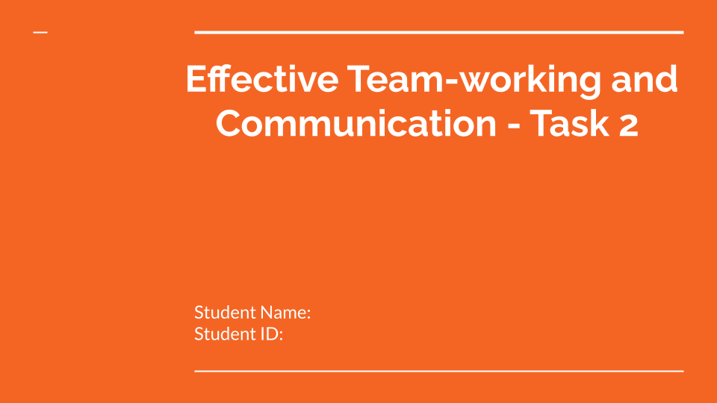
IRINA GORBE
2330421
Table of Contents
Introduction 3
What we have learnt about effective teams? 4
Conclusion 7
References 8

Introduction
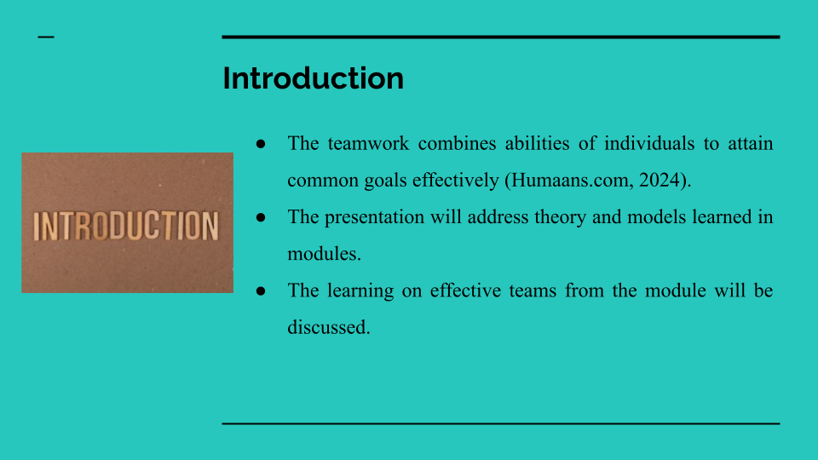
Bullets Points:
- The teamwork combines abilities of individuals to attain common goals effectively (Humaans.com, 2024).
- The presentation will address theory and models learned in modules.
- The learning on effective teams from the module will be discussed.
Speaker Notes:
Teamwork can be understood as work that involves a group of people combining their abilities and resources to accomplish a common goal in the most efficient manner possible (Humaans.com, 2024). This presentation will address the different models and theory learned in the module. Furthermore, the learning of the effective teams from the module will be expressed in detail in the presentation.

What we have learnt about effective teams?
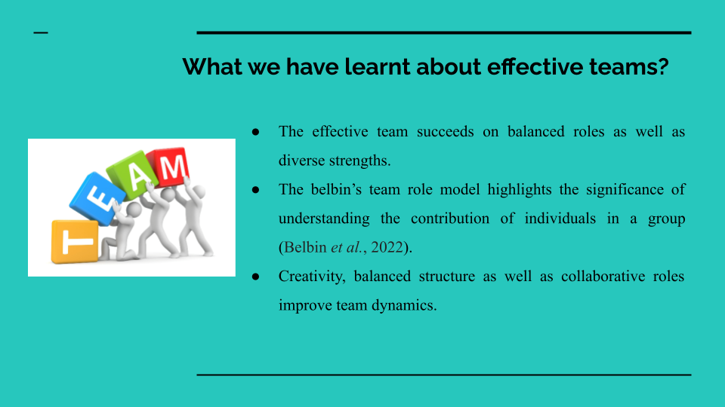
Bullets Points:
- The effective team succeeds on balanced roles as well as diverse strengths.
- The belbin’s team role model highlights the significance of understanding the contribution of individuals in a group (Belbin et al., 2022).
- Creativity, balanced structure as well as collaborative roles improve team dynamics.
Speaker Notes:
From the learning of the module, I have discovered that various roles and capabilities are essential for effective teams. Furthermore, the belbin's team role model highlighted the significance of understanding the individual’s contributions in the group (Belbin et al., 2022). Moreover, being an implementer helps me to translate concepts into actual activities for the team and control deadlines. Additionally, I have learned that it works best when I incorporate my structured approach with creative roles like the Plant and the Resource Investigator for the team to achieve optimum results.

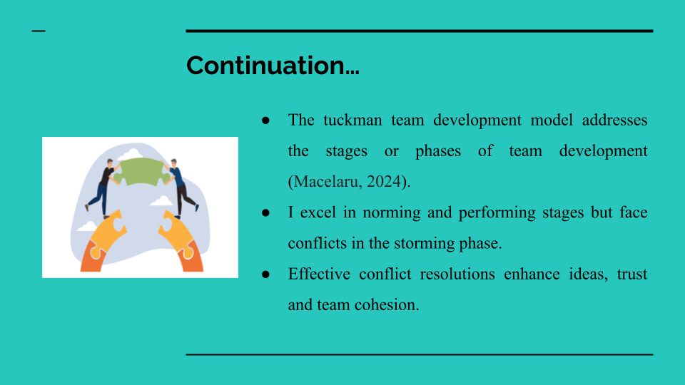
Bullets Points:
- The tuckman team development model addresses the stages or phases of team development (Macelaru, 2024).
- I excel in norming and performing stages but face conflicts in the storming phase.
- Effective conflict resolutions enhance ideas, trust and team cohesion.
Speaker Notes:
I learnt from the tuckman team development model that teams go through stages of forming, storming, norming and performing (Macelaru, 2024). I stand out well in the norming and performing phases where the team is all set to deliver its objectives. Moreover, during the storming phase, I have to actively engage to resolve conflicts early. Conflict management helps unlock the means of communication with the other person and forms the basis of shared trust for team work. Disagreement should be handled in professional ways which results in better ideas as well as stronger team relationships.
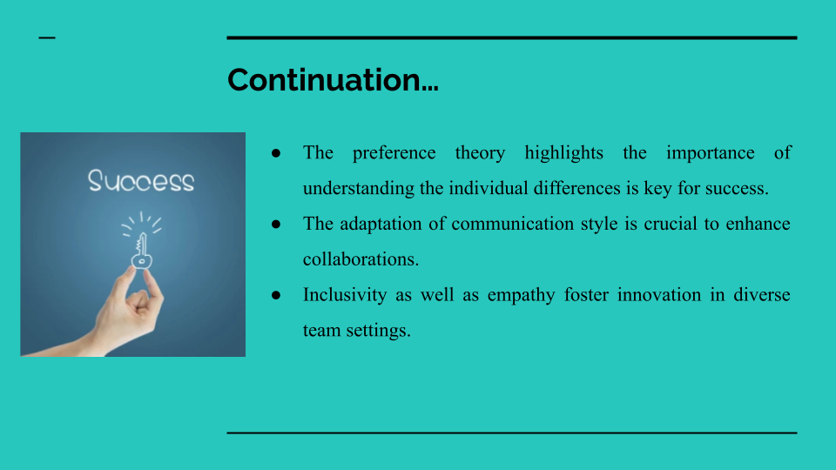
Bullets Points:
- The preference theory highlights the importance of understanding the individual differences is key for success.
- The adaptation of communication style is crucial to enhance collaborations.
- Inclusivity as well as empathy fosters innovation in diverse team settings.
Speaker Notes:
Moreover, from preference theory, I have learned that respecting the individual differences is a key for the success of the team. Every person in a team has different preferences concerning communication, decision-making and delegation of tasks. Adapting my communication strategies as per the needs can enhance productivity at the workplace. Apart from this, I learned that accepting and appreciating the development of such differences has increased my level of understanding and helped improve my ability to address an inclusive and creative team atmosphere.

Conclusion
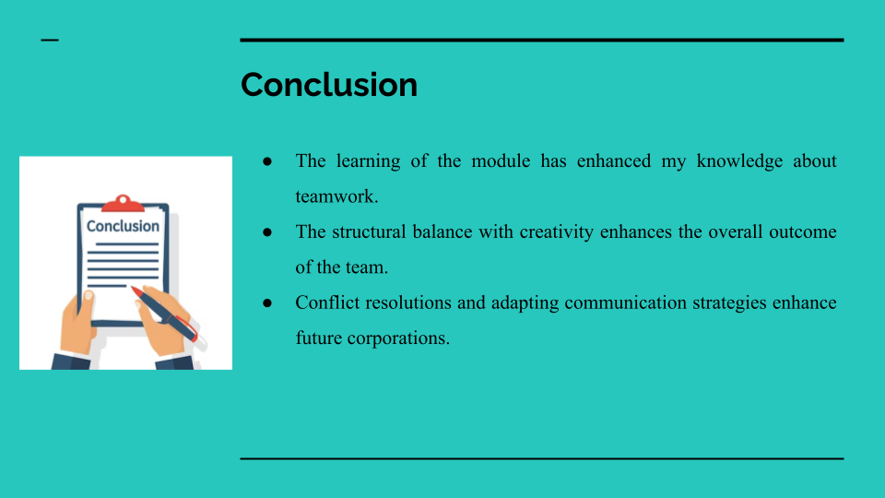
Bullets Points:
- The learning of the module has enhanced my knowledge about teamwork.
- The structural balance with creativity enhances the overall outcome of the team.
- Conflict resolutions and adapting communication strategies enhance future corporations.
Speaker Notes:
The theory and models studied in the course have improved my knowledge of teamwork and my position as an implementer. I have identified the importance of balancing the structured approach with creativity, the need for increasing the effectiveness of conflict solving, and changing communication strategies. These findings helped me to understand how I can be more useful in group activities and promote cooperation in the future.

References
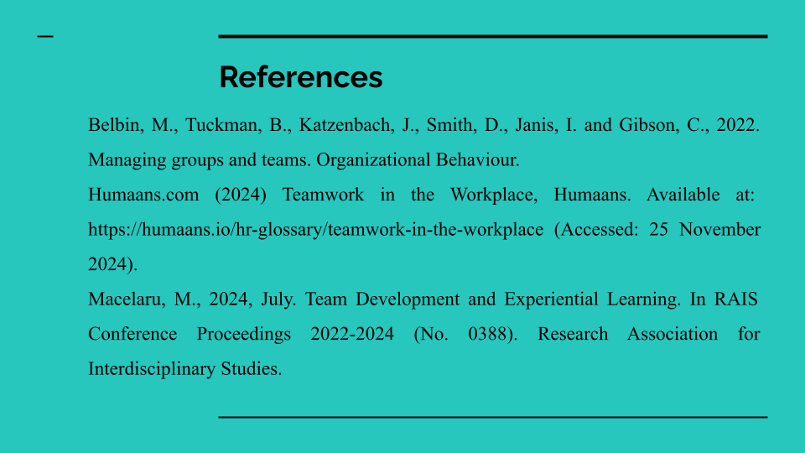
Belbin, M., Tuckman, B., Katzenbach, J., Smith, D., Janis, I. and Gibson, C., 2022. Managing groups and teams. Organizational Behaviour.
Humaans.com (2024) Teamwork in the Workplace, Humaans. Available at: https://humaans.io/hr-glossary/teamwork-in-the-workplace (Accessed: 25 November 2024).
Macelaru, M., 2024, July. Team Development and Experiential Learning. In RAIS Conference Proceedings 2022-2024 (No. 0388). Research Association for Interdisciplinary Studies.


