

LITERATURE REVIEW
Student Name：XU LUYANG
ID：2006295

Contents
1. Chapter One: Introduction 1
1.1Introduction 1
1.2 Background and Rationale 1
1.3 Aims and Objectives 3
1.3.1 Aim: 3
1.3.2 Objectives: 3
1.4 Research Structure 3
1.5 conclusion 4
2. Chapter Two: Literature Review 5
2.1 Introduction 5
2.2 CSR Theories 6
2.21 Stakeholder Theory 6
2.22 Triple Bottom Line 7
2.23 "four-in-one" corporate social responsibility model 7
2.3 The Influence of Social Responsibility Activities on Corporate Value over 10 Years in China 9
2.4 CSR and performance improvement 10
2.5 Meituan and CSR in the takeout industry 11
2.6 Conclusion of the literature review 12
3. Methodology 13
3.1 Introduction 13
3.2 Research Philosophy 14
3.3 Research Approach 14
3.4 Strategy 15
3.5Time Horizon 19
3.6Techniques for Data Collection, Processes and Analysis 19
3.7 Validity 20
3.8Limitations 20
3.9 Ethical considerations 21
3.10 Conclusion 21
4. Chapter Four: Data Analysis 21
4.1 Introduction 21
4.2 Data Analysis 22
4.3 Methods 22
4.4 Demographics and Descriptive Statistics 23
4.4 Analyze people's dietary preferences for takeout 24
4.5 Independent T Test for gender 27
4.6 ANOVA for age 28
4.7 Chi-Square Analysis 29
4.8 Discussion 29
4.9 Conclusion 31
Chapter 5 - Conclusion and recommendations 33
5.1 Introduction 33
5.2 The achievement of objectives 33
5.3 Main findings 34
5.4 Implications 34
5.5 Recommendations 35
5.6 Limitations 35
5.7 Conclusion 36
REFERENCES 37

1. Chapter One: Introduction

1.1Introduction
This chapter aim provides the background of Meituan and the theoretical basis of corporate social responsibility for this study. Objectives and Research Structure of this study will also be described.

This dissertation aim analyze Meituan's image of corporate social responsibility in people's minds. In order to promote the sustainable development of Meituan in the future. What is worth the researchers' attention is the lack of research on the corporate social responsibility of Meituan takeout industry in this field. So it will be particularly high-frequency use of Meituan takeout and corporate social responsibility.

1.2 Background and Rationale
Meituan takeout is an online food ordering platform under the banner of Meituan (Xu and Huang, 2019). In November 2013, it officially dominated the university market. Meituan takeout officially entered the white-collar market in the first half of 2015. In mid-2016, the growth curve of Meituan takeout users became steeper, and Meituan takeout entered a stage of rapid growth. There is a huge consumer demand in the takeout service industry ((Johns and Pine,2002). Among them, white-collar workers have the highest market share of consumption. Most of them are young, and this group has a high degree of acceptance of new things. Then the major Internet giants began to set foot in to seize the market, through the subsidy strategy.
Currently, with the continuous maturity of the market environment, various platforms have begun to enhance the user experience and strengthen the quality of service. Meituan has always pursued the operation mode of coordinated development. Meituan combines responsibility with the company's strategy and business development to develop new infrastructure advantages and promote the development and progress of all participants (Ram and Sun,2020). The total amount of Meituan's orders increased steadily. However, affected by the gradual narrowing of user dividends, the growth rate of the takeout industry has gradually slowed down. Although a large number of subsidies prompted users to develop takeout consumption habits, but did not take into account the rapid growth of the commercial model will be an unreasonable barbaric expansion.

Therefore, Meituan is actively exploring a commercialization model that suits him. Because Meituan platform continues to crack down on merchants, increase commissions, competitive promotion services, that is, according to the merchants' bidding, charge promotion service fees. Since Meituan appeared on the market, many customers have found that Meituan's delivery is particularly slow. In terms of the environment. Recent researcheres Zhou et al., (2020) found that China has a rapidly growing online food delivery and takeaway market, serving 406 million customers with 10.0 billion orders and generating 323 kilotonnes of tableware and packaging waste in 2018.

While there is still a lot of room for the growth of users in the sinking market, the author is sure that Meituan has a bright future, but there will still be negative news affecting his image. Meituan platform continues to crack down on merchants for profit and is controversial in environmental protection. The survey results show that negative publicity has a negative impact on employment intention and organizational attractiveness (Ouyang et al., 2020).

Meituan can still continue to expand his market share, but corporate social responsibility is not only the need of the contractual relationship between the enterprise and the consumer, but also the need to realize its social organizational role. The researcher also wants to give people's views on corporate social responsibility through this study, and give some suggestions for the sustainable development of Meituan. Based on the development of China, CSR represents a new opportunity for the development of Meituan takeout, by grasping people's demand for takeout and their preferred responsibilities.Promote the development of new markets and create new growth from the starting point of consumers.

1.3 Aims and Objectives

1.3.1 Aim:
This dissertation aim analyze Meituan's image of corporate social responsibility in people's minds. In order to promote the sustainable development of Meituan in the future.

1.3.2 Objectives:
1. To critically analyzed the academic literature on the impact of Chinese corporate social responsibility on all aspects of the company.

- To complete the second objective, to choose appropriate research methods to explore the public's awareness of the importance of Meituan corporate social responsibility.

- To analyse the data collected to discuss the importance of Meituan's corporate social responsibility to the public and the public's view of Meituan CSR.

- To explore the practical significance of the research, and look forward to the future development for Meituan.

1.4 Research Structure
In order to successfully achieve the research objectives. The study is divided into five chapters. The first section introduces the background information and determines the aim,objectives,research structure of the study.

The second chapter is the literature review, through the input of a large number of documents, the valuable part will be output to understand the previous research and defects. Therefore, by raising research questions to make up for the shortcomings.

The third chapter is methods and methodology. Describe the research problems and deal with the corresponding methods to draw conclusions. Then protect the privacy of the respondents and conduct first-hand data research.

The fourth chapter is to ensure that the information collected in the third chapter is objective, and then analyze and discuss the original data collected to make up for the gaps left by previous discussions.

In the last chapter, we focus on reviewing the research problems and literature, comparing and summing up to draw more refined conclusions, and discuss the recommendations and limitations of the study, and look forward to the future development.

1.5 conclusion
This chapter completes the introduction of this study, and the subject words will revolve around Meituan, corporate social responsibility. The researchers identified the aim and objectives, of this study and described research structure in detail. In the next chapter, the researcher will return to the previous literature and dig deeply.

Chapter Two: Literature Review

2.1 Introduction
The change in the way of ordering has greatly stimulated the development of the takeout industry (Wu et al., 2020). In China, there has been a deep combination of takeout and the Internet in recent years. The researchers studied Meituan, which has developed into a takeout giant. O2O online ordering is a product of inevitability and an automatic upgrade (Susskind and Chan, 2000). Takeout has always been regarded as a branch of traditional catering business, starting from the independent construction of takeout website platform, extending a complete industrial chain, website platform construction, independent product production line, independent distribution team and online customer service. Management confusion, product limitations, high costs and other reasons will eventually be replaced by faster and more perfect mechanisms and models.

China's food and beverage takeout system will be improved, and the national standards, industry standards and enterprise standards will be continuously improved (Qianwen et al., 2017). Food takeout further through big data, cloud computing, block chain, artificial intelligence and other ways to make food takeout more and more accurate, the grasp of consumer behavior, food and beverage products will be more and more clear. Realize the accurate docking of multi-links under the condition of high information. In addition to the takeout system, travel system, behind each management system is the responsibility of data products, affecting the manual waste of operation in the system. It is expected that with the further development of the industry, the user group will be gradually layered and subdivided, and the vertical takeout field still has its room for development (Chin, 2008). Currently, with the trend of greening, takeout is safer and healthier, and it is more low-carbon and green in the choice of packaging and matching tools (Xu, 2014). Different types of takeout are constantly emerging. Takeout has become an important market for diners to be reckoned with.

The purpose of this chapter is to critically analyze the academic literature on corporate social responsibility in Meituan's takeout industry. In addition, its purpose is to more deeply understand and explore the role and impact of corporate social responsibility practiced by Meituan. The researchers will extensively read the literature in this field to study the current situation, and summarize, analyze and critically evaluate the current literature.
The following is from the University of Wales Trinity Saint David’s (UWTSD) online library and Google academic. Search terms include "corporate", "corporate social responsibility","Sustainable development" and "Merituan"

2.2 CSR Theories

2.21 Stakeholder Theory
Stakeholder theory can be traced back to Freeman's strategic management (1984). This thought of enterprise management theoretically describes that the enterprise is a kind of institutional arrangement for testing intelligence and management professional investment, and the response of the enterprise to the interests of various stakeholders can determine the prospect of the development of the enterprise. The contribution of Freeman's stakeholders is self-evident, but his research does not point out the criteria for the importance of stakeholder identification and how internal stakeholders are influenced. Further scholar (Sternberg, 1997) shown that Stakeholder theory is indeed intrinsically incompatible with all substantive objectives and undermines private property and accountability.

2.22 Triple Bottom Line
The triple bottom line is proposed by Further scholar (Elkington, 2004).It means that the premise of the harmonious unity of environment and society should be taken into account in advance when expanding or acquiring resources and economic value. With the development of the times, enterprises as an economic entity, more and more enterprises will begin to consider their own social and environmental benefits, not only by the economic yardstick to measure success. The development of an organization or society should be fully coordinated with the interests of the public and the natural environment to make it sustainable. It is a very challenging task for enterprises to achieve the goal of triple bottom line. (Henry et al., 2019)

2.23 "four-in-one" corporate social responsibility model
Because developing countries have different environmental, legal and economic differences, developing and developed countries have different ways of promoting them (Griesse, 2007). The theoretical basis of corporate social responsibility in China is mainly based on triple bottom line and stakeholder theory. Based on these two theories, the Corporate Social responsibility Research Center of the Economics Department of the Chinese Academy of Social Sciences issued the "China Corporate Social responsibility report compilation Guide (CASS-CSR)" by Hongwu in 2009, creating a "four-in-one" corporate social responsibility model. The model highlights the role of responsibility management, which believes that responsibility management is the origin and important guarantee of corporate social responsibility. Responsibility management includes responsibility strategy, responsibility governance, responsibility integration, responsibility performance, responsibility communication and responsibility research. This model recombines the triple bottom line principle. brings customer responsibility into market responsibility, and replaces "economy, society and environment" with "market, society and environment". (Xu and Yang, 2010) suggest that China's corporate social responsibility is closely related to its social and cultural background, and its performance is different from that of western countries. The traditional economic responsibility mainly refers to shareholder responsibility, while market responsibility is not only shareholder responsibility, but also customer responsibility and partner responsibility, thus maintaining the balance between responsibility plates. avoid a large number of indicators of social responsibility and environmental responsibility while too few indicators of economic responsibility, so that the structure of the index system can be optimized. Recent researches (Chen and Liu, 2019) found that More and more Chinese enterprises have sufficient ability and conditions for social responsibility performance.

Researches (Guan and Noronha, 2013) have both shown that in the research of CSR performance evaluation in China, the mainstream measurement tool is the self-developed index system, rather than the international system. The theoretical model gives a score to an enterprise, with a full score of 100%. In 2009, a total of 400 enterprises issued reports, and the average social responsibility development index of China's top 300 enterprises was 15.2 points. By 2017, more than 1700 enterprises had issued reports, and the social responsibility development index of China's top 300 enterprises had increased to 37.4 points. The study found that the score of China's CSR development index continued to increase and the growth rate showed a steady upward trend, indicating that the construction of the theoretical model has greatly promoted the in-depth understanding and concrete implementation of CSR. can establish a systematic and scientific management system to ensure green and sustainable development. CSR should be viewed from the perspective of corporate practice. (Vicianov, 2011)

Although carry forward the spirit of entrepreneurs to fulfill their responsibilities, dare to take on, and serve the society. The research scholar (Noronha et al., 2013) shows that the CSR report in China is still in a early stage and more empirical research is needed. Due to the orders issued by different regulatory departments and the outcry of international authoritative non-governmental organizations, enterprises are faced with the pattern of cross-reference of different standards. This results in vague focus of reports, poor transmission of information, and lack of comparability of information between reports. It also leads to the increase of enterprise establishment cost and the decline of compilation enthusiasm.

2.3 The Influence of Social Responsibility Activities on Corporate Value over 10 Years in China
Zhang and Jung (2020) through multiple regression analysis of a-share listed companies in Shanghai and Shenzhen stock markets, this paper studies the impact of Chinese corporate social responsibility (CSR) on corporate value from 2009 to 2018.

This means that the Chinese government has shifted from rapid growth to high-quality growth for a decade. Yin and Zhang (2012) both suggests the understanding and practice of corporate social responsibility will be affected and restricted by the economic environment. Consider whether it is helpful for Chinese enterprises to promote sustainable development through corporate social responsibility activities.

This study uses the corporate social responsibility score provided by the authoritative third-party organization RKS as the corporate social responsibility score. Recent scholar (Lu et al., 2019) shows that China's progress toward a sustainable path. By studying the relationship between corporate social responsibility and corporate value at different times. Zhang and Jung (2020) confirmed that there is both negative and positive correlation between CSR activities and corporate value, and there is also no correlation between CSR activities and corporate value. Zhang and Jung (2020) found that with the development of corporate social responsibility activities to increase corporate value, the impact is increasing. (Pang and Yuan, 2019) also suggest that the market is increasingly resistant to irresponsible companies.
This study has several limitations. First of all, considering the average value obtained, the researchers are unable to analyze the change degree of the impact of CSR activities on corporate value. The researchers also did not study the impact of corporate social responsibility activities on corporate value in future. Finally, The researchers' sample selection may lead to a deviation in sample selection, which is extended to companies where all financial information is available in 2009-2018.

2.4 CSR and performance improvement
Zhu et al, (2016) based on stakeholder theory and using questionnaires to collect data and analyze CSR reports covering 100 SOEs. The researchers developed seven practical dimensions of CSR, from the practice of CSR, this paper examines whether the practice of social responsibility of state-owned enterprises brings about the improvement of financial performance and social performance.

Zhu et al, (2016) research results show that it is necessary for state-owned enterprises to emphasize the implementation of CSR, in operation and extend the efforts of CSR to the management of all parts of the supply chain. State-owned enterprises need to pay more attention to these CSR practices. When the economy is developing well, there is a positive correlation between corporate social responsibility practice and financial performance (Skare and Golja, 2012) therefore, the Chinese government should formulate more policies to encourage enterprises to implement community-oriented social responsibility practices, and further include the relevant work of corporate social responsibility in the annual assessment.

Zhu et al, (2016) stated that second-hand data were obtained from corporate social responsibility reports to evaluate their CSR practices, and only one year's published data were selected for analysis. There may be a gap between CSR disclosure and real practice ((Font et al., 2012). This makes it impossible for the data to be studied more rigorously and deeply.

2.5 Meituan and CSR in the takeout industry
The Food Safety Law of the people's Republic of China was implemented in 2015, bringing online food management into the scope of supervision for the first time(Geng et al., 2015). There is little public opinion research on the safety of takeout food (Song et al., 2020). The researchers used software to collect texts about takeout food safety releases on social media between 2015 and 2018. After preprocessing the text on social media, the natural language processing technology is used to analyze the status of users. This author Song et al., （2020）use potential Dirichlet assignment (LDA) and k-Means to extract and cluster topics in posts and found that the topics discussed by the public are diverse and rich, and there are many kinds of topics about food safety in takeout. Emotional analysis shows that it is more than 90% positive．In terms of environmental protection, Meituan's 3.27 plastic products per order unintentionally exacerbates microplastic pollution (Liu et al., 2020). Although Meituan has a public service campaign for Green Mountain Takeaway, it still faces huge pressure on environmental protection.

Meituan sits on the world's largest real-time distribution network and home platform, and many deeds have emerged in the epidemic (Diebner et al., 2020). Continue to consolidate the real-time distribution of this new social infrastructure, as one of the important pioneers in the field of real-time distribution in China, Meituan has accumulated rich resources in the field of real-time distribution. Meituan's performance during the epidemic was commendable(Zhao and Bacao, 2020).

The researchers（Chen and Zheng）2020 studied the protection of user information on the e-commerce platform of the credit evaluation system. Through the research on the business autonomy of the network e-commerce platform. Meituan can obtain customers' private information through forced selection terms. The autonomous rules of network e-commerce platform business are scored through a scientific and rigorous evaluation index system. It endangers the legitimate rights and interests of network users. Finally, it is pointed out that Meituan, as a tripartite organization, has the responsibility to urge the platform to improve its autonomous rules, so as to protect the legitimate rights and interests of users.

At present, there are no clear rules for the responsible department and a complete set of industry regulations (Xiao, 2018). the relevant state departments have noticed that there are problems and contradictions in the takeout catering industry, and are actively trying to legislate. Now, many relevant regulations are still in the high opinion and temporary stage. Relying on the prior supervision mechanism of the third-party platform, the takeout ordering platform is required to examine and supervise the corresponding food safety issues of its qualifications and supervise the qualifications of the merchants during their stay.

2.6 Conclusion of the literature review
This chapter has critically analyzed the academic literature on the impact of Chinese corporate social responsibility on all aspects of the company. In addition, the author also analyzes the importance of corporate social responsibility for the future development of a company. To sum up, with the rapid development of China, From today's point of view, it is not comprehensive, it only takes into account the unilateral impact of stakeholders on the enterprise.China's CSR also came into being corresponding to the society, resulting in China's unique four-in-one CSR model. On the whole, it studies the correlation between CSR and Corporate Value, which shows a positive positive correlation with performance. The researchers (Kolk and Van Tulder, 2010) found that the number of articles on CSR or sustainable development as the main research topic is quite small.However, it seems that the lack of literature and research shows that in this specific time, enterprises are affected by the interpretation of CSR. Meituan as an emerging industry in the era of rapid economic development in China, this study can explain how corporate social responsibility affects Meituan's sustainable development.

Methodology

Introduction
The purpose of this chapter is to complete the second objective, to choose appropriate research methods to explore the public's awareness of the importance of Meituan corporate social responsibility. Methodology is a scientific and systematic search for relevant information about specific problems and the exploration of knowledge (Kothari, 2004). The emergence of methodology provides a new way for people to solve problems more scientifically and rationally. The concept of studying the onion, as proposed by Saunders, et al is suitable for studying the onion to construct a research design for future studies (Melnikovas, 2018). By peeling the onions and revealing the meaning of each layer, the researchers were able to understand the phenomenon of seeking understanding (Sinha et al., 2018). The content of this chapter is to explain the selected methods and methodology related to the selected topic research. The research methods of the researchers will use the Research Onion of Saunders, et al as the knowledge guide for analysis, and select the most suitable approach, strategy, selection, data analysis to promote and demonstrate. At the end of this chapter, the author will also consider reliability, effectiveness, limitations and ethical issues.
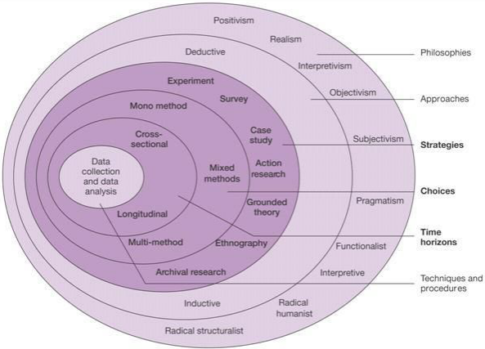

Figure 1 research onion (Saunders, Lewis, & Thornhill, 2009)

Research Philosophy
Philosophy has long been regarded as one of the most important analyses (Deleuze, 2006). The philosophical choices for this study is positivism. Scientists choose positivism to ensure that their theories are confirmed by the data (Durant, 1961). Positivism regards the relationship between philosophy and science as the central issue of its theory, and tries to dissolve philosophy in science(Godfrey-Smith, 2009). The descriptive analysis of positivism related to research methodology is not only the introduction of the philosophical basis of research, but also the basis of quantitative discussion (Crossan, 2003). The closed-ended questions in the questionnaire will be analyzed by the researcher using positivism.

Research Approach
The approach of the research injects additional advantages into the exploratory ability of researchers to explore and study their research (Alase, 2017). In a broad sense, the inductive is from the objective existence of natural and social phenomena, and finally can make a general result. Deduction is to deduce the research hypothesis from the theory, and then test the hypothesis through observation. If the hypothesis is confirmed, an effective theoretical explanation can be made for the specific phenomena observed. Earlier research (Fereday and Muir-Cochrane, 2006) suggests that choose induction or deduction when interpreting and analyzing the original data.
In order to draw a conclusion, according to the theme of the research and discussion, the researchers choose deduction, this method is more inclined to hypothesis testing, the analysis and research stage of the survey data, it is necessary to clarify the research conclusion and its universal guiding significance, the logical conclusion is reliable, and can reflect the characteristics.

Strategy
For reasons of cost and ease of implementation, email surveys are used more frequently in social surveys (Dillman, 1991). The researchers conducted an online questionnaire survey. Whittemore, et al. (2001) found that developing validity standards in qualitative research is challenging because of the necessity to incorporate rigor and subjectivity as well as creativity into the scientific process. The researchers strictly designed the closed questionnaire through the questionnaire star, and considered the method of compiling the Likert scale, and then distributed it to the general public only by clicking on the link to understand the opinions of the public. The researchers can ensure that the questionnaires filled out by voluntary participants are confidential and anonymous. Questionnaire research can obtain a large amount of data at low cost in a short time (Lajunen and Summala, 2003). The researchers can successfully summarize the standardized results, and detailed directional research and analysis are beneficial to the author's quantitative research.
Questionnaire and Literature Review Matrix
Questions： | References Pertaining to Questions Drawn From Previous Chapters:
What's your gender?  Male.  Female.  2.What's your age range?  18-20.  20-30.  30-40.  Above50.  3.What is your occupation?  Students.  Office workers.  Other. | Questions 1-3 are all demographic problems. Relevant information about participants is collected and analyzed by SPSS.
4. Do you prefer Meituan takeout or restaurant food?  Takeout.  Eat in the hall.  Both.  5. How often eat Meituan takeout several times a month?  1 ≤ 5.  6-10.  11-15.  Above16. | This question is to understand how often customers use Meituan.  Previous research (e.g.Wu et al., 2020 Susskind and Chan, 2000).  The popularity of Meituan
6. What is your Satisfaction with Meituan takeout hygiene?  1 strongly dissatisfaction  2 dissatisfaction  3 neutral  4 almost satisfaction  5 satisfaction  8. How importance of Environmental Protection Awareness in Enterprises?  1. strongly disagree  2. disagree  3. neutral  4. agree  5. strongly agree  11 What is your support the degree to which Meituan charges 20% of the seller's commission?  1. strongly disagree  2. disagree  3. neutral  4. agree  5. strongly agree | This question is to understand the customer's satisfaction with Meituan.  Previous research (e.g.Geng et al., 2015；Song et al., 2020）Meituan takeout food safety  Previous research (e.g.Griesse, 2007；Xu and Yang, 2010）Meituan's corporate social responsibility  Previous research (e.g.Xiao, 2018）Restrictions on the norms of the takeout industry
7.Have you ever seen Meituan engage in the cause of environmental protection?  1. Never 2. Seldom 3. usually  9 How importance of economic profitability?  1. strongly disagree  2. disagree  3. neutral  4. agree  5. strongly agree | The purpose of questions are to understand customers' views on Meituan's practice of CSR.  Previous research (e.g.Zhang and Jung 2020; Yin and Zhang 2012，Chen and Liu, 2019）  The importance and influence of Corporate Social responsibility
10 Which is better than Meituan before?  before.  Now.  It's all the same. | This question is to understand the customer's attitude towards Meituan industry.  Previous research (e.g.Diebner et al., 2020；Zhao and Bacao, 2020；Diebner et al., 2020）The contribution made by Meituan
12. Is there a lack of corporate social responsibility for Meituan and big data to kill acquaintances?  1. disagree  2. neutral  3. agree | The purpose of questions are for the public's view of Meituan's disclosure of customer privacy.  Previous research (e.g. Chen and Zheng) evaluation system of user information
- In what ways do you think Meituan can be improved?  1. Diet safety  2. Food delivery speed  3. Price  4.Taste  5. Packing  6. Deliver food upstairs  7. Other  - What kind of competition do you think Meituan belongs to in the takeout industry?  1. Perfect competition.  2. Monopoly competition.  3. Oligopoly | In order to understand the part that customers still need to improve on Meituan.  Previous research (e.g.Yin and Zhang ) the present situation of Meituan in the market in the past

3.5Time Horizon
Levin (2006 ) shows that cross-sectional studies are carried out at one time point or over a short period.Through the selection of a specific range of people for a fixed period of time, a horizontal study will tend to save a considerable amount of time and money. This facilitates operational implementation and will be representative, and the final results of the study will be highly transferable. Horizontal studies are more time-sensitive.

3.6Techniques for Data Collection, Processes and Analysis
Research use two types of data-primary and secondary data. (Rabianski, 2003). Primary data is directly obtained by means of researcher-initiated methods, and researchers who want to address unidentified issues can do so by collecting primary data. Secondary data are data collected for the purpose of certain non-direct questions, including information provided by commercial and government agencies, market research firms and computer databases. Primary data are data collected by researchers for the purpose of studying the specific problem in front of them.
The investigators take samples according to their own convenience and the supervisor is a non-probabilistic sample(Kälviäinen et al., 1995). The researcher uses the quantitative original data collection method to send out the questionnaire form, design a closed questionnaire in advance and distributed the questionnaire through links to ensure that detailed data were collected on the premise of involuntary and anonymity. Sampling has always been the center of discussion on sociological research methods(Berk, 1983). Due to time and cost constraints, researchers are asking for general voluntary public participation to gain greater accessibility. The data will also be more up-to-date and reliable. Primary data is collected by researchers who want to study the problem ahead, so it is convenient to keep it confidential.

Data analysis is the most challenging of all phases of a qualitative project(Thorne, 2000). To analyze the qualitative data collected, the researchers downloaded the software social science statistics package (SPSS), and then made further statistical analysis in next chapter. The researchers used independent sample t-test, ANOVA and chi-square test for significant differences.

3.7 Validity
Creswell and Miller (2000) have both shown procedures for validity include those strategies used by researchers to establish the credibility of their study. Validity is divided into internal validity and external validity. Researchers use online questionnaires to obtain data-primary, which can greatly ensure the validity of the original data. Reliability is evaluated and dealt with as an important aspect of structural design (Nowak and Collins, 2012). The questionnaire with high validity is reliable.

3.8Limitations
Firstly, in a short period of time, in the context of a pandemic, it may still be a challenge for researchers to obtain a sufficient amount of data, and the number of copies collected by the questionnaire is not enough.Secondly, due to the different scope of theme design chosen by researchers, the relevant literature will be limited. Researchers who design questionnaires may ignore questions that are not included in the questionnaire.

3.9 Ethical considerations
In order to carry out the questionnaire effectively, the researchers informed each participant that it was voluntary, the data received by the researchers were confidential, and the participants were anonymous and protected to ensure that no one would be harmed.The questionnaire questions are not biased and instructive, and participants can withdraw at any stage. Allay the concerns of the participants and let them answer the questionnaire in a relaxed state.

3.10 Conclusion
To conclude, this chapter determined the appropriate research methods, and the researchers chose the positivist quantitative method to obtain the original data from the general public in the form of questionnaires. The collection and analysis of information data will appear in the next chapter.

Chapter Four: Data Analysis

4.1 Introduction
Chapter 3 introduces the methodology of the preliminary study and provides a clear direction for it. This chapter aims to fulfil the purpose of this dissertation, which is to critically analyse data about Meituan's implementation of corporate social responsibility.

The purpose of this chapter is to analyse the impact of CSR on Meituan's sustainable development. The researcher analyses the primary data collected from an online questionnaire. A total of 106 questionnaires were collected by the researcher.

4.2 Data Analysis
Data analysis is the inspection, transformation modeling and other appropriate statistical analysis of the collected data in order to maximize the usefulness of the data (Brandt and Brandt,1998). Excel and SPSS Statistics 26.0 software analyze the data, provide descriptive statistics, and complete in the form of charts.
T-test can be used to compare the mean of the two samples and between the mean of the sample and the mean of the population. There is also an analysis of variance, which separates the relevant factors and estimates its effect on the total variation. Then the chi-square correlation test is used to test the linear correlation between multiple variables.

4.3 Methods
Because the researchers did not know the age range of the participants, the researchers subdivided the age range to investigate any differences among the respondents.. The required process of the study is intended to be evaluated and improved to ensure that the results are reliable and effective (Damian and Chisan, 2006).
The collected questionnaire can receive a large number of quantitative data, and the researchers do descriptive statistics in the empirical analysis to explore the trend of data distribution. In the choice of methods, questionnaire studies usually use analysis of variance. The premise of t-test is that the two groups of data come from the population with normal distribution, and the variance of the data is uniform and independent. Independent sample t-test, which is used to test the difference of data obtained by two groups of unrelated samples (Archie, 1985). Chi-square test is used to analyze the relationship between classified data and classified data. In order to understand the preference differences. Chi-square is to judge the difference by analyzing the relative selection frequency and proportion of different types of data. Consider using SPSS to provide different analysis and test methods to operate the statistical analysis of counting data.

The quantitative data obtained from the questionnaire need to be coded into nominal categories, male = 1, female = 2. There are many questions on the Likert scale, so the codes for these possible answers are strong disagreement = 1, disagreement = 2, neither agree nor disagree = 4, and strong agreement = 5 (Vagias, 2006).

4.4 Demographics and Descriptive Statistics

The study was conducted through social software and online platform questionnaires, and a total of 106 questionnaires were collected, all of which participated voluntarily. Researchers in order to obtain more questionnaires to obtain more representative samples. Of a total of 106 respondents, 62 were males and 44 were females. At least 5.66% of people aged between 18 and 20 are aged between 21 and 20, accounting for 71.7% of the total. 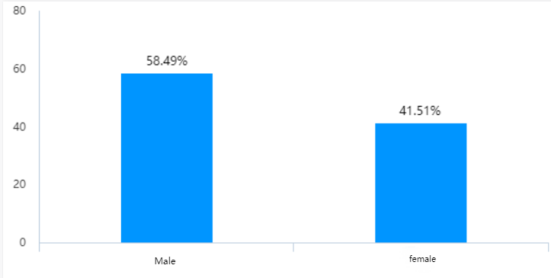
Figure4. 1 Graph of gender identification.

Office workers mainly accounted for 79.25%, followed by students and others accounted for 10.38%. The reason for filling in these questions is to understand the distribution and characteristics of volunteer writers. These figures show that men are more likely to order Meituan takeout. These people focus on work and have a dominant share in Meituan's market.

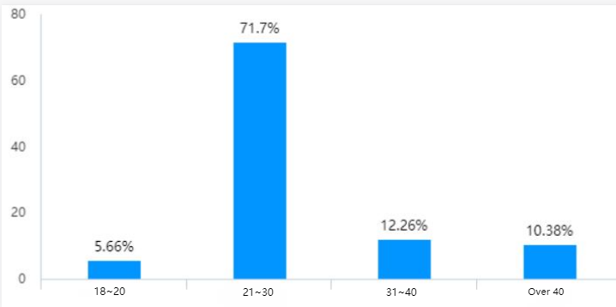
Figure4. 2 Age

4.4 Analyze people's dietary preferences for takeout

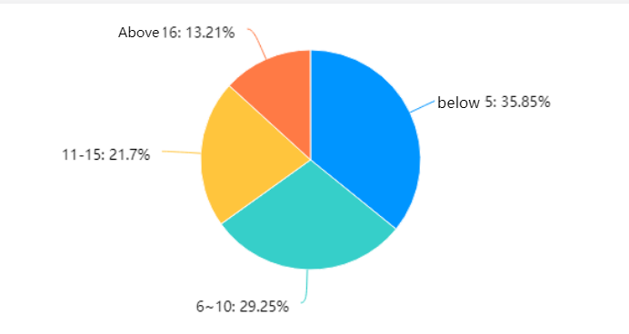
Figure4. 3 The frequency with which people eat takeaway.

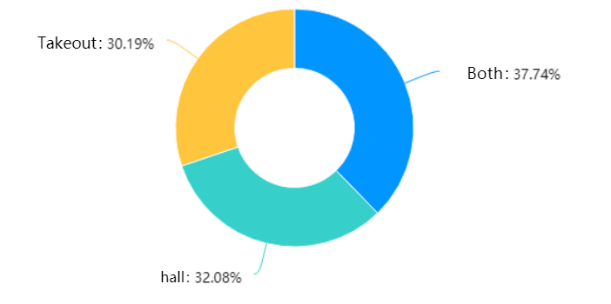
Figure4. 4 People's choice of places

Judging from the data, there is a good demand for takeout. More than half of the people will frequently choose takeout for two or three days to eat, and 13.21% of them will order more than 16 times a month. As the choice becomes more and more diversified, takeout is almost the same as eating in a restaurant, as long as 32.08% of people prefer to eat in a restaurant.
According to the data in the chart above, it is clear that most of the reasons why people order takeout with such intensity are at work. Because there are very few researchers under the age of 20, the proportion of students is only 10.38%, which still shows that students are also under pressure to study. Meituan as a popular takeout ordering platform, has attracted a lot of students and working groups (Shi et al., 2021).This reflects from the side that people show a strong willingness to choose Meituan takeout.

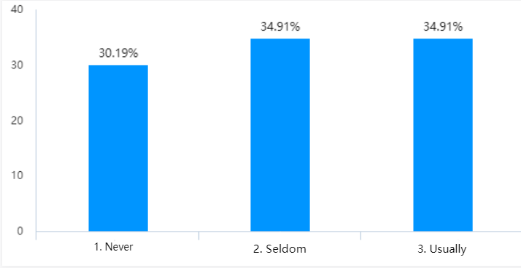
Figure4. 5 Frequency of Meituan's engagement in environmental causes
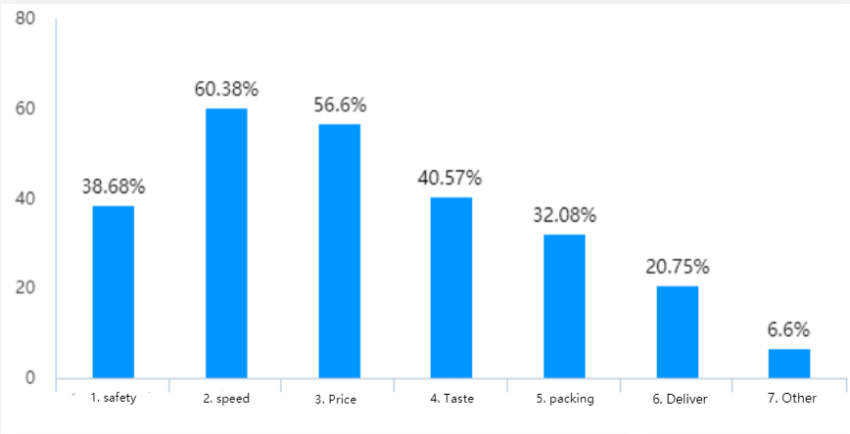
Figure4. 6 People's suggestions for Meituan

The above two Figure are Q7 and Q12 (multiple), respectively, which are the frequency of Meituan's environmental protection and public welfare publicity and the areas where people suggest that Meituan needs to be improved.

4.5 Independent T Test for gender
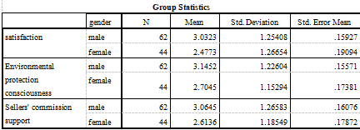
Table 4. 1 Group Statistics

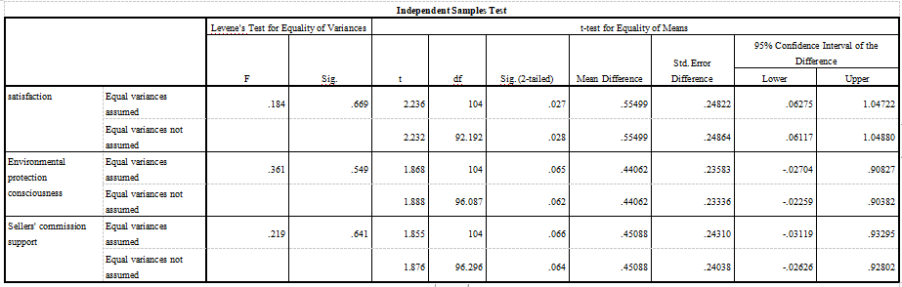
Table 4 2 Independent Samples Test

In designing the questionnaire, a five-point scale was designed in terms of strength of degree. The researcher did continuous data processing on satisfaction for Q6,8 and 11.

The table shows that there is a significant difference in satisfaction by gender, with men's satisfaction being significantly higher than women's satisfaction (t=2.236 p<0.05); environmental protection consciousness is not significantly different by gender (t=1.868 p>0.05); sellers' commission support is not significantly different by gender (t=1.855 p>0.05); and sellers' commission support is not significantly different by gender (t=1.855 p>0.05). 0.05); Sellers' commission support did not differ significantly by gender (t=1.855 p>0.05).

4.6 ANOVA for age
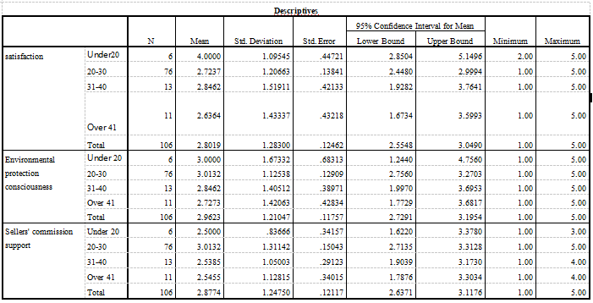
Table 4. 3 Descriptives analysis of age and Q6，8，11

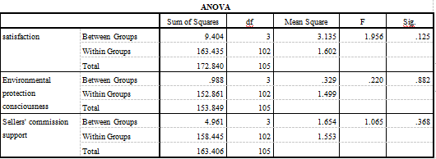
Table 4. 4 ANOVA

The table shows that there is no significant difference in the age of satisfaction (Fang 1.956p > 0.05p > 0.05.There is no significant difference in the age of) Environmental protection consciousness (Fang 0.220p > 0.05p), and there is no significant difference in age of Sellers' commission support (Fang 1.065p > 0.05p).

4.7 Chi-Square Analysis
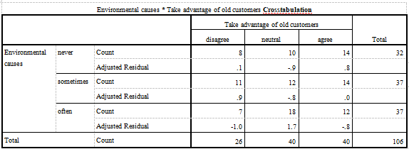
Table 4. 5 Environmental causes * Take advantage of old customers Crosstabulation

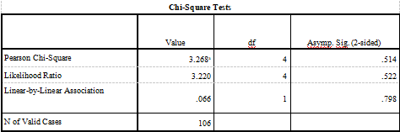
Table 4. 6 Chi-Square Tests

The chi-square test of Environmental causes and Take advantage of old customers showed that there was no significant difference between them (Chi-Square=3.268 p > 0.05).

4.8 Discussion
The purpose of this study is to discuss the importance of Meituan's corporate social responsibility to the public and the public's view of Meituan CSR. According to previous research (e.g.Zhang and Jung 2020; Yin and Zhang 2012), the study found that the corporate social responsibility of Meituan takeaway was correlated with the business, but that the responsibility for food safety was considered more important than the economic responsibility of the business to achieve profits. People do not care much about the responsibility to protect the environment in CSR and Meituan does not impress people in this regard.

Independent sample t-tests and ANOVAs were conducted between questions 6, 8 and 11, and it can be seen that there were no significant differences in gender and age in relation to people's satisfaction with the endorsement. In terms of consumer voting, there is a normal distribution for the commission charged by Meituan. In particular most for workers seem to be less concerned with the corporate profitability part of CSR, consumers will be more concerned with what they get and barely more than half of them are satisfied with the taste of the food. Overall, people, both males and females, are more concerned about Meituan's CSR as a stakeholder in the interests of consumers

Previous researchers (e.g. Zhang and Jung 2020; Yin and Zhang 2012) have found that the development of Meituan takeaway is indeed affected by CSR, but the extent of the impact and future development of No in-depth research has been done. This study shows that both men and women are more concerned about food safety than CSR in terms of corporate profitability. Past researchers (e.g. Geng et al., 2015; Song et al., 2020) have found that for the Meituan takeaway e-commerce platform, only preliminary food safety laws have been set. With regard to the issue of Meituan's monopoly, it was recently reported that the State Supervision of the Central Commission for discipline Inspection conducted a case investigation into Meituan's suspected monopoly in accordance with the law. There is hope that the government can take responsibility for corporate social responsibility, but further regulation requires screening by third-party platforms. From the results of this study, people do not have enough highlights on Meituan's products, which further side hints that Meituan takeaway still needs to take further updates and management on food safety and taste.

Then with the development of takeaway, previous researchers found that people are interested in Meituan in the waste is there is a public service campaign to protect the environment (e.g. Liu et al., 2020). The chi-square test was significantly not different. For takeaway meal consumers choose environmentally friendly orders i.e. no cutlery required, is their own environmental material requirements, in short people show a preference for the service they ordered takeaway immediately received. The results of this study also show that customers also do not show care for the implementation of Meituan's corporate social responsibility to care for the environment. The researcher believes that Meituan takeaway does not actually do a significant contribution to caring for the environment as the data suggests, and that the effort is so small that it is rarely seen by the public.

According to previous studies, Meituan has been consistently praised by the public for its many donations, charity events, and contributions to society during epidemics (Diebner et al., 2020; Zhao and Bacao, 2020). However, the researchers found that it was not the charitable responsibility of Meituan takeaway that attracted consumers. This study shows that most people, especially workers and students, would prefer Meituan to meet the pressures of work and study, which is why most customers are still satisfied with Meituan takeaways. Meituan's high level of implementing CSR plays a role in maintaining and keeping.

4.9 Conclusion
This chapter achieved the third objective: to analyse the data collected to discuss the importance of Meituan's corporate social responsibility to the public and the public's view of Meituan CSR.

In summary, according to previous studies (e.g., Zhang and Yung 2020; Yin and Zhang 2012), the CSR of Meituan's takeaway was found to be business-related. In this study, CSR is broken down to further understand the impact of Meituan in terms of customer preference concerns and thus CSR. This study found that i.e. people under the age of thirty, as the main consumers, are more inclined to focus on the rights and interests obtained by the consumers and do not give higher importance to the economic and philanthropic responsibilities of the business. There are no further criteria for corporate pro-poor public services and further management. There is a preference for these responsibilities to fall on the platform of government and third parties.

This chapter analyses the data collected by the questionnaire and explores the public's perception of Meituan's corporate social responsibility. In the final chapter, the researcher will reach an understanding of the implications and limitations of the study, and make recommendations and discuss the next steps for future development.

Chapter 5 - Conclusion and recommendations

5.1 Introduction
The previous chapter analyzed the data, and achieving the third objective of this study. This chapter will realize the last objective, of this article to understand the practical significance of the research, and look forward to the future development for Meituan.

5.2 The achievement of objectives
1. To critically analyzed the academic literature on the impact of Chinese corporate social responsibility on all aspects of the company.

The researcher completed a literature review by searching for studies that focused on Meituan takeaway and CSR practices and identified gaps in past research.

- To complete the second objective, to choose appropriate research methods to explore the public's awareness of the importance of Meituan corporate social responsibility.

The researcher devised a methodology based on theresearch onion and distributed a questionnaire to the general public.

- To analyse the data collected to discuss the importance of Meituan's corporate social responsibility to the public and the public's view of Meituan CSR.

The researcher assessed significant differences through SPSS 26.0, using independent samples t-test, ANOVA and chi-square. The analysis was completed based on the questionnaire.

4. To explore the practical significance of the research, and look forward to the future development for Meituan.

The researcher summarizes this study and puts forward some suggestions for Meituan to have a better prospect.

5.3 Main findings
It is mainly finding that young people in the questionnaire put the food quality of Meituan's products above the economic responsibility and charitable responsibility of corporate social responsibility. The results of the survey show that people are concerned about the quality of Meituan takeout products and the services they receive. Meituan's efforts to protect the environment and charitable responsibility can only play a maintenance role.
In addition, the study found that although Meituan had Castle Peak public welfare, he served the people during the epidemic. But its public welfare activities are not well known, and now Meituan takeout is suspected of monopolizing. The implementation of corporate social responsibility will depend on the supervision and improvement of the government and the third-party takeout platform. Because workers and students will have a certain degree of pressure, there is some tolerance for Meituan takeout.

5.4 Implications
Meituan's corporate society has a related impact on the future development of enterprise value, or it is state-dependent. Nowadays, the rapid development only focuses on short-term interests, which conflicts with the interests of those related to food safety and environmental pollution, and Meituan takeout is no exception.Therefore, to explore the social responsibility of Meituan takeout should not be ignored in the process of development.
This study has this significance and will promote the development of the takeout industry and the environment, and promote the sustainability of the takeout industry. In order to study the promotion of corporate social responsibility, vinegar essence enterprises better fulfill corporate social responsibility.

5.5 Recommendations
After this study, the researchers put forward some suggestions in order to gain more market share and customer loyalty in the future.Generally speaking, Meituan takeout should pay more attention to corporate social responsibility and make rectification with the help of this survey.
First of all, customers feel that what is most necessary for the Meituan industry to improve the speed and price of food delivery is that Meituan takeout has so many consumers due to consumer pressure.Therefore, Meituan should pay most attention to the services that consumers receive. Deliver cheap and good food as quickly as possible.
Secondly, because of the epidemic, the catering industry has been in a low mood market. Although consumers do not care, in order to encourage the catering industry, the proposal to reduce commissions by between 10% and 15% is also a sign of corporate social responsibility. Take-out food safety public opinion analysis, the interests of the government and the industry to strengthen censorship and supervision, in order to promote the health and prosperity of the food industry. Finally, Meituan should also increase the ecologicalization of the environmental protection industry and work with consumers to promote the sustainability of the takeout industry.

5.6 Limitations
The researchers believe that this study has the following limitations. The study was conducted in the context of an epidemic, and a questionnaire with open-ended questions was originally designed, but all quantitative questions were still used in the end. This makes the depth of the questionnaire not enough to expand.
Secondly, the age of the survey is concentrated, basically under the age of 30, and the number of people surveyed is just over 100. There may be some deviations in the answers to the questionnaire.Researchers should expand the data sample to obtain a more comprehensive data distribution. But also in the design questionnaire, the surrounding real-time dynamic news occurs, Meituan is suspected of monopoly investigation, the degree of Meituan monopoly designed in the questionnaire survey is not timely.

5.7 Conclusion
This chapter implements the last objective. It achieves the practical significance of understanding this study, discusses the limitations and suggestions, and looks forward to the future development of Meituan.The study highlights people's preference for the corporate social responsibility part of Meituan's industry, while others are not concerned. The takeout industry still needs higher supervision and try legislation to cooperate with the supervision and review of Meituan platform.

REFERENCES
ALASE, A. 2017. The interpretative phenomenological analysis (IPA): A guide to a good qualitative research approach. International Journal of Education and Literacy Studies, 5, 9-19.

ARCHIE, J. W. 1985. Statistical analysis of heterozygosity data: independent sample comparisons. Evolution, 39, 623-637.

BERK, R. A. 1983. An introduction to sample selection bias in sociological data. American sociological review, 386-398.

CHEN, J. & LIU, W. 2019. The Belt and Road Strategy in International Business and Administration: Corporate Social Responsibility. The Belt and Road Strategy in International Business and Administration. IGI Global.

CHIN, J.-B. A study of Taiwan takeout beverage franchise chain business performance model. 2008 4th International Conference on Wireless Communications, Networking and Mobile Computing, 2008. IEEE, 1-5.

CROSSAN, F. 2003. Research philosophy: towards an understanding. Nurse Researcher (through 2013), 11, 46.

DAMIAN, D. & CHISAN, J. 2006. An empirical study of the complex relationships between requirements engineering processes and other processes that lead to payoffs in productivity, quality, and risk management. IEEE Transactions on Software Engineering, 32, 433-453.
DIEBNER, R., SILLIMAN, E., UNGERMAN, K. & VANCAUWENBERGHE, M. 2020. Adapting customer experience in the time of coronavirus. McKinsey & Company, 1-7.

DILLMAN, D. A. 1991. The design and administration of mail surveys. Annual review of sociology, 17, 225-249.

ELKINGTON, J. 2004. Enter the triple bottom line. The triple bottom line: Does it all add up, 11, 1-16.

FEREDAY, J. & MUIR-COCHRANE, E. 2006. Demonstrating rigor using thematic analysis: A hybrid approach of inductive and deductive coding and theme development. International journal of qualitative methods, 5, 80-92.

Font, X., Walmsley, A., Cogotti, S., McCombes, L., Hausler, N., 2012. Corporate social responsibility: the disclosure-performance gap. Tour. Manag. 33, 1544–1553.

Freeman, R.E. (1984) Strategic Management: A Stakeholder Approach. Pitman: Boston.

GENG, S., XU, L. & BEACHY, R. 2015. New Food Safety Law of China and the special issue on food safety in China. Journal of Integrative Agriculture, 14, 2136-2141.

GODFREY-SMITH, P. 2009. Theory and reality: An introduction to the philosophy of science, University of Chicago Press.

GUAN, J. & NORONHA, C. 2013. Corporate social responsibility reporting research in the Chinese academia: a critical review. Social Responsibility Journal.

Griesse, M.A., 2007. The geographic, political, and economic context for corporate social responsibility in Brazil. J. Bus. Ethics 73, 21–37.

HENRY, L. A., BUYL, T. & JANSEN, R. J. 2019. Leading corporate sustainability: T he role of top management team composition for triple bottom line performance. Business Strategy and the Environment, 28, 173-184.

Hongwu, Z. (2009) Guidelines for the preparation of Chinese Corporate Social responsibility reports. China: Economic Management Press

KäLVIäINEN, H., HIRVONEN, P., XU, L. & OJA, E. 1995. Probabilistic and non-probabilistic Hough transforms: overview and comparisons. Image and vision computing, 13, 239-252.

KOLK, A. & VAN TULDER, R. 2010. International business, corporate social responsibility and sustainable development. International business review, 19, 119-125.

KOTHARI, C. R. 2004. Research methodology: Methods and techniques, New Age International.

LAJUNEN, T. & SUMMALA, H. 2003. Can we trust self-reports of driving? Effects of impression management on driver behaviour questionnaire responses. Transportation research part F: traffic psychology and behaviour, 6, 97-107.

LIU, J., ZHANG, T., PICHé-CHOQUETTE, S., WANG, G. & LI, J. 2020. Microplastic Pollution in China, an Invisible Threat Exacerbated by Food Delivery Services. Bulletin of Environmental Contamination and Toxicology, 1-8.
LU, Y., ZHANG, Y., CAO, X., WANG, C., WANG, Y., ZHANG, M., FERRIER, R. C., JENKINS, A., YUAN, J. & BAILEY, M. J. 2019. Forty years of reform and opening up: China’s progress toward a sustainable path. Science advances, 5, eaau9413.

MELNIKOVAS, A. 2018. Towards an explicit research methodology: Adapting research onion model for futures studies. Journal of Futures Studies, 23, 29-44.

NORONHA, C., TOU, S., CYNTHIA, M. & GUAN, J. J. 2013. Corporate social responsibility reporting in China: An overview and comparison with major trends. Corporate Social Responsibility and Environmental Management, 20, 29-42.

OUYANG, Z., ZHANG, Y. & HU, X. 2020. Negative publicity and potential applicants' intention to apply amid a discrimination scandal: a moderated mediation model. Personnel Review.

PANG, S. & YUAN, J. 2019. Research on the Impact of Corporate Social Responsibility Reputation on Financial Performance¡ªBased on Listed Company Data. Open Journal of Social Sciences, 160-169.

QIANWEN, F., QINGGUO, W. & XIANG, H. 2017. Evaluation of O2O Takeout Distribution System Based on Fuzzy Comprehensive Evaluation Method. INNOVATION AND MANAGEMENT.

RABIANSKI, J. S. 2003. Primary and secondary data: Concepts, concerns, errors, and issues. The Appraisal Journal, 71, 43.

SAUNDERS, M., LEWIS, P. & THORNHILL, A. 2009. Research onion. Research methods for business students, 136-162.

SHI, Y., TAO, T., CAO, X. & PEI, X. 2021. The association between spatial attributes and neighborhood characteristics based on Meituan take-out data: Evidence from shanghai business circles. Journal of Retailing and Consumer Services,

VAGIAS, W. M. 2006. Likert-type scale response anchors. clemson international institute for tourism. & Research Development, Department of Parks, Recreation and Tourism Management, Clemson University, 4-5.

Vicianov,2011, J. 2011. CORPORATE SOCIAL RESPONSIBILITY IN THE AUTOMOBILE INDUSTRY IN SLOVAK REPUBLIC. Studia Universitatis Vasile Goldis Arad, Seria Stiinte Economice.

WHITTEMORE, R., CHASE, S. K. & MANDLE, C. L. 2001. Validity in qualitative research. Qualitative health research, 11, 522-537.

WU, X., HUANG, X. & LIU, Q. Exploring a New Social Co-governance Model of Takeout Food Safety Based on Third-party Supervision. IOP Conference Series: Earth and Environmental Science, 2020. IOP Publishing, 012072.

XIAO, P. 2018. Legislative Development of Food E-commerce Regulation in China and its Challenges. Eur. Food & Feed L. Rev., 13, 313.

XU, S. & YANG, R. 2010. Indigenous characteristics of Chinese corporate social responsibility conceptual paradigm. Journal of Business Ethics, 93, 321-333.

XU, X. & HUANG, Y. 2019. Restaurant information cues, Diners’ expectations, and need for cognition: Experimental studies of online-to-offline mobile food ordering. Journal of Retailing and Consumer Services, 51, 231-241.

XU, Y. 2014. Understanding CSR from the perspective of Chinese diners: the case of McDonald’s. International Journal of Contemporary Hospitality Management.

YIN, J. & ZHANG, Y. 2012. Institutional dynamics and corporate social responsibility (CSR) in an emerging country context: Evidence from China. Journal of business ethics, 111, 301-316.

ZHANG, F. & JUNG, J.-Y. 2020. Changes in the Influence of Social Responsibility Activities on Corporate Value over 10 Years in China. Sustainability, 12, 9506.

ZHAO, Y. & BACAO, F. 2020. What factors determining customer continuingly using food delivery apps

ZHU, Q., LIU, J. & LAI, K.-H. 2016. Corporate social responsibility practices and performance improvement among Chinese national state-owned enterprises. International Journal of production economics, 171, 417-426.

