DISSERTATION
A STUDY ON AIMS AND IMPACTS OF RECENT
DEMONETISATION OF INDIA

STUDENT ID: 2122542
STUDENT NAME: ALISHA SANGHANI
COURSE: MBA (general management)
SUPERVISOR NAME: JIA MIAO


Master’s Degrees by Examination and Dissertation
Declaration Form.
1. This work has not previously been accepted in substance for any degree and is not being concurrently submitted in candidature for any degree.
Signed: ALISHA SANGHANI
Date: 28/02/2023
2. This dissertation is being submitted in partial fulfilment of the requirements for the degree of Master’s in business administration.
Signed: ALISHA SANGHANI.
Date: 28/02/2023
3. This dissertation is the result of my own independent work/investigation, except where otherwise stated.
Other sources are acknowledged by footnotes giving explicit references.
A bibliography is appended (if you use bibliography)
Signed candidate: ALISHA SANGHANI
Date: 28/02/2023
4. I hereby give consent for my dissertation, if accepted, to be available for photocopying, inter- library loan, and for deposit in the University’s digital repository
Signed: ALISHA SANGHANI
Date: 28/02/2023.
Supervisor’s Declaration.
I am satisfied that this work is the result of the student’s own efforts.
Signed: (supervisor’s full name here)
Date: ……………………………………………………………………………...

ABSTRACT
On November 8th, 2016, at midnight the Prime Minister of India Announced Demonetisation in which all the current note of 500 and 1000 rupees will be demonetised and new notes of 500 and 2000 was introduced with extra security features. This policy was introduced with intention to combat all black money, to detect counterfeit notes circulating in India, for tax evasion and to make India cashless economy. The banks were crowded with people all day for many weeks. The Aim of this project is to do research on whether the policy was successful in their intention, how much it effected the Countries Economy, how it effected the different sectors of India, how it affected normal people life, and also was the decision of this policy favoured in countries benefit.

Acknowledgement
I would like to thank my supervisor for being always supportive and encouraged me to do work with all the efforts. He helped me choose this topic and guided me in the right direction. I have gained so much information on Aims and Impacts of Demonetisation and hope this work of mine will be very helpful in my future endeavours. Also, I am Grateful of the Authors who helped me complete my work.

Table of Contents
CHAPTER.1: INTRODUCTION 6
1.1: Cases Where Demonetisation Worked 7
1.2: Cases Where Demonetisation Didn’t work 7
1.3: Positive & Negative Impact of Demonetization: - 7
1.4: Aims of the project: 8
1.5: Objectives of the project: 8
CHAPTER.2: LITERATURE REVIEW: 8
2.1: History of all the demonetisations 8
2.2: Studying the reasons why demonetisation took place and did those reason was fulfilled or not? 10
2.2.1: Combating black currency from the market: 10
2.2.2 Making India a Cashless economy: 11
2.2.3: Terrorism: 13
2.2.4: Stop counterfeit currency Rotation from the Market: 14
2.2.5: TAX EVASION: 16
CHAPTER.3: Analysing the Impact of Demonetisation in India: 17
3.1: Impact of Demonetisation on Employment: 17
3.2: Impact on GDP: 19
3.3: Inflation rate: 20
3.4: Impact on Real Estate Sector: 21
3.5: Impact on Bank and Financial Sector: 21
3.6: Impact on E-Commerce: 22
3.7: Impact on Tourism: 23
3.8: Impact of demonetisation on health cares: 24
3.9: How demonetisation effected people in their day-to-day life: 26
3.10: 0nline transaction and other modes of payment: 26
Chapter 4: CONCLUSION 27
References 29



CHAPTER.1: INTRODUCTION
On November 8, 2016, The Indian government proclaimed that considerable denominations banknotes were no longer legal currency; with limited exceptions, they were to be deposited into banks by the end of the year. These notes (in the denominations of Rs.500 and Rs.1,000) made up 86% of the currency in use. In a country like India, where approximately 90% of dealings are made in cash, such an abrupt disclosure destroyed the economy. The policy's declared goals were to boost the revenue base, reduce terrorism funding, and shrink the extent of the "black economy." There is substantial scepticism that the policy was successful in accomplishing any of these, if not outright doubt.
As the banks received 99% of the money in circulation, the programme was deemed a failure. As expected by the administration, many notes would not be returned. There is little doubt that many people with hidden wealth devised strategies to "launder" their wealth. These methods, which appeared quickly and were widely used, included paying employees in advance, debt settlement, and even finding businesses (typically unofficial ones) that were willing to sell goods at a premium if paid for with the defunct notes. Brokers who found low-income households or account holders with zero balances were another method. The common element of all these strategies was the payment of premiums or fees to the middlemen, who then paid the investors, leading to an unauthorised transfer. The logical question that follows is whether the possible transfer through avenues like money laundering may be significant enough to have any expansionary influence that would balance out what could have been a significant drop-in business activity. For an exact computation, the amount of unaccounted cash in the country before to demonetization, which is still mostly unknown, is required. Since there isn't a gun that can fire, we may nevertheless make a cautious assumption. In an upgrade to their earlier, well-known study, Medina and Schneider (2018) calculate that from 2004 to 2015, India's black economy made up, at average, almost 25% of GDP.
The first demonetisation, which involved the elimination of silver coins and their replacement with gold coins as legal money, occurred in the USA in 1873, not alone in India. This was just done to join the gold standard, but as a result, the USA has been in a recession for more than five years. After five years, the countries' status in 1878 (Areendam Chanda, 2022) In order to manage black money, the United States declared all banknotes over $100 null and useless in 1969. Yet, unlike the previous time, this time the action was incredibly effective and contributed to the growth of the American banking system.

1.1: Cases Where Demonetisation Worked
According to a survey by the Free Press Journal, while demonetisation policies have been applied by governments of many nations throughout the years, just four nations and the European Union had positive economic effects. The "Euro" became the unified currency of the 12 countries that make up the European Union on January 1, 2002.The study states that 2.8 million sales outlets, 218,000 banks, and post offices delivered about 8 billion notes and 38 billion coins. In 2016, Pakistan implemented its demonetisation programme, which affected earlier versions of the 10, 50, 100, and 1,000 rupee notes and required the State Bank of Pakistan (SBP) to print new banknotes.
The study states that in 2015, the Zimbabwean government switched the Zimbabwe dollar for the US dollar in an effort to "stabilise" its hyperinflation-stricken economy at the time. Australia made the decision to switch from paper bank notes to polymer bank notes of the same denomination to get rid of black money and for security reasons. According to the analysis, this had no negative consequences on the economy in general and instead made Australia a more "business-friendly" nation. The decimal currency had been established in 1971 in the UK in place of the pounds, shillings, and pence. (the quint, 2018)

1.2: Cases Where Demonetisation Didn’t work
In North Korea in 2010, when Kim Jong II, the country's then-dictator, had reduced the face value of the country's former currency by two zeros, one of the worst examples of the demonetisation strategy failing. Another Free Press Journal story noted that this resulted in a lack of food, a rise in the cost of necessities, and a lack of housing.
In an effort to combat illegal money, Mikhail Gorbachev's Soviet Union removed the 50- and 100-Ruble notes from circulation in 1991. The decision backfired, causing the Soviet economy to collapse and dissatisfaction among the populace, which may have contributed to the disintegration of the Soviet Union. In an effort to eradicate the underground economy, the military in Myanmar had outlawed the circulation of nearly 80% of the nation's currency in 1987. Nevertheless, this quickly sparked widespread protests and student demonstrations, which prompted the government to retaliate by murdering hundreds of people. In 1982 and 1984, respectively, Ghana and Nigeria also experienced excruciating demonetisation experiences. The 50-cedi notes were outlawed in Ghana by the government to combat corruption and tax fraud. Nonetheless, this caused the public to embrace the operation of a black market, invest in tangible goods, and accept foreign currency.
The administration of Muhammadu Buhari of Nigeria released new currency notes with new colours, making the previous ones quickly obsolete. As a result of the failure of this strategy, Buhari was overthrown from office in a coup the following year. (Anjali Ahuja, 2017)

1.3: Positive & Negative Impact of Demonetization: -
Black money, often referred to as dirty finances, is money on where no tax is collected by the government and which stays unreported for during the taxation analysis period, resulting in revenue loss for the government. The government's demonetization initiatives are reportedly helping to lessen the quantity of "black money" the country has in circulation. Corruption will inevitably decline because of removing illegal financial transactions from the economy.
- Impact of Counterfeit Currency: To stop the flow of unlimited counterfeit currency from the economy the govt of India implemented demonetisation because this policy is the only way to overcome such a huge flow through its not permanent because eventually criminals who are doing these activities start to make the new demonetised notes after some time.
- Impact on GDP: GDP of any country depends on cash circulation in the economy needed for production of good and demonetisation impact drastically on cash flow as it takes a lot of time for the country to change whole lot of money because of which countries GDP goes down.
- Lower Inflation: On the other hand, demonetisation helps to reduce inflation as inflation is more when liquidity is more and the reason for country having high inflation is black money and counterfeit currency and due to demonetisation both activities is stopped for certain period of time.
- Effect on Buying Power: Demonetization has reduced purchasing power. Property investment, automobiles, and the major cement and steel corporations are the primary long-term investment goods that are impacted by this.
- Effect on real-estate: Demonetization had a devastating effect on the real estate sector, which will see an even more than 50% drop and last for a further 5 to 6 months. Although the immediate result is unpleasant, the long-term impact was not too awful because of the demonetisation, which will lower home prices and encourage people to buy land and houses.
- Impact on Banking Sector: Demonetization will have both positive and negative effects on banks and other financial institutions. But long-term impacts will be better. Yet, the negative effect will also have a negative impact on bank profitability for the next two to three quarters. The lending book might not be seen by us.
- Impact on E-commerce: E-commerce sector also got hit due to demonetisation as the main purchase were due to cash on delivery and they cannot accept old currency which let them to high loses as people were not using their website for certain time.
- Impact on Tourism: The tourist industry is severely impacted by Cash Crunch. Many find it incredibly challenging to obtain cash from ATMs and institutions. The tourism and hospitality sectors are having difficulty. Peak travel season from November to December suffers greatly.
- Online Transactions and other modes of payment: The government aims to eliminate cash from society, and demonetization will benefit digital transactions and other forms of payment. The demand for alternate means of payment will increase as the number of cash transactions declines.
- Impact on health care sectors: People who lived their life daily wages faced great deal of problem for paying bills and buying medicine other than that there was no big impact as govt gave order to accept old notes to health care services.
- Impact on Employment: Demonetisation resulted in decrease in employment rate and labour forces.
- Impact on people day to day life: People were suffered a lot due to demonetisation from exchanging currency to purchasing grocery as most of the places were not accepting old currency.

1.4: Aims of the project:
The main aim of my dissertation is Firstly, to do complete literature review about countries condition which happen due to the policy of Demonetisation. Secondly, analysing the condition of different sectors by seeing the impacts of demonetisation on them like agriculture, banking and finance sectors, tourism and Finally coming to the conclusion of whether the idea of demonetisation was in favour of the country or not and if there may be any other way of introducing this policy will be more successful .The motivation behind this research project Is to find out how strongly those impact effects the economy and should any countries must go through demonetisation or not.

1.5: Objectives of the project:
- To find the reasons behind demonetisation.
- To evaluate both positive and negative impact of demonetisation.
- To do research about problems faced by different sectors contributing to countries economy.
- To suggest whether the idea of demonetisation works or not if yes what can be the negative effects comes with it.

CHAPTER.2: LITERATURE REVIEW:

2.1: History of all the demonetisations

country | year | Purpose | Outcome
USA | 1873 | To adopt the Gold instead of Silver as legal Tender | Led to shortage of money in rotation and recession took place for 5 years economy and was very hard for USA to recover
USA | 1969 | To stop the flow of Black money from market by declaring all bills above $100 as void. | Brought huge success in USA economy and led to brilliant development of Banking sectors. And made $100 bill the most used note as foreign exchange currency.
INDIA | 1978 | To overcome the increased flow of black money by taking 10,000,1000,500 out of rotation from market. | Even though a lot of time was given to people for exchange of notes not many people needed it as such a high valued note was not in use by many people in those time so there was not a very big impact on economy or able to seize the black money.
GHANA | 1982 | To decrease the Tax Evasion and flow of cash from the economy so the banned its 50 cedi from rotation. | The outcome was not good as they started to adopt the use other foreign currency and other assets as their goods exchange and people lost the trust from banking sector and made, their way to illegal activity with black money.
NIGERIA | 1984 | The purpose of Nigerian demonetisation was to pay the old debts and overcome countries inflation problem by completely banning old notes and implementing new colour notes and gave six weeks’ time to do the exchange. | The policy terribly failed and broke the countries economy in a way that still the country didn’t recover. Because of such drastic change people suffered from anxiety and Anger issue.
MYANMAR | 1987 | To combat the illegitimate money rotation from the market by declaring 80% of total currency as a void. (i.e,23,35,75-kyat notes) | The outcome was completely unexpected as people lost complete trust on government and led people use of foreign currency and forced them protest the policy. Also, country faced very high Inflation Rate.
SOVIET UNION | 1991 | To cure countries economy problem and reduce the criminal activities by banning the 50 and 100 rubble notes which made around 1/3 of total notes in rotation. | The policy was unsuccessful. Places like Kazakhstan and Ukraine of Soviet Union faced the most problem. The exercise lost people trust, left people unemployed, and country went through hyperinflation.
ZAIRE | 1993 | To overcome the problem country facing due to black money and criminal activities taking place in the country and to stop the highly rising inflation. | As a result of this demonetisation effect the Administrator or Dictator Motubu Sese Seko was detained from his position in 1997 as because of his drastic action people were devastated and economy of country fall badly. As a result, the event was highly unsuccessful.
AUSTRAILIA | 1996 | Australia was the first country to think of such an innovative Demonetisation to improve security by changing paper-based currency to polymer-based. Also, to as every other demonetisation the aim was to curb out black money from the market. | Australia managed to bring success to policy. The exercise also increased the life span of the notes and made people interested in doing the business from other countries as their notes were more trustable and business friendly.
EUROPEAN UNION | 2002 | The aim of European Government by introducing demonetisation was to Create different currency for their country. | The act was successful as the transformation of currency took place very smoothly and people were given enough time and support to exchange the old currency with the new ones.
NORTH KOREA | 2010 | To raid the black currency market, which was leading the country to face financial crisis, to improve economical condition and to reduce inflation. | This demonetisation was the worst of all in the history as it led to very serious situation like day-to-day activities were stopped, people panicked, they started protesting as there was strict limit on exchange people became unsecured of their legally paid money and as a result worst happened and the finance minister was assassinated.
ZIMBABWE | 2015 | To stabilize the economic condition of country due to hyperinflation by shifting to complete use of US dollar. | The movement was not successful as people felt of losing their wealth due to sudden change in currency. The consumer using export services felt high decrease in their sales due to currency shift and situation just made the country economy worse.
INDIA | 2016 | To combat black money  To make India Cash less economy  To fight against terrorism and  To control tax evasion | As the Decision was very sudden it was hard for people to accept it eventually led to failure of the event as people who were having lots of black got their ways to turn them by purchasing and money laundering. But it was not completely unsuccessful as people as the time passed adapted digital transaction to use for exchange of goods.
VENEZUELA | 2016 | To control rising hyperinflation which had reached to 425% and to fight against international gangsters ruining the country’s Image. | As the time given was just 72 hours for exchange of old 100 bolivar to the new one people started to panic and started violent protest, destruction of stores, breaking down ATM seeing the situation government has to extend the time limit for exchange.
(Self-sourced)

2.2: Studying the reasons why demonetisation took place and did those reason was fulfilled or not?

2.2.1: Combating black currency from the market:
Prime Minister Narendra Modi claimed on Sunday, the fourth anniversary of the policy's implementation, that it had increased tax compliance, reduced black money, and formalised the economy. Rahul Gandhi, a former leader of the Congress, accused it of "damaging" India's economy and allowing Bangladesh to "surpass" India. "Demonetization has increased tax compliance and formalisation, decreased black money, and increased transparency. These results have immensely aided in the advancement of the nation, Mr. Modi tweeted with the hashtag #DeMolishingCorruption.
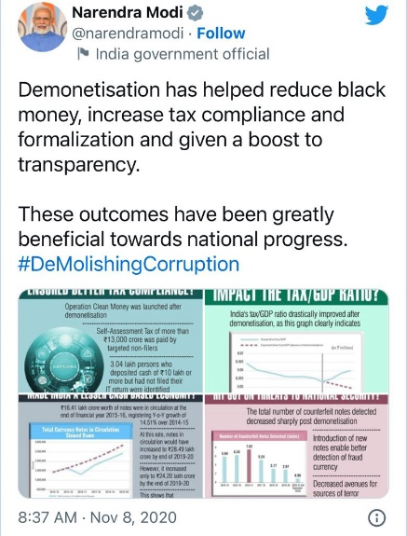
The 2016 demonetisation was India's second attempt at such a policy since independence. The Janata government had previously conducted a similar initiative in 1978. Black money is defined as income and riches that have not been reported to the appropriate government agency by people or organisations. The money may not have been taken by the government, but that does not mean it is still economically inactive. It frequently moves around the economy because of typical business transactions. The abrupt removal of money from circulation meant that daily company operations would be interrupted. Given that cash is mostly used in transactions in the retail, agricultural, and informal sectors, those in the middle class and the poorest people were always going to feel the disruption more keenly. Comparing a government policy's approach and results to its goals is the only logical way to assess it.
What goals did the demonetization process have?
The goals were dual, according to the remarks made at the time by the RBI and the Centre.
First, to void any black money that has been kept in cash and second to Stop using fake or counterfeit currency to fund terrorism. It is impossible to assess whether the government was successful or unsuccessful in combating black money. This is because the administration notified the Parliament that it had no estimate of the amount of black money shortly after announcing the demonetisation programme. There is just no way to determine if demonetisation was necessary without an estimate. Also, there is no way to evaluate how it will turn out. It's not like the government didn't have any estimations on hand. NIPFP, a research organisation for economics, had created an estimate. The World Bank independently calculated that black money made up around 23.7% of the economy in 2007.
However, the Modi administration's stated position was that it lacked an estimate. Demonetisation was therefore akin to giving someone strong medicine without first making a diagnostic to determine the seriousness of the problem. The second goal was to deal with fictitious or counterfeit money. The old Rs. 500 and Rs. 1000 notes lost their status as legal tender after 85% of the money in circulation was demonetised. The measure eliminated both legitimate and counterfeit versions of those two denominations of currency notes from circulation. Therefore, it may be said that this goal was achieved, even if the achievement was only momentary because new counterfeit notes started to circulate again.
How severe was the problem of fake currency is a related issue.
The National Investigation Agency and the Indian Statistical Institute's joint investigation, which was conducted before demonetisation, estimated that 0.022% of the cash in circulation was counterfeit, according to data that the Centre submitted to the Parliament.

2.2.2 Making India a Cashless economy:
Only digital methods, such as bank transfer, debit and credit card payments, digital settling, and payment processors like India's Immediate Payment Service (IMPS), National Electronic Funds Transfer (NEFT), and Real Time Gross Settlement, are permitted for banking system payments (RTGS). There is no flow of currency inside the financial system in cashless economies. The most relevant aspect of the cashless economy for schooling today. In India, which still makes the majority of its payments in cash, less than 5% of all transactions are conducted online. India ranks third internationally with a cash to GDP ratio of 12.42 percent, one of the highest in the world. It changed to 4% or 9.47% in Brazil or China. Also, there are a lot more foreign currency notes in use than in other large nations; in 2012–13, India had 76.47 billion notes in use compared to the US's 34.5 billion. For a variety of reasons, Indians choose cash transactions over computerised ones. First off, due to barriers to accessing banks, a sizeable segment of the population is left with no alternative except to utilise cash. Second, clients gain while making purchases since there are no additional fees associated with cash payments. Electronic bills have not been practical for low-cost transactions, but this is gradually changing. Lastly, using cash offers convenience and flexibility since transactions just need switching hands; there are no concerns about computers failing or transactions being lost. Finally, there is a dearth of information among people about the use of digital payments. Like elderly individuals who have never used a mobile device other than a keypad, they are still unfamiliar with how to use smartphones and cannot begin utilising online payments. (Roy, 2017)
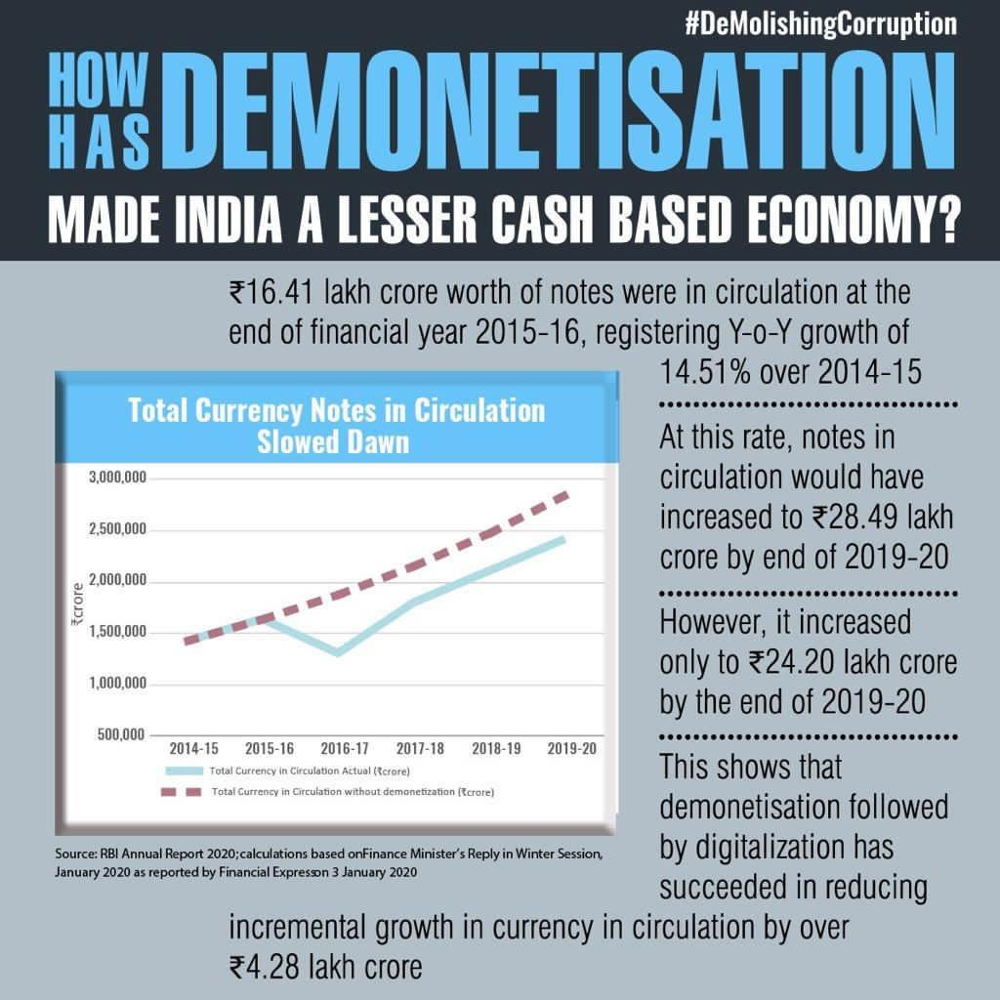
(Source: PM Modi’s Tweet)

Advantage of Cashless economy:
A society without cash has benefits. Transaction costs are declining and will continue to do so. The cost of producing, maintaining, and shipping money would decline once a sizable fraction of transactions become cashless. The digital banking also swiftly resolves issues like cash withdrawals during extended vacations, the risk of carrying cash, etc. Also, cutting back on spending reduces the shadow economy, stops money laundering, and boosts revenue collection. The state's revenue would increase, and more money would be available to pay social programmes if the tax structure was expanded. Via technical channels that promote monetary mobility, it is possible to circumvent the potential of cash's physical nature to obstruct the movement of money. The telecom and smartphone industries are going to undergo a digital makeover. This transformation will be driven by the corporate sector. To promote the usage of electronic payments, the government is also considering giving incentives, such as tax exemptions. The transition must be managed by the private sector. In addition to this, the government may offer incentives for online purchases.
Aiming at less cash Society:
The Reserve Bank of India released its "Payment and Settlement Systems in India" framework on June 24, 2016, with the intention of fostering a "less-cash" culture and enabling even infrequent phone users to utilise mobile banking services. According to RBI, the Vision-2018 reinforces RBI's commitment to encouraging greater adoption of electronic payments by all social groups to develop a society with "less cash." According to the statement, most users of non-smart phone handsets would have easy access to mobile banking services. It was also mentioned that this would be done in several languages. The 5Cs are used in Vision-2018 to emphasise responsive regulation, reliable infrastructure, effective monitoring, and customer centricity (Coverage, Convenience, Confidence, Convergence, and Cost). According to RBI, the new rules that are being suggested to be created under the Vision with an emphasis on electronic payments will affect trends in the nation's payment systems. "A wide range of payment service providers are progressively using the high mobile penetration in the nation to offer payment services, it added, in order to create an on-the-go, speedier payment experience for the clients.
According to RBI, service providers will be pushed to employ technology to offer cutting-edge, simple-to-use mobile-based payment solutions in an environment that supports interoperability without compromising security. According to RBI, the Vision will lead to a sustained decline in the proportion of clearing instruments made of paper as well as a rise in the use of NEFT, IMPS, card transactions, and mobile banking among retail electronic payment systems. Along with a rise in the number of people who have signed up for mobile banking, a major expansion of the infrastructure for accepting payments, and a quicker adoption of Aadhaar in payment systems. (Roy, 2017).
Disadvantages of cashless economy:
Internet safety
The convenience of transactions has improved as reliance on the internet has grown. Digital payment methods have, however, also made it easier for internet scams to operate. According to a recent Microsoft estimate, in 2021 an average Indian consumer will have lost Rs. 15,334 because of internet scams. Bank transfers and credit cards were the most frequently used payment methods for these customers. There are currently no strict rules or legal procedures that can assist in eradicating internet fraud. Add to this the possibility of data theft, which exposes the financial data of thousands of users and can result in significant security breaches.
Increase in government spending.
A cashless transaction system's convenience could become compulsive. When making digital payments, people and businesses frequently overspend, which can result in spending traps, especially for the younger population. This could eventually lead to a considerable rise in public spending rates.
Identity fraud
The country is experiencing a rise in identity theft due to a lack of financial literacy. Those who use cashless payment methods without sufficient industry understanding run the risk of losing both private information and hard-earned cash.
Illiteracy
The major obstacles to shifting to cashless payment transactions in India are financial illiteracy and a reluctance to digitise. The country is still catching up in terms of smartphone and internet usage. In tier 3 towns and villages, most of the populace lacks the technological sophistication necessary to use digital payment features with ease. People may find it challenging to transition from a cash-based to a digital medium since they need more time to get used to such transactions and a greater understanding of finance.
Was India Ready for Cashless Economy:
Over time, consumers have become more equipped to use a variety of fintech products thanks to government initiatives. India has made great strides toward being entirely digital, but there is still a long way to go. The government must launch ongoing, extensive campaigns to educate the public about digital technology in addition to literacy programmes and digital banking knowledge. This will help the cause of disseminating knowledge about electronic transactions and digital currency. It is necessary to significantly simplify digital banking and regulate transaction costs. These elements will guarantee that individuals do not hesitate to make the changeover to daily transactions based on digital technology. Although there may be certain difficulties and worries, they do not outweigh the benefits of a cashless society. With the appropriate plans in place, most parts of India adapted cashless economy. (TRANZACT, 2022)

2.2.3: Terrorism:
It is crucial to look at the role played by 500 and 1,000 rupee denominations at different phases of the finance of terrorism cycle in order to draw a correlation between demonetisation and its influence on each of the formal and informal channels of funding for terrorism. The amount of financial damage a terrorist organisation is likely to suffer is directly correlated with its cash reserves, its capacity to maintain liquidity in the businesses in which it chooses to invest, and the simplicity with which these assets can be converted back into liquid funds. As a major amount of their financial reserves are more likely to have been held as cash, groups in Northeast India and the CPI (Maoist) operating in the nation's Naxal-affected regions are expected to be hurt the worst. Additionally, it will become more challenging to liquidate real estate interests to raise money for organisational support systems.
Terror organisations operating in Pakistan and J&K, however, will recover more quickly due to their funding sources, which include the Pakistani State, wealthy donors in West Asia, Pakistani voluntary collections, FICN, and drug money. None of these can be permanently altered in a way that makes it impossible for terrorist organisations to continue operating.
The money available for funding operations like civil disobedience in the Kashmir Valley, however, will be pulled out of the terror economy in the short- and medium-term future. Demonetization is a crucial step in the fight against terrorism and has the potential to help establish the conditions needed to stop the financing of terrorism. If the interrelated threats of corruption, crime, and terrorism financing need to be managed, it is neither the first nor the last time. Demonetization's goal is to get rid of unaccounted riches (also known as "black money"), criminal proceeds (which are distinct from black money), as well as FICN and Indian currency that terrorist organisations have been hoarding and distributing. It is obvious that the strategy cannot be the "ultimate answer" to the problems of systemic violence, counterfeit money, and black money.
The approach may remove counterfeit money from the system for a while, but it will not be able to block the flow of new and improved counterfeit money. For counterfeiting to succeed, the copies only need to be "good enough" to sow discord in the financial system. Days after the contentious change was made, the then-Defence Minister, Manohar Parrikar, asserted that J&K had shown a steady drop in violent crimes following "demonetization." In the wake of the death of Burhan Wani, a local Hizbul Mujahideen leader, in 2016, the Kashmir Valley had turned into a hotbed of demonstrations and violence. While the government and the minister both asserted that "demonetization" will dry up the sources of black money and, consequently, terrorist support, militants in Kashmir were discovered in possession of brand-new 2000-rupee notes just a few days after the programme was implemented! This assertion is completely refuted by what has been happening in the Kashmir Valley over the past few weeks, including attacks on uniformed men and stone-throwers.
Because of this, it is important to consider the declared impact of the action on terrorism and other security threats in India in the context of the actual situation. (Dogra, 2017)
Positive impact of demonetisation in combating terrorism:
Without the support of money, a terrorist organization's ideology and support base have little impact. All these activities depend on financial resources, which in turn determine the veracity of the threat posed by the relevant group or organisation. Attacks can be carried out, ranks can be filled with dedicated fighters and paid for, weapons can be purchased, and propaganda can be produced. Since the "demonetization" process will be able to remove the FICN from the economy, it is anticipated that it will only have a short-term impact on terrorism.
FICNs are essential to funding terrorist activities, whether it be for purchasing weapons or funding the final stage of any terrorist activity. FICNs are largely introduced into the Indian economy by neighbouring countries (and other non-State actors) (transportation, food, accommodation, etc.).
Despite the policy's good intentions, the focus on demonetisation and how it would affect the security of the nation is incredibly narrow. While it tries to target black money and counterfeit money in the system, it is certain to have a very limited and short-term impact on the sources of finance for terrorism and the people who support it.
To the government's credit, the new policy will put obstacles in the way of militant and terrorist groups that rely on extortion, abduction, and taxes for income production, or that deal with enormous sums of readily available cash. The impact of substituting currency and the ensuing cash shortage on groups particularly Naxals will be felt in the immediate term, which will restrict the range of their operations. (Dogra, 2017)

2.2.4: Stop counterfeit currency Rotation from the Market:
Counterfeit currency means to produce or to use fake currency to buy good in exchange of money this act is fraud and is illegal by laws all over world. The time before paper notes were introduced the most used method currency was coins in which the most counterfeit took place by mixing iron or other metals with gold and silver. The main problem happens due to fake currency rotation is that it reduces the value of real money and lead to inflation as increase circulation of money. (M, 2018).
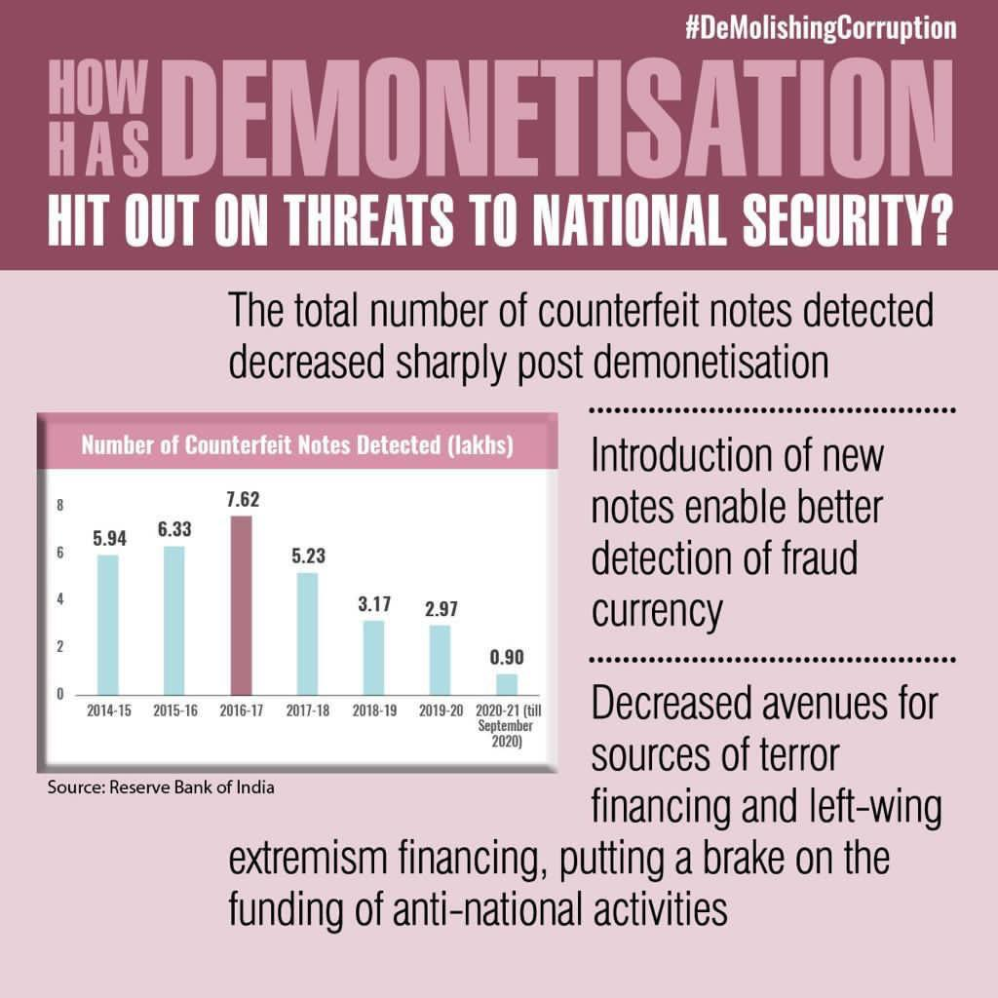
(Source: PM Modi’s tweet)
PM Narendra Modi himself tweeted claiming the demonetisation hit out threats to national security with extra security with better fraud detection also demonetisation decreased the fund for terror activities by combating black money and detecting all the counterfeit currency from circulation. Reducing the flow of counterfeit currency was also one of the important Objective of Demonetisation at that time there was a lot of fake currency running all over Indian economy countries like Bangladesh, Pakistan and Dubai are the main countries to smuggle and print fake Indian notes and bring them India via Nepal borders. Due to Demonetisation for certain time gap people who are involved in this crime stopped their production of counterfeit notes and also faced a lot of losses. But after some time, they started to make print new notes and brought them India back so as per Central Banks annual report Demonetisation did not help in reducing the flow of counterfeit currency.
DENOMINATION | 2015-16 | 2016-17 | 2017-18
50 | 6453 | 9222 | 23447
100 | 221447 | 177195 | 239182
200 | - | - | 79
500(old) | 261695 | 317567 | 127918
500(new) | - | 199 | 9892
1000 | 143099 | 256324 | 103611
2000 | - | 638 | 17929
Source: RBI
Initial when demonetisation took place it was believed that the denomination 2000 and 500 are made with a lot of extra security to stop people to print fake bills of high denomination which according to RBI report 199 fake bills of 500(new) and 638 of 2000 in 2016-2017 but it raised to 9892 and 17929 in 2017-2018 which clearly means even with lot of security function people made fake currencies which was not even detected by machines. The only reason the percentage of counterfeit note of 500 and 1000 were less in 2017-2018 was because this denomination was banned, and people need time to adapt to new bills.
Every time any countries undergo demonetisation the huge amount of fake currency come out of the circulation but as the time passes people gets there way to start use of counterfeit currency again. As per the RBI report of India a total of fake notes seized around 230971 pieces due to demonetisation policy.in 2021-2022 a total of 79669 pieces of 500 fake notes and 13604 pieces of 2000 fake notes were found. According to economics times illegal notes detected by intelligence kept on increasing every year from 2017, the research says that about 190% rise in 2020 in the 5th year of demonetisation than previous years. (RBI, 2022)

2.2.5: TAX EVASION:
Tax evasion means completely or partially not paying the taxes in other words not declaring the income or by showing fake expenses. It is criminal activity and punishable offence. Tax evasion is illegal in India. So as a solution to this government of India launched the Taxation Law act 2016 According to this plan, for every 100 rupees the taxpayer disclosed, he would lose 50 rupees in taxes and be required to provide the government another 25 rupees in the form of a four-year interest-free deposit. He lost another Rs 10 in interest during this time that he could have gained by investing the money placed somewhere else at a 10% annual return. Given how ugly it was, it was not surprise that this plan was unsuccessful. On the other hand, Income tax department launched Operation clean money in order to discover suspicious deposits that were out of proportion to claimed revenues, it carefully examined bank deposits over Rs 2.5 lakh with the use of cutting-edge data analytics tools. It sent 18 lakh questions, to which 9.72 lakh taxpayers have responded, involving 13.33 lakh bank accounts and deposits totalling Rs 2.89 lakh billion. (singh, 2017)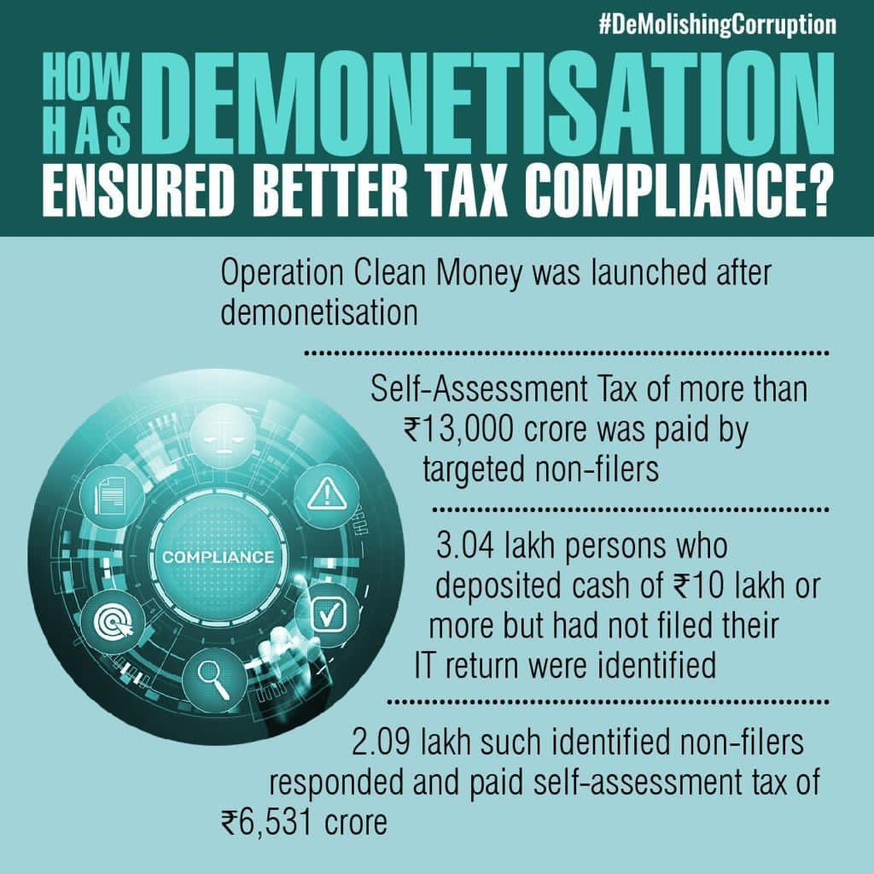
(Source: PM Modi’s tweet)
PM Narendra Modi himself launched Operation Clean Money after demonetisation on 31st January 2017 to ensure better tax compliance by fair and clear payment of tax were all Indian pay their taxes without trying to avoid and as a responsibility towards their country. The operation aims to increase awareness of importance of tax payment to the people, to increase knowledge of tax obligation using IEC (information, education, and communication) approach. They started promoting voluntarily by giving e-delivery services and reducing compliance costs. By keeping complete record of taxes from third party so we can evaluate the situation of tax system. Also started to collaborate with government agencies and middleman who are responsible for data exchange, proper use of leveraging technology and data analytics. This operation bought self-assessment tax of 13000 crore by targeted non-filers. Around 3.04 lakh people deposited cash of 10 lakhs or more but didn’t file their IT returns.2.09lakh people non-filers had to pay self-assessment tax of 6531 crore.
To create more awareness, they send Emails and text massages to the tax dues. The timing of this operation was thoroughly thought as after demonetisation there was a lot of cash crunch and was easy as the people had just changed all of their money via banks, so it made to have record of all the money circulation all over India.

CHAPTER.3: Analysing the Impact of Demonetisation in India:

3.1: Impact of Demonetisation on Employment:
The disturbance to people's daily lives, businesses, and the Indian economic system caused by the demonetization of large paper currency on November 8, 2016, is still clearly visible to many people. There was much discussion at the time concerning the immediate effects on the cash-based informal economy and the eventual effects on everyone engaged, whether directly or indirectly.
Rising currency has returned at larger numbers than before since it was designed to abruptly withdraw throughout the years. Considering this reversal, it is crucial to evaluate the extremely long pattern that the economy has taken since demonetization. With the reintroduction of cash, any claims of positive effects from the substantial formalisation of the Indian economy are exceedingly improbable. Nonetheless, the economy's rising cash intensity may not have completely countered the negative impacts.
The market doesn't quite operate like a rubber band that stretches back to its original shape after being stretched. Bad experiences typically make an imprint that lasts. As demand picks up, small firms that closed because of a lack of customers don't come back up right away. When borrowers are unable to make loan payments, it is more challenging to obtain a loan in the future, especially from unreliable sources. Consequently, one may assume that the shock of demonetisation would have some longer-term negative repercussions, barring later economic policies working to help individuals who were hurt and offset these implications. We find that things had already drastically worsened before the Covid-19 debacle when we look at how the Indian labour force has functioned in the years before demonetisation.
- Immediate repercussions
After an already catastrophic economic situation for the Indian labour market, demonetisation was implemented. According to the Consumer Pyramid Household Survey by the Centre for Monitoring Indian Economy, between May and September 2016, just a few months before the announcement of demonetisation, the labour force participation rate was 43%. The percentage of the population that is employed and of working age is shown by this ratio. Between January and April of 2017, just a few months after the announcement of demonetisation, the workforce rates decreased to 42%. This one percentage point decrease may not seem like much when compared to the total number of employees, but over the course of these four months, it really results in the loss of 95 lakh jobs. (To calculate the anticipated population that is employed and 15 years of age or older, we utilised employment rate statistics and population forecasts from the UN World Population Perspective 2019). This ratio displays the percentage of the working population that is employed. Consider comparing this amount to the whole population of a city like Hyderabad to put it into perspective. (Srivastava, 2021)
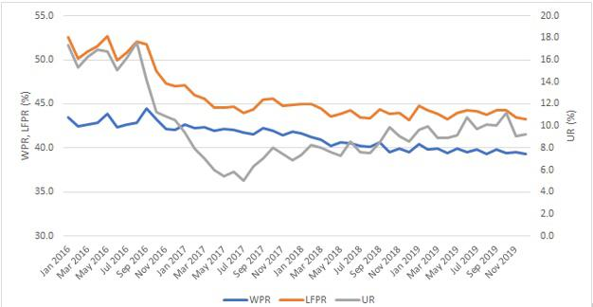
(Source: CMIE-CPHS, multiple waves.)
With respect to the percentage of people of working age who are employed, actively seeking employment, or who are willing to do so, demonetization caused a minor but significant reduction in the employment rate as well as a steep decline in the participation in the labour force. A total of over 47.7 million (4.77 crore) people left the labour market in the months after demonetization, as the workforce participation rate dropped from close to 50% to roughly 45%. One explanation for some of this loss is the decline in the total employment. Yet a large chunk of it came from those who had previously been keen to accept a job offer and/or on the lookout for one, but who stopped after that. The percentage of the labour force that is not employed but is actively seeking employment and/or is willing to work, and which in this case declined, is known as the rate of unemployment. Although a declining unemployment rate is typically viewed as a good thing, in this situation, the reduction in unemployment is the result of people giving up their job hunt rather than a rise in employment.
The "discouraged worker" effect is a phenomenon that happens when declining job opportunities lead potential employees to stop even actively looking for work and to totally abandon the labour force, which decreases unemployment. The fall in unemployment that followed demonetisation was mostly caused by a drop in unemployment rates among youthful and less qualified workers. When these people realised their odds of finding employment were poor, they presumably stopped seeking. (Srivastava, 2021)
- In the long run
The employment rate has been dropping since 2017, and it fell below 40% in 2019. The population of working age in India increased by 32 million from 2017 to 2019, as indicated by the United Nations demographic forecasts. The economy will consequently need to generate close to 13 million new jobs in order to keep the unemployment rate at 42% during the following two years. However, we really lost 6.7 million jobs, which resulted in a decline in the employment rate. It goes without saying that this is in addition to the 9.5 million that were seized in the months following demonetisation. After peaking in the months just following demonetization, the jobless rate has been continuously rising during this time. Even while it may indicate that some "discouraged" people are returning to the workforce, the dropping employment rate demonstrates that their employment prospects remain dismal. As a result, part of the rise in unemployment may also be ascribed to previous employees quitting their positions and finding themselves jobless. The second possibility appears likely, given that employment rates are also declining at the same time.
We observe a change in the working and unemployed demographics between before and after demonetisation, in addition to the workforce contracting and rising unemployment. The workforce, or all those who are employed, has aged most dramatically over the past three years, with diminishing percentages of those between the ages of 15-20 and 20–24. In 2016, they made up around 13% of the workforce. By 2019, they made up under 10% of the population.
Remarkably, over this time, their ratio of unemployed individuals has increased. It can be shown that these tendencies are also strongly confirmed by official employment surveys by contrasting the Labour Bureau's 2015–16 forecasts with the current labour market surveys from 2018–19.
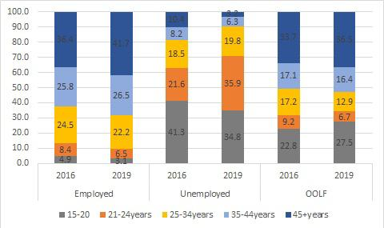
(Source: CMIE-CPHS. 2016 and 2019 estimates are from the second wave, that is May-August.)
This is a worrying trend since the population of individuals who are of working age is increasing younger. According to shifts in the workforce's demographics, younger individuals are having a hard time obtaining work and are more actively seeking employment or quitting the labour force altogether. There are various effects of the economy's failure to employ young workers. The younger generation is not only denied employment but also the chance to build social capital and gain experience; these shortfalls have been shown to have a long-term negative impact on worker earnings. Additionally, it generates a pool of young people without productive job who might be mobilised for a variety of reasons, such as to cause social unrest. Demonetization certainly appears to have contributed to a decline in India's labour force, as well as a particular dearth of possibilities for young people. Empirical economists will continue to argue over whether the demonetisation is solely to blame for this. The government's failure to take any meaningful action to address the employment problem raises a more pressing concern. (Srivastava, 2021)

3.2: Impact on GDP:
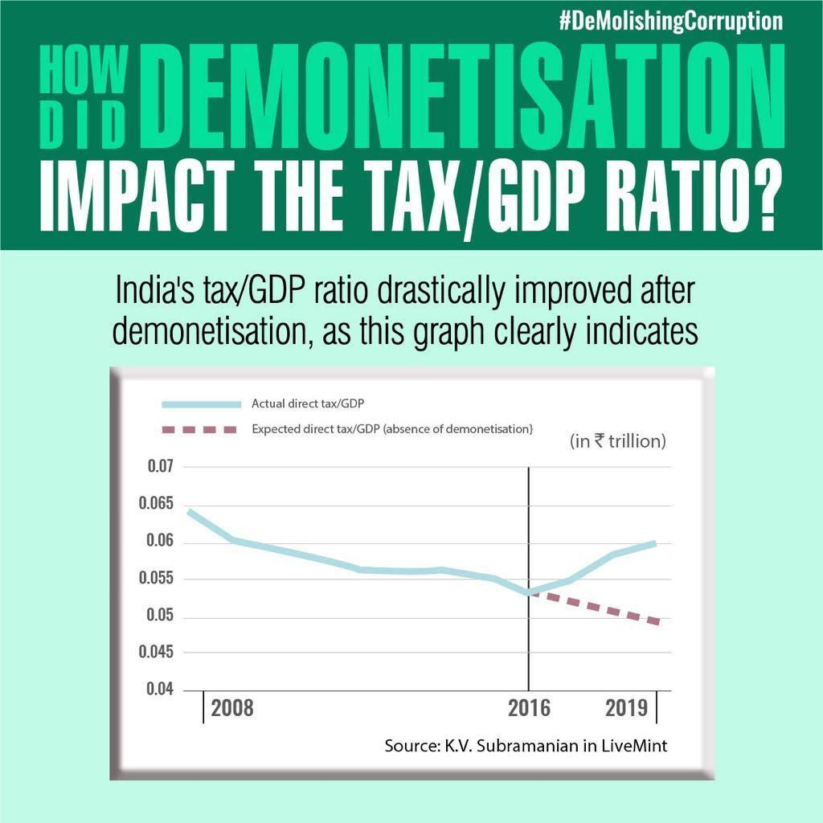
(Source: PM Modi’s tweet)
The demonetisation impacted in favour of country in terms of GDP as PM Modi tweeted with above graph which clearly shows the rise in GDP after 2016 while the real GDP fell sharply after Covid -19.While as per other reports from different newspaper like Business today in there article on demonetisation said that after six months of demonetisation the GDP fell down to 6.1% which was lowest in two years and by march india lost the title of fastest growing country.
If you look at the inflation trend over the past year, it has consistently been on the down. This has been attributed to a liquidity crisis by several observers. That's not right at all! Either individuals are becoming less comfortable with using cash or the hidden cash has entered the mainstream of banking. People are now generally reluctant to pay with cash, which has decreased excessive spending and, as a result, the rate of inflation. In reality, the massive OROP and 7CPC pay-outs last year had a beneficial effect on inflation but managed to have little effect on consumer spending. Real interest rates have fallen dramatically as a result of the substantial decline in inflation, which has allowed the RBI to lower rates even more and boost IIP and GDP. The banking system received cash in the amount of Rs. 7 trillion throughout the whole demonetization process. The growth is not showing signs of picking up despite the RBI releasing new notes to the tune of nearly 80% of the demonetized amount. This is due to the fact that slow GDP growth is more of a result of weak demand, sluggish capital investments, and slow capacity expansion. Apart than bringing attention to the more underlying issues that are plaguing the Indian economy, demonetization has had little effect on GDP. Yet the true increase might not appear until the demonetization's overall advantages begin to materialise. Banks will be ready for a spike in business lending, which will have a positive effect on GDP growth, thanks to an increase in bank deposits and reduced interest rates. A strong rupee strategy may give way to a weak rupee strategy as domestic financial savings increase and the government will have less motivation to rely on international hot money flows. An increase in exports may be the last step in the process of increasing demand. The main lesson from demonetization could be that. And it will be favourable. (Motilal Oswal)

3.3: Inflation rate:
One of the biggest risks to world prosperity in 2022 is inflation, which is defined as an increase in costs throughout a financial system. When prices rise, money doesn't travel as far as it formerly did. This might lead to higher demands, which subsequently fuel further inflation. Rapid cost increases can impair an economy's ability to function on a fundamental level. People hurry out to spend money as soon as they earn a commission, for example, during "hyperinflationary" periods since the costs increase every hour they wait to spend. In order to do this, key banks typically set an inflation goal and employ hobby fees to ensure that fees increase at a fixed rate. If it is widely anticipated, a small amount of inflation is usually unharmed. (Frick, 2022)
Increased market liquidity leads to inflation. Inflation decreases because of demonetization since there is a considerable reduction in market liquidity and financial activity. Once the illegal money leaves the device, the quantity that is in circulation will steadily decline. This will reduce inflation in the absence of any open market activities by the Central Bank of India. Annual inflation of consumer prices in India unexpectedly dropped from 5.88% in November to 5.72% in December of 2022, beating expectations of 5.9%. It is the lowest analysis because December 2021 will be the second straight month when inflation will be below the Central Bank of India's target range of 2-6%. Costs for food (4.19% vs. 4.57%), which were pushed down by a 15.1% drop in vegetables, clothing, and footwear (9.58% vs. 9.83%), and housing (4.47% vs. 4.7%), all decreased. On the other hand, costs increased more quickly for petrol and other soft goods (10.97% vs. 10.62%), food, cigarettes, and alcoholic beverages (2.55% vs. 2.02%), and other items (6.17% vs. 6.07%). The CPI decreased by 0.45% from the previous month, marking the largest decrease since January 2021. (implementation, 2021)

3.4: Impact on Real Estate Sector:
In many ways, demonetisation modified the manner real estate business is historically accomplished. Developers now opt for joint task tasks over outright buy of land, because they now have much less liquidity. Real property is a capital in depth sector and demonetisation worsened coins crunch of developers. This turned into more so for builders within the National Capital Region and Mumbai markets, which noticed domestic income dive after demonetisation because both those markets are investor-pushed. Developers from South India fared quite better than their peers in NCR and Mumbai markets. The stop effect of demonetisation is that builders now prefer to make investments less capital in initiatives. The benefit of joint ventures is builders with limited capital can expand a couple of tasks at the equal time. From a domestic client’s factor of view, the wonderful impact of demonetisation is a fall in home prices. Speculative buyers, who bought belongings and flipped it over for a profit in the quick term, exited the marketplace, due to the general scarcity of cash. This placed a cease to speculative pricing, which became pushing domestic prices up.
Post-demonetisation the actual estate area noticed a drop in fees by means of up to 5%-10%, consistent with information shared by the housing and concrete affairs ministry. Real property builders also presented freebies to entice domestic buyers, which brought the general price of homes down. Residential market is now predominantly driven by using real buyers with much less of speculative purchases. Demonetisation workout however had no effect on land expenses, that are predicted to remain the identical.
Home mortgage rates have additionally dropped, which has reduced Equated Monthly Instalment (EMI) for home buyers. Rates are now at a decade low inside the variety of 8.35%-8.5%. Lower interest charge, method lower EMIs, which increases the budget of home customers. It is a recognized truth that globally the property area is used as a conduit to legitimise or “easy” the proceeds of illegally received budget. This holds genuine for India as properly. The Modi authorities has made its goal abundantly clear. It wants to pass after such unlawful financial interest via measures which includes demonetisation and Benami Transaction (Prohibition) Act. While it is hard to quantify the effect of demonetisation on black money transactions inside the actual estate sector, there may be no denying that demonetisation has institutionalised the real property area and made coins transactions difficult.
The largest, superb impact of demonetisation is a cleaning up of the sector. Real estate region is predicted to turn out to be greater obvious with more sales happening thru banking channels. Demonetisation together with different reforms - Real Estate (Regulation and Development) Act and Goods and Services Tax (GST), will help in bringing in transparency and efficiency in real property. While reforms could make a massive difference, the arena ought to also examine adopting international moral practices to address black cash and reduce instances of corruption. (RICS, 2018)

3.5: Impact on Bank and Financial Sector:
India's economy relies mostly on cash, and the country's black money problem is thought to be quite small compared to the overall amount of coinage. Also, historically, people may have simply kept a little quantity of cash equivalent to black money. Black money is generally converted into physical assets like gold, land, buildings, stock investments, and so on. The Indian economy is still dealing with the complicated effects of demonetization. It was widely accepted that there was a lot of unhappiness among small and medium-sized firms, as well as in the real estate and construction industries, and that only those companies with strong financial results had survived the worst conditions. The stock market suffered as a result of the limited financial options, which also had a detrimental impact on the sales of Indian businesses. A drop in asset value, bank deposits, bank interest rates, and other critical financial parameters are all directly impacted by demonetization.
- Impact on Banking Deposits:
In bank deposits, the banking industry has long experienced. The Government of India set a strict deadline for clients to deposit their expensive foreign currency notes as the major motivation for this scenario. 5.5 lakh crore had already been deposited in banks as of the date of November 18, 2016, according to information provided by the Indian government, which served as the basis for the demonetization proof. Hence, the financial industry saw an overabundance of liquidity. Nonetheless, up to November 18th, 2016, fresh foreign currency notes worth 1.03 lakh cores were released. Till about the middle of February 2017, the banking industry's deposit growth slowed. With the 8 November 2016 announcement of demonetization, the increased role of liquidity in the banking sector has aided banks in reducing their high-cost deposits and raising their ratio of current accounts and financial savings accounts (CASA).
- Impact on Bank Interest Rate:
Due to a rise in bank deposits made to take advantage of the rate of interest at banks even during demonetization phase, interest rates at financial institutions decreased. Although demonetization forced them to take the bulk of deposits in cash, the events that followed forced the banks to discontinue paying interest on bank deposits. Financial coverage may be moved to market interest rates in circumstances when there is an excess of liquidity and the situation's development demands assistance. Several banks reduced their local time deposit rates and loan and advance expenses in response to the demonetization. However, after demonetization the repo price dropped by means of 0.25%, while the lower in Weighted Average Lending Rate (WALR) on high-quality loans by way of 0.50%. After a Year of demonetization commanded considerable declined in lending and deposits costs.
- Impact on Falling Asset Condition:
The banking industry was hit particularly hard by the demonetization since it had an emotional impact on the banks' ability to satisfy their assets in the form of loans and advances given to diverse industries. The compensation of loans had been significantly impacted by the income harm suffered by small and medium-sized borrowers. The increased operating capital rotation that demands money for supply chain investments has been hurting corporate firms as well. Medium to small businesses are heavily reliant on cash in the Indian economy, which has led to a surge in concerned loans. (Neralla, 2019).

3.6: Impact on E-Commerce:
As a result of demonetization, Indians are experiencing cash shortages since they cannot pay for goods and services with cash. They have money in their bank accounts to use for online payments using Paytm, credit/debit cards, internet banking, MIPS, NEFT, UPI, and other e-payment options. Online options paid off growth for this reason. Following November 8th, the variety and cost of card transactions increased by an additional 300% and 500%, respectively. using mobile wallets for transactions Increase in terms of transaction volume and price increased by more than 200%. (PJ, 2019)
eCommerce companies were under pressure to disallow "cash-on-delivery" modes on their website due to the limitation on foreign currency notes. There are certain online merchants who put a cap on the order transaction price of up to Rs 1000, including Flipkart and Snapdeal. After the big disclosure, Amazon India stopped accepting orders for cod. Moreover, numerous eCommerce companies stopped taking legacy currencies and started collecting payments online. Demonetization affected some firms' eCommerce conversions from Flipkart to Zomato, a meal delivery service with several enterprises that rely on hard money for 60–70% of total orders' revenue. Demonetization has increased the digital payment options available for use in online purchases together with a decline in cod orders. According to research, "Cash on transit would lose market share, forcing users to pay payments online. Ecommerce businesses may suffer initially in the following one to two months.” (Parker, 2022)
Due to the demonetization of the currency, which was used to make purchases from several eCommerce stores, this dip was also ascribed to a decline in illicit money. Amrish Rau, the CEO of PayU India, asserts that "research conducted before two years ago found that about 40% of business was fuelled through dirty money." Moreover, he added, "This might have a serious impact on GMV as not all Cod will move virtual money. Consumers in rural areas who are still adjusting to digital platforms and are less at ease using virtual currency may avoid doing business with them.”. Because of the lack of money, conversion fee optimization strategies are practically suffering, which has a knock-on effect on eCommerce sales.

3.7: Impact on Tourism:
With ATMs running out of cash and banks being overrun with customers from early morning till late at night, the country came to a complete standstill from Kashmir to Kanyakumari. Due to the financial shortage, India found itself in an extremely difficult situation. As a result, inhabitants of the whole state were forced to endure hardships in order to obtain new notes and deposit their old notes, throwing the entire state into a state of anarchy. The surprise decision had a profound impact on visitors and travellers from all over the world who were visiting India in addition to Indian citizens. Because the majority of travellers prefer notes with values of 500 and 1000, which are also convenient to carry, the government's abrupt action completely confused and alarmed them. The budget travellers who had made India their destination had done so in order to experience the "genuine Indian experience," which included taking the public transportation system or dining at neighbourhood restaurants, and who had done so by using their savings to pay for the trip to Indian places. India experiences a large influx of foreign tourists from November to January who visit places like Delhi, Maharashtra, Gujarat, Karnataka, Rajasthan, U.P., and so on. The liquidity of currency transactions inside the economy was negatively impacted by a sudden cash constraint.
With outdated currency notes in their possession, the foreign tourists in India were having a tough time travelling the nation. They were completely reliant on cash to pay for their tour costs, unlike Indian nationals who had the option of borrowing money from someone. There was no shortage of local businesses that were unfairly profiting from the situation by selling things for a premium and accepting foreign cash in exchange. The frequently international tourists rely more on cash than plastic money or traveller’s checks when they are there. They were hard-hit by the demonetization exercise. Foreign currency can be exchanged for Indian notes up to a limit of Rs 5,000 every week, or around US$73, according to the Reserve Bank of India. Compared to what travellers often request at the airport, the restrictions established by the authorities were far lower. The ability of foreigners to exchange their notes at Indian branches of the international banks they use has been unclear to them.
Apparently, some foreign tourists have been forced to busk on Indian streets in order to collect money, according to a report in Hindustan Times, the country's most widely read daily. At many venues, including Pushkar, Agra, Jaipur, and others, they have been seen performing. putting up posters to solicit assistance from the community. As an illustration, a traveller from Australia claimed in an interview with the newspaper that they felt compelled to comply since they were unable to withdraw money from their bank account because all the ATMs were empty. Lack of money created a difficult scenario. People were working together, and in some places, they even traded British pounds for rupees from us in an effort to solve this issue. The circumstance is rather challenging. Credit cards have been their only source of payment, according to another traveller.
The vacationers who have been leaving India throughout the duration of demonetization were also going through problems at the same time in re-exchanging the remaining Indian foreign money into their domestic forex. The scenario was awful for folks that have been carrying the old Rs500 and Rs1,000 notes. Although a few banks had a separate queue for overseas travellers, however nevertheless they have been dealing with hard time even as retreating cash from their debts. Adding to this many vacationers have been ignorant of the authorities’ guidelines and their information. Most badly hit had been individuals who arrived in India on November 8 to attend the famous Pushkar fair and observed themselves bankrupt. In the wake of demonetization, governments of various countries had issued a tour advisory caution their citizens regarding latest policy changes in India which proved fatal for Indian tourism as it reduced our FTA (Foreign Tourist Arrival).
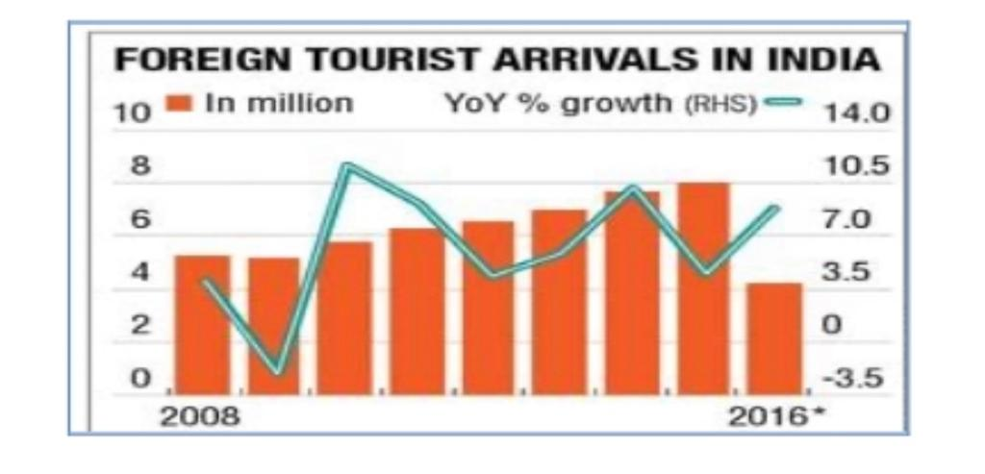
From the above figure it can be clearly seen that demonetisation significantly affected the Indian tourism by decreasing rate of FTA. (DR.Kumar Ashutosh, 2019)

3.8: Impact of demonetisation on health cares:
According to reports in the print and electronic media, outpatients in peripheral hospitals have decreased by around one-third. The folks who were paid daily found it challenging to pay for their medical care. According to reports, a number of hospitals reportedly refused to provide care in return for the demonetized INR 500 and INR 1000 notes. Evidently, they believed that they were intended solely for hospitals in the public sector. In these situations, the state governments had to provide further guidance to private hospitals before they would accept demonetized notes. Several hospitals accepted the demonetized notes on the grounds that "hospital services" may fall within the heading of "essential services." There were scattered reports of a few unverified deaths and the delayed delivery of essential supplies and medications. A non-resident, according to the media. Patients and carers from India who travelled there for scheduled procedures or treatments may have encountered short-term challenges. Contrary to what the media has stated, no such substantiating incidents of adverse health occurrences linked to financial pressure were documented by the hospitals. There were no observable barriers to the sale of drugs in pharmacies. Almost all pharmacies accepted old notes as payment. Personal interviews with carers and healthcare professionals revealed no evidence of such a negative impact on the delivery of healthcare. Just a small percentage of patients at private hospitals acknowledged the difficulties associated with paying bills or buying medications, but they also concurred that these issues might be resolved by cashless or online transactions. The note ban had less of an impact on the poorest members of society because they mostly used lower denomination bills. It's interesting to note that these people were able to endure the challenges of demonetization because to the general excitement for bringing in a clean economy. Patients, doctors, and pharmacists all agreed that the initiative's overall goal was to improve financial reforms and enable closing of economic gaps between the public.
Examination of the immediate post-demonetization scenario at the national level reveals that the government had put in place effective coping mechanisms at the same time, and overall, the demonetization and the ensuing transition were well received. Together with popular backing, the expanded acceptance of the use of demonetized currency notes in healthcare facilities and the swift transition to cashless payments contributed to the tide's smoothing. The transition to cashless transactions was handled by financial systems with amazing speed throughout. A cash-based health-related transaction culture may have developed in the nation because of the low population coverage under health insurance and rising dominance of the private health-care sector. As a result, it is crucial to implement cashless digital transactions across the nation's health service sectors if we are to envision universal health insurance. (Sanghamitra Pati, 2018)
Demonetization had a detrimental effect on the pharmaceutical industry as well, although this effect was only transitory and is projected to continue. We may perhaps anticipate "achche din" shortly with the influx of fresh cash into the market if this is only a temporary phase. The choice to launch this surgical attack on dark money was not made within a couple of days. This plan is the result of the Prime Minister's meticulous planning and never-ending battle against corruption, just as Rome was not built in a day. He has therefore successfully performed the appropriate stroke at the appropriate moment. Furthermore, the harsh penalties will make it difficult for corrupt practises to spread once more. Notwithstanding some immediate problems, demonetization will undoubtedly improve the Indian economy eventually.
But, because more than 85% of the cash in circulation has been made illegal in a single move by the most recent wave of demonetisation, the general population and bankers are clearly suffering. While demonetization is undoubtedly hurting the current economy and will do so for the foreseeable future, it will also have a favourable long-term influence on India's GDP over the next two quarters. The reason why demonetization was necessary at this time is a valid one. The demonetization process has certain benefits and drawbacks. Businesses and organisations in the healthcare sector are under incredibly fresh financial, demographic, and regulatory challenges. In addition to the businesses and taxpayers who ultimately bear the cost, a difficult global economy continues to put pressure on the pharmaceutical, payer, and provider industries' bottom lines. Cost reduction and operational effectiveness are now primary priorities across the healthcare supply chain due to tighter budgets and declining margins. Almost 80% of Indians do not have health insurance, according to the National Sample Survey. Private physicians are one-man armies that manage the majority of patients in both urban and rural locations.
According to a Forbes study, India spends roughly $60 per person per year on healthcare, which is relatively low compared to other BRIC countries and little when compared to industrialised nations given that the USA spends over $8600. The startling statistic in this case is that over 90% of healthcare spending in India is personal. India is a booming country in terms of medical tourism since the medical facilities there are less expensive than those in other affluent countries. By 2020, it is expected that India's anticipated $3 billion medical tourism market would have increased to $7-8 billion. These patients at these super-specialty hospitals are being affected by the demonetization. The shift, according to the foreign nationals, has brought about a disastrous transformation since hospitals no longer take old money. They don't have an Indian account to convert the old cash because they are foreign nationals. To establish the long-term order, however, this short-term turmoil must first be resolved. As the system becomes more capable of handling digital transactions, the situation should start to improve in the upcoming quarter. (BANERJEE, 2017)

3.9: How demonetisation effected people in their day-to-day life:
People usually don’t talk about how drastic change in or implementing new policy in country can affect common people. As I did research on demonetisation, I saw all the things about GDP, Inflation, benefits to countries etc, but the very less information or rarely mention of middle class or poor category people suffered due to demonetisation is considered. Till today when there is a news that PM Narendra Modi is going to give his speech people are scared remembering that day when he came on TV and said about “NOTE BANDHI”. India is country with highest population of 1.4 billion people and with poverty of 60% which means most of the people survive their life with 3$ to 4$ per day. A country with such critical situation is no way capable of sudden change of currency change. For few months the bank was filled with lots and lots of people every day, all the ATM were out of cash most of times. Normal people with a very little saving of 50-60$ were not able to exchange their currency. I know the main aim of demonetisation was to combat black money and to detect and stop increase of counterfeit currency which means the demonetisation should affect the rich people with lots of black money but instead the people with very less saving suffered more. The rich anyways found their way to convert their black money into white.
Within half an hour of the announcement by PM Modi on Television about demonetisation the gold of rupees 5000 crore were sold. As buying gold with cash convert the black cash into gold which can sold back in the future. While middle class people had to stand for hours and hours in a line for converting their money and not a single rich person waited in a queue. People were starving for food but as they have no new currency and the retailers were not accepting the old currency the situation got worse and worse, but no one was there to help them. Most of the old age were not even had accounts in bank as they never thought of such situation. The middle-class Taxpayer must wait in queue to get their hard-earned money taking off from their jobs. The business which was most benefitted due to demonetisation was Jewellers. Bank faced hard time as they were flooded with cash and lots of people every day to exchange their money, they dint had time to breath. Many corporate workers faced severe delays in their salaries. Some people also committed suicide.
Many people invested in housing as the price house fell and people needed to convert their cash even people with white money chose investing over exchanging their money as the prices dropped and standing in line for exchange was real pain.

3.10: 0nline transaction and other modes of payment:
India is a major supplier of generating services and has a competitive telecommunications sector and well-developed economic marketplaces. All those factors contribute to the rise of cashless payments. In contrast to its contemporaries, India has not made significant progress towards cashless payments. Card bills, computerised direct transactions, and non-cash paper transactions make up the majority of non-cash payments in India. In India, cards are the most popular form of cashless payment. In India, non-cash payments made by cards, online banking, demand draughts, and checks presently make up 22% of all consumer bills, with projections showing that this percentage would rise to 59% by 2025. In India, digital transactions have consistently increased by 50% over the past few years. Moreover, ATM transactions increased by 15%, while department-based transactions declined by 7% in FY15 compared to FY14.The prevalence of smartphones, rapid internet access, and support for digitisation from the main banking institution have all contributed to the growth of digital transactions, which will change the country's price structure.
Increase in online Payment:
The main goal of demonetization is to encourage consumers to use digital payment methods. Individuals don't always have money on hand; therefore, they switch from using coinage to online payment options. As a result, starting November 8, 2016, daily rise in digital payment transactions was rapid. More than 300% in terms of range & more than 500% in terms of transaction value increase occurred in card transactions. Growth increased by more than 200 percent in terms of transaction volume and value when using mobile wallets. The number of transactions on e-wallets has surged from 17 lakh to 63 lakh per day, while the number of people using Rupay cards has climbed from 3.85 lakh to 16 per day (Times of India enterprise Dec 9,2016). (PJ, 2019)
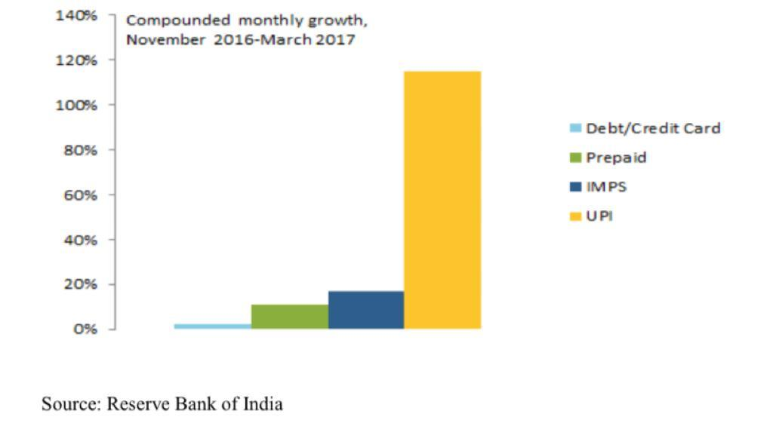

Chapter 4: CONCLUSION
We have seen impacts of Demonetisation in India in different sectors but there are many more effects of demonetisation which cannot be neglected as it effected people day to day life and its effect is still one of the reasons for India’s poor economy. The main moto behind demonetisation was combat black money which we will analyse and see whether the country was succeeded to took out illegal money in rotation. Also, there are many other reasons like the prime minister wanted to make India a cashless country and use more electronic payment which was not successful at first but as the time passed people adapted it. Many big organisations were in loss because not all the people had smart phones at that moment. And many saw the opportunity in this scenario like Jio they launch there SIM card just before demonetisation and Mukesh Ambani founder of Jio started to give free Sim card and also free internet after few months when he realised that most of the population of India started using his sim as at that moment people were facing financial problem and due to cashless transaction they needed internet and cannot afford the regular prices and later Ambani started charging for internet but most of the were addicted to use lots of internet and he was charging less than other sim card companies and By this he became richest man in India. The idea of Implementing policy was good but I think if the execution of the policy was done properly the result would bring lot of development in India. The main drawback of these policy was the time given to change the currency which created kiosk and only effected the poor and middle-class population while the people for whom this act was implemented did not had to suffer as they got money for all the jobs to be done. The main reason of kiosk was because there was a limit in withdrawal of cash which was only amount of 5000Rs at a time. So, people has to stand in line every day to change little bit of money slowly.
The main benefit of demonetisation was people has started using digital payment methods. The adaptation was not sudden in the beginning people hardly knew about online payment methods but as the time pass most of the transaction in India now happen is online. The main idea was to combat all the black money by giving such a surprised decision of demonetisation buy as soon as they heard about this act the people holding black money started to invest them in property, houses, and gold all India got was very little amount of black money in which tax were not paid. Even people found very innovative way laundering their money Instead of the choosing the way which was expected by the government. Government intended that if the people will not find way to use their black money, they will destroy it or will pay the taxes. One more aim was to seize all counterfeit notes it did worked for some time after the demonetisation people were stop printing notes for short time but as the time passed the new counterfeit of new currency came in the market and now it’s all over the economy of India.
All people have different point of views for demonetisation if we see in records everyone has their own different record as per their way of seeing it. There is no strong proof that demonetisation is the only reason for destroying economy of India because covid-19 hit at the same time people were dealing from with new currency crisis. And also, there is no trusted evidence that it was successful to combat black money people talked about it for few months but as soon the situation was starting go to their original way, they stopped taking record or showing them in newspaper. But if talk about on point of view as a citizen of India and living in India at that time what I saw was people suffering for exchanging their hard-earned money, some of them committed suicide due to lack of knowledge about what actually was demonetisation all about. I myself was Standing in queue for hours for many weeks to exchange my family savings and also tried to help my old aged neighbours who were incapable of standing in queue but at that moment all I thought was some good will happen in future but nothing changed still lots and lots of counterfeit notes circulating all over India, still people are having lot of black money, the only change took place according to me is people started using online payment methods foy payments and purchase of goods.

References
Anjali Ahuja, S. A. (2017). Impact of Demonitisation on Indian economy. 5(11), 3.
Areendam Chanda, C. C. (2022). Journal of Macroeconomics. Was India's demonetisation redistributive?
Ball, M. (2019). Recent Trends in Banknote counterfeiting. Australia: Reserve Bank of Austrailia.
BANERJEE, D. M. (2017, FEB 16). Demonetisation-Slowdown effect on health care/pharma industry. Retrieved from LINKEDIN: https://www.linkedin.com/pulse/demonetization-slowdown-effect-healthcare-pharma-banerjee
bansal, N. (2019). Impact of demonetisation on indian Banking sectors: Astep towards governance . Research gate .
Caudron.S. (2001). The myth of job happiness. workforce, 32-35.
Dogra, S. (2017). Impact of demonetisation on terror funding in India. Retrieved from University of North Bengal: https://ir.nbu.ac.in/bitstream/123456789/2994/1/September-2017_06.pdf
DR.Kumar Ashutosh, K. B. (2019). Impact of demonetisation on Inbound Tourism of India. Journal of Advances and scholarlyin Allied education, 16(6). Retrieved from http://ignited.in/p/89463
Frick, W. (2022). what causes inflation. harvard business review.
implementation, M. o. (2021). india inflation rate . Retrieved from Trading economics : https://tradingeconomics.com/india/inflation-cpi
Jain, M. a. (2018). Progress in digital banking after demonetisation. International education and research journal, 50-59.
Jungid R, S. S. (2017). Demonetisation and its impact on indian economy. Technical report presented at Indian Institutes of Tehnology Kanpur.
K.A, S. a. (2016). Demonetisation and its impact on indian economy. International journal of Humanities ,Arts and sciences, 2348-0521.
Kumar, S. a. (2016). Demonetisation and complete financial inclusion. International journal of management research and reviews, 1703.
M, M. (2018). Bad Money . Ancient counterfeits and their fake coins.
M.K.Venu. (2021). Five years after demonetisation,Cash with public is still high.
Medina, L. (2018). Shadow economy around the World. what did we learn in last 20 years?, 17-18.
Motilal Oswal. (n.d.). The demonetisation impact on GDP may actually be Beneficial.. Retrieved from Motilal Oswal: https://www.motilaloswal.com/blog-details/the-demonetization-impact-on-gdp-may-actually-be-beneficial../1374
Nagaranjan, K. (2016, DECEMBER 15). India's Demonetisation drive is affecting access to medical care. Retrieved from THE LANCET: https://www.thelancet.com/journals/lancet/article/PIIS0140-6736(16)32587-9/fulltext
Neralla, N. G. (2019, May). Demonetisation Impact over Banking Loans & advances: A case study. Retrieved from Reseach Gate: https://www.researchgate.net/publication/334456366_Demonetisation_Impact_over_Banking_Loans_Advances_A_Case_Study
Pant.R, N. (2017). Demonetisation: A harrowing Nightmare or a dawn of new era. Journal of exclusive management science, 6(6).
Parker, J. (2022, august 13). How is demonetisation effecting E-commerce and other business sector. Retrieved from knowband: https://www.knowband.com/blog/ecommerce-blog/how-is-demonetization-affecting-the-ecommerce-and-other-business-sectors/
PJ, S. R. (2019). Effect of online payment System : A Review. International Journal of Scientific Research and Review, 770-773.
R, V. G. (2005). The origin of paper money in china . Oxford: Oxford university press.
RBA. (2018). Reserve bank of Australia annual report 2018. 73-75.
RBI. (2022). RISE OF COUNTERFEIT CURRENCY.
RBZN. (2017-2018, october). RBZN annual report 2017-2018. Retrieved from Reserve Bank of New zealand: https://www.rbnz.govt.nz/about-us/annual-reports/2018-annual-report
RICS. (2018). Demonetisation & its impact on black money in real estate. RICS South Asia.
Roy, A. (2017). Cashless economy in india .
S.K.Govil. (2017). Demonetisation and its impact on indian economy. Journal of management value and ethics .
Sanghamitra Pati, P. M. (2018). Health at the time of demonetisation. Journal of family medicine and primary care, 495-496.
Shankar, S. (2020, november 9). Demonetisation was hardly ever about Fighting Black Money. Retrieved from Times of India: https://timesofindia.indiatimes.com/blogs/cash-flow/demonetisation-was-hardly-ever-about-fighting-black-money/
singh, H. (2017). After note ban creackdowm Income tax department should focus on simplifying laws. The economics times.
Singhal, S. (2017 ). Demonetisation and E- banking in india . International journal of new technology of research , 20-25.
Smith, Q. E. (2015). The economics of counterfeiting . Econometrica,83(3), 1211-1236.
Srivastava, R. A. (2021, november 10). No country for young workers: How demonetisation has hurt a generation of Indians. Retrieved from Scroll.in: https://scroll.in/article/1009877/no-country-for-young-workers-how-demonetisation-has-hurt-a-generation-of-indians
the quint. (2018, april 18). Demonetisation : where it worked and where it didn't. Retrieved january 03, 2022
TRANZACT. (2022, december 16). Cashless economy in India Benefits,Importance and more. Retrieved from Tranzact: https://letstranzact.com/blogs/cashless-economy

