Job Offer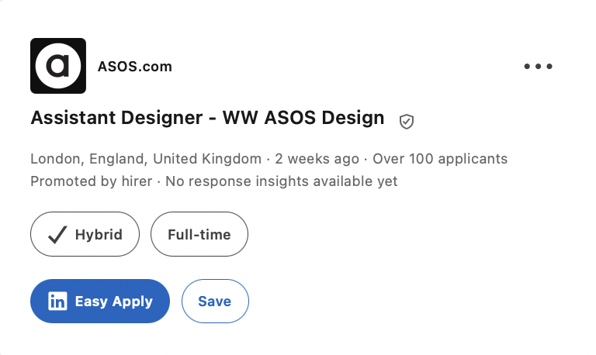
https://www.linkedin.com/jobs/view/4433164473/

About the job
We're ASOS, the online retailer for fashion lovers all around the world.
We exist to give our customers the confidence to be whoever they want to be, and that goes for our people too. At ASOS, you're free to be your true self without judgement, and channel your creativity into a platform used by millions.
Everyone needs some help showing up as their best self. We're Disability Confident Committed - let our Talent team know if you need any reasonable adjustments throughout the recruitment process
Job Description
THE ROLE
As an Assistant Designer at ASOS, you will be working closely with the Designer/Senior Designer, designing the amazing ASOS DESIGN ranges for our trend loving customer. If you love fashion design, researching the latest trends and want to be part of a fast-paced fashion forward design team this could be the opportunity for you.
We are particularly interested in candidates with a strong fashion eye, clear handwriting and taste level, and the ability to translate inspiration into compelling product. Technical development and processes can be supported within the team.
THE TEAM
ASOS is one of the UK’s top fashion and beauty destinations, with a growing global presence. Our values are to be authentic, brave, and creative, and we live and breathe these in everything we do.
The Design Team look for inspiration all around the world, along with street style, vintage shopping, music, art, the catwalk and all things creative, to design the latest product for our ranges. It’s all about newness and finding and designing the most exciting product across a wide range of categories for our fashion loving customers, whatever their style.
PRINCIPLE ACCOUNTABILITIES
- Researching, developing, and designing ranges for ASOS DESIGN, including identifying key shapes for the season, colour, fabric and building a range which offers choice for our global customer base.
- Reacting to sales information and design commercially relevant fashion forward ranges.
- Researching current and future trends by a collection of different sources to identify newness and interpret into first to market pieces.
- Working with the technical team on initial fits. Identifying and helping problem solve for the department, bringing a strong design point of view while being supported with technical problem-solving where required.
- Building relations with suppliers and advising factories on trend direction, construction, key details, materials, and trims.
- Adhering to the critical path to achieve deadlines, ensuring product is developed for the relevant and optimum selling period.
- An ability to research and develop unique product working on long lead time product as well as quick reaction short lead Test & React ranges.
JOB FUNCTIONAL KNOWLEDGE
- Assistant Designer with experience in designing for a Womenswear and/or Footwear & Accessories department, bringing a strong fashion handwriting aligned to the ASOS customer.
- Previous experience in designing for an aspirational brand or similar High Street Retailer. This experience may come from a Womenswear, Footwear, Accessories or adjacent fashion category brand.
- Previous experience of working with Far East, European and UK suppliers.
- Experience in working with a Buyer to plan and deliver a balanced range and first to market pieces
- Commercial handwriting and understanding of the ASOS Brand and Customer
- Demonstrates strong taste level, creative instinct and idea generation; technical ability is valued but not required to be fully developed at this level.
- Excellent Computer Skills: Photoshop, Adobe, CAD, Miro, AI design.
CATEGORY PLANNING & TRADING
- Delivering on brand OKRs.
- Consistently using data & analytics to trade risks & opportunities and proactively shape the future department strategy.
- Recommending creative actions to Designer/Senior Designer & Management.
- Contribute to the critical path management and speed to market initiatives for the department relating to the brand strategy & our Heart initiatives.
- Identify opportunities to be first-to-market.
Qualifications
Who We’d Like to Meet
Essential
- Experience in, or relevant studies related to, Fashion Design, with a portfolio submission required as part of the application to be considered for the role.
- A fashion forward perspective, with a clear sense of handwriting and relevance to the ASOS customer.
- Strong time management.
- The confidence to identify problems and makes improvement suggestions, seeking practical ways to overcome barriers and remaining calm under pressure.
- The ability to communicate to the team & senior management the performance and strategy of the department
- Willingness to travel in the UK and potentially Internationally as required, for supplier meetings and inspiration / development trip.
- Ability to work in an agile and dynamic style identifying risks and opportunities.
Desirable
- Proactive nature with the confidence to work independently within a framework.
- Thrives in a fast paced, agile environment with exceptional organisational skills and ability to adapt and prioritise.
- AI experience, Midjourney, Fermat etc
Additional Information
What’s in it for you?
- Employee discount (hello ASOS discount!)
- ASOS Develops (personal development opportunities across the business)
- Employee sample sales
- Access to a huge range of LinkedIn learning materials
- 25 days paid annual leave + an extra day for your birthday
- Discretionary performance related bonus scheme
- Private medical care scheme
- Flexible benefits allowance - which you can choose to take as extra cash, or use towards other benefits

Inna Romanovych
Mobile: 07467413344
Email:innaromanovic@gmail.com
Location: East London
Availability: Full-time
Personal Profile
I consider myself to be a creative person who is inspired and motivated to develop a variety of projects from conception to end product. As well as hardworking and honest, I know how to take on responsibility so that the end result is not only of high quality but also completed within the set timeframe. I understand the importance of productive criticism and respect other’s input with the aim of producing an excellent outcome. Not only have I had experience of working independently, but also of forming part of a team. I have a clear understanding of textiles, design and the stages in the production of garments. A knowledge of the history of costume and nature of different fabrics also supports the final quality result.

Key Skills

- Pattern making
- Sample making
- Alterations
- Restaurations
- Digitizing
- CAD GARBER, Clo3D
- Photoshop, Adobe InDesign
- Draw sketches.
- Pix Plant, PureRef
- Microsoft Office, Excel
- AI Midjorney
- Deep understanding of sewing technology and garment construction
- Repairing and altering garments
- Fabric and trim selection

Education

2018  2019 |  | Fashion workshop  Cours ‘Cutting and sewing’  Andre Tan Academy  Cours ‘Fashion Stylist’
Professional Experience

04.2020-02.2022  07 2022-  05 2024 | ‘Pravda Tut’ UA TV channel  Fashion stylist  Kyiv, Ukraine. Lesia Ukrainka Boulevard, 26a  Two TV presenters host a morning show every week from Mn-Fr.  Find suitable outfits for presenters for every morning.  Create a style and image for the hosts, find suitable clothing brands, establish relationships with clothing brands sign a partnership agreement; ensure that the morning show hosts have enough outfits each week to host the program  I was able to complete my tasks perfectly, we established excellent collaboration with the presenters, worked closely with them to create a stunning look and personal style for each of them, and built effective communication and fruitful partnerships with clothing brands that were interested in working with us, as this was also beneficial for them and improved their sales and overall financial situation.  Fashion Enter  Garment Technologist and Pattern Room Assistant  Unit 4, 167 Hermitage Rd, Harringay Warehouse District, London  N4 1LZ  Making and developing experimental garment sample.  To make sure we have all necessary materials, measurements sheet, pattern measurement, sample description and tech pack to procced with the order.  Assist Senior pattern cutter during work on the pattern  Record measurements  Make copy of the pattern  Cut sample  Communicate with seamstress  Ensure that all technical specifications and requirements are retained  Ensure that the sample is completed to a high standard on time

Hobbies & Interests

- Blogging
Creating blogs which include interesting content on clothes, fashion events and celebrities.
- Drawing and painting
This includes decorating clothes and household items to create an original item.
- Sport
I enjoy participating in a variety of sporting activities, but especially dance. This helps me to relax as well as becoming more receptive to inspiration and forming original ideas.

English (Advance)
Ukrainian (Native)
Russian (Advanced)
Phone:+44 (0) 7467413365
Email: innaromanovic@gmail.com
Instagram:
https://www.instagram.com/inna_romanovych/?hl=tr
Linked in
https://www.linkedin.com/in/inna-romanovych-319a24240/

Cover Later
Hello, I hope this message finds you well.
My name is Inna, for very long time I’ve tryed to get a job with ASOS,
I have approximately 7 years of experience, in fashion textile back home in Ukraine and there in London in various facets of the garment production industry, including factory, atelier craftsmanship, bespoke tailoring, fashion show.
I used to apply for many roles, but unfortunately have not received any offers or feedback yet, but I would like to express my continued interest in the prospect of joining the ASOS dream team.
I had followed you in LinkedIn and I’m so fascinated to see how you helping people to get their dream job in ASOS, I would really like to ask you if you could help me reach to my career goal too.
In my recent role at a garment factory, I have gained valuable insights into mass production while reinforcing the principles of quality and sustainability in fashion. With a keen eye for detail and a deep appreciation for ethical practices.
I had the opportunity to learn about ASOS range too, as you were one of our clients.
This was a great experience, and I enjoyed every stage of production for these orders. I was so impressed by quality of the garments. The attention to detail is exceptional, and the fabric selection, prints, colours, trims, and packaging are all top-notch. It's clear that a lot of care and effort went into creating this product. This experience was truly remarkable and left me with no doubt as to the exceptional standards of the company.
Furthermore, as I learned more about the brand, I became even more impressed by its strategy. I am excited about the prospect of working directly for ASOS and hope to get a suitable vacancy soon.
I am confident that I can make a significant contribution to the company and grow professionally. Securing a position as an Assistant Designer has always been a dream of mine. I am thrilled about the opportunity to use my skills and expertise to make a positive impact within your esteemed company. My work ethic is characterized by diligence, attention to detail, and punctuality. I am confident that my innovative mindset and willingness to embrace new challenges will enable me to contribute to the continuous improvement of your processes. As someone who is driven by goals, I have developed the ability to navigate challenging situations with creativity and resilience. Whether working independently or as part of a team, I am committed to delivering results that exceed expectations and to build meaningful connections with colleagues.
Thank you for considering my application. I am believe that you are the exactly person, who could guide me through the career destination.
I'm looking forward to hearing from you soon.
Have a wonderful beginning of the week!
For this big opportunity, I had also included my CV and portfolio.
https://new.express.adobe.com/webpage/SYTjkE68zyOMR
Thank you!
Sincerely, Inna Romanovych

