

Assessment Component 2
Individual Report

Student name:Kawther Chible
Student ID:2008114

Module name: Psychology for Health and Social Care
Module code : (BMHP4003_LON)
Lecturer name: Bianca Sanfilippo

Table of Contents
1.Introduction 3
2. Erikson’s Psychosocial Theory 3
3. The role of health care practitioners in supporting the wellbeing of individuals in a health or social care settings. 9
4. Reflection on the application of Erikson’s Psychosocial Theory in my own practice 10
5. Conclusion 11
6. References 12

1.Introduction
In the normal case of individual growth and development, social interactions and relationships are key in supporting one’s life from childhood to adulthood. The main aim of developing this report is to present Psychological Theory by Erikson in terms of its importance and how it is being applied in health and social care.

2. Erikson’s Psychosocial Theory
According to Darling-Fisher (2019), Erikson used the theory to describe how social experiences influences individual personalities during development to adulthood from childhood. From his theory, psychosocial development occurs in eight defined stages where individual experiences a psychosocial crisis in each stage, which has either negative or positive outcomes towards personality development.
From the theory, basic virtues and a healthy personality are promoted when an individual completes all stages successfully. These basic values acquired are critical aspects that an individual can use to manage and resolve issues. However, when an individual fails to complete a single stage successfully, this can result in the inability of completing other stages hence an unhealthy personality. It is clear that human virtue is developed when a positive outcome controls the negative outcome successfully (Darling-Fisher, 2019).

The stages of Erikson theory
Psychosocial Stages: A Summary Chart
Age | Conflict | Important Events | Outcome
Infancy (birth to 18 months) | Trust vs Mistrust | Feeding | Hope
Early Childhood (2 to 3 years) | Autonomy vs Shame and Doubt | Toilet Training | Will
Preschool (3 to 5 years) | Initiative vs Guilt | Exploration | Purpose
School Age (6 to 11 years) | Industry vs Inferiority | School | Confidence
Adolescence (12 to 18 years) | Identity vs Role Confusion | Social Relationships | Fidelity
Young Adulthood (19 to 40 years) | Intimacy vs Isolation | Relationships | Love
Middle Adulthood (40 to 65 years) | Generativity vs Stagnation | Work and Parenthood | Care
Maturity (65 to death) | Ego Integrity vs Despair | Reflection on Life | Wisdom

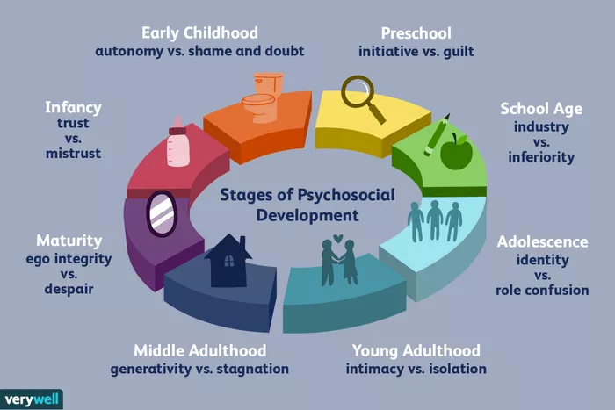
(Image1: Source: Google image, 2021)
1‘Trust vs mistrust’ - Infant (0-1.5)


(image1: Source: Google image, 2021)
This is the most fundamental stage that occurs between birth and the 18 months of a baby. Since the infant is fully dependant, the level of trust or mistrust will depend on the nature of the relationship they have with the primary caregiver (Orenstein and Lewis, 2020). This is simply because the infant is uncertain about the surrounding environment and require consistent care for basic needs such as love, food, safety and warmth to survive. In this case, trust is developed in the infant when caregivers are reliable, consistent and predictable in providing primary needs or mistrust and fear when they are emotionally unavailable, unpredictable and inconsistent. For this case, the theory is applicable in health and social care by ensuring clear rules that are consistent and reliable towards caregivers and the nature of care given to a baby after birth.
Success and Failure in Stage One
The positive outcome at this stage to the child is the ability to develop HOPE as a virtue, while the negative outcome makes a child develop FEAR, low-esteem, lack of confidence, and feel uncertain about the future life. For this case, a child with the virtue of HOPE develops the ability to manage conflict as the infant believes other people are a source of support, thus able to succeed in life.
2 Autonomy vs Shame and Doubt 1.5 to 3.
It is the second stage of psychosocial development, according to Erikson, that occurs in children between age 18 months and three years. At this period, such children develop a desire to be independent and take personal control of their bodies. They develop a desire to eat independently, play and being trained for simple life activities.

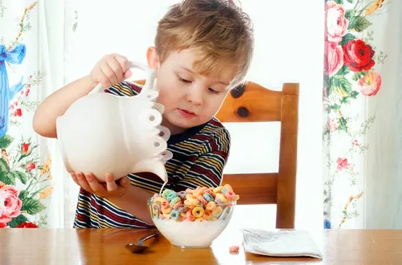
(Image2: Source: Orenstein and Lewis, (2020)
Success and Failure in this stage
A sense of Autonomy develops to a child when they are given the opportunity to become independent and make mistakes. Shame is a virtue that a child develops in case the carers criticise the child for making a mistake.
The virtue of will is the positive outcome of this stage when children are motivated and encouraged that it indicates the ability of a child to believe in their confidence and independence thus able to survive. On the other hand, children lack self-esteem while doubting their strength or being over-controlled (Greene, 2012).
3 Initiative vs Guilt (3-5)

(Image3: Source: Orenstein and Lewis, (2020)

At this third stage, child development is lively and rapid while regularly interacting with peers. Playing is a critical activity that enables them to get opportunities of understanding their interpersonal skills (Çelik and Ergün, 2016).
Success and Failure in this stage
The success in this stage results in the virtue of purpose, while the sense of guilt is created as a result of failure. A sense of initiative develops in such children, thus making them develop good decision making while leading others.
4 Industry vs inferiority (5-12)

(Image4: Source: Sokol (2020)

At this fourth stage of personal development, a child begins to undertake some activities for their own such as playing, reading and writing. As the child engages in specific activities, teachers have an important role in assisting the child while peer group becomes an important source of self-esteem.
Success and Failure in this stage
A child feels confident and industrious when they are encouraged for their initiative, while failing to encourage the child result in inferiority, thus making them doubt their abilities and inability to attain their set goal (Sokol, 2020).
5 Identity vs Role Confusion (12-18)
During this adolescent stage, individuals transit from childhood to adulthood, thus a critical period during growth. They become independent while developing personal identity through exploring individual goals and values. Such people focus on future plans, careers and ways of fitting in their society. There is peer pressure that influences the decision-making process of such individuals (Sokol, 2020).

(Image5: Source: Sokol, (2020)

Success and Failure in this stage
In this stage, the virtue of fidelity is a positive outcome that indicates that individual is able to accommodate others irrespective of their diversity. The role of confusion, on the other hand, indicates failure when the individual is unable to understand one’s role in society, thus trying several options due to being unable to understand what one exactly need.

6 Intimacy vs Isolation (21-39).

(Image6: Source: Darling-Fisher, (2019).

The sixth stage of physical development occurs between ages 21 to 39 when an individual is a young adult. The stage is characterised by sharing intimacy with others and exploring relationships that result in a commitment with a non-family member. People become independent and begin their careers.
Success and Failure in this stage
In the case of success, there is a sense of commitment, happy and safe relationships, while failure to commitment, relationships and intimacy promotes loneliness, isolation and depression. The virtue of love is, therefore positive outcome at this stage.
7 Generativity vs Stagnation (40-65)

(Image7: Source: Darling-Fisher, (2019).

At this seventh stage of psychosocial development for ages 40 to 65 where individuals give back to society through undertaking community activities, raising their children and being productive.
Success and Failure in this stage
In the case of success, the individual develops a feeling of accomplishment and usefulness, thus resulting in virtue of care. Failure, on the other hand, has negative outcomes of shallow involvement in daily activities, thus making an individual become disconnected from their society.
8 Ego Integrity vs Despair 65 +

(Image6: Source: Karkouti (2014)).

This is the last stage of psychosocial development that occurs past 65 years. Here, individuals can see their past success in life and feel proud or not.
Success and Failure in this stage
The success at this stage promotes the virtue of wisdom, thus making individuals reflect on their life with a sense of completeness and achievement hence accept death without fear and support other people (Karkouti, 2014). Failure, on the other hand, results in a feeling of bitterness and despair, thus promoting unhappiness and dissatisfaction.

3. The role of health care practitioners in supporting the wellbeing of individuals in a health or social care settings.
According to Maree (2021), psychosocial theories mainly focus on describing individual behaviour as well as predicting individual behaviour in the future based on a given stage of life. The theory is well designed to give a clear description of various issues of human life development at different stages of growth. The use of this theory is, therefore, essential to assisting professionals within healthcare in understanding the behaviour of people at different stages of life and develop the ability to predict their behaviour in future. It will be easier for medical practitioners to give necessary support and care to the specific needs of an individual when they know human behaviours at different stages as well as expected issues (Karkouti, 2014). Also, such practitioners are able to structure their environment using approaches of theory like giving primary caregiver to a child in the early stages of growth. This is critical in ensuring children develop trust in their parents whenever they are left in care homes to the right people.

Marcia et al. (2017) argue that professionals in healthcare need to indicate their ability to show empathy when handling individuals that require care. Through this skill, such professionals are able to understand and manage the needs of those people who have come to seek help within the healthcare facility. From Erikson psychosocial theory, the description given in each stage of the crisis is essential to professionals in healthcare for the development and application of empathy skills. This is realised since they are able to understand specific needs and issues faced by individuals at different stages of development.
The healthcare professionals are able to develop effective communication skills thus able to adapt their mode of communication to meet the specific needs of individuals in need of care. This is well catered and promoted in Erikson theory, as indicated in the third stage, where effective communication is key in promoting a sense of initiative among children in order to make the right decisions.
According to Çelik and Ergün (2016), various mental disorders affecting individuals in society and their causes can be well understood by healthcare professionals through the application of Erikson theory. From this theory, various disorders can occur to individuals at different stages of life when a failure occurs. This includes shame, mistrust, inferiority, guilt, despair, stagnation, isolation and confusion. When such disorders are properly understood, such professionals in healthcare are able to give relevant interventions to help people in need. In this case, the applicability of Erikson theory is essential to such healthcare professionals because they develop the ability to promote positive outcomes of individuals in various stages of life such as trust, autonomy, initiative, amongst others.

4. Reflection on the application of Erikson’s Psychosocial Theory in my own practice
For my future career, I will apply Erikson’s Psychosocial theory in a number of ways. Through communication skills developed from this theory, I will be able to address the needs of individuals that require my help through active listening, providing suitable support and making the right decision. I will be in a position to manage mental issues through developing the aspect of empathy, thus appreciating the diverse feelings of people in different stages of life while giving them a suitable remedy.

5. Conclusion
In conclusion, Erikson Psychosocial Theory is an essential framework in health and social care as it describes how individual personalities are influenced by the social interactions from childhood to adulthood. From the various stages of life described in this theory, healthcare professionals who apply Erikson’s Theory are able to understand individual behaviour and predict their future behaviour when giving care services. Also, some skills like empathy and effective communications are developed using Erikson’s theory which are key in promoting individual effectiveness when giving care services.

6. References
Çelik, B. and Ergün, E. (2016). An integrated approach of Erikson’s psychosocial theory and adlerian counselling. International Journal of Human and Behavioral Science, 2(1), pp.20-26.
Darling-Fisher, C.S. (2019). Application of the modified Erikson psychosocial stage inventory: 25 years in review. Western Journal of Nursing Research, 41(3), pp.431-458.
Greene, R.R. (2012). Psychosocial theory. HANDBOOK OF PSYCHOSOCIAL, p.229.
Karkouti, I.M. (2014). Examining psychosocial identity development theories: A guideline for professional practice. Education, 135(2), pp.257-263.
Marcia, J.E., Waterman, A.S., Matteson, D.R., Archer, S.L. and Orlofsky, J.L. (2017). Ego identity: A handbook for psychosocial research. Springer Science & Business Media.
Maree, J.G. (2021). The psychosocial development theory of Erik Erikson: a critical overview. Early Child Development and Care, 191(7-8), pp.1107-1121.
Orenstein, G.A. and Lewis, L. (2020). Erikson's stages of psychosocial development. (online). Available at: https://www.ncbi.nlm.nih.gov/books/NBK556096/ (Accessed: 17 Aug 2021).
Sokol, J.T. (2020). Identity development throughout the lifetime: An examination of Eriksonian theory. Graduate journal of counselling psychology, 1(2), p.14.

