University of Wales Trinity Saint David
London

The Global Business Environment
(LCBB4005)
Assessment 2

IMPACT OF COVID 19 PANDEMIC ON NEXT PLC

Submitted to: Submitted by:
Molly Jack Grigor Zarankov
1914055

Contents

INTRODUCTION 3
RETAIL SECTOR IN THE CONTEXT OF A GLOBAL COVID 19 PANDEMIC 3
IMPACT OF COVID 19 PANDEMIC ON NEXT PLC 5
ANALYSIS OF NEXT PLC AS AN OPPORTUNITY FOR DEVELOPMENT AFTER THE COVID PANDEMIC 19 6
CONCLUSION 10
REFERENCES 11

INTRODUCTION
This report provides a critical analysis of the economic environment at the moment, which is most affected by the World Virus Pandemic called COVID 19. In view of the affected sectors, the clothing and textile sales sector is one of the most affected. That is why a company from this branch is represented - NEXT PLC. The report is divided into two conditional parts and in the first part an overview and critical analysis of the overall retail sector is made and also presents the specific situation and the impact of the viral pandemic on the selected company. The second part is dedicated to the possibility to make development recommendations and overcoming the crisis by developing a SWOT analysis of the activity.

RETAIL SECTOR IN THE CONTEXT OF A GLOBAL COVID 19 PANDEMIC
At the end of 2018 an event occurred that at that time no one suspected would change the way of life on the planet. An event of a health nature, but having an overall impact on life in social and economic terms. The World Health Organization defines this phenomenon as "Coronavirus disease (COVID-19) is an infectious disease caused by a newly discovered coronavirus" (WorldHealthOrganization, 2020). This virus has affected in an economic aspect negatively almost all economic entities on the global market. The European market as one of the major trading communities has also been severely affected. This can be seen from the official statistics presented in the EUROSTAT report for the period January 2020 - October 2020 (Figure 1.).
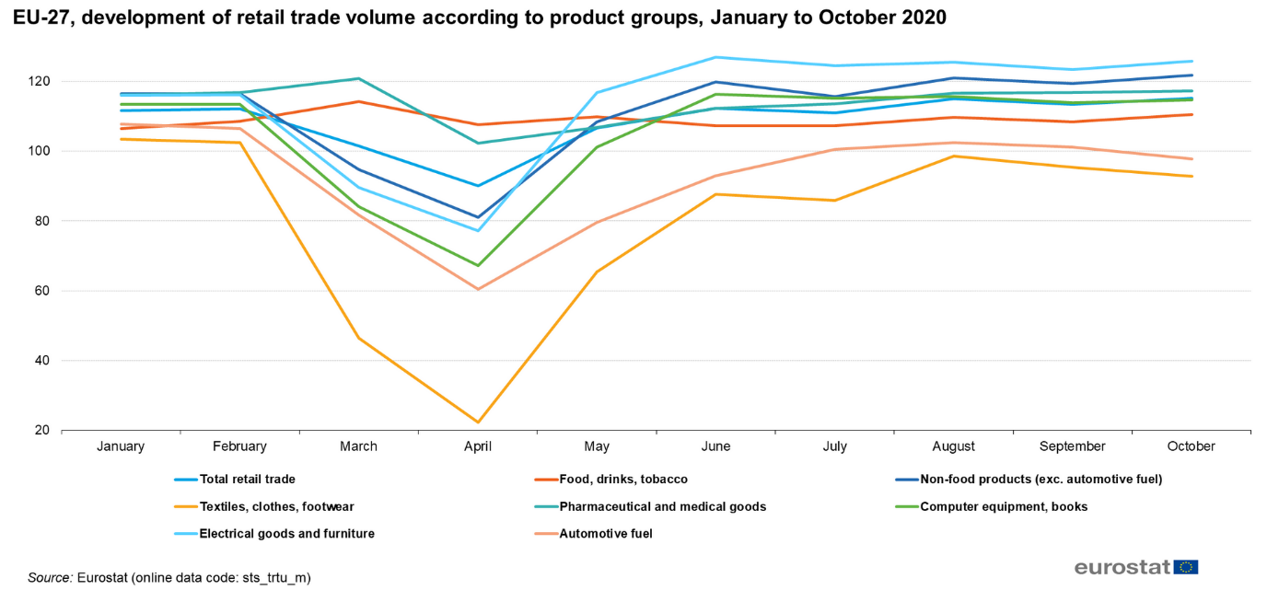
Fig. 1. EU-27, development of retail trade volume according to product groups, January to October 2020

It is clear from the figure that the situation in the retail sector for the European Union is not good. The trend is to maintain a negative trend in the coming months. It can be said that the sales of clothing and textiles are one of the most affected, which is why studying them. It was found that sales in the UK for the same period almost overlapped with those of the European Community. This becomes apparent in Figure 2. (Eurostat, 2020).
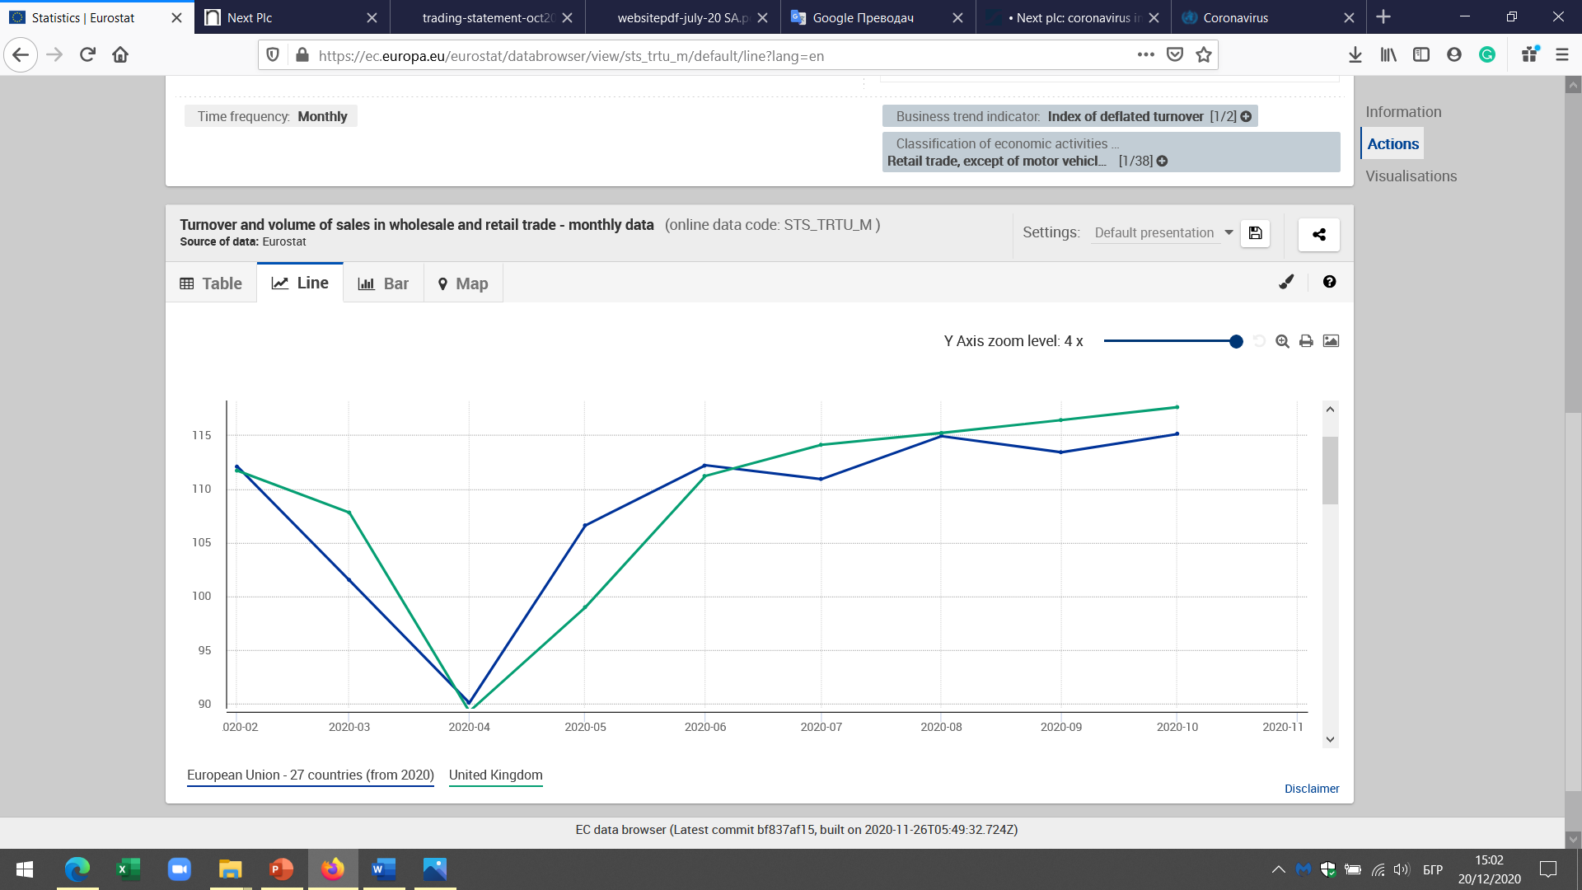
Fig. 2. Turnover and volume of sales in wholesale and retail trade - monthly data
Source: https://ec.europa.eu/eurostat/databrowser/view/sts_trtu_m/default/line?lang=en

The reasons lie in the fact that almost all of the retail sector stores closed due to the pandemic situation. In order to limit the viral infection, the authorities have taken unprecedented measures in response to the situation. This, unfortunately, did not lead to the desired results in the social aspect, but in the economic created a crisis stronger than the one after the Second World War. The economy is currently in recession (Blanchard, 2017). Many authors have given definitions of recession, but Investopedia (2020) makes the shortest and most accurate description, namely recession is
"A recession is a macroeconomic term that refers to a significant decline in general economic activity in a designated region.".
Typically, this economic situation is calculated for a minimum of two reporting periods (three months) (Frank, 2008).
To clarify this economic effect - recession due to the global pandemic COVID 19, an analysis of a company from the retail sector for clothing trade will be made.

IMPACT OF COVID 19 PANDEMIC ON NEXT PLC
The British company Next Plc is an international seller of quality clothing and home products. The company owns about 700 stores worldwide. It is headquartered in Leicester, United Kingdom. This company was founded in the distant 1864. by Joseph Hepworth (Next Retail Plc, 2020).
According to official data, as a result of the pandemic since the beginning of the year, the company has generated significant retreats compared to previous periods. Not only in the UK market, but also in the world market. It is clear from the figure below (Figure 3.) that the situation is quite negative (Statista, 2020).
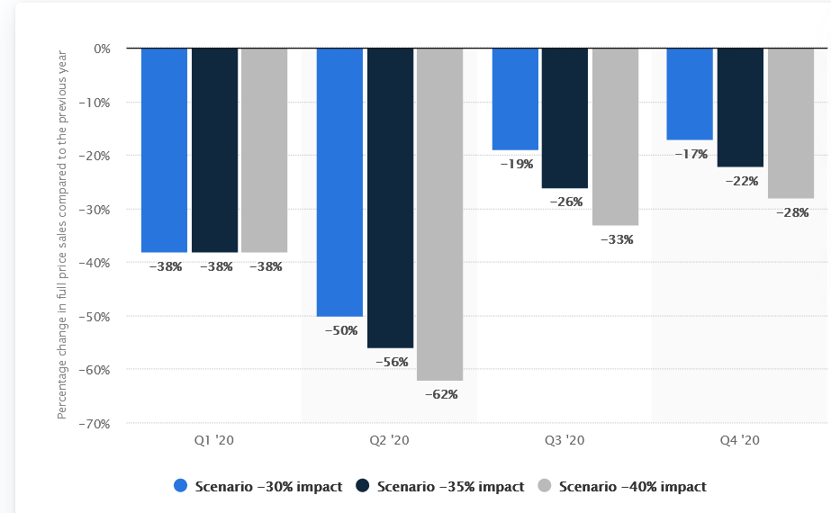
Fig. 3. Forecasted percentage change in the quarterly full price sales of Next plc worldwide in 2020, by scenario
Source: www.statista.com
Officially, all this is proven in the report published by the company, and as a result of the pandemic there have been many changes in organizational, functional and managerial activities, nationally and globally. The officially published NEXT report for the first half of 2020 (Next Plc, 2020), entitled "Results for the Half Year Ending July 2020", provides a global analysis of the consequences of the pandemic and rather outlines a strategic path for future development. The company focuses on four main themes that have emerged since the beginning of 2020. These are:
Sales Resilience - Fortunately, Strategic Management found that despite the losses from the pandemic, sales results were more sustainable than expected. This, in the opinion of management, is due to many reasons such as the internationality of the business model, as well as the diversification program.
Financial Stability - The strategic management claims that the company is financially stable. Behind this phenomenal result are many managerial actions such as reducing reserves and restructuring the business. Separately, management claims that cash flow has been found from the sale of some assets. Hopes are for a relatively smooth and sustainable transition throughout the pandemic.
New ways of working - Everyone is aware that the viral pandemic has been described as one of the most costly and devastating events in human economic history. But like anything, it could provide valuable lessons for development. As a result, many options have been found for digitizing routine operations, working from home, and optimizing interactions with suppliers and customers.
Opportunities for New Business Development - The strategic management makes a general conclusion that as a result of the pandemic the economic reality has been totally changed and in fact it is possible to do a new type of business. New ideas and development projects are being developed. The pandemic has created a new business environment, thanks to technology this environment is becoming more flexible and new prerequisites for future success are emerging.
The overall results presented so far for the company show what the situation is after the pandemic. In the next part we will make a SWOT analysis (Kotler & Keller, 2016) of the company from the point of view of COVID 19. This will actually represent not only the position of the company on the changes they want to achieve, but in this paragraph, we will indicate our development recommendations in view of the current difficult situation.

ANALYSIS OF NEXT PLC AS AN OPPORTUNITY FOR DEVELOPMENT AFTER THE COVID PANDEMIC 19
The company Next could not only cover the accumulated losses so far, but also start the new calendar year with a positive result. All this is supported by the objective fact that a table for the analysis of sales was published in the general report by 24 October (Table 1) (Next Plc, 2020).

Table 1. SALES FOR THE THIRD QUARTER AND YEAR TO DATE
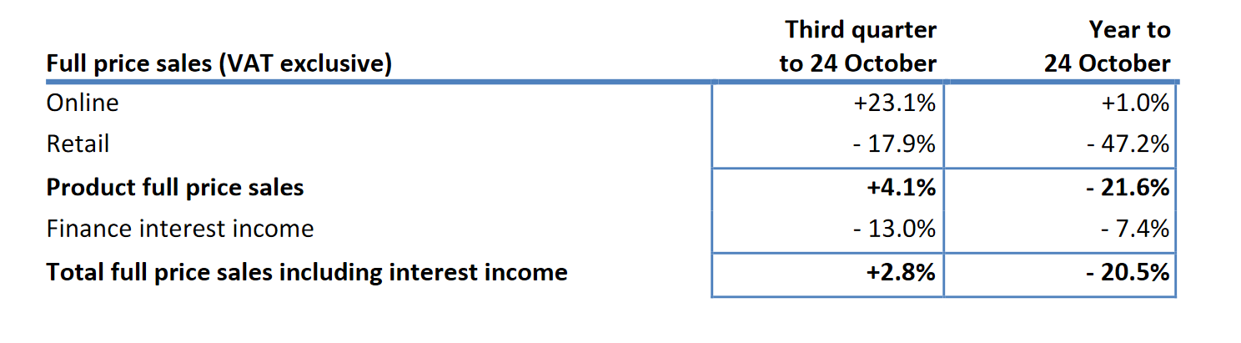
Source: www.nextplc.co.uk
It is interesting to see that the table has data on a quarterly and annual basis until October. It is important to note that online commerce generates profits, albeit insignificant, while direct sales are declining significantly. At the moment it is not possible to compensate all the losses and damages from the direct sales of the brand, but in the future reserves could be sought in this regard.
The strategy and the analysis that the strategic management makes by predicting what the future situation will be are interesting. This could be seen from Table 2. (Next Plc, 2020).

Table 2. SALES, PROFIT AND CASH SCENARIOS
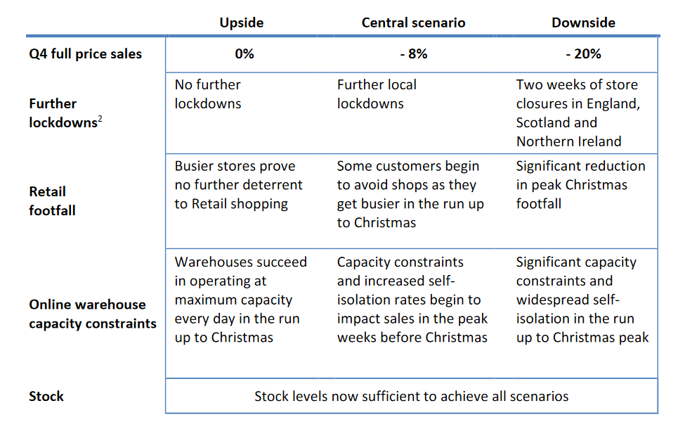
Source: www.nextplc.co.uk

The management analyzes the pandemic situation as of the fourth quarter of 2020. There is a fairly high degree of uncertainty, so the business waiting for the government's position. However, a prognostic analysis is made in the direction of throughput regimes in the physical stores of the brand, as well as limiting the number of active users in local stores. These predictions are made for the purpose of prevention and increase Christmas sales, something that is an increasingly difficult and impossible task. Unfortunately, the situation suggests that these scenarios may not come true. The prognosis at the moment is rather in a negative direction.
The SWOT analysis (Armstrong & Kotler, 2013) was done in the direction of proposals to deal with the situation and reduce the negative consequences of the pandemic.
- Strengths

The British company Next is one of the leaders in the global clothing market (Shishoo, 2012). Here are some strengths that, according to them, could bring success in the fight against COVID 19:
Many years of experience in developing new products and services. Therefore, it will not be difficult to invent new ways of trading and effective communication in terms of distribution channels and interaction with customers.
In its long history, the brand creates many products collectively presented in one of the strongest and most recognizable fashion items. Over the years, the brand has survived many other economic shocks and shows that it has a strong distribution network and also reliable partnerships. This leads to coping with the current difficulty as well as allows for the growth of the competitive environment.
As a result of the many market facilities built around the world, Next shows that it manages without problems in new markets and new realities.
The company is a leader in customer service and thanks to its highly qualified staff manages to maintain online sales while not announcing a policy of redundancies.

- Weakness

There will be pointed out a vision in which areas the company can improve to become even more successful.
Given the expansion of the brand and its location in many locations, it is necessary to make numerous investments in different regions of the world. This is a rather risky task at the moment in view of the recession.
Numerous R&D expenditures are being made to create new products to meet growing markets. This is also one of the things Next needs to rethink. Perhaps it is more appropriate to buy a few companies that are in difficulty in local markets. Instead of looking for a way to actively expand.
- Opportunities

The main opportunities facing the company is in the discovery of new production technologies. It needs to be understood that after Britain leaves the European Union (Hantzsche, et al., 2018), the country will not be bound by so many environmental directives and could produce more environmentally friendly. This is not the case with the world market. There are also opportunities, but they are hidden by local law. That is why the government could also facilitate the process of tackling the global pandemic.
After the first pandemic situation, NEXT call centres for customer service were created, which led to an increase in distribution channels and efficiency with customer loyalty.
There is an opportunity to reduce prices as a result of reducing the cost of online commerce, from which both the company and consumers could benefit.
In this way, loyal customers are preserved, but it is also possible to break through with minimal resources, through virtual technologies in new markets.
- Threats

Naturally, the biggest threat so far is the negative impact of the pandemic called COVID 19. So far, it was listed many changes that the company is making and could make to deal with this negative phenomenon.
Another major threat to the company is the reduced possibility of future employees working as salespeople at physical sites around the world losing their jobs. This is due to the development of online commerce. To date, the company has not announced such intentions, but the danger remains real. Opportunities in this regard may lie in the retraining of employees and the opportunity to work in call centers as sales advisor.

CONCLUSION

The developed report analysed the situation in view of the impact of the most economically negative phenomenon today - the global viral pandemic COVID 19. Not only the entire sector of the retail industry was analysed, but also a specific British company as a typical leading representative of this industry. Basic recommendations were made in the form of SWOT analysis of how the crisis situation could be overcome by the management of NEXT PLC.
On the other hand, these recommendations were effectively and purposefully based on an analysis report already made by the company itself as of October this year. Some non-traditional methods for strategic management of the company were presented, which the organizational management hopes to use to deal with the pandemic situation. It is only a matter of time before some of these activities are put into action, but only the future will show what will happen. At the moment it is not very encouraging, but everything has an end and most likely the pandemic will end soon. The lessons will be at the expense of all mankind.

REFERENCES

Armstrong, G. & Kotler, P., 2013. Marketing an Introduction. 11th ed. London: Pearson Education, Inc..
Blanchard, O., 2017. MacroeconoMics. 7th ed. London: Pearson Education,.
Eurostat, 2020. Eurostat. [Online]
Available at: https://ec.europa.eu/eurostat/databrowser/view/sts_trtu_m/default/line?lang=en
[Accessed 20 December 2020].
Frank, R., 2008. Microeconomics and behavior. 7th ed. New York: McGraw-Hill Companies, Inc.
Hantzsche, A., Kara, A. & Young, G., 2018. THE ECONOMIC EFFECTSOF THE GOVERNMENT'S PROPOSED BREXIT DEAL. National Institute of Economic and SocialResearch, 18 November, pp. 1-25.
Investopedia, 2020. Investopedia. [Online]
Available at: https://www.investopedia.com/terms/r/recession.asp
[Accessed 20 December 2020].
Kotler, P. & Keller, K., 2016. Marketing Management. 15th ed. Pearson Education Limited: Essex.
Next Plc, 2020. Next Plc. [Online]
Available at: www.nextplc.co.uk
[Accessed 20 December 2020].
Next Retail Plc, 2020. Next Retail. [Online]
Available at: https://www.nextdirect.com
[Accessed 20 December 2020].
Shishoo, R., 2012. The global textile and clothing industry. 1st ed. Cambridge: Woodhead Publishing Limited.
Statista, 2020. Statista. [Online]
Available at: https://www.statista.com/statistics/1134591/next-plc-sales-scenarios-following-coronavirus-crisis/#statisticContainer
[Accessed 20 Decmber 2020].
WorldHealthOrganization, 2020. WorldHealthOrganization. [Online]
Available at: https://www.who.int/health-topics/coronavirus#tab=tab_1
[Accessed 20 December 2020].

