University of Wales Trinity Saint David School of Engineering
Energy in a Flywheel
Engineering Science 1 (M4X00385)
Rhodri Jenkins
1801396
18/11/19

Table of Contents
1 Introduction 3
2 Experimental Procedure 4
2.1 Setting up the experiment 4
2.2 Carrying out the experiment 5
3 Results 6
4 Analysis 7
4.1 Graph Results 7
4.2 Graph and Results analysis 7
5 Conclusion 8
6 Evaluation 9
7 Further work 10
8 References 11

Figure and Tables
Figure 1-Example diagram of flywheel experiment (Blog.oureducation.in, 2019) 3
Figure 2- Weights and plastic guide and rope (R.Jenkins.2019) 4
Figure 3-Side view of pulley connected to work plate (R.Jenkins.2019) 4
Figure 4-Back of the work panel where nuts are holding pulley block (R.Jenkins.2019) 4
Figure 5-Weight hanger being added to pulley via rope (R.Jenkins.2019) 4
Figure 6-Moment of Inertia Graph 7

Table 1-Blank Table for during experiment 5
Table 2-Results during the experiment 6
Table 3-Results that can be obtained by what known 6
Table 4-Results used to work out moment of inertia 6

1 Introduction

This report will aim to prove the theory of energy in a flywheel from the Potential and Kinetic Energy Kit from TecQuipment. (2012) , It will explain the experiment setup including how to carry out the test, the results obtained (which will be shown on an excel table) and finally, the analysation of the results and calculations to be able to obtain a graph y=mx+c to figure out the gradient of the moment of inertia (I). Through collecting and calculating the results, this report will be able to show the potential energy lost and its relationship with the mass of the flywheel; there is a linear relationship between the two, as mass increases the potential energy also increases. The gradient result for I, can be compared to the nominal value of ($4.696 {X10}^{-4}kg.m^{2}$); they should produce a linear relationship. The end of this report will explain discrepancies in the equation PE+PE loss=KE, whilst also looking at why the heavier flywheels have larger PE losses up to a certain point.

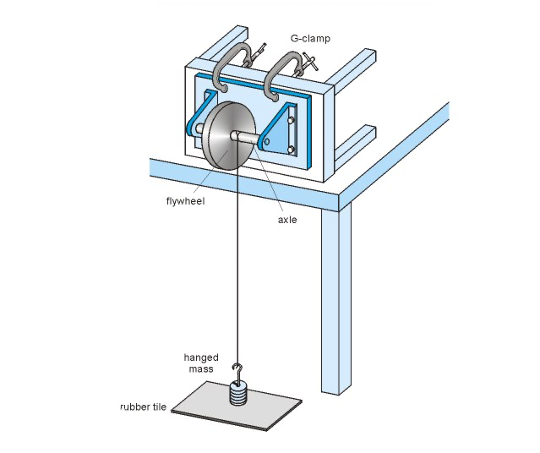
Below is an example of the set up aimed to achieve for this experiment.

Figure 1-Example diagram of flywheel experiment (Blog.oureducation.in, 2019)

2 Experimental Procedure

Before proceeding with the experiment, make sure to have all the equipment required to carry out the test and enough participants to be able to do separate parts of the experiment e.g. stopwatch, someone watching distance travelled by the flywheel etc.
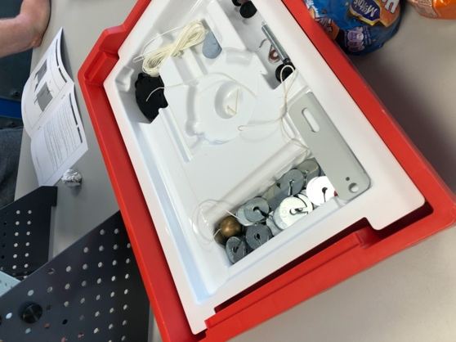
Equipment needed:
- Stopwatch
- Work panel
- Pulley Block
- Flywheel
- Ruler
- Weight hanger
- Thin strong rope (approx. 0.5m)
- 10g weights to put on hanger
- Plastic guide
Figure 2- Weights and plastic guide and rope (R.Jenkins.2019)

2.1 Setting up the experiment

The experiment should be done on a flat and level surface e.g. a workbench.
- Place the triangle plate stands on the table and then insert the bolt screws into the work panel.
- Next, insert the pulley block at the top centre of the work panel and bolt behind to make sure it’s secure. Place the flywheel on the rotating pole that is connected to the pulley block.
- To be able to attach the weight hanger, the rope needs to be tied around the pulley block. Tie a not in the rope for the weight hanger to hook onto.
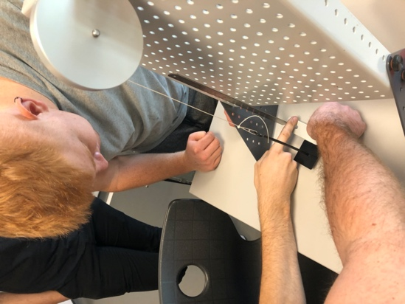
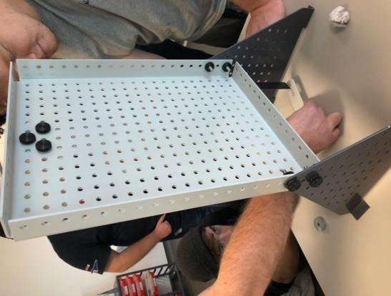
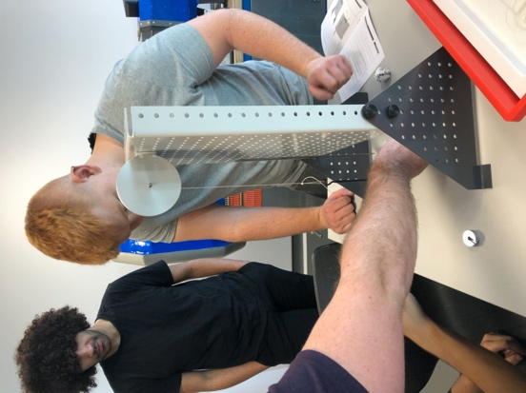
Below are images of how the setup should look like.
Figure 3-Side view of pulley connected to work plate (R.Jenkins.2019)
Figure 4-Back of the work panel where nuts are holding pulley block (R.Jenkins.2019)
Figure 5-Weight hanger being added to pulley via rope (R.Jenkins.2019)

2.2 Carrying out the experiment

- Insert the plastic guide on to the bottom of the weight hanger.
- The rope should allow the weight hanger to travel on a vertical drop of approximately <290mm.
- Whilst allowing the weight hanger to fall to the table surface; move the magnetic ruler behind the hanger so that it’s 0mm edge aligns with the plastic guide.
- As the hanger weighs 10g, add 90g to the hanger to give it a combined weight of 100g (0.1kg).
- Rotate the flywheel in any direction to elevate the weight hanger until the bottom of the weight hanger reaches 280mm on the ruler.
- Use the stopwatch to measure the seconds taken for the flywheel to fall from 280mm ($h_{1}$) to 0mm and back up to the maximum height which will be called $h_{2}$.
- Repeat this three times to calculate an average value. These will be the results used in the table.
- Repeat steps 6 and 7 whilst adding weight to the hanger in 100g increments until the weight hanger reaches 500g (0.5kg)
Below is an example of a blank results table:
Table 1-Blank Table for during experiment
Mass  m  (kg) | Time to fall and rise  t  (seconds) | $$h_{2}$$(m)
0
0.1
0.2
0.3
0.4
0.5

- Once results are obtained; calculate:
Potential Energy ($PE=mgh)$
mg
Potential Energy Lost (adjusted) ($PEloss X h_{1}(h_{1}-h_{2})$)
Falling Time ($t_{f}=t_{t}X\frac{h_{1}}{h_{1}+h_{2}}$)
Acceleration ($a=\frac{h_{1}}{{t^{2}}_{f}}$)
Velocity ($v=at_{f}$)
(mg-ma)r
$\frac{a}{r}$ values
- Add the nominal values for I for flywheel and pulley to get total nominal I value for the flywheel. This can be used to calculate kinetic energy by the equation ($\frac{1}{2}Iω^{2}$)
- Use the function in Excel to plot a graph of (mg-ma)r against $\frac{a}{r}$. the results given should create a straight line and can be used to find the average value I for the flywheel by calculating the gradient of the graph. TecQuipment. (2012).

3 Results

After carrying out the experiment, collecting the results and inserting them in a table, there are already results that can be noted. For this particular experiment:
$$h_{1}=280mm (0.28m)$$
$$r=0.0065m (allowing for the rope thickness)$$

Calculating nominal I is achieved by: flywheel + shaft and pulley
Which for this experiment:
$$flywheel=3.862 X {10}^{-4}kg.m^{2}$$
$$Shaft and pulley=0.834 X {10}^{-4}kg.m^{2}$$
Table 2-Results during the experiment
Mass  m  (kg) | Time to fall and rise  t  (seconds) | $$h_{2}$$(m)
0 | 0 | 0
0.1 | 4.2 | 0.24
0.2 | 3 | 0.25
0.3 | 2.5 | 0.252
0.4 | 2.1 | 0.25
0.5 | 1.9 | 0.24

After completing the results table, the table below can be completed with the results and figures received.
PE  mgh  (J) | Mg  (N) | PE loss adjusted  (J) | Falling Time  t  (seconds) | Acceleration  a  (m.s-2) | Velocity  v  (m.s-1) | Velocity  w  (rad.s-1) | KE  (J)
0 | 0 | 0 | 0 | 0 | 0 | 0 | 0
0.275 | 0.981 | 0.021 | 2.262 | 0.055 | 0.124 | 19.067 | 0.085
0.549 | 1.962 | 0.031 | 1.585 | 0.111 | 0.177 | 27.207 | 0.174
0.824 | 2.943 | 0.043 | 1.316 | 0.162 | 0.213 | 32.771 | 0.252
1.099 | 3.924 | 0.062 | 1.109 | 0.227 | 0.252 | 38.867 | 0.355
1.373 | 4.905 | 0.106 | 1.023 | 0.268 | 0.274 | 42.147 | 0.417
Table 3-Results that can be obtained by what known
(mg-ma)r  (Nm) | $$a/r$$  (rad/$s^{2}$)
0 | 0
0.00634 | 8.422
0.0126 | 17.149
0.0188 | 24.881
0.0249 | 34.998
0.0310 | 41.156
From the results obtained in table 4, the moment of inertia can be found by plotting a graph (mg-ma)r against $\frac{a}{r}$ and calculating its gradient. (y=mx+c).
Table 4-Results used to work out moment of inertia

4 Analysis

Using the data calculated in table 4, we are now able to plot a graph to show the average value for moment of inertia, this should have little scatter and be a straight line (showing a linear relationship). Following this, the graph will obey y=mx+c and will be calculated using Excel. This graph’s results will be compared with nominal value for I ($4.696 {X10}^{-4}kg.m^{2}$)

4.1 Graph Results

Figure 6-Moment of Inertia Graph

4.2 Graph and Results analysis

The above scatter graph shows that gradient is 0.0007 to double check this, there is an equation that can be used: $Gradient (m)=\frac{rise}{run}$
Taking the data from Table 4 allows us to calculate rise and run.
- Work out the rise =y2-y1
- Work out the run =x2-x1
- Gradient (m) = $\frac{0.0310-0.00634}{41.156-8.422}=7.537{ X10}^{-4}kg.m^{2}$
By working out the gradient with this equation, this shows a more accurate set of data than Excel, but the difference is not big enough to change the accuracy of the data.
Comparing the average value for I ($7.537{ X10}^{-4}kg.m^{2}$) and the nominal value ($4.696 {X10}^{-4}kg.m^{2}$.) A difference of 2.841 x10-4kg.$m^{2}$ is observed, this could be viewed as a significant difference, but could be the result of human or equipment errors.

5 Conclusion

This experiment can be deemed successful after reviewing the results and the Excel graph. The theory suggested that as the mass attached to the flywheel increases, the Potential Energy loss should also increase. The results in table 4 prove this theory increasing the accuracy of the results. However, the value of inertia in this experiment ($7.537{ X10}^{-4}kg.m^{2}$) doesn’t show the correct nominal value as a value of ($4.696 {X10}^{-4}kg.m^{2}$) was expected to be found. This could be due to the flywheel mass being different to the value in the experiment booklet. Another reason the nominal value may have been inaccurate is that there may have been a misprint on the experiment booklet, the flywheel could have had more mass than stated.

This experiment has shown that an increase in the mass of the flywheel gives larger PE losses up to certain point, a reason for this could be that forces other than gravity affected the results such as friction. As there is more kinetic energy, this means there is a larger figure of heat energy which reduces the total kinetic energy.

Using the Kinetic Energy data from Table 3 an example of the PE + PE loss = KE equation in this experiment would be 1.373+0.106=1.479 J for mass 0.5Kg. This equation is not a reliable option to solve Kinetic Energy. Kinetic energy takes into consideration the environment of a moving object e.g. air resistance and friction whereas Potential Energy does not account for these. The equations for Kinetic Energy takes into account the linear velocity squared when potential energy only considers height and a constant gravitational speed. (Surbhi, 2017)

Looking at the graph, it has very little scatter. The theory explains that moment inertia should be a straight line, showing that the results obtained are accurate and reliable. The only scatters on the graph are on point 4 and 5 which could be due to human error. Another reason for this is that a heavier flywheel was used at these points, the rope and mass hanger did not rise in a stable way and wobbled, which may have cause slight stretches or unthreading on the rope.

6 Evaluation

Like in every experiment, minimizing human error is a key part to receive accurate data and results, but this can’t always be avoided. An example of human error for this experiment is the participant reading the distance of ($h_{2}$); the weight hanger was raised to the point ($h_{2}$) after being released from the 280mm drop was not at eye level with the ruler, producing an error in the results.

Another big human error to consider is that this experiment depends on the reaction time of the person saying the hanger has finished rising and also the reaction time of the person controlling the stopwatch. Both factors can impact the results slightly. To minimize the effect as much as possible, it is best to have 2 or 3 people on independent stopwatches and after each test, take all 3 times and find the average value. This will make the experiment more accurate will give the best possible outcome. Another way to overcome the problem is to use the same person for each task, this way the results will be more accurate as the reaction time error is constant.

An error that could have occurred is the rope stretching as the mass of the weight hanger increased, meaning the string had more stress as the weight hanger fell and came back up via the rope. The best way to avoid this outcome is to change the piece of rope after every mass, this makes sure the rope has not got any weakness in the thread.

7 Further work

(Vlab.amrita.edu, 2015) was able to create a very similar set up and set of equations but also adds kinetic energy of the flywheel, the weight and friction into the calculations to work out potential energy loss. Friction was calculated using the number of times cord is wrapped around the axle, which is attached to the flywheel, multiplied by the work done to overcome the frictional torque by rotating the flywheel assembly. Vlab.amrita.edu could have changed how the results could have been on the experiment e.g. adjust PE loss.

Having sensors at the bottom of the table could be a way of improving this experiment. This would have accurately solved the falling time of the mass hanger and this would reduce the reaction time of starting the stopwatch from the hanger falling.

8 References

Blog.oureducation.in. (2019). moment of inertia of flywheel by falling weight method. [online] Available at: https://blog.oureducation.in/moment-of-inertia-of-a-flywheel-by-falling-weight-method/
[Accessed 5 Dec. 2019].

Surbhi, S. (2017). Difference Between Kinetic Energy and Potential Energy (with Comparison Chart) - Key Differences. [online] Key Differences. Available at: https://keydifferences.com/difference-between-kinetic-and-potential-energy.html
[Accessed 5 Dec. 2019].

TecQuipment. (2012). Potential and Kinetic energy kit ES9. (Energy in a Flywheel).

Vlab.amrita.edu. (2015). Moment of Inertia of Flywheel (Theory) : Mechanics Virtual Lab (Pilot) : Physical Sciences : Amrita Vishwa Vidyapeetham Virtual Lab. [online] Available at: http://vlab.amrita.edu/?sub=1&brch=74&sim=571&cnt=1
[Accessed 5 Dec. 2019].

