In this document I will aim to address the different stages of my teaching development during my professional teaching practice (PTE) while highlighting the importance of reflection and how it allows learning professionals to adapt their teaching styles and approach to better their performance inside and outside the classroom environment. Reflection practice is seen as a “process of thinking through professional issues, problems or dilemmas, which do not have an obvious solution.” (Welsh Government, 2015). The reflection needed for a positive PTE experience focusses on the same process where you will face challenging situations such as additional learning needs (ALN) pupils, contingency planning, and unsuccessful lessons. A positive reflective system is vital for these grey areas of teaching as you will need to use certain methods of reflection to ensure you are getting the best results for the future when facing these challenging situations again.
Within the first stage of my PTE I was assigned to the Nursery class of the school. In this first week I found that the best system for the reflective process for me was the Assisted Reflective Conclusion (ARC), and the tracking records that the university assigned for us to use. Also, I chose to use individual observational notes during my first week as I found I could focus more on specific attributes the pupils had as well as the essential that we had to observe. I chose to split my individual observations into three categories; Manners, Understanding, and Enjoyment. I have chosen these three categories as I feel they may allow an educator the chance to better understand the pupils all round lives and the support they receive at home. This is a vital cog in educating young learners as they carry their home life to their schooling, also it gives the educator the ability to reflect on these three categories to support the pupil through their schooling. This is supported by Bruner’s and Vygotsky’s thoughts that “adults should play an active role in assisting the child’s behaviour” (McLoed, 2018).

The Target or Qualified Teaching Status (QTS) standard I have focussed on when designing my first lesson plan for the first week of my PTE is S1.2,
“They demonstrate the professionalism to ensure that relationships with learners are built on mutual trust and respect and to recognise that this will help maximise their learning potential”.
(Welsh Government, 2009)
This target allowed me as a professional learner to focus on building a professional positive relationship with the pupils to highlight how positive reinforcement impacts the child’s learning. During the first week of my teaching practice I found that using a kind approach worked well when getting pupils to work and stay engaged. However, there were some downsides to this approach that made it extremely difficult to engage the pupils when they did not want to work. This highlights the respect in the QTS standard I have chosen. For example, a pupil who I had a positive rapport with during play time and fun hands on activities decided that he did not want to sit down and complete a drawing task as to this pupil it was not seen as fun and exciting. At first, I allowed the pupil to continue with this behaviour and do as much work as he wanted to, which was averaging at two minutes each activity. After observing this pupil with other teachers and his general written work in other tasks, along with conversations of the expectations of this child with my class mentor I found that I needed to change my approach (See Appendix 1). My class mentor specified that this specific pupil works very well with paper activities such as drawings, matching items and counting with visual aids. However, he needs to be told to stay where he is and have a constant aid of questioning and positive reinforcement. I was pleased with this feedback as there were only slight adjustments to my approach that I needed to change which encompassed using more assertive language and reinforcing what I have said with actions that ensured he did his work. I also achieved this outcome by changing the level of difficulty in his activities. I used simple tasks to begin and as I moved through the activities, I added more difficult task to challenge the pupil. This supports Vygotsky’s theory of Zone of Proximal Development (ZPD), more specifically scaffolding. The ZPD states that is the “difference between what a learner can do without help and what he or she can achieve with guidance and encouragement from a skilled partner” (McLeod, 2018), which relates to the simple tasks to begin and myself and other peers as the skilled others giving encouragement. I was using simple tasks to encourage the pupil by sub conscientiously improving his self-esteem and then adding challenges as he knew he could achieve the previously set task so he would accept the challenge and continue to try his best on his own. This further relates to what Vygotsky’s theory states that the “support is tapered off as it becomes unnecessary” (McLoed, 2018) and once the support is removed the pupils confidence and ability will remain high so “the student will then be able to complete the task again on his own” (McLoed, 2018).

The Target or Qualified Teaching Status (QTS) Standard I have focussed on when designing my second lesson plan for the second week of my PTE is S3.1.3,
“They select and prepare resources, and plan for their safe and effective organisation, taking account of learners’ interests and their language and cultural backgrounds, with the help of support staff where appropriate”.
(Welsh Government, 2009)
While focussing on this target I was able as a professional learner to design a lesson that would engage all learners to the best of my ability by including a wide range of different teaching styles and reinforcement methods. The difficulties in designing this lesson were conducting a risk assessment, creating a contingency plan for different weather conditions and educating a pupil with no welsh language background of welsh numbers and colours, and also to keep them under control and focussed on exactly I wanted from them during the task. Using my ARC model as a reflective tool I was able to record what I had observed during my first lesson of this task, which was a lack of control of the pupils when they were undertaking the task of collecting different shapes. The pupils were collecting as many shapes as they wanted at a time and once matching them, continued to run off again to get more. From the recording of events I was able to adapt my session with the solutions of instructing the pupils to collect specifically one shape at a time, and also bring their shapes to myself or my Teaching Assistant (TA) to explain the name of the shape, how many sides and the colour, in welsh where possible.
Another issue that was solved by using my ARC and observational notes to reflect on was tackling the lack of Welsh one pupil had (see Appendix 2). This specific pupil had moved into the nursery class at the start of this week and quickly proved that he had a very high ability to take in all information given to him, which is evident by joining in with group songs through the week and understanding the routine along with enjoying his learning experience with all activities he was involved in. Using my ARC and observational notes I was able to see that This pupil responded well to other pupils’ interaction with me as groups and joining in with repetitive and patterned work such as counting to ten in Welsh. This is supported by Albert Bandura’s social learning theory of “Children pay attention to some of these people (models) and encode their behavior. At a later time they may imitate (i.e., copy) the behavior they have observed” (McLoed, 2016). With this pupil I decided to use repetitive speaking thoroughly throughout the activity. Instructing the pupil to repeat the words as I and other pupils say them. Asking him what the shape was, then translate to welsh for him, and finally get him to repeat it back to me in welsh. Following this, to assess if the understanding was there, further, I used reverse questioning such as, can you tell me which shape is glas? which shape has pedwar sides?
To summarise reflection is seen as a key cog in the developmental machine of a professional learner, specifically teaching. Reflection is needed to further educate ourselves and others on what we can change and adapt to improve our overall performance. This is supported by Jennifer Moon as she states that we reflect in order to “learn something, or we learn as a result of reflecting – so ‘reflective learning’ as a term, simply emphasises the intention to learn as a result of reflection” (Moon, J, 2004, p.80). Without reflective practice, improving your work and overall performance will become exceedingly more difficult.

Reference List

Welsh Government, (2015), Reflective practice, Available at: https://learning.gov.wales/docs/learningwales/publications/150611-reflective-practice-booklet-en.pdf
Welsh Government, (2009), Qualified Teaching Status Standards Wales, Available at: https://gov.wales/legislation/subordinate/nonsi/educationwales/2009/3220099/?lang=en
McLoed, S. (2016) Bandura – Social Learning Theory, Simply Psychology, Available at: https://www.simplypsychology.org/bandura.html
McLoed, S. (2018) The Zone of Proximal Development and Scaffolding, Simply Psychology, Available at: https://www.simplypsychology.org/Zone-of-Proximal-Development.html
McLoed, S.(2018) Bruner, Simply Psychology, Available at: https://www.simplypsychology.org/bruner.html
Jennifer A Moon. (2004) A Handbook of Reflective and Experimental Learning – Theory and Practice, 1st edn, RoutledgeFalmer, London

Appendix List

Appendix 1 – Observational Notes
Appendix 2 – ARC 14/03/2019

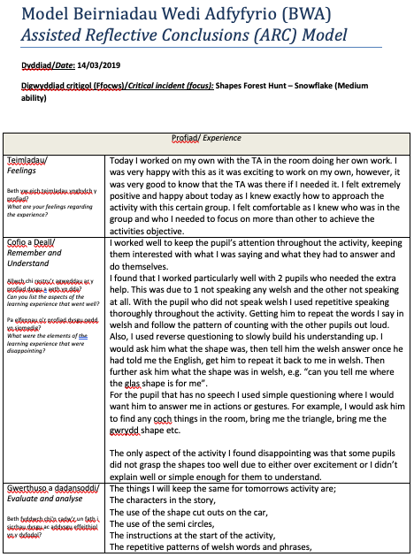
Appendix 2

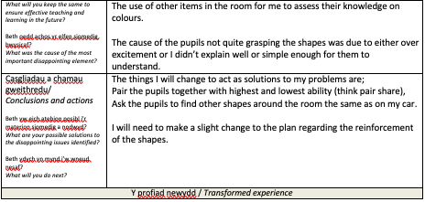
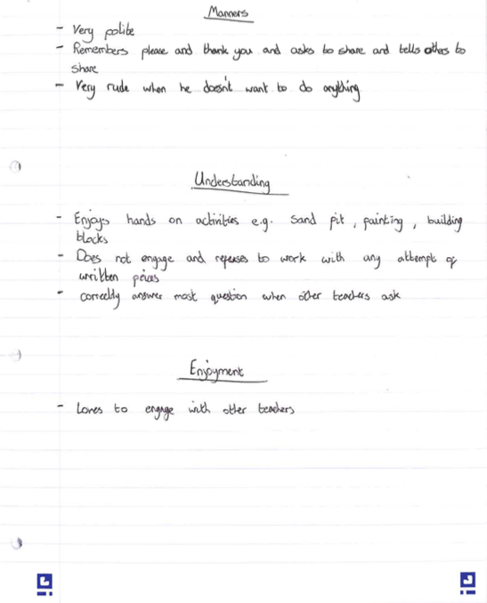
Appendix 2

