Student’s Name: Vasilka Nikolova
Student Number:1906941
Module Title: The Impact of Virtual Learning Environment (Vle) – Moodle on Students’ Learning Experience in The University of Wales Trinity Saint David London Campus
Assignment Title: Digital Skills and Research Methods
Module: BMSW4003
Lecturer’s Name: Joy Botu

Introduction
In the contemporary world of technology and communication, Virtual Learning Environments (VLEs) are widely employed in education and other sectors typically to facilitate communication and deliver instructional materials (Rienties and Rees, 2016). In the education sector, VLE may be a web-based computer code outlined to encourage educating and learning with the utilize of instruments and exercises. Learners utilizing a VLE framework can be set an assignment to total in lesson or at their claim time, pace and area. Other than, learners can contribute to offbeat and synchronous dialogs to help in creating their learning (McGill and Hobbs,2008). Empirical studies (Barker and Gossman, 2013; Rienties and Rees, 2016) indicate that the use of VLEs has significant impacts on student’s achievement, as they encourage independent learning, boost the teachers’ interests to teach, and increases the learners’ motivation to learn.
In the University of Wales Trinity Saint David London Campus, the benefits of employing the VLEs can be seen in positive practices. This research gives a preview of the students’ encountered almost the utilize of the VLEs and its impacts on their learning, and from the inquire about discoveries, proposals are made for instructors and instructor teachers.
Objectives
The survey investigated the reported impacts of Virtual Learning Environment (VLE) – Moodle on Students’ Learning Experience in The University of Wales Trinity Saint David London Campus.
The inquire about overview was based on three investigate questions that explored : Whether the utilize of the Moodle (VLE) includes a positive effect on the students 'learning; whether the utilize of a VLE in instructing and learning help make free learning : and whether the use of VLE encourages students’ inspiration to memorize. The inquire about discoveries and proposals will be of wide intrigued to instructors and educator teachers as they appear regions for consideration in advancing the VLE utilize to upgrade learning.
A quantitative think about was conducted within the frame of an e-questionnaire (Study Monkey) permitting information examination with Exceed expectations. The investigate questions were organized and gathered inside the three thinks about questions. All the Certificate HE, B.S.C, and B.A. students at the University of Wales Trinity Saint David London Campus were welcomed to total the study. The survey completion advancement was done amid the gather instructional exercises where students were welcomed to fill and total the study at their own time. To set up a required least agent test, a test measure calculation of 95% certainty level was carried out and a reaction rate of 59% with a least test measure of 12 was required to create agent comes about. The three investigate questions (RQ) were posed and each address was reworded to make a testable speculation.
Sometime recently the inquire about study went “live” a web pilot was carried with a randomly chosen certificate HE students gather. Thus, the wording of one address was corrected and the survey was developed into two segments. Within the to begin with area, questions 1 to 10 utilized closed ended numerous questions that inquired respondents almost their utilize and involvement of Moodle. The moment segment inquired closed-ended questions connected to the points of the three inquire about questions (RQ). Each of the moment area questions constituted of four sub-questions to which the chosen members chosen a point on a Likert scale (Agree or Disagree). An in general score of the reaction was calculated for each address from the summation of their four sub-questions. A neutral reaction such as not one or the other concur or oppose this idea was not considered inferring as it were “no” or “yes” signifies the degree of understanding.
In any case, all the survey comes about were mysterious and the students were educated earlier to beginning and completing the think about overview. Additionally, a data sheet was managed to the students amid the instructional exercise period and was accessible on the University of Wales Trinity Saint David London Campus VLE. The overview completion for one week and the group mentors were asked to energize understudy completion to guarantee an essentially huge test was gotten.
Primary Data Analysis
Amid the one week, 12 useable surveys were completed speaking to a 59% reaction rate from a cohort of 21 students. Of the 12 respondents 83.33% get to the Moodle without helped, 16.67% require aid get to the Moodle. Based on the utilize of the University of Trinity Saint David London Campus Moodle as an integrated part of students’ learning, 66.67% of the respondent check email in Moodle once a week while only 25% check every day. A relatively small figure of 8.33% never checks email in Moodle at all. For RQ1(Does the utilize of a VLE have a positive effect on understudy learning?), the cruel rating was calculated with all the detailed over 3.0 and “Yes” reaction. An totaled explanation reactions demonstrated a “Yes” reaction and 100% of the respondents concur “Yes” that the use of the University of Wales Trinity Saint David London Campus Moodle has a positive impact on their achievements and motivation to learn and 0% of the respondents ‘’ disagree (‘’No’’).
The comes about for RQ2 (Does the utilize of a VLE in learning and educating help make autonomous learning?) shown that 100% respondents concur (“Yes)” that the opportunity to memorize utilizing the Moodle at a pace, time and put (uploading their task) to suit the student’s self-empowers free learning. 100% respondents concur (“Yes”) that assets constituted within the Moodle energizes communication between students. Totaled articulation reactions illustrated that 100% of the respondents concur (“Yes”) the use of Moodle in the University of Wales Trinity Saint David London Campus encourages the students’ independent learning.
The comes about for RQ3(Does the utilize of a VLE for learning and educating encourage students’ inspiration to learn?) demonstrated that 100% concur (“Yes”) that being in control of learning and instructing, learning at a pace, time and put, encourages inspiration to memorize. 75% of the respondents concur (“Yes”) that the assortment and different course apparatuses and assets accessible on Moodle encourages or increases the students 'inspiration to memorize. 75% concur (“Yes”) that distinctive designs available on the Moodle encourages the students’ inspiration to memorize and 75% concur (“Yes”) that criticism on Moodle exercises encourages or stimulates the students’ inspiration to memorize. The cruel reaction score for all the RQ3 sub-questions was over the “agree “side of unbiased. The totaled explanation reaction demonstrated that 100% of the students concur (“Yes”) that the utilize of VLE- Moodle on students’ learning within the University of Wales Trinity Saint David London Campus encourages or increments the learning and 0% disagreeing(“No”).
Each of the three questions within the study was cross tabulated (chi-squared tests) with the other 10 questions approximately the VLE-Moodle utilize. The chi-squared test was based on a comparison of the watched values collected announcing the measurable probability of the relationship happening by chance. In all the cases, there was a significant chi-squared statistic with possible impacts nature of the association.
Secondary Data Analysis
The writing survey from observational thinks about gives prove that the utilize of Moodle gives adaptability for understudies to settle coursework around active plan expanding the students 'inspiration to memorize , advances collaborative learning , and communication by means of the utilize of chats, gatherings, and dialogs that are exceedingly propelled to memorize . McGill and Hobbs (2008) emphasized that online discourses and learning through a VLE has the capability of improving collaboration and concept improvement. Opposite Barker and Gossman (2013) contend that collaborative instruments such as gatherings and chats have positive impacts on the students’ learning. Within the think about of internet –based courses, Rienties and Rees (2016) found that seen adaptability and convenience of VLE are emphatically related with the students’ fulfillment with a course. From a learning approach a VLE-Moodle gives differing openings for review, hone and suit different learning assets and groups such as interactive media.
Contemporary writing shows that VLEs give an opportunity for the studies to be in control of instructing and learning forms that lead to moved forward accomplishment, fulfilment and maintenance for a bigger and more assorted understudy body. Sumak and Hericko(2010) recommend that arrangement of littler bunches who lock in themselves through the VLE program can make an person understudy feel less humiliated subsequently empowering understudies to share thoughts. Essentially, assignments given on a VLE give openings for students to memorize at characterized, time, put and pace thereby empowering understudies to require a level of possession to their learning and teaching which increments their inspiration and freedom to memorize. Barker and Gossman (2013) claim that guides can viably give direction in initiating online discourses and providing introductory contentions to spur learners included effectively within the moment.
A Sumak and Hericko (2010) within the UK moreover back the positive impacts of the utilize of VLEs on the students 'learning. Upper-grade basic students and instructors utilized a program collaboration apparatus to empower instructors and understudies to communicate online to create their explanatory aptitudes and understanding. Understudies who utilized the computer program collaborative apparatus performed altogether way better on the standardized test in dialect, perusing, lexicon, numerous viewpoints and free thought compared to understudies who did not utilize the program. The think about concluded that VLEs energizes dynamic thought, maximizes students’ reflection and autonomous considering. In research conducted in a better instruction setting into VLE-Moodle utilize over the UK, Rienties and Rees (2016) studies social work understudies exploring whether computer-dependent technology-based instruction advantaged impeded understudies. The student concluded that the utilize of VLEs suit the requirements of impeded student

Conclusion
The utilize of Virtual Learning Environment (VLE)-Moodle in The University of Wales Trinity Saint David London Campus is essentially developing over the past few a long time. When it comes to the student’s discernments of the utilize of VLEs in their learning handle, it can be concluded that several understudies who respected the utilize of the VLEs come with positive impact. Students see the utilize of VLEs as advantageous and discover the applications utilized amid the Moodle interaction to be simple, useful, fulfilled and they will suggest it to other students. The lion’s share of students suggest that the Moodle includes a positive effect on their learning, makes a difference them create free learning and increments their inspiration for learning.
The inclusion of technology in the University of Wales Trinity Saint David London Campus courses is positive and rewarding for students and teachers. However, strategies should be implemented to encourage non-directed use of the Moodle to ensure that the VLEs use is interactive, but not limited to a role as an information repository. Thus, a CPD staff in the development and use of the VLE must be provided to ensure that all students have access to the VLE at their pace, time, and place (home).

References:
McGill, T.J. and Hobbs, V.J., 2008. How students and instructors using a virtual learning environment perceive the fit between technology and task. Journal of Computer Assisted Learning, 24(3), pp.191-202.
Barker, J. and Gossman, P., 2013. The learning impact of a virtual learning environment: students’ views. Teacher Education Advancement Network Journal (TEAN), 5(2), pp.19-38.
Rienties, B., Giesbers, B., Lygo-Baker, S., Ma, H.W.S. and Rees, R., 2016. Why some teachers easily learn to use a new virtual learning environment: A technology acceptance perspective. Interactive Learning Environments, 24(3), pp.539-552.
Šumak, B., Polancic, G. and Hericko, M., 2010, February. An empirical study of virtual learning environment adoption using UTAUT. In 2010 Second international conference on mobile, hybrid, and on-line learning (pp. 17-22). IEEE.

Appendix one: Questionnaire About Moodle Platform
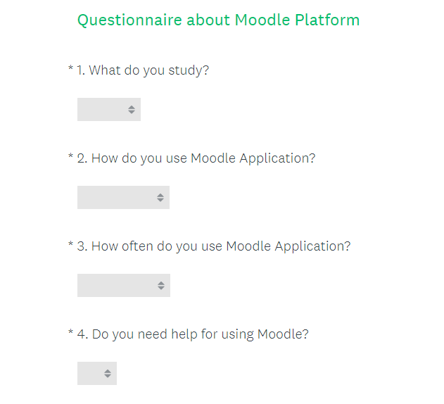
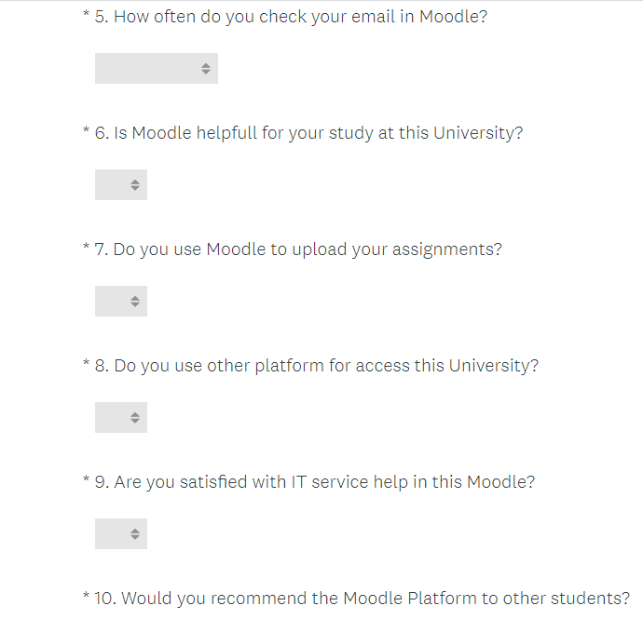

Appendix Two: Questionnaire Response Results


