Problem Solving and Decision making
Student name: Klaus Ivan
Student ID: 21079380
Course code: BMSW4004
Professor: Chijioke Uba

Table of Contents
Introduction: 3
Nature of the problem: 3
Impact of the absence on the organisation: 5
Causes: 7
Health-related issue: 7
General issues: 8
Child care: 8
Harassment: 8
Flexibility: 8
Poor leadership: 9
PESTLE analysis of absenteeism 9
Alternative solution: 10
Creation of a clear attendance policy: 10
Rewarding system: 11
Providing support: 11
Feedback: 11
Reducing stress: 11
Evaluation: 11
Action plan: 12
Conclusion: 13
References: 14

Absenteeism Report

Introduction:
The employees at the workplace have to go through a number of issues which makes them unable to pay attention to what they are doing. These factors can make or break the companies effectively, and therefore the management has to look out for the possible causes of the issues that are underpinning the growth of the companies. A great workforce can spell a major difference in the company. A healthier and happier workforce tends to produce more significant growth for the company. However, it can't be guaranteed that this will always be a situation. There are a number of issues that the employees face, which leads to other problems as well. Absenteeism is one of those issues which are caused by a number of factors, and after that, they can lead to other problems as well. This very issue will be part of the discussion of the report presented. The report will cover the nature of the issues, their impact, pestle analysis, and adequate solutions. Moreover, the report will present the MPI evaluation and implementation of the plan. The paper will discuss the fishbone diagram through which the important factors that lead to the increased rate of absenteeism so that a more structured pattern of absenteeism can be presented.

Nature of the problem:
The report requires to discuss the problem from the Mid Cheshire Hospitals NHS Foundation Trust (MCHT), a medium level hospital that has to face a decreasing rate of presence of employees. Despite the implementation of the program, the rate of absenteeism is not reduced to a satisfactory level; rather, there was a concerning number of losses in terms of productivity. The poor quality of services and the need for compensation of the absent employees increased the loss to reach up to $1 million. These numbers are concerning for the management since such loss every year can make the company suffer to a large extent. Therefore the need for an effective solution to this problem rises to make the employees stay present at the workplace and fulfil their duties.
Absenteeism can be defined as the habitual absence from the workplace of the employees. These habitual absences can be intentional and planned, or they can be unintentional. However, when discussing it in the workplace, mostly intentional absence is part of the discussion, which causes more harm to the company as compared to unintentional.
Intentional absence refers to the absence from work without any specific reason or solid justification. On the other hand, unintentional absences are those absences that employees make due to the presence of unforeseen circumstances. These circumstances can't be avoided; therefore, employers can't take enough measures to deal with them. Behind these circumstances, there are certain factors that can be controlled. The same is the case with the health sector employees.
The employees working in the hospitals are very vulnerable to the virus and bacteria which would attack these employees to get them sick. Therefore more sick call-ins have become part of the problem. However, the issue isn't only remained to the limits of the hospitals. The offices around the UK have to face more sickness based absent as compared to any other European Union country. Not only is this the impact of the problem highly diverse, which makes the organisation and authorities think about how to moderate the situation and make the employees stay longer and more regular at their position.

Impact of the absence on the organisation:
The impact of the employees' absence is very diverse, which makes it almost enough to categorise each type of reason and cause of the absence. However, the impact of this absenteeism occurs in the form of financial damages, lower quality of services, customer dissatisfaction and the company's shattered image.
Though the rate is decreased as compared to the previous years, however, they are still not at a satisfactory level. As presented labour force survey from the government of the UK shows the following statistics:
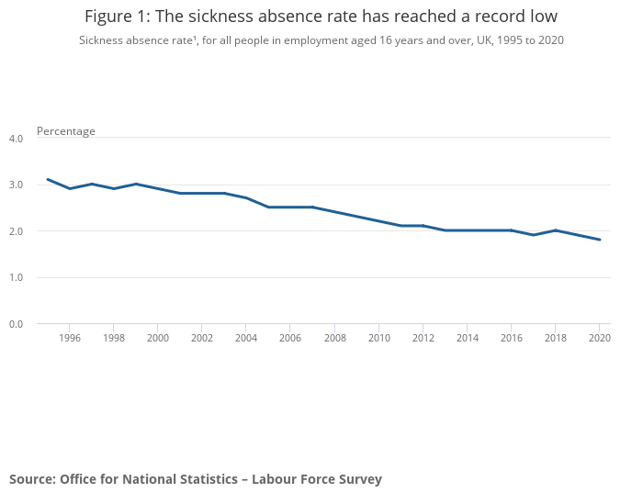
(Leaker and Kumar, 2021)
The rate of absence has been decreased from more than 3% to 1.8% in 2020. The major reason behind this was that the employees had to work from their homes; therefore, they were less infected by any virus and had better working conditions. As a result, the absence rate decreased. However, the loss incurred by the organisation in the previous years indicates that if the employees are back to the normal working conditions, they are more likely to show the same results. The data from the UK economy shows that the companies had to face £91.9 billion in terms of ill health-related absenteeism (Chaffer, 2020). Employers in the UK had to suffer from 38 working days lost per employee due to the mental and physical health problems in employees. This shows that the productivity of the employees has been decreased to the concerning level since, in the year 2014, the number of days lost per employee was about 23 days per employee which is very less than the current rate of absence. A very major factor here also rises in the form of presentism which says that the employees showed up for work; however, they weren't able to be productive, which almost 43% of the UK employees admitted to be suffering from.
The critical issue here is the presence of conflicting data. Where the employers present that the rate of absence has been decreased over the past few years; however, the present pandemic showed very unconventional reasons for the absence. The employers showed that the employees were getting absent in terms of self-isolation, and therefore the hospitals, particularly where work from home is nearly impossible, had to suffer from the lower presence rate. There is a projected loss which says that the companies might hit £36.70 billion due to omicron. The amount of this loss is 8.8% of the GDP of the country, and the government was ready 25% of the absenteeism rate. The UK was hit with a record absence during the pandemic, which was more than any other average (Milliken, 2022). However, London had a lower absence rate than the average in the UK. Many reports show that the long Covid pandemic presence resulted in the presence of a longer absenteeism rate among the employees (Buckley, 2022).

Causes:
The causes of the higher rate of absenteeism are very diverse; therefore, they are presented to be divided into health-related issues and general issues.

Health-related issue:
The statistics from the office for national statistics showed that health-related issues were the major reasons for the absence of the employees; therefore, the main concerns always remain health-related absenteeism. Minor health illness makes up to 26.1% of the total absent rate; other condition shows 17.1%, muscuskelte made up to 15.4% of the problem and mental health conditions were comprised 11. 6% of the health-related absence. Following is the data presented by ONS:
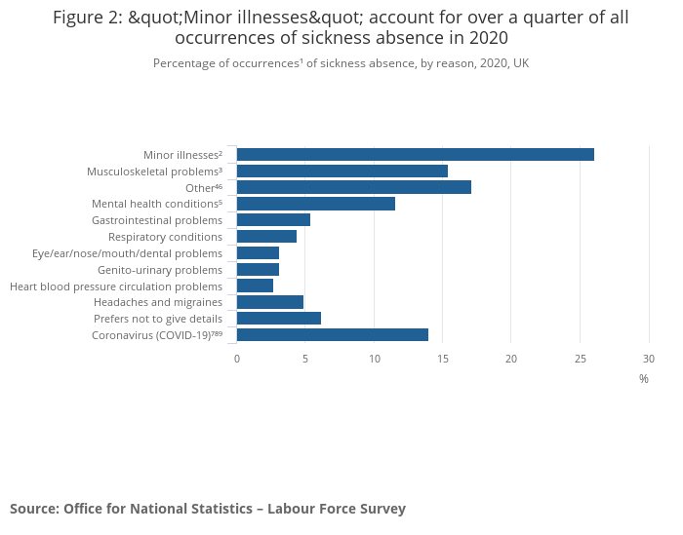
(Leaker and Kumar, 2021)
Though there was no concept of the mental health problem in the past and the poor rate of productivity due to the presence of any of these issues, there were more chances that the employees were put into the unjustified excuse of absence; however, with the increased rate of researchers explaining their impact, the employers are accepting the presence of the absenteeism rate due to the mental health issues.

General issues:

Child care:
Child care is one of the top reasons why 80% of female employees get absent from their workplace since they are unable to find an alternative for their care. Adult care can also be part of this issue since the employees can have the elderly at their homes, and they can find caretakers for them (GOFF, MOUNT and JAMISON, 1990).

Harassment:
Harassment is also a major reason why employees get absent from their workplace. Both bullying and harassment make the workplace unfavourable for the working of the employees, which causes them to get absent (Merkin and Shah, 2014). Bullying costs 18 million workdays every year.

Flexibility:
The employees are many times unable to find a better work-life balance which makes them feel burnt out at the workplace, making them seek other ways to get relaxed. When the policies at the organisations are not flexible, the employees will use unrealistic excuses for their absence. There are many companies like Cable Communication, which is a publishing company, which had accepted the employees' excuse that they didn't feel like coming to work when they woke up. The employees are provided with four paid duvet days or mental health days per year. The company believes that if employee does not feel like they want to work, they are not productive at their job. Therefore the need for a work-life balance is very important for the employees.

Poor leadership:
Poor leadership of the organisation also plays a significant role in making the employees get off from their work frequently. This is because the organisation wasn't able to create a commitment with the organisation, as the survey shows that 80% of the employees showed a lack of real commitment to their jobs. As a result, they are more likely to take their time off from their work (Frooman, Mendelson and Kevin Murphy, 2012).

PESTLE analysis of absenteeism

The following fishbone diagram is present to present more causes of absenteeism based on the pestle analysis and the causes and effects analysis given above.
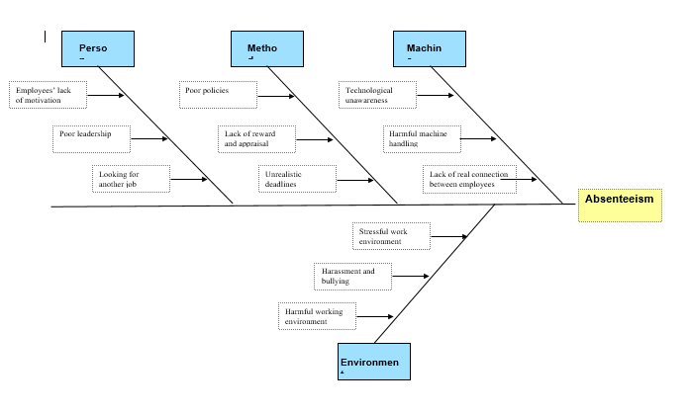

Alternative solution:
There are many solutions that can be given to employers to decrease the rate of absenteeism of the employees:

Creation of a clear attendance policy:
The employees should be aware of what they are expected to do about their presence in the workplace. The policies of the company should be crystal clear to let the employees get all the information about how they can take time off when they are required. The reporting and monitoring process should be very clear as this will help the employers to assess the performance of the employees.

Rewarding system:
There can be a situation when the regular employees are not recognised; therefore, the lack of appreciation makes them show poor performance. Therefore, employers should reward employees who have a good attendance rate.

Providing support:
The employees should be provided with adequate support for the issues that they are facing, such as the presence of an employees assistance program that will help the employees with their health-related issues.

Feedback:
Employees should be provided with effective feedback that would help them to assess their own performance. In this way, they will be able to understand their lacking areas and will perform better in the future.

Reducing stress:
The work-life balance creation is the responsibility of the employers; therefore, they should work to provide every facility which will reduce the level of stress on the employees, and as a result, their burnt out will reduce.

Evaluation:
Solution | Plus | Minus | Interesting
Creation of a clear attendance policy | A clear policy will reduce ambiguity | The policy can lack flexibility | A flexible clear policy can be created
Rewarding system | Will encourage employees | Employees will lack real motivation | A short term motivation can be created
Providing support | It will help the employees to deal with their problems | This will create an extra burden on the company | Employers will have to face the extra cost of support
Feedback | Will guide the employees | Employees might not like negative feedback | An interactive and effective feedback system can be created
Reducing stress | Will create an effective work-life balance | Employees can be distracted | An active and effective working environment should be created

Action plan:
Following are the steps that should be taken by employers to implement an effective plan for the control of absenteeism:
- Distinguish between long-term and short-term absence and classify them into health-related absence or general absence
- Looking at the provided data and finding the root causes
- Looking out for the red flags that are present in the trends
- Creation of a listening system
- Introducing an absence mechanism
- Talking to the employees
- Creating a rewarding system.

Conclusion:
The presence of the absenteeism rate in the organisation is clearly a concerning matter that affects the employees and the organisation significantly. The classification of the absenteeism trends provides the organisation with the effective analysis and trends with the help of which they can create their action plans customised for their needs. The focus of the employers should be on causes and effects so that the solutions can be implemented according to these causes.

References:
Buckley, T., 2022. U.K. Firms Grapple With ‘Impossible’ Numbers of Covid Absences. [online] Bloomberg.com. Available at: <https://www.bloomberg.com/news/articles/2022-01-04/u-k-firms-grapple-with-impossible-numbers-of-covid-absences> [Accessed 7 April 2022].
Chaffer, A., 2020. Britain's £92 Billion Productivity Loss: Nations ‘First Productive Day’ Is Now 21st February | Mercer. [online] Uk.mercer.com. Available at: <https://www.uk.mercer.com/newsroom/britains-92-billion-pounds-productivity-loss-nations-first-productive-day-is-now-21st-february.html> [Accessed 7 April 2022].
Frooman, J., Mendelson, M. and Kevin Murphy, J., 2012. Transformational and passive avoidant leadership as determinants of absenteeism. Leadership &amp; Organization Development Journal, 33(5), pp.447-463.
GOFF, S., MOUNT, M. and JAMISON, R., 1990. EMPLOYER SUPPORTED CHILD CARE, WORK/ FAMILY CONFLICT, AND ABSENTEEISM: A FIELD STUDY. Personnel Psychology, 43(4), pp.793-809.
Leaker, D. and Kumar, K., 2021. Sickness absence in the UK labour market - Office for National Statistics. [online] Ons.gov.uk. Available at: <https://www.ons.gov.uk/employmentandlabourmarket/peopleinwork/labourproductivity/articles/sicknessabsenceinthelabourmarket/2020#measuring-sickness-absence-during-the-pandemic> [Accessed 7 April 2022].
Merkin, R. and Shah, M., 2014. The impact of sexual harassment on job satisfaction, turnover intentions, and absenteeism: findings from Pakistan compared to the United States. SpringerPlus, 3(1).
Milliken, D., 2022. UK hit by record staff absences, hospitality slump from Omicron wave. [online] https://www.reuters.com/. Available at: <https://www.reuters.com/world/uk/uk-diners-slump-after-omicron-hit-staff-absences-hit-record-2022-01-13/> [Accessed 7 April 2022].

