Component 2 - Research Report
Student Name: MIOARA COSTEA
Student Number: 2126840
Lecturer Name: Seyed Navid Nasirpourosgoei
BMSW4003_BIRM
Digital Skills and Research Methods.

Abstract
Technology that collaborated at UWTSD by the students is an innovative process and availing it with training will be the best use of it. This assignment is based on the technology that is used in the education and chosen research question is needed for training for using the technology to collaborate at UWTSD. This assignment is cover research design along with the research approach, philosophy, and approach. This research has followed the primary quantitative data process. In the case of research philosophy, it followed the positive, and in the case of the research approach, it follows the inductive research approach. This research has further done survey as it follows the primary quantitative data process.

Contents
1. Abstract 2
2. Introduction 4
3. Research design 4
3.1 Research Question 4
3.2 Method 4
3.3 Ethical Considerations 5
4. Results 6
5. Discussion 10
6. Conclusion 12
7. Reference List 13
8. Appendix A – A blank copy questionnaire. 15

2. Introduction

This assignment is based on the technology that is used by the students of “University of Wales Trinity Saint David” or UWTSD. University has received some of the best rankings in “Complete University Guide 2022” for its genuine and excellent study. Normally the technology used by the university is organized by Microsoft Teams. Digital learning is further accepted by the university. JISC is a discovery tool that is used by the students as a part of the “Digital skill framework”. This assignment has made it further research on the training that is needed to provide for generating the methods of using the technology to collaborate at UWTSD.

Research design

Research Question
Q1: Is there a need for training for using the technology at UWTSD?
Q2: What is the need of providing training for using technology at UWTSD?
Q3: How to use the technology to improve digital learning?

Method
Research philosophy
There are majorly three types of research philosophy: positivism, realism, and interpretivism. Positivism supports the reality that can be described and observed from any objective viewpoint. This can be related to the existing evidence. As per the opinion of Nefdt, (2019), in the case of interpretivisum, this process prefers the quantitative aspects where the realism is based on the key assumptions of different research layers. In this case, the “positivism research philosophy” has been followed as this process is effective in research and interpreting the research outcomes.
Research Approach and design
It is a major part of any research work and there are three major research approaches that determine any research such as deductive, inductive, and abductive research approaches.As per the view of Frankenhuis et al. (2020), the inductive approach follows the development of new hypotheses and ideas whereas the deductive approach concludes the evidence and is based on the objectives and aim of the research. In this case, the inductive research approach is followed.
Research design is the property that helps to diagnose the focus of the researchers. There are three important research designs that are majorly followed such as exploratory, explanatory and descriptive design. Exploratory helps in explaining the best-suited option for different factors whereas explanatory design helps in explaining the predefined factors. Descriptive design supports different perspectives and viewpoints for analyzing the outcome of the topic. In this case, the most relevant research design is a descriptive research design that helps the researcher in collecting different information regarding the topic.
Data collection method
The future of the research mostly depends upon the data collection method as the result of the research is dependent on this. Future, as well as the success of the research, is followed by this method of the data collection process. There are broadly two types of data collection process: primary and secondary. As per the view of Szwarcwald et al. (2019), when the data is made by the different authors and the researcher is using the previously existing data in their own research work then it is called the primary data process. The data discovered by the researcher himself is known as the secondary data collection process. In this research work, the “primary data collection process” has been followed. There are two types of data that are generally found that are qualitative and quantitative. Data collected by the numerical process is known as quantitative and data collected on non-numerous methods is known as qualitative data type. In this context the quantitative data type has been followed. Overall data collection is done by following primary quantitative data analysis. This analysis of primary quantitative data is done with the help of a survey. The survey is conducted on 20 people including the staff, teachers, and students.

Ethical Considerations
Proper rules and ethics need to be followed in the case of conducting research. In this research work, the primary data process has followed that supports the ethical consideration. In order to conduct primary research, the survey has been organized with people that are related to UWTSD. It was a good survey as all of the participants supported equally and all of them shared a lot of good information. The proper process has been maintained throughout the search and proper referencing is done as per needed. The Copyright Act is maintained properly as every source that has been followed is genuine. It is to be mentioned that if any data is found breached then certain action will be taken against the researchers. ( you need to add an in-text citation to define ethic )

- Results
This research has followed the primary quantitative data process and for which the survey has been conducted with 20 people. The response of those people in the survey is collected and is mentioned here.
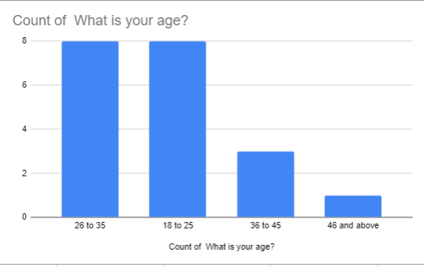
Figure 1: Response of Q1
(Source: self develop)
The maximum of responses was from the age 18 to 35 and there were comparatively less of people 36 to 45 and above.
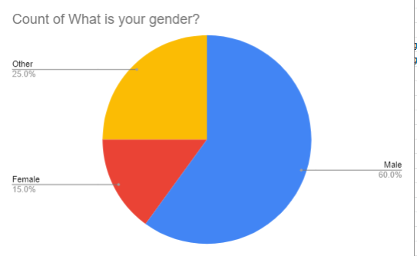

Figure 2: Response of Q2
(Source: Self Develop)
Among the responses, there were 60% of males, 15% of females along with 25% of others.
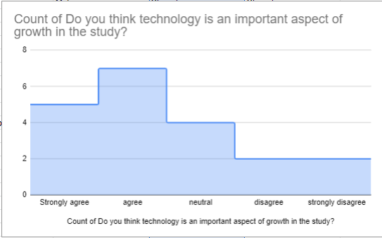
Figure 3: Response of Q3
(Source: Self Develop)
The third question was about the importance of technology in the growth of study and it was agreed by 7 out of 10 people among them whereas 5 out of 10 strongly disagreed. 4 out of 10 supported as neutral and 2 out of 10 strongly disagreed.

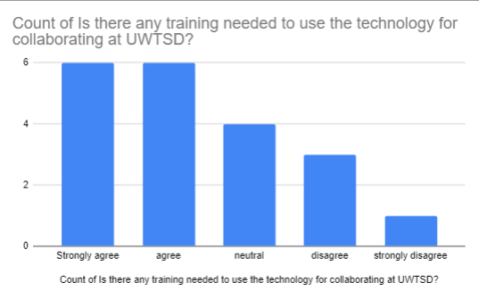
Figure 4: Responses of Q4
(Source: Self Develop)
This was the question about whether the training is needed for using the technology for collaborating at UWTSD. It is to be noted that there were mostly positive answers as most of the people strongly agree with this proposal.

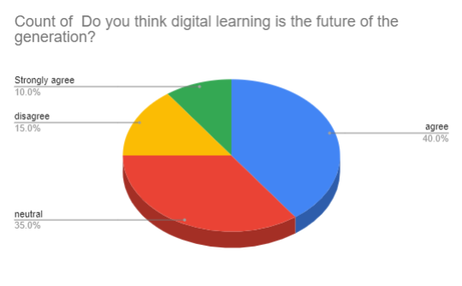
Figure 5: Responses of Q5
(Source: Self Develop)
This fourth question was about whether digital learning is the future of this generation. It is to be noted that around 40% of those respondents agree with this whereas 35% of them stand as neutral. 10% of people strongly agree whereas 15% of people disagree with the fact.
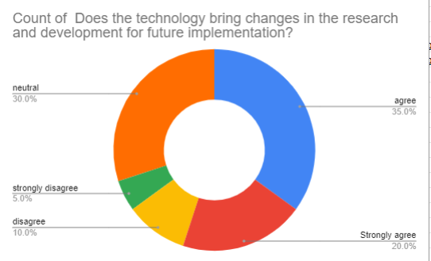
Figure 6: Response of Q6
(Source: Self Develop)
The following question is about whether technology brings a change in the research and development sectors for future implementation. 35% of the people supported it by agreeing with it where 20% strongly agreed. 30% of them were neutral and 10 % disagreed. 5% responded as strongly disagreed.
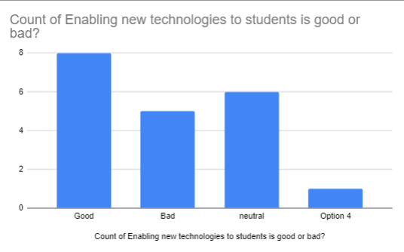
Figure 7: Responses of Q7
(Source: Self Develop)
This question was about whether enabling new technology to students is preferred or not and the response was assertive as most of them supported it as good thought. Few of them were neutral and negative.

Discussion
Technology is an important aspect of growth in study
Growth of study in this generation is an important aspect. It enables the student's distance learning and enables access of up to date information. Technology also enables online education which can be a good option in the time of a pandemic. Technology also helps in access to education resources. These days children use their smartphones and tablets outside of school to access the applications of school. As per the view of Whitehill et al. (2022), technology also helps in improving learning experiences as modern technology enables artificial intelligence for developing innovative and creative lesson plans for holding the attention of their classes. It is the future of the growing development of the study. Technology enables the growth of learning which improves the learning experiences along with the own pace of the students. This technology also helps in preparing the future careers of the students and soon it will become the only source of importance that will provide uncountable opportunities.
Need for training in the use of technology for collaborating at UWTSD
Technology is an important as well as innovative property that authorizes some more new creativity and innovation in every sector whether it is education or some new discovery. Before providing any technological innovation it is important to provide the training. As per the opinion of Watt et al. (2019), for every application or new technology, it is important to provide the proper training to use it. Only prowler training can enable us to know about the proper use properties of technology. UWTSD needs to provide proper training through schemes to the students so that they can easily use every technology and grow their learning abilities.
Digital learning is the future of this generation
There is not only one reason but there are several other reasons that let people know that digital learning is the future of this generation. As per the knowledge of Penaluna et al. (2020), the reasons are: it is flexible. Online education led the students and teachers to set their learning pace and there’s the addition of flexibility that fits the agenda of everyone. This system allows a wide program of selections as there are infinite subjects and skills offered to learn and teach. Higher numbers of education schools offer online versions of the program for various disciplines and levels. Another reason is it is accessible. Online education permits teaching or studying from the whole world. This means there is no need to reduce from any place or follow any rigid schedule. One of the major reasons is it is a time saver along with it saves the money may be on transport and other. According to Wainwright et al. (2020), it allows customized learning experiences as it enables greater intersections with more feedback between the teacher and students. The overall experience of digital learning is a fluent service and it provides seamless services so that the tutor and students both become helpful. These numbers of digital productivity is the proof of being the future of this generation
Technology brings changes in research and development for future implementation
In the era of digitalisation, the implementation of technology will help to bring a drastic change in the sector of research and development. There so much research is paused due to a lack of modern technologies. Effectively implementation of modern technologies will provide the researcher as well as students an advantage to conduct their research (Gashi Shatri, 2020). Technologies will help to digitalise the education system and moreover, so many students will get access to different books and data sources to acquire knowledge and proceed with their research. Implementation of technology will effectively reduce potential human errors and increase the efficiency of the research process. Tutors can use technology to meet their learning goals as well as productivity. Implementation of digital tools helps to enhance educational opportunities for students across the world. It also helps the tutors to improve their instructive method and personalize learning skil.
- Conclusion
It can be concluded as this assignment is based on the technology used by the University of Wales Trinity Saint David. In order to enhance the research, positivism research philosophy has been chosen along with the inductive approach. The primary quantitative data collection method has been prioritized. A small survey was also conducted through Google form. Descriptive research design has been followed to design the whole research. A brief discussion has been formed on the basis of survey results to evaluate the real facts as well as justification of the survey results. In end, it can be stated as technology provides all students with a competitive advantage to continue their studies as well as also helping them enhance their field of research. Effectively implementation of modern technologies will provide the researcher as well as students an advantage to conduct their research.

- Reference List
Bell, A. and Emanuel, L., 2014. Engaging Communities in their Heritage: Collaboration between Higher Education and the Voluntary Sector in Wales and Ireland. Almatourism-Journal of Tourism, Culture and Territorial Development, 5(2), pp.32-38.https://doi.org/10.6092/issn.2036-5195/4516
Davies, C., 2021. Online seminars in statistics for doctoral students: A case study. Journal of University Teaching & Learning Practice, 18(2), p.06.https://doi.org/10.53761/1.18.2.6
Griffiths, D.A., Inman, M., Rojas, H. and Williams, K., 2018. Transitioning student identity and sense of place: future possibilities for assessment and development of student employability skills. Studies in Higher Education, 43(5), pp.891-913.https://doi.org/10.1080/03075079.2018.1439719
Hayles, C., 2018. Embedding education for sustainable development through the well-being of future generations (Wales) Act 2015.10.3990/4.2535-5686.2019.02
Hayles, C.S., 2019. INSPIRE sustainability internships: Promoting campus greening initiatives through student participation. International Journal of Sustainability in Higher Education. https://doi.org/10.1108/IJSHE-03-2019-0111
Hayles, C.S., 2019. Integrating Teaching and Learning around the Seven Sustainable Development Goals of the Well-Being of Future Generations Act 2015 (Wales). In Culture and Environment (pp. 343-365). Brill.https://doi.org/10.1163/9789004396685_021
Penaluna, A., Penaluna, K. and Polenakovikj, R., 2020. Developing entrepreneurial education in national school curricula: lessons from North Macedonia and Wales. Entrepreneurship education, 3(3), pp.245-263. https://doi.org/10.1186/1471-2288-11-100
Wainwright, N., Goodway, J., Whitehead, M., Williams, A. and Kirk, D., 2020. Playful pedagogy for deeper learning: exploring the implementation of the play-based foundation phase in Wales. Early Child Development and Care, 190(1), pp.43-53. https://doi.org/10.1080/03004430.2019.1653551
Watt, A.J., Phillips, M.R., Campbell, C.A., Wells, I. and Hole, S., 2019. Wireless Sensor Networks for monitoring underwater sediment transport. Science of The Total Environment, 667, pp.160-165.https://doi.org/10.1016/j.scitotenv.2019.02.369
Weicht, R. and Jónsdóttir, S.R., 2021. Education for social change: The case of teacher education in wales. Sustainability, 13(15), p.8574.https://doi.org/10.3390/su13158574
Whitehill, S., Hayles, C.S., Jenkins, S. and Taylour, J., 2022. Engagement with Higher Education Surface Pattern Design Students as a Catalyst for Circular Economy Action. Sustainability, 14(3), p.1146.https://doi.org/10.3390/su14031146
Frankenhuis, W.E., Young, E.S. and Ellis, B.J., 2020. The hidden talents approach: Theoretical and methodological challenges. Trends in cognitive sciences, 24(7), pp.569-581. DOI: https://doi.org/10.1016/j.tics.2020.03.007
Nefdt, R.M., 2019. The philosophy of linguistics: Scientific underpinnings and methodological disputes. Philosophy Compass, 14(12), p.e12636. DOI: https://doi.org/10.1111/phc3.12636
Szwarcwald, C.L., Malta, D.C., Souza, P.R.B.D., Almeida, W.D.S.D., Damacena, G.N., Pereira, C.A. and Rosenfeld, L.G., 2019. Laboratory exams of the National Health Survey: methodology of sampling, data collection and analysis. Revista Brasileira de Epidemiologia, 22.DOI: https://doi.org/10.1590/1980-549720190004.supl.2
Gashi Shatri, Z., 2020. Advantages and Disadvantages of Using Information Technology in Learning Process of Students. Journal of Turkish Science Education, 17(3), pp.420-428. Available at: https://files.eric.ed.gov/fulltext/EJ1272770.pdf [Accessed on 14th June, 2022]
Gashi Shatri, Z., 2020. Advantages and Disadvantages of Using Information Technology in Learning Process of Students. Journal of Turkish Science Education, 17(3), pp.420-428. Available at: https://files.eric.ed.gov/fulltext/EJ1272770.pdf [Accessed on 14th June, 2022]

- Appendix A – A blank copy questionnaire.
Appendix 1
Survey questionnaire
1. What is your age?
2. What is your gender?
3. Do you think technology is an important aspect of growth in the study?
4. Is there any training needed to use the technology for collaborating at UWTSD?
5. Do you think digital learning is the future of the generation?
6. Does the technology bring changes in the research and development for future implementation?
7. Enabling new technologies for students is good or bad?
Survey link
https://docs.google.com/forms/d/e/1FAIpQLSeA1Jr1wdrqGJoC9qFWgVAIm8pVToyWwfOIqPwD4cHW1BeLmA/viewform?usp=sf_link

