

Name: Leticia Maison
Student Number: 2328708
Module Code: BMHP5015
Assignment Title: Component 1: Online Portfolio of Set Exercises
Programme: BSc Health and Social Care
Module Title: Changemakers: Building your Personal Brand for Sustainable Employment

Task 1 – Personal Brand
Write about your own person brand and how you could develop this to enable you to reach your employment goals (250 words- Minimum of 2 referenced sources)

A personal brand is essentially a promise of your abilities, behaviour, and performance. It shows employers who you are and what makes you different from other candidates. explains that a strong personal brand helps individuals stand out from the competition, especially when applying for roles in a busy job sector. (Cote, 2024) explains that employers want to understand your identity, strengths, and what makes you unique, so developing a clear brand is important.
When I think about my own personal brand in a professional sense, I can identify several qualities that represent me well. I am trustworthy, sincere, and eager to learn. These qualities matter because employers value people they can rely on and trust. Job platforms such as CV Library and Indeed also highlight the importance of resilience, flexibility, and confidence. (Herrity, 2023). I recognise that I can continue improving in these areas, especially when it comes to adapting to new situations and believing in myself.
However, I recognize that my personal brand may currently appear quiet or reserved to employers, so I need to show my strengths more confidently. To strengthen my personal brand, I want to focus on improving my communication skills, building my confidence, and gaining more experience. I can achieve this by taking part in training, asking for feedback, and challenging myself with new opportunities. I also want to show more initiative and maintain a positive attitude even when facing difficulties
Enhancing my personal brand will bring me closer to my ideal job by showing employers that I am motivated, capable, and committed to growth. By continuing to build my brand, I can make a stronger impression and stand out confidently in the future job market. (Linkedin.com, 2026)

Task 2 - Network Map and Rationale
Create a map of your own network considering career, support, social and community dimensions. Additionally, you should provide a supporting rationale explaining and critically assessing this (250 words-Minimum of 2 referenced sources).
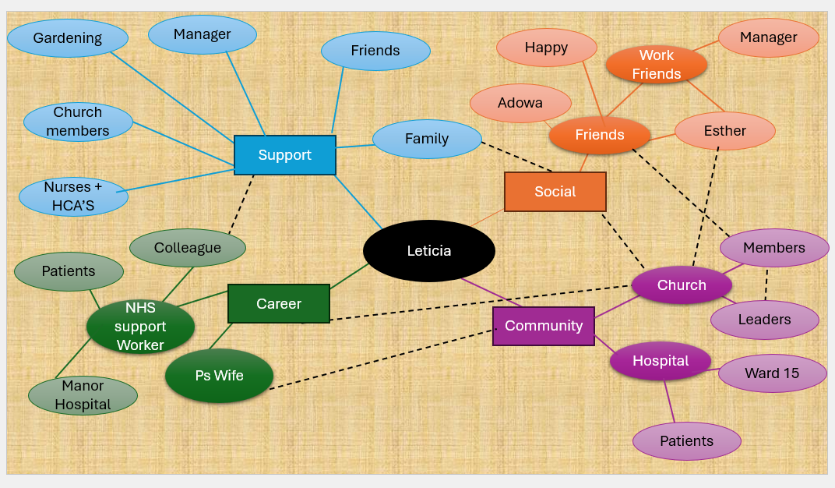
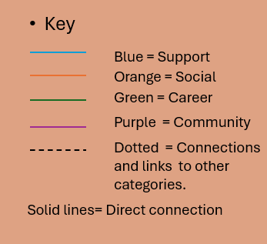
My network map puts me (Leticia) in the centre because all my relationships, roles and connections link back to my daily life. I organised my network into four areas: support, career, social and community. These areas help me understand who me is around, who helps me, and how different parts of my life connect. This is why it was important for me to separate each category clearly. (Nihr.ac.uk, 2024)
My support network includes family, friends, church members, my manager, nurses, HCAs and even gardening. My support network is strong because I have reliable family and church connections. I used solid lines to show strong relationships and dotted lines to show lighter or cross-category links.
However, my career network is smaller, and I rely heavily on a few people, which may limit opportunities. This means I may struggle to access new roles unless I expand my professional contacts. These connections help me learn, grow and feel confident at work. Research shows that professional networks can improve development and open doors to new opportunities (Faizan, 2025)
My social network includes friends, work friends, Esther, Adowa and things that make me feel happy. These relationships help me feel balanced and supported outside of work. My community network includes my church, leaders, hospital, Ward 15 and patients, showing how I am part of bigger groups that shape my life.
Overall, the map shows how all these networks connect to support my wellbeing, identity and growth.

Task 3- Blog
Write a blog exploring a current topic or issue of your choice within the health and social care sector in the UK. The purpose of this is to inform a specific target audience of your choosing (400 words) Referencing of your sources of information is not a compulsory requirement but could be beneficial
Blog: Why NHS Staff Shortages Are Becoming a Crisis for Everyone in the UK
The aim of my blog is to enlighten members of the public who want clarity in understanding the current issues in the Uk NHS today. It explores one of the most urgent issues staff shortages, in the health and social care setting.
Staff shortages are a problem that keeps appearing across not just hospitals GP surgeries, care homes and mental health services. It is noticeable that the population is ever rising and life expectancy is longer, the NHS and social care sector need a lot of staff to deliver high-quality health care or social care at the required times. (Dixon-Woods et al., 2024) When you look closely, it becomes transparent that staff shortages are not just a workforce problem they are a patient safety problem, a public health problem, and a long-term national challenge. (Care Quality Commission, 2022)
There are several reasons behind the shortages. The UK has an ageing population, meaning more people need treatment, long-term care, and support for chronic conditions. At the same time, many NHS workers have left the sector due to stress, burnout, and low pay. The COVID-19 pandemic intensified this, pushing staff to emotional and physical limits. (Chukwunwuba Richard Onyejesi, James and Kalpa Kharicha, 2025) Even now, many report feeling exhausted and undervalued. When experienced staff leave, the workload increases for those who remain, creating a cycle that is hard to break.
The impact on patients is impossible to ignore. Staff shortages lead to longer waiting times, delayed diagnoses, and cancelled appointments. In social care, it can mean rushed home-care visits or vulnerable people going without support. (Care Quality Commission, 2023) In hospitals, fewer staff can increase the risk of mistakes and reduce the amount of time professionals can spend with each patient. Mental health services are also struggling, with young people often waiting months for assessments or therapy. (Mind.org.uk, 2019)
For staff, the pressure is constant. Many feel they cannot provide the level of care they want to give. This affects morale, increases sickness rates, and makes it harder to retain skilled workers. When teams are stretched thin, the whole environment becomes more stressful, and this directly affects the quality of care.
Solving staff shortages will require long-term investment and meaningful change. Better pay, improved working conditions, more training places, and stronger mental health support for staff are essential. Recruitment campaigns help but keeping experienced workers is just as important. (Burns, 2025)
NHS staff are they are real people; this affects real patients and has real consequences. The public, policymakers, and NHS leaders must work together to protect staff and ensure safe care for everyone.

Task 4- NHS Equality, Diversity and Inclusion Quiz (250 words equivalent)
- What is the primary goal of the NHS Equality, Diversity, and Inclusion Improvement Plan?(Answer in one or two sentences.)
  - The primary goal of the NHS Equality, Diversity and Inclusion Improvement Plan is to improve equality, diversity and inclusion across the NHS and strengthen staff’s sense of belonging, while tackling discrimination and unfair treatment within the workforce.

- How does the NHS EDI Improvement Plan propose to tackle the gender pay gap?
a. In order to address the gender, pay gap, the method encourages NHS organizations to examine, explain, and eliminate any unjust compensation inequalities between men and women. Additionally, they must eliminate discrimination in hiring and progress and enhance women's progress into top positions.

- What is meant by the term ‘intersectionality’ as used in the NHS EDI Improvement Plan?
(Answer in one to two sentences.)

  - In the NHS EDI Improvement Plan, intersectionality means understanding that individuals may experience several, intersecting types of disadvantage (e.g., gender + race + disability). It observes that these combined characteristics can generate greater inequity, so the NHS must assess each aspect of a person’s identity when striving for fairness and inclusion.

- Why is it important for the NHS to create a psychologically safe work environment?
(Answer in one to two sentences.)

  - To increase patient safety, the NHS needs a psychologically secure workplace where employees can voice concerns, errors, or prejudice without fear of repercussions. Additionally, it lessens stress and burnout by making employees feel valued, supported, and capable of giving their best work.

- How does the NHS EDI Improvement Plan suggest improving the experience of internationally recruited staff?
(Answer in one to two sentences.
a. The plan says the NHS should give better support to internationally recruited staff, like helping them settle in and making sure their well-being is checked through staff surveys.

- What role does leadership play in advancing EDI objectives according to the NHS Improvement Plan?
(Answer in one to two sentences.)

  - leadership plays an important part in advancing EDI in the NHS. It ensures that the EDI woven into daily operations and decision-making. It aims to hold organizations accountable, essentially strong leaders promote change.

- Identify one way the NHS EDI Improvement Plan aims to reduce health inequalities within the workforce.
(Answer in one to two sentences.)

  - Enhancing recruiting, development, and promotion opportunities for under-represented groups and guaranteeing equal access to career advancement is one method the NHS EDI Improvement Plan seeks to eliminate health inequalities among the workforces. This contributes to a more equitable workforce with equal opportunities for success.

- Why does the NHS EDI Improvement Plan emphasise the importance of collecting and analysing data on protected characteristics?
(Answer in one to two sentences.)

  - The NHS EDI Improvement Plan places a strong emphasis on gathering and evaluating data on protected characteristics since it makes it easier to pinpoint areas where disparities in hiring, advancement, and employee experience occur. The NHS can use this data to target certain issues and assess the effectiveness of EDI initiatives.

- Explain how flexible working policies can contribute to equality and inclusion in the NHS workforce.
(Answer in one to two sentences.)

  - Flexible working policies enhance equality and inclusion by allowing workers to balance work with their own or family issues, this can help reduce barriers faced by carers, parents, disabled staff, and others. They also create a more friendly and accessible workplace, making it simpler for people from all backgrounds

- What is one strategy mentioned in the NHS EDI Improvement Plan to combat bullying and harassment in the workplace?
(Answer in one to two sentences.)

  - Strengthening reporting procedures and making sure employees feel comfortable speaking up are two tactics the NHS EDI Improvement Plan employs to fight bullying and harassment. Establishing a zero-tolerance culture in which occurrences are taken seriously and promptly addressed.

Task 5- A Letter to Yourself
Think of a time in the past when you may have been experiencing issues or difficulties, and after considering what you have learned in this module about emotional intelligence and resilience write a letter to your younger self explaining how these attributes were important at that time and perhaps how developing these areas could have been useful (300 words)

Dear Younger Me,
I want to reflect on a period in your life when things felt challenging and overwhelming, particularly after you lost a loved one. At that time, you were balancing family responsibilities, work demands, and personal emotions without fully understanding how to manage them. Through studying this module, I have learned more about wellbeing, emotional intelligence, resilience, and social support, and I can now see how these ideas would have been helpful to you during that stage.

This module has taught me that emotional intelligence involves recognising, understanding, and managing our emotions in a healthy way. Back then, you often kept your feelings to yourself because you believed staying quiet meant staying strong. With greater awareness of emotional intelligence, you might have interpreted your emotional reactions more clearly and felt more confident expressing them.

The module also explains resilience as the ability to adapt positively and continue functioning during difficult circumstances. Understanding resilience earlier may have encouraged you to acknowledge your limits, pace yourself, and recognise that adjustment takes time.

Another key concept from this module is social capital, which highlights the importance of supportive relationships and networks. You had people around you who cared, but you did not always feel able to rely on them. Learning about social capital has shown me that accepting support is an important part of maintaining wellbeing, especially during periods of change.

Finally, this module has taught me that losing a loved one represents a major life transition. Change theory suggests that significant transitions often involve emotional, cognitive, and behavioural adjustments.

Learning these concepts sooner might have supported you more effectively, Understanding these concepts now helps me manage stress better and support others more confidently.
With care, Your Future Self

Task 6- GANTT Chart (200 words equivalent)
Compile a Gantt chart which illustrates the tasks you have to complete to achieve your future employment goals
This Gantt chart shows the steps I will take to progress into a higher NHS band. It includes training, skill development, updating my CV, and applying for roles. The timeline is realistic and supports my long-term career goals.
Task | Jan | Feb | Mar | Apr | May | Jun | Jul | Aug | Sep
Task 1: Identify Higher Band Roles I want (4/5) | ☒ | ☒
Task 2: Speak to Manager about Career Progression |  | ☒ | ☒
Task 3: Complete Mandatory & Optional Training. | ☒ | ☒ | ☒ | ☒ | ☒ | ☒ | ☒
Task 4: Build New Skills e.g observations, admin, care planning |  | ☒ | ☒ | ☒ | ☒ | ☒
Task 5: Update CV & NHS profile |  | ☒ | ☒
Task 6: Apply for Higher Band Roles |  |  |  |  | ☒ | ☒ | ☒ | ☒ | ☒

Task 7- Making Changes- Report
You are the manager of a care home and want to make changes your workplace. Identify one specific change that you want to implement and write a brief report on how this is going to be achieved considering the necessary skills needed and addressing possible barriers to success. Relevant change models can be highlighted (350 words Minimum of - 3 referenced sources).
Proposed Change: Improving staff training and confidence in dementia care.
As the manager of a care home, one important change I want to put into place is a structured dementia-care training programme for all staff. Many residents have dementia, and staff often report feeling unsure about communication, behaviour support, and person-centred approaches. (Alzheimer’s Society, 2026) Improving training will help staff feel more confident and will improve the quality of care we provide. (Cqc.org.uk, 2024)
To achieve this change, I will follow Lewin’s Change Model. Lewin’s model is simple and easy to follow, but critics say it does not fully reflect the complexity of modern healthcare settings which includes three stages: unfreeze, change, and refreeze. In the unfreeze stage, I will explain to staff why the change is needed, using real examples from our care home and evidence showing that good training improves person-centred care. A rapid review found that care home training improves staff skills but can be blocked by barriers such as time pressures and low staffing. Sharing this information will help staff understand the importance of the change. (ScienceInsights, 2026)
In the change stage, I will introduce short, practical training sessions, including communication skills, understanding behaviours, and supporting independence. I will also use shadowing, mentoring, and reflective practice. According to StatPearls, change in healthcare often fails because of poor planning, lack of motivation, and weak communication (ScienceInsights, 2026). To avoid this, I will make sure staff have protected time for training and clear support from senior carers.
In the refreeze stage, I will embed the new training into our regular practice. This includes refresher sessions, supervision, and ongoing feedback. Kotter’s model highlights the importance of reinforcing new behaviours, so they become part of everyday culture (ScienceInsights, 2026). I will celebrate improvements, share positive outcomes, and encourage staff to continue using the new skills.
Possible barriers include staff shortages, resistance to change, and limited time. To address these, I will plan training around shift patterns, involve staff in decision-making, and provide reassurance and support. (Alzheimer’s Society, 2026)
Overall, this change will improve staff confidence, strengthen teamwork, and provide safer, more compassionate care for residents.

Reference List
Cote, C. (2024). Personal branding: What it is and why it matters. [online] Harvard Business School Online. Available at: https://online.hbs.edu/blog/post/personal-branding-at-work.
Herrity, J. (2023). How To Create a Personal Brand (And Why It’s Important) | Indeed.com. [online] Indeed Career Guide. Available at: https://www.indeed.com/career-advice/career-development/how-to-create-a-personal-brand.
Linkedin.com. (2026). LinkedIn. [online] Available at: https://www.linkedin.com/pulse/7-steps-developing-professional-brand-exum-mba-shrm-scp-cir-cdr-kxdrc [Accessed 4 Jul. 2026].
Faizan, R. (2025). The Importance of Professional Networking: A Pathway to Career Success. Scientific Societal and Behavioral Research Center, 1(1), pp.59–65. doi:https://doi.org/10.63329/av3nz1236.
Nihr.ac.uk. (2024). Understanding and cultivating our networks. [online] Available at: https://www.nihr.ac.uk/understanding-and-cultivating-our-networks.
Dixon-Woods, M., Summers, C., Morgan, M. and Patel, K. (2024). The future of the NHS depends on its workforce. BMJ, [online] 384(384). Available at: https://www.bmj.com/content/384/bmj-2024-079474.
Care Quality Commission (2022). Staff Shortages and the Impact on Patients - Care Quality Commission. [online] CQC. Available at: https://www.cqc.org.uk/publications/monitoring-mental-health-act/2021-2022/staff-shortages.
Chukwunwuba Richard Onyejesi, James, T. and Kalpa Kharicha (2025). Understanding why health professionals are leaving the UK national health service (NHS) – A systematic review and narrative synthesis. Journal of Health Services Research & Policy. doi:https://doi.org/10.1177/13558196251384845.
Care Quality Commission (2023). Access to care - Care Quality Commission. [online] www.cqc.org.uk. Available at: https://www.cqc.org.uk/publications/major-report/state-care/2022-2023/access-to-care.
Mind.org.uk. (2019). Care Before Crisis: our report on young people’s mental health. [online] Available at: https://www.mind.org.uk/news-campaigns/campaigns/children-and-young-peoples-mental-health/care-before-crisis-our-report-on-young-peoples-mental-health/.
Burns, H. (2025). Managing Staff Shortages: 10 Strategies That Work - The Holiday Tracker. [online] The Holiday Tracker. Available at: https://www.theholidaytracker.co.uk/blog/managing-staff-shortages-strategies/.
Cqc.org.uk. (2024). People with dementia - Care Quality Commission. [online] Available at: https://www.cqc.org.uk/publications/major-report/state-care/2024-2025/focus/dementia.
ScienceInsights. (2026). What Is Lewin’s Change Model? Stages and Limitations. [online] Available at: https://scienceinsights.org/what-is-lewins-change-model-stages-and-limitations/.
ScienceInsights. (2026). What Is Lewin’s Change Model? Stages and Limitations. [online] Available at: https://scienceinsights.org/what-is-lewins-change-model-stages-and-limitations/.
ScienceInsights. (2026). What Is Lewin’s Change Model? Stages and Limitations. [online] Available at: https://scienceinsights.org/what-is-lewins-change-model-stages-and-limitations/.
Alzheimer’s Society. (2026). The training gap: a hidden injustice in dementia care and how to fix it. [online] Available at: https://www.alzheimers.org.uk/what-we-do/policy-and-influencing/training-gap.

