Learning and Development Blog
Author: Eve Churchward Dated: 2nd October 2024.

PCSO assessment strategy.
I have been training Police Community Support Officers (PCSO’s) during their initial training for the past four years and within that time I have developed the assessment strategy to ensure the student officers have the knowledge, skills, attitude and behaviour to be effective in their roles.
When I took over the PCSO training I shadowed the previous trainer during the 8 -week course and realised that there was no formal assessment process taking place. The trainer completed simple verbal knowledge checks at the end of each session to find out if the outcomes had been achieved, however only some of the students answered the questions and it wasn’t clear that all students had reached the knowledge level required. In addition to this there was no formal summative assessment although there was a practical role play assessment conducted near to the end of the course for the students to show how to apply the knowledge and skills in scenario based role plays.
The initial training was followed by a competency-based assessment phase that consisted of a 6-week tutorship period in the community. The assessment included testing basic skills in a tick box format that didn’t explain how, why and what the assessment included and how competent the student was at achieving the outcome. Furthermore the records were not stored but simply signed by a supervisor and placed in a drawer.
I quickly realised that this was not the standard of assessment practice I was happy with or consistant with the College of Policing assessment standards so instead I created an inclusive assessment strategy that encompassed far more of the learning outcomes than previously completed to achieve the required standards. I changed the process to include formative written knowledge tests, quizzes, Q&A’s, peer assessment and individual tasks. The Chloe Campbell Education link below explains what formative assessments are and provides 15 examples of formative assessment examples that can be used in education and training. Not all are suitable as it depends upon the subject being delivered however it gives examples of some effective methods regularly used.

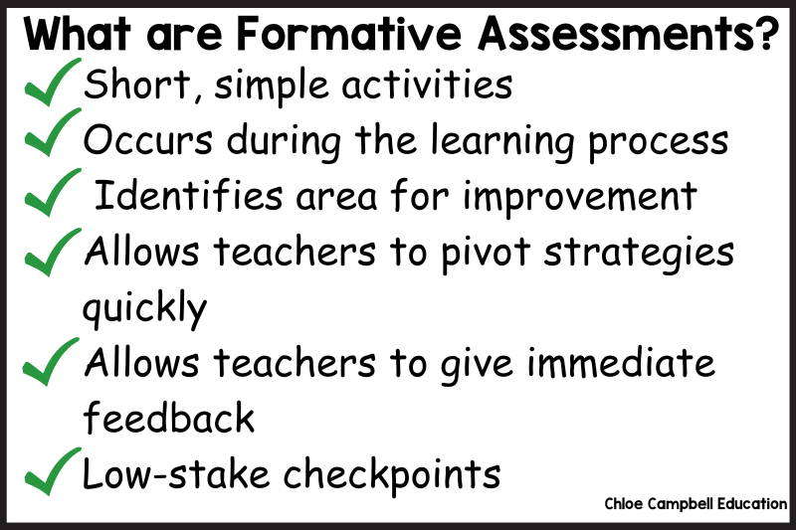
15 Formative Assessment Examples for Elementary Students | Chloe Campbell Education
I included as many different formative assessment methods as possible for inclusivity where all students have the opportunity to gain understanding from methods that best suit their learning styles.
I included a formal summative assessment in the form of a written test to ensure all of the learners reached the knowledge standards required by the College of Policing.
Summative assessment is a way of evaluating a students knowledge and understanding at the end of a course or learning period. There are several ways of conducting summative assessment as the eTutor picture and link describes below.

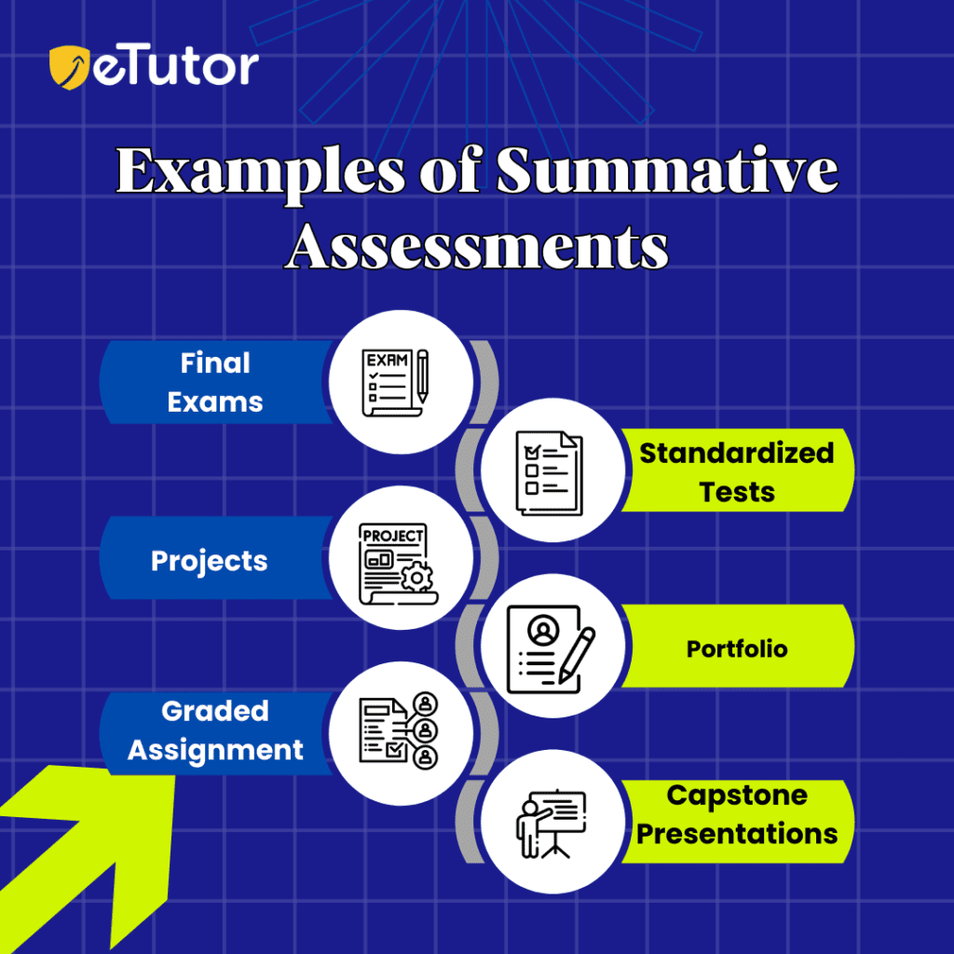
7 Effective Formative Assessment: Meaning, Types & Examples
I developed the community-based assessment into an electronic portfolio that the learners were required to submit evidence to prove that they have reached the required level of skill and knowledge for each competency based category.
The eportfolio enabled me to assess the learners more effectively as I am a qualified assessor and I know what standard the learners are required to meet to pass their tutorship phase. I also included a requirement that the Tutor PCSO and Sergeant supervisor have regular one to one meetings to ensure the learner is progressing and if appropriate, any issues can be addressed. The problem with competency-based assessments are that they don’t capture the interpersonal and behavioural skills required of the role of PCSO. ‘Observational job performance can never yield the collection of abilities which constitute being good at your job’ and further explains that ‘if work tasks are complex and involve subtle ethical and interpersonal decisions, it is difficult to see how a comptence-based assessment can do them justice’ (Duckworth, 2014, p.137).
To fill the personal and behavioural skills gap, both the Tutor and Sergeant are required to write a short testimony explaining how the PCSO has developed as a whole which includes attitude and behaviour. They will then make the decision to pass them as suitable for Independent Patrol. This is important as they are able to comment and assess the learners attitude and behaviour both with the public, with colleagues, time keeping and work ethic to ensure it is right for the role which is something I can’t do remotely when purely assessing competency-based evidence.
To assist with the transition to the new assessment method, I provided training to both the Sergeants and Tutors on their duties for the new method and explained the process for the learner to reach the required standards.
The eportfolio is now checked and verified by an IQA and standardised to ensure transparency and fairness of the process. They are then saved and stored to the organisations digital confidential records.
Standardisation is important for the organisation as the standards are set by the College of Policing for all Learning and Development courses. The PCSO initial training in Gwent Police follows the Level 4 in Police and Community Practice but does not use the accredited qualification for a number of organisational reasons, however the standards are followed to meet the national requirements for PCSO assessments. ‘moderation and standardisation procedures are designed to increase the reliability of assessment through opening up assessors’ judgements to scrutiny’ (Avis, Fisher and Thompson, 2019, p.198). It is essential that the decisions made by assessors are fair and not biased in way that could compromise the process as this could have repurcussions for the learner, the assessor and the organisation.
The Standardisation process enables a fair and transparent judgement of the learners ability across the whole organisation and on a national basis. Assessors are able to gain valuable feedback from the IQA’s to develop the quality of their decision making in the assessment process as I have achieved in Gwent Police.
The following link provides further reading on standardisation activities and how technology can be effective in the process.
Standardisation

References:
Chloe Campbell Education www.chloecampbelleducation.com (Accessed 22/10/2024).
Setu eTutor 15/06/2023 www.setu.etutor.com (Accessed 22/10/2024).
Duckworth, V. (2014). How to be a Brilliant FE Teacher. Routledge.
Avis, J. Fisher, R. and Thompson, R. (2019). Teaching in Lifelong Learning. A guide to Theory and Practice. Open International Publishing.
Ann Gravells. www.anngravells.com/information/standardisation (Accessed 14/11/2024).

