UNIVERSITY OF WALES TRINITY SAINT DAVID

DIGITAL SKILLS AND RESEARCH METHODS
L
IMPACT OF VIRTUAL LEARNING ENVIRONMENT

GLENNY MARIA RODRIGUEZ MOLINA (( 2133847)

2022
IJDJ

TO THE INTRODUCTION REPORT

OVERVIEW OF VIRTUAL LEARNING ENVIRONMENT (VLE)

INTRODUCTION:

With the use of technology, different educational institutions in the UK and around the world employ a virtual learning environment as a platform. In other words, this is a virtual platform where educators such as instructors and students may interact. Technology is necessary to make learning and teaching possible, however. For this learning environment, you need technology like computer hardware, software, and the internet.
In this essay, the author provide a quick overview of virtual learning environments, which are becoming essential components of online learning (also known as e-learning) in higher education all around the world. With special reference to the study of business, the author define what they are, the features they offer, and the sorts of advantages they bring to universities.

VIRTUAL LEARNING ENVIRONMENT (VLE)

A virtual learning environment (VLE) is a group of software programs that assist academic management, instruction, and research over the Internet, especially the World Wide Web1. As information and communication are increasingly performed online, these systems are becoming a crucial component of the educational infrastructure in many institutions of higher learning. Similar to e-mail, VLEs are centrally administered services that are offered throughout the university primarily to supplement, not replace, current academic procedures (Paul Trafford and Yukari Shirota, 2011).
Some people can identify "virtual" with a made world that stands in for the actual version. But virtual learning environments don't take the role of traditional classrooms or teaching methods. They are beneficial because they increase the physical learning environment's floor area. They provide instructors and students alike the chance to use their imaginations to the fullest.
Technically speaking, virtual learning environments are made to seem like highly developed structures.
Weller Martin stated in 2007 that a virtual learning environment provides learners, teachers, and students with a comfortable setting in addition to a beautiful design area for teaching and learning. A successful VLE enables users to progressively co-create their learning environments.
Instead of creating an anti-social environment that displaces real life, an appropriate VLE expands the social space of a classroom. It makes polls, surveys, and discussion threads possible. It allows students to submit their work without having to locate their lecturers.

A virtual learning environment provides learners, teachers, and students with a comfortable setting in addition to a beautiful design area for teaching and learning. A successful VLE enables users to progressively co-create their learning environments.
The appropriate VLE increases the social space of a classroom rather than creating an anti-social environment that displaces real life. It creates opportunities for polls, surveys, and discussion threads. Without needing to locate their lecturers, it enables students to submit their work. It offers central locations for an infinite amount of materials, including papers, workbooks, and PowerPoint presentations.
With the use of a VLE, teachers may direct students to other online resources, insert YouTube videos, and newspaper articles, and offer spaces for student-made podcasts. The most beneficial virtual learning environments and virtual learning software provide gateways to infinite routes of connection, content, and learning from which teachers, school administrators, students, and parents can all benefit. These routes go beyond serving as a virtual repository for learning resources.

WHEN WAS INTRODUCED:
Personal learning environments (PLE) have existed since the early VLE systems (the first recorded use of the term was at the Cetis conference in 2004). The concept recognizes the need for learners to create their own learning environment and gives them control over this.
This concept is especially appropriate for online learning, where students can select which technologies and services are most appropriate for them, which may include an institutional VLE.
Social networking software that allows students to take control of their learning experience provides opportunities for students to truly personalize their learning experience.

The accessible in different has seen a significant transformation in the twenty-first century. The day when teaching could only take place in a classroom has long since passed. The fundamental method of learning has undergone a paradigm shift as a result of the internet. Learning has been brought into everyone's hands and outside the revered walls of the colleges. But how did this immediate change happen?

How It All Started
E-learning is a term with several meanings. To add to the confusion, terms like "learning technology" and "educational technology" exist, each with its own meaning. The United Kingdom's Department for Education and Skills (DfES) defines e-learning in broad terms, stating in 2003: "If someone is learning in a way that uses information and communication technologies (ICTs), they are using e-learning" (DfES, 2003, P 4).
DfES, on the other hand, believes that E-learning has the potential to transform the way we learn and bring high-quality, accessible learning to everyone, allowing each learner to reach his or her full potential (DfES, 2003, p1).

Even though there are many historical examples of the use of tools and technology education, e-learning in the contemporary sense is a relatively recent idea. Since the 1950s, slide projectors and schools that use television have been popular. However, one of the earliest recorded examples of online education took place in 1960 at the University of Illinois in the United States. Students started studying using computer terminals that were interconnected to make a network even though the internet had not been created.
The University of Toronto provided the first ever full online course in 1984. The Electronic University Network was created in 1986 for use with Commodore 64 and Pc computers. Three years later, the University of Phoenix launched the first fully online academic institution in the history of education, providing both bachelor's and master's degrees. This marked the start of a revolution whose potential was completely unknown to the general public at the time, but which would dramatically increase access to learning and bring it closer than anybody could have ever expected.
In the early 1990s, The Open University in Britain launched one of the earliest online distance learning programmes in the whole world. With almost 4 million students enrolled, the Indira Gandhi National Open University in India is now the biggest university in the world. The majority of these students today receive their education online.
Online education is becoming available outside of colleges and institutions. Online education is increasingly being introduced into the curriculum starting in elementary school.
The current COVID-19 epidemic serves as yet another example of the value of online education in today's educational system since it has helped students and teachers who are unable to attend classes because of the risk of illness transmission. Online learning is progressively growing its market share at the pre-university level after high school. E-learning is also becoming increasingly prevalent outside of conventional disciplines.
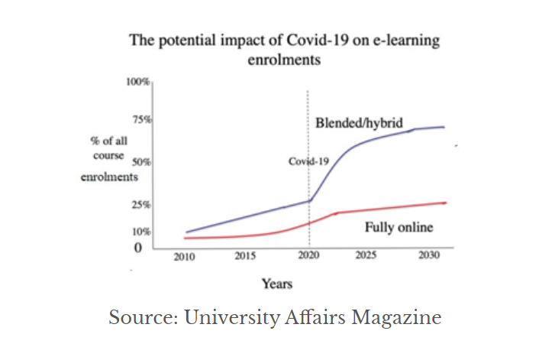

Who uses this technology?
Since 2000, the eLearning industry has grown by more than 900%. The growth of the internet is a major reason for the massive explosion of this industry, which is expected to continue as technological advancements improve. The United States and Europe account for the majority of the global eLearning industry. Statistics show that the United States and Europe account for 70% of the global eLearning market, indicating that the majority of eLearning activity is concentrated in the United States and Europe.
eLearning courses can be completed nearly 60% faster than face-to-face classes. In-person classes are long and exhausting for students all over the world. Because students can work at their own pace, eLearning courses can be completed much faster than traditional semester-long courses.
As more institutions offer mobile learning, it appears that more people are taking advantage of the offer. As a result, mobile learning is expected to outperform this figure.

Why is it important to conduct a study on this subject?
Learning courses produce 86% fewer greenhouse gases. This statistic reveals the impact that eLearning has on our environment, given that eLearning can be done remotely and that there is no need for students to commute. The reduced travel also reduces the carbon emissions from transportation, and a single eLearning course can help lessen CO2 emissions by up to 86 percent than a comparable in-person time.
ICT has made it possible for a true revolution to place in practically all sectors and aspects of human being. ICT has taken on a variety of roles within each line of work, including that of a tool for interpersonal communication and interaction as well as that of an intermediary between individuals and organizations.
Due to the general technologies that make up virtual learning environments (VLE) and the support they provide for students, professors, and institutions, VLEs have come to the forefront within the context of higher education.

Advantages and Disadvantages:
The Benefits of Online Learning
Simmons (2022) stated that Organizations are increasingly using online learning as the primary method of training employees. Simultaneously, educational institutions are moving toward the use of the internet for delivery, both locally and remotely. There is a perception among these organizations that using online learning will provide significant benefits.
With this, the author created a chart below displaying the main benefits that students have found with online learning. It demonstrates that most participants had a favorable opinion of online learning. Online education was initially used as a temporary fix to maintain the educational process. However, the students were aware of the benefits of online learning, including having more free time for independent study, being exposed to novel and engaging learning methods, and having quick and simple access to useful online resources.

Table No. 1:
Benefits of online education
effects of online education Percentages
1. Ensuring community and individual safety.
2. Reducing travel time.
3. Introducing new learning methods.
4. Adhering to the semester's initial plan.
5. Having more time to study on your own.
6. Having quick access to materials online.

The limitations of online education
The survey's findings point to a few key limitations that students must endure when enrolled in online courses, which are compiled in Table 2 below.
Table No. 2
Lists the student's limitations and challenges.

The challenges and impediments
1. Spending a lot of time looking at displays.
2. Lack of motion of the body.
3. There aren't enough opportunities for people to practise social skills.
4. Aversion to online testing.
5. Exhibiting a decline in concentration.
6. Loss of peer connection in online classes.
7. Problems hearing the lecturers' voices.
8. Inability to communicate with classmates and teachers to practise speaking.
9. Having trouble understanding the lesson's material.
10. Limited communication with teachers.
11. Problems keeping to study routines and poor governance.

METHOD (PRIMARY RESEARCH)
In this research, secondary research methodology was used to collect quantitative and qualitative data to better understand the services offered by VLEs, the technologies needed to support them, as well as their advantages, disadvantages, and difficulties faced by university students, and faculty members, and administrators. Numerous sorts of books, journals, periodicals, and articles were used to collect both quantitative and qualitative data in this instance (how you collected data). Accessing university Moodle and other online resources were used to gather pertinent information.
Then, using a primary research technique, data about our university's Moodle, both quantitative and qualitative, were collected. In order to get feedback from classmates and teachers, an online technology was used to create a survey that has 10 questions about the university's Moodle. The email was used to send the survey. In order to conduct the analysis, information was collected and put into tables.

QUESTIONS | YES | NO
1 | 10 | 0

The first question of this questionnaire was answered by all students as a YES , referring to having experience in relation to the usage of virtual learning environment.
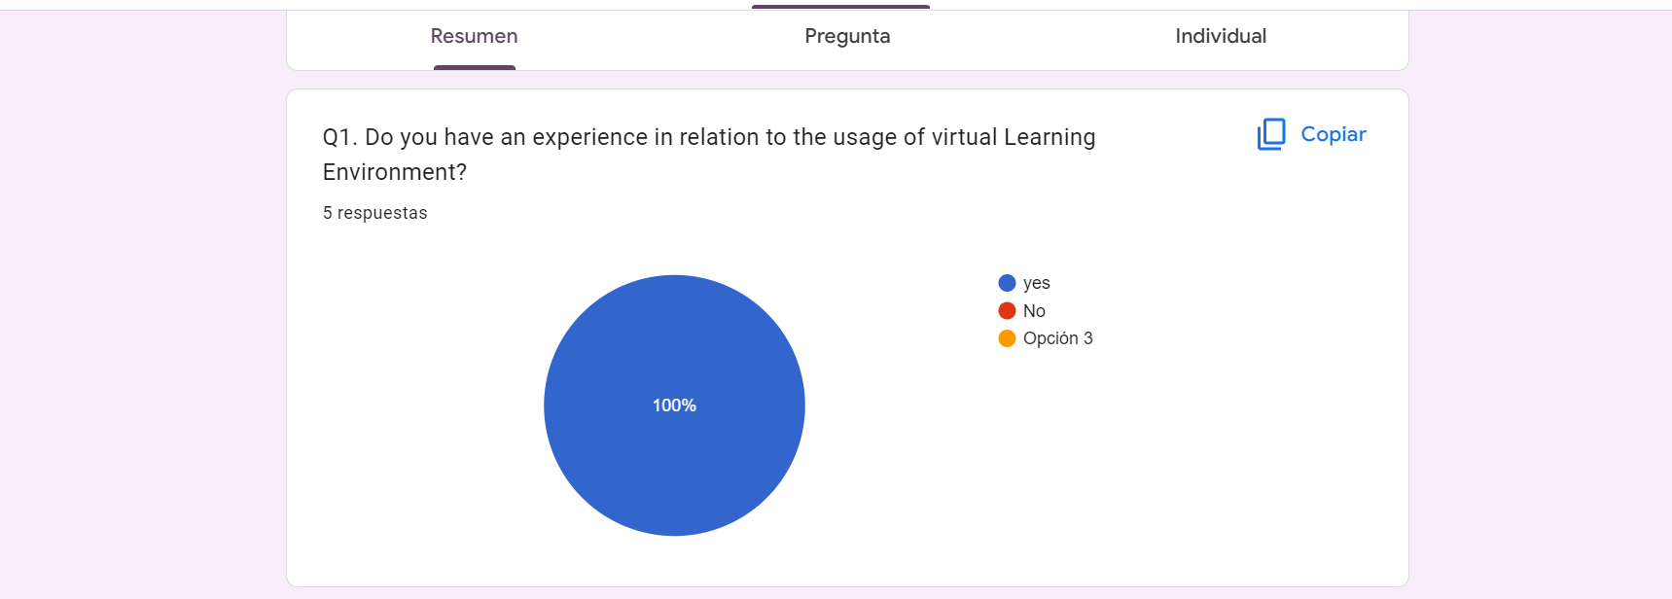

QUESTIONS | YES | NO
Q2. | 2 | 8

In the second question of the qiuestionnaire , the students were asked if they prefer to use VLE for higher students. 80% of students selected YES and 20% NO.
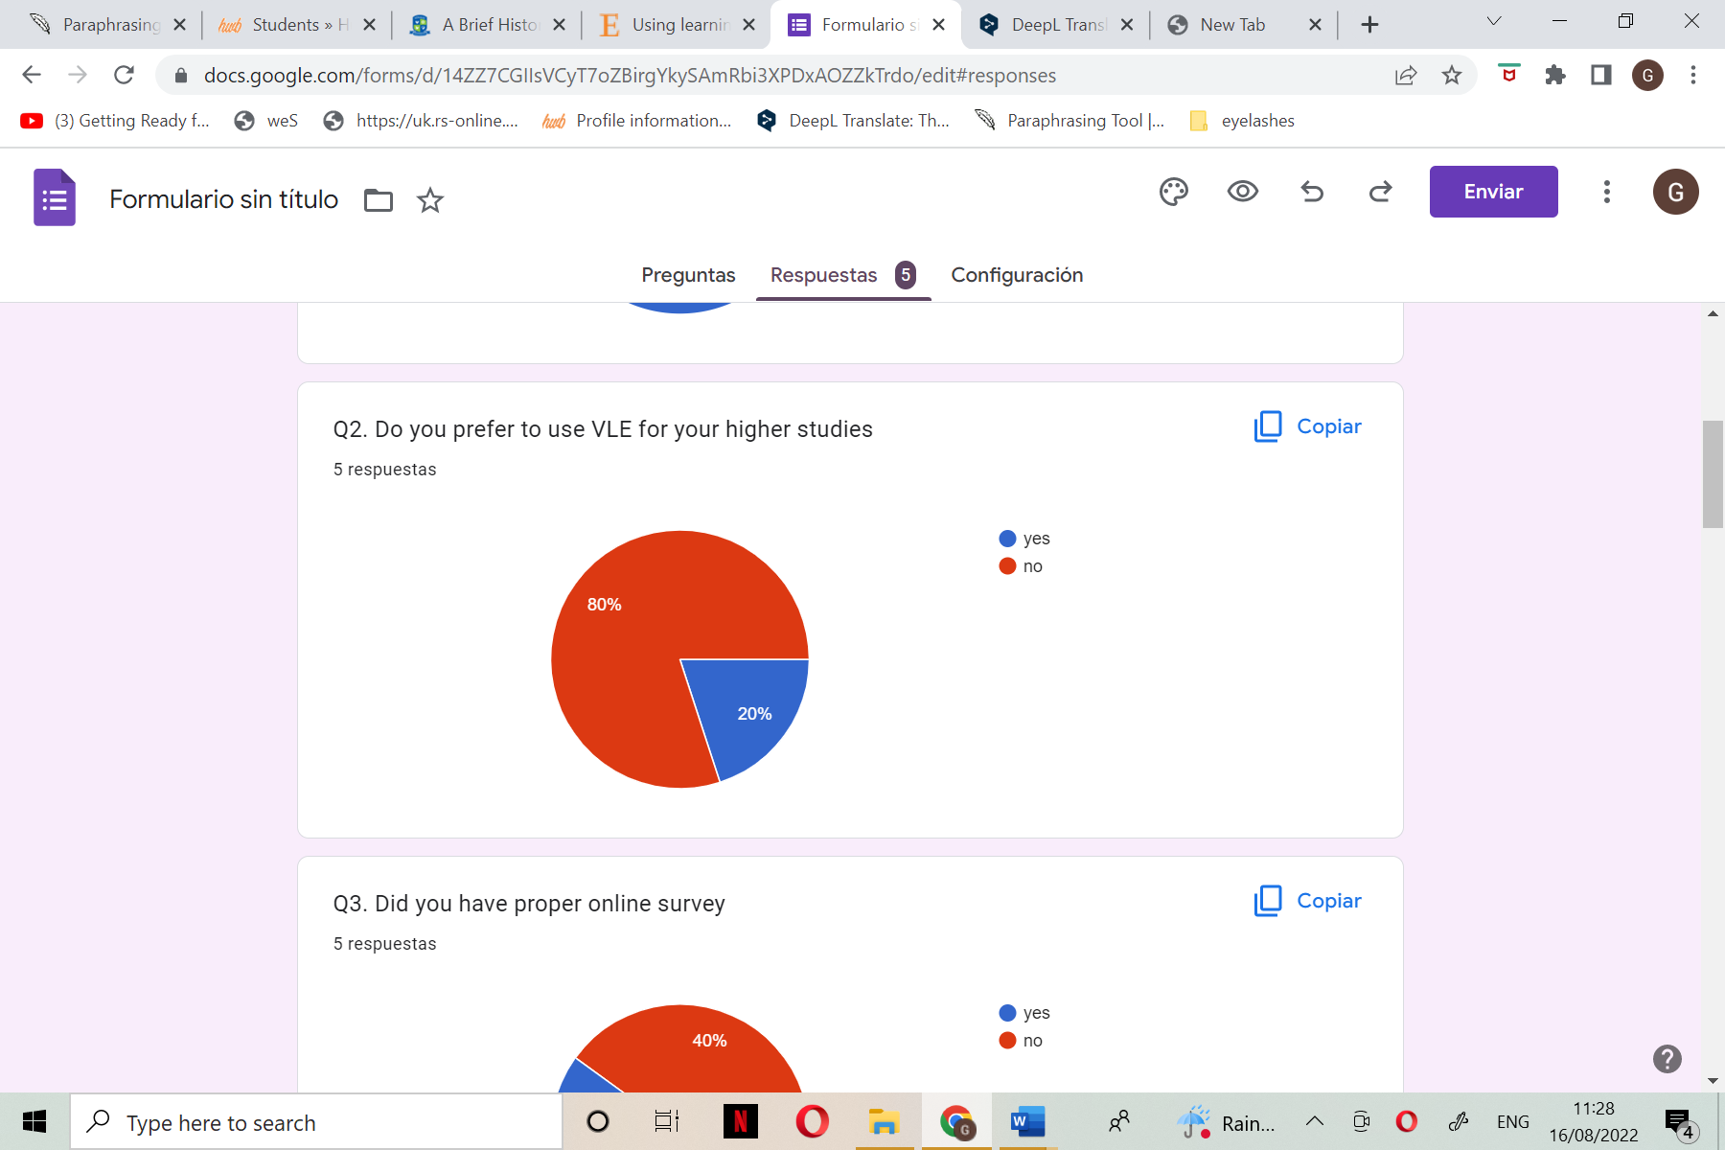

QUESTIONS | YES | NO
3 | 6 | 4

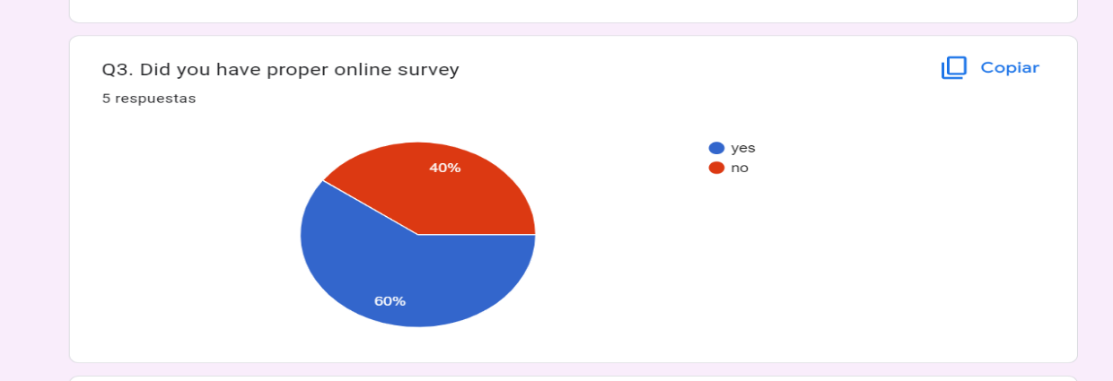
In the third question of the questionnaire students were asked if they had a proper online survey. 60% of students selected Yes and 20% No.

QUESTIONS | STRONGLY DISAGREE | DISAGREE | NOT SURE | AGREE | STRONGLY AGREE
4 | 0 | 6 | 4 | 0 | =
In the 4th question of this questionnaire to the students , students were asked if they would like to see that the university will continue to use VLE platform after the pandemic and surprisingly 60% of students disagreed and 40% weren’t sure.
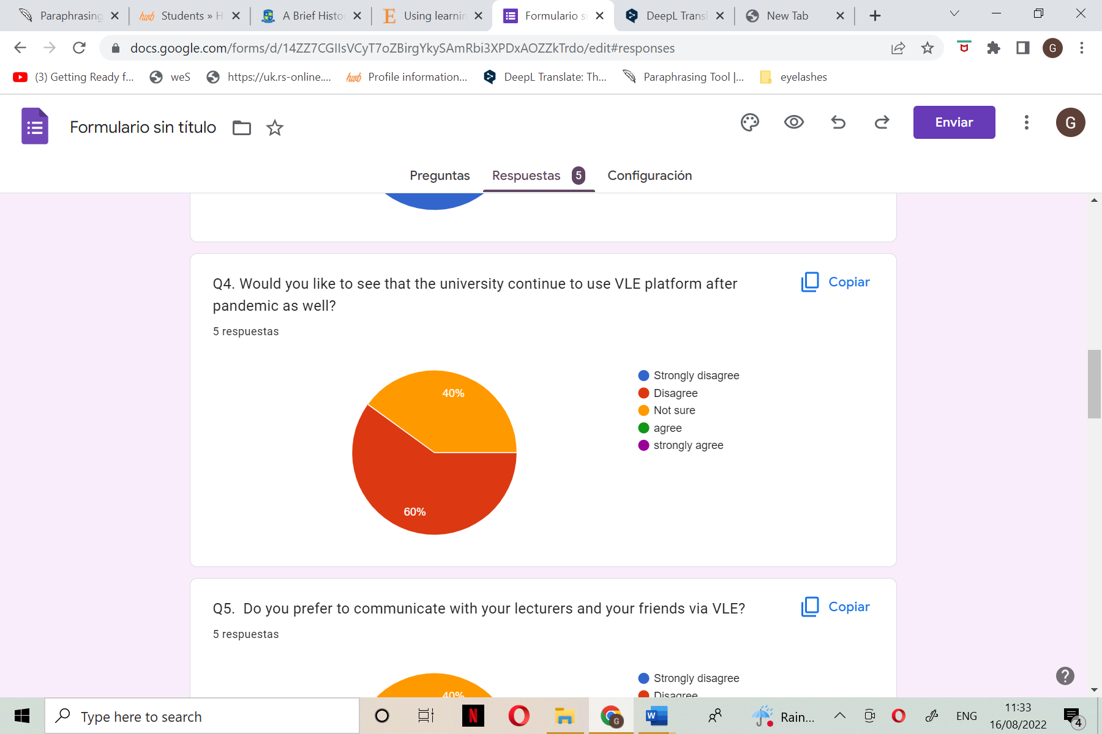

On the 5th question students were asked if they preferred to communicate with their lectures and friends via VLE and 60% of students selected disagreeing and 40% weren’t sure.
QUESTION | STRONGLY DISAGREE | DISAGREE | NO SURE | DISAGREE | STRONGLY AGREE
5 | 0 | 6 | 4 | 0 | 0

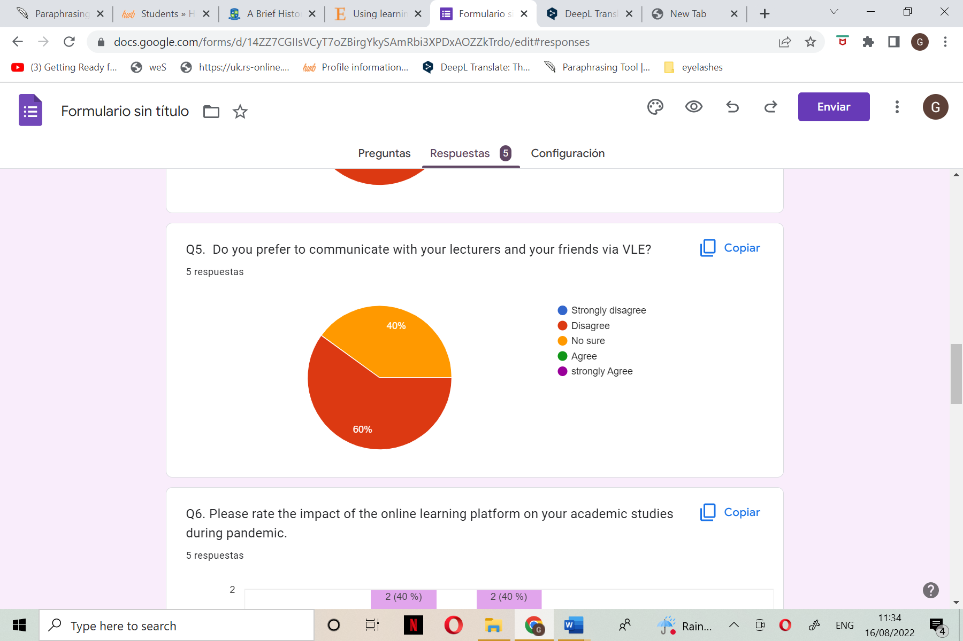
QUESTION | 1 | 2 | 3 | 4 | 5
6 | 0(0%) | 40% | 40% | 20% | 0%

On the 6th question students were asked to rate the impact of the online learning platform on their academic studies during the pandemic. 40 % of students went up to 2 , another 40% of students went up to 2 in the bar chart and 20% of students were on 1.

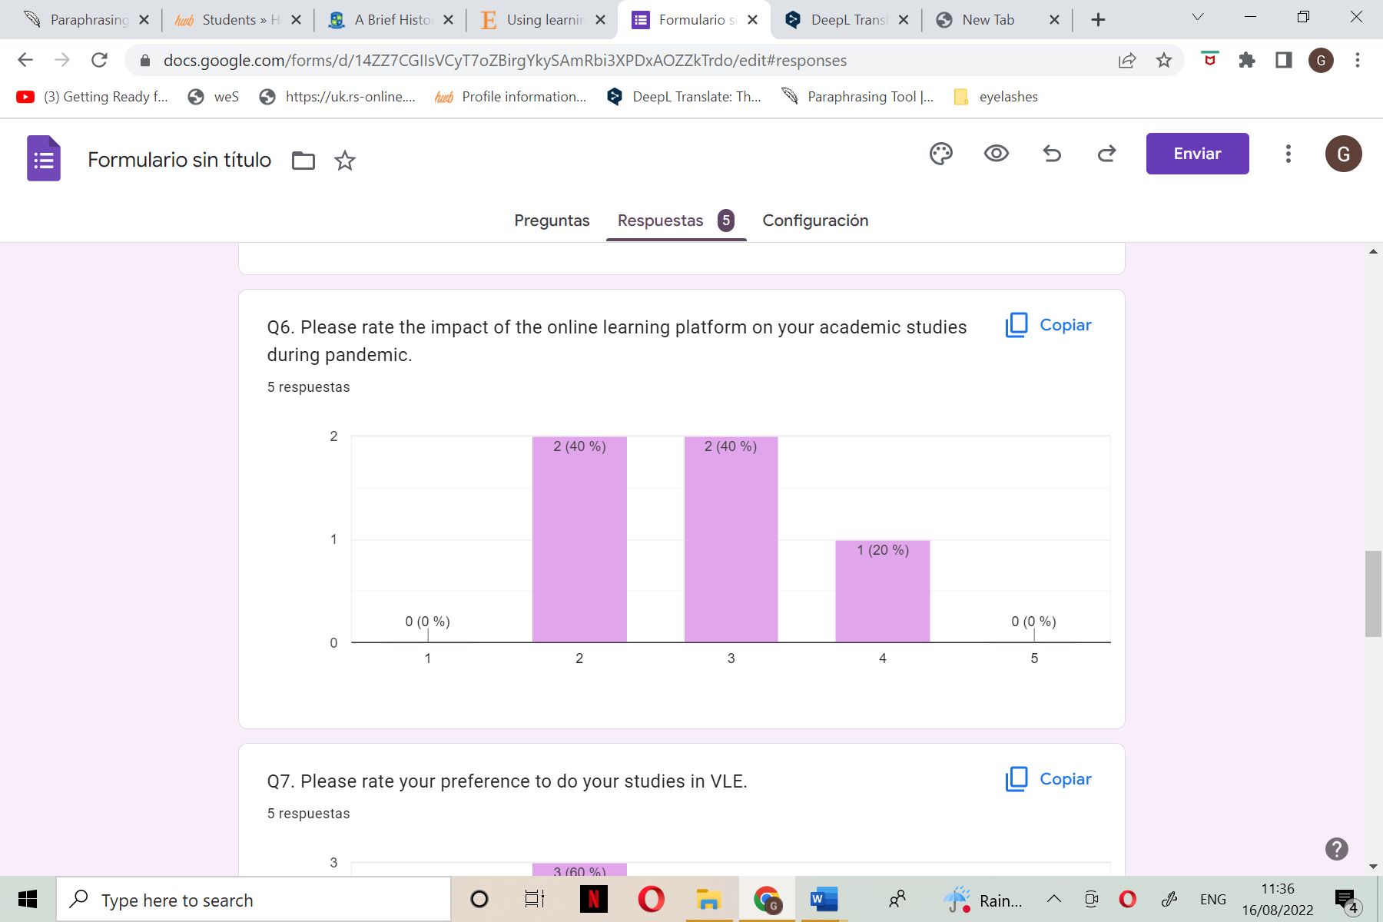
QUESTION | 1 | 2 | 3 | 4 | 5
7 | 0% | 60% | 40% | 0% | 0%

On the 7th question of this questionnaire, students were asked to rate their preferences to their studies in VLE and 60% of the students went up to 3 and 40% went up to 2.

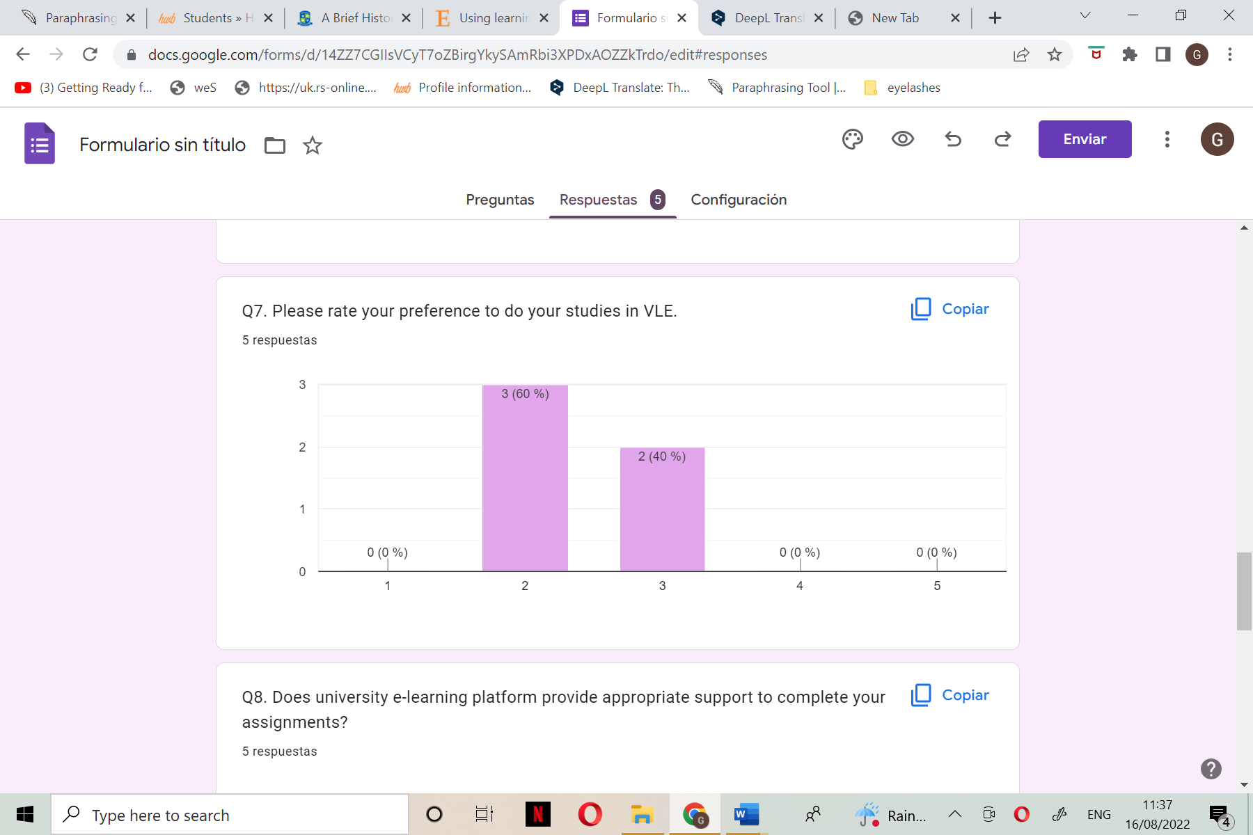

QUESTION | YES | NO
8 | 8 | 2

On the 8th question of this questionnaire, the students were asked if university e-learning platforms provide appropriate support to complete your assignments and 80% selected YES and 20% selected NO.
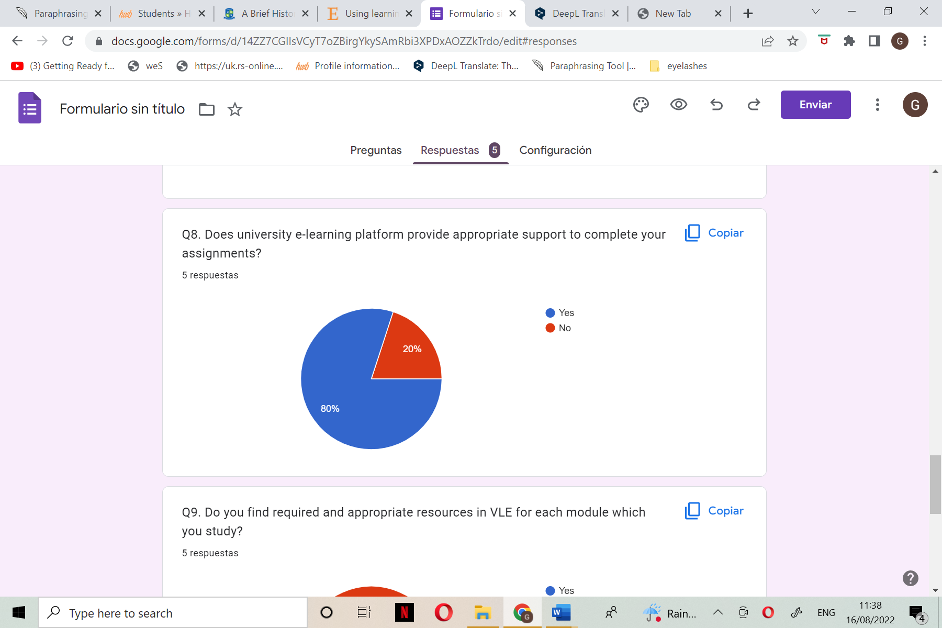

QUESTION | YES | NO
9 | 6 | 4

On the 9th question of the questionnaire students were asked if they find requires and appropriate resources VLE for each module which they study and 60% selected YES and 40% NO.
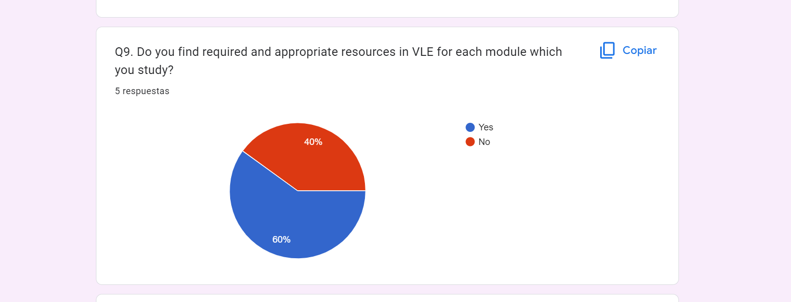

QUESTION | ESTREMELY DISSATISFIED | DISSATISFIED | NOT SURE | SATISFIED | EXTREMELY SATISFIED
10 | 0 | 0 | 6 | 4 | 0

On the 10th questionnaire ,lastly the students were asked since lockdown , how satisfied are you in relation to the support which you received from lectures , university admin and management through VLE toward your studies , 60% of the students selected not sure and 40% of students selected satisfied.
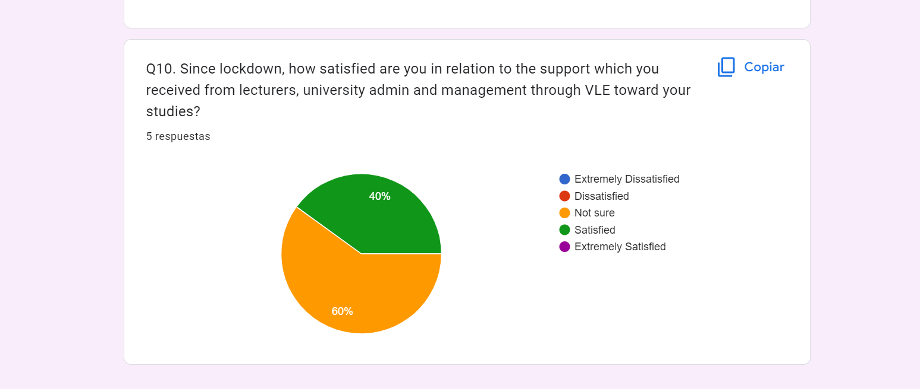

CONCLUSION:
The performance of the students as well as their enjoyment of the place are significantly improved by the virtual learning environment. It can be stated that when it comes to students' opinions of utilising a VLE in their learning process, the proportion of students who thought using the Internet and the resources that come with it was useless, complicated, and confusing significantly fell after experiencing it. These students believe that using a VLE is useful and appreciate how simple and useful the applications are. However, with the development of new technology, there are still some students who do not agree with this decision.
My personal view is that I will always prefer in-person learning, which includes being in the same classroom as my professors. This is because it is very difficult for me to understand, listen, ask questions, and learn in a virtual environment since I often find it difficult to focus.

References:
Adamas University (2020) A Brief History of Online Education, Available at: https://adamasuniversity.ac.in/a-brief-history-of-online-education/ [Accessed on 5th August 2022].

CORE (2011) An Introduction to Virtual Learning Environments, Available at: https://core.ac.uk/download/pdf/292912897.pdf [Accessed on 25th July 2022].

E-learning Industry (2015) Advantages and possible limitations of online Learning, Available at: https://elearningindustry.com/advantages-and-possible-limitations-of-online-learning [Accessed on 11th August 2022].

Firefly (2022) What is a Virtual Learning Environment (VLE)? Available at: https://fireflylearning.com/what-is-a-virtual-learning-environment-vle [Accessed on 2nd August 2022].

IGI Global (2016) The importance of Virtual Learning Environments in Higher Education, Available at: https://www.igi-global.com/chapter/the-importance-of-virtual-learning-environments-in-higher-education/142761 [Accessed on 10th August 2022].

Jisc (2016) Virtual Learning environments (VLE), Available at: https://www.jisc.ac.uk/guides/technology-and-tools-for-online-learning/virtual-learning-environments [Accessed on 9th August 2022].

Kaltura (2021) Advantages and Disadvantages Of online classes, Availability at: https://corp.kaltura.com/blog/advantages-disadvantages-online-classes/ [Accessed on 11th August 2022].

Scribbr (2017) Qualitative vs Quantitative Research / Differences, examples and Methods, Availability at: https://www.scribbr.com/methodology/qualitative-quantitative-research/ [Accessed on 12th August 2022].

Secker, J. 2004. Electronic Resources in the Virtual Learning Environment: A Guide for Librarians. United Kingdom: Elsevier Science, Pp. 2-14.

Silverman, D. (2013) cited in International Journal of Caring Sciences September- What Counts as Qualitative Research? December 2021 Volume 14, Issue 3, pp 204.
Terry, A. (2008) The Theory and Practice of Online Learning. United States: University of Washington Press, Volume 12, Issue 6, Pp. 10-23.

Weller, M., 2007. Virtual learning environments: Using, choosing, and developing your VLE. Routledge. Pp. 1-10.

