The External Challenges and Opportunities Facing Swansea Stadium Management Company

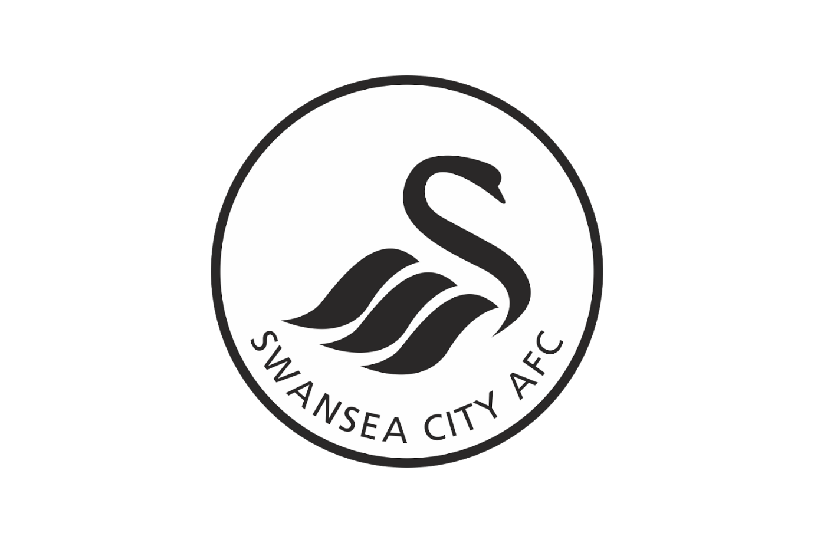

MARCH 2018

MODULE NAME: The Global Business Environment – M4X00801
Name: Joshua Dean
Student Number: 1701282

Table of Contents

1. eXECUTIVE sUMMARY …………………………………………………………………1
2. Introduction ………………………………………………………………………….2
2.1 Report Remit 2
2.2 Background of the organisation 2
3. PEST ANALYSIS ………………………………………………………………………….2
3.1 Political Factors 2
3.2 Economical Factors 3
3.3 Social Factors 4
3.4 Technological Factors 5
4. Conclusion ………………………………………………………………………….6
5. References ………………………………………………………………………….6

List of Figures
FIGURE 1-1 – Swansea Population Pyramid (Jones, 2016) 3

APPENDICES
APPENDIX A – Swansea Stadium Management Company (SSMC) consists of directors from the City of Swansea, Swansea City A.F.C and Ospreys Rugby. The SSMC are responsible for various aspects of the stadium including security, operation and commercial activity of the Liberty Stadium.

eXECUTIVE sUMMARY

The purpose of this report is to provide a simple and comprehensible basis in which the analysis of the external environmental factors affecting SSMC can be understood to the full extent, maintaining ease and mental clarity when observing the findings within this report.

This report has concluded that there are various different external threats and opportunities facing SSMC in the management of the Liberty Stadium. Primarily, the political factors affecting SSMC include the threat of terrorism within the UK and the uncertainty of the outcome of the United Kingdom’s withdrawal from the European Union. These political aspects are perceived as threats. However, the uncertainty of Brexit could also be positively resolved within the near future, increasing demand for entering the UK. This aspect would then turn into an opportunity. In addition to this, the external economic factors affecting SSMC include the increase in demand for season tickets and the increase in demand for live music events.

Furthermore, the external economic factors that present themselves to SSMC include the threat of supply and demand levels being reached, and the opportunity to host additional live music events. Due to alterations within the music industry, musical artists now gather sufficient profits from touring and live shows instead of selling their music. This has now created a significant demand for venues to host live music events, presenting an opportunity to SSMC to further their turnover.

The external social factors affecting the SSMC include the changes in attitudes towards the various disadvantaged groups in the UK, more specifically Swansea, and the age distribution within the city of Swansea. As this report finds, there has been an increase in the number of people residing in Swansea between the ages of nineteen and thirty. The attendance of live music and football events is most popular among this age range as certain studies have demonstrated. Thus, SSMC are presented with an external opportunity to generate further income by hosting more frequent live music events.

The external technological factors affecting SSMC include the increase in popularity in watching football games and music events online and the technological advancements in electronic advertising within the Liberty Stadium. The increase in the number of people watching football matches and live music events at home poses as a great threat to SSMC as people are far less inclined to attend live music and football events held at stadiums such as the Liberty Stadium.

Introduction

Report Remit

This report places focus on the analysis of the external environmental threats and opportunities presented to Swansea Stadium Management Company. This report aims to achieve a comprehensible examination into the political, economic, social and technological factors that directly affect SSMC and the management of the Liberty Stadium.

Brief background on your project

“The Liberty Stadium opened in 2005 to provide a home to Swansea City and Ospreys Rugby while giving Swansea a facility to be proud of.” (Greenwood, 2018) Until recently the stadium was managed by the Swansea Stadium Management Company (SSMC) but is now managed by Swansea City A.F.C. whom also own SSMC. Swansea council is now able to receive direct revenue from the stadium via rental payments in addition to Swansea City A.F.C competing fully with other Premier League football clubs by understanding new revenue streams at the stadium.

PEST Analysis

POLITICAL Factors
The extent to which a government has impact and influence upon a particular industry, an organisation or an economy is highlighted during this section of a PEST analysis. “This can include – government policy, political stability or instability in overseas markets, foreign trade policy, tax policy, labour law, environmental law and trade restrictions.” (Wesley, 2018). With the current threat of terrorism in the UK maintaining a high status, security within stadiums remains a primary concern. SSMC is required, along with all the large venues and stadiums across the UK, to invest in security requirements such as security screening and technical necessities that may be imposed by the UK government. This would lead to a greater amount of expenditure by Swansea City A.F.C on requirements and additional security personal, which would have significant impact on the price of tickets for football and music events. Thus, the management of the Liberty stadium would have to increase ticket prices to accommodate for the increase in expenditure for security, resulting in the possibility that ticket sales might decrease due to the rise in cost to attend a live event. However, this threat could become more significant if the risk of terrorism increases in the UK, resulting in further security expenditure to be made.

In contrast to this, due to the increase in security measures, customers will feel safer and more secure when attending any type of event at the Liberty Stadium. This would lead to trust and confidence in ticket sales and would therefore, maintain the current sales of tickets. Consequently, this would turn a threat into an opportunity.

In addition to this, the uncertainty of Brexit creates a volatile environment for exchange rates and trade regulations. Should the UK become supressed by other countries when negotiating new deals, then this would only add to the significant difference between the pound and other foreign currency. As a result of this, the UK, more specifically Swansea, will become less appealing to visit due to the high costs of traveling. This would have negative impacts on the overall profit of Swansea City A.F.C as less people are inclined to visit the UK and spend money. However, should the UK benefit from negotiations and EU talks then this would undoubtedly lead to a stronger economic environment for the UK and result in the encouragement of foreign investment and interest in and around the area of Swansea. Therefore, creating an area in which affluence thrives. This would have significant positive impacts on SSMC as a higher percentage of income may be generated. Therefore, it is imperative that SSMC maintain a closed eye on the Brexit negotiations so that the management board can move with the outcome to either mitigate any negative impacts or embrace any positives.

Economical Factors

There are many external economic opportunities and threats facing SSMC. The aspect of supply and demand is a prominent threat within the management team of SSMC. This is due to that fact that the Liberty Stadium has currently reached maximum capacity, supported by the fact that the sale of season tickets has been halted. However, there is a large waiting list of people wishing to purchase season tickets. This would indicate that the consideration to expand the Liberty Stadium would be discussed within the SSMC.
The music industry has undergone significant alteration within the past decade, with focus upon the impact of the internet. Due to the popularity of streaming services such as Spotify and Apple Music, artists can no longer obtain sufficient profits from music sales. As of 2018, 17 million people are subscribed to Apple Music and there are 140 million active accounts on Spotify. (Smith, 2018). This is partly because the average musical artist operates on a percentage basis and does not gain adequate income from the individual sales of songs. As a result of this, artists now make more profits from touring and live shows. Thus, this opportunity offers SSMC to generate further income from hosting an increased number of music events because there is a higher demand for live music. Currently, according to the management of the Liberty Stadium, no more than two music events are hosted for one year. Increasing this number would not only lead to further profits but also to a greater appeal for the youth on Swansea to attend events held at the Liberty Stadium, creating a broader target audience.

Social Factors
“Coupled with the changing economic environment has been a continues change in social attitudes and values that are likely to have important implications for marketing management.” (Hooley, Saunders, & Piercy, Marketing Strategy and Competitive Positioning, 2004). In light of this statement, the attendance of live musical concerts and events along with the attendance of live football matches is predominantly more popular among the age range between late teens and thirties. Primarily, the attendance of live music events is well received by both male and female audiences whereas attendance of live football matches is favoured by those who are male. Based on statistics generated in 2016, when analysing the demographics of Swansea, it is clear that there is a notable number of people living in Swansea between the ages of nineteen to thirty. Figure 1-1 demonstrates this.

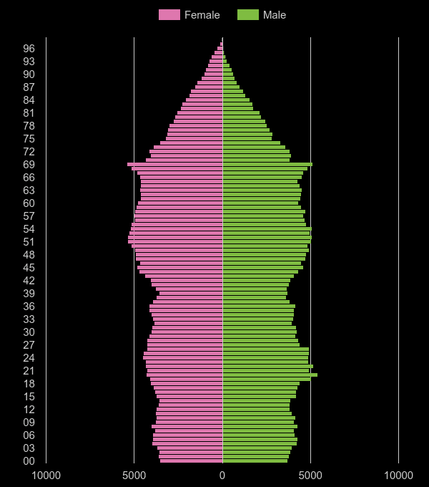

Figure 1-1 (Swansea Population Pyramid)

The pyramid shows a large ‘spike’ in the 19 – 30 age groups, largely reflecting the presence of student residents at Swansea’s two universities. Therefore, it is evident that there would be an increase in demand for the Liberty Stadium to host such events as there is a large target audience present in Swansea.

Furthermore, among the newer/younger generations in today’s society attitudes towards minority groups have become far more accommodating than ever before. There is a lower tolerance for racism and discrimination and a greater amount of care towards special needs groups. Thus, SSMC needs to meet the requirements of minority groups in order to keep the customers satisfied. Some of the aspects put in place to accommodate the needs of disadvantaged groups attending events at the Liberty Stadium include the vast array of disabled access for wheelchair users and the loop system in operate for hearing impaired visitors. (Greenwood, 2018). Therefore, SSMC has capitalised on the fact that there is an increase in demand for special needs requirements to be met and as a result, has satisfied customers needs and wants. Thus, maintaining the rate of ticket sales.

Technological Factors

“The latter part of the twentieth century saw technological change and development impact on virtually every industry.” (Hooley, Piercy, & Nicoulaud, 2008). The UK is one of the leading countries that accommodates technological advancements and developments. One technological aspect that has created an opportunity for SSMC is the implementation of the electronic billboards within the Liberty Stadium. During live football matches and music events, with the recent technological advancements in advertising, companies will now pay money to advertise their product or service on electronic billboards. This provides a significant opportunity for SSMC to create further income as the management of the Liberty Stadium can now charge a lot more money because of the additional space to advertise.
In addition to this, the number of people using the internet and television to stream live football events has increased dramatically in the past few years. “Openly, broadcasters like Sky, BT and Eurosport treat the social platforms as friends, not foes. But they are wise to the threat. Sky this year has focused on channels for specific sports, a move that should help it measure the value of those audiences when deciding what rights to renew and pursue.” (Joseph, 2017). This is sufficient evidence to suggest that the increase in popularity of watching football games at home is recognised and respected by organisations such as Sky and certain methods are being implemented in order to captivate this already existing market. Therefore, this poses as a significant threat to SSMC as there may be a decrease in the number of people wishing to attend live football events in the Liberty Stadium due to the ease and low cost of remaining at home. This would undoubtable lead to a reduction in the number of tickets sales for these events. Statistics found online support the argument that there is a high number of people illegally streaming football matches online to avoid additional costs. “According to a poll of 1,000 people for 5 live Daily nearly half of fans say they have streamed a match online through an unofficial provider - just over a third do so at least once a month and about one in five at least once a week.” (Malcolm, 2017). In coherence with the belief that less people are attending live football events, SSMC faces a huge potential threat that maintains the probability of becoming far larger in the years to come.

Conclusion
To conclude, there are many different external opportunities and threats presented to Swansea Stadium Management Company (SSMC). There is sufficient evidence to suggest that the external opportunities outweigh the external threats, creating a positive outcome for SSMC. The most prominent opportunity is the increased demand for live music events and concerts to take place. With confirmation of such demand supplied by statistics found within this report, it can be concluded that significant further additional income can be generated should SSMC, and consequently Swansea City A.F.C, host regular and frequent live music events in the Liberty Stadium. This opportunity in coherence with the demographics of Swansea suggest that there is a large market for hosting live music events as there is an increase in people residing in Swansea between the ages of nineteen and thirty. As this report demonstrates through means of reliable statistics, the attendance of such live events is popular among the age range previously stated. Thus, providing SSMC with a significant opportunity to obtain supplementary profits.

5 References

Greenwood, B. (2018, March 13). The Liberty Stadium: Swansea City. Retrieved March 13, 2018, from Swansea City: https://www.swanseacity.com/club/liberty-stadium
Hooley, G., Piercy, N. F., & Nicoulaud, B. (2008). Marketing Strategy and Competitive Positioning (4th ed.). Essex: Pearson Education. Retrieved March 14, 2018
Hooley, G., Saunders, J., & Piercy, N. (2004). Marketing Strategy and Competitive Positioning (3rd ed.). Essex: Pearson Education. Retrieved March 14, 2018
Jones, D. (2016, January 1). Swansea Population Statistics. Retrieved March 27, 2018, from Plum Plot: http://www.plumplot.co.uk/Swansea-population.html
Joseph, S. (2017, September 25). The State of Live Streaming In sports. Retrieved March 27, 2018, from Digiday UK: https://digiday.com/media/state-live-streaming-sports/
Malcolm, B. (2017, July 4). Premier League: Third of fans say they watch illegal streams of matches - survey. Retrieved March 27, 2018, from BBC Sport: http://www.bbc.co.uk/sport/football/40483486
Smith, C. (2018, February 11). How Many Users Do Spotify, Pandora, iHeart Radio, Apple Music and Other Top Music Steaming Have. Retrieved March 28, 2018, from DMR Business Statistics: https://expandedramblings.com/index.php/how-many-people-use-spotify-pandora-music-streaming-services/
Wesley, H. (2018, January 1). Marketing Theories - Pestel Analysis. Retrieved March 26, 2018, from Professional Academy: https://www.professionalacademy.com/blogs-and-advice/marketing-theories---pestel-analysis

