Problem Solving and Decision Making
BMSK4004_LON
Kamrul Ahmed
Yeyesh Kumar

Content Page

- Introduction
- About Asda
- Defining Complex Problem
- Analyse Identified Problem
- Problems Solving Tools and Techniques
- Decision-Making Techniques to Evaluate Solutions
- Plan for Solution Implementation
- Communication Plan for Stakeholders
- Monitoring and Review Techniques for Solution
- Implementation
- Conclusions
- References

Introduction
In this assignment, I will be taking about my chosen topic which Asda, Asda descriptions, problems solving, tools, techniques, plan for solutions, communications for stakeholders and etc, there will lot to cover up but I will write it down as I go or please. I think this assignment will be challenging since I like challenging and yet somehow, I can’t seem to be focused well I suppose its must be a problem for me and not just for imagine this was a businesses and I want to see the differences between other supermarkets such as Tesco, Morrison or Waitrose. I’m sure you all wondering which of the supermarkets quality foods or same ranges of products at similar prices but some of the ranges of products use different types of recipes although some of the supermarket sells similar types of products around the UK, or which may the cheapest one, but according to some online servey that Morrisons is cheapest supermarket in UK. So what is the purpose of introduction, is it about or is it about engagement or presenting your ideas to the reader and if it is make it clear to them.

About Asda
In this assignment I will be talking about my selected organisation which is Asda as my chosen topic.
Asda was founded in 19 of February 1949s, about 70 years ago and the names of these founders are Peter, Fred Asquith and sir Noel Stockdale.
Asda is a British supermarket retailer in the UK, the headquarter is in Leeds near West Yorkshire. The company was founded by an owner of a supermarket name is Asquith family and merged with the associated Dairies company of Yorkshire and after that the companies expended into south of England during 1970s and 1980s. Asda has being here in the UK for 70 years at least that show how long it being since they opened, this show us how large this organisation is. Asda has been other cities as well, for example in Birmingham, Wallington, Burgh Heath, Sutton these are just few cities I just names but I am sure there are many more around other cities or maybe other countries too.
Asda the service their provide is quite good and not only that but instore services is also good, instore services is always packed and useful services to make your trip worth your time and fun and productive time. Inside Asda they have a pharmacy not many supermarkets have their own pharmacy but Asda does which makes them even better than most supermarkets organisations. Their pharmacy accepts NHS and private prescriptions and a pharmacist on hand or you can get advice about your medications. Asda has many others sections such as Café, optician, travel money bureau etc.
The story of Asda is full of amazing people working for them and they enjoy being at Asda. Asda story, as I said earlier Asda was founded during 1960s in Yorkshire and as you know Asda is one of the UK largest leading retailers or supermarket which is dedicating themselves to consumers satisfactions from their stores or online shopping services, also living stores, petrol filling stations and also depots around in UK more than 18 million people who shop with Asda every week with 98 percent and that just show how much we depends on Asda as one of the UK largest supermarket. Oh! I forget to mentions this but here is the quote they say ‘’Save Money Live Better’’, now can you imagine how people did react when they first saw those quotes and open since, 70 years ago. (Corporate.asda.com, 2019)
Between the timeline and introducing Asda during mid-1960s must being hard for the Asquith brothers since they ran a butch shop at the time, then next think you know is that they made a huge discovery; the concept foods of discount or discounting, at that moment the brothers of Asquith came with ideas of late night shopping. Getting this kind of ideas would make anyone go crazy since its open late night and at that time I don’t think there was any other supermarket who was open during late night, but yet Asda was the first supermarket to be open as late night of 24 hours. Now can you believe that Peter Asquith built his first new supermarket in mid-1960s from scratch not only that but next to a cars knowing that would changes how people shop, soon after the Queens changed into a supermarket. Later Peter was looking to partnership with someone and he found Noel Stockdale, on third of may 1965 Asda was BORN. Asda has been here for many generations and many more to come.

Defining Complex Problem

This may be hard to believe but apparently Asda 95% of their products is already at risk because of the weather climate changing due to it’s British weather, not only that but the UK supermarket put hard figures on the impact on their products climate since the weather in UK changes time to time and they may have big impact on all the supermarket in the UK. As you may know 95% of Asda products is at risk due to its climate change, some says it’s according to a ground-breaking study by the supermarket itself. The report which indicate will be published during June time, and it is the first attempt by retailer to put hard figures against the impact of global warmining and it will have major impacts on its food’s suppliers across the world and in the UK as well. This is because of the climate changing around the world but especially in the UK and in the UK the weather changes more frequently than any other country such Pakistan, India, Bangladesh etc.

Since Asda being owned by Walmart, I am sure they will come up with some kind ideas or improvement on their products and how they could change some of their products and doing so it will reduce the number of products being affective by the weather change climate. One of the senior directors of Asda, according to Brown ‘’ the study shows the impacts are already being felt and will get progressively worse as time goes on’’. This means that the weather climate goes into bizarre as time goes on and not only but also the products will be affective by this changing climate in the UK. According to Brown the results which indicate that have gone into high levels of managements and apparently some of the results was good surprising but however it did highlight things which they did not expect to see or that as well as was qualifying the impacts on the products.

Analyse Identified Problem

The SWOT which analysis is a strategic planning tools that can be used by ASDA managers to do a situational analysis of the organisations, this is useful technique to analyse the present Strengths, Weakness, Opportunities and Threats Asda is currently facing business environments, and those who doesn’t know what SWOT stand for, the SWOT stand for are….

- S: Strengths
- W: Weakness
- O: Opportunities
- T: Treats

These what SWOT stands for, this because its to help any organisations that may be facing difficult times while be affective by the environments or the climate weather changes. As you know Asda is one of the main supermarkets industry in the UK. Of course, Asda maintains its positions in the market by carefully analysing and reviewing SWOT. By analysing the SWOT, they can pin point what location inside the ASDA needs help or improvement such as finance, operations, marketing and managing information’s systems. This also allows you to enable to analyse the framework of SWOT, which can indicate how to identify problems for the organisation and you can take action to improve the internal factors such as weakness and strengths.

Strategic Analyse
Internal | External
- Strengths  Build, enhance  - Weakness  Resolve, reduce | - Opportunities  Exploit, expand  - Threats  Avoid, threats

Before you can solve a problem, you must understand that a problem does exists and if it does, how would you approach it to the problem-solving and its crucial and you understand where the problems lies. I think you shouldn’t allow the problem to intimidate you otherwise you won’t able to solve problems. When you remain approach, the problems make sure you are calm and making decision rationally
the Fear can block your ability to think clearly, but if you:
- Follow a workable procedure for finding solutions
- Accept the fact that you can't foresee everything
- Assume that the solution you select is your best option at the time
- Accept the possibility that things may change and your solution fail
When you enter the problem-solving process rationally, you should try to view it as an intellectual exercise. Of course, when you recognise that a problem does exists, your next step should be how to identify the problem. First, you need to discover how the problem occurred. Ask yourself the following questions:
- Did something go wrong
- Did something breakdown
- Were there unexpected results or outcome
4. Is something that once worked no longer working
The other think should you know need to the nature of the problem is:
- Is it people, operational, technicals
- Is it with a particular department, product or services
- Is it an external or internal problems

Problems Solving Tools and Techniques
Have you ever asked yourself or wonder, What is a problem or problems, the problem is a situation that presents difficulty to solve. Problems come in many shapes and sizes that we don’t know ourselves that because it’s in our human nature. For example, it can be….
Let say something did not work as it should and you don't know how or why. Something you thought was unavailable, and something must be found to take its place right, I mean employees are undermining a new program. The market is not buying it because it not selling as it should do or maybe the products lack quality. How can a business survive these harsh environments and not only that but at same time you have consumers are complaining. Now you tell me how you going to handle their complaints, you can always write an apologise letter to those consumers who complaints about your service and about your business industry.
Now you must think which type of root cause analysis tool is the best one to use and how-to manufacturers the range of methods at your disposals, each of which is appropriate for different situations.

Below this you five common root cause analysis tools, including……

- Pareto Chart
- The 5 Whys
- Fishbone Diagram
- Scatter Diagram
- Failure Mode and Effects Analysis (FMEA)
Now these charts can help you and your business to improve and how you can best use this situation or when think you may be in trouble, so use this methods that you know of and handle it with a responsibility of business owner. If you do not do this then you and your precious business will go down with you and not mention also your reputation as a business owner.
Now imagine your using fishbone diagrams and how would you best use this diagram?

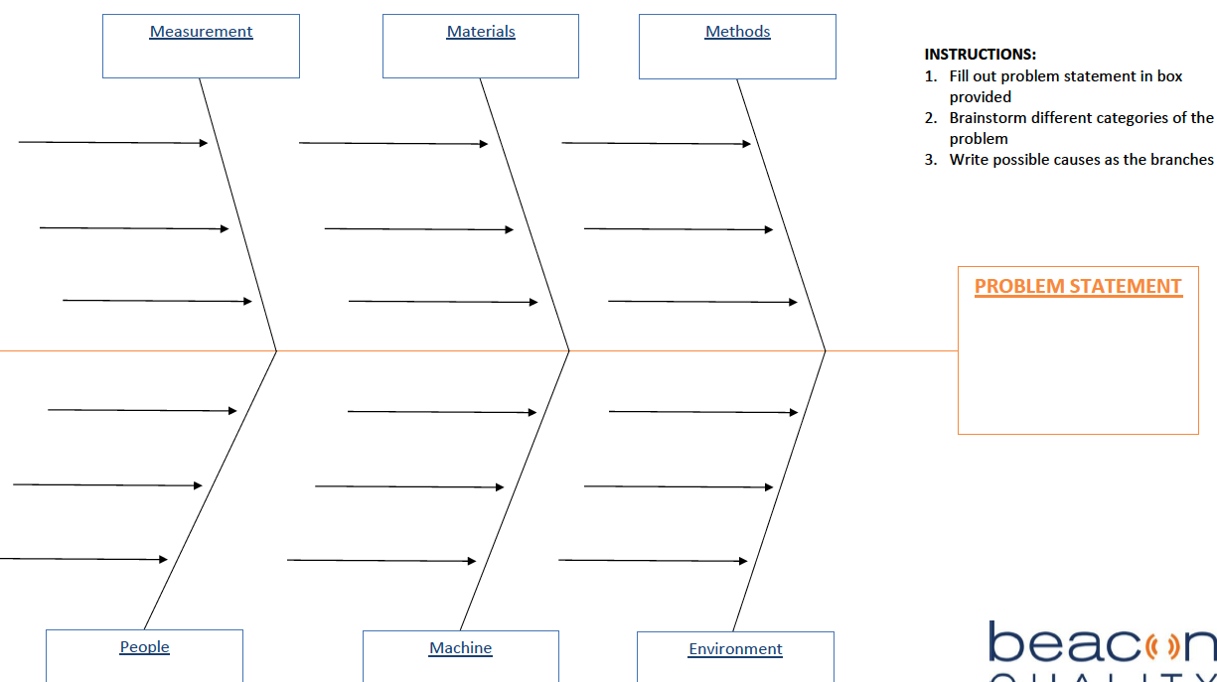

This is the fishbone diagram which show the various of categorise branch off from the original source or the problems. This cause or affect on Ishakawa diagram but a fishbone diagram has multiples sub causing branching off each identify targets or category.

Decision-Making Techniques to Evaluate Solutions
Before you take any action or considering of taking action for your business make sure you follow the following and while you at it make sure everyone knows what you thinking. The following are….
- Create a constructive environment
- Investigate the situation in detail
- Generate good alternatives
- Explore your options
- Select the best solution or the outcome of your business
- Evaluate your best plan or to take action for your business
- Communicate your decision, and take action

Plan for Solution Implementation

Communication Plan for Stakeholders

Monitoring and Review Techniques for Solution

Implementation
In order to assure successful implementation of your solution and plan of action, you should remember to do the following…

- Prepare your staff well in advance
- Train your staff well in advance
- Order equipment, material, etc, well in advance;
- If it is required then hire new staff and do so well in advance
- Use PR at every meeting and in memos as much as possible
- Evaluate the effects of each phase as it is implemented and make the necessary adjustments
- Attempt to remain flexible and open-minded

Conclusions

References

En.wikipedia.org. (2019). Asda. [online] Available at: https://en.wikipedia.org/wiki/Asda [Accessed 21 Aug. 2019].

Foster, P. (2019). 5 Root Cause Analysis Tools for More Effective Problem-Solving. [online] Beaconquality.com. Available at: https://www.beaconquality.com/blog/5-root-cause-analysis-tools-for-more-effective-problem-solving [Accessed 4 Sep. 2019].

Confino, J. (2019). Asda: 95% of our fresh produce is already at risk from climate change. [online] the Guardian. Available at: https://www.theguardian.com/sustainable-business/asda-food-waste-risk-climate-change [Accessed 4 Sep. 2019].

Corporate.asda.com. (2019). Our Story - ASDA Corporate. [online] Available at: https://corporate.asda.com/our-story [Accessed 2 Sep. 2019].

