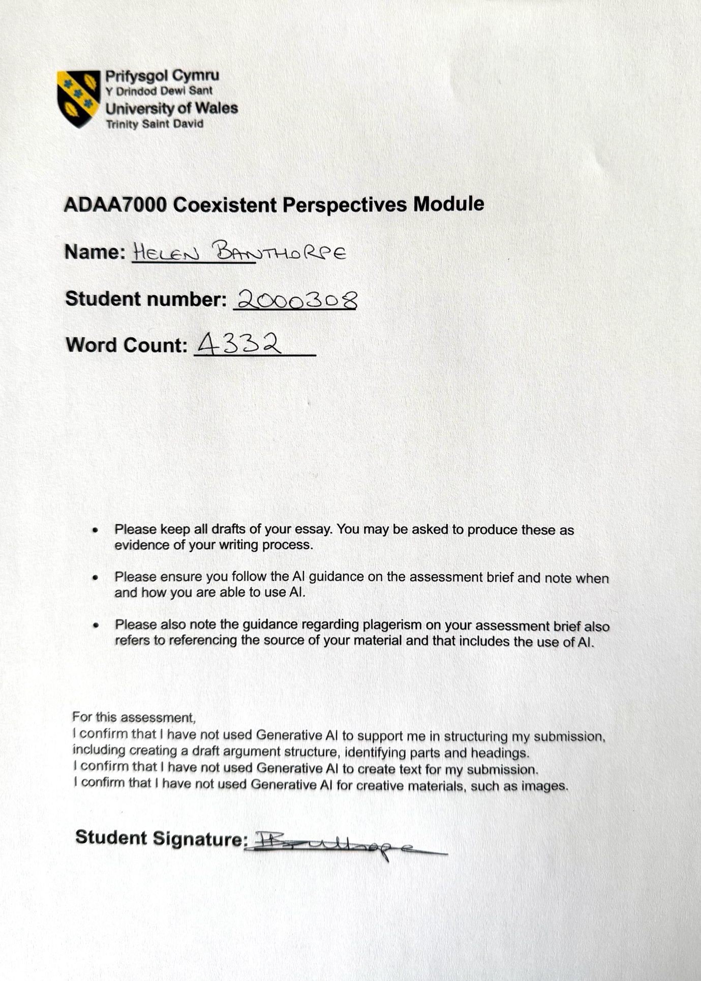

Helen Banthorpe
Student No: 2000308

Essay taken from Question 5. Design Thinking and Material Practices:
How are contemporary practices of design and making reshaping ideas of authorship, agency, and materiality in response to shifting technological, ecological, and philosophical paradigms? Consider how approaches such as speculative design, generative systems, or post-digital craft are contributing to these developments.

How Does James Turrell Construct Light as an Immersive Perceptual Environment that Configures Space, Materiality, and Spiritual Encounter?

Abstract
This essay examines the work of James Turrell, how he uses light, not as an image or a symbol, but rather an immersive experience, and invites the viewer to engage in the art. The philosophical frameworks of Maurice Merleau-Ponty, Henri Lefebvre and Jean-Francois Lyotard are explored, alongside the political theorist, Jane Bennett. The essay considers Merleau-Ponty’s explanation of what perception means and how humans experience it within the world, alongside light and colour relevance. Lefebvre explores perception within the social construction of space, and how this influences someone’s experience of an object or environment through their past knowledge and understanding. Bennett looks at these objects and questions how they are observed as energetic rather than passive matter. She believes everything is connected, although not always understood, and that creative materiality is used to convey depth to art. Through Turrell’s art, specifically Skyspace and Aten Reign light installations, architecture is utilised purely as a framework to project the changing light and colour of the sky for the viewer. This incorporates a contemporary notion of Lyotard’s explanation of art-sublime, how that impacts the perceived experience, and the encounter of stillness and contemplation. Examining Turrell’s Quaker upbringing, this essay makes a strong connection between his artwork and a foundation of spirituality, linking reformation theology. In conclusion, Turrell’s work is contemporary, whilst rooted in 17th century purist beliefs, and illustrates how light can be used as the main focal point within a space, allowing for a time of meditation and spirituality.

How Does James Turrell Construct Light as an Immersive Perceptual Environment that Configures Space, Materiality, and Spiritual Encounter?

Introduction
James Turrell uses light to create art, rather than the traditional sense of enhancing an art object, like a painting or sculpture. In the 1960’s, he admired the New York Minimalist artists who used materials, including wood and metal, to create cube like structures. Turrell chose instead to use light, air and space as the materials for his art installations. Early on in his career he created white seamless rooms in the empty Mendota hotel, Santa Monica, whilst cutting holes into the sides of the building, bringing natural light inside and framing the changing light during the day and night-time (Govan, 2013, p.37). Turrell also became part of the Californian Light and Space Movement, along with other artists who all focused on the perception of light and space as their main mediums.

James Turrell believes that by viewing art as an interaction rather than a static object, the viewer can take the art with them when they leave due to the experience they have encountered (Hue-Williams, 2007, p.66). He claims, ‘perception is his true medium’, and through his installations the viewer is left questioning what it is they are observing (Govan, 2013, p.13). According to Louise Blouin, light can influence how people are feeling, as different levels of light are known to affect the brain, leading to changes in behaviour and mood (Hue-Williams, 2007, p.3).

During his studies in Pomona College in early 1960’s, Turrell found he was often drawn to the light radiating from the light projector, and this led to his first light artworks. However, this fascination goes back further to his childhood, where he was brought up in a strict Quaker home (Govan, 2013, p.39). His grandmother often encouraged him to “go inside and greet the light” (Govan, 2013, p.40), a term used widely by Quakers where ‘inside’ refers to the person and ‘light’ signifies God, thus encouraging people to take time to quietly meditate and wait for God. James Turrell claimed for many years that his Quaker upbringing had not influenced his art. When he returned to Quakerism in his 40’s, for his children’s spiritual input, he realised that he had missed the structure and forthright nature of those earlier meetings. More recently he acknowledges how that strict upbringing has impacted his work but prefers to use more general references when explaining his art, to appeal to a wider audience. (Meads, 2011).

The nature of Turrrell’s light installations, by his own admission, encourage the viewer to contemplate beyond themselves, providing potential space and time for a spiritual encounter. This reiterates the role spirituality has played, through his Quaker upbringing but also through an interest in Asian culture. The Roden Crater was the precursor to his best-known Skyspace installations, where he first considered ‘celestial vaulting’ through the architecture of his spaces. The sacred dome shaped Buddhist monument, called a stupa, is where Buddhist pilgrims go to meditate, worship and atone (Anderson, 2019), Turrell chose to form a similar shape to enhance the dome of the sky, or as he says, “symbolic architecture replaced with real perception” (Govan, 2013, p.210).

James Turrell is best known for his architectural light installations, particularly Skyspaces and Aten Reign. Both encourage the viewer to relax and look up towards the sky, taking time to watch the changing light. Skyspaces enhances the natural changing light as the day progresses. Whereas Aten Reign is likened to an indoor Skyspace, with artificial light coming from elliptical rings positioned above, immersing the space in controlled, changing light levels and colours, rather than the sky itself (Johnson, 2025).

Perception, Space, and Light as Encounter
James Turrell’s light installations are more than just art. He invites the viewer to stay a while, to allow their minds to rest and wander while looking at the light, thus providing an experience rather than just seeing a static object. The theorist Maurice Merleau-Ponty believed that past knowledge or understanding is not essential to be able to experience or perceive something (Langer, 1989, p.9). He said, “perception is not a deductive inference”. Essentially, perception is not an analytical approach that can be proven by known facts (Pietersma, 1988). Whereas another theorist, Baruch Spinoza, believed that mental capacity required intellect, Merleau-Ponty considered that it was achieved through being insightful, observant, and understanding deeply, and didn’t need to be understood to exist (Pietersma, 1988). Both men, however, agreed that humans exist on the same ontological plane as nature, rather than treating nature as an object. Turrell’s work echoes this by encouraging people to consider the sky and how it makes them feel. Merleau-Ponty questioned “Who among us has not had the experience of becoming one with the sky or the sea on a clear summer’s day?’ He believed that to sense something is to cohabit with it, and allow it to shape people’s feelings (Langer, 1989, p.74).

Merleau-Ponty held the view that space and distance are not an external relationship that humans have with objects, but rather a two-way interaction between the lived body and the world. The further away something is the less understanding someone has about it, making it less visible (Langer, 1989, p.85). James Turrell’s Skyspace structures are designed to bring the sky much closer to the viewer, allowing them space to contemplate.

Colour plays a part in object recognition, affected by the glow and gloss of lighting. Changeable and dependant on what the viewer is drawn to, it involves more than just the sense of seeing, instead together they aid object perception. Merleau-Ponty observed that lighting is used in paintings, drawing the eye to see images, rather than the light itself. By adding depth to an image, light becomes important in perception. He said the ‘phenomenon of lighting’ was where light is not the object itself but the environment surrounding it, allowing changes in the colour shades, and resulting atmosphere that was created (Langer, 1989, p.92-97). Turrell challenges this by creating art where light is the object and not just a material to create ambience. Merleau-Ponty summarised this by stating, “the ‘logic of lighting’ is what makes possible the emergence of a coherent spectacle.” (Langer, 1989, p.95).

Merleau-Ponty questions whether space can just be experienced ‘out there’ objectively or ‘in here’ subjectively, or a combination of both (Langer, 1989, p.80). Another philosopher, Henri Lefebvre takes Merleau-Ponty’s concept that space is more than just a passive backdrop or container for human activities, to a deeper level. According to Lefebvre, there are three levels of space that exist at the same time. Space is perceived within the physical environment, specifically the externalised and material environment. Secondly, space is conceived and represented, by directing people through a space, with maps or guidance from political leaders. Thirdly, space is seen as how people experience life within their environment and alongside others (Gottdiener, 1993). Lefebvre questions what people see when they look at the space around them. People live time, because they are in time, and nature is limited within space through the hours of the day, seasons, temperature changes, the positions of the sun and moon. All these phenomena are observed by people rather than the modern way of isolating time through instruments, specifically watches and clocks (Lefebvre, 1991, p. 95). Rex Ambler observes that people can struggle with stillness and silence, required for spiritual contemplation, as their minds are full of words and images, often through technology. Does this mean that the skill of ‘simply paying attention’ is lost? (Ambler, 2002, p.31).

Lefebvre also considers the relationship between power and space through the contrast between abstract and social space. Abstract space is where knowledge is used by powerful people to control and direct the population, and the space they live in. Social space is the everyday space, lived and experienced by all members of society, including rulers, and defies conventional constraints (Gottdiener, 1993). Turrell Skyspaces, provide a place for everyone to experience an encounter, together and individually regardless of status or beliefs. Lefebvre reiterates this by stating that perception of an object depends on the individual’s past experiences and knowledge of the subject matter, thus influencing how they identify with it and experience it on different levels (Lefebvre, 1991, p.113-114).

Jane Bennett, a political theorist, considers how objects are perceived, whether passively or energetically, and about bringing what is often in the shadow to the forefront. Her work is directly influenced by the theories of Merleau-Ponty and Spinoza and indirectly by Lefebvre. Whereas Lefebvre focuses on space in terms of humans and how they interact with it, Bennett believes in the vitality of space. She considers that ‘matter’ has intentionality, is not just limited to humans but spans across non-human objects, nature, and technologies. Bennett questions whether this intentionality belongs to humans, to God or whether it extends further to matter, making it more than a lifeless object (Bennett, 2010, p.119).

Bennett refers to Merleau-Ponty’s book Phenomenology of Perception as a focus on the ‘embodied character of human action’ through the concept of ‘motor intentionality’ (Bennett, 2010, p.30). Motor intentionality was used by Merleau-Ponty to describe actions that are non-reflective, directing the person towards practical goals, rather than conscious and intentional actions

Bennett believes that everything is connected, and that creative materiality is used by artisans to convey meaning, emotion, and narrative. By looking at how the materials they use interact with the audience, and naturally affect their behaviours in a predisposed way, rather than just the physicality of the materials (Bennett, 2010, p.56). This is how Turrell uses light, as an energetic material at the forefront of the viewers experience, providing a quiet space for contemplation and potential spiritual encounter.

In her book Vibrant Matter, Bennett refers to Michel Foucault’s mention of the ‘incorporeal’ as the stimuli for human perception (Bennett,2010, p.57). Linking incorporeal to light, it refers to the light or energy that exists outside of a physical body and is often associated with spiritual concepts, like God and souls. This light becomes non-material and invokes an experience beyond understanding. Aristotle defined light as a transparent material requiring vision. He said that light was incorporeal, that it could appear and disappear instantly and was not dependent on movement (Sambursky, 1958, p.114). Aristotle also believed that light is a presence, essential only for seeing something else, allowing people to see colour. Light itself is not a brightness but an illumination (Sorabji, 2004). This suggests that light has a purpose, but Bennett challenges this idea by saying that all materials have the capacity to have a vitality, and ability to impact humans on how they think or act, once recognised, and to act in their own right (Bennett, 2010, preface).

These theories and concepts become interesting when examined through Turrell’s work, especially Skyspace and Aten Reign, where light is used for more than just atmosphere and ambience. Light at the forefront of this sensory experience, within a physical structure, can shape and influence people’s experiences, giving it a vitality.

Skyspace
Skyspaces are the best-known site-specific works by James Turrell, with more than ninety created worldwide, in varying sizes and locations. Each space is designed to connect people not only to the sky but to each other through a shared experience of wonder and awe. Spending time in a Skyspace, allows the viewer to be transformed through connection with the sky, in a way that enables transcendence. (Crosbie, 2024). These architectural spaces are described as ‘rooms that had apertures that open to the sky’ drawing the viewers eyes upwards creating art with the light and sky (Govan, 2013, p.12).

Helen De Cruz argues that wonder is essential in helping people to see nature as valuable and not just a commodity. Awe and wonder can change people’s outlooks on life and can transform them, by reminding them that these things are invaluable and interconnected with the rest of the world (De Cruz, 2024, p.156, 158-159) She suggests that how people respond to nature is personal but says “We wonder at something outside of us (usually), but wonder comes from within.” Everyone can experience moments of wonder in nature, especially in ‘a quiet, reflective state of mind’ allowing the ability to take time to experience it. (De Cruz, 2024, p.2-3).

Skyspaces all have a similar core design, architecturally simple enclosed spaces, either in an existing building or purpose-built. Benches are positioned around the internal walls, and a skylight draws the viewers gaze upwards, framing the sky and bringing it closer to the viewer. While quietly spend time in this environment, light changes are observed in colour and quality, atmosphere and weather conditions, with the best time being twilight hours (Govan, 2013, p. 132). The sky is a large distance from our ‘perceived space’. By framing the sky and bringing it into the viewers physical space it brings the sky closer, and thus becomes the art (Govan, 2013, p.12).

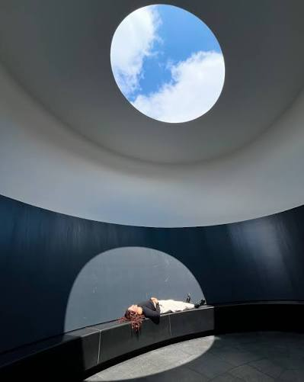 image: Govan (2013)

Turrell inspired by the Pantheon in Rome, believed it to be a ‘sanctuary built for all gods’, although Cassius Dio, a third century historian, said “my own opinion of the name is that, because of its vaulted roof, it resembles the heavens” (Ranogajec, 2015) This ominously large domed building has a circular opening at the top providing the only source of natural light, with light beams traveling across the walls and floor throughout the day. Turrell observed that in the Pantheon the sky is faraway and inaccessible, whereas his Skyspaces bring the sky closer and more accessible to the viewer (Govan, 2013, p.134).

Although the Skyspace designs have become more complex as technologies have changed, and with access to larger sites, the common factor remains the same; this concept of using light as the main material and the architecture purely as a vessel to enhance the viewers experience (Govan, 2013, p.137). Skyspaces described as ‘shrine-like chambers’, are rooms open to the sky allowing the viewer to stop and think beyond themselves, immersed in the pure atmosphere of natural light (Hue-Williams, 2007, p.22). They are also referred to as ‘secular chapels’, due to their simplicity and similarity to the Quaker meeting rooms that Turrell regularly attended as a child. In fact, several Skyspaces have been designed specifically for meditation within Quakers meeting houses. Turrell said that his Quaker upbringing compelled him to be “responsive to the straightforward, strict presentation of the sublime”, something he compares to the Asian cultures where enlightenment is linked to connecting the ‘light outside with that inside us’ (Govan, 2013, p.134).

When Turrell started creating his light installations, he claimed they were not religious, but there are obvious links to reformation theology. During the reformation, stained glass panels in churches were destroyed and replaced with clear glass, allowing the light of God to shine directly onto the congregation. Similarly, it could be argued that Turrell made light the main experience by relinquishing any imagery in his artworks (Hue-Williams, 2007, p.35).

In medieval times, stained glass windows were designed to depict biblical stories and coloured glass was used to bring these stories to life. The coloured glass was believed to have supernatural qualities, making them perfect for these sacred spaces (Walker, 1978, intro). Coloured glass was also used to elicit emotion, as the light passed over textured glass or diffused through the glass to give the overall effect a sense of ‘otherness’ (Lee, 1977, p.61).

In late 15th century, many stained-glass windows were destroyed, especially in the Netherlands, by the Calvinist iconoclasm, and in the UK, through the Reformation and Dissolution of the Monasteries, by the Protestants. The Reformers claimed they “fostered the spirit of individualism and the importance of personal virtue as a means to salvation” (Brown, 1994, p.106, p.111).

By 17th Century, most people in England believed in God and Christianity, helped by the recent translation of the bible and its availability to individuals. During this time the Quaker movement was formed as a religious and puritan group, believing everyone could access God directly. They met in unadorned, simple rooms with clear glass windows so as not to be distracted from God. Oliver Cromwell was threatened by the rapid rise of this movement and persecuted those praising God openly. This led to the Quakers using the term ‘The Light’ as opposed to speaking directly about God (Meads, 2011). Still used by modern Quakers, it links directly to the quote, mentioned earlier, by Turrell’s grandmother, “go inside and greet the light” (Govan, 2013, p.40). Lefebvre observed that for centuries, leaders determined to destroy a society, often try to do so by publicly destroying that society’s monuments, the spaces and objects that are deemed meaningful (Lefebvre, 1991, p. 221).

Skyspaces appear to reflect the architecture of current Quaker Meeting Houses, where ‘friends’ sit in a simple circular seating area, waiting in silence and stillness for God. It is not considered to be an act of individual meditation, rather a collective time of waiting. While experiencing Turrell’s works, people of all ages have been reported to settle into a state of stillness and quietness while looking up to the opening to the sky or with their eyes closed (Mead, 2011).

One Quaker practice in particular shows strong similarities to what Turrell is trying to achieve within his Skyspace settings. In 1996, Rex Ambler started a practice called ‘Experiment with light’ to help Quakers with spiritual contemplation. Firstly, ‘mind the light’, then ‘open your heart to the Truth’. Next, to wait in the light and lastly to submit to what is shown in the light (Ambler, 2002, p.16-21).

Aten Reign
When James Turrell was approached to design a temporary light installation at the Guggenheim Museum, New York, specifically in the rotunda, he was reported as saying that, if he could, then he would have removed the roof to incorporate a Skyspace. (Kwon, 2013). Instead, through the concept of Aten Reign, Turrell succeeded in transforming the iconic spiral rotunda, designed by Frank Lloyd Wright, into a new, more colourful form of Skyspace. On visiting the exhibition, Frank Johnson described it as a “breathtaking, immersive manipulation of light, space, and the observer’s perception” (Johnson, (2025). Usually, the rotunda lets in natural daylight from the ‘oculus’, but rather than framing this light, Turrell created a new environment, comprising of five stacked, elliptical rings encased within the architectural spiral ramps of the rotunda.

When the exhibition first opened, there was criticism in Turrell choosing to enclose the museum’s stunning architecture with temporary walls and hide the openness and fluidity envisioned by Wright’s design, and yet there are similarities between the two men. Both are known for being inspired by nature and for bringing the outside world inside, and for using ‘pure geometric forms to create modern versions of ancient temples’ (Kaplan, 2013). In fact, Wright is reported to have called his Guggenheim masterpiece as a “temple of the spirit” (Johnson, 2025). Lefebvre comments that Wright sought to eradicate the internal walls designed to separate the inside from the outside. By permitting light to flood into a space, nature could be reflected and considered, and thus liberating the internal space (Lefebvre, 1991, p.303).

Aten Reign refers to the ancient Egyptian sun god who wore a sun disc headpiece (Aten), and the sovereignty of this divine light within a space (Reign). This reflects Turrell’s interest in light as a pure divine force and links directly to his spiritual upbringing. Turrell believes that by changing the light colours and intensity within a space as the viewer looks upward, it can alter their perception of how deep the sky is. He argues that rather than seeing a distinction between natural and artificial light, there is merely ‘our light versus the light outside’. Turrell creates new architecture within a building by changing the angle and intensity of light to create and control the size of that space. Through both Aten Reign and Skyspaces he challenges the limits of the close connection between the inside and outside area. Connecting people to outside spaces can remind them that they live in an expanse much larger than the buildings that they inhabit. He is quoted as saying his aim is to create “spaces that protect and contain light and to apprehend it for our perception.” (Kwon, 21013).

Aten Reign was exhibited for three months at the Guggenheim Museum, and on completion was classed as an engineering and architectural transmutation. Five enormous elliptical rings with LED lights were hung from the central space of the Guggenheim rotunda and enclosed in a darkened internal space, enabling Turrell to control the colour, intensity and concentration of the light radiating from each ring. The lights were programmed to slowly change colour and although there were distinct rings, the subdued lighting and surrounding enclosed space created an atmosphere of a “sensation of losing depth perception and being enveloped in color”. In effect, the viewer became shrouded within the art, rather than just observing it from a distance (Johnson, 2025).

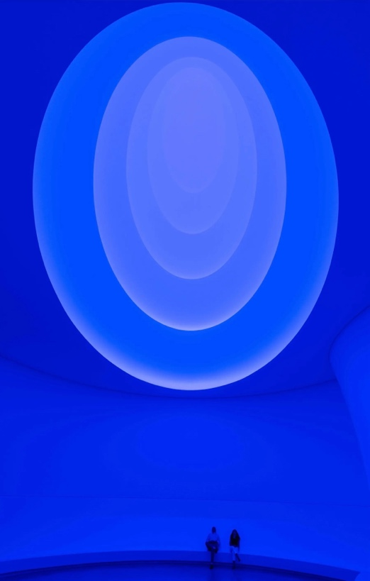 image: New York Times

To fully appreciate any of Turrell’s installations people are advised to stay in the space for at least twenty minutes to appreciate the subtle shifts of light, while lying down and looking upwards towards the sky. By taking time to allow their mind to wander, their eyes to adjust, and by not overthinking the experience, they can surround themselves in light, and the ‘deeper perceptual phenomena’ can then materialise. These experiences cannot be rushed, and people are discouraged from taking photos, as this can disrupt their encounter (Johnson, 2025). These guidelines are like the Quaker meditative practice mentioned above (Ambler, 2002).

This experience is considered by the French philosopher, Jean-Francois Lyotard as describing the sublime. Lyotard suggests that the sublime found in artwork, rather than that in natural objects, is unstructured and like minimalism in its simplicity. Turrell was influenced by Minimalism in his early career, and this helped to guide this art form. Lyotard observed how this type of art is imperceptible, leading to something that has never been experienced before. Like nature, artists can provide indeterminate entities through ‘negative presentation’ (Zuckert, 2011). It could be argued that Turrell uses light as his ‘blankness’, allowing people to think beyond what they are seeing. When explaining art-sublime, Lyotard refers to the ‘blankness’ as the way that artists can provide an image that has nothing obvious to pay attention to or focus on. This makes it possible to expand beyond the recognisable, specifically when referring to divinity and reality (Zuckert, 2011).

By using the easily accessible space of the Guggenheim Museum as the location for Aten Reign, a much larger volume of people could experience James Turrell’s art works in a reimagined way, by using light to control the space within existing profound and inspiring architecture. The legacy of this is perhaps that “sometimes, the most unforgettable experiences are the ones that demand us to simply stop, breathe, and open our eyes to the light.” (Johnson, 2025).

This larger volume of people visiting the exhibition did cause its own problems, however, making it difficult for some to find a space to stop and relax, along with the noise of others around them. There was also the criticism around enclosing and therefore obscuring the original Frank Wright architecture and the fact that although billed as another skyscape, this one felt more artificial. But overall, this exhibition was deemed to be a huge success and significant in making James Turrell a much better-known artist.

Conclusion
Overall, James Turrell’s artworks have been influenced by his Quaker upbringing and experiences, by removing any outside and visual distractions and providing a space that nurtures stillness, patience and contemplation. Rather than providing a clear narrative or symbolic meaning, requiring interpretation in his installations, Turrell instead uses light and space to invite the viewer in. By increasing their awareness of their own perception, within an environment, reminds the viewer of “the profound beauty in simplicity, the complexity in pure sensation, and the importance of direct, unmediated experience” (Johnson, 2025).

Each experience is different, as individual’s perceptions are all unique and dependant on their own life encounters, upbringings, emotions, and belief systems. Turrell’s work provides a pure escape from a world that is increasingly surrounded by digital input, changing trends and overstimulation. His work brings the focus back onto nature, specifically the sky and the light that is seen, in a space that is simplistic and devoid of imagery and clutter.

James Turrell’s light installations are revolutionary in the contemporary art world, whilst being inspired mainly by the 17th Century beliefs of Quakerism, which formed the mainstay of his childhood upbringing, alongside his interest in Asian spiritual belief systems and architecture. This is shown in his simple dome shaped architectural designs, alongside the primary use of light and environment as the main art form. Through his work, he challenges the idea that light is a medium purely used to enhance a piece of artwork and is needed to ‘draw the eye’ to its colour and depth. Instead, he makes this nonmaterial the main material and focal point of his art, and thus aligning with Jane Bennett’s understanding that matter is not static but instead vibrant, energetic and spontaneous.

The space that is created in Turrell’s art is both physical, in the design of the enclosed areas, and metaphorical, in allowing the viewer to consider more than just what they are seeing, providing opportunity for quiet and contemplative time to explore what that means to them. This can then lead to a spiritual experience, enhanced by the purity and simplicity of the surrounding environment, although this is obviously down to each individual.

In conclusion, James Turrell explores the power, spirituality and immersion of light in all his artwork, and questions what materiality and perception of space and time is. By using light as the main focal point, he enables the viewer to actually become the art and immerse themselves in a unique experience over a prolonged time, as opposed to a potentially fleeting moment in a more traditional art gallery.

Bibliography
Ambler, R. (2002). Light to Live by: An Exploration in Quaker Spirituality. London: Quaker Books.

Anderson, C. (2019). Holy Ground: What is a Stupa and Why is it Important to Buddhists. https://www.internationalmissionboard.org

Bennett, J. (2010). Vibrant Matter: A Political Ecology of things. Durham: Duke University Press.

Brown, S. (1994). Stained Glass: An Illustrated History. London: Bracken.

Crosbie, M. (2024). Wonder and Awe in a James Turrell Skyspace. https://www.commonedge.org/wonder-and-awe-in-a-james-turrell-skyspace

De Cruz, H. (2024) Wonderstruck: how Wonder and Awe Shape the Way We Think. 1st ed. Princeton: Princeton University Press.

Gottdiener, M. (1993). A Marx for Our Time: Henri Lefebvre and the Production of Space. Sociological Theory, 11(1), pp. 129-134.

Govan, M and Kim, C. (2013). James Turrell: A Retrospective. Munich: Prestel.

Hue-Williams, M. (2007). James Turrell: A life in Light. Paris: Somogy Editions d’Art.

Johnson, F. (2025). James Turrell Guggenheim Museum: Unraveling the Light and Space Experience with ‘Aten Reign’. https://www.wonderfulmuseums.com/unraveling-the-light-and-space-experience-with-aten-reign/.

Kaplan, L (2013). Perceiving James Turrell. https://www.artsynet/article/laurenalbie-perceiving-james-turrell

Kwon, M (2013). 1000 Words: James Turrell. Artforum International, 51(9), pp. 284-287. Artforum International Magazine Inc.

Langer, M. (1989). Merleau-Ponty’s Phenomenology of Perception. A Guide and Commentary. The Macmillan Press Ltd.

Lefebvre, H. and Nicholson-Smith, D. (1991). The Production of Space. Oxford: Blackwell

Lee, L. (1977). The Appreciation of Stained Glass. London: Oxford University Press.

Meads, H. (2011). The Quaker Meaning of Light (and James Turrell’s Works). https://www.massmoca.org/the-quaker-meaning-of-light/.

Pietersma, H. (1988). Merleau-Ponty & Spinoza. International Studies in Philosophy. 2(3). Philosopher Documentation Center.

Ranogajec, P. (2015). The Pantheon, Rome. Smarthistory. https://www.smarthistory.org/the-pantheon/.

Sambursky, S. (1958). Philoponus’ Interpretation of Aristotle’s Theory of Light. Osiris vol 13, p114-126. The University of Chicago Press.

Sorabji, R. (2004). Aristotle on Colour, Light and imperceptibles. Bulletin of the Institute of Classical Studies, 47, pp129-140. London: Oxford University Press.

Walker, S. (1978). The Life of Christ in Stained Glass. Walker Publishing Co.

Zuckert, R (2021). Presenting the Unpresentable: Jean-Francois Lyotard’s Kantian Art-Sublime. Kantian Review; Cambridge 26(4), pp549-565.

