Student Name: Jeet Patel
Student ID: 2532588
Module Name: International Business Concepts
Module Code: LCMB7034
Lecturer’s Name: Akshay Narayanan
Word count: 5639
Term 2

Table of Contents
1. Introduction 5
2. Company Overview: Primark 6
2.1 Background and Business Model 6
2.2 International Footprint and Financial Performance 6
3. Critical Evaluation of Primark's International Strategy 9
3.1 Bartlett and Ghoshal's Typology Applied to Primark 9
3.2 Implications for Entry into Japan 10
4. Japan Market Environment: PESTLE Analysis 11
4.1 Macro-Environmental Overview and Factor Prioritisation 11
4.2 Political Factors 12
4.3 Economic Factors 12
4.4 Social and Cultural Factors 14
4.5 Technological Factors 15
4.6 Legal and Environmental Factors 16
5. Cultural Distance Analysis 16
6. Competitive Landscape Analysis 18
6.1 Key Competitors 18
6.2 Critical Assessment of Competitive Dynamics 19
7. Entry Mode Analysis 20
7.1 Dunning's Eclectic Paradigm 20
7.2 Transaction Cost Analysis 22
7.3 Evaluation of Entry Mode Options 22
8. Key Challenges and Risks 23
8.1 Operational Challenges 23
8.2 Strategic and Competitive Risks 23
8.3 Currency and Financial Risks 23
9. Strategic Recommendations 24
9.1 Recommended Entry Mode 24
9.2 Phased Market Entry Strategy 24
9.3 Product and Service Adaptation 25
9.4 Digital Channel Development 26
9.5 Sustainability Positioning 26
10. Conclusion 26
11. Reflective Account 27
Reference List 29

List of Figures
Figure 1: Primark sales by region, H1 FY2026
Figure 2: Primark financial performance, FY2025 versus H1 FY2026
Figure 3: PESTLE factor prioritisation for Primark in Japan
Figure 4: Japan apparel market, online versus offline transactions, 2024
Figure 5: Hofstede cultural dimensions, UK/Ireland versus Japan
Figure 6: Indicative revenue scale comparison, Fast Retailing versus Primark
Figure 7: Phased market entry roadmap for Primark in Japan

List of Tables
Table 1: Non-financial indicators of Primark's international footprint
Table 2: Primark key financial metrics
Table 3: PESTLE factor prioritisation for Primark in Japan
Table 4: Key economic indicators for the Japanese apparel market
Table 5: PESTLE analysis summary for Primark in Japan
Table 6: Prioritisation of technological sub-factors
Table 7: Hofstede cultural dimensions comparison, UK/Ireland versus Japan
Table 8: Competitive landscape, key players in the Japanese apparel market
Table 9: Critical OLI assessment for Primark in Japan
Table 10: Entry mode evaluation for Primark in Japan
Table 11: Phased market entry roadmap for Primark in Japan
Table 12: Analytical challenges encountered and lessons learned

1. Introduction
Strong pricing competition, quickly shifting consumer preferences, and mounting demands for social and environmental sustainability define the global fashion retail sector (Dhir et al., 2021). While international development creates important strategic problems, it also presents opportunity for revenue growth for existing retailers. Assessing transferable ownership advantages, host-country institutions and competition, cultural distance, and a suitable entry strategy that balances control, risk, and resource commitment are all necessary for a successful foreign market entry (Anderson and Gatignon, 1986; Dunning, 1988; Johanson and Vahlne, 1977).
The possibility of Primark, the Dublin-based value-fashion division of Associated British Foods plc (ABF), entering Japan is assessed critically in this paper. As of June 2026, Primark had 485 locations in 19 markets throughout Europe, the US, and the Middle East; it had no notable foothold in Japan or other parts of East Asia (Associated British Foods plc, 2026a; Primark, 2026a). Therefore, Japan offers a good setting for analyzing global expansion in situations where there is no established market presence.
Japan offers a compelling yet difficult possibility. Its apparel and footwear market was estimated to be worth JPY 8.489 trillion in 2025, making it the fourth largest economy in the world (METI, 2025). The nation presents problems such as fierce domestic rivalry, high operating expenses, high service demands, and an aging population, but it also offers institutional stability, dense urban retail locations, and significant tourism (Leingpibul et al., 2025; OECD, 2026).
Primark's business model and global reach, corporate strategy using Bartlett and Ghoshal's (1989) framework, Japan's macroenvironment using PESTLE, cultural distance using Hofstede's (2011) dimensions, competitive conditions, and entry-mode options using Dunning's eclectic paradigm and transaction-cost reasoning are all examined in this report. After that, it assesses the main dangers, offers practical suggestions, wraps up the investigation, and considers the analytical procedure.

2. Company Overview: Primark

2.1 Background and Business Model
In 1969, Primark was established in Dublin, Ireland, under the name Penneys. It became the main retail arm of ABF and one of the biggest value-fashion retailers in Europe after entering Great Britain in 1973 (Primark, 2026b). Its business strategy enables reasonably priced, trend-driven fashion by fusing economies of scale, effective logistics, cheap overhead, and high-volume, low-margin retailing. Primark earned £1.126 billion in adjusted operating profit and £9.489 billion in revenue in FY2025, resulting in an 11.9% margin (Associated British Foods plc, 2025).
Primark's store-led concept is a key component of their strategy. Its website mainly facilitates stock checking, range browsing, and store discovery rather than direct purchasing, despite a 37% rise in digital traffic in the first half of FY2026 after a website redesign (FashionNetwork.com, 2026). Home delivery is still not accessible, although click-and-collect is available in the UK. When compared to competitors, this strategy lowers fulfillment and return costs but also creates vulnerability in areas where online buying is anticipated.
Cost flexibility is supported by Primark's asset-light sourcing strategy. The business depends on outside suppliers in Asian regions and does not own any production facilities (Primark, 2025). However, this exposes one risks related to exchange rates, freight volatility, geopolitical disruption, and ethical compliance. All apparel, textile, and footwear suppliers were added to traceability systems, and 74% of clothing units sold thru Primark Cares in FY2025 comprised recycled or more sustainably sourced fibers (Associated British Foods plc, 2025).

2.2 International Footprint and Financial Performance
From 483 stores in 18 markets in February 2026 to 485 stores in 19 markets by June 2026 with 19.8 million square feet of selling space, Primark has grown gradually (Associated British Foods plc, 2026a; Primark, 2025). Western Europe continues to account for the majority of revenue, with continental Europe accounting for 48% (£2.235 billion), the UK and Ireland for 45% (£2.096 billion), and the US for 6% (£300 million), together with newly established franchise businesses in the Middle East (Associated British Foods plc, 2026a).
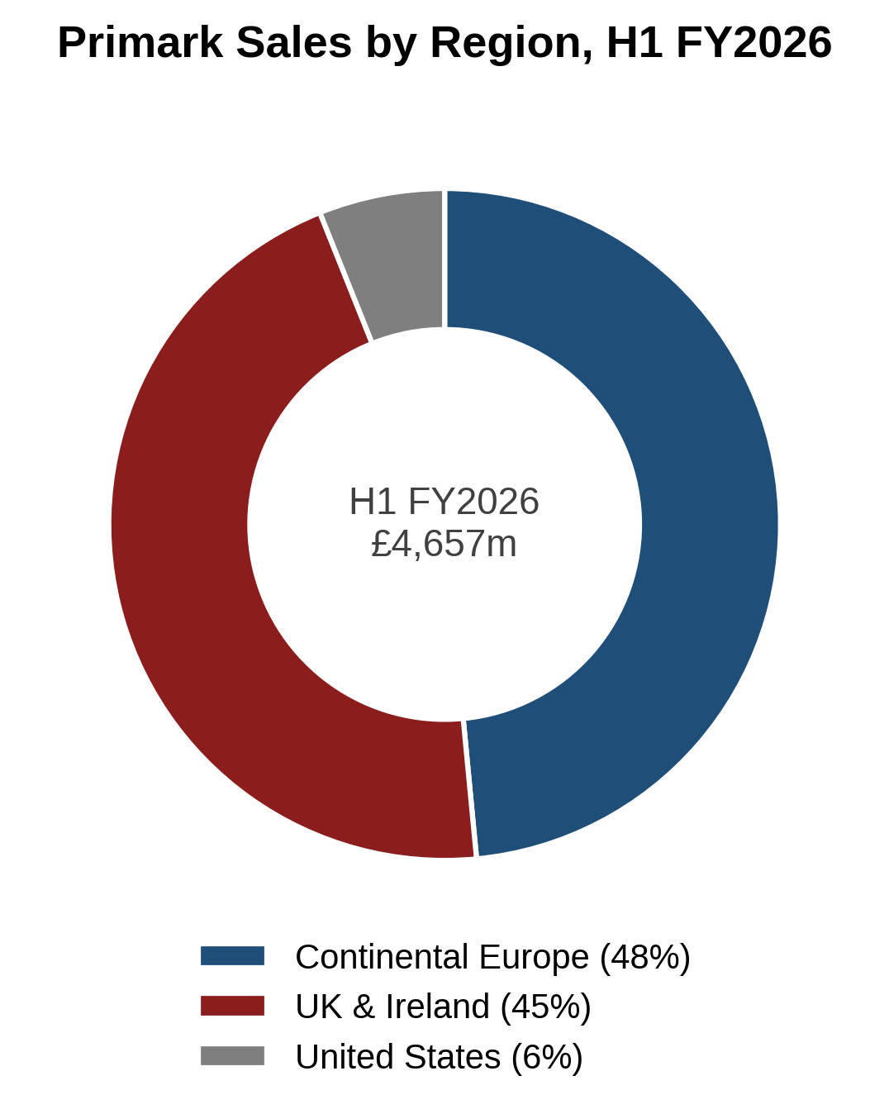
Figure 1: Primark sales by region, H1 FY2026 (Source: Associated British Foods plc, 2026a)
Regional concentration is both a source of scale and a strategic vulnerability, as Figure 1 demonstrates that around 93% of group revenue comes from Western Europe. Four factors are listed in Table 1 that have an impact on Primark's capacity to increase its global presence. First, the company's geographic specialization exposes it to unseasonal weather, consumption instability, and economic downturns in Europe. Second, there are disparities in brand equity: Primark is well-known in Europe and is becoming more well-known in the US, but it is not as well-known in East Asia. Third, in advanced markets, ESG skills, such as 74% adoption of sustainable fiber and complete supplier traceability onboarding, enhance credibility. Fourth, its Alshaya Group franchise in Kuwait and the United Arab Emirates exemplifies entry-mode agility by offering a tested, low-capital-intensive approach for culturally remote markets (Associated British Foods plc, 2025; Primark, 2025).
Table 1: Non-financial indicators of Primark's international footprint (Source: Associated British Foods plc, 2025; 2026a; Primark, 2025)
Indicator dimension | Operational status / metric | Strategic significance for Japan entry
Geographic diversification | 485 stores; 19 markets; 19.8m sq ft; 93% of sales in Europe | High regional concentration; Asian expansion provides long-term geographic hedging.
Brand equity and awareness | Established in Europe; growing in the US; near-zero in Japan | Intangible brand assets are not easily transferable; substantial initial marketing investment required.
Supply chain traceability | 100% of tier-1 textile suppliers onboarded (FY2025) | Robust governance mitigates Japanese regulatory and consumer scrutiny of product origin.
Sustainable materials | 74% of clothing units contain recycled or sustainable fibers | Supports credibility against Japan's demanding environmental and quality expectations.
Digital discovery infrastructure | Website traffic +37% (H1 FY2026); UK click-and-collect | Provides a digital baseline, but the absence of transactional capability remains a gap.
Entry-mode flexibility | Franchise partnership with Alshaya Group in the Middle East | Demonstrates capacity to leverage local partners when entering culturally distant markets.

In terms of finances, Table 2 and Figure 2 demonstrate margin compression in the face of global cost pressures. Revenue rose to £4.657 billion in the first half of FY2026, while adjusted operating profit dropped to £471 million, lowering the operating margin from 11.9% in FY2025 to 10.1% (Associated British Foods plc, 2025; 2026a). Regional differences were seen in like-for-like performance, which increased by 12% in the US and 2% in the UK and Ireland but decreased by 1% in continental Europe. This pressure indicates that Japan needs a capital-disciplined approach and restricts tolerance for a loss-making entry.

Table 2: Primark key financial metrics (Source: Associated British Foods plc, 2025; 2026a)
Financial metric | FY2025 (full year) | H1 FY2026 (interim) | Strategic implication
Total revenue | £9,489 million | £4,657 million | Consistent top-line growth driven by selling space expansion.
Adjusted operating profit | £1,126 million | £471 million | Erosion driven by freight volatility and wage inflation.
Adjusted operating margin | 11.9% | 10.1% | Compression limits tolerance for loss-leading market entry.
Retail selling space | 19.5 million sq ft | 19.8 million sq ft | Sustained physical expansion across core markets.
Total store count | 483 stores (18 markets) | 485 stores (19 markets) | Recent Middle East entry via Alshaya franchise.

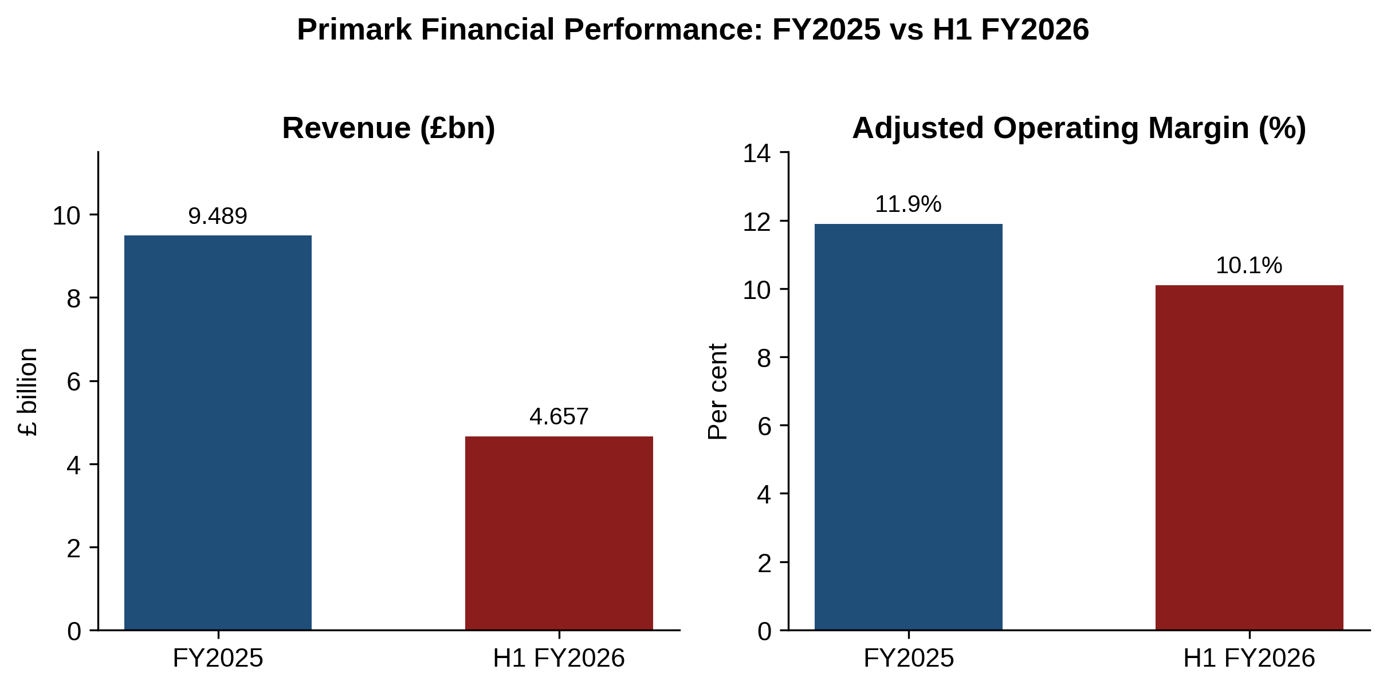
Figure 2: Primark financial performance, FY2025 versus H1 FY2026 (Source: Associated British Foods plc, 2025; 2026a)

3. Critical Evaluation of Primark's International Strategy

3.1 Bartlett and Ghoshal's Typology Applied to Primark
According to two pressures—global integration, which includes cost reduction and scale efficiency, and local responsiveness, which includes national differentiation—Bartlett and Ghoshal's (1989) integration–responsiveness typology divides multinational strategies into four archetypes. Global (high integration, low responsiveness), multidomestic (low integration, high responsiveness), international (low on both), and transnational (high on both) are the resulting archetypes (Bartlett and Ghoshal, 1989; Johnson et al., 2011).
Using this matrix shows that Primark's approach is mostly worldwide. Integration is the foundation of its competitive advantage: centralized executive leadership at ABF, standardized high-volume ranges, uniform shop marketing strategies, and centralized procurement across Asian supplier hubs. Smaller rivals are unable to match the unit cost leadership that global sourcing scale provides. However, when store designs are adapted to municipal retail footprints, marketing efforts are localized across digital platforms, and products are selectively modified for Southern European and US sizing; aspects of local responsiveness are emerging. Primark thus maintains a global core with practical and careful local tailoring rather than a fully international approach.
When compared to competitors, these restrictions are more obvious. Inditex employs a global strategy that blends local responsiveness with centralized design. When preferences diverge, H&M's more globalized business model may result in excess inventory. Primark prioritizes low-cost, high-volume operations, but this strategy is less successful in regions with a varied population.

3.2 Implications for Entry into Japan
Primark would face serious risks in Japan's unique retail industry if it adopted a purely global strategy. An unaltered European retail model is inappropriate for Japanese consumers, who have high standards for clothing fit, fabric quality, seasonal collections, and customer service. These difficulties are exemplified by the experience of Forever 21, which ultimately shut down its Japanese operations after finding it difficult to modify its merchandising and quality to suit local tastes. Therefore, Primark ought to implement a transnational strategy that blends local responsiveness with worldwide efficiency. While Japanese management should oversee merchandising, sizing, service standards, and marketing initiatives to guaranty that goods and operations meet local customer expectations, centralized procurement can maintain economies of scale.

4. Japan Market Environment: PESTLE Analysis

4.1 Macro-Environmental Overview and Factor Prioritisation
Decision-makers receive minimal guidance and analytical ambiguity when all macroenvironmental aspects are treated equally importantly. Thus, Japan's PESTLE dimensions are explicitly prioritized in Figure 3 and Table 3 based on how they directly affect Primark's operational viability and the extent of business model modification needed. While political, legal, and environmental aspects are controllable, compliance considerations, economic, sociocultural, and technological elements emerge as crucial drivers that determine commercial viability.
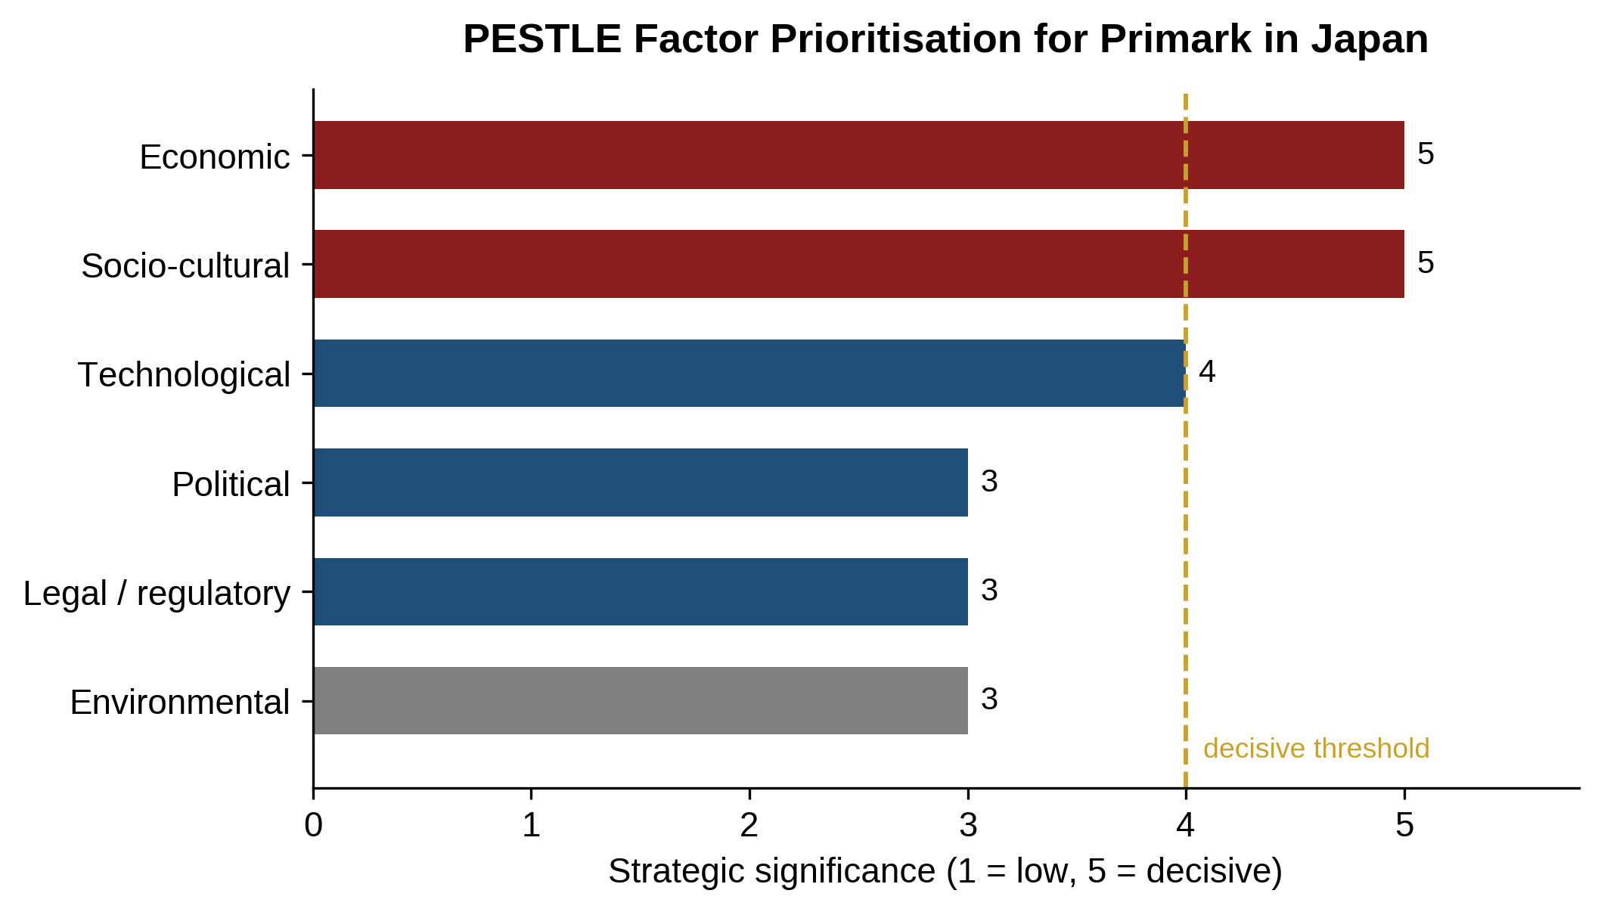
Figure 3: PESTLE factor prioritisation for Primark in Japan (Source: Author's analysis)
Table 3: PESTLE factor prioritisation for Primark in Japan (Source: Author's analysis, based on JETRO, 2026; OECD, 2026)
PESTLE dimension | Priority | Core operational implication for Primark
Economic | Decisive | A weak yen and 9.0% apparel tariffs threaten value pricing; currency hedging is required.
Socio-cultural | Decisive | Zero tolerance of product defects; extensive service training and fit re-engineering needed.
Technological | Decisive | A physical-only model is a liability; localised click-and-collect and a mobile app are required.
Legal and regulatory | Manageable | Compliance with the Household Goods Quality Labeling Act and local legal partnership.
Environmental | Manageable | Leverage Primark Cares to counter fast-fashion reputational stigma.
Political | Low to medium | Minimal sovereign risk; foreign retail ownership is fully permitted.

4.2 Political Factors
Japan offers a highly stable political and institutional environment, supported by strong contract enforcement, property rights protection, and regulatory transparency (JETRO, 2026). Through JETRO, the government actively encourages foreign direct investment by providing relatively straightforward incorporation procedures, equal treatment for foreign investors, and unrestricted profit repatriation (JETRO, 2025; 2026). Japan’s participation in major regional trade agreements, including the RCEP and CPTPP, also facilitates efficient textile trade with Southeast Asian manufacturing markets. However, foreign retailers may face administrative challenges, including complex local zoning requirements, detailed employment regulations, and extensive Japanese-language documentation (OECD, 2026). Consequently, successful market entry requires strong local administrative expertise to navigate regulatory procedures effectively, avoid compliance issues, and minimize delays before commencing operations.

4.3 Economic Factors
The macroeconomic climate in Japan blends structural restraint with stability. The important indicators controlling the garment industry are listed in Table 4. According to the IMF (2026), real GDP is expected to grow by 0.8% in 2026, reflecting mature conditions where market share must be gained from incumbents rather than from total market expansion. Due to yearly shunto salary settlements of roughly 5.0% and import expenses, core inflation has stabilized between 2.5 and 3.0% (Bank of Japan, 2026; OECD, 2026). Middle-class households are more price sensitive due to ongoing cost-of-living pressure, which increases the addressable market for high-quality value clothing.

Table 4: Key economic indicators for the Japanese apparel market (Source: IMF, 2026; Bank of Japan, 2026; METI, 2025; JNTO, 2026; OECD, 2025)
Economic indicator | Value / trend | Strategic implication for Primark
Real GDP growth | 0.8% (2026 projection) | Mature market; growth requires capturing existing share.
Core CPI inflation | 2.5–3.0% (FY2026) | Rising living costs increase appetite for value fashion.
Shunto wage growth | ~5.0% (2025–26 rounds) | Supports spending power but inflates retail staff costs.
Apparel and footwear market | JPY 8.489 trillion (2025) | Substantial volume potential in a major single-country market.
Apparel e-commerce share | 23.38% (JPY 1.98tn, 2024) | Offline dominance validates stores, but O2O integration is essential.
Inbound tourist arrivals | 36+ million (+30% YoY, 2025) | Tourist footfall boosts sales in prime Tokyo and Osaka districts.
Unemployment rate | Below 3.0% | Intense competition for floor staff; competitive wages required.

In 2025, the garment and footwear industry in Japan produced JPY 8.489 trillion, or roughly 1.5% of the country's GDP (METI, 2025). Retail expenditure has surged in key cities like Tokyo and Osaka due to strong tourism growth, with over 36 million foreign arrivals (JNTO, 2026). However, the ongoing depreciation of the yen drives up the price of imported clothing and strains the profit margins of shops, especially those that depend on foreign production denominated in dollars (Japan Customs, 2026).
Although borrowing costs and consumer spending have been impacted by the Bank of Japan's move away from negative interest rates, the yen is still weak because of interest rate discrepancies with the US and Europe. A declining value of the yen would lower profit margins for Primark and raise the cost of imports denominated in dollars. Japan's tariffs of 9.0% on woven clothing and 10.9% on knitted clothing exacerbate this pressure (Japan Customs, 2026). Primark might use preferential trade agreements to source additional goods from CPTPP and RCEP members like Vietnam and Cambodia to maintain price competitiveness. The total PESTLE analysis and accompanying strategic responses are provided in Table 5.
Table 5: PESTLE analysis summary for Primark in Japan (Source: Author, based on JETRO, 2026; IMF, 2026; METI, 2025; OECD, 2026)
Dimension | Key environmental findings | Strategic response required
Political | High stability and open FDI regime; complex municipal approvals. | Establish a local corporate entity; partner to navigate licensing.
Economic | 0.8% GDP growth; JPY 8.49tn market; weak yen; 36m tourists. | Hedge yen exposure, hold value pricing, target tourist retail nodes.
Social | Ageing society; exacting quality standards; omotenashi service culture. | Adapt sizing and fabrics, strengthen quality assurance, train service staff.
Technological | 23.38% e-commerce penetration; O2O behaviour; cashless payment. | Launch a localised app, digital stock check and click-and-collect.
Legal | Household Goods Quality Labeling Act; strict fiber and care disclosure. | Provide Japanese-language care labelling and full textile testing compliance.
Environmental | Circularity policies, textile recycling push, green consumerism. | Promote Primark Cares and install in-store garment take-back.

4.4 Social and Cultural Factors
Over 30% of Japan's population is 65 years of age or older, while the country's younger population is declining (OECD, 2025). The quality, longevity, and craftsmanship of clothing are also highly valued by Japanese shoppers. According to Dhir et al. (2021), even small problems like loose threads or uneven stitching could be perceived as flaws, increasing returns and reputational concerns.
Omotenashi, which emphasizes attentive service, cleanliness, well-organized businesses, and quick checkout, has a significant impact on Japanese retail culture (Leingpibul et al., 2025). Therefore, Primark's high-density, European-style self-service concept might need to be modified to satisfy local demands. Opportunities are also created by generational differences: younger Generation Z and millennial customers in areas like Tokyo, Osaka, and Fukuoka are drawn to inexpensive, trend-driven fashion, such as Y2K and Korean-inspired trends, while older consumers typically favor durability. By providing locally appropriate clothing fits and upholding strict standards for store presentation, Primark might appeal to these younger customers.

4.5 Technological Factors
Japan has a highly digitalized retail business ecosystem. As illustrated in Figure 4, METI (2025) reports that business-to-consumer apparel e-commerce reached JPY 1.98 trillion in 2024, representing a 23.38 percent e-commerce penetration rate. Japanese consumers incorporate digital channels into their physical shopping journeys thru mobile inventory checking, in-app couponing, digital loyalty schemes, and mobile payment at the point of sale. However, physical stores still account for 76.62 percent of apparel transactions, validating a store-led entry (METI, 2025).
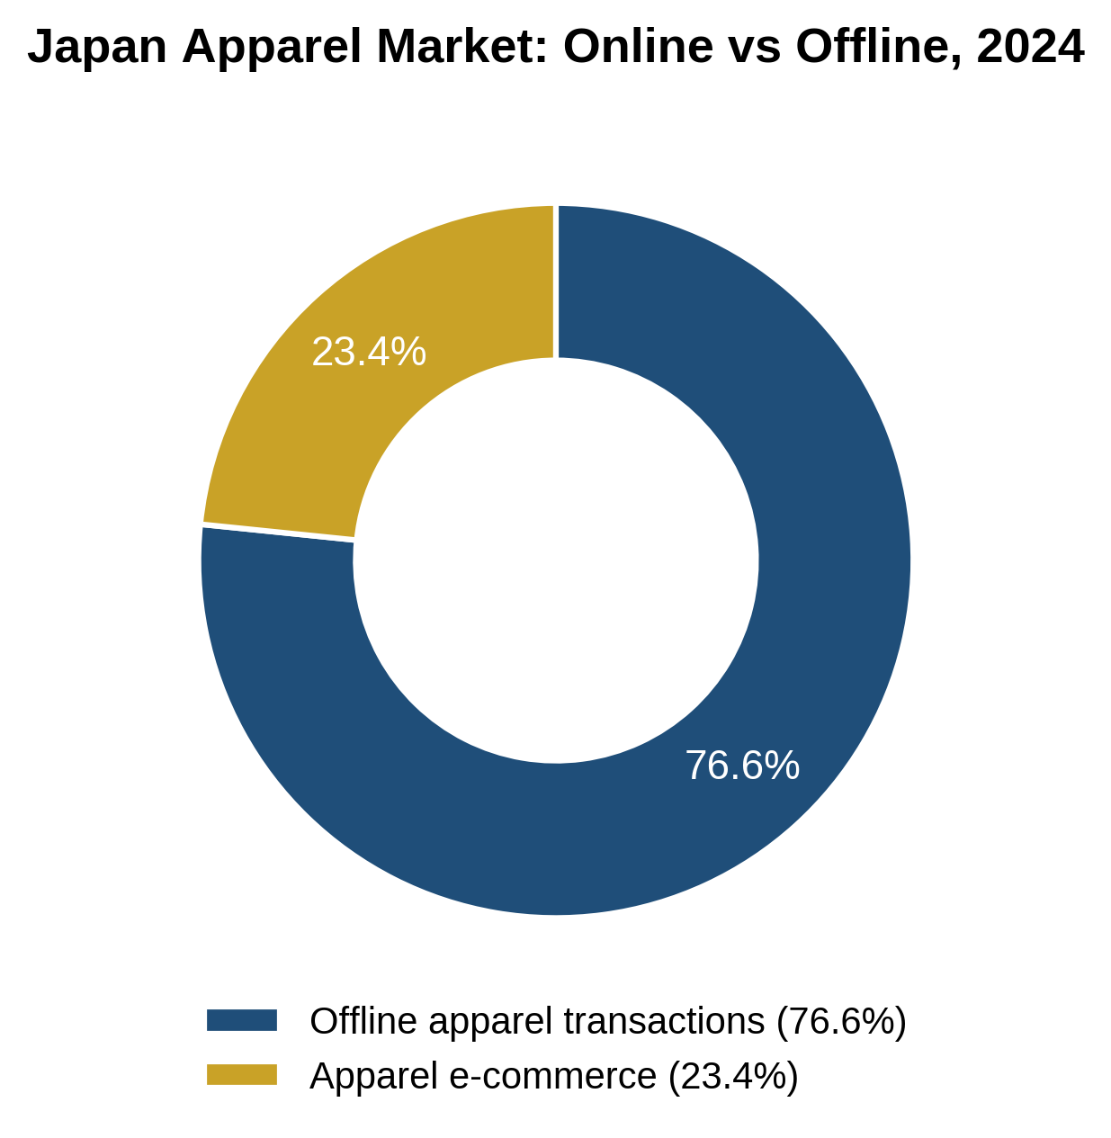
Figure 4: Japan apparel market, online versus offline transactions, 2024 (Source: METI, 2025)
The main technological elements influencing Primark are shown in Table 6. Real-time inventory, click-and-collect, and mobile payments are just a few of the digital services that Japanese customers expect to be seamlessly integrated with physical storefronts. Frictionless checkout is crucial for cashless systems like PayPay, LINE Pay, Suica, and Pasmo. Additionally, social media sites like Instagram and TikTok are crucial for discovering new styles. Therefore, in order to properly compete with technology-focused retailers like Uniqlo and GU, Primark would require a robust omnichannel strategy and a localized internet presence.
Table 6: Prioritisation of technological sub-factors (Source: Author's analysis, based on METI, 2025)
Technological sub-factor | Priority | Empirical baseline and rationale
E-commerce and O2O convergence | Decisive | 23.38% online penetration; consumers expect digital inventory checking and click-and-collect.
Mobile payment and digital wallets | High | PayPay, LINE Pay and Suica dominate; poor integration slows checkout throughput.
Social commerce and influencers | Medium to high | Instagram and TikTok drive youth fashion trends and rapid awareness building.
In-store automation and RFID | Medium | RFID self-checkout reduces floor staffing needs in a tight labour market.

4.6 Legal and Environmental Factors
The Household Goods Quality Labeling Act, which covers textile composition, care instructions, and country-of-origin labeling, is strictly enforced in Japan (Japanese Law Translation, n.d.). Care labels in Japanese, JIS L 0001 symbols, fiber percentages, and importer contact information must all be present on clothing. Strict product responsibility and warranty restrictions are also enforced by consumer protection laws.
With the Ministry of the Environment encouraging extended producer responsibility, Japan is putting more emphasis on recycling, circularity, and textile waste (Sueda and Seo, 2024). Fast-fashion merchants are under more pressure to cut waste and overproduction as a result. A solid foundation for satisfying Japan's rising environmental demands is provided by Primark's advancements thru Primark Cares, which include a 74% sustainable fiber content and enhanced supply-chain traceability (Associated British Foods plc, 2025; Dhir et al., 2021).

5. Cultural Distance Analysis
Hofstede's (2011) cultural aspects framework is used to assess the cultural differences between the Japanese market and Primark's home base in the United Kingdom and Ireland. One of the main causes of the liability of foreignness is cultural distance, which influences partner negotiations, organizational communication, and consumer behavior (Brouthers, 2002; Johanson and Vahlne, 1977). The comparison scores for the six dimensions are shown in Figure 5 and Table 7.
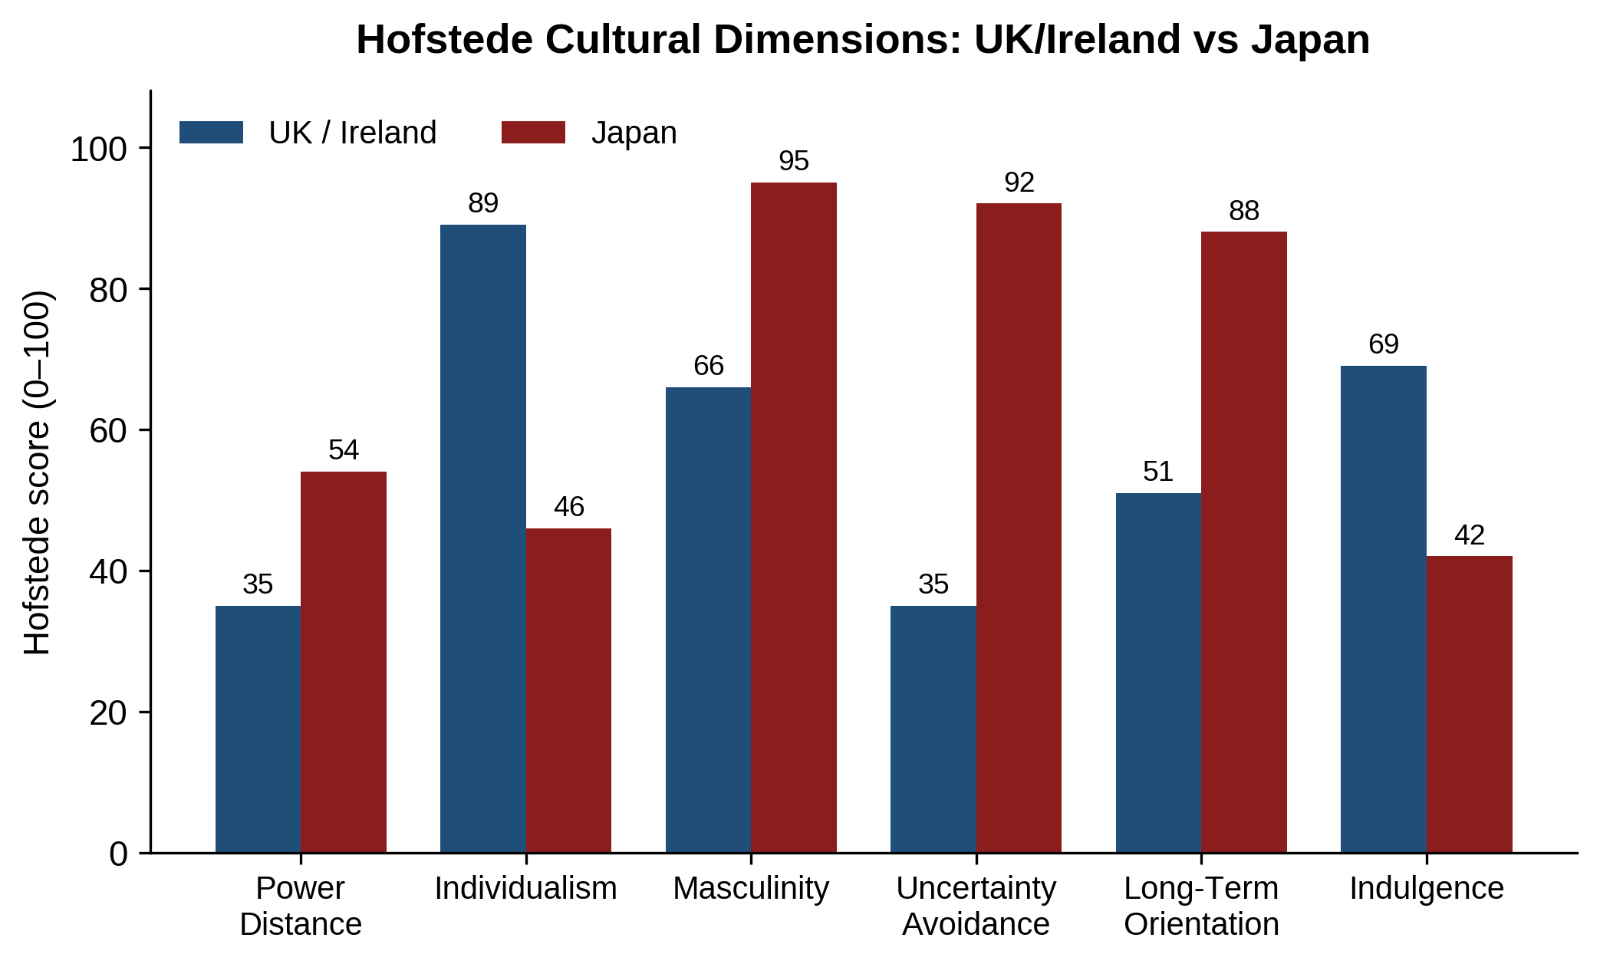
Figure 5: Hofstede cultural dimensions, UK/Ireland versus Japan (Source: Hofstede, 2011)
There is a significant difference between the two. Japan ranks 92 against the UK's 35 in uncertainty avoidance, which is the most significant disparity. Before making a purchase, Japanese customers are notoriously risk-averse and require dependable goods, transparent return policies, cautious packing, and a well-established brand reputation. Low costs do not make up for perceived flaws or uncertain durability in Japan, whereas consumers in low uncertainty-avoidance cultures are willing to accept subpar retailing in exchange for low pricing.
Primark must prioritize community-based styling above individual self-expression due to Japan's lower individuality score (46 vs. 89 for the UK), which indicates that customers place more value on social harmony and peer influence (Sueda and Seo, 2024). Strong desires for quality, accuracy, and reliable brand performance are also indicated by Japan's high levels of masculinity (95) and long-term orientation (88) (Hofstede, 2011). Additionally, its lower indulgence score (42) indicates consumption that is utility-focused and restrained. Primark should present reasonably priced apparel as long-lasting and sustainable rather than disposable, bolstered by its sustainability initiatives, in accordance with the cultural ideal of *mottainai*, which opposes waste.
Table 7: Hofstede cultural dimensions comparison, UK/Ireland versus Japan (Source: Hofstede, 2011; Author's analysis)
Dimension | UK / Ireland | Japan | Gap | Implication for Primark
Power distance | 35 | 54 | +19 | Formal management structures and respectful, hierarchical customer interaction.
Individualism | 89 | 46 | −43 | Marketing must emphasise social harmony and curated group trends.
Masculinity | 66 | 95 | +29 | Zero tolerance of defects; quality must match domestic benchmarks.
Uncertainty avoidance | 35 | 92 | +57 | Consumers demand guaranteed quality, flawless packaging, and clear returns.
Long-term orientation | 51 | 88 | +37 | Patient brand building and durable supplier relationships are essential.
Indulgence | 69 | 42 | −27 | Messaging should highlight functional utility and durability.

6. Competitive Landscape Analysis

6.1 Key Competitors
The Japanese clothing market is fiercely competitive and highly consolidated. A structured examination of the major incumbents and foreign competitors in the value and fast-fashion sectors is given in Table 8.
Table 8: Competitive landscape, key players in the Japanese apparel market (Source: Fast Retailing, 2025; METI, 2025)
Competitor | Market position | Core strengths | Threat to Primark entry
Uniqlo (Fast Retailing) | Domestic leader; group revenue ~JPY 3.1tn (FY2025) | Brand trust; functional fabric technology; extensive network. | Dominates high-quality value essentials with entrenched loyalty.
GU (Fast Retailing) | Youth-focused fast-fashion sub-brand | Trend-led design below Uniqlo prices; shared supply chain. | Occupies Primark's target demographic with superior local insight.
H&M | Established international entrant (~100 stores) | Global recognition; sustainability initiatives; omnichannel reach. | Demonstrates viability but also the margin of risk of the segment.
Zara (Inditex) | Premium fast-fashion leader | Agile design cycle; rapid replenishment; prime locations. | Captures a higher price tier and sets fashion velocity benchmarks.
Shein | Ultra-fast-fashion e-commerce disruptor | Algorithmic trend detection; ultra-low pricing; digital reach. | Capture digital youth spending without store overheads.

6.2 Critical Assessment of Competitive Dynamics
The primary barrier to competition is the domestic position that Fast Retailing created through Uniqlo and GU, as seen in Figure 6. Fast Retailing manages more than 800 Uniqlo stores and over 450 GU stores in Japan, with FY2025 revenue of JPY 3.103 trillion (Fast Retailing, 2025). Primark's intended position is effectively bracketed by the group: While GU targets youth trends at extremely competitive pricing points, Uniqlo dominates the functional, high-quality basics market with significant brand loyalty. As a result, Primark would be caught between GU's quick local execution and Uniqlo's reputation for quality.
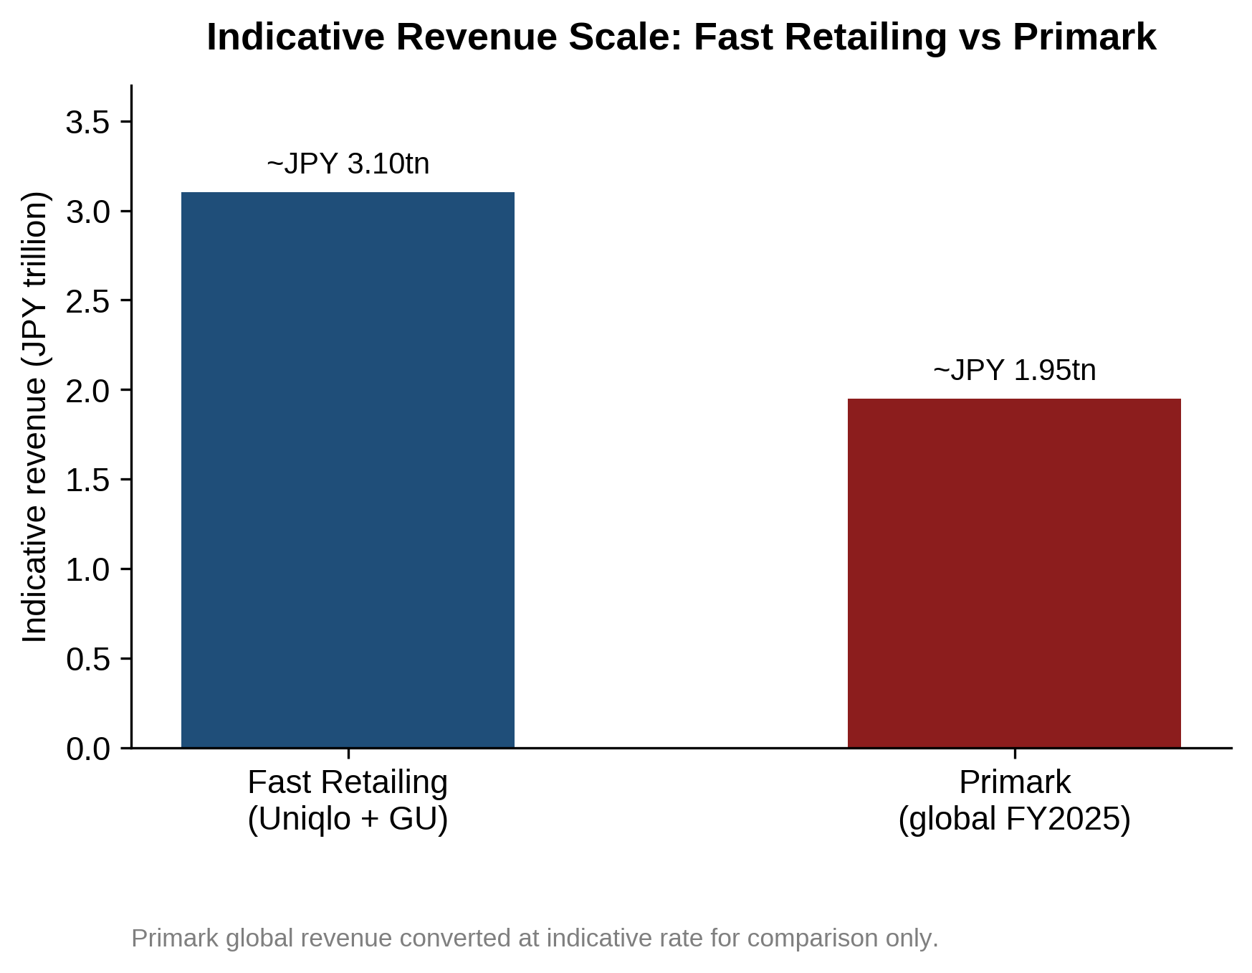
Figure 6: Indicative revenue scale comparison, Fast Retailing versus Primark (Source: Fast Retailing, 2025; Associated British Foods plc, 2025; Author's analysis)
In Japan, Primark is up against fierce competition from well-known stores like Fast Retailing and online marketplaces like Shein that provide cheap rates, a wide selection, and quick product cycles. The difficulties posed by high rents, fierce pricing competition, and regional preferences are further demonstrated by H&M's experience. Primark should therefore offer unique in-store experience rather than depending on low prices. Major station and department store complexes like Lumine, Parco, and Atre, whose good locations are frequently obtained thru well-established local relationships, also dominate Japan's retail business. Therefore, Primark may be able to get over obstacles to entry and find acceptable premises by collaborating with a well-connected Japanese retail firm.

7. Entry Mode Analysis

7.1 Dunning's Eclectic Paradigm
Dunning's eclectic paradigm (1988, 2000) assesses the advantages of ownership, location, and internalization when entering international markets. Table 9 identifies significant theoretical and empirical limitations while applying these parameters to Primark in Japan.
Table 9: Critical OLI assessment for Primark in Japan (Source: Author's analysis, based on Dunning, 1988; 2000)
Dimension | Theoretical advantage | Critical evaluation in the Japanese context | Verdict
Ownership | Procurement scale; value pricing; store design; ESG standards. | Scale buying power is eroded by 9% tariffs and a weak yen, and brand awareness is negligible. | Partially met operational scale is strong, brand power absent.
Location | Fourth-largest economy; JPY 8.49tn market; 36m tourists; urban density. | Benefits are generic and shared by incumbents; prime rents, labor shortages and logistics costs offset them. | Met with caveats: lucrative, but the cost structure is severe.
Internalisation | Full operational control; protection of operating routines; margin capture. | High psychic distance elevates behavioral uncertainty, so full internalisation raises failure risk. | Partially met with full hierarchical control is sub-optimal.

Potential ownership benefits from Primark's worldwide purchasing power and inexpensive sourcing are mitigated in Japan by poor brand recognition, import duties, and yen devaluation (Japan Customs, 2026). Due to its sizable retail market, Japan offers significant geographical advantages; yet operating expenses are increased by labor shortages and high rents in places like Ginza and Shibuya (OECD, 2025). Furthermore, due of Japan's significant psychic distance, internalizing operations thru a completely owned structure may raise dangers. Therefore, while choosing its entry strategy, Primark should carefully weigh control against local market expertise (Anderson and Gatignon, 1986).
Applying the eclectic paradigm to multinational corporations in the retail and service sectors has drawbacks. Fashion retail, in contrast to manufacturing, is more dependent on consumer availability and appropriate locations than production costs. When brand value does not translate across cultural boundaries, ownership advantages may also diminish. Consequently, behavioral and transaction cost views should be added to the paradigm.

7.2 Transaction Cost Analysis
Transaction cost analysis, developed by Anderson and Gatignon (1986) and expanded by Brouthers (2002), assesses entry mode by balancing the administrative load of hierarchical integration with the governance costs of market interactions. It asserts that hybrid models, like joint ventures, perform better than fully owned subsidiaries in situations when asset specificity is low to moderate and external uncertainty is high because they distribute risk and lower the cost of navigating new institutions.
Due to unique consumer preferences, language constraints, and intricate real estate practices, external unpredictability in Japanese retail is particularly significant. Additionally, the Uppsala model recommends that businesses use incremental commitment and experiential learning to overcome the liability of foreignness (Johanson and Vahlne, 1977). Collaborating with a well-established local business offers quick access to real estate pipelines, distribution networks, and regulatory expertise, significantly reducing transaction costs in the crucial early stages.

7.3 Evaluation of Entry Mode Options
Table 10 assesses Primark's three main options: master franchising or licensing, a joint venture, and a completely owned subsidiary.
Table 10: Entry mode evaluation for Primark in Japan (Source: Author, informed by Anderson and Gatignon, 1986; Brouthers, 2002)
Entry mode | Advantages | Disadvantages and risks | Suitability
Wholly owned subsidiary | Complete strategic control; full margin retention; protection of operating routines. | Highest capital expenditure; full exposure to operational and property risk; slow learning curve. | Low: high failure risk given cultural distance and entry costs.
Joint venture | Shared capital commitment; access to partner real estate and logistics; local knowledge. | Shared control; potential friction over merchandising and positioning, and profit sharing. | High: optimal balance of risk, control, and local learning.
Master franchising / licensing | Minimal capital outlay; no direct property risk; rapid scalability. | Loss of direct brand control; lower margin capture; risk to quality standards. | Medium: viable, but risks brand dilution in a quality-critical market.

A completely owned subsidiary bears prohibitive capital risk and maximizes exposure to the liability of foreignness, as Table 10 shows, whereas pure franchising runs the risk of brand degradation if a franchisee mismanages store standards in a market where quality is crucial. Therefore, a joint venture is the best option since it allows Primark to take advantage of a partner's real estate connections, human resource capacity, and logistics infrastructure while maintaining control over global sourcing and brand standards.

8. Key Challenges and Risks

8.1 Operational Challenges
There are a few operational difficulties when entering the Japanese retail industry. Due to the high rental expenses associated with prime locations like Shinjuku, Shibuya, and Ginza, profitability requires substantial sales volumes. In addition to causing labor shortages, low unemployment—below 3.0%—also raises salary and retention expenses (OECD, 2025). Primark's inventory replenishment and supply chain efficiency may be hampered by the lengthy shipping durations, customs processes, and compliance checks associated with importing clothing from South Asia.

8.2 Strategic and Competitive Risks
Fast Retailing, which has a large store network, strong brand loyalty, and sophisticated omnichannel capabilities, poses a serious threat to Primark. Additionally, Primark's low brand awareness in Japan raises the possibility that customers may view it as inexpensive rather than stylish and value oriented. Additionally, Primark's reputation among younger consumers who care about the environment may suffer due to growing concerns about fast-fashion waste (Dhir et al., 2021).

8.3 Currency and Financial Risks
One ongoing financial risk is currency volatility. Prolonged yen weakening drives up procurement costs and puts pressure on Primark's operating margin, which already shrank to 10.1% in H1 FY2026. Primark sources mostly in US dollars and would make revenue in yen. The company could not easily transmit such increases to customers without losing its price advantage against GU and Uniqlo, given its dedication to bargain pricing. Therefore, preferential-origin sourcing and forward currency hedging are essential elements of the entrance strategy rather than optional ones.

9. Strategic Recommendations

9.1 Recommended Entry Mode
A 50:50 equity joint venture with a reputable Japanese retail business, like Seven & i Holdings, Eon business, or Marui Group, is advised for Primark's entry into the country. With this arrangement, Primark would be able to take use of the partner's access to commercial real estate, recruitment pipelines, logistics hubs, and municipal connections while maintaining control over design, international procurement, and brand marketing (Anderson and Gatignon, 1986). To reduce the partner friction shown in Table 10, governance arrangements should initially identify brand standards, quality levels, and escalation mechanisms.

9.2 Phased Market Entry Strategy
Primark should adhere to a three-phase plan over five years, as shown in Figure 7 and described in Table 11, to manage capital commitment and facilitate institutional learning to commensurate with incremental internationalization.
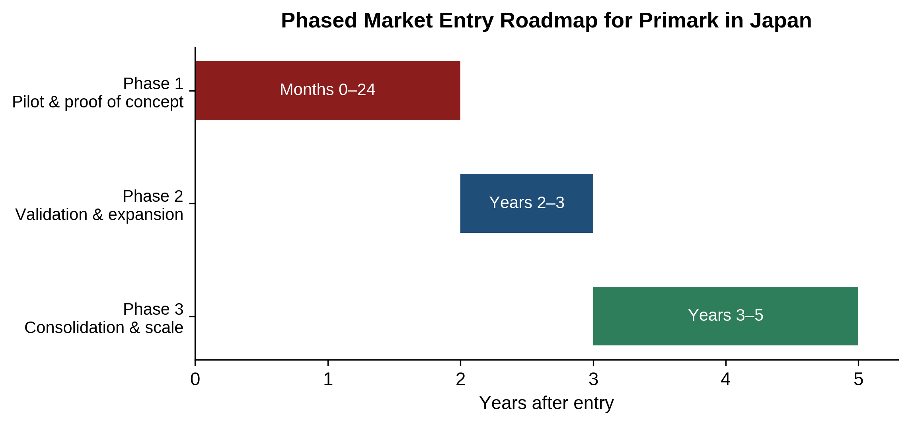
Figure 7: Phased market entry roadmap for Primark in Japan (Source: Author, informed by Johanson and Vahlne, 1977)
Table 11: Phased market entry roadmap for Primark in Japan (Source: Author, informed by Johanson and Vahlne, 1977)
Phase | Horizon | Strategic focus | Key milestones and store targets
Phase 1: Pilot and proof of concept | Months 0–24 | Market testing, awareness building, and fit validation. | Establish the JV entity; open two to three flagship stores in prime Tokyo locations; launch a localised discovery app; embed quality assurance protocols.
Phase 2: Validation and expansion | Years 2–3 | Assortment refinement, O2O integration and selective regional rollout. | Expand to five to eight stores across Tokyo, Osaka and Fukuoka; launch nationwide click-and-collect; initiate local sourcing collaborations.
Phase 3: Consolidation and scale | Years 3–5 | National consolidation and supply chain optimisation. | Scale to 15–20 stores nationwide; establish a dedicated Japanese distribution hub; integrate garment circularity programmes.

9.3 Product and Service Adaptation
Primark must adapt its products and store operations to Japanese market expectations. This includes considering local sizing, dimensions, and aesthetic preferences, while using pre-shipment inspections to improve quality control. In-store staff should also be trained in the Japanese omotenashi service approach, supported by effective visual merchandising and efficient checkout processes (Leingpibul et al., 2025). These measures address the cultural differences in masculinity and uncertainty avoidance identified in Table 7.

9.4 Digital Channel Development
Primark should release a specialized Japanese mobile application that offers real-time store inventory lookup, mobile loyalty rewards, contactless payment thru Papay and Suica, and store-based click-and-collect fulfillment given the 23.38% apparel e-commerce penetration and high online-to-offline expectations (METI, 2025). This is a significant shift from the group's current digital stance, but it is necessary to be competitive in this market.

9.5 Sustainability Positioning
Primark should collaborate with regional recycling organizations to set up in-store garment take-back locations and prominently display its Primark Cares accomplishments throughout Japanese stores and digital campaigns to dispel skepticism about quick fashion. The idea is in line with the mottainai sensibility covered in Section 5 when affordability is framed in terms of durability and ethical sourcing (Sueda and Seo, 2024).

10. Conclusion
According to this analysis, Primark has an appealing but fiercely competitive retail market in Japan, which is bolstered by robust institutions, urban retail infrastructure, and more than 36 million yearly visits. The dominance of fast retailing, wary customers, high standards for quality, operating expenses, and weakening yen are obstacles, too. Primark should implement a transnational strategy that combines global sourcing with local product adaption, robust service, and digital integration, according to frameworks developed by Bartlett, Ghoshal, and Dunning. A 50/50 joint venture with a reputable Japanese partner would offer a well-rounded approach to investment, risk, and local market expertise. Primark may thus be able to establish a successful and long-lasting foothold in Japan with the aid of a staged five-year entry strategy.

11. Reflective Account
This assessment offered a chance to apply international business theory to a practical strategic problem. Reconciling disparate institutional viewpoints was a major challenge. Although JETRO portrayed Japan as a comparatively business-friendly country, OECD (2026) emphasized labor shortages, administrative delays, and regulatory complexity. Therefore, it was crucial to compare several independent sources to create a fair and trustworthy evaluation.
There were five major obstacles to the analysis. First, Hofstede's national cultural scores might ignore urban and generational distinctions, especially among younger fashion buyers in Tokyo. Second, the eclectic paradigm and transaction cost analysis may underestimate consumer accessibility and competitive retaliation from companies like Fast Retailing due to their manufacturing bias. Third, partner governance and knowledge leakage must be carefully considered for the proposed joint venture. Lastly, accurate modeling of tariff and currency implications was hampered by a lack of unit-level cost data, necessitating qualitative scenario analysis.
Table 12: Analytical challenges encountered and lessons learned (Source: Author)
Analytical challenge | Specific example | Lesson and future application
Institutional source bias | Reconciling JETRO optimism with OECD warnings on labour and bureaucracy. | Triangulate promotional government sources with independent multilateral data.
Cultural aggregation limits | High national uncertainty avoidance versus Tokyo youth experimentation. | Avoid treating national culture as monolithic; segment by cohort and geography.
Framework mismatch | Adapting manufacturing-centric OLI logic to service-based retailing. | Modify classical frameworks to incorporate retail variables such as footfall and brand resonance.
Incumbent retaliation | Assessing Fast Retailing's defensive position, which OLI underweights. | Combine institutional frameworks with competitive dynamics analysis.
Quantitative bounding | Estimating margin compression from tariffs amid limited cost disclosure. | State analytical limitations explicitly and use structured scenario reasoning.

Quantitative modeling, especially financial sensitivity analysis to evaluate breakeven thresholds and hedging methods, is a crucial field for advancement. Future research might benefit from a deeper understanding of East Asian customer behavior and retail laws. All things considered, this experiment demonstrated the significance of making decisions based on data, being sensitive to cultural differences, and questioning Western-centric presumptions in international policy.

Reference List
Anderson, E. and Gatignon, H. (1986) 'Modes of Foreign Entry: A Transaction Cost Analysis and Propositions', Journal of International Business Studies, 17(3), pp. 1–26. Available at: https://doi.org/10.1057/palgrave.jibs.8490432 (Accessed: 12 August 2026).
Associated British Foods plc (2025) Annual Report and Accounts 2025. London: Associated British Foods plc. Available at: https://www.abf.co.uk/investors/results-and-presentations (Accessed: 12 August 2026).
Associated British Foods plc (2026) Interim Results Announcement: 24 weeks ended 28 February 2026. London: Associated British Foods plc. Available at: https://www.abf.co.uk/investors/results-and-presentations (Accessed: 12 August 2026).
Bank of Japan (2026) Outlook for Economic Activity and Prices, April. Tokyo: Bank of Japan. Available at: https://www.boj.or.jp/en/mopo/outlook/ (Accessed: 12 August 2026).
Bartlett, C.A. and Ghoshal, S. (1989) Managing Across Borders: The Transnational Solution. Boston, MA: Harvard Business School Press.
Brouthers, K.D. (2002) 'Institutional, cultural and transaction cost influences on entry mode choice and performance', Journal of International Business Studies, 33(2), pp. 203–221. Available at: https://doi.org/10.1057/palgrave.jibs.8491013 (Accessed: 12 August 2026).
Dhir, A., Talwar, S., Sadiq, M., Sakashita, M. and Kaur, P. (2021) 'Green apparel buying behaviour: a Stimulus–Organism–Behaviour–Consequence (SOBC) perspective on sustainability-oriented consumption in Japan', Business Strategy and the Environment, 30(8), pp. 3589–3605. Available at: https://doi.org/10.1002/bse.2821 (Accessed: 12 August 2026).
Dunning, J.H. (1988) 'The eclectic paradigm of international production: a restatement and some possible extensions', Journal of International Business Studies, 19(1), pp. 1–31. Available at: https://doi.org/10.1057/palgrave.jibs.8490372 (Accessed: 12 August 2026).
Dunning, J.H. (2000) 'The eclectic paradigm as an envelope for economic and business theories of MNE activity', International Business Review, 9(2), pp. 163–190. Available at: https://doi.org/10.1016/S0969-5931(99)00035-9 (Accessed: 12 August 2026).
FashionNetwork.com (2026) 'Is famously stores-focused Primark preparing to sell online?', 17 May. Available at: https://ww.fashionnetwork.com/news/ (Accessed: 12 August 2026).
Fast Retailing Co., Ltd. (2025) Results Summary for Fiscal 2025 (year to 31 August 2025), 9 October. Available at: https://www.fastretailing.com/eng/ir/ (Accessed: 12 August 2026).
Hofstede, G. (2011) 'Dimensionalizing cultures: the Hofstede model in context', Online Readings in Psychology and Culture, 2(1). Available at: https://doi.org/10.9707/2307-0919.1014 (Accessed: 12 August 2026).
International Monetary Fund (2026) IMF Executive Board Concludes 2026 Article IV Consultation with Japan, 2 April. Washington, DC: IMF. Available at: https://www.imf.org/en/news/ (Accessed: 12 August 2026).
Japan Customs (2026) Japan's Tariff Schedule as of 1 April 2026. Tokyo: Ministry of Finance. Available at: https://www.customs.go.jp/english/tariff/ (Accessed: 12 August 2026).
Japan External Trade Organization (JETRO) (2025) How to Set Up Business in Japan. Tokyo: JETRO. Available at: https://www.jetro.go.jp/en/invest/setting_up/ (Accessed: 12 August 2026).
Japan External Trade Organization (JETRO) (2026) A Foundation of Trust and Stability for Investment. Tokyo: JETRO. Available at: https://www.jetro.go.jp/en/invest/investment_environment/ (Accessed: 12 August 2026).
Japan National Tourism Organization (JNTO) (2026) Visitor Arrivals to Japan in December 2025 and Annual Total, 21 January. Tokyo: JNTO. Available at: https://www.jnto.go.jp/news/press/ (Accessed: 12 August 2026).
Japanese Law Translation (n.d.) Household Goods Quality Labeling Act (Act No. 104 of 1962). Available at: https://www.japaneselawtranslation.go.jp/en/laws/view/3935/en (Accessed: 12 August 2026).
Johanson, J. and Vahlne, J.-E. (1977) 'The internationalization process of the firm: a model of knowledge development and increasing foreign market commitments', Journal of International Business Studies, 8(1), pp. 23–32. Available at: https://doi.org/10.1057/palgrave.jibs.8490676 (Accessed: 12 August 2026).
Johnson, G., Whittington, R. and Scholes, K. (2011) Exploring Strategy: Text and Cases. 9th edn. Harlow: Pearson Education.
Leingpibul, T., Newell, S.J., Nakamori, T. and Han, B.T. (2025) 'The role of omotenashi in developing committed customer relationships in Japanese retail establishments', The International Review of Retail, Distribution and Consumer Research, 35(5), pp. 625–651. Available at: https://doi.org/10.1080/09593969.2025.2515421 (Accessed: 12 August 2026).
Ministry of Economy, Trade and Industry (METI) (2025) Results of FY2024 E-Commerce Market Survey Compiled, 26 August. Tokyo: METI. Available at: https://www.meti.go.jp/english/press/2025/0826_003.html (Accessed: 12 August 2026).
OECD (2025) OECD Employment Outlook 2025: Japan. Paris: OECD Publishing. Available at: https://www.oecd.org/en/publications/ (Accessed: 12 August 2026).
OECD (2026) OECD Economic Surveys: Japan 2026. Paris: OECD Publishing. Available at: https://doi.org/10.1787/54cc833d-en (Accessed: 12 August 2026).
Primark (2025) 'Primark opens first Middle East store in Kuwait in partnership with Alshaya Group', 23 October. Available at: https://corporate.primark.com/en-gb/a/news/ (Accessed: 12 August 2026).
Primark (2026a) 'Primark celebrates 10 years in Italy with €22 million investment to expand store network', 6 May. Available at: https://corporate.primark.com/en-gb/a/news/ (Accessed: 12 August 2026).
Primark (2026b) Who We Are. Available at: https://corporate.primark.com/en-gb/a/about-us/who-we-are (Accessed: 12 August 2026).
Sueda, R. and Seo, Y. (2024) 'Understanding consumer perception of sustainable fashion in Japan: insights based on recycled and secondhand clothing', Sustainability, 16(23), 10223. Available at: https://doi.org/10.3390/su162310223 (Accessed: 12 August 2026).

