Final Report
XXXXXXXXXX Coffee Shop & Tea Room Ltd. Consultancy Project

5/4/2015

University of Wales Trinity Saint David

Contents
1. Executive Summary 2
2. Introduction 3
3. Project Aims and Objectives 3
4. Literature Review 4
5. Methodology 6
5.1 XXXXXXXXXX’s Primary data Collection 6
5.2 Sources of Information 6
5.3 Field Research 7
5.4 Observational Research 7
5.5 Personal Interview 7
5.6 Focus Groups 7
5.7 Questionnaires 7
5.8 Sampling Methods 8
6. Collected Data 9
6.1Survey Results 9
6.1.1 Question 1 9
6.1.2 Question 2 10
6.1.3 Question 3 11
6.1.4 Question 4 12
6.1.5 Question 5 13
6.1.6 Question 6 14
6.1.9 Question 9 17
6.1.10 Question 10 18
7. Survey Analysis 18
7.1 Focus group Results 23
7.2 Interview Results 25
7.2.1 Staff 25
7.2.3 Local Residents 26
7.3.3 Local Business 27
8. Findings 28
8.1 Current Customer Profile 28
8.2 Trends and Opportunities 29
9. Conclusion 30
10. Recommendations 30
11. Project Implementation Guidelines 31
12. Appendix 34
13. Bibliography 35

Business | XXXXXXXXXX Coffee & Tea Room Ltd.
Consultant  Mentor |   xxxxxxxxx  Michael Davies – University Of Wales Trinity Saint David

**The information contained in the final report will not be made available to others without the express permission of the XXXXXXXXXX’s owner. The University of Trinity Saint David has been allowed access to the information**

Executive Summary
Competition is a very big part of the food and beverage market, and small independent eating and drinking establishments are facing stiff competition from large restaurant chains. According to the Swansea West Wales Post (2015) during the year 2014, 26 venues shut down in the Swansea area, with 19 new ones opening up in the same year; this figure shows a loss of over half a dozen shops. However, in the past few years the eatery scene in Uplands, Swansea has seen a big increase with many outlets opening and aiming to attract those who no longer want to venture to Wind Street.
XXXXXXXXXX Coffee and Tea Room Ltd. has been trading in Uplands since 2013 and has in the past tried to expand their market share by opening weekends as a Bistro, offering evening meals with live music and entertainment. Unfortunately, this approach was unable to sustain itself and the decision was made to solely trade as a coffee shop. While this decision was taken, market research was being carried to establish how to increase the bistro evening trade, this was done by collecting data from 100 survey participants, 5 interviews, 2 focus groups and competitor research. This final report provides XXXXXXXXXX’s management with quantitative and qualitative information, analysis and guidance that can aid to the decision-making process for the planning of future bistro nights and/or embrace the new trend opportunities found during the investigation for this project. With businesses’ constant battle to create an edge over their competitors, this market research provides XXXXXXXXXX with the prospect of gaining a competitive advantage over similar businesses in the area, as the discovery of their current customer profile and competitors performance gaps will give the coffee shop the opportunity to establish new strategies to increase their business, either by day or night.

Introduction
This is the final report for XXXXXXXXXX Coffee & Tea Room Ltd. The market research preformed aimed to provide a competitive edge and strategic advantage with respect to XXXXXXXXXX’s direct competitors. The final document outlines the detailed research approach undertaken by the consultant and provides the analysis of results, along with recommendations and an implementation strategy.
The market research for this project has been moulded around XXXXXXXXXX’s business goals of boosting evening trade and attain a larger food market share in the Uplands area. Through various research approaches the consultant has been able to gather primary and secondary data to assist the management of XXXXXXXXXX in finding possible solutions for the business difficulties which were defined during the owner-consultant first meetings.

Project Aims and Objectives
Since the Project Initiation Report (PID) back in February 2015, competition has continued to have a negative impact on XXXXXXXXXX. Currently, the business is no longer trading as a ‘bistro’ at weekends and the management has decided to focus on the coffee shop alone. Although, the market research was aimed at increasing the sales of XXXXXXXXXX’s bistro nights, the data gathered is still able to assist the management in the decision-making process for current or any future business set ups. The worked carried out for this report and its outcomes can be adapted to create value for XXXXXXXXXX as it consists of transferable information that can be used to build meaningful relationships with customers through the obtained knowledge of XXXXXXXXXX’s customer profile, competitor’s weakness and the insights of potential customer which are provided in this final report.

Literature Review
In today’s competitive market, businesses are looking into ways that satisfy the wants and needs of consumers. Understanding what influences people to buy can increase sales and profit opportunities while giving businesses a sustainable competitive advantage (Kotler & Armstrong, 2010). However, the understanding of purchase behaviour and decision process of consumers has a degree of complexity due to people wanting different things which are influenced by their culture, social class, age, personality and psychological factors to mention a few (Williams, 2014). Blythe (2009) favours this view by sustaining that is not easy to define whether a product/service is a need or want for people as consumer’s choices are not driven by their instincts alone but also by physiological factors which drives human behaviour (Maslow 1954).
Through the process of market research, organisations are able to obtain insights into customer’s motivations, buying behaviours and satisfaction of services and products (Kotler & Armstrong, 2010). According to the American Marketing Association, market research provides organisations with the relevant data to address business issues through the process of collecting and analysing information in regards of consumers' preferences for products and services. Furthermore, Blythe (2009) is of the agreement that through market research businesses are also able to find their market segment size, new market tends and customer characteristics, all of which can help businesses evaluate new potential markets, and the effectiveness of their current business strategies. However, for market research to be beneficial to a business it will be necessary to assess organisation’s weaknesses and set research objectives to be able to address the correct problems with the aim to assist organisations to make better informed and profitable decisions. This view is supported by Hague (2004) whom believes market research is able to reduce business risks by providing organisations with specific data evidence to adjust their business activities for a more effective use of resources.
According to Bradburn (2004) once the nature of the research problem becomes clear, it will be necessary to transform it into specific research questions that lead to actions. Kotler and Armstrong (2010) also maintain their views on the importance of making sure the primary data is ‘relevant, accurate, current and unbiased’. Palmer (1999) states that deciding which information-generating method is the most appropriate for the research is an important part of process, as the way in which the information will be collected will be a key component in how to solve the problem, as a casual, unstructured research will be misleading and become wasteful. Although, data collection presents some challenges due to being heavily reliant on participants expressing their feelings, possible time constraints and funding, these barriers could be overcome by the use of alternative methods (Dietel & McKenna, 2013).
However, according to (Katobe & Helsen, 2000) the real concern relating to market research is about the ‘validity’ and ‘reliability’ of the data. Authors, such as (Gabriel , 1990) have expressed their concerns with the potential mistakes that can be performed during data collection. Furthermore, critics such as Brenner and Earl (1977) believe that the integrity of the information obtained via market research can sometimes be affected by ethical problems related to the person undertaking the research.
In other words researchers could manipulate responses with the aim to satisfy their self-interest and their clients which allows for the failure of new products (Hall & et al, 2001). However, this is argued by Palmer & Hartley (1999) whom states that respected organisations in the world of market research service industry, have in the past conducted extensive research among consumers before the introduction of new products/services which did not met criteria found before their launch. A case study by Schindler (1992) highlights that the problem with market research is often due to the reliability of data, by giving the example of a globally recognised cola brand that launched a new drink product which the pre-launch research suggested will be a success, however this was not the case and the product had to be withdrawn, which demonstrates that having a product the public likes is not always enough (Paulter, 1996).

Methodology
The research was conducted over a 62 day period during the months of March to May in 2015. Every effort has been made to provide accurate information for the final report.

5.1 XXXXXXXXXX’s Primary data Collection
Research Approaches | Contact Methods | Sampling | Research Instruments
Observation  Survey  Focus groups  Interviews | Online  Personal  Mail | Cluster Sample | Questionnaire (Survey Monkey)

5.2 Sources of Information
For the purpose of this project, two data sources have been utilised: Desk research and field research. Desk research involved the gathering and investigation of secondary data through external sources, which included:
- Exiting market research reports: Has provided information about specific market factors affecting the food and drink sector in the UK.

- Internet data: Allowed for the collection of the ‘grey literature’ on stock market listed food & beverage business relating to XXXXXXXXXX (London Stock Exchange Group plc, 2015). However, as the restaurant market is commercially based there has been a limitation on the amount of information that could be gathered for the purpose of this project, which could diminish the value of this type of research for the final report. Nonetheless, the data collected via this medium was found to be valuable in time in contrast to field research (Griffiths & Wall, 2011).

- Government Publications: The research into UK government’s publications allowed for the examination of food and beverage trade bodies, regulators and reports covering the food and drink sector in the Britain, in particular Wales (Business Wales , 2014)
- Competitor’s information (Uplands): Research in to XXXXXXXXXX’s immediate competitor’s promotional materials, products and prices.

- Data from XXXXXXXXXX’s food/service complaints.

- Literature Research: Studies from market research scholars and trade journals have provided the consultant with a comprehensive body of knowledge in the food/beverage management sector and Market research industry, which has been used as evidence for backing up the final recommendations.

5.3 Field Research
Field research involved the collection of primary data; this was achieved by the consultant using a triangulation method to be able to find accuracy in the information received (Blythe, 2009). The different methods for gathering quantitative and qualitative data included:

5.4 Observational Research
The observation of XXXXXXXXXX’s location, pedestrian flow, staff, customers, actions and situations in the premises, has aided to the analysis of XXXXXXXXXX’s current business structure and how it affects present and potential new customers. Furthermore, observation was used to monitor XXXXXXXXXX’s competitor’s activities, such as menu selections, prices and service quality.

5.5 Personal Interview
Data for the final report was also obtained through individual face-to-face interviews with some of XXXXXXXXXX’s internal and external stakeholders. Whilst interviewees were willing to participate, and the use of open questions allowed for detailed responses which helped discover the participants’ attitudes, thoughts and wants. It was noted that some members of the XXXXXXXXXX’s workforce were cautious with their answers, which could be linked to the concept of ‘psychological contract’ between employees and the organisation (Mullins, 2010).

5.6 Focus Groups
Through this method, the researcher was able to obtain first-hand and insightful information from consumers regarding their views on the current business, brand awareness and their thoughts on the XXXXXXXXXX’s ‘bistro’ strengths and weakness against those of its competitors. The focus group contained a range of individuals who were believed to be representative of XXXXXXXXXX’s current and potential customer segment market. Originally, it was decided to gather 2 groups of 6 people for an easier and interactive discussion, however last minute cancelations had an adverse effect in the group sampling, with one group heavily weighted towards the views of current customers.

5.7 Questionnaires
A simple, clear and self-completion questionnaire was designed with a mixture of open and closed questions to discover the participant’s behaviours, attitudes and need/wants. The structure of the questionnaire was based on the outline questions which can be found on page 13 in the PID report to be able to achieve the proposed objectives. Due to there being no funding available for this project, the use of ‘Survey Monkey’ allowed for the creation of a free online survey. Through this process the consultant was able to reach the target of 100 responses (Survey Monkey, 2015).

5.8 Sampling Methods
The cluster sampling method has been utilised with the aim to collect primary data from residents of Swansea and in particular the Uplands area. This method was found to be the quickest and most effective way to reach XXXXXXXXXX’s current and potential customers (Hall & et al, 2001). 100 responses have been collected for this report, however due to the Uplands population currently estimated at 16,200 (City and County of Swansea, 2015) the survey figure is relatively small in comparison, which would be unlikely to represent the population as a whole, this is because individuals tend to differ widely in their opinions. Although, the consultant found people to be willing to participate in the research and there was an opportunity to acquire more responses, the limitations of time and funding for the project only allowed for the use of the ‘basic package’ from the online survey provider, which only allowed a maximum of 10 questions and 100 responses (Survey Monkey, 2015).

Collected Data

Survey Results

6.1.1 Question 1
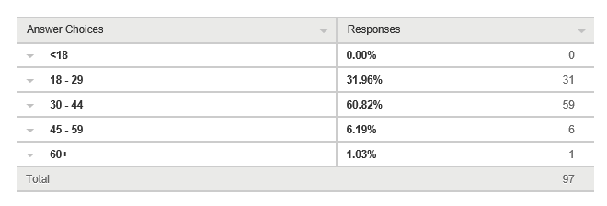
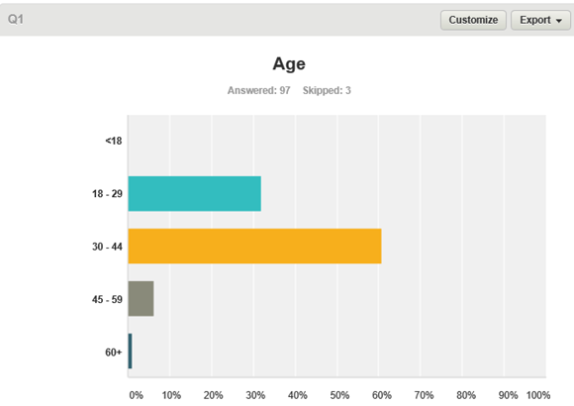

Question one relates to the age of the participants. This question was asked to find out the age range of people eating-out in the Uplands area. The results show that the under 17’s group has not been included in the survey because they are categorised as children and adolescents.
The highest rate group with 60.82% is the 30-44 category, followed by the 18-29 group with 31.96%. The 45-59 and over 60+ have the minority percentage of just over 7% in total. The results show that there is a clear ‘evening trade’ demographic where XXXXXXXXXX is located, with the main target audience of people being out of education and holding a part-time or full-time positions.
According to Hall (2001) businesses are starting to take note of their customer’s age groups because of the difference needs and wants from each age group. Furthermore, studies show that people like to feel a sense of belonging and look to surround themselves with like-minded people. McCabe (2012) states that the finding of consumers’ age groups in market research will give a business a good indication of where to aim their services and adapt strategies to suit this group(s) giving the business a better chance to ensure repeat visits.

6.1.2 Question 2
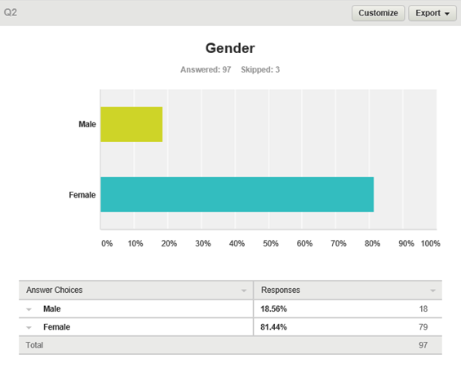

Questions two has been asked to establish the split between male and female participants. The survey shows that the majority of responses were female with 79 out of 97 responses (81.44%), while 18% were male.
From the results, it can be assumed that the females taken part in the survey are more likely to be the decision-makers in regards to eating out. This coincides with the results found later in the research were the majority of respondents were found to be in a relationship. According to McCabe (2012) gender analysis is a particularly effective marketing tool that businesses’ have picked up on. If businesses can determent the gender making the decisions then, targeting the advertising at that particular market will have a greater impact. Dae-Young (2007) agrees with McCabe by stating that, men and women vary in the ways they process information and as a result requires different strategies to ensure they target the right group. Determining XXXXXXXXXX’s larger gender group can give the business essential information which can be used to ensure the product/service reaches the target market.

6.1.3 Question 3
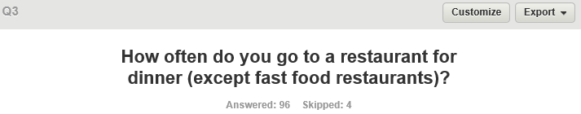
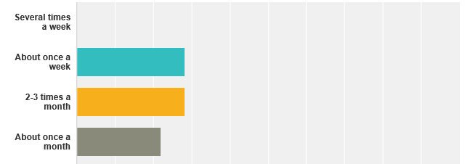

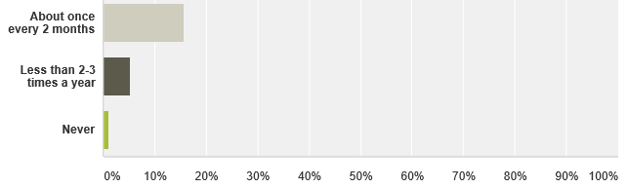

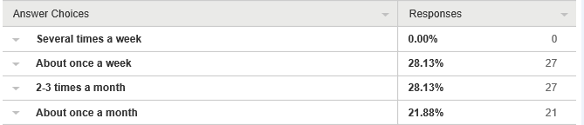

Question three was asked to establish how often people eat-out in restaurants. The results are varied; it shows that the vast majority do dine-out and they do so at least twice a month.
There are three very distinct groups showing above 20%. Out of the 96 respondents 27 people (28.13%) eat out at restaurants 2-3 times a month. The equal percentage is seen on people dining out about once a month. The survey also shows that 15 people (21.88%) go out to eat at restaurants once every two months. The minority results which combines to 6% shows that 5 respondents eat out less than 2-3 times a year, with one person stating to never dining out at restaurants. The survey also highlights that of the 96 people taking part in the survey none of them eat out at restaurants more than twice a week.
According to Warde and Martens (2000) the act of ‘eating out’ has in the past been studied for the nutritional values, however much recent studies have also incorporated the social aspect of the meal: the meeting, greeting and eating. Researchers in the food field have also examined the way in which people choose a food destination and the frequency of their visits (behaviour). The study explains that people’s eating-out behaviour is based on three things: time, place and money. The syncing of the three will also help determent the frequency of visits.

6.1.4 Question 4
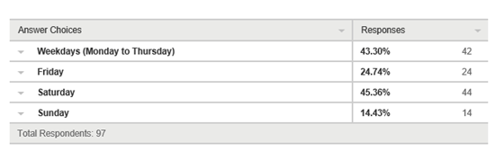
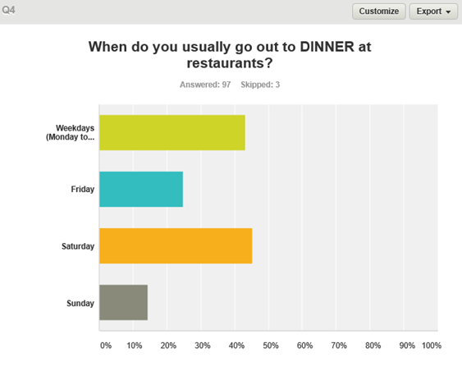

Question four was asked with the aim to establish the most popular day people go out to eat at restaurants. The results show that the most popular evening to eat out is on Saturdays with 45.36%. The finding also shows that (43.30%) 42 people enjoy dining-out on week days. Friday was chosen by 24 people out of 97, while Sundays was the less popular with 14.43%. According to Mullins (Mullins, 2010) attitudes are learnt through life and embodied in the socialisation process which may be highly resistant to change. However the social aspect of dining-out is something that has changed, as back in the 1990’s the main day to dine and socialise with family and friends was the weekend. The survey indicates these days’ people are venturing out to eat at restaurants during week days.

6.1.5 Question 5
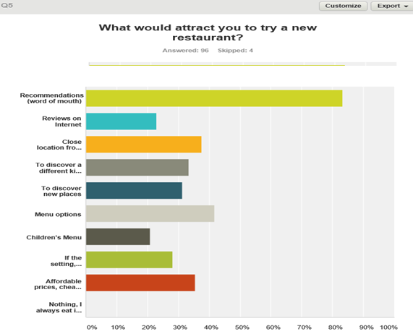

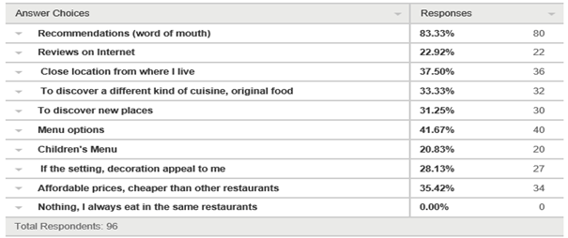

Question five was aimed at finding out what attracts people to restaurants. Through this question the consultant can find out what XXXXXXXXXX’s potential customers will be looking for if a bistro was re-launched.
80 out of 97 responders indicated that ‘word of mouth’ is the main driver for them trying a new food venue. In this case, recommendations from family, friends or through social media are important for the growth of XXXXXXXXXX’s evening trade. Food options in a restaurant also have an impact on whether people will try them or not. 41% of respondents indicated menu options as a major incentive to try/visit a restaurant. Four out of 10 categories (Location, price, trying different foods and new places) all congregated between 31% and 38%. While, children menus, reviews and decor ranged from 21% to 28%. According to Boone and Kurtz (2015) the best forms of advertising are ‘word of mouth’ and ‘recommendations’ view that has been confirmed on this survey.

6.1.6 Question 6
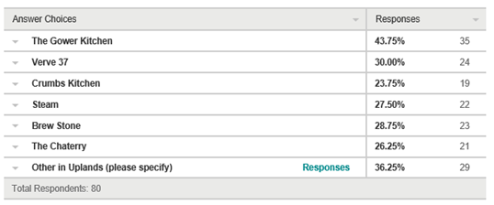
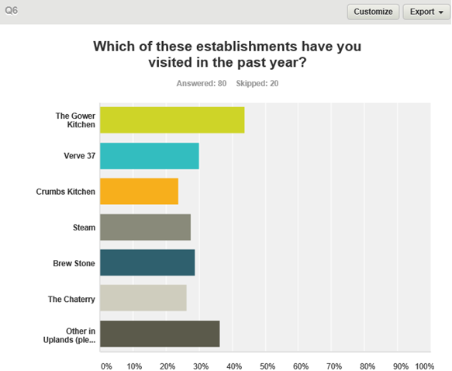

Question six, provides the results on XXXXXXXXXX’s main competitors with in the immediate area of Uplands. This question was targeted to people living in the area which were more likely to know of these establishments.
35 out of 80 (43.75%) have visited the Gower Kitchen; this restaurant has been opened for approximately the same time as XXXXXXXXXX and has been able to establish a good customer base.
The verve obtained 30% with 24 people from the survey eating there. However, it is important to highlight that the appealing for this venue can be due to offering other social areas apart from the restaurant section of the business. The newest restaurant in Uplands, Brew Stone received 28.75%. This indicates that 23 of the respondents have already visited the restaurant which has been opened for 5 months. The other venues such as Crumbs 23.75%, the Chattery 26.25% and XXXXXXXXXX 27.50% all seem to show they have been visited by respondents in the last 12 months.
Everyone has their own preference when it comes to dining out, be it from the food to the customer service. However, people making the decision can be influenced by the marketing strategy set out by the establishment. One such strategy that could work in the restaurant business is differentiation, this strategy according to Kotler and Armstrong (Kotler & Armstrong, 2010) is designed to target several market segments and offer a separate offer for each segment, by doing this businesses are able to offer their wares to a wider range of customer. Due to the competitive nature of the restaurant industry this method will also allow the business to trial different foods and offers to match the competition.

6.1.7 Question 7
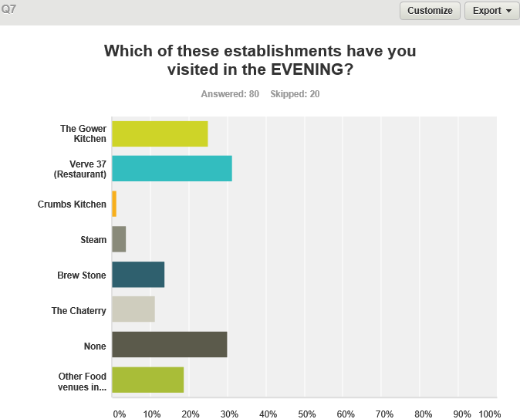

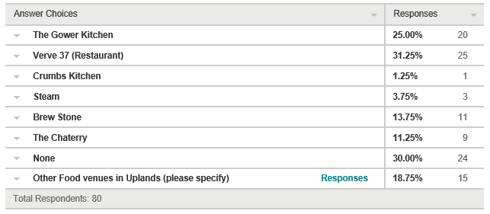
Question seven shows that 25 out of 80 people (31.25%) have visited Verve37. Surprisingly, 24 respondents (all from Uplands) have indicated that they have not dined at any of the above venues. However, a quarter of all respondents (25%) have dined at the Gower Kitchen. Brew Stone and The Chattery have both been visited by approximately 10 people each, while XXXXXXXXXX (3.75%) and Crumbs (1.25%) having the least visits. 15 respondents have indicated that they have ‘eaten out’ at other venues in the Uplands area.
From the data collect from this question it can be deducted that Verve37 and Gower Kitchen have been able to gain a customer base since opening in 2012 and 2013 respectably. Both are known in the area for the quality of food, atmosphere and service, which is supported by the figures collected.
According to Rahal et al (2015) location is an important factor, which can help a business succeed. However, further studies have shown that having a large urban area surrounding a business does not automatically guarantee an increase in footfall, business profit or customer base. This complements Kotler’s (2010) views on the importance of marketing strategies to maintain a competitive advantage competitive in the market place.

6.1.8 Question 8
Why did you choose this establishments?

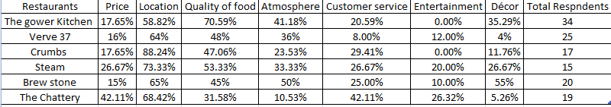

Due to the amount of information gathered in question eight, the results will been broken down for each individual venue, showing the order of importance from the respondents for choosing each venue. As from the data collected on this survey, the most important factor for respondents choosing a restaurant is location (Rahal & et al, 2015), followed by food quality, and atmosphere.
(1 = Most important reason / 7 = Least Important reason)
Gower Kitchen | Verve37 | Crumbs
- Food  - Location  - Atmosphere  - Décor  - Customer service  - Price  - Entertainment | - Location  - Food  - Atmosphere  - Price  - Entertainment  - Price  - Décor | - Location  - Food  - Customer service  - Atmosphere  - Price  - Décor  - Entertainment

XXXXXXXXXX | Brew Stone | The Chattery
- Location  - Food  - Atmosphere  - Price  - Customer Service  - Décor  - Entertainment | - Location  - Décor  - Atmosphere  - Food  - Customer Service  - Price  - Entertainment | - Location  - Price  - Customer Service  - Food  - Entertainment  - Atmosphere  - Decor

6.1.9 Question 9

Question nine provided richer qualitative data. The answers gave the consultant helpful insights on respondent’s opinions on a new possible eating place in Uplands. Furthermore, this data can provide in XXXXXXXXXX’s with useful information on current opportunities and emerging food trends.
There has been a mixture of responses; however the majority of respondents indicated that an Italian restaurant will be better welcome in the area. Please refer to Appendix for individual responses.

6.1.10 Question 10
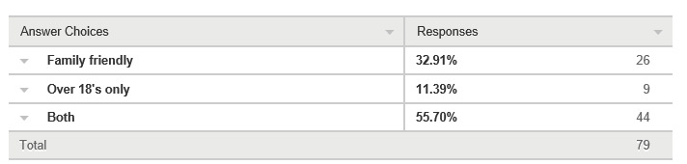
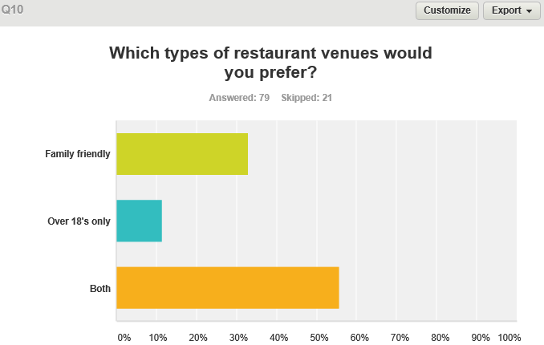

Question ten was asked to establish if there is a gap in the market for an adult’s only restaurant. However, this type of establishment is only wanted by 9 out of 79 people in Uplands.

7. Survey Analysis
Question 1
Age can have a big impact on how people perceive a venue. According to Kotler and Armstrong (2010) if the marketing strategy is not reaching the correct segment, in this case age, it could have a detrimental effect on a business. This is one area which XXXXXXXXXX has not been able to achieve. XXXXXXXXXX’s primarily ambition was to attract the trendy student population in Uplands; however the business has was no able to meet the expectations of this type of consumer, instead XXXXXXXXXX has become a coffee shop that is appealing to those looking for a quiet place to read and enjoy a hot drink. While the business has a customer following during the days, the expansion to the restaurant market to attract more customers did not last.
The survey results show that the age group (30-44) should be XXXXXXXXXX’s main customer focus, as it represents (60%) of all respondents. This figure corresponds with the research observation and staff interviews regarding XXXXXXXXXX’s current customer’s characteristics. The (18-29) age group is the second highest with (31%) which is representative of the student population in the area. The age group 45-60+ represent a minority with (7%). Stroud (2007) argues that the results found in surveys using ‘age’ as a target can be unreliable and too simplistic, this is because the data cannot be used in the assumption that everyone in one age group will want or need the same products/services, nor that they have the same thought process. Lamb (2012) counters Stroud’s argument, stating that generation (Y) newborn to early 20s requires a brand on a product to ensure the product has the “cool factor”. Yet, Lamb goes on to say that generation (X) have different requirements, as this group of people are not looking for named brands but quality and recommendations from reliable sources. Question one gives XXXXXXXXXX an indication of which age group to target their marketing strategy.
Question 2
Each ‘gender’ requires different persuasions to entice them to buy, in this case visit a restaurant. According to Moore and Pareek (2009) to meet the unsatisfied needs of each gender requires a complete marketing mix that is tailored to that gender. The majority of respondents to the survey were female at just over 81%, this gives an indication of the gender XXXXXXXXXX should aim its marketing strategy towards. However, XXXXXXXXXX still needs to try to entice males to visit the shop as some of them will naturally be the spouses of the main gender. However, because the current customer profile is female, the focus on the marketing strategy should be aimed at them from the outset.
Question 3
One of the most valuable piece of information gathered during the market research has been how often people eat out at restaurants. Although, this varies from person-to-person due to financial situations, working times and family commitments, the research is able to assist XXXXXXXXXX in establishing whether there is a market for bistro nights. The results from respondents show that the majority (28%) eat out at restaurants at least once a week, while some respondents would only venture out to dine once a month (21%) or once every two months (15%).
These results are important for XXXXXXXXXX in regards of future ‘evening openings’ because having knowledge of how often people currently chose to eat out, enables XXXXXXXXXX to adjust their opening times/dates to meet the current demand. However, as a small independent business, XXXXXXXXXX does not have the backing of a large corporation to off-set any losses that might occur if they reach out to unknown markets, which makes it essential that the business should have a clear understanding of their customers and what/when they are going to want the products. This type of data is essential for the existence of Small Medium Enterprises (SME) (Griffiths & Wall, 2011).
Question 4
Question 4 provides important pieces of information required to ensure a successful business. 100 people were asked ‘what day of the week they were most likely to dine out at restaurants’.
Results showed that ‘week days’ are highly popular. However, the perception of ‘weekends’ being the most popular days to eat out have now become inaccurate as reflected on this survey. The busiest day for restaurants still remains a Saturday with (45%). Friday evenings only received (24%) figures that back the disappointed sales of XXXXXXXXXX’s bistro nights on these evenings. (43%) of the respondents choose to eat out at restaurants during weekdays, this percentage establishes that if XXXXXXXXXX decides to re-open the bistro it should reconsider their opening days to accommodate new ‘weeks days’ trend and satisfy current customer needs and wants. This in turn can result in more sales and profit.

Question 5
According to Warde and Martens (2000) the best way to attract people to your business is by recommendation, which is recognized as one of the best marketing tools. This statement coincides with the survey findings as (83%) of respondents indicating that ‘recommendations’ and ‘word of mouth’ have influenced their visits to restaurants. The figure clearly shows the need for XXXXXXXXXX to ensure that the four main factors (location, food, atmosphere and price) are improved to be able to achieve positive recommendations, which will in turn increase business and customer base. Yet, there other factors that requires consideration in regard of ‘word of mouth’, the internet and in particular, social media sites can be used as an effective tool for advertising however, it can also be a source of negative exposure. Negative reviews on such sites can be damaging to a business as it can result in people choosing other restaurants over theirs within a matter of seconds (Blythe, 2009).
In the case of XXXXXXXXXX’s ‘food’ the Uplands area offers a selection of restaurant with a variety of foods options which gives customers ample choice, which puts XXXXXXXXXX in the position to aim to improve their food product to entice people to choose them over their competition. Décor has been found to be an area that XXXXXXXXXX might need to review. Findings from the focus groups and interviews highlighted that the business current layout is not within customer’s liking for a bistro set up. The tables and chairs although visually appealing for a coffee drinker, do not suit a restaurant type business. The consumption of foods during focus groups was noted to be uncomfortable and comments from people not feeling enticed to order meals that required the use of cutlery.
According to Foley and Dismore (2014) decor and atmosphere are key factors that tempt people to enter new ‘eating places’. Suitable furnishings, lighting and music can set the mood and attract customers. However, what will also be important to observe the most successful competitors and see what works for them, not with the aim to duplicate but to understand what people like, as sometimes being too different does not work. If the decision was made for XXXXXXXXXX to trade as a bistro, it will be advisable to review the current seating plan to be in keeping with the needs of market.
Question 6
The restaurants selected for the survey have been indicated by XXXXXXXXXX’s management to be their main ‘evening’ competitors. The data shows that the Gower Kitchen is the most visited with (43%), while (30%) have chosen Verve37. Brew Stone is the newest restaurant in the area with (28%) of the visits. Out of 97 survey participants from the Uplands area only (27%) have visited XXXXXXXXXX. It is important to emphasize that, Gower Kitchen opened 3 month after XXXXXXXXXX, while Brew Stone opened earlier in 2015 and both venues have larger amount of customers in contrast to XXXXXXXXXX.

The market research has brought into attention that one of XXXXXXXXXX’s main disadvantages is location. Although, there is footfall outside the shop, XXXXXXXXXX is located at the high end of the road and it is easily missed. Furthermore, XXXXXXXXXX’s current layout is too crowded with too many tables (reel) and chairs (tubs and arm-chairs) which do not offer customers a comfortable eating experience. Investment into improving furnishings that entice people to spend more on food and drinks would increase profits and positive recommendations.
Question 7
Socializing in the Uplands area has become a new trend with students and professionals, which has seen an increase of businesses and competition in the area. Question 7 asked respondents on which of the selected venues have they eaten, this in turn indicated the establishment’s popularity and offered point for comparison with XXXXXXXXXX.
Verve37 has been the most visited with (31%), The Gower Kitchen received (25%) while, Brew Stone received (14%). XXXXXXXXXX has only been visited by 3 out of 100 respondents (3.75%) which were found to be considerably lower than its competitors. Crumbs received the lowest percentage of (1.25%) however, this venue only cater for a niche market of vegetarian and vegan customers.
The issue of concern deducted from this question is that XXXXXXXXXX has been opened since 2013 and has not been able to increase its market share during this period, while Gower Kitchen whom also opened in 2013 has been able to reach and connect with more customers.
Question 8
According to Warde and Martens (2000) the decision of dining out in restaurants comes down to three main factors: location, quality and price. If XXXXXXXXXX is able met the standards required by their target market / customer profile, then the likelihood of business being chosen over their competitors will be more likely. The survey results coincide with Warde and Martens opinion however, it is important to point out that on this particular survey ‘location, quality of food and price’ have been chosen as the top 3 reason why people choose restaurants. Yet, customer service was found to be fifth, which indicates that people may forgive bad service and give restaurants another chance but if quality of food or price do not meet customer expectations could affect repeat visits and consequently their market share.

Question 9
Question 9 was aimed at establishing if there is a market for a bistro in Uplands, also to find out any new trends and business opportunities for XXXXXXXXXX. This question provided insightful information from 100 need/wants in the restaurants market. The most reacquiring answers have been the desire for a new Italian restaurant in the area. For XXXXXXXXXX to take advantage of this need, it would require to employ a professional chef to be able to accomplish the standards of food needed for a successful restaurant. The wish for Spanish, Mexican and Steak House restaurants has also been expressed. However, the current size of XXXXXXXXXX’s kitchen represents a limitation for these types of restaurants. Yet, XXXXXXXXXX could alternatively focus on mastering one product, such ‘steaks’ where staff could be taught/trained (as present) on how to cook to high standards relieving the need to employ a chef. Furthermore, the survey alighted the wish for a ‘late-night coffee house’ although, this was low in the response level, this could be an opportunity for XXXXXXXXXX to increase sales without changing the business essence and take advantage of their current customer profile.
Question 10
Question 10 was asked to established if XXXXXXXXXX’s bistro did not grow due to its 18’s only strategy and to assess if any future bistro ‘nights’ should be kept with this restriction. The data shows that 44 people out of 100 (55%) do not mind if the restaurant they visited was over 18’s or family friendly. While, 9 people (11.39%) would prefer an adult’s only restaurant in Uplands. 26 respondents (32.91%) would prefer a family-friendly restaurant to suit the needs. In this case, a family-friendly approach will be more beneficial and profitable for XXXXXXXXXX, as families with children tend to be more than 3 and able to increase sales though optional extras on the menu e.g. puddings. While the adult’s only approach can increase XXXXXXXXXX’s profits though the sale of alcohol it is common in the Uplands area to dine and drink at different places.

7.1 Focus group Results
Two focus groups were organised by the consultant with the assistance of XXXXXXXXXX’s supervisor to take place on the 14/4/2015 at 12-2pm and 4-6pm.
Prior to the ‘get-togethers’ the supervisor became indisposed and was out of work for a couple of weeks, soon after the supervisor resigned her position. Although, this did not directly affected the focus groups, it did however present a drawback as the consultant was required to re-discussing the focus groups arrangements (foods examples and table set up) with other members of staff, whom did not feel the urgency or did not wish to take responsibility. A dozen people confirmed their attendance; however on the day 3 people could not make it.
Group #1 (12-2pm) | Group #2 (4-6pm)
- Alice Sullivan  - Abi Jones  - John-Paul Gillies  - Darren Curtis – Cancelled  - Cat Davies  - Sian Breeze – No show | - Georgia Thomas  - Thembi Sinbanda  - David Harkness  - Nora Meyzen  - Mark Bridges – No show  - Paula Wall

*The 12 people selected to take part in the focus group were a mixture of XXXXXXXXXX’s current and non-customers, they all showed an interest in taken part in the ‘trial’ when approached.
Key Findings
Each person was offered one complementary non-alcoholic drink to choose from, and a selection of 3 dishes were offered for sharing – This was a disappointing amount of dishes for the ratio of the ‘expect’ number of people. Through a rating system similar to ‘Trip Advisor’ participants were asked to rate on a scale of 1 – 5 with their satisfaction on the following:
(5 = Very Satisfied / 1 = Not very satisfied)
 | Location | Atmosphere | Decor | Food Choice | Food Quality | Food presentation | Cleanliness
Excellent
Very Good
Average
Poor
Terrible

Most of the discussion related to XXXXXXXXXX was thorough verbal communication. During both sets of focus groups if was found that XXXXXXXXXX’s unusual décor was eye-appealing to the majority of participants however, this soon warded off as each table (reels) and the size of the arm-chairs did not allowed for comfortable communication and eating.
Food presentation and quality (House Burger, Charcuterie Board platter, Chilli con Carne *Nachos) was well received however, the quantity supplied was not substantial enough for everyone to have a sufficient portion, which left people feeling disappointed. No vegetarian option was provided as originally organised, which quickly was ratified with a soup dish with crusty bread.
Menu choice was found to be limited but people were not put off by it, however the options for vegetarian customers were found to be poor and in need of revising. Price structure of bistro menu had a positive response at it appears lower to competitors.
Visibility of XXXXXXXXXX was a main topic of conversation, with 4 locals no being aware of XXXXXXXXXX, while 6 did not know the coffee shop traded as a bistro. Suggestions of an ‘open L.E.D. sign’ or fairy lights on the front windows were expressed.
Main observations from participants:
Positive | Negative
Price | Cash-only
Wi-Fi | No table top service (order at till)
Food choice | Unsuitable tables/chairs for dinning
Food presentation | Alcohol licence – (Evening Only)
Hot drinks choice | Parking
Book corner | Shop easily missed
Craft workshops | Poor atmosphere
Cake selection | No background music (out of order)
Cleanliness | No children menu / activity pack
Facebook page | Limited Vegetarian option
 | No Website

7.2 Interview Results

7.2.1 Staff
XXXXXXXXXX Staff Interview – 9/12/15

Interview with XXXXXXXXXX’s members of staff highlighted their wishes for business success. Individually they provided their personal ideas for the improvement of business operations. Their insight knowledge on current customer’s habits, likes, dislikes has been useful for this report. Due to confidentiality the information gathered from the personnel will be unnamed.
Staff Comments
Card Machine | - Customers are believed to be unhappy when told that they only accept cash
Children facilities | - High chair only.  - The staffs believe that XXXXXXXXXX will be attractive to the Uplands’ customer if the bistro was family-friendly.
Bistro | - Some members of staff are concerned with the prospect of working longer/later hours and learning to cook complicated meals. This reactions can be categorised a type of ‘resistance to change’ due to the worry the opening of the bistro will affect their university/work balance and sense of freedom at weekends (Mullins, 2010).  - Concerns with the kitchen being too small
Décor | - In their opinion the shop floor has too many tables and arm-chairs  - Furniture is awkward and heavy to move when cleaning  - Bare walls
Visibility | - Staff are of the agreement that XXXXXXXXXX needs a more ‘eye-catching’ front and better outside lighting
Atmosphere | - New sound system required
Cake Display | - According to the staff cake sales are always good, but a bigger display is necessary
Alcohol Licence | - At times lunch customer ask for the wine list
Complaints | - XXXXXXXXXX’s most common complaints were discussed
Tea Room | - Only 3 Tea Room packages have been sold since 2013  - No enough promotion online or at the venue
Website | - XXXXXXXXXX does not have a website only a social media page

Possible solutions for some of these concerns could be rectified by the introduction of the following: Card machine, there could be a minimum spend charge to covers banks fees. Bare walls can be covered with art from local artists who can display and sell their pieces while XXXXXXXXXX gains a percentage of the sale. The shop’s small hub-room (4ft x 6ft approx.) which currently seats three, can easily be set up as a children’s corner, which will please the family-friendly market. XXXXXXXXXX’s visibility could be improved by the creation of window displays to attract the attention of pedestrians which can result in people being keen to see season-related display. Open L.E.D signs are also easy to get ranging from £16.99 - £44.40.

7.2.3 Local Residents
Uplands Residents Informal Interviews on 10/4/15 and 3/5/15

- Mrs Rebecca Lowe – Mrs Lowe was unable to meet with the consultant on the agreed date. However, as a current XXXXXXXXXX customer who enjoys writing and poetry, kindly has written a review for this projected. Please see Appendix for copy.

- Leanne Clulee – Local Uplands resident and part-time Fashion Design Lecturer at Cardiff University was interviewed on March 30th 2015 at Noah’s Yard Uplands. The main findings during the conversation were that the interviewee had in the past visited XXXXXXXXXX for coffee with her friends after a trip to the ‘Uplands Market’. She recalls that it was a very busy day and they had to queue to order their coffees which took too long; as she was with friends and the place was busy she did not put too much attention on the surrounding while in the shop. Mrs Clulee was not aware of XXXXXXXXXX’s late openings at weekends; neither does she follow XXXXXXXXXX on Facebook. The interviewee, seem interested in the idea of a bistro with live acoustic music, she mention her and her husband would like that type of set up as they no longer enjoy going to Wind Street but they ‘when they can’ like to go out for food and drinks. Regarding food selection, it was expressed that she likes more ‘elaborated’ foods and or a good selection on salads as mains, which the XXXXXXXXXX bistro menu showed did not satisfied her needs. When asked which food places in Uplands she likes to eat, her favourite was the Gower Kitchen followed by Wasabi. She has visited all the restaurants in the area and really likes the décor of the newly opened Brew Stone although she found the service poor but stated that she will go again. Finally Mrs Clulee does not believe Uplands is in need of any more restaurants or bars, but indicated that if XXXXXXXXXX could cater for her children (6 and 8) she will be seen there more often, especially on rainy days.

- Mr Wayne Williams – Local resident and owner of ‘Zorb Football Wales’ agreed to an informal interview that took place on Friday 10th April at Uplands Tavern. Mr Williams has not been to XXXXXXXXXX due to his distaste for hot drinks. He is aware of the establishment due to being located in between the local ‘Tesco’ and ‘Celebrations’, two well-known places in the area. The interviewee indicated his contentment with Uplands becoming a trendy place to hang-out. As an entrepreneur Mr Williams’s views and answers were more inclined towards the operation management of XXXXXXXXXX and into the areas he thought needed improvement. As a business owner Mr Williams understands the problems of limited resources when running a small business, he states attracting attention to XXXXXXXXXX through social media should be priority as the business is not using it to their full potential. He is also in agreement with other participants that XXXXXXXXXX requires better visibility, as it is easily missed in the row of shops.

7.3.3 Local Business
Local Businesses

- Celebrations – Located next to XXXXXXXXXX the business has been running successfully for many years, during their shop refitting earlier this year, the management teamed up with XXXXXXXXXX to display some of their birthday and wedding cakes in the coffee shop, giving XXXXXXXXXX an opportunity to reach out to new customers. As it is understood, the two members of staff at Celebrations do not frequent XXXXXXXXXX as they have a kitchen facility on premises; however they have in the past brought take-away lunch and really enjoyed. During the interview it came to light their concern with the growing competition in the area, especially after Costa Coffee. Although, not directly affected by the coffee chain they are aware of other business finding difficulties in meeting their overheads. The main problems they are encountering which also affects XXXXXXXXXX are the lack of parking and lighting on their side of the road. They have in the past contacted the council to ask if the outside tree can have fairy lights as the rest of the street trees but no reply has been received. Furthermore, in regards of customer profiles, their main customer are more women (30+) looking to buy unique cakes for special occasions however, they are aware of the student population and are trying to target this segment buy displaying and selling cupcakes but are finding Tesco as they main competitors in regards of the student market.

- Hair Quarter – Located on the same road as XXXXXXXXXX the business is privately owned, employs 5 members of staff and has been running for a number of years. Through an informal conversation on February 9th it was inquired about their knowledge regarding XXXXXXXXXX. It was mention that staff occasionally buy lunch in their breaks, and that they pass the coffee shop every day on their way to work or to the shop. Staffs are not inclined to eat at XXXXXXXXXX as it lacks atmosphere and they can buy cheaper foods at other local shops (KFC, Subway and Tesco).
In regards of bistro night, the staff did not know XXXXXXXXXX opened late on Fridays and Saturdays, however it was mention that the staff rather enjoy other evening food venues located in the city centre (Nando’s and Cosmo). Lack of atmosphere and advertising displays are the two main reasons for 5 of these people no visiting XXXXXXXXXX.

- Cooperative Pharmacy – Staff were not available for comments.

8. Findings

8.1 Current Customer Profile
Through the research it has become evident that XXXXXXXXXX has not been able to connect with their original target market. However, since the business opened in 2013 the establishment has obtain some customer following. Establishing the profile of these customers will enable the business to understand its clients and to create strong relationships, which in turn XXXXXXXXXX will be able to refine or change products/service to better meet the needs of their customers.
The combination of data found below can be used to tailor XXXXXXXXXX’s marketing strategy and promotional design.
XXXXXXXXXX’s Current Customer Profile
Demographic | Psychographic
- Locals  - Aged 30-45  - Female  - In relationships  - Employed  - Non driver | - Enjoys going reading, poetry and crafts  - Tends to favor quiet venues from busy ones  - Values alone time  - Enjoys taking to people  - Enjoys company of small groups  - Enjoys coffee drinking  - Wants a healthy lifestyle

8.2 Trends and Opportunities
- A trend that surfaced during the market research has been people’s increasing desire for healthier food choices which has been manifested during surveys, focus groups and research into XXXXXXXXXX’s competitor ‘Crumbs’. Demand for fresh ingredients, local produce and personalized diets (food intolerances) have also been a topic of conversation during focus groups and interviews. This represents an opportunity for XXXXXXXXXX’s bistro to utilise the present demand for healthier dining options which could compliment the current national healthy eating campaigns and the introduction of healthy food-related TV programs (Taylor, 2014), (Change4Life Wales, 2015). However, research into consumer attitudes towards healthy-eating suggests, that the perceptions of healthy-meals are less enjoyable and more expensive (GS1 UK, 2014).

- According to 2014 Swansea Bay report, Swansea University has over 15,000 students that come from 120 different countries all over the world (SwanseaBay, 2014), many from a continental and/or ethnic background which are more custom to the ‘coffee culture’ or simply are no alcohol drinkers. This is a sizeable population looking for places to socialise and study. Data collected for the final report featured some comments from respondents in regards of the need/want of a late coffee shop, which prompted the consultant to further research into this market. The investigation led to various sites where Swansea students enquired for such venues (The Student Room , 2014), (Blankley, 2013) (South Wales Evening Post, 2011). In the past XXXXXXXXXX has not been able to connect with the student population, this could be due to an incorrect marketing strategy or directed to the wrong millennial demographic (Brandau , 2012), (Weissmann, 2015). Although, there are other venues in Uplands that sell coffee, Costa Coffee will be XXXXXXXXXX’s main competitor in the late-night coffee market however, Costa closes at 7:30pm leaving XXXXXXXXXX with an opportunity to secure that market position (Costa Coffee, 2015). This possible venture would require minimal capital investment as the business has already decided to stay trading as a coffee shop. However, a new advertising strategy will be necessary to attract the millennial subgroups which can be divided into the young millennials (18-24) and Gen-Xers (30-45) who already use XXXXXXXXXX (Mullins, 2010).

9. Conclusion
Market research while required to be done frequently to keep up with new trends and changing customer habits is not the only way in which XXXXXXXXXX can access customer feedback on their business. A simple use of customer feedback forms can be utilised to improve the business, foods and the overall customer experience. The new knowledge of their current and potential customers opens new ways of generating successful sales; however this alone is not enough to compete in the current food and beverage market. There is also an urgency to improve many areas of the business as mention in previous sections on the final report, however XXXXXXXXXX is not lacking the ‘inner game’ needed to overcome these challenges and become frontrunner in their segment market. Investment in advertising and promotion will be however essential for any business route XXXXXXXXXX decides to take.

10. Recommendations
XXXXXXXXXX opening times could be increased to 22:00 and trade as a Late-Night Coffee Shop capturing customers who are not served by competitors during these times. This would involve extra hourly rates of 2 staff members; however this new business path could increase the amount of customers XXXXXXXXXX currently has while being different from the rest (Kotler & Armstrong, 2010).
Gower Kitchen has been found to be well received by the Uplands customer, the survey states that they have been able to in sync the three top main factors of location, food quality and atmosphere. It is recommended that if XXXXXXXXXX wishes to carry on as a restaurant type venue during the evenings to use Gower Kitchen as a main body of comparison and target for future benchmarking.

11. Project Implementation Guidelines

Late-Night Coffee Shop and/or Bistro
XXXXXXXXXX has a two year experience in the running of a coffee house; this expertise shows an opportunity to expand into the late-night coffee shop market, which currently has limited on a competition in the Uplands area.
The implementation of this prospect would take minimal time and cost.
Week 1:
- Staff will require additional training to ensure they have a good understanding of the evening trade, however, some staff already have been working this shift.
- New advertising to ensure there is knowledge of the new opening hours and the advertising is directed to the correct market segmentation
- Organise and re-lunch gathering with internal and external stakeholders
Week 2:
- Reshuffle of shop furniture - Some fittings will be removed or repositioned.
- New sound system – Improvement of shop atmosphere
- New window advertisements
Week 3
- Re-launch – Invitation to the Evening Post
- Start of new opening times
- Introduction of new coffee loyalty card for evening customers

Explanation of time to implementation:
Week 1
- Training - Additional staff training to ensure a clear understanding of evening procedures.
- Advertising – Investment on new marketing will be required. Costs will be kept to a minimal by targeting the Swansea student forums and university social media sites. The marketing campaign would consist of a full page spread in the local publication that is freely distributed around the Swansea area. The advert will be bought for week 1, 2 and 3. Pamphlet drop by royal mail.

Week 2
- Marketing - Continuation of the campaign for maximum exposure before opening
- Reshuffle of furniture - At present the shop furniture is in very close proximity to each other, removal of some tables and arm-chairs will ensure a more welcoming environment while given customers personal space.
- New sound system - The installation of a new sound system will help with the ambiance of the shop. Once the tables and chairs have been set, the installation of system to make sure the music is evenly displayed. .
Week 3
- Re-launch celebration – Gathering of XXXXXXXXXX’s closes friends
- New Opening - Week three will see the first opening as a late-night coffee shop.
Cost Breakdown
- Training - The training will be given by the management and it will be done in-house.
- Extra working hours - x2 employees @6.31per hour, 6 days per week = £302.88
- New Layout - No additional cost. However, there may be a need for some storage for any unused tables/chairs if they unable to fit in the external shed in the rear of the property.
- Music system – Bose sound touch 20 series 2. Multi speaker system and installation £349.95
Marketing
- Radio advertising including production, voice over and air time £700.00
- Local paper - Half page advertisement for 1week £150 / 2weeks £250.00
- Pamphlet drop - Delivered by postman at £0.06 pence per leaflet (Swansea area) 10,000 @ 0.06 pence £600.00
Total cost
- £2352.83

Opening as a bistro will encounter additional costs:
- Chef - Cost of £9.00ph @ 4hrs a day 6 day a week = £216 per week approx.
- New tables and chairs – Purchase of more traditional tables/chairs and selling the reels and tub-chairs.
- Sale of 9 reels @£25.00 plus 18 tub-chairs @15.00, estimated return £495.00. approx
- Purchasing of 4x4 tables, 2x3 tables and 24 chairs £797.00 approx.
- £797.00 – £495.00 = £302.00 for new tables and chairs
- New front open sing - £16.00 approx.
- Food – Management will agree on menu costing

Total Cost
£3,015.83
**Point of consideration: 20% will need to be added as a contingency fund for potential over running on costs.
.

12. Appendix
1. Mrs Lowe’s Review
2. Photographs
3. Competitors Information

13. Bibliography
Bradburn, N. M., & et al. (2004). Asking Questions: The Definitive Guide to Questionnaire Design -- For Market Research, Political Pools, and Social and Health Questionnaires. San Francisco: John Wiley and Sons, Inc.
Biggs, D. (2010). Management Consultancy: A guide for students. Cengage Lerning.
Blankley, E. (2013, August 30). How to Survive Fresher’s Week as a Non-drinker. Retrieved May 1, 2015, from Student Wire Web site: https://studentwire.co.uk/survive-freshers-week-non-drinker/
Blythe, J. (2009). Principals and Practice of Marketing. Hampshire: Cengage Learning EMEA.
Brandau , M. (2012). Millennials. Nation's Restaurant News, 46(9).
Brenner, S., & Earl, M. (1977). Is the Ethics of Business Changing. Harvard Business Review, 55.
Business Wales . (2014). Food and Drink: Sector Research Guide. Cobweb Information Ltd.
Change4Life Wales. (2015). Home: Change4Life. Retrieved April 10, 2015, from Change4Life Wales Web site: http://change4lifewales.org.uk/?lang=en
City and County of Swansea. (2015, March). Information, Research & GIS Team,. Retrieved April 30, 2015, from City and County of Swansea Web site: http://www.swansea.gov.uk/media/5179/Uplands-Ward-Profile-March-2015/pdf/Uplands_Ward_Profile_-_March_2015.pdf
Costa Coffee. (2015). Opening Times: Costa Coffee Uplands. Retrieved May 1, 2015, from Costa Coffee: http://www.costa.co.uk/
Dae-Young, K., & et al. (2007). Gender differences in online travel information research: Implications for marketing communications on the internet. Tourism Management, 28(2), 423-433.
Dietel , R., & McKenna, B. (2013). Overcoming Common Barriers to Research Use. San Francisco: American Educational Research Association .
Dismore, H., & Foley, R. (2014). Running a Bar for Dummies. John Wiley &Sons.
Gabriel , C. (1990). The Validity of Qualitative Market Research. Journal of the Market Research Society.
Griffiths, A., & Wall, S. (2011). Economics for Business and Management . Essex: Pearson Education Limited.
GS1 UK. (2014, November 28). The inevitable rise of healthy dining? Retrieved April 10, 2015, from GS1 UK: https://www.gs1uk.org/our-industries/news/2014/11/28/the-inevitable-rise-of-healthy-dining
Hague, P., & et al. (2004). Market Research in Practice. London: Kogan Page Publishers.
Hall, D., & et al. (2001). Business Studies. Lancs: Causeway Press Limited .
Holden, L. (2002). The Millennials: Why you're a desirable demographic. The Irish times.
Katobe, M., & Helsen, K. (2000). Global Marketing Management . Danvers: John Wiley & Sons, Inc. .
Kotler, P., & Armstrong, G. (2010). Principles of Marketing. New Jersey: Pearson Education.
Kurtz , & Boone. (2015). Contemporary Marketing. Boston: Cengage Learning.
Lamb, C., & et al. (2012). Marketing. Cengage Learning.
London Stock Exchange Group plc. (2015). Food & Drink 2015 Report. London: London Stock Exchange Group plc.
McCabe, S. (2012). Marketing Communications in Tourism and Hospitality. Routledge.
Moore, K., & Pareek, N. (2009). Marketing: The Basics. Routledge.
Mullins, L. J. (2010). Management and Organisational Behaviour. Essex: Pearson Education Limited.
Newton, R. (2010). The Management Consultant: Mastering the art of consultancy. Harlow: Pearson.
Palmer, A., & Hartley, B. (1999). The Business and Marketing Environment. Berkshire: McGraw-Hill Publishing Company .
Palmer, A., & Hartley, B. (1999). The Busniess and Marketing Environment. Berkshire: McGraw-Hill Publishing Company.
Paulter, C. (1996). Investigating Business. Hampshire: Macmillan Press Ltd.
Rahal, P., & et al. (2015). The relationship between restaurants failure and demographic factors. Cornell Hospitality Quarterly, 56(1), 80-90.
Saunders, M., & Lewis, P. (2012). Doing Research in Business and Management. Harlow: Prentice Hall.
Schinder, R. M. (1992). The real lesson of new Coke: The value of focus groups for predicting the effects of social influence. Marketing Research, 4(4), 22.
South Wales Evening Post. (2011, October 18). Discussion: “Wondering if anyone knows somewhere in Swansea that I can get a cup of coffee in the evening? I'm a student and not really a big drinker but still would like to go out and meet friends. Would appreciate any input. Many thanks!”. South Wales Evening Post.
South West Evening Post . (2015, March 16). Cafes, card shops and hairdressers bucking trend of high street closures in Swansea and Wales. South West Evening Post.
Straud, D. (2007). 50 Plus Market - Why the future is age-neutral when it comes to marketing. Kogan Page Publishers .
Survey Monkey. (2015). Home: Survey Monkey. Retrieved May 1, 2015, from Survey Monkey Web site: https://www.surveymonkey.com
Survey Monkey. (2015). Plans and Pricing: Survey Monkey. Retrieved April 10, 2015, from Survey Monkey Web site: https://www.surveymonkey.com/pricing/?ut_source=header
SwanseaBay. (2014). Research Excellence Framework (REF). Swansea: Swansea University.
Taylor, K. (2014). The 10 Biggest Restaurant Trends for 2015. Irvine: Entrepreneur Media.
The Student Room . (2014, August 8). Forums: Swansea as a non-drinker. Retrieved May 1, 2015, from The Student Room: http://www.thestudentroom.co.uk/showthread.php?t=2786251
Thompson, M. (2014). How Marketers Can Use Maslow's Hierarchy of Needs. Demand Media.
Warde, A., & Martens, L. (2000). Eating Out: Social differentiation. consuption and pleasure. Cambridge University Press.
Weissmann, A. (2015). Today's millennials. Travel weekly.
Wickham, L., & Wilcock, J. (2012). Management Consultancy. Harlow: Pearson.
Williams, P. (2014). Emotions and Consumer Behavior. Journal of Consumer Research., 40(5).

