
Analysis on Feasibility of
Sustainable Hospitality Event By Lavinia Rotaru Student Id- 2117880 Lecturers Name: Philippa Fitzgerald

By

Introduction


A creative approach to the environment sustainability in restaurant and hotel business is the foundation of our event concept. The aim is to transform traditional event management through incorporation of environmentally responsible approaches in every aspect (Journal of Hospitality & Tourism Education, 2019). This means sourcing environmentally sound supplies, minimizing waste and promoting environmental consciousness. A concise description of the MICE sector is presented, emphasizing its vital role as a site for conducting business meetings and facilitating communication between people in various fields (Chibaya, 2021). Our event’s goals are in line with the evolution of MICE; therefore, we have an audience that is diverse and tuned to our needs. Highlighting the importance of incorporating sustainability in events shows how committed we are to reducing footprints. By implementing eco methods in our practice, we not only set a precedent but also contribute to the world trend toward ecological awareness.

Event Theme and Purpose

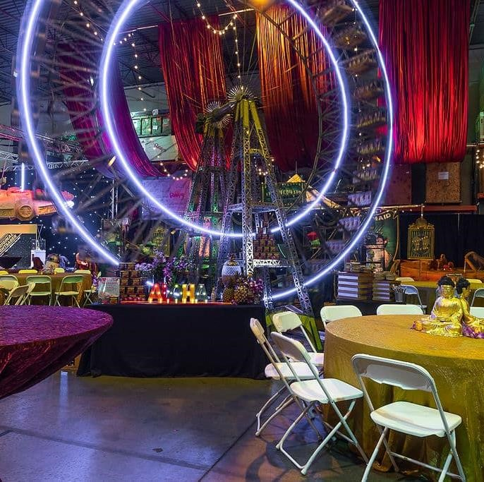
The title of the event, "Sustainability in Hospitality: But "A Green Horizon." reflects our commitment to helping the hospitality industry find their path towards being more environmentally responsible in future (Waheed Ali Umrani et al., 2020). This topic is the event’s North Star, guiding everything towards activating eco-friendly behavior. “A Green Horizon” symbolizes our desire to evolve the limits of environmentally considerate event management and alter industry standards. The purpose of the event is to be a catalyst by bringing professionals, enthusiasts and stakeholders together with an aim of interacting over showcasing latest GREEN technologies in hospitality industry (Proctor, Dunne and Flanagan, 2023). By presenting sustainable solutions, we aim to motivate and educate participants about practical approaches on minimizing their environmental impact (Žalėnienė and Pereira, 2021). Apart from developing a contemporary approach to ethical event practice, this theme and goal contribute towards creating an atmosphere of sustainability for the greater hospitality
niche.


Situational
Analysis
-
Market Factors
The target group of our market includes the
experts in hospitality, environment conscious
consumers and event organizers who share a
similar interest for sustainable methods
Our event
is very popular because there has been a rising
interest in sustainability and the demand for eco
-
friendly events that meet ecologically tolerant
principles
(
Dhananjaya
Nawarathna
and R. S. S. W.
Arachchi
, 2021)
.
We’re leading a cultural shift in
the hospitality industry towards sustainable
practices given that there is increased demand
(
Current Issues in Tourism,
2020)
.
The supply side
shows a vacuum in the market because currently
not many feasible events are present within the
industry.
Observing that space, we are arranging
this event to fill the gap and provide an unmet
requirement for ecologically sustainable events
(
Panda et al.,
2022)
.
We conduct a thorough study
on competitiveness to identify the possible
threats or situations that can affect
attendance.
Such an analysis allows us to
distinguish our event and make it unique,
strategically standing out in a competitive

Situational Analysis Operational Factors
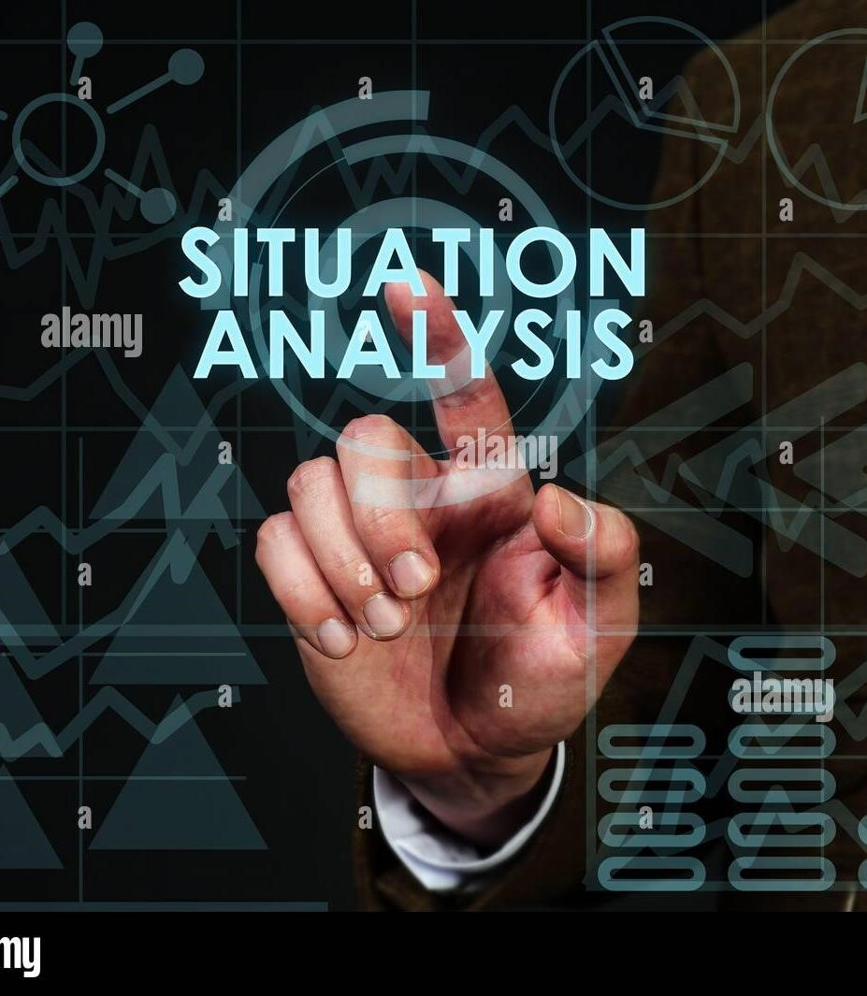
In order to ensure a successful implementation, the site study for our sustainable hospitality event scrutinizes several valuable factors. When assessing various venue options, we pay close attention to location, design elements and the impact on nature (Souji Gopalakrishna Pillai et al., 2021). Compatibility is measured by the requirements and topic of an event, while availability makes sure that a chosen place can be available on particular day only (Abdou et al., 2020). Space issues ensure that with our anticipated audience capacity we have enough space at the venue. To keep the eco-friendly touch of this event our crew members are specially trained with sustainability practices (Baldassari et al., 2023). This means knowing about energy saving, waste reduction and environmentally oriented resource use. The detailed catalog of available resources is created, including essential elements like green catering, energy efficient lighting sustainable parking and eco-friendly seating arrangements. This holistic analysis of venue, skills and resources highlights our dedication to building an environmentally sustainable and effective event.
Situational Analysis -

Financial Factors
The financial sustainability of the sustainable hospitality event is clearly reflected in a detailed cost breakdown that involves significant items such as venue rental, employee salary costs catering also decoration and advertising (Scholz, Ivica Linderová and Kristýna Konečná, 2020). Hiring cost is looked at carefully, and salaries for staff are determined according to their level of knowledge as professionals in green event management. Catering costs put emphasis on eco-friendly options, particularly locally sourced and sustainable foods. The sustainability of decor costs is another factor that amplifies the green theme of this event. The primary funding source for the organization is ticket sales that are supplemented by strategic partnerships and sponsorship (Google Books, 2023). These partnerships also add value in income generation and on the experience of events. Sources of funding are diversified to ensure budget balance and include probable sponsors, grants, as well as possible collaborations. This comprehensive financial analysis seeks to ensure the sustainability of budgets with an objective to avoid loss and build positivity toward nature and all stakeholders on the event.

Unique Theme: The event's "Sustainability in Hospitality: A Green Horizon" theme sets it apart, offering a distinctive and appealing concept. | Potential Challenges: Identifying reliable ecofriendly suppliers may pose challenges, and the initial costs associated with sustainable practices might be higher.
Strengths Weaknesses SWOT Analysis

Growing Demand: There is a noticeable and Higher Initial Costs: The commitment to increasing demand for sustainable events, sustainable practices may result in higher initial
reflecting a broader societal shift towards eco- financial investments, requiring careful financial conscious choices. management.

Opportunities Threats
Collaborations: Opportunities exist for meaningful collaborations with green businesses, enhancing the event's impact and eco-friendly practices. | Competing Events: Other events in the same space may pose a threat, requiring strategic differentiation and marketing efforts to stand out.
Positive PR: Embracing sustainability offers Resistance to Change: Traditional practices within opportunities for positive public relations, the hospitality sector may face resistance, attracting environmentally conscious attendees necessitating effective communication to
and sponsors. encourage widespread adoption of sustainable
principles.

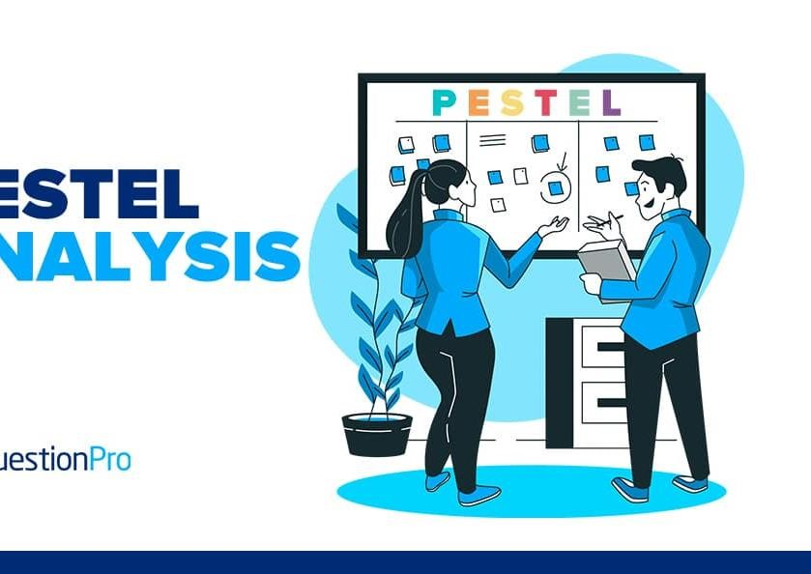
PESTLE Analysis
PESTLE analysis provided in our sustainable hospitality event is
also capable of providing a detailed overview of various aspects
that are relevant for the strategic planning.
There is a potential
positive political effect of government incentives for sustainable
events that support our endeavours, financial aid and other
benefits.
The law industry is responsible for the application of
environmental legislation in which sustainable practice norms
show major impact
(
Litvinenko et al.,
2022)
.
The economic
analysis basically entails factoring in the costs of sustainable
practices, problem
-
solving any hurdles and noting long term
benefits as well as improved brand image.
On the social side,
our event can also align with contemporary society standards
due to increasing knowledge and interest in more eco
-
friendly
activities.
Technologically, looking at state
-
of
-
the art answers
for environmental practices in events management reinforces
our commitment to sustainability
(
Simon Elias Bibri,
2020)
.
The
environmental aspect counts for any ecological consequences
of the event and is responsible for preventive planning to be
able to reduce all harmful impacts.
This PESTLE analysis forms
the basis of our event planning so that we can respond to
external variables vital for success.

Feasibility and Strategic Pre-Planning Research
The situation assessment together with SWOT and PESTLE analysis gives us an essential direction for our strategic approach towards planning events. The importance of our event in market trends and demands is also emphasized by these studies as a whole (Verma et al., 2021). Validating our chosen topic, the situational study showed a growing demand for sustainable events. This unique point of the event is one strong advantage that has been brought up by SWOT analysis. Other possible issues include higher startup costs. In the PESTLE study, the outside variables that could have a positive influence on our event were identified as societal interest and government incentives. These findings are highlighted in our strategic pre-planning actions, such as cooperating with green companies and addressing weaknesses by looking into feasible sustainable techniques. While seizing opportunities involves using technological advances to facilitate effective marketing aimed at attracting in eco-conscious customers and efficient operation of sustainable event management (S, 2023). This holistic approach ensures that our event meets and surpasses market requirements, making it a leading initiative in the field of sustainable hospitality.


Conclusion
At the end, it is worth mentioning that our feasibility study deals with pivotal issues which are critical to ensuring a successful sustainable hospitality event. The theme of "Sustainability in Hospitality: Our project is modern and relevant since it portrays “A Green Horizon”. The situational analysis, SWOT and PESTLE assessments jointly confirm the event's feasibility where its unique strengths emerge as well. We restate that our event is viable and can become an outlier in the disruptive hospitality industry (Burbano et al., 2022). The subsequent stage of the planning process is to actualize these thoughts into workable solutions. We encourage creating an integrated plan which should include such issues as selecting eco-friendly vendors, establishing alliances then beginning ad campaigns and implementing sustainable event management technologies. This timeline provides for a coordinated and methodical approach, ensuring the smooth operation of our sustainable hospitality event.

References
Journal of Hospitality & Tourism Education. (2019). Hospitality and Tourism Managers’ Perceptions of Sustainable Practices in Hospitality and Tourism during the Pandemic: Implications for Education. [online] Available at: https://www.tandfonline.com/doi/abs/10.1080/10963758.2022.2056470 [Accessed 16 Jan. 2024].
Chibaya, T. (2021). A critical assessment of the sectorial development potential of business tourism events. Nwu.ac.za. [online] doi:https://orcid.org/0000-0002-5445-5380.
Elias Simon Bibri, Krogstie, J., Amin Kaboli and Alexandre Alahi (2024). Smarter eco-cities and their leading-edge artificial intelligence of things solutions for environmental sustainability: A comprehensive systematic review. Environmental Science and Ecotechnology, [online] 19, pp.100330–100330. doi:https://doi.org/10.1016/j.ese.2023.100330.
Waheed Ali Umrani, Nisar Ahmed Channa, Yousaf, A., Ahmed, U., Munwar Hussain Pahi and T. Ramayah (2020). Greening the workforce to achieve environmental performance in hotel industry: A serial mediation model. Journal of hospitality and tourism management, [online] 44, pp.50–60. doi:https://doi.org/10.1016/j.jhtm.2020.05.007.
Proctor, D., Dunne, G. and Flanagan, S. (2023). Towards a model of sports franchise leverage for destination marketing. Journal of Destination Marketing and Management, [online] 30, pp.100829– 100829. doi:https://doi.org/10.1016/j.jdmm.2023.100829.
conditions for tritium fuel
self sufficiency
.
Nuclear Fusion
, [online] 61(1), pp.013001
–
013001
.
doi:https
:
//doi.org/
10.1088/1741
-
4326
/abbf
35.
Žalėnienė, I. and Pereira, P. (2021). Higher Education For Sustainability: A Global Perspective. Geography and Sustainability, [online] 2(2), pp.99–106. doi:https://doi.org/10.1016/j.geosus.2021.05.001.
From niches to regime: sustainability transitions in a diverse tourism destination. (2022). Tourism Geographies. [online] doi:https://doi.org/10.1080//14616688.2023.2280179.
Consumer behavior and environmental sustainability in tourism and hospitality: a review of theories, concepts, and latest research. (2021). Journal of Sustainable Tourism. [online] doi:https://doi.org/10.1080//09669582.2021.1903019.
Dhananjaya Nawarathna and R. S. S. W. Arachchi (2021). A Study on Sustainable Event Management Practices in Sri Lanka; Event Managers’ Perspective. Tourism and Sustainable Development Review, [online] 2(1), pp.49–64. doi:https://doi.org/10.31098/tsdr.v2i1.40.
Current Issues in Tourism. (2020). Consumer perceptions towards sustainable supply chain practices in the hospitality industry. [online] Available at:
https://www.tandfonline.com/doi/abs/10.1080/13683500.2018.1526258 [Accessed 16 Jan. 2024].
Panda, S., Mohanty, S., Pravat Kumar Rout, Binod Kumar Sahu, Bajaj, M., Zawbaa, H.M. and Kamel, S. (2022). Residential Demand Side Management model, optimization and future perspective: A review. Energy Reports, [online] 8, pp.3727–3766. doi:https://doi.org/10.1016/j.egyr.2022.02.300.
Muhammad Shehryar Shahid, Hossain, M., Shahid, S. and Anwar, T. (2023). Frugal innovation as a source of sustainable entrepreneurship to tackle social and environmental challenges. Journal of Cleaner Production, [online] 406, pp.137050–137050. doi:https://doi.org/10.1016/j.jclepro.2023.137050.
Souji Gopalakrishna Pillai, Kavitha Haldorai, Won Seok Seo and Woo Gon Kim (2021). COVID-19 and hospitality 5.0: Redefining hospitality operations. International Journal of Hospitality Management, [online] 94, pp.102869–102869. doi:https://doi.org/10.1016/j.ijhm.2021.102869.
Abdou, M., Riva, M., Ying, A., Day, C., A. Loarte, Baylor, L.R., Humrickhouse, P.W., Fuerst, T.F. and Cho, S. (2020). Physics and technology considerations for the deuterium–tritium fuel cycle and

https://uowtsd-my.sharepoint.com/:v:/g/personal/2117880_student_uwtsd_ac_uk/EdAJIw5nfu5BuhF38cEFQSQBV5uy9GYGTAsgBK0TBFEUxw?referrer=Teams.TEAMS-ELECTRON&referrerScenario=MeetingChicletGetLink.view.view

