
Applied Leadership and Management in the Workplace
Module Assignment Submission
Student Name: | Rebecca Forshaw
Student Number: | 2238205
Module No: | BMSK5009
Module Title: | Developing a High-Performance Culture

Statement of Confirmation of Authenticity
By the act of making this submission, the student declares that this is the work of the student named above. The work has not, in whole or in part, been knowingly presented elsewhere for assessment, or where assessment has been built on a previous assessment, this has been identified. Where materials have been used from other sources it has been properly acknowledged. If this statement is untrue, the student acknowledges that an assessment offence has been committed.
Attention is drawn to the plagiarism and unfair practice policies of both the University and of ILM.

Contents
Introduction 1
What defines a high-performance culture and how does it enhance the working environment? 2
The Employees. 2
Tesco's culture and context. 3
Tesco's wider environment. 4
Tesco's ethical and cultural behaviour. 5
Culture Defined 6
The ‘why’ of Different Cultures. 10
Differences in Culture and Ethics. 10
Conclusion. 12
Refrences. 12
APPENDICIES. 13

Introduction

Any business's performance and long-term viability are greatly influenced by its organisational culture and surroundings. The common beliefs, customs, and behaviours that shape a company's internal processes and stakeholder interactions are all referred to as its culture (Schein, 2010). According to Johnson et al. (2017), context includes market trends, regulatory systems, and internal processes that affect what an organisation does and how it acts. In order to investigate how these elements interact and affect Tesco's operations, this project critically evaluates the company's culture and environment. Tesco is a major international retailer.
Tesco's strong customer-focused culture and adaptability to a variety of changing circumstances support its position as the industry leader. The paper will assess the importance of Tesco's cultural practices and cultural reactions by using theoretical frameworks such Handy's cultural typologies, Schein's levels of culture, and Johnson and Scholes' Cultural Web. The evaluation seeks to show how context and culture interact to produce synergies that promote creativity and performance.

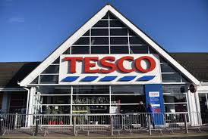

What defines a high-performance culture and how does it enhance the working environment?

A high-performance culture is one in which employees are empowered to make decisions, shared goals, and responsibility are all factors that contribute to the achievement of exceptional results. It is said by Schein (2010) that a culture of this sort is founded on strong ideals, effective leadership, and the consistent reinforcement of activities that are in accordance with the objectives of the corporation. Tesco's customer-centric strategy, emphasis on teamwork, and commitment to continuous improvement are all strong indicators of the company's high-performance culture. The phrase "Every Little Helps" that Tesco uses draws attention to the company's commitment to achieving operational excellence through the supply of value to customers and the maintenance of efficiency.

The Employees.

The employees are provided with a sense of purpose and belonging as a result of this culture, which ultimately leads to an improvement in the working circumstances. In situations when members of a team think that their efforts contribute to the achievement of organisational goals, engagement and morale are boosted, which in turn encourages collaboration and innovation. That is possible to see at Tesco because they have training programs for their employees, like the "Options Development Program," which gets workers ready for leadership roles.
The implementation of these programs not only enhances performance but also increases job satisfaction, which in turn reduces employee turnover and ensures the long-term success of the company. To avoid burnout, maintaining such a culture requires addressing issues such as balancing job expectations and creating a good work-life balance.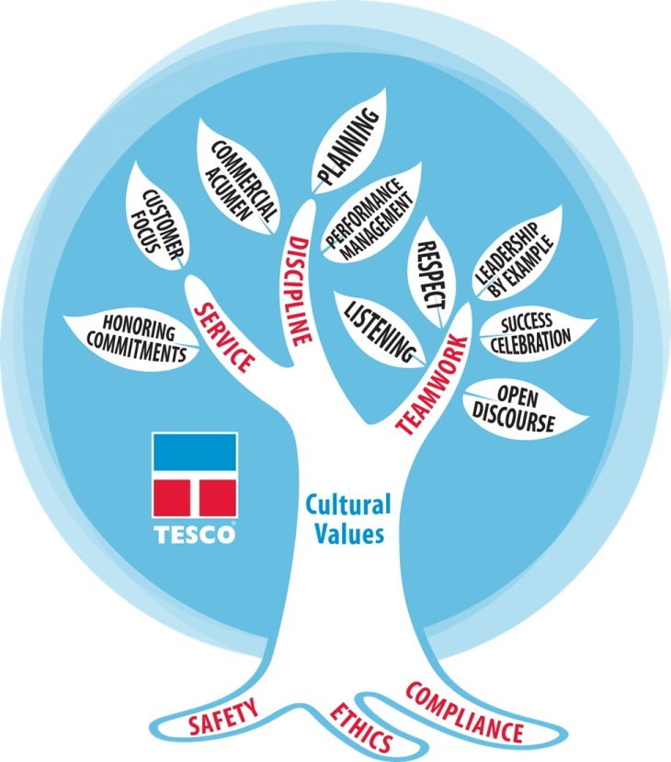

Tesco's culture and context.
The company culture of Tesco is driven by the company's emphasis on efficiency, customer satisfaction, and innovation. By using Schein's three levels of culture—artifacts, promoted ideals, and underlying assumptions—it may be possible to gain a deeper understanding of Tesco's business processes. Things such as digital platforms, staff apparel, and retail designs illustrate Tesco's commitment to provide customers with entirely fulfilling experiences. Tesco supports ethical sourcing, sustainability, and inclusivity as attributes that appeal to its stakeholders, all of which help to develop the Tesco brand.

In a more fundamental sense, Tesco's ability to remain competitive in a retail market that is always evolving is protected by the fundamental principles of efficiency and flexibility. The circumstances around Tesco are shaped in part by both internal and externally. At the level of the team, the organisation operates according to a hierarchical structure that places an emphasis on responsibility and fosters innovation within the organisation. Among the challenges that Tesco must overcome are intense competition and shifting patterns of customer behaviour from the outside in. The Cultural Web that Johnson and Scholes created in 2017 demonstrates how Tesco's practices, rituals, and power structures support the company's strategic objectives, so ensuring that all of the company's operations are consistent with one another.

Tesco's wider environment.
PESTLE analysis and Porter's Five Forces analysis are two useful methods that may be utilised to investigate Tesco's wider environment. Tesco is impacted by a variety of factors, including political, financial, social, technological, legal, and environmental factors, as highlighted by the PESTLE framework. As an illustration, Brexit caused problems with the availability of workers and the management of supply chains, whilst the expansion of e-commerce led to an increase in the amount of money spent on online purchasing systems. In response to societal issues, especially the increased demand from customers for sustainable products, Tesco has adopted ecologically friendly strategies, such as reducing the usage of plastic and purchasing items in an ethical manner.

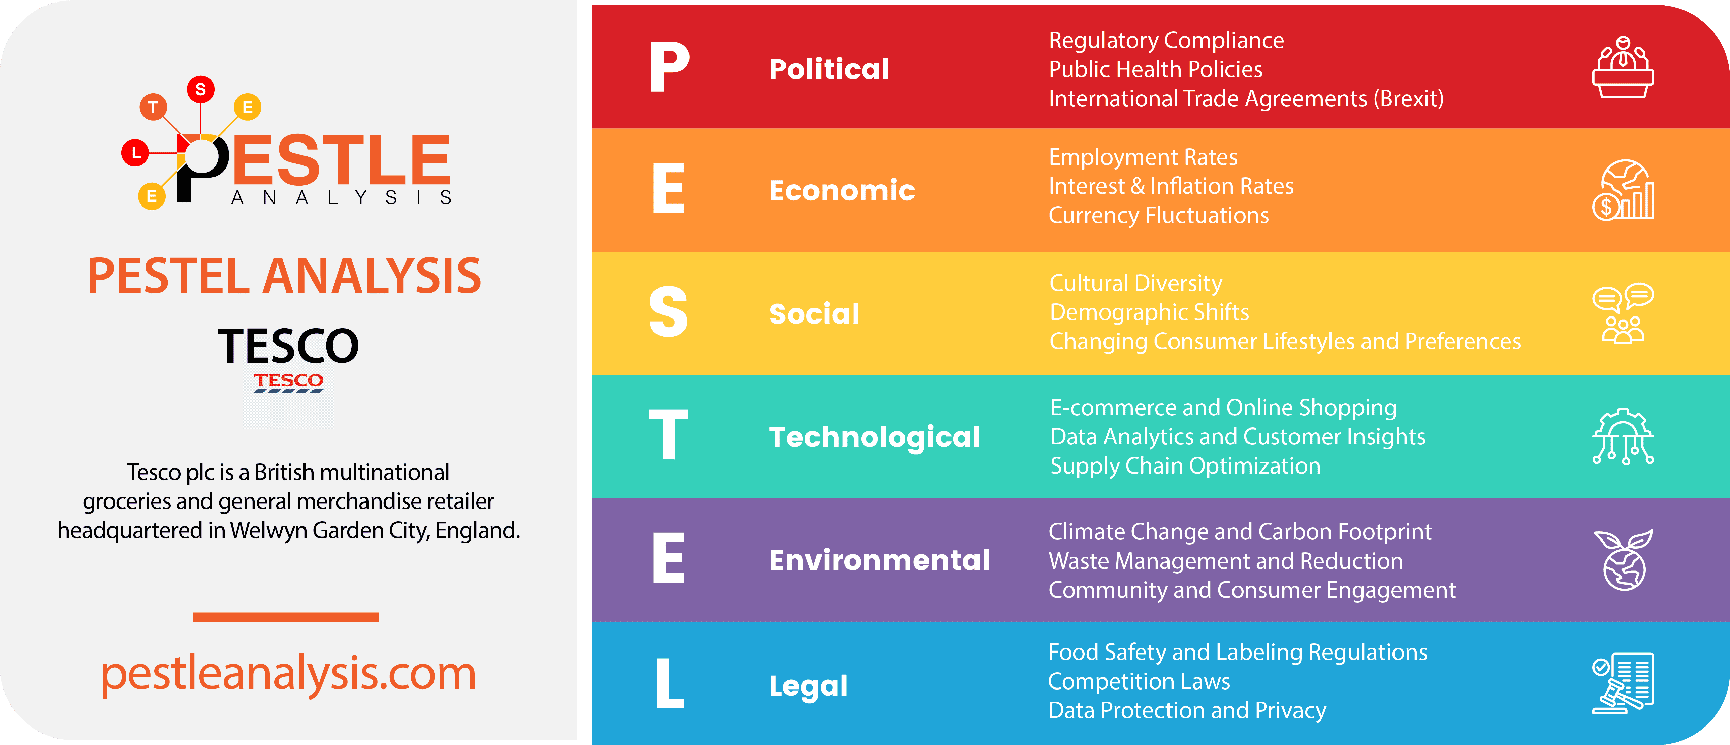

It is possible to gain an insight of Tesco's competitive position by using Porter's Five Forces. Due to the intense competition from discount retailers such as Aldi and Lidl, Tesco is compelled to maintain its value and affordability. In spite of the fact that Tesco's size and ability to negotiate favourable terms contribute to the explanation of why supplier power is relatively low, buyer power is substantial since customers have access to a wide variety of alternatives. The threat of alternatives, such as meal delivery services, and the likelihood of new rivals entering niche markets are two further factors that highlight the necessity of continuous innovation for Tesco.

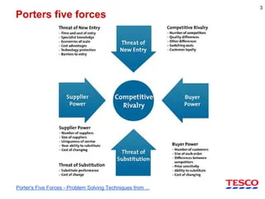

Tesco's ethical and cultural behaviour.
Tesco has made significant strides in incorporating corporate responsibility into its culture and the development of ethical conduct. The company has established programs to address environmental concerns, such as reducing the amount of food that is wasted and committing to achieving net-zero carbon emissions by the year 2050. Additionally, Tesco's Code of Business Conduct establishes moral requirements for employees, which ensures that the company's operations are carried out in an honest manner. The cultural characteristics explained by Hofstede provide us with a better understanding of Tesco's approach for managing its diverse staff across a number of different markets. Tesco fosters an environment that is conducive to collaboration, one in which employees are encouraged to freely express recommendations.

Despite this, Tesco's standards regarding ethics and culture have been subjected to a thorough investigation. Previous situations, such as the accounting crisis that occurred in 2014, brought to light deficiencies in corporate governance and the requirement for a more comprehensive control system. In addition, Tesco must always find a way to strike a balance between ethics and profitability, particularly with regard to problems such as the sustainability of the supply chain and the treatment of employees. By incorporating ethical concerns into decision-making processes and fostering an environment that encourages openness, Tesco may foster cultural integrity and increase the confidence of its stakeholders.

Tesco is a shining example of how a high-performance culture that prioritises customer attention, collaboration, and innovation can lead to improvements in the circumstances of the workplace where employees work. The company's culture and setting are connected, which contributes to the definition of the company's resilience and adaptability in a retail industry that is highly competitive. Using frameworks such as Schein's degrees of culture, PESTLE, and Porter's Five Forces, it is possible to conduct an accurately appraised assessment of Tesco's internal dynamics as well as its more broad influence on the environment. Despite the fact that Tesco has achieved significant progress in promoting ethical and cultural conduct, the company's continued success is contingent on addressing concerns such as corporate responsibility and the well-being of its employees, despite the fact that these areas have made significant progress.

Culture Defined
Organisational culture is the shared set of values, beliefs, and behaviours that influence how people interact and collaborate inside an organisation to achieve common goals. Hofstede (1991) writes of culture as "the collective programming of the human mind that differentiates one group of people from another." For Tesco, this common knowledge appears in its driving principle, "Every Little Helps," which represents operational efficiency, a customer-centric attitude, and a dedication to teamwork. As Trompenaar (1998) explains, groups join together to survive and flourish; in Tesco's case, its long-standing position in the very competitive retail sector has moulded its culture.

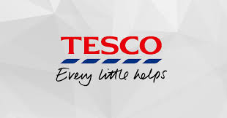

Jaques (1951) emphasised the unified nature of culture inside companies when he said, "the conventional and traditional manner of thinking and doing things, shared to a greater or less degree by all its members." Tesco's mirror this, from how staff members treat consumers to the operational procedures guaranteeing effectiveness in its shops and online services. As one of the top stores in the country, Tesco's success depends on management practices and performance, hence Hofstede emphasises even more the crucial part that culture plays in understanding them.

Emphasising "culture is all about how people treat one other – how leaders treat their teams and colleagues," Edmonds (2016) offers a human-centered viewpoint. Tesco's commitment in employee development initiatives like "Options Development," which not only upskill people but also promotes an inclusive and kind workplace environment, shows how in line its leadership practices are with this attitude. These cultural components are absolutely essential for establishing a high-performance atmosphere that inspires staff members and increases customer satisfaction.

Power, Role, Task, and Person cultures are four cultural forms that Charles Handy (1993) found may coexist in companies. Tesco's organisation mostly fits a Role Culture, in which structure and well defined roles control activities. This guarantees consistency throughout its large chain of stores and suppliers. However, project-based teams that inspire creativity—such as those working to improve digital shopping platforms and sustainability projects—clearly show aspects of Task Culture as well.

Edgar Schein (2010) put out a three-tiered approach for examining organisational culture that fits Tesco really well. Tesco's artefacts include obvious aspects like as shop layouts, employee uniforms, and consumer loyalty schemes like Clubcard. These concrete features highlight Tesco's dedication to ease of use and accessibility. Tesco's public statements and business initiatives, which include eliminating food waste and assuring ethical sourcing, reflect its stated principles, such as inclusion and sustainability. Underneath these layers are the fundamental underlying assumptions that drive the company's Flexibility and efficiency—core concepts that have allowed Tesco to remain competitive in a rapidly changing retail environment.

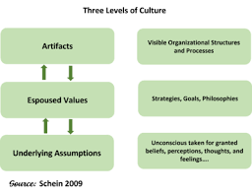

Johnson and Scholes (1992), the Cultural Web offers a structure for examining the linked components of corporate culture. Stories of Tesco's development from a modest market stall to a worldwide store support a resilience and growth story there. Stories like these appeal to consumers as well as to workers. Weekly team briefings and daily operating procedures are among the rituals and routines that create a rhythm guaranteeing seamless operation throughout stores.

Tesco's logo and Clubcard serve as symbols of the company's brand identification and client loyalty. The organisational structure promotes a mix of centralised decision-making at the headquarters and localised operations to fulfil regional client demands. Tesco's leadership team defines its power structures by driving strategic initiatives; control systems, like performance measures and consumer feedback systems, guarantee that objectives are efficiently reached.

Hofstede's cultural dimensions show how national and organisational cultures affect companies like Tesco. For instance, Tesco works in areas with different levels of need, so it changes the way it leads in each area. Tesco advocates open communication and group decision-making in the UK, where need is somewhat minimal. Trompenaar's cultural aspects also show how Tesco manages to balance global standards with localised practices.

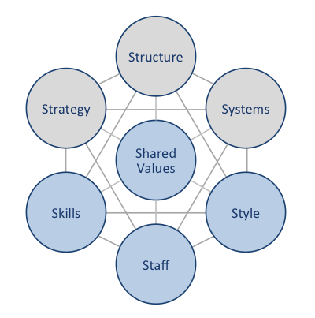
Tesco's success revolves mostly on its shared ideals of customer service and sustainability. Its approach to innovate and increase its market share, its structure supporting scalability, and its technologies simplifying supply chains and digital operations all help to underline these principles. Tesco's excellent organisational culture is further enhanced by the soft components, like inclusive leadership styles and competent workforce.

Tesco's ongoing success depends on a knowledge of and encouragement of organisational culture. As Schein (2010) points out, culture provides a pattern of common beliefs that guides companies towards solutions. At Tesco, this culture helps the business to meet demands like changes in customer behaviour, legal changes, and competition from bargain shops. Tesco fosters an atmosphere whereby both staff members and the company may flourish by encouraging a high-performance culture that gives sustainability, customer happiness, and employee development first priority.

Strategic flexibility and operational success of Tesco depend mostly on its culture. Tesco uses concepts including Handy's cultural kinds, Schein's levels, and the Cultural Web to show how it combines common principles, efficient systems, and creative ideas into its daily operations. This cultural focus guarantees Tesco's continued reputation in a cutthroat industry and drives performance as well.

The ‘why’ of Different Cultures.

Organisational culture refers to the common values, attitudes, and beliefs that shape how employees behave and make decisions. The company's goals and strategies often shape its culture, but its moral foundation is also very important to its character and long-term success. Ethics in organisations are the rules that everyone follows when making decisions, from leaders to regular employees. There are two main types of ethics: based on consequence and non-consequentialist. Each type has its own effects on the attitude and behaviour of an organisation.

Tesco works in a very competitive retail setting, so it has to pay attention to both how well it does its own work and how it affects other people. Since Tesco is a consequentialist company, it thinks about how its actions will affect customers, workers, and communities. This is clear from its dedication to eco-friendly and socially responsible projects, like reducing food waste, getting goods in an honest way, and running community programs. These projects show that people think long-term success is linked to making the world a better place. This fits with the idea of consequentialist ethics, which says that actions are judged by the results they produce.

For instance, Tesco's efforts to use less plastic packaging and make its supply chain more environmentally friendly show that they are in line with larger community worries. Values like honesty and duty are pushed on employees, creating a work environment where each person's actions are in line with the company's overall goals. In this way of thinking, things like protecting the earth and keeping customers trusting you are more important than making money for the business.

Oxfam has a strong consequentialist moral stance.
On the other hand, Oxfam is an organisation that takes a clear consequentialist view of social ethics. Deeply rooted in global social justice, its culture focusses on how its actions affect disadvantaged groups in the bigger picture. Oxfam's main goal is to fix structural problems like poverty and unfair treatment of people. Oxfam's goal to make the world a better place makes it likely that its employees will share values like kindness, advocacy, and selflessness. Oxfam's beliefs put external results ahead of internal measures. This shows that the charity's culture puts the wellness of all its members above all else.

Tesco does some good things for society, but because it is a sales-driven, goal-oriented company, its objectives are different. Tesco has a mix of consequentialist and non-consequentialist ideas because it cares about both how its actions affect others and how well its own operations run. As an example, sustainability efforts are in line with a consequentialist view, but the company's sales aims and profit-driven goals are more in line with a non-consequentialist view, where internal metrics are more important.

Differences in Culture and Ethics.
The ethical and cultural differences between Oxfam and Tesco show that they have different views, values, and attitudes. Tesco's business goals have shaped its culture, which puts innovation, efficiency, and customer happiness at the top of the list. Internal benchmarks like sales and market share are likely to drive employees to value competitiveness, adaptability, and an attitude focused on results. Oxfam's culture, on the other hand, values teamwork, compassion, and advocacy, and workers are driven by things like making a difference in the community and bringing about social change.

These differences come from the different ethical models that each organisation uses. Tesco's focus on sales and profit is partly non-consequentialist, which means they believe that the success of the individual organisation is the most important thing. Oxfam, on the other hand, believes that social responsibility to the global community is more important.

The 7S approach from McKinsey helps us see how these differences in culture and ethics show up in the two companies. Tesco's strategy is based on being competitive in the market and keeping customers coming back. This is made possible by systems like modern supply chain logistics that make sure operations run smoothly. Tesco's shared values are all about giving people value while also taking care of social issues like sustainability.

On the other hand, Oxfam's strategy is based on advocacy and reaching out to people all over the world, with systems in place to ensure maximum openness and moral responsibility. Human rights and social justice are at the heart of Oxfam's shared beliefs, which guide every part of its work. At Oxfam, leadership is about getting people to work together and make social change happen, while at Tesco, leadership is about success metrics and new ideas.

Both Tesco and Oxfam take different methods, which shows how culture can affect a business's morals. Oxfam's mission-driven focus puts societal outcomes at the centre of its culture, while Tesco has to find a balance between its internal and external goals. This comparison shows how different moral views affect how employees act, what decisions they make, and how their actions affect the organisation. Organisations can better align their culture with their strategic goals and ethical values if they understand these dynamics.

The "why" behind different cultures is their core morals and how these affect how people act in the workplace. Tesco and Oxfam are at opposite ends of the ethical range. To reach its goals, Tesco uses both consequentialist and non-consequentialist principles, but Oxfam stays firmly in a consequentialist social ethical framework. Both ways produce different work cultures, showing that values, attitudes, and beliefs affect not only how employees act but also how the organisation affects society as a whole.

Conclusion.
This paper focusses on how culture and context influence organisational beliefs, behaviours, and performance. It is clear from theories from Schein (2010), Handy (1993), and Hofstede (1991) that culture shapes the behaviour and interaction of companies with their employees. Tesco's mix of consequentialist and non-consequentialist values shows its emphasis on both internal success—such as revenue and efficiency—and external objectives—such as sustainability and community effect. By comparison, Oxfam's strong consequentialist approach emphasises world social justice and gives community needs top priority above internal goals.
Tesco and Oxfam's comparison reveals how differently ethical points of view affect their cultures. Oxfam stresses cooperation and advocacy; Tesco's culture promotes creativity and competitiveness. Both companies show that success depends on matching culture with strategic objectives. Models such as the Cultural Web (Johnson & Scholes, 1992) and the McKinsey 7S paradigm expose how systems, leadership styles, and shared values define these surroundings.
Ultimately, securing long-term success and a good working environment depend on a strong organisational culture based on ethical values. Leaders have to deliberately mould their cultures to strike a balance between personal interests and more general social and ethical obligations so that their companies may flourish in an environment that is complicated and changing.

Refrences.

- 2010: Schein, E. H. Fourth Edition: Organisation Culture and Leadership San Francisco is Jossey-Bass.
- Edmonds, S. C. (2016). Culture Change Made Easy. San Diego: Blurb.
- Handy, C. ( 1993 ). Recognising Organisations. Penguin Books London
- Hofstede, G. (1991). Cultures and Organisations: Software of the Mind. London: McGraw-Hill.
- Jaques, E. (1951). The Changing Culture of a Factory. New York: Dryden Press.
- Johnson, G., Scholes, K., & Whittington, R. (1992). Exploring Corporate Strategy. London: Prentice Hall.
- Johnson, G., Scholes, K., & Whittington, R. (2017). Exploring Strategy: Text and Cases. 11th Edition. Harlow: Pearson Education.
- Porter, M. (2008). Competitive Strategy: Techniques for Analyzing Industries and Competitors. New York: Free Press.
- Porter, M.2008. Competitive Strategy: Methodologies for Examining Competitors and Industries New York: Free Press;
- Schein, E. H. (2010). Organizational Culture and Leadership. 4th Edition. San Francisco: Jossey-Bass.
- Schein, E. H. (2010). Organizational Culture and Leadership. 4th Edition. San Francisco: Jossey-Bass.
- Trompenaar, F., & Hampden-Turner, C. (1998). Riding the Waves of Culture: Understanding Diversity in Global Business. New York: McGraw-Hill.
- Whittington, R.; Scholes, K.; Johnson, G., 2017. Investigating Strategy: Text and Case Studies eleventh Edition. Harlow: Pearson Academic Development
- Tesco's Corporate Governance: https://www.tescoplc.com/investors/corporate-governance/
- Tesco's Sustainability Initiatives: https://www.tescoplc.com/sustainability/.
- For Oxfam- https://www.oxfam.org/en

APPENDICIES.



