
Module Name: Managing Hotel Administration
Module Code: BMIH6004

Student Name: Salman Ali
Student ID: 2119165
Lecturer Name: Jessica Newport

AI Acknowledgement
This report was written based on my own placement experience at Holiday Inn Sunderland, City Centre. I have only used AI tools to support with structure, research, and proofreading, as allowed by the module guidelines. All reflections, examples, and analyses are my own and based on real tasks I completed during my placement. No content has been generated by AI in place of my personal learning or practical experience.
Table of Contents
Introduction 3
My Role and What I Learned at the Front Office 4
Training Problems I Saw During My Placement 6
New Trends That May Change Front Office Work 7
Conclusion 9
References 10

Figure 1: Gibbs Reflective Model 4
Figure 2: Trends in Front Office Work 7

Introduction
My placement was at Holiday Inn Sunderland, City Centre. I worked in the front office department. This team checks guests in and out, answers call, helps with bookings, and supports guests with their questions (ASET, 2017). I picked this department because it is busy and important in hotel work. I wanted to see how it runs and how the staff helps guests every day. I had three clear learning objectives. First, I wanted to improve how I speak with guests, especially in busy or stressful moments. Second, I wanted to learn how to use the front office computer system, including making bookings and updating records. Third, I wanted to learn how to solve guest problems calmly and professionally. These goals helped me stay focused during my placement.

My Role and What I Learned at the Front Office
During my placement at Holiday Inn Sunderland City Centre, I worked in the front office department. I welcomed guests, checked them in and out, answered calls, gave room keys, and helped with bookings. I also gave guests information about the hotel. My supervisor helped guide me, gave me tasks, and supported the team. They showed good leadership by solving problems and managing shifts well.
To think clearly about my learning, I used Gibbs’ Reflective Cycle. This reflection model helped me understand what happened, how I felt, what was good or bad, and what I should do next time (Bardi, 2010).
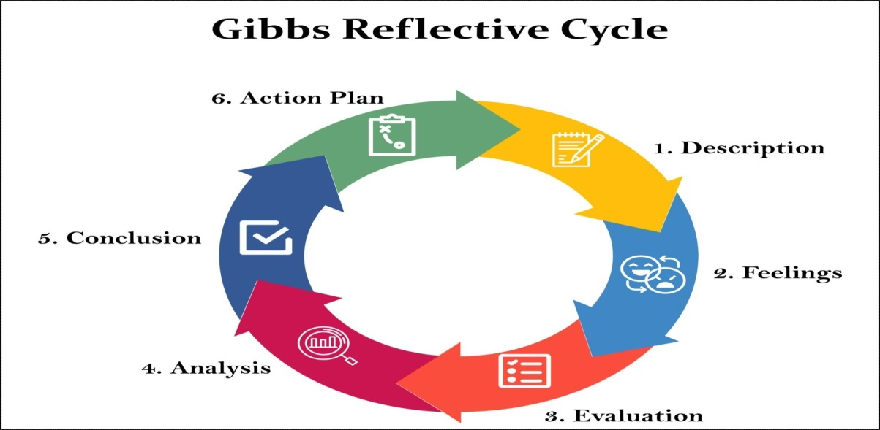
Figure 1: Gibbs Reflective Model
Source: (Midwinter and Dickson, 2015)
In the beginning, I felt nervous. I had never worked on a hotel front desk before. I was scared to speak with guests and worried I would use the system wrongly. I also felt unsure when things went wrong. But after a few days, I became more confident. My team was friendly and always ready to help (Hagg, 2013). I started to feel better and enjoyed learning new things.
One day, I faced a booking issue. A guest’s room was booked under the wrong name. I calmly searched the system again, found the right booking, and fixed it. The guest smiled and said Thank you. I felt happy because I solved the problem alone and stayed calm.
Another time, a guest was angry about the noise outside. I listened carefully, stayed polite, and called the supervisor. The supervisor gave them another room. I felt nervous but proud afterwards because I handled the situation correctly.
These experiences taught me that communication, staying calm, and knowing when to ask for help are very important skills (Casado, 2012). I also learned that I can solve problems when I try my best.
In the future, I want to become quicker with the system and more confident when handling guest issues. I will keep practising and learning. This placement helped me grow, and I now feel more ready for real hotel jobs.

Training Problems I Saw During My Placement
During my placement at Holiday Inn Sunderland City Centre, I saw a problem with training. Some new staff started working before full training. They did not know how to use the system or follow proper steps. This caused delays and mistakes. During busy times, service was slow, and the team felt stressed (QAA, 2018).
One time, a new staff member struggled to check in a guest. They could not find the booking in the system. The guest waited for a long time. The supervisor had to step in. It made the front desk feel tenser. This showed me how important good training is in hotel jobs.
This reminded me of what I learned in Personnel Resourcing & Development in Level 5. In that module, I studied how training helps staff feel confident and ready. We learned that training improves work quality and helps staff understand their role. One lecture taught me that training should start before the job begins. Onboarding must be planned and simple. Without this, staff feels lost and makes mistakes. I saw this happen in real life during my placement (Fallon and Rutherford, 2010).
I also read research to support what I saw. Jones (2020) wrote that training helps staff improve speed and service. Smith and Lee (2021) said that simple onboarding helps new staff feel prepared. These match what I saw at Holiday Inn.
I think the hotel should give a short training before new staff start. It can include basic system use, guest service role-play, and hotel rules. Also, a buddy system could help. New staff can watch experienced staff first and ask questions. This makes them feel more confident.
In the future, I will remember these lessons. I want to give proper training when I become a team leader. This will help new staff, the team, and the hotel.

New Trends That May Change Front Office Work
While working at Holiday Inn Sunderland City Centre, I started to notice how hotel front office work is changing. I also learned about new trends that will affect this department in the future (Wood, 2013).
One important trend is the use of technology. Many hotels are now using self-check-in kiosks. These machines allow guests to check in by themselves. This saves time for guests. It also helps staff focus on other tasks. During my placement, our hotel did not have these machines, but I read that other Holiday Inn hotels use them (Johnston, Clark and Shulver, 2012).
Another trend is the use of artificial intelligence, also called AI. Hotels use AI to chat with guests online, take bookings, and answer questions. This helps give faster replies. It also helps hotels stay open 24/7 online. AI can do many small tasks, but not everything (Rughubalan, 2009).
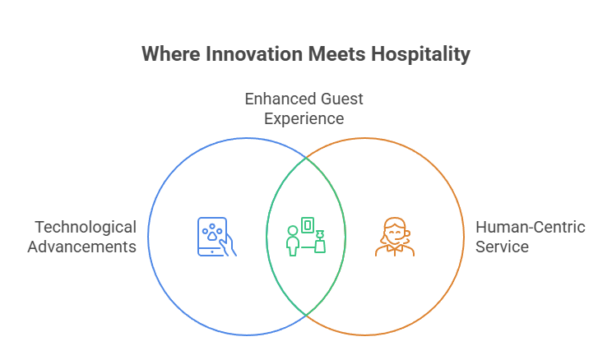
Figure 2: Trends in Front Office Work
Source: Self- created
There is also a change in what guests want. Many guests like to use mobile apps for check-in. They want fast and easy service. They also want contactless options to feel safe. However, not all guests like this. Some people still prefer to speak with a real person. This means front desk staff must be ready to offer both types of service (Tewan, 2009)
I think the front office will not disappear. Technology will help, but human help is still needed. During my placement, I saw how much guests liked polite and friendly service from real staff.
I read in an article by Thomas (2022) that hotels should train staff to use new systems. But they must also train staff to stay friendly. Another report by Green (2021) said hotels with both tech and personal service will do better in the future.
There are some pros and cons. A good thing is that technology saves time and helps reduce queues. It also helps staff manage work better. A bad thing is that not all guests understand the machines. Older guests or first-time visitors may feel confused or lost (Vallen and Valen, 2014).
I want to learn more about new systems. But I also want to keep giving good service to guests. This will help me in future hotel jobs.

Conclusion
This placement helped me grow in many ways. I learned how to speak with guests, use the hotel system, and stay calm when solving problems. I also saw how team leaders support the staff and manage daily tasks. I believe I met all three of my learning objectives. I improved my guest communication by speaking more clearly and politely. I learned how to use the front office system by practicing every day. I also handled guest problems better by staying calm and asking for help when needed. This shows that I am ready to keep growing in hotel work. I now feel more confident and more prepared for real hotel jobs. In the future, I want to work faster and solve more problems on my own. I will keep learning and improving. This placement gave me real skills that I will use as I move forward in hotel management.

References
- ASET (2017) Good Practice Guide for Workbased and Placement Learning in Higher Education. Sheffield: ASET.
- Bardi, J. (2010) Hotel Front Office Management. London: Wiley.
- Casado, M. (2012) Housekeeping Management. London: Wiley.
- Fallon, M. and Rutherford, D. (2010) Hotel Management and Operations. London: Wiley.
- Hagg, E. (2013) Internship Guide: Work Placements Step by Step. 5th Ed. The Hague: Eleven International Publishing.
- Johnston, R., Clark, G. and Shulver, M. (2012) Service Operations Management: Improving Service Delivery. 5th Ed. London: Pearson.
- Midwinter, R. and Dickson, J. (2015). Embedding Counselling and Communication
- QAA (2018) UK Quality Code, Advice and Guidance: Work-based Learning. London: QAA.
- Rughubalan, G. (2009) Hotel Housekeeping: Operations and Management. Oxford: Higher Education Press.
- Skills: A Relational Skills Model. Hove, East Sussex ; New York: Routledge.
- Tewan, J. (2009) Hotel Front Office: Operations and Management. Oxford: Higher Education Press.
- Vallen, G.K. and Valen, Jerome J. (2014) Check-In Check-Out: Managing Hotel Operations. 9th Ed. Harlow: Pearson Education Limited.
- Wood, R.C. (2013) Key Concepts in Hospitality Management. London: SAGE Publications Ltd.

