BA DEGREE ASSIGNMENT SPECIFICATION
SCHOOL OF INTERNATIONAL HOTEL MANAGEMENT
Student name: | Paraschiva Ramona Vrasneag | Student P number: | 2122736
Programmes: | BA International Hotel Management
Module: | Cultural Awareness | Module Level (4, 5,  6): | 5
Module code: | BMIH5003 | Contribution to  Overall  Module Assessment  (%): | 25%
Lecturer: | Rodrigo F. Aguilera | Internal Verifier: | Kathryn Roberts
Assignment  Title: | Hotel Handbook for  Intercultural Competence | Assignment No: | 2
Hand Out  Date: | September 2022 | Submission deadlines: Return date of provisional marks & written feedback: | 10th March 2023  By 23:59  By 17th April  2023

Table of Contents
Introduction 1
Cultural Intelligence and Sensitivity 4
Hofstede's Model: 4
Lewis Model: 5
Implications for Guests from India 5
Adaption of Services in Hotel Departments 5
Summary Table 6
Recommendations 7
Conclusion 8
References 9

Introduction
With millions of international visitors travelling for leisure or business in today's globalised world, the hospitality industry has become a significant contributor to the economy. The success of hotels is dependent on providing the best experience possible to all guests. Providing exceptional guest service, on the other hand, can be difficult, especially when dealing with people from different cultures. The assignment here is a report that aims to explore aspects related to cultural intelligence and sensitivity. It also deals with the application of relevant theories and implications of guest services in India.

Cultural Intelligence and Sensitivity
Hotel employees must be culturally aware and sensitive when dealing with guests from various cultural backgrounds. The ability to function and manage effectively in culturally diverse settings is referred to as cultural intelligence, whereas cultural sensitivity is the ability to recognise and adapt to cultural differences. Both of these abilities are essential for hotel employees who interact with guests from various cultural backgrounds. There are various departments in a hotel and each department must be culturally aware and sensitive to deliver the best services within the hospitality industry (Jandt, 2016).
Cultural intelligence and sensitivity, for example, will allow hotel staff to anticipate the needs and expectations of guests from various cultures, such as language barriers, dietary restrictions, and communication preferences. Furthermore, cultural sensitivity and intelligence will help hotel personnel recognise cultural nuances and norms, which may influence guests' behaviour and expectations, resulting in a more enjoyable and comfortable stay. From both examples, it can be understood that cultural intelligence and sensitivity is crucial for various segment of customer services within a hotel (Samovar, 2009).

Hofstede's Model:
Hofstede's cultural dimensions model provides a framework for understanding cultural differences. Six cultural dimensions are identified.
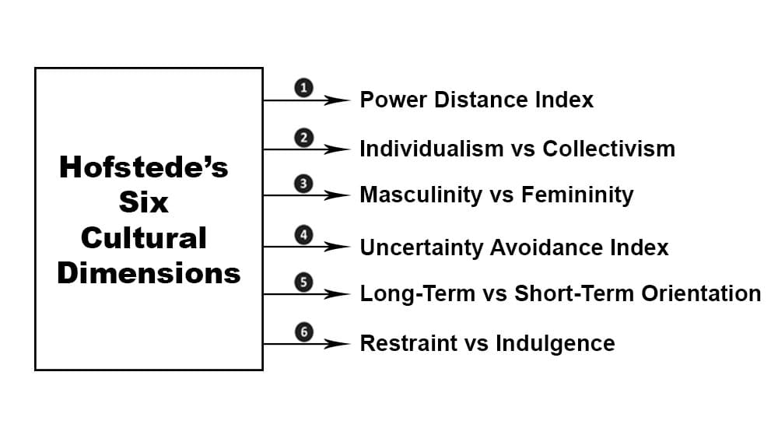
(Source: (Minkov and Kaasa, 2021)
According to Hofstede's model, people from different cultures have different attitudes, beliefs, and behaviours, which can influence their travel preferences and expectations. For example, India has a high power distance, which means that people expect a hierarchical structure and have a high regard for authority. As a result, hotel staff should treat guests with dignity, especially those who are older or in positions of authority. Also in India, people are polite and prideful which must be understood by the staff in order to deliver better services to an Indian citizen (Minkov and Kaasa, 2021).

Lewis Model:
The Lewis Model is a framework for analysing communication styles across cultures. It categorises cultures into three types: linear-active, multi-active, and reactive. People-oriented cultures, such as India and Brazil, value relationships and communication. According to the Lewis Model, communication styles differ across cultures, which can lead to misunderstandings and conflicts. To avoid misunderstandings, hotel personnel should adapt their communication style to the culture of their guests. Also, people-oriented culture means Indian people love being respected and treated well with suitable hospitality. Also, making effective relationships with the Indians can help staff to deliver better services to them (Jacobsen, 2016).

Implications for Guests from India
From the above evaluation, it can be noted that there are several implications for guests from India which must be complied with for delivering effective services within the hotel. One of the major aspects is to understand the cultural differences within the country because India has diverse languages, cultures, religions and customs. Understanding these differences will help in dealing with Indian guests. In order to greet, staff can prefer “Namaste” rather than a handshake or hug. Also, there are a lot of Indian citizens who prefer vegetarian food and a separate kitchen, which can add better value in terms of dealing with an Indian citizen. Also, Indian guests value personal space, and they may feel uncomfortable with close physical contact or invading their privacy (DeVotta et al., 2021). These are some crucial implications for guests from India.

(Source: DeVotta et al., 2021)

Adaption of Services in Hotel Departments
When it comes to Indian guests, hotels need to be aware of the following cultural norms and requirements to ensure they provide the best possible service:

Indian visitors are generally respectful of elders and appreciate being addressed by titles. As a result, front-desk personnel should be trained to address guests by their proper titles, such as "Sir" or "Madam." Many Indian guests may prefer spicy food because Indian cuisine is rich in spices and flavours. To meet their specific needs, hotels should consider having a separate menu or food station dedicated to Indian cuisine. Vegetarian food options would also be beneficial, as many Indians are vegetarians or adhere to dietary restrictions for religious reasons. Housekeeping may be more personalised for Indian visitors. Housekeeping staff can help by addressing them correctly and leaving extra amenities (Moran, 2018). Indian guests tend to value family time and often travel in groups. Concierge personnel can recommend family-friendly activities and arrange transportation for larger groups. In this way, it can be noted that several departments of a hotel can meet the specific cultural norms and requirements of an Indian citizen (Jacobsen, 2016).

Summary Table
Do's | Don'ts
- Address Indian guests by their proper titles such as "Sir" or "Madam". | - Avoid using slang or casual language while addressing Indian guests.
- Offer vegetarian food options or a separate menu for Indian cuisine | - Assume that all Indian guests eat spicy food or are vegetarians
- Recognize the diversity of Indian cultures, religions, and customs | - Assume that all Indian guests are the same or have similar preferences
- Be aware of the different communication styles across cultures and adapt accordingly | - Use a one-size-fits-all approach in communication with Indian guests
- Be polite and respectful to Indian guests, especially to those who are older or in positions of authority | - Disrespect or disregard the importance of hierarchy and authority in Indian culture
- Recommend family-friendly activities and arrange transportation for larger groups of Indian guests | - Assume that Indian guests are travelling alone or with small groups
- Personalize housekeeping services for Indian guests by addressing them correctly and leaving extra amenities | - Use a generic approach to housekeeping services for Indian guests
(Source: Jacobsen, 2016; DeVotta et al., 2021)

Recommendations

- It is recommended that the staff understand the cultural differences and treat every citizen according to their cultural backgrounds in India because many hotels fail in doing so because of the same treatment to each citizen from, diverse backgrounds of India (Timm, 2011).
- Staff should also value the power distance and people-oriented culture of people as Indians value elders and every single people are treated politely with a low voice tone (Timm, 2011).

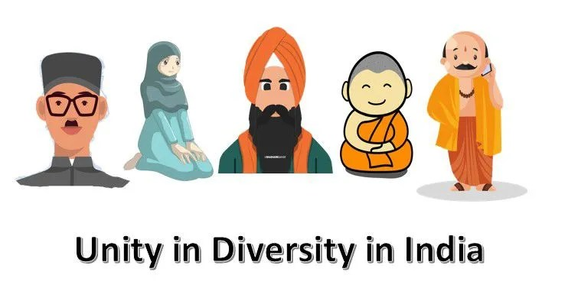
(Source: Jacobsen, 2016)

Conclusion
In conclusion, it can be noted that the hotel department has to comply with various norms and requirements of people from different cultural backgrounds. The assignment here is a report that explored the aspects related to guest services in relation to tourists from India. It covered the discussion on cultural awareness and sensitivity with the application of Hofstede’s and Lewis’s theory of cultural dimension.

References
Jandt, F (2016) An Introduction to Intercultural Communication, 8th edition, Sage: San Bernadino.
Moran, R. (2018) Managing Cultural Differences, 10th edition, Routledge: Abingdon.
Samovar, L. (2009) Communication Between Cultures, Wadsworth, London.
Timm, A. (2011) Intercultural Problems in the Tourism Industry, GRIN Verlag.
DeVotta, N., Hill, D., Ganguly, S., Cohen, B.B., Sridharan, E., Mukherji, R., Zarhani, S.H., Jaffrelot, C., Bauman, C.M., Embree, A.T. and Trivedi, L. (2021). Understanding Contemporary India. Lynne Rienner Publishers.
Jacobsen, K.A. (2016). Routledge handbook of contemporary India (p. 522). Taylor & Francis.
Minkov, M. and Kaasa, A. (2021). A test of Hofstede's model of culture following his own approach. Cross Cultural & Strategic Management, 28(2), pp.384-406.

