Session 2 booklet
The Apocolocyntosis
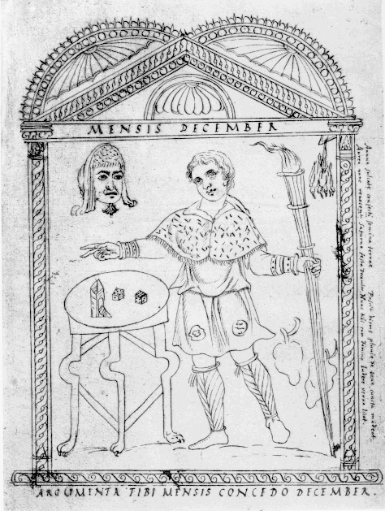

Depiction of man next to a table with Saturnalian dice and an oscillum, connected to the month of December (when the Saturnalia took place). From the Chronography of 354 by Filocalus (4th century AD). Copies of the original illustrations have survived in a 17th century manuscript from the Barberini collection (Vatican Library, cod. Barberini lat. 2154).

In this session we will examine the Apocolocyntosis (Pumpkinification or Gourdification) – a text attributed by many to Seneca. This short text is a savage lampoon of Claudius’ deification in which the gods, including Augustus, debate whether he should be allowed into heaven. A link is given below to the Loeb Classical library e-book collection where you can find a translation of this text (this link is also provided on Moodle). In addition, some optional modern scholarship is also available. Consider the questions set out below:

Questions:

1) Was hatred of Claudius the primary (or sole) motive for Seneca to write this text?

2) Who might have read this text and how widely may it have circulated?

3) What are the main points of debate between the Gods and why is Claudius rejected from Heaven?

4) In what capacity does Nero feature in this text and why?

5) Why might some scholars in the past have been reluctant to associate this work with Seneca?

Modern Scholarship (optional reading, link on Moodle):
Whitton, C. L. (2013) ‘Seneca, Apocolocyntosis’, in A Companion to the Neronian Age (Buckley, E. and Dinter, M. T. eds.), Wiley-Blackwell: 151-169.
Background Context

Cassius Dio – trans. from Cary (1925)
“The emperor [Claudius] received the state burial and all the other honours that had been accorded to Augustus. Agrippina and Nero pretended to grieve for the man whom they had killed, and elevated to heaven him whom they had carried out on a litter from the banquet. On this point Lucius Junius Gallius, the brother of Seneca, was the author of a very witty remark. Seneca himself had composed a work that he called "Pumpkinification" — a word formed on the analogy of "deification"; and his brother is credited with saying a great deal in one short sentence. Inasmuch as the public executioners were accustomed to drag the bodies of those executed in the prison to the Forum with large hooks, and from there hauled them to the river, he remarked that Claudius had been raised to heaven with a hook.
Nero, too, has left us a remark not unworthy of record. He declared mushrooms to be the food of the gods, since Claudius by means of the mushroom had become a god.” (60.35.2-4)

Tacitus Annals – trans. from J. Jackson (1937)
“Perturbed by her attitude [Agrippina’s threat to throw her support behind Britannicus], and faced with the approach of the day on which Britannicus completed his fourteenth year [that is he could put on the toga virilis and be classed as an adult citizen], Nero began to revolve, now his mother's proclivity to violence, now the character of his rival, — lately revealed by a test which, trivial as it was, had gained him wide sympathy. During the festivities of the Saturnalia, while his peers in age were varying their diversions by throwing dice for a king, the lot had fallen upon Nero. On the others he imposed various orders, not likely to put them to the blush: but, when he commanded Britannicus to rise, advance into the centre, and strike up a song — this, in the hope of turning into derision a boy who knew little of sober, much less of drunken, society — his victim firmly began a poem hinting at his expulsion from his father's house and throne. His bearing awoke a pity the more obvious that night and revelry had banished dissimulation. Nero, once aware of the feeling aroused, redoubled his hatred; and with Agrippina's threats becoming instant, as he had no grounds for a criminal charge against his brother and dared not openly order his execution, he tried secrecy and gave orders for poison to be prepared…” (13.15.1)

