

Assessment 1 – Reading Task Template
Upload your photo of your A3 in-class notes here:
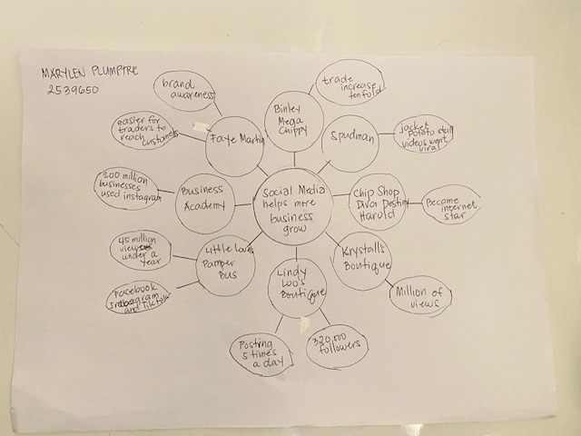

1. Answer these questions using the sentence starters below
a. What is the main idea of the text?
The main idea is that social media helps more businesses grow by promoting their business online in different social media platform like Facebook, TikTok and Instagram. At first, it may seem difficult to promote one’s business but through consistency and resilience you will get more customers or viewers and earn more profit
b. What are two key points?
One key point is the social media helps small businesses through exposure and awareness.
Another key point increases sales and profit margin.
c. What part of the text did you find most important? Why?
The most important part is the response on social media has honestly changed the business because many customers can create new sales leading to potential profit and create more loyal customers.
d. Was anything unclear or difficult to understand?
I was not sure about how they accumulate more viewers and followers in social media platform to grow the business.
e. How did your group help you understand the text better?

2. One sentence reflection
Question: What did you find challenging about this task?
The hardest part was to think of what kind of business that consumer’s demand globally and earning profit.

