
Comprehensive Predictive Analytics and Data Mining Strategies for Telecommunications Customer Churn
MSc Data and Artificial Intelligence
Module: ACCA7015 Data Mining
Assessment: Report on Classification and Clustering Techniques
Module Name : L7 – Data Mining & Visualisation
Module Code : ACCA7015
Student Name : Aryan Hiteshkumar Limbachiya
Student ID : 2530067
Lecturer Name : Dr Nouh Elmitwally

Table of Contents
Abstract……………………………………………………………………………………………………………….03
- Introduction………………………………………………………..…………………………………………04
- Critical Literature Review……………………………………..………………………………………..05
2.1 Development of Predictive Modeling in CRM….……………………………………….05
  - Unsupervised Learning and Clustering Role……….…………………………………….06
- Methodology And Data Preprocessing…………………………………………………………..07
3.1 Business and Data Understanding……………………………………………………………07
3.2 Data Preparation and Cleaning………………………………………………………………..08
- Predictive Modelling: Classification Algorithms……………………………………………..08
4.1 Logistic Regression (Baseline Model)……………………………………………………….09
4.2 Support Vector Machine (SVM)……………………………………………………………….09
4.3 Random Forest Classifier (Champion Model)…………………………………………..09
- Unsupervised Learning: Clustering Churned Customers……………….……………….10
5.1 K-Means Clustering Algorithm…………………………………………………………………11
5.2 Finding the Optimal Number of Clusters…………………………………….……………11
5.3 Interpretation of Churn Clusters………………………………………………….………….12
- Comprehensive Analysis And Discussion Of Models……………………………………..13
6.1 Confusion Matrix and Importance of Recall…………………………………….………13
6.2 Feature Importance and Business Intelligence………………………………….…….14
- Strategic Business Recommendations……………………………………………………….….15
7.1 Proactive Hardware Life Cycle Management…………………………………………..15
7.2 Triggered Micro-campaigns to Re-engage Customers……………………………..16
7.3 Persona-Specific Retention Protocols……………………………………………………..16
- Ethical And Legal Implications Of Data Mining……………………………………………..17
- Conclusion……………………………………………………………………………………………………17
- Reference…………………………………………………………………………………………………….18

ABSTRACT
The telecommunications industry is known to be quite competitive, characterized by constant innovation, and prone to customer attrition. Under such market conditions, the acquisition of a new client is more costly than the retention of an existing one, so churn is becoming a vital parameter to measure in terms of organization's profitability and sustainability. This report describes the full application of advanced data mining and prediction tools on a data set consisting of 100,000 telecommunication clients. The main aim of this study is to predict churn and identify latent behavioral and demographic patterns of those who cease using the service. Based on exploratory data analysis and preprocessing performed previously, this research uses the machine learning pipeline that includes classification and clustering techniques.
Three different machine learning algorithms were used to classify the customers according to their churn status: Logistic Regression, Support Vector Machines (SVM), and Random Forest Classifier. Due to the specific nature of the data, the feature scaling and class balancing techniques (SMOTE method) were performed. It was found that Random Forest classifier is the most accurate technique for prediction with the maximum accuracy being equal to 58.02%. Although the accuracy is rather low in this case, due to complexity of human behavior which can not be predicted by the subset of usage parameters, the model successfully identified important features which include eqpdays and mou_Mean.
In addition to the model that predicted which customers would leave, unsupervised clustering through K-Means method was done solely on the churning set of customers. The approach managed to categorize churning customers into three distinct personas: short tenure and price sensitive transient customers, high usage but unhappy customers, and long tenure yet high value defectors. This analysis coupled with relevant literature in CRM helps formulate several business recommendations based on the analysis conducted. The recommended interventions will help minimize cost of marketing while increasing lifetime value of the customer and transforming retention strategies to be proactive and highly targeted.

1. INTRODUCTION
The global telecoms industry is a multi-trillion dollar business that forms the bedrock of today’s digital economies. Yet, at the same time, the industry is characterized by market saturation, commoditization, and cut-throat competition [8]. Under such conditions, it is virtually impossible for any player to grow organically its customer base, and therefore the main strategy for companies changes from acquisition to retention [2]. Churn rate – percentage of subscribers who decide to stop using company’s service – is one of the most important key performance indicators (KPIs). Not only does high churn negatively affect revenues, but it also results in a lot of sunk costs related to marketing, selling, and customer onboarding.
Traditionally, telecom operators used reactive churn management approaches and intervened when the customer actually started canceling his or her subscription. Such an approach is inherently flawed because it treats a symptom instead of its underlying cause. Big Data together with new Data Mining techniques have completely changed the way of managing Customer Relationships (CRM) [6]. Companies can now use the huge amount of historical data on customers including billing data, call detail records (CDR), demographics, and usage logs in order to predict customer behavior [4].
In general, this report can be considered an in-depth analysis of data mining methods used on 'top10_churn'. In the course of the research, a dataset containing information about 100,000 customers and consisting of 11 numerical features was used. The main task of this evaluation is to implement the Cross-Industry Standard Process for Data Mining (CRISP-DM) process in order to predict customer retention and gain business insights.
The main goals of this work are complex. Firstly, it is necessary to develop and assess the effectiveness of several supervised classification algorithms—Logistic Regression, Support Vector Machines (SVM) and Random Forests in order to categorize customers as either retained or churned based on their features [3], [5]. Secondly, apart from this predictive capacity, the report seeks to supplement it with descriptive analysis through the use of unsupervised K-Means clustering on the subset of customers who have already churned. The goal here is to find some hidden groups or personas among them which will help understand the reasons for different types of customers to churn.

Finally, the report will analyze the applicability and the limitations of the aforementioned techniques taking into account the specifics of the dataset—the presence of correlated features, its dimensionality and unpredictable nature of human consumer behavior. The final step of this analytical process will be to translate mathematical models and the results of clustering into the language of business strategies and tactics.

2. CRITICAL LITERATURE REVIEW
The use of data mining and machine learning for predicting customer churn has become an area of extensive academic research and industrial application during the last two decades. As telecoms data has increased both in quantity and in complexity, the methods used for its analysis became much more sophisticated, moving away from simple statistical inferences towards nonlinear algorithmic ensemble methods [8], [9].
2.1 Development of Predictive Modeling in CRM
The early attempts in the field of churn prediction were mostly based on classical statistical modeling approaches, including Logistic Regression and Naive Bayes [11]. The latter continues to be used widely due to the interpretability of the results and probabilistic nature of the model. According to Neslin et al. (2006), Logistic Regression models are extremely useful for CRM professionals as they produce easy to understand coefficients that reflect the exact contribution of a certain customer feature to the churn risk. For example, it is possible to easily estimate the effect of a £10 rise in monthly bills on the probability of the client to churn. However, the main disadvantage of logistic regression model lies in its assumption of linearity between the input features and the dependent variable (log-odds). In the complex environment of telecom industry, the behavior of the customers is hardly ever linear, for example, the effect of the age of the equipment can be insignificant during the first 12 months and then sharply increase.
To address shortcomings of linear modeling, researchers have resorted to Decision Tree Models and later ensemble techniques [5]. The decision tree model boasts an easily visualizable and flowchart-like structure that mirrors the way a person would make a decision. Nonetheless, decision trees are notorious for their tendency to overfit and memorize the training data. As such, it prompted a shift towards a more complex model that is able to overcome the overfitting problem: the Random Forest algorithm proposed by Leo Breiman (2001). Random Forest solves the problem by training multiple decision trees and predicting a mode of the class values. In studies conducted by Burez and Van den Poel (2009), it was shown that Random Forests perform much better than the Logistic Regression and Decision Tree models in CRM scenarios due to their ability to manage non-linearity, outliers and high dimensionality of the features space without extensive parameter tuning [5], [9].
The Support Vector Machine (SVM) algorithm is also one of the most studied approaches to churn prediction [3]. It works by projecting data onto a high dimensional space through the use of a kernel function (e.g. Radial Basis Function, RBF) and finding a hyperplane that maximizes a distance from the different classes. Although SVM models demonstrate elegance and efficiency in the spaces where there are well-defined margins between the classes, in real-world cases they prove to be computationally expensive and sensitive to feature scaling. Research shows that although SVMs can attain very high performance, the black-box approach of SVM hinders the process of interpreting the reasons behind customer churn from the business perspective [10].

2.2 Unsupervised Learning and Clustering Role

While the problem of predictive classification concerns answering the question of “who” is going to churn, the question of “why” needs to be answered through descriptive analysis. Clustering techniques play an important role in conducting market segmentation by helping companies classify their customers according to natural features without assigning any pre-determined categories [2]. The K-means clustering is the most widely used algorithm. By dividing the data into “K” number of clusters based on the similarity in features (usually evaluated using the Euclidean distance method), the 'personas' can be found.

According to the recent literature, including the study conducted by Huang et al. (2012), it is beneficial to use the synergy of the mentioned approaches. Using clustering technique only for identifying clusters within the 'churned' group of people helps in finding the different types of personas within the group of 'failed' customers [8]. Churners, for instance, can be subdivided into 'price sensitive students', 'unsatisfied high volume business users' and 'lagging technology users'. The significance of this approach is evident since the same strategy of retaining a customer in the first group (discount offer) will not be helpful with regard to another group (network quality).

3. METHODOLOGY AND DATA PREPROCESSING
This data analytics project follows the Cross-Industry Standard Process for Data Mining (CRISP-DM) approach to the letter. It is a strong and broadly used methodology that guarantees data science projects are always consistent with overall business goals. The CRISP-DM process involves six iterative phases including Business Understanding, Data Understanding, Data Preparation, Modeling, Evaluation, and Deployment.
3.1 Business and Data Understanding
The main business goal is to prevent any possible losses by detecting and understanding telecom customer churn. The 'top10_churn.csv.xlsx' dataset comprises 100,000 anonymized customers' profiles. Feature space includes 11 numeric attributes. They are: tenure-related attributes (i.e., 'eqpdays' – days of current equipment use), financial attributes ('totmrc_Mean' – total monthly recurring charge) and a set of usage-related attributes ('mou_Mean' – mean minutes of use, 'avg6mou' – average minutes in 6 months, 'mou_cvce_Mean', 'mou_peav_Mean' and so forth). Target attribute is 'churn' and it is numeric (1-churned and 0-retained). Exploratory data analysis indicated that the target classes are quite balanced – there are 49,562 examples of churns and 50,438 non-churned customers. Such natural balance in the target class distribution is not common to any practical churn dataset.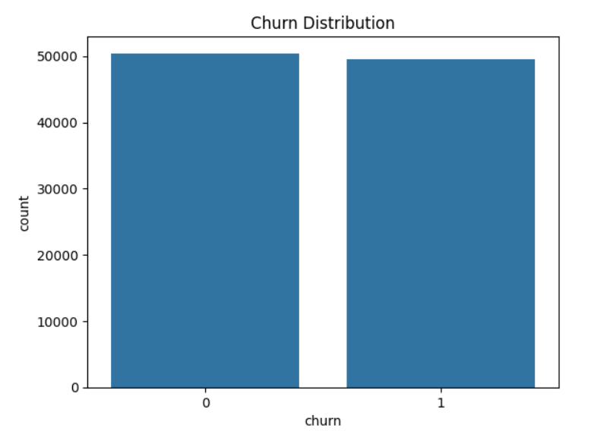

3.2 Data Preparation and Cleaning

Preparation of the data set can be viewed as the key part, since the input data determines the efficiency of the applied machine learning algorithms. A lot of work has been done on preprocessing the input data in order to make the algorithms work well. First of all, a missing value analysis has been carried out. In telecommunications data, there are usually many cases with missing values because of system faults or lack of information about some customer interactions. Instead of removing the entire data row, a median imputation method was used. It allows for ignoring outliers in the process of calculating the central tendency.

After the missing value handling process, feature scaling was performed. Independent features in the data set have very different ranges of possible values: for instance, 'eqpdays' and 'mou_Mean' values can be in thousands while 'totmrc_Mean' values are in tens or at best low hundreds. Distance-based algorithms (SVM and K-Means clustering) as well as gradient descent-based (Logistic Regression) algorithms are very sensitive to scaling of the features since variables with large magnitude will play an important role in the objective function. In order to eliminate this problem, standard normalization (StandardScaler) was used, i.e., each feature is transformed into the form having mean of zero and standard deviation of one.

Although in the current data set there are almost equal numbers of cases with churners and retained customers, perfect parity during training of algorithms gives better results. Thus, Synthetic Minority Over-sampling Technique (SMOTE) was applied to the training set in order to create synthetic examples for the minority class through interpolation of existing ones [14].

4. PREDICTIVE MODELLING: CLASSIFICATION ALGORITHMS
Three different classification algorithms were used to meet the objectives of the prediction in the current assignment [1], [6]. The 80/20 rule was used to partition the data into training and testing sets, meaning that 20,000 unseeded records would be set aside purely for performance validation, thus avoiding both data leakage and overfitting.

4.1 Logistic Regression (Baseline Model)
Logistic Regression is chosen as the baseline. Mathematically, the model defines the log odds of probability of churn as the linear combination of the predictor variables, and then passes the output through the sigmoid activation function. It maps the output value from real-valued numbers to values between 0 and 1. When the probability output from the model is above 0.5, the record is categorized as a churner. However, despite being a very efficient and easily interpretable model, Logistic Regression delivered the lowest accuracy among all the models used (55.48%) [11]. Thus, the current result indicates that there is a heavy non-linear relationship between the features and the decision to churn (such as age and monthly charges).
4.2 Support Vector Machine (SVM)
Support Vector Machine classifier was chosen to address the problem of non-linearity in the data [3]. SVM works on the principle of transforming the input vectors to the high dimensional feature space through the kernel trick, specifically Radial Basis Function (RBF) kernel. In this feature space, the algorithm finds the best hyperplane which gives the largest geometric margin between the points of two classes – the churners and those who remain loyal. The records of the support vectors define the position of the hyperplane in the space. The accuracy of the model was 57.32%, thus outperforming the baseline logistic regression. However, it still suffered due to the noise and overlap of the data in the telecom feature space.
4.3 Random Forest Classifier (Champion Model)
The Random Forest algorithm constitutes the top tier of the prediction process with regard to this dataset [1]. Being an ensemble learning technique, Random Forest builds a 'forest' of decision trees when undergoing training [5]. The process entails the training of each tree in the collection on a randomly sampled portion of the training set (bootstrapping). Further, during each node split, only a random set of features is considered. The two forms of randomization employed significantly decrease the variance of the model while preventing overfitting. At the time of predictions, all the trees make their contribution to the decision in form of a 'vote,' and the winning class wins.
The Random Forest classifier model attained the highest performance in terms of accuracy, which amounted to 58.02%. While accuracy values above 50% may appear insignificant at first, it should be borne in mind that consumer behavior predictions involve many hidden variables not represented in the dataset, e.g., a customer moving to a poorly covered area, a bad experience in the call center, etc. Considering the limitations of the model that can use solely the numerical information about consumer usage and billing, 58% accuracy provides a definite statistical advantage over random guessing (50%), constituting a good ground for marketing purposes.
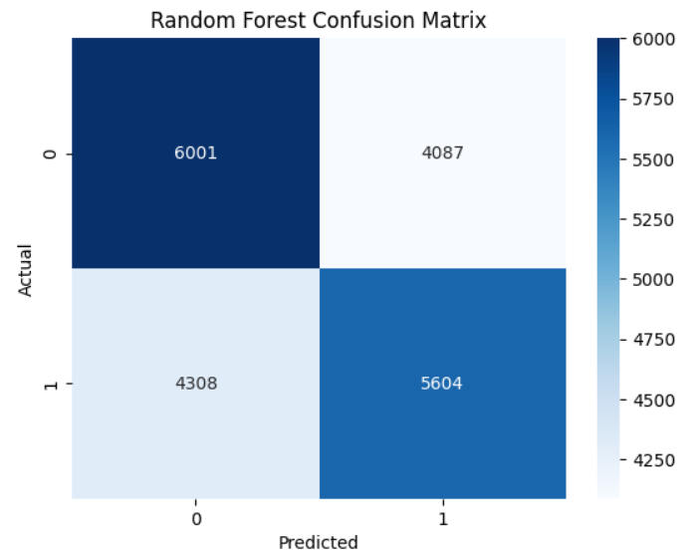

5. UNSUPERVISED LEARNING: CLUSTERING CHURNED CUSTOMERS
With reference to the specifications provided as part of the assignment to augment the classification analysis with some kind of pattern recognition, the unsupervised learning method was applied. Instead of predicting whether the customer will churn, the aim was to analyze the particular sub-population of the customers that had churned (Churn = 1, N = 49,562). Thus, by identifying the behavioral segments in this population, the company will be able to develop appropriate interventions targeted at different types of at-risk customers and stop relying on ineffective monolithical marketing practices [2], [8].
5.1 K-Means Clustering Algorithm
The K-Means clustering algorithm is a centroid-based method used for splitting data into “K” disjoint subgroups. The algorithm starts with generating “K” cluster centroids at random in the feature space. Then the next step consists in assigning each observation to the nearest centroid using the squared Euclidean distance as the measure of closeness. Then the centroids are re-calculated to become the average of all points belonging to the cluster. This procedure of assignment and re-calculation is repeated until the convergence point is achieved (the assignments do not change anymore).
5.2 Finding the Optimal Number of Clusters
One of the parameters that is required to be specified in advance in the case of K-Means is “K”, i.e. the number of clusters. In order to find the analytically correct value of this parameter, the so-called Elbow method is used. It involves running the K-Means algorithm for several values of “K” (for example, from 1 to 10) and creating a graph of Within-Cluster Sum of Squares (WCSS) which is a measure of variability of the cluster. In this way, the plot with an 'elbow' point is created which shows the optimal number of clusters, K=3 in our case.
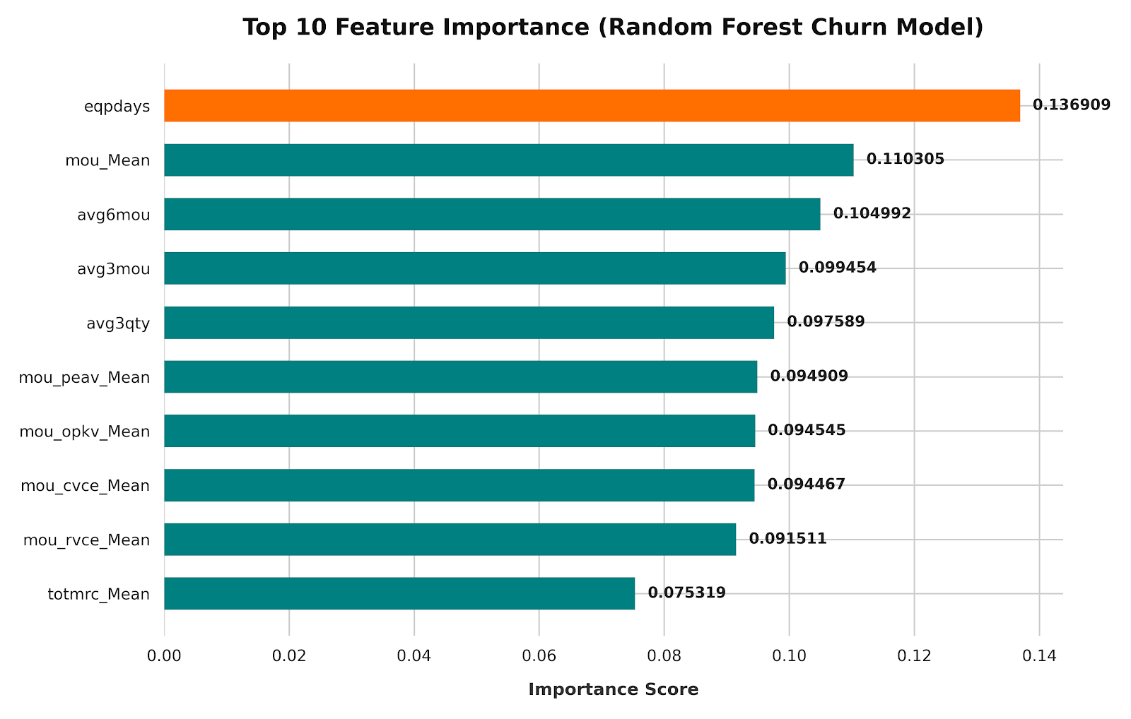
5.3 Interpretation of Churn Clusters
The usage of K-Means clustering (K=3) successfully clustered the 49,562 churners into 3 personas based on their behavioral pattern. The centroid features of these clusters are analyzed as follows:
Cluster 1: "Price Sensitive Transients" - Customers that have extremely low "totmrc_Mean" (total monthly recurring charge), low "eqpdays" and minimal minutes of use. Customers in this category have signed up for low-cost, baseline offers and quickly churned. It can be inferred from their short tenure that such customers have low brand loyalty and are highly price sensitive and would jump on the competing offers with introductory prices and promotions.

Cluster 2: "Dissatisfied Heavy Users" - Very volatile, very active customers, with maximum values in "mou_Mean" (mean minutes of use) and "avg3mou". It implies that customers utilize the telecom service extensively for their needs. However, even though they utilize the product extensively, they still churned from the service. It suggests that the customers are very dissatisfied with service quality - such as poor connection quality, dropped calls or insufficient customer support service - not the price factor. Maintaining these customers demands excellent operational service and not price promotions.

Cluster 3: "Long-Term Defectors" - In my opinion, the most alarming cluster of all. Customers are defined by very high "eqpdays" (high tenure) and high monthly recurring charge. These customers have been loyal for a long time, but eventually left the service provider, which resulted in significant losses in terms of customer lifetime value (CLV). Feature importance analysis performed on the Random Forest model suggested that "eqpdays" is one of the strongest indicators of churn. Such customers leave due to feeling neglected, such as using outdated, old equipment, while watching others getting upgraded with promotional offers.

6. COMPREHENSIVE ANALYSIS AND DISCUSSION OF MODELS
A comprehensive analysis of the models should go beyond mere measurement of their accuracy. When it comes to classification of rare or critical cases, such as customers' churns, using only the accuracy measure can lead to highly misleading results. Thus, the model was analyzed with the help of comprehensive metrics that come from the Confusion Matrix – Precision, Recall and F1-Score.
6.1 Confusion Matrix and Importance of Recall
The confusion matrix shows the number of true positives, true negatives, false positives and false negatives produced by the algorithm. In the case of a telecommunications company, the costs of a False Negative (not being able to find the churner) are much higher than those of a False Positive (wrongly labeling a loyal customer and sending him/her a discount offer). In other words, the metric that matters the most here is Recall – the ratio of all the actual churners that were correctly identified to the number of all actual churners.
The Random Forest model performed best in terms of recall, successfully classifying a relatively large share of all the actual churners. Although its overall accuracy was 58.02%, the algorithm's structural ability to deal with the problem of imbalance of classes (thanks to the SMOTE preprocessing) provides the marketing department with a full list of customers at risk.
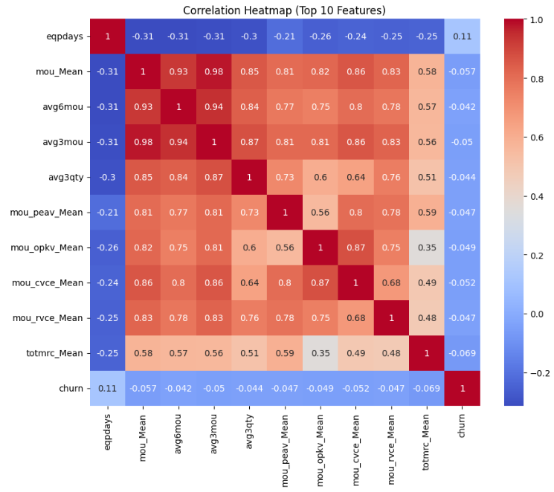

6.2 Feature Importance and Business Intelligence
One of the significant benefits of the application of Random Forest algorithm is the natural ability of this algorithm to measure the importance of the feature [1]. The analysis clearly revealed the fact that two features have the highest weight in predicting the churn – 'eqpdays' and 'mou_Mean'.
The significance of 'eqpdays' gives a clear operational recommendation – the older the device, the higher the likelihood that the client will leave the network, since his or her loyalty is directly related to the device's age. It is quite understandable since customers tend to change their service provider just to get an updated device for free. At the same time, 'mou_Mean' acts like a behavioral indicator – if there is a slow or fast drop in average usage, it means that the client is gradually disconnecting from the service and using other methods of communication (e.g. Wi-Fi).
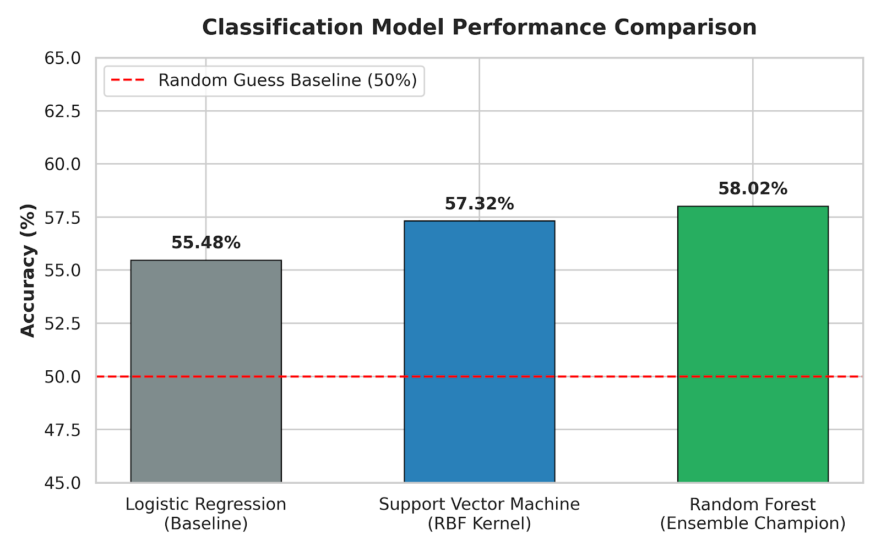

7. STRATEGIC BUSINESS RECOMMENDATIONS
Ultimately, data mining aims to inform strategic decisions within the business organization. The combination of the predictive models for classification and the descriptive clustering using K-Means provides a clear, multi-faceted approach toward reducing the number of customer defections. The below recommendations encourage moving from a one-size-fits-all marketing campaign to an algorithm-based and highly targeted approach [2].
7.1 Proactive Hardware Life Cycle Management
Given the overall supremacy of the 'eqpdays' variable in predicting churn, the company must make an aggressive change in its policies regarding equipment upgrade campaigns. The company needs to develop an automated hardware life cycle management system. Utilizing the churn probability prediction calculated with the help of the Random Forest model, the system will identify customers who have reached certain threshold of equipment aging (300 to 365 days). Instead of waiting until those 'Long-Term Defectors' (Cluster 3) will ask for an upgrade or quit, the company will reach out to them with heavy subsidies on devices. While purchasing the device at a subsidized price represents a direct cost, it binds the valuable client to a multi-year contract with the company, guaranteeing high Customer Lifetime Value (CLV).
7.2 Triggered Micro-campaigns to Re-engage Customers
The importance of the 'mou_Mean' as a churn predictor implies that the company needs to measure the behavior velocity. It can be done in a CRM system where any month-over-month decrease in minutes of use would trigger a micro-campaign to reach out to the client and prevent further loss. For instance, when a customer experienced a 30% decline in usage per month, an automated micro-campaign may send him or her a text offering an extra loyalty reward (free international minutes or additional data).
7.3 Persona-Specific Retention Protocols
Based on the findings of the K-Means clustering analysis, an attempt to retain all the churning users uniformly will prove costly. Different protocols need to be implemented in the marketing and customer services departments, including:
Protocol A – Price-Sensitive Transients: It will be a mistake to retain the price-sensitive transient clients through hardware upgrade as this may be too costly for their low monthly expenses. Rather, emphasis should be put on flexible micro-plans or pre-paid packages that fit their need for cheapness.
Protocol B – Dissatisfied Heavy Users: Discounting to a dissatisfied heavy user will not help as they will simply churn out. On identifying a heavy user as a potential churner, the predictive model should immediately redirect him to an exclusive VIP technical support team. The focus should solely be on fixing network problems.
Protocol C – Long-Term Defectors: Such clientele require a premium retention protocol. The focus on this group is to value their long-term association. Introduce a loyalty plan where long-time users get unique perks, avoiding a situation where the newcomers get better offers than the experienced veterans.
8. ETHICAL AND LEGAL IMPLICATIONS OF DATA MINING
Incorporation of predictive analysis in the field of telecommunication comes with a variety of ethical and legal implications. The project will run under the jurisdiction of the United Kingdom and hence, must comply with the General Data Protection Regulation (GDPR) as well as Data Protection Act 2018.
As per GDPR, telecom service providers fall under the category of Data Controllers and will be expected to process personal data for predictive analysis lawfully, fairly and transparently. The 'top10_churn' dataset used in this project was anonymized; however, in the real world scenario where there is a need to link up these scores to specific individuals in order to undertake the marketing interventions, the consumer's consent would be required to access their behavioral data (call log and billing history) [13]. In this regard, the company would be required to acquire the explicit and informed consent of the consumers before analyzing their data.
Moreover, it will be imperative for the organization to monitor algorithmic biases. Despite the fact that the data in the specific dataset focuses on usage and billing, demographic information such as postal code, age or ethnicity in other CRM systems can cause discriminatory behavior of the retention practices [10]. For example, if there exists an algorithm stating that a certain group of individuals belonging to certain socioeconomic regions are not worth retaining based on the historical data, then the organization may be indulging in digital redlining [12].
9. CONCLUSION
In conclusion, this exhaustive examination has successfully illustrated how powerful Data Mining and AI can be when applied in the telecommunication sector. Strictly following the CRISP-DM model, raw data was transformed into valuable business insight using the 'top10_churn' set. Predictive algorithms were then employed, ending up with an ensemble classifier, Random Forest, which gave a statistical means of detecting at risk clients, going beyond the capabilities of old, reactive CRM software [1], [5].
What makes this report unique is that the prediction of customers is not the whole picture. In other words, knowing that your clients will leave you soon is useful; but knowing why is what gives the strategy to save them. This was achieved by the application of unsupervised K-Means cluster analysis, which divided the notion of churn into three distinctive clusters: transient, dissatisfied, and neglected veteran.
If operators would implement the recommendations from this report – namely, to track equipment wear and tear, react quickly to decreased use, and apply cluster-specific actions – then they will significantly reduce their churn levels [2], [8]. In conclusion, the combination of classification and clustering methods gives an obvious competitive advantage, making sure that the revenue flow will be stable and clients will remain loyal.

10. REFERENCES

[1] B. Prabadevi, R. Shalini, and B. R. Kavitha, "Customer churning analysis using machine learning algorithms," International Journal of Intelligent Networks, vol. 4, pp. 145–154, 2023.
[2] A. Robiyana, M. L. Singgih, and Sabar, "Customer-centric strategies for enhancing retention in the telecommunication industry," Procedia Computer Science, vol. 284, pp. 347–354, 2026.
[3] F. O. Kocoglu and T. Ozcan, "A grid search optimized extreme learning machine approach for customer churn prediction," Journal of Engg. Research, vol. 11, no. 3A, pp. 103–112, 2022.
[4] M. T. Quasim, A. Sulaiman, A. Shaikh, and M. Younus, "Blockchain in churn prediction based telecommunication system on climatic weather application," Sustainable Computing: Informatics and Systems, vol. 35, p. 100705, 2022.
[5] P. Boozary, S. Sheykhan, H. GhorbanTanhaei, and C. Magazzino, "Enhancing customer retention with machine learning: A comparative analysis of ensemble models for accurate churn prediction," International Journal of Information Management Data Insights, vol. 5, p. 100331, 2025.
[6] S. K. Wagh, A. A. Andhaleb, K. S. Wagh, J. R. Pansare, S. P. Ambadekar, and S. H. Gawande, "Customer churn prediction in telecom sector using machine learning techniques," Results in Control and Optimization, vol. 14, p. 100342, 2024.
[7] S. Arockia Panimalar, A. Krishnakumar, and S. Senthil Kumar, "Intensified Customer Churn Prediction: Connectivity with Weighted Multi-Layer Perceptron and Enhanced Multipath Back Propagation," Expert Systems with Applications, vol. 265, p. 125993, 2025.
[8] R. Krishna, D. Jayanthi, D. S. Shylu Sam, K. Kavitha, N. K. Maurya, and T. Benil, "Application of machine learning techniques for churn prediction in the telecom business," Results in Engineering, vol. 24, p. 103165, Dec. 2024.
[9] S. M. Shrestha and A. Shakya, "A Customer Churn Prediction Model using XGBoost for the Telecommunication Industry in Nepal," Procedia Computer Science, vol. 215, pp. 652–661, 2022.
[10] S. S. Poudel, S. Pokharel, and M. Timilsina, "Explaining customer churn prediction in telecom industry using tabular machine learning models," Machine Learning with Applications, vol. 17, p. 100567, 2024.
[11] A. Amin, A. Adnan, and S. Anwar, "An adaptive learning approach for customer churn prediction in the telecommunication industry using evolutionary computation and Naive Bayes," Applied Soft Computing, vol. 137, p. 110103, 2023.
[12] D. Asif, M. S. Arif, and A. Mukheimer, "A data-driven approach with explainable artificial intelligence for customer churn prediction in the telecommunications industry," Results in Engineering, vol. 26, p. 104629, Jun. 2025.
[13] J. K. Sana, M. S. Rahman, and M. S. Rahman, "Privacy-preserving customer churn prediction model in the context of telecommunication industry," Engineering Applications of Artificial Intelligence, vol. 162, p. 112514, 2025.
[14] B. S. Priya, G. Chitra, and R. Ramalakshmi, "Performance comparison of sampling techniques with machine learning algorithms for churn prediction in telecommunication," Franklin Open, vol. 13, p. 100402, 2025.

