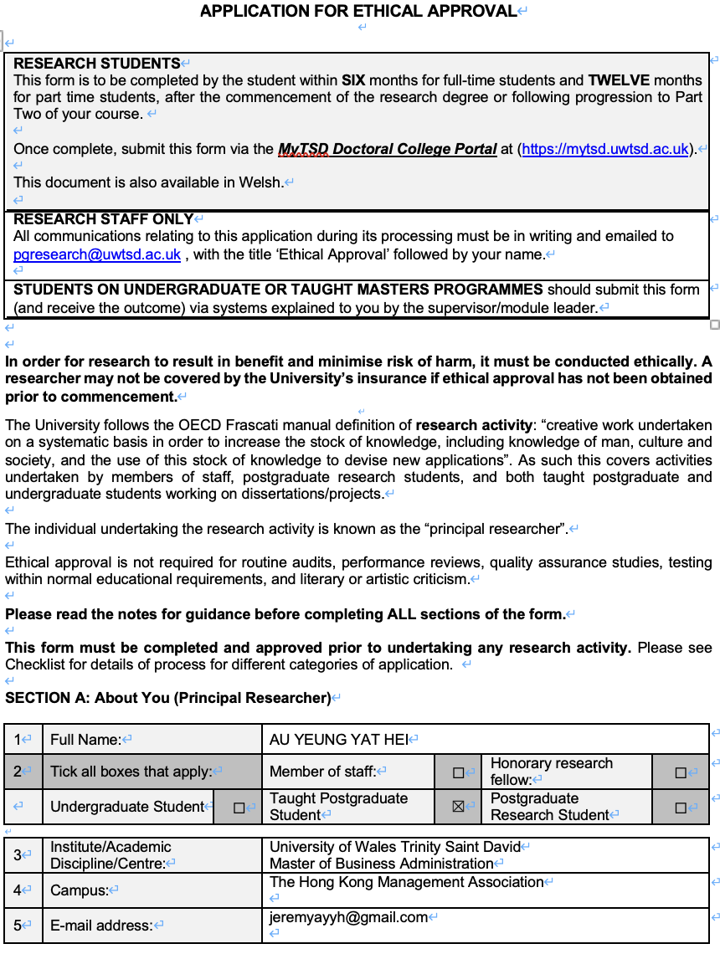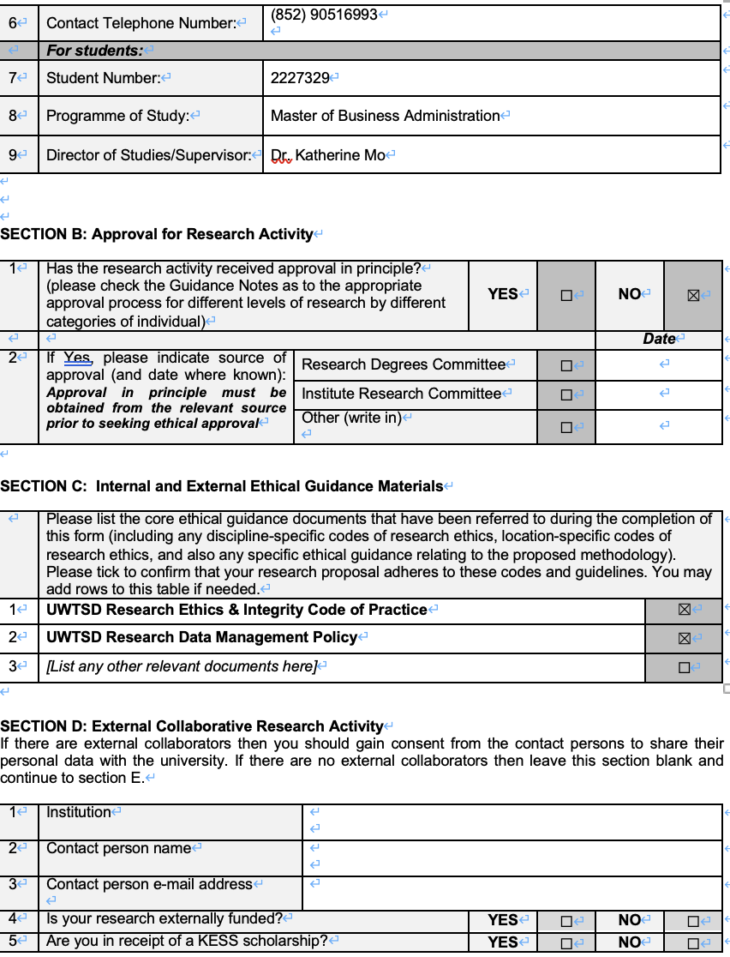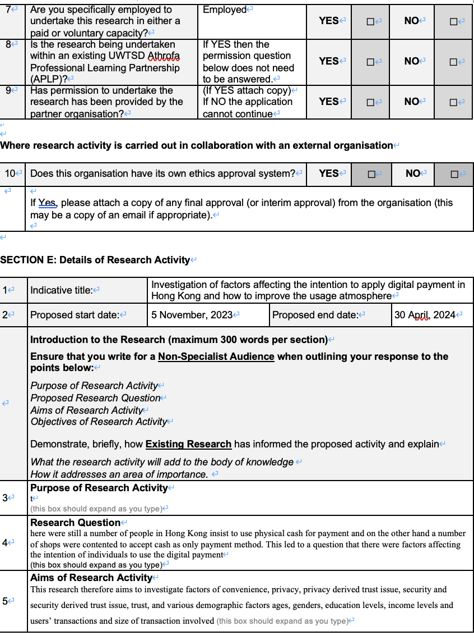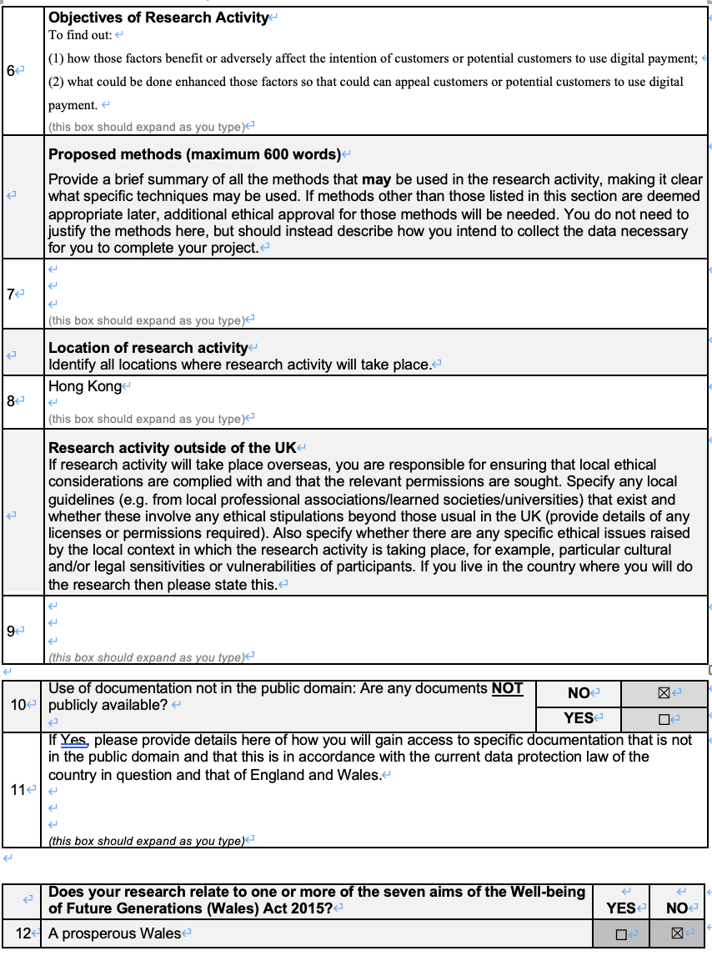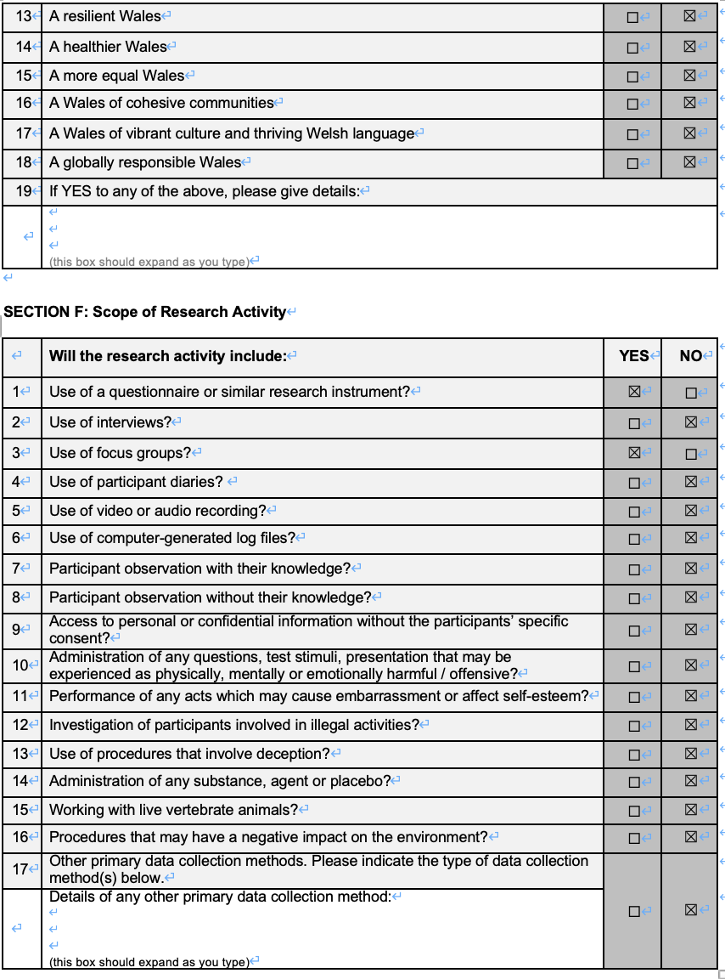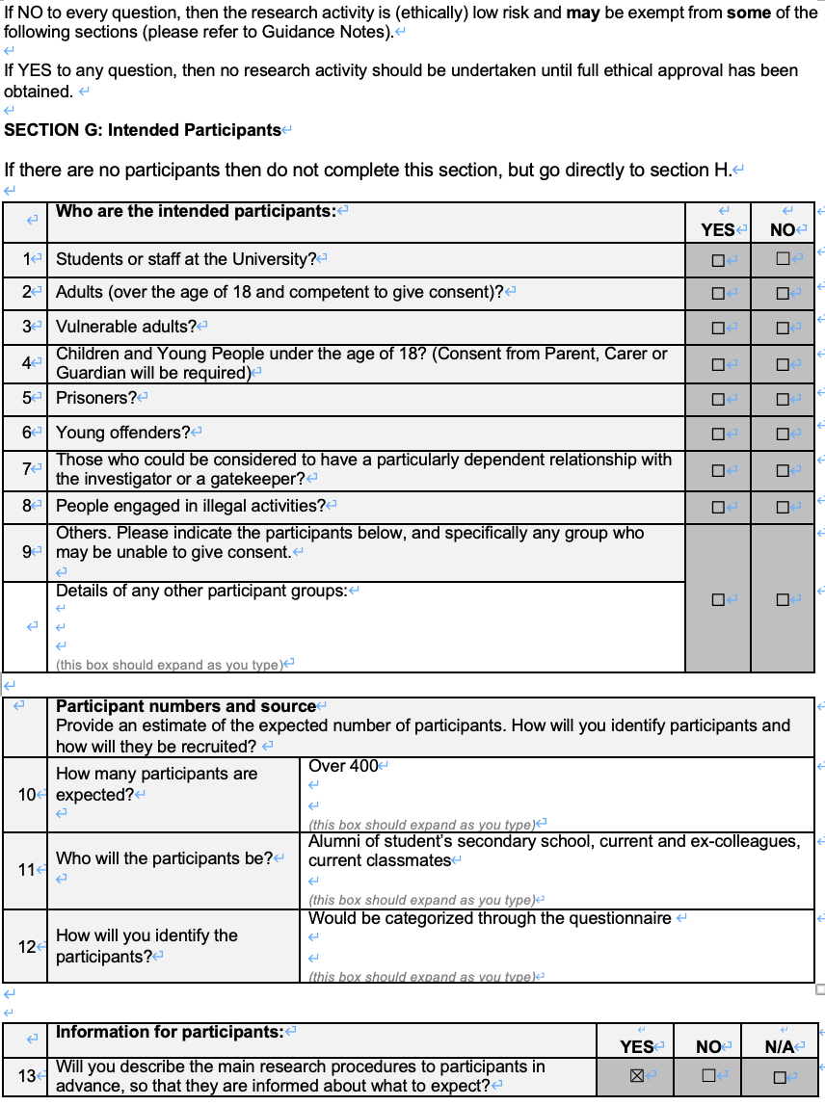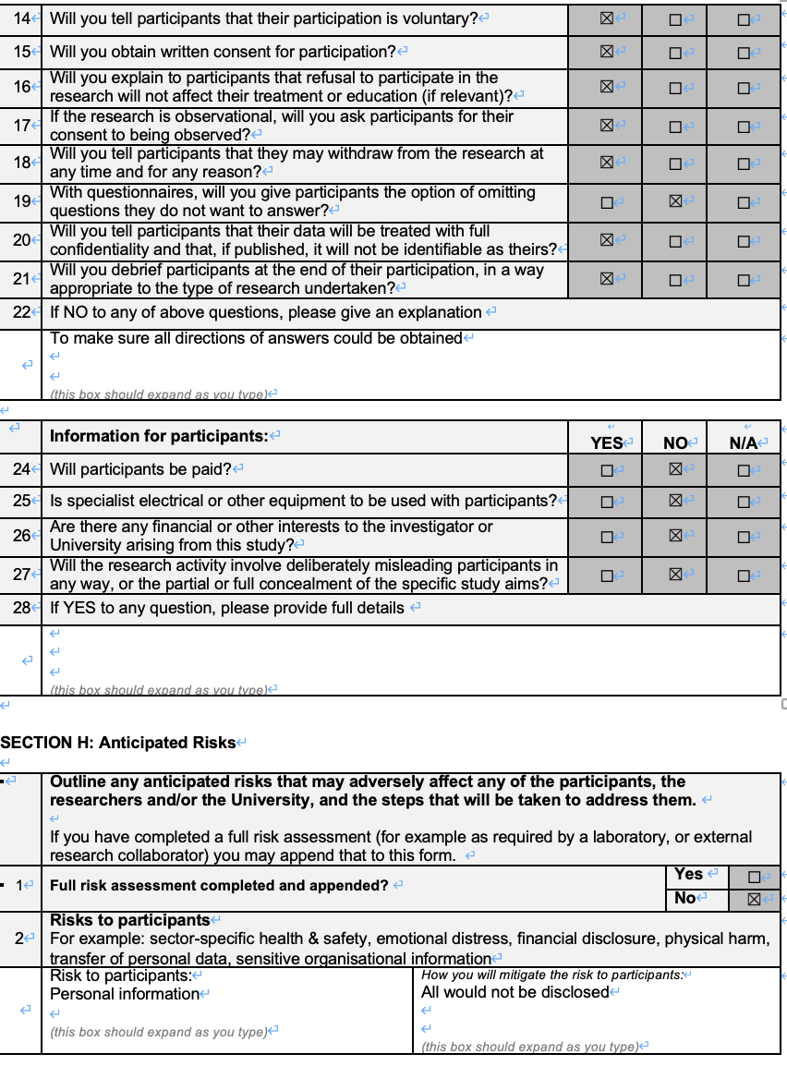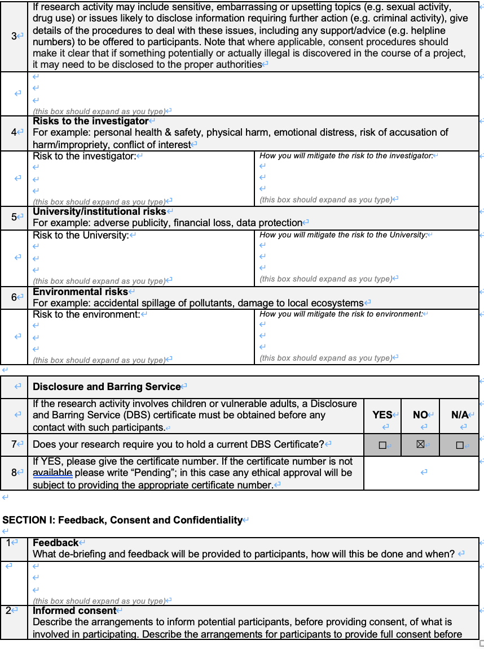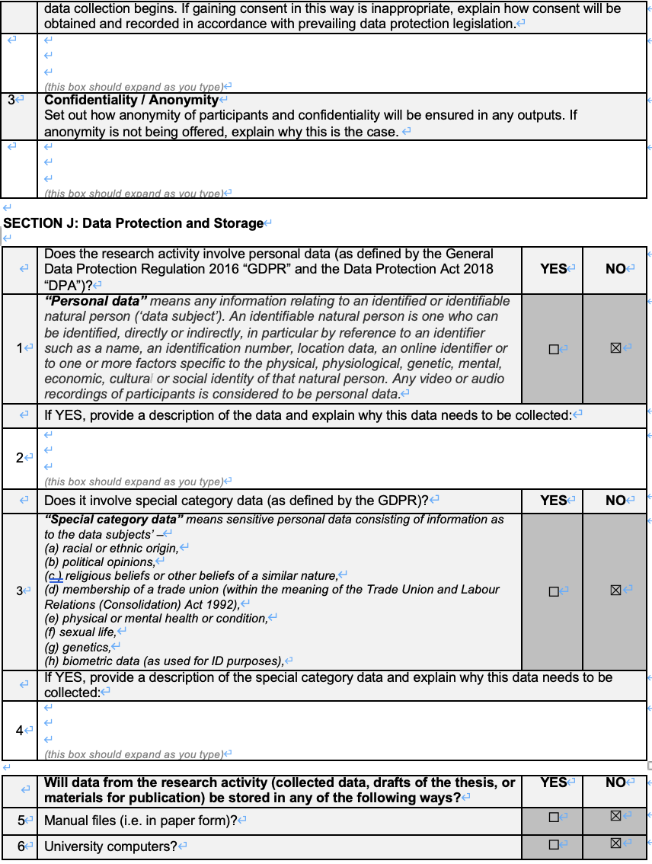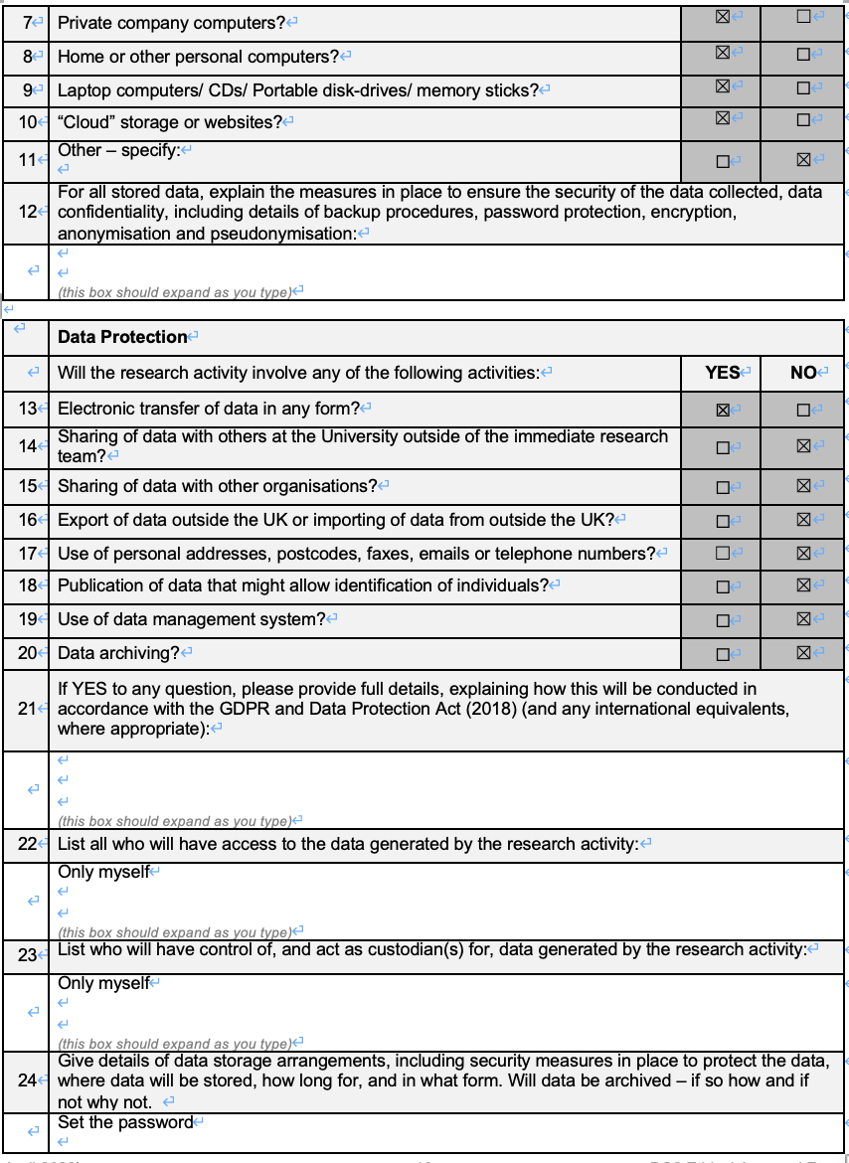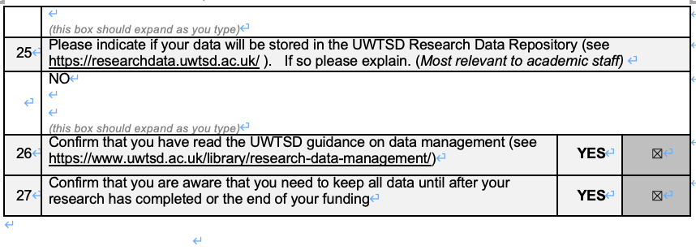

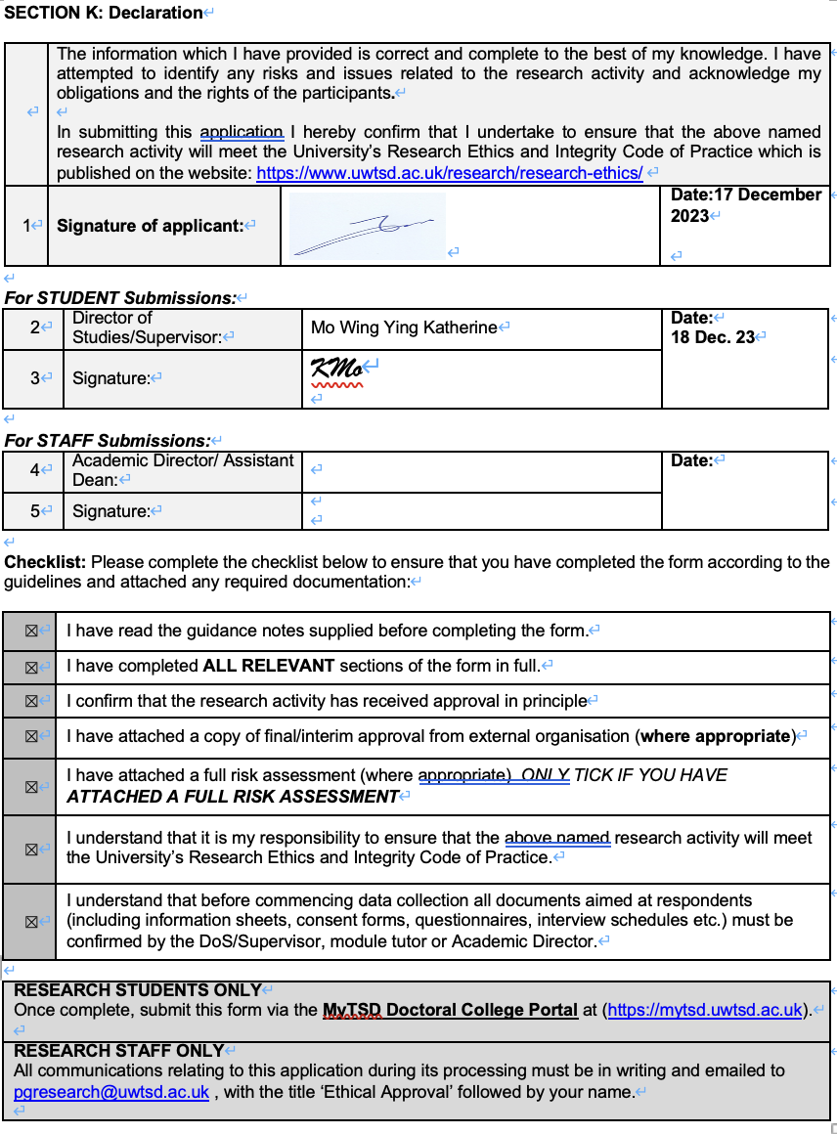
Table of Contents

 |  |  |  | Page
1 | Introduction |  |  | 1
 | 1.1 | Research background |  | 1
 | 1.2 | Research motivation, |  | 2
 | 1.3 | Research questions/problems |  | 3
 | 1.4 | Research aims and objectives |  | 3
 |  | 1.4.1 Research aims |  | 3
 |  | 1.4.2 Research objectives |  | 4
 | 1.5 | Summary |  | 4
2 | Literature Review |  |  | 6
 | 2.1 |  | Convenience | 6
 |  |  | 2.1.1 Definition | 6
 |  |  | 2.1.2 Construct and Measurement | 6
 | 2.2 |  | Security | 7
 |  |  | 2.2.1 Definition | 7
 |  |  | 2.2.2 Construct and Measurement | 7
 | 2.3 |  | Privacy | 8
 |  |  | 2.3.1 Definition | 8
 |  |  | 2.3.2 Construct and Measurement | 8
 | 2.4 |  | Trust | 10
 |  |  | 2.4.1 Definition | 10
 |  |  | 2.4.2 Construct and Measurement | 10
 | 2.5 |  | Customer Characteristic | 11
 |  |  | 2.5.1 Definition | 11
 | 2.6 |  | Relationship | 11
 |  |  | 2.6.1 Definition | 11
 |  |  | 2.6.2 Between Trust and Security (H2) | 12
 |  |  | 2.6.3 Between Privacy and trust (H3) | 13
 |  |  | 2.6.4 Construct and measurement | 15
3 | Research Methodology |  |  | 16
 | 3.1 |  | Research model with hypotheses | 16
 | 3.2 |  | Triangulation | 17
 | 3.3 |  | Qualitative and Quantitative research | 18
 | 3.4 |  | Focus group | 19
 | 3.5 |  | Quantitative survey methodology | 20
 | 3.6 |  | Target population | 21
 | 3.7 |  | Sampling method | 21
 | 3.8 |  | Sample size | 21
 | 3.9 |  | Data Analysis technique | 22
 | 3.10 |  | Research Method limitations | 23
 | 3.11 |  | Research Ethics | 23
 |  |  | Reference | 24

Chapter 1
Introduction

1.1 Research Background
Digital payment (Khaitan and Joshi, 2023) is not a new innovation in Hong Kong had been common in Hong Kong and is not difficult to notice that people in Hong Kong played majority means of payment method the Covid-19 pandemic (“The pandemic”).
Digital payment Mobile Payment Applications (“Apps”) such as Apple Pay, Google Pay, Samsung Pay, and local options like Tap & Go, AlipayHK, and WeChat Pay; besides, QR Code Payments that customers could use the smartphone mobile payment Apps to scan the QR code for the contactless payment; Online Payment Platforms under E-commerce with online payment platforms like PayPal, Stripe, and local options such as PayMe and Faster Payment System(“FPS”); Contactless credit/debit cards nowadays are as bread and butter in Hong Kong; other means of digital payments in Hong Kong has been enable fund transfers and payments between individuals and business counterparties easily, such as Octopus, EPS (Easy Payment System), and the aforementioned FPS.

Figure 1.1 Value of cashless payments in Hong Kong (HKD billion)

Source: BIS, (2023), graph constructed by author

1.2 Research Motivation
The pandemic has made significant impact on non-cash payments such as paper cash, credit and debit card and cheque payment (BIS, 2021), total value of non- paper based and digital credit card transactions had been growing drastically in both all economies. Nowadays, non-physical shopping experience online shopping would be in favor in certain gender and other demographic factors such as education levels, individual’s income levels, employment, and contactless device such as smartphone ownership, and internet knowledge, would be significantly contributed to individuals’ intention to use digital payment. Apart from demographic factors mentioned above, individuals’ intention to use digital payment would be affected by the “external” factors such as conveniences of the digital payment against cash-payment methodology, macroeconomic, regulatory of the local government, cultural, and digital infrastructural readiness differences between countries. Overall, the findings provide support for evidence-based decision making by all digital payment ecosystem stakeholders.

1.3 Research questions/problems
Hong Kong is a modern city and daily transactions could be done by non-cash digital payments. People only need to use the digital payment system mentioned in section 1.1 and no cash form of money would be taken out from customers’ pocket (Khaitan and Joshi, 2023), it seemed safe and efficient as nobody would access physical cash However, by observing, it is not difficult to notice that there were still a number of people in Hong Kong insist to use physical cash for payment and on the other hand a number of shops were contented to accept cash as only payment method. This led to a question that there were factors affecting the intention of individuals to use the digital payment for transactions including convenience, privacy, privacy derived trust issue, , security and security derived trust issue, trust, and other demographic factors (Sahi et al, 2021) such as ages, genders, education levels, income levels and users’ transactions and size(or amount) of transaction involved.

1.4 Research aims and objectives
1.4.1 Research aims
From the figure1.1 the total value of cashless transaction upto year 2021 was 1,395 billion Hong Kong dollar, 20% more than that in year 2020 and just 6% more than that in year 2019, although there was a significant increment in e-money payment by 68% to 373 billion Hong Kong dollar (BIS, 2023).
This research therefore aims to investigate factors of convenience, privacy, privacy derived trust issue, security and security derived trust issue, trust, and various demographic factors ages, genders, education levels, income levels and users’ transactions and size of transaction involved in order to find out:
(1) how those factors benefit or adversely affect the intention of customers or potential customers to use digital payment;
(2) what could be done enhanced those factors so that could can appeal customers or potential customers to use digital payment.

1.4.2 Research objectives
For the objectives, after conducting the analysis and finally come up the recommendations for improving individuals’ intention to use digital payment, the recommendations would be delivered to the institutional organizations or financial services providers which could have more power to implement relevant policies or take relevant actions based on the recommendations and conclusions.

1.5 Summary
Taking into account the past considerations, we define the introduction including the background, aim of research, objectives of research and the limitations of background. This research structured as follows (Figure 1.2).

Figure 1.2 The Flow Chart of the Research

Source: constructed by author

Chapter 2
Literature Review
In this chapter, the hypotheses which might affect the intention to use digital payment for transactions, namely technological trust, convenience, interpersonal relationship, privacy and regulatory currently would be assessed. The related empirical studies were also used to review and constructing the literature base in order to build up this study’s theoretical foundation from theoretical framework developed.

2.1 Convenience

2.1.1 Definition
Digital payment, like other products and service, would encourage people to use would be supported by its convenience, that people would be easy to access (Ma, 2022) by providing quick and easy ways to close users’ financial transactions at anywhere ant any time (Sahi et al, 2021)
2.1.2 Construct and measurement
Niankara and Traoret (2023) stated that convenience factors could be determined by the two factors: meant customers could complete the transactions seamlessly; and consequently, settling bills, without involving extra physical cash handling for either in shops or online purchasing.
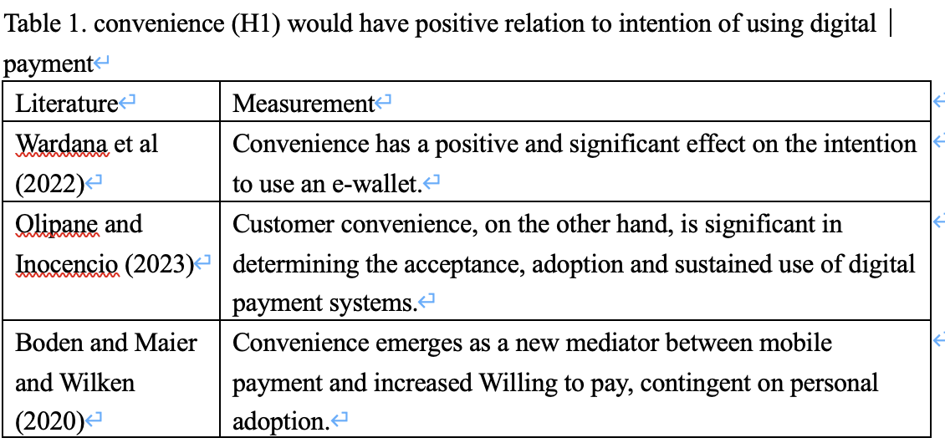
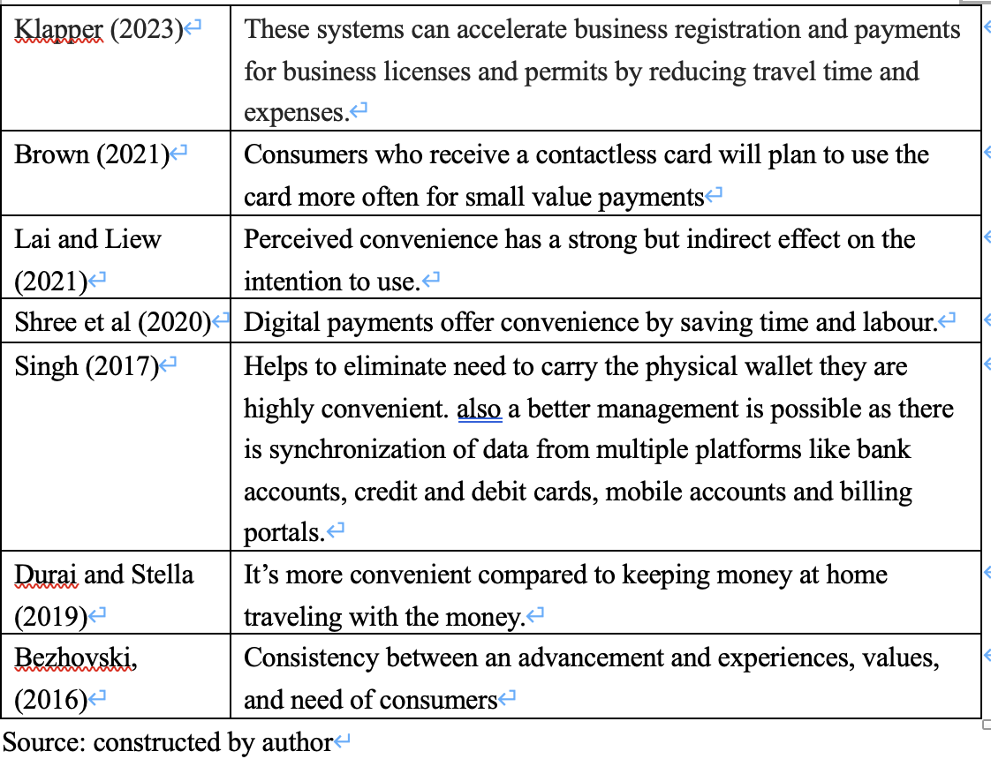
2.2 Security

2.2.1 Definition
Security was usually thought be the environment people stay at was protected or safe from threat and it became crucial for customers to decide whether to use digital payment for transactions (Lai, 2016)
2.2.2 Construct and measurement
Technology acceptance model (TAM) by Davis (1989), would be applied as usually many of similar studies would focus on customers' perception such as the perceived ease of use and perceived usefulness., Security would be measured in terms of five security objectives: confidentiality, authentication, integrity, authorization and nonrepudiation (Al-Dala’in and Luo and Summons, 2008) from the users or potential users to determine the usefulness
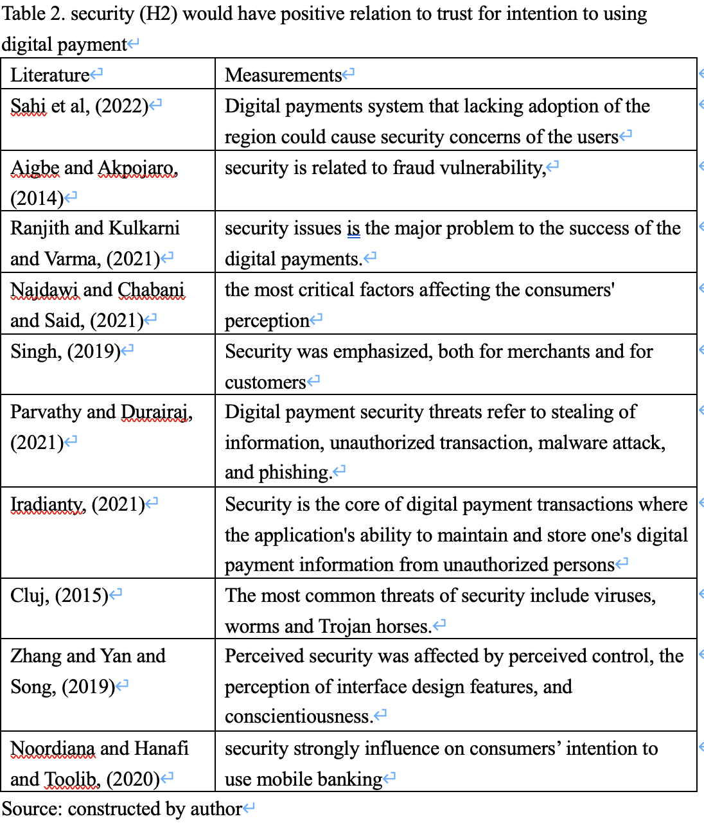
2.3. Privacy
2.3.1 Definition
Alfarizia and Saria (2023) states that information Privacy is the ability of one or a group of individuals to defend their personal lives and affairs from the public, or to control the flow of information about them. only accessed by interested parties according to the nature and purpose of the information.
2.3.2 Construct and measurement
Technology acceptance model (TAM) by Davis (1989), would be applied as usually many of similar studies would focus on customers' perception such as the perceived ease of use and perceived usefulness., Privacy would be measured in terms of perception from the users or potential users to determine the usefulness because individual’s concern about the potential harm to their personal information (Ma et al 2022)

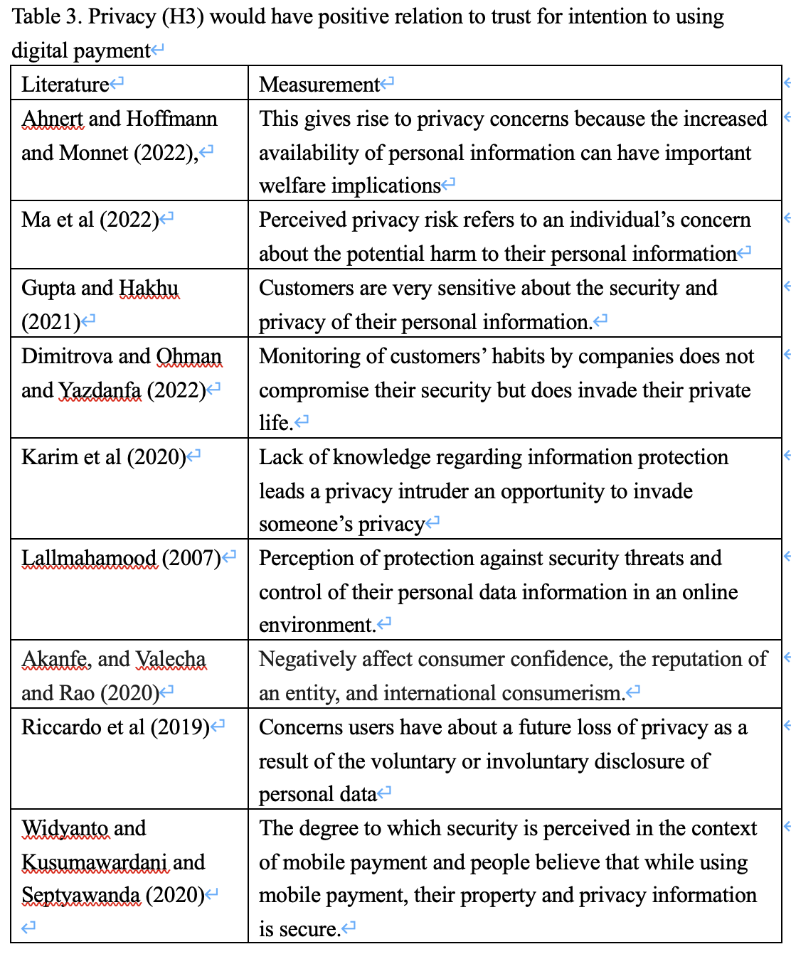
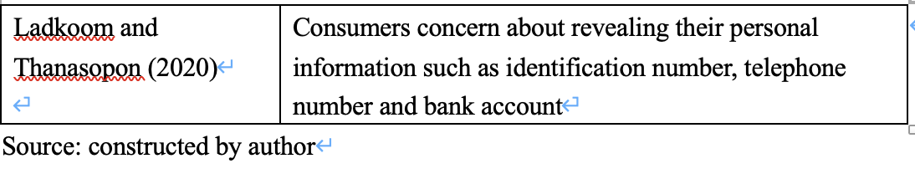

2.4 Trust

2.4.1 Definition
Trust as the expectation of efficiency, reliability and effectiveness of technical devices and systems, from the perspective of people who have created the given technology, information systems of material objects, etc. (Szumski, 2020) and
It was also found that others factors such as perceived enjoyment, facilitating conditions, personal innovativeness, coupon availability, perceived ease of use perceived usefulness and users' attitude (Zhong et al, 2021)

2.4.1 Construct and measurement
Technology acceptance model (TAM) by Davis (1989), would be applied as usually many of similar studies would focus on customers' perception such as the perceived ease of use and perceived usefulness., Trust would be assessed in terms of perception from the users or potential users to determine the usefulness because trust develops first image product Talwar et al (2020) and users would not use digital payment when losing trust.
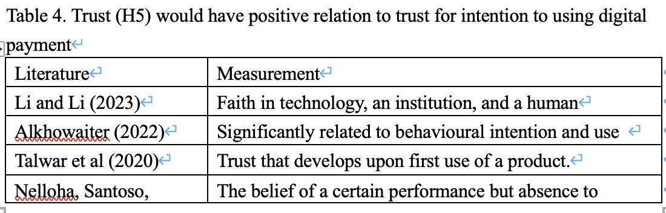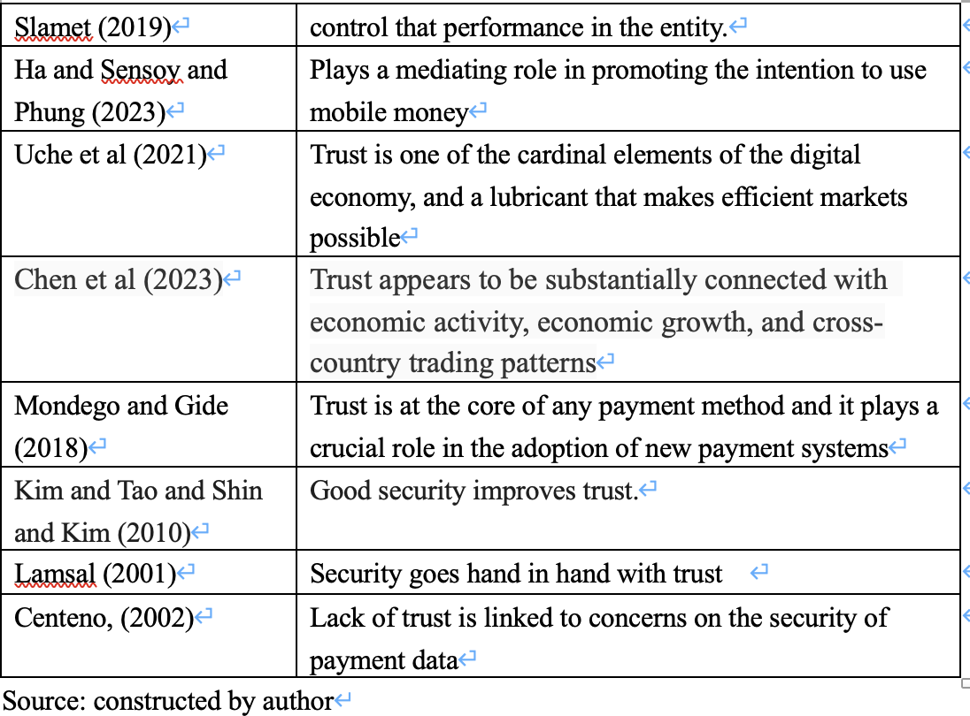
2.5 Customer Characteristics
2.5.1 Definition
(Sahi et al, 2021) have looked beyond the direct relationships and included several demographic and such as such as ages, gender, education level, income levels, usage frequency and volume of transactions involved would be the factors determined whether the user would use the digital payment as the transaction method.

2.6 Relationships
2.6.1 Definition
Both (Tsiakis and Sthephanides, 2005) and (Kim and Seok and Roh, 2023) had mentioned the relationship between security and trust and privacy and trust respectively and eventually determine the intention to use digital payment as referred in trust in section 2.4 and Security in section 2.2.

2.6.2 Between trust and security(H2)
Tsiakis and Sthephanides, (2005) stated that satisfying customers security expectations would be a crucial factor to earn absolute trust to the digital payment system that customer and therefore the trust is closely related to the security of the system providing digital payment services.
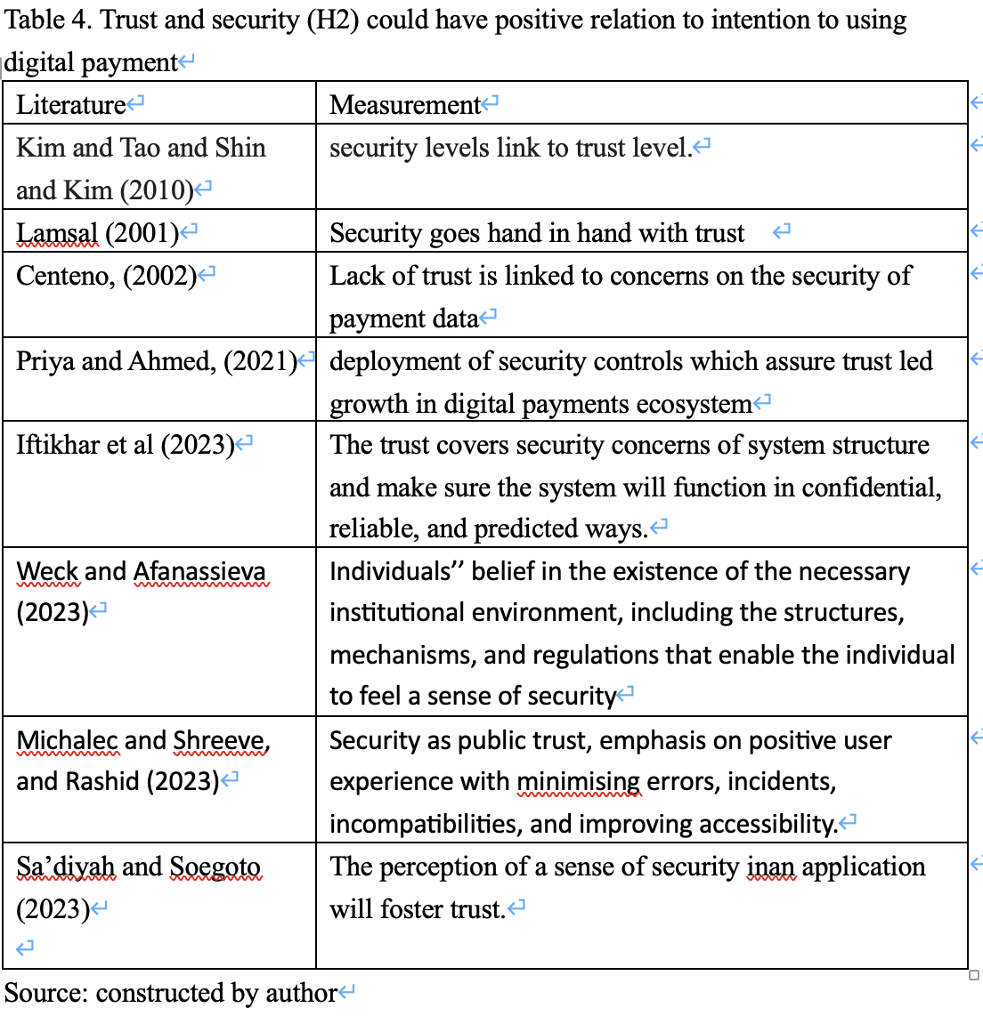

2.6.3 Between privacy and trust (H3)
Customers would worry that customers’ personal private information might be distributed to the other parties through the digital payment devices or system, and consequently impacting consumer satisfaction, loyalty, and behavioural intention. (Kim and Seok and Roh, 2023) Therefore, trust-based privacy protection would play an important role to ensure the digital payment devices or systems were trustworthy to the users or potential users.
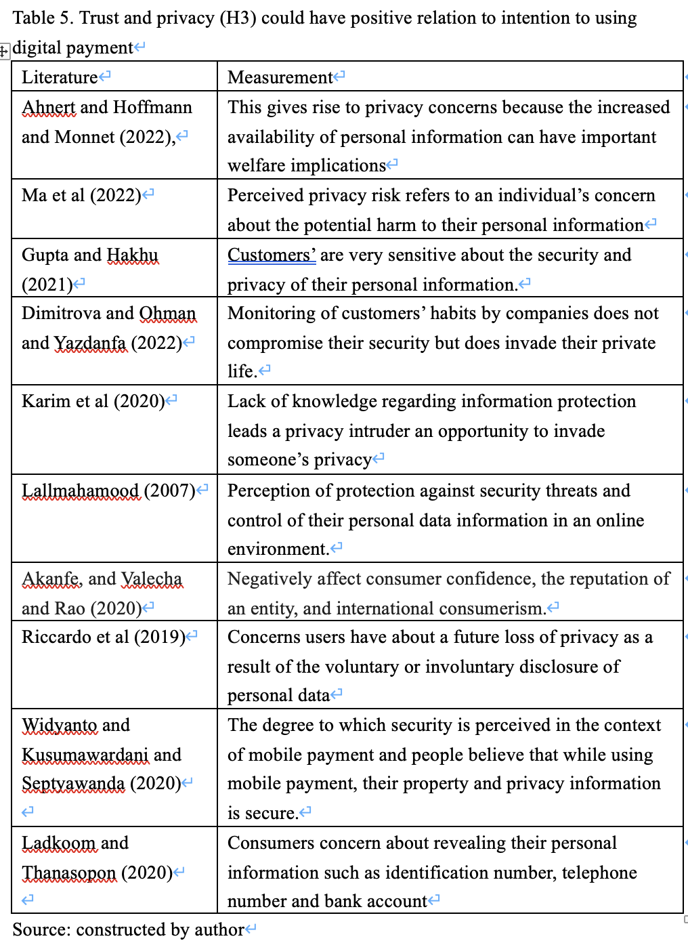
2.6.4 Construct and measurement
Technology acceptance model (TAM) by Davis (1989), would be applied as usually many of similar studies would focus on customers' perception such as the perceived ease of use and perceived usefulness., relationships between trust and privacy and security would be assessed respectively as privacy and security were the building block of trust and will develop to the intention of using digital payment.

Chapter 3.
Research Methodology
3.1 Research model with hypotheses
This Study aims to provide the conceptual framework for checking the relationship between Convenience, Security, Privacy and the intention to use the digital payment for transactions.

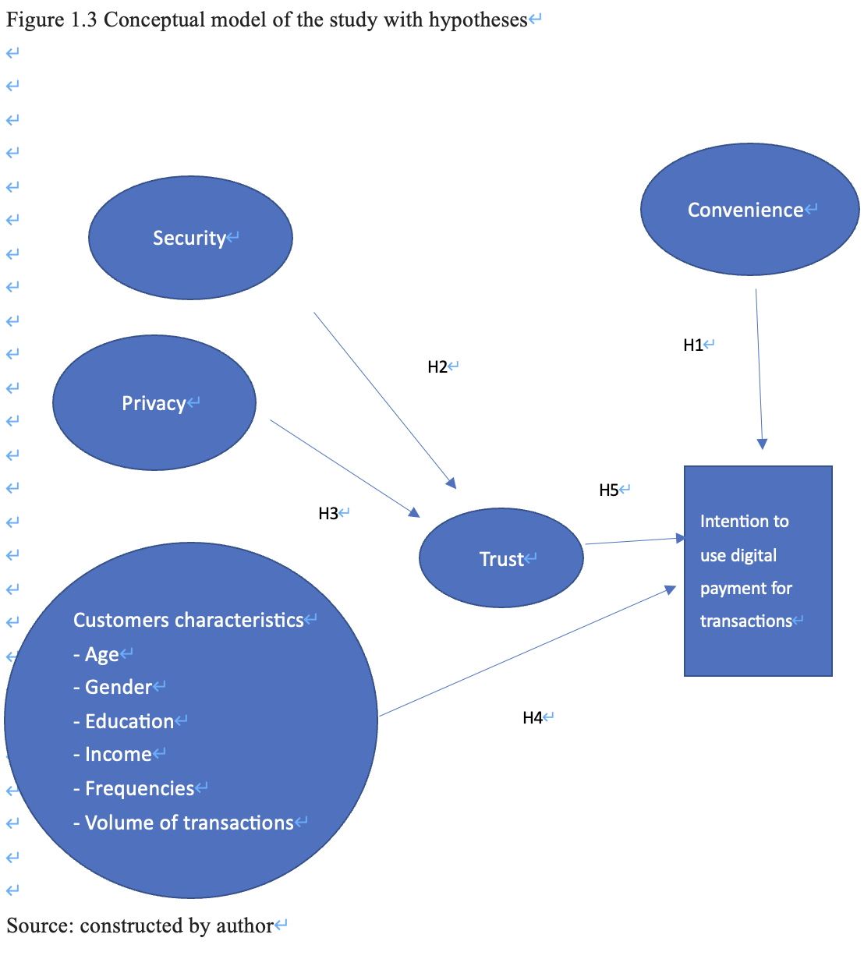
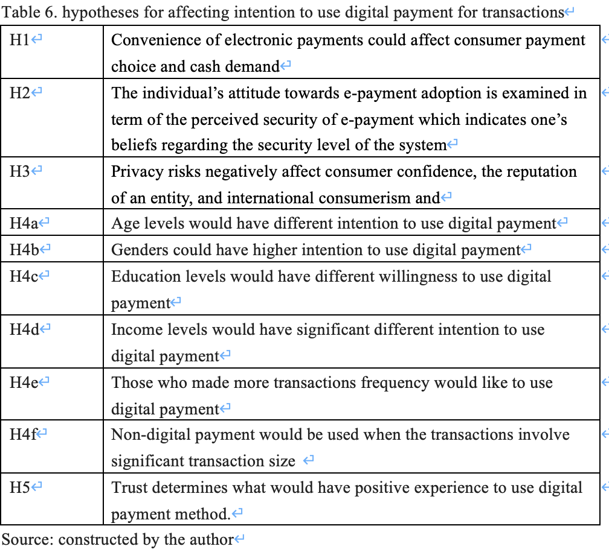
3.2 Triangulation
Triangulation which was developed by Denzin in year 1978, was a methodology that for conducting research that uses different data sets from different researchers, theories, to that the data, analysis, and conclusions of a research study are as completed and precise. (Moon, 2019)

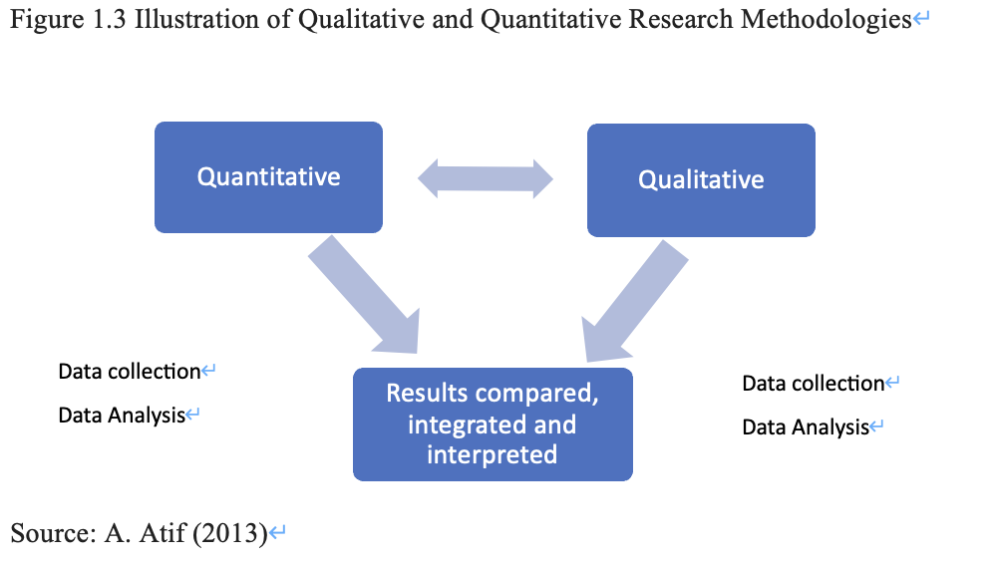

3.3 Qualitative and Quantitative research
When mentioning quantitative research, it involves obtaining and then studying data, and the data usually refers to numerical figure and statistics., while qualitative research is mentioned, it made use of non-numerical figures such as wordings. Both qualitative and quantitative factors were equally important for gaining different kinds of knowledge as some factors could not be accurately quantified. (Streefkerk, 2023)

For qualitative research data collection, as mentioned above, it would refer to the focus group with more experience on digital payment that to have more discussions on what would be the crucial factors and what hard and soft infrastructure could be provided so that people would be more likely to use digital payments in Hong Kong.

For quantitative research data collection, it could be completed by computing questionnaire and randomly deliver to the population and would sort out two groups: those have got exposure using digital payment and those who have not have got any experience on using digital payment for their transactions., and further questions would be asked. The data collected would be interpreted together with the government reports or statistics, journals and research reports from other institutions. Moreover, for data collecting through questionnaire, Likert Scale of 5-scale would be applied for each questionnaire question (Anjaria, 2022).

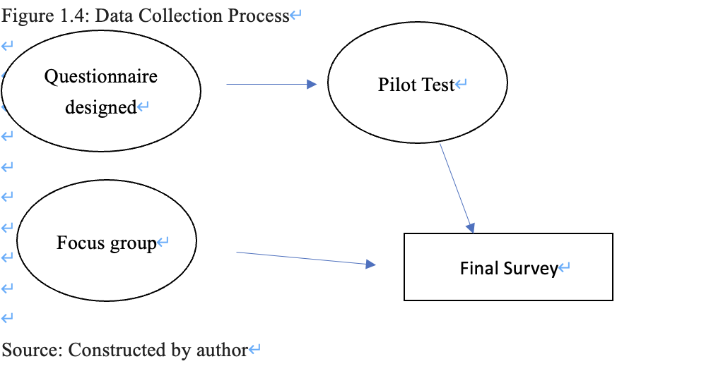
3.4 Focus group
Focus group is a means for qualitative data collection, and becoming popular amongst professionals in various area including but not limited to the health and social care. (Rabiee, 2004).
The focus group would be held in Hong Kong, the discussion would last for about 45 minutes and would be conducted in both English and Cantonese. The progress would be recorded on paper and transcribed for further analysis. During the focus group discussion, the participants would be asked with a number of open-end questions on how to improve the intention to use digital payment. When there was situation that most of the answers or comments to the questions were similar and no addition answer exists, the focus group session would end.

3.5 Quantitative survey methodology
Due to privacy policies of each of the digital payment providers, it is totally not possible to gather a list of all digital payment users from the sampling frame. Therefore, the research would apply non-probability sampling which respondents could access to the Internet and conducting web surveys (Lamm and Lamm, 2019), this method is thus the cost would be relatively lower and the web surveys could be conducted online.
With Likert scale (Likert, 1932) that allows participants to express various level of agreement and disagreement to certain agenda or question. This research questionnaire would be graded with 5-point Likert Scale. Odd number scale made the respondents to pick among different level of agreement or disagreement, so that the participant can made a neutral opinion when the opinion is duly neutral (Taherdoost, 2019)
A pilot test was developed before full scale survey, so that the result of the pilot test, could reflect the hypotheses could be treated as acceptable and dependable, and at the same time allowing researcher to to amend or enhance in the research questionnaire.
(Gani and Rathakrishnan and Krishnasamy, 2020). For sample size of pilot test, Some studies recommend over 30 samples (In, 2017).
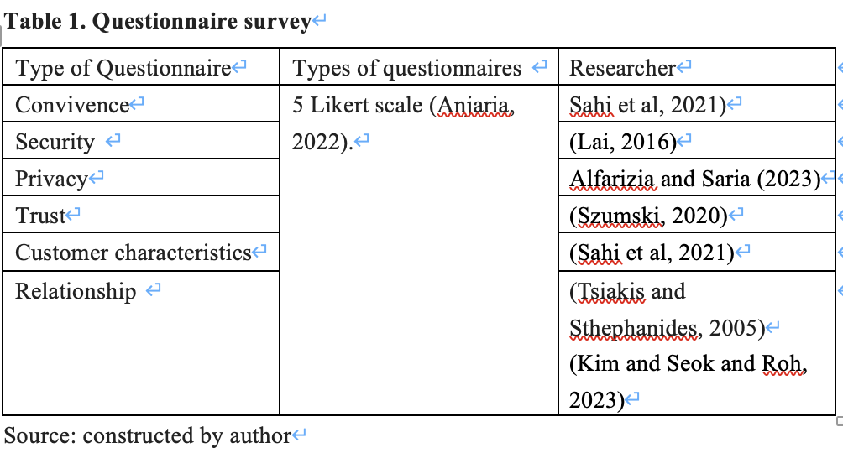
3.6 Target population
A target population could be treated as a group or collection of factors that wish to learn more about. The target population is a number of the general public spotted as the targeted customer or user for a given product or services for research. It is a group of the whole population in the region picked up to serve as the objective opinion provider. For this research, the population who from age higher than and living in Hong Kong in last 12 months who have experience or exposure using digital payment. According to the provision figure of population information from Hong Kong Census and Statistics Department (2023), there were 7.4981million people in Hong Kong., and referring to the Statista (2023) there were 6.1 million in Hong Kong have involved digital Commerce.

3.7 Sampling method
After the pilot test was conducted, the questionnaire would be launched an disseminated widely to groups of individuals through the snowballing method.
3.8 Sampling size
Sampling is about choosing a subset of a number of people from a population and deduce the general characteristics of whole population (Singh and Masuku, 2014)Each observation measures one or more properties of observable subjects distinguished as independent individuals.
The sample size (“n’”) would be computed as per formula as below:
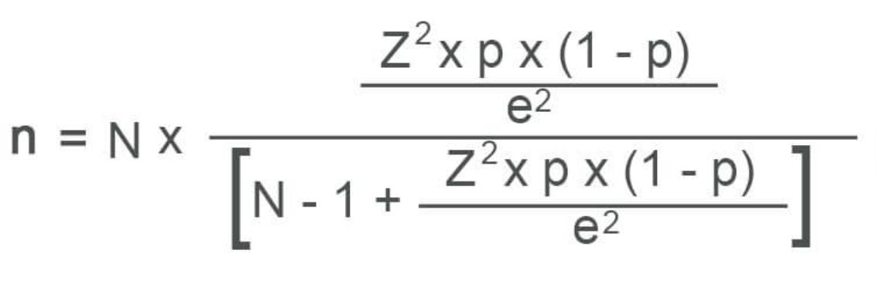
Source: Noah (2022)

3.9 Data analysis techniques
SPSS version 29 would be applied to evaluate descriptive statistics on the demographic data. The reliability test, correlation analysis, simple and multiple regression analysis, independent T-test and one-way ANOVA test would be applied in this study.
The independent t-test could help in comparing two sample means from different people providing scores for each group (Independent t-test, 2023) and this t-test is to determine whether there were different samples from each of the group.
The one-way analysis of variance (ANOVA) is used to compare the means of three group or more groups that are totally independent and satisfy the ordinariness and equal variance assumptions, when each group is paired with another to attempt three
paired comparisons (Kim, 2017)

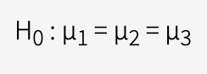

Source: (Kim, 2017)
3.10 Research Method limitations
For Qualitative research methodology for answering the questions, as it would be more on the focus group that the participants usually have got experiences on using digital payment as they could share more feedback on intention to use the digital payment. However, it might come to the situation that it might not reach those who did not have exposure on using the digital payment, this would cause “handicapped” that the suggestion from them for attracting non-users to even try to use digital payment.

3.11 Research Ethics
This Research maintains the confidentially and privacy of the information gathered from the interviews, and all information is utilized solely for the purpose of conducting this academic research project. In order to protect the confidentiality of the information given by the interviewers, this research does not reveal personal data and no identifying data is necessary in the interviews, such as name, company, and contact information, are not necessary in the focus group interviews.

Reference:

Alfarizia M. and Saria R. (2023), Adoption Of Cash on Delivery (COD) Payment System in Shopee Marketplace Transaction, available at https://doi.org/10.1016/j.procs.2023.10.508 Accessed 17 December 2023

Alkhowaiter (2022), Use and behavioural intention of m-payment in GCC countries: Extending meta-UTAUT with trust and Islamic religiosity, Available at https://doi.org/10.1016/j.jik.2022.100240 accessed 10 December 2023

Ahnert T. and Hoffmann P. and Monnet C. (2022), The digital economy, privacy, and CBDC, Working Paper Series, European Central Bank, available at https://dx.doi.org/10.2139/ssrn.4109696 Accessed 11 December 2023

Aigbe P. and Akpojaro J. (2014), Analysis of Security Issues in Electronic Payment
Systems, available at https://d1wqtxts1xzle7.cloudfront.net/87365135/pxc3899993-libre.pdf?1654984848=&response-content-disposition=inline%3B+filename%3DAnalysis_of_Security_Issues_in_Electroni.pdf&Expires=1702804359&Signature=V3PKDvimNa~30wRzOIOTpG345AzErNWXaphc5R2mXADgTKi3CySaWO9jFb50xzWlqF6ob078UovodWViwlxNABS-MuuA~7dJf-IEIYLqtHZICmKOIG2y6SrRSdpecYmqZqR87OJosvdzHegfOGGgibjIvEL73lhLGSwNLvxCVxs~I6lxzDnrs7B1Gr3XFpmmu-pgPHIzUfpwh2MJmqIk5hRNs602lThL6nRycNtbcryEESKXs7NIZJyxpGosX727Z4WorCFW~OjeMR5y9~F-7~FzGunIz3eZ3Cf9AMDqAESMEiMZ1dR0D7cMkgoy0PsrZ7BmScGTdkRkI29E53juRQ__&Key-Pair-Id=APKAJLOHF5GGSLRBV4ZA Accessed 17 December 2023

Akanfe O. and Valecha R. and Rao H. (2020), Assessing country-level privacy risk for digital payment systems, available at https://doi.org/10.1016/j.cose.2020.102065 Accessed 12 December 2023

Al-Dala’in T. and Luo S. and Summons P. (2008), A REVIEW OF CURRENT ONLINE PAYMENT SYSTEMS RELATED TO SECURITY AND TRUST SOLUTIONS, available at https://scholar.googleusercontent.com/scholar?q=cache:pbzxhXtT-PQJ:scholar.google.com/+security+relate+to+trust+digital+payment&hl=zh-TW&as_sdt=0,5 Accessed 17 December 2023

Anjaria (2022), Knowledge derivation from Likert scale using Z-numbers, available at https://doi.org/10.1016/j.ins.2022.01.024 Accessed 15 December 2023

Atif A. (2013), A Student Retention Model: Empirical, Theoretical and Pragmatic Considerations, https://www.researchgate.net/figure/A-Visual-Diagram-of-the-Mixed-Methods-Concurrent-Triangulation-Strategy-The-researchers_fig1_280860447 Accessed 12 December 2023

Bezhovski Z. (2016), The Future of the Mobile Payment as Electronic Payment System, available at https://eprints.ugd.edu.mk/15691/1/The%20Future%20of%20the%20Mobile%20Payment%20as%20Electronic%20Payment%20System.pdf Accessed 10 December 2023

BIS (2023), T6: Value of cashless payments and withdrawal/deposit transactions, Bank of International Settlement, available at http://stats.bis.org:8089/statx/srs/table/T6?c=HK&f=xlsx 14 December
2023

Boden J. and Maier E. and Wilken R. (2020), The effect of credit card versus mobile payment on convenience and consumers’ willingness to pay, Available at https://doi.org/10.1016/j.jretconser.2019.101910 Accessed 10 December 2023

Brown M. and Hentschel N. and Mettler H. and Stix H. (2021), The Convenience of Electronic Payments and Consumer Cash Demand – Causal Evidence from the Staggered Introduction of Contactless Debit Cards, Available at https://papers.ssrn.com/sol3/papers.cfm?abstract_id=3582388 Accessed 10 December 2023

Chen J.and Lin P. and Aminah H. and Rizaldy H. and Dinh D. (2023), How Digital Payment Applications and Digital Trust Response Industry 5.0?Avaliable at https://doi.org/10.1145/3568834.3568906 Accessed 10 December 2023

Cluj B. (2015), SECURITY ISSUES AND SOLUTIONS IN E-PAYMENT SYSTEMS, available at https://fiatiustitia.ro/wp-content/uploads/2021/03/203-Article-Text-390-1-10-20151105.pdf Accessed 17 December 2023

Davis F (1989), Perceived Usefulness, Perceived Ease of Use, and User Acceptance of Information Technology, available at https://doi.org/10.2307/249008 Accessed 17 December 2023
Dimitrova I. and Ohman P. and Yazdanfa D. (2022), Barriers to bank customers’
intention to fully adopt digital payment methods, available at https://www.emerald.com/insight/content/doi/10.1108/IJQSS-03-2021-0045/full/html Accessed 12 December 2023

Durai T. and Stella G. (2019), DIGITAL FINANCE AND ITS IMPACT ON FINANCIAL INCLUSION, available at https://www.researchgate.net/profile/Tabitha-Durai-2/publication/330933079_DIGITAL_FINANCE_AND_ITS_IMPACT_ON_FINANCIAL_INCLUSION/links/5c5c28c1a6fdccb608af1cf1/DIGITAL-FINANCE-AND-ITS-IMPACT-ON-FINANCIAL-INCLUSION.pdf Accessed 10 December 2023

Gani N. and Rathakrishnan M and Krishnasamy H. (2020), A PILOT TEST FOR ESTABLISHING VALIDITY AND RELIABILITY OF QUALITATIVE INTERVIEW IN THE BLENDED LEARNING ENGLISH PROFICIENCY COURSE, available at https://www.researchgate.net/profile/Mohan-Rathakrishnan/publication/342864562_Journal_of_critical_reviews_Journal_of_Critical_Reviews_A_PILOT_TEST_FOR_ESTABLISHING_VALIDITY_AND_RELIABILITY_OF_QUALITATIVE_INTERVIEW_IN_THE_BLENDED_LEARNING_ENGLISH_PROFICIENCY_COURSE/links/5f0946cc45851550509c732a/Journal-of-critical-reviews-Journal-of-Critical-Reviews-A-PILOT-TEST-FOR-ESTABLISHING-VALIDITY-AND-RELIABILITY-OF-QUALITATIVE-INTERVIEW-IN-THE-BLENDED-LEARNING-ENGLISH-PROFICIENCY-COURSE.pdf Accessed 17 December 2023

Gupta P. and Hakhu R. ( 2021), Impact of Perceived Security and Perceived Trust on
Intention to Use Digital Payments – A Study on Indian Customers, available at https://www.webology.org/data-cms/articles/20220212013917pmwebology%2018%20(6)%20-%2064%20.pdf Accessed 11 December 2023

Ha D. and Sensoy A. and Phung A. (2023), Empowering mobile money users: The role of financial literacy and trust in Vietnam, available at https://doi.org/10.1016/j.bir.2023.10.009 Accessed 10 December 2023

Iftikhar A. and Qureshi K. and Shiraz M. and Albahli S. (2023), Security, trust and privacy risks, responses, and solutions for high-speed smart cities networks: A systematic literature review, available at https://doi.org/10.1016/j.jksuci.2023.101788 17 December 2023

Independent t-test (2023), Independent t-test, Academic Success Center, National University, available at https://resources.nu.edu/statsresources Accessed 17 December 2023

In J. (2017), Introduction of a pilot study, available at https://doi.org/10.4097/kjae.2017.70.6.601 Accessed 17 December 2023

Iradianty A. (2021), Exploring Design and Security Perception on Digital
Payment Adoption Among the Z Generation in Indonesia, available at https://ejournal.aibpmjournals.com/index.php/JICP/article/view/1336/1213 Accessed 17 December 2023

Karim W. and Haque A. and Ulfy M. and Hossain A. and Anis Z. (2020), Factors Influencing the Use of E-wallet as a Payment Method among Malaysian Young Adults available at https://d1wqtxts1xzle7.cloudfront.net/62478254/JIBM-2020-2-2120200325-72624-cpu9ko-libre.pdf?1585268125=&response-content-disposition=inline%3B+filename%3DFactors_Influencing_the_Use_of_E_wallet.pdf&Expires=1702364172&Signature=NAi3oM-RzXnuayTxfP7pvASbTHCetfq42wKcbCANN2T-wd7ECOZD1HsREISzCR~uh53GXwodTb9eclxCaNUGyesj59J5wsJEU-COI0cmL-aPA~N87-E4UVjSIjNCAu84Wf6Slyq1dX~9gCra5ydMdZtV9UgVc6ewxHjdkq2gy04Nkw4ixI8xd41cuwUNVVOneY07I~zxdsciJmWa1o7TGDNKG3NqO6RcH2gFpTpyEVbN1ymHzz-tYVe4wnoe00dV0CpojK~gSEGfHLeNIhUFShVVNW1BoX9-Z1~Gcnp~E7AV-H8BrDXeztzNLUJRNMAW5slKbp8sgv1jBVrQLXzNvw__&Key-Pair-Id=APKAJLOHF5GGSLRBV4ZA Accessed 12 December 2023

Khaitan, (2023), What Is A Digital Payment and How Does It Work? Available at https://www.forbes.com/advisor/in/banking/what-is-a-digital-payment-and-how-does-it-work/ Accessed 9 December 2023

Kim C. and Tao W. and Shin N. and Kim K. (2010), An empirical study of customers’ perceptions of security and trust in e-payment systems, available at https://doi.org/10.1016/j.elerap.2009.04.014 Accessed 12 December 2023

Kim Y. and Seok J. and Roh T. (2023), The linkage between quality of information systems and the impact of trust-based privacy on behavioral outcomes in unmanned convenience store: Moderating effect of gender and experience, available at https://doi.org/10.1016/j.techfore.2023.122852 17 December 2023

Klapper L. (2023), How digital payments can benefit entrepreneurs, available at https://wol.iza.org/articles/how-digital-payments-can-benefit-entrepreneurs/long Accessed 10 December 2023

Ladkoom K. and Thanasopon B. (2020), Factors Influencing Reuse Intention of e-Payment in Thailand: A Case Study of PromptPay, available at https://www.scitepress.org/Papers/2020/94104/94104.pdf Accessed 12 December 2023

Lai P. (2016), Design and Security impact on consumers’ intention
to use single platform E-payment, available at https://doi.org/10.4036/iis.2016.R.05 17 December 2023

Lai P. and Liew E. (2021), Towards a Cashless Society: The Effects of Perceived Convenience and Security on Gamified Mobile Payment Platform Adoption available at https://doi.org/10.3127/ajis.v25i0.2809 Accessed 10 December 2023

Lallmahamood M. (2007), An Examination of Individual’s Perceived Security and
Privacy of the Internet in Malaysia and the Influence of This on Their Intention to Use E-Commerce: Using An Extension of the Technology Acceptance Model, Journal of Internet Banking and Commerce, available at https://d1wqtxts1xzle7.cloudfront.net/3245725/Muniruddeen_Final-libre.pdf?1390830562=&response-content-disposition=inline%3B+filename%3DAn_Examination_of_Individuals_Perceived.pdf&Expires=1702364389&Signature=LMyHTyCub4dwqdqr25JPZi3Va7SXxRSc5Omwk52Pc2JRJVzfQDWiV3yK-s61KNa3zm1ysSUX-s1~mEWOs~pbr0Nohwc7lrDLgnWpI0LqE6xWIGOS4ocB2KJdnrruS-S9OJxMOyVXiyY8pccKG0sQj5cmCx1y2RjS45FYz2UBH9mye5HBcOBzjCQitq6iJ4TqeNt1eIyoCmobAhO1TzR6Lb37goO0beeMzA8o0by4cTCM~m1kNc67cwCttREU3usfKNgDjoekTPqMpayqNTbFEcl28-32dFyVlZDijqpbJZ-RWY0X4kkGhIyZZcrpZOwtjUX0G8rWBCWl3hwQomC~kA__&Key-Pair-Id=APKAJLOHF5GGSLRBV4ZA Accessed 12 December 2023

Lamm and Lamm (2019), Using Non-Probability Sampling Methods in Agricultural and Extension Education Research, available at doi: 10.5191/jiaee.2019.26105
Accessed 17 December 2023

Lamsal P. (2001), Understanding Trust and Security, available at https://citeseerx.ist.psu.edu/document?repid=rep1&type=pdf&doi=056712cf5bc0fba369eb60ebbc23b327d23b1ab8 Accessed 12 December 2023

Likert R. (1932), A technique for the measurement of attitudes, Archives of Psychology, available at https://psycnet.apa.org/record/1933-01885-001 Accessed 17 December 2023

Ma C. and Jin Z. and Mei Z. and Zhou F. and She X. and Huang J. and Liu D. (2022) Internet of Things Background: An Empirical Study on the Payment Intention of Central Bank Digital Currency Design, available at https://www.hindawi.com/journals/misy/2022/4846372/ Accessed 11 December 2023

Michalec O. and Shreeve B. and Rashid A. (2023), Who will keep the lights on? Expertise and inclusion in cyber security visions of future energy systems, available at https://doi.org/10.1016/j.erss.2023.103327 Accessed 17 December 2023

Mondego D. and Gide E. (2018), THE EFFECT OF TRUST ON MOBILE PAYMENT ADOPTION: A COMPREHENSIVE REVIEW OF LITERATURE, Available at https://d1wqtxts1xzle7.cloudfront.net/58200165/THE_EFFECT_OF_TRUST_ON_MOBILE_PAYMENT_ADOPTION-_A_COMPREHENSIVE_REVIEW_OF_LITERATURE_-libre.pdf?1547699602=&response-content-disposition=inline%3B+filename%3DThe_effect_of_trust_on_mobile_payment_ad.pdf&Expires=1702201238&Signature=A9OOZpOrklkp5YsqGTF5tr4Vf2bfIc-c4ZBleuGnOVysydXb~xr2rtydFpectoasoAMji6Xk7ylsqZa~9Xz6jPB3IEBzkrTyyn46nrpKK6tTfr8SIwKxnOmGUoQR7wbviyx5sJuzoVl~0514l4Bb6Gls93FmAQ6ctI61PF2d-2iaD6CferpGHyvg~BNWkCuXJ9-pF3hn3cZHNizsiYKEOXEE5-OmYZo3t0qydfRzufMGZiq3uXXWqlEgbxDzinNuwWUWrhiZk0KHedWFQnrOjbZge5xNZtx6z8wHSqdT5Bc52-dZW5IUdeiegOH~iLl9wIqh1AOYJCwpj7Id~KMqlQ__&Key-Pair-Id=APKAJLOHF5GGSLRBV4ZA Accessed 10 December 2023

Moon M. (2019), Triangulation: A Method to Increase Validity, Reliability, and Legitimation in Clinical Research, available at https://doi.org/10.1016/j.jen.2018.11.004 Accessed 12 December 2023

Najdawi A. and Chabani Z. and Said R. (2021), Factors Impacting Digital Payment Adoption: An Empirical Evidence from Smart City of Dubai, available at https://www.researchgate.net/profile/Zakariya-Chabani-2/publication/349692929_Factors_Impacting_Digital_Payment_Adoption_An_Empirical_Evidence_from_Smart_City_of_Dubai/links/60680b72458515614d2e5d65/Factors-Impacting-Digital-Payment-Adoption-An-Empirical-Evidence-from-Smart-City-of-Dubai.pdf Accessed 17 December 2023

Nelloha, L. and Santoso A. and Slamet M. (2019), Will Users Keep Using Mobile Payment? It Depends on Trust and Cognitive Perspectives, available at https://doi.org/10.1016/j.procs.2019.11.228 Accessed 10 December 2023

Niankara I. and Traoret I. (2023), The digital payment-financial inclusion nexus and payment system innovation within the global open economy during the COVID-19 pandemic, available at https://doi.org/10.1016/j.joitmc.2023.100173 Accessed 17 December 2023

Noordiana and Hanafi and Toolib S. (2020), Influences of Perceived Usefulness, Perceived Ease of Use, and Perceived Securityon Intention to Use Digital Payment: A Comparative Study Among Malaysian Younger and Older Adults, available at https://journal.uniten.edu.my/index.php/ijbm/article/view/225/266 Accessed 17 December 2023

Olipane H. and Inocencio M. (2023) DIGITAL PAYMENT AND ITS INFLUENCE TO CUSTOMER CONVENIENCE, available at https://www.ajhssr.com/wp-content/uploads/2023/09/D237095667.pdf Accessed 10 December 2023

Parvathy V. and Durairaj D. (2021), A Study on Users Perception and Awareness towards Digital Payment Security Threats among Youngsters in Chennai, Tamil Nadu, India, available at https://www.researchgate.net/profile/Parvathy-v-2/publication/356475150_Asian_Review_of_Social_Sciences_A_Study_on_Users_Perception_and_Awareness_towards_Digital_Payment_Security_Threats_among_Youngsters_in_Chennai_Tamil_Nadu_India/links/619d659f07be5f31b7b2e10a/Asian-Review-of-Social-Sciences-A-Study-on-Users-Perception-and-Awareness-towards-Digital-Payment-Security-Threats-among-Youngsters-in-Chennai-Tamil-Nadu-India.pdf Accessed 17 December 2023

Neha Priya N. and Ahmed J. (2021), A Survey on Digital Payments Security: Recent
Trends and Future Opportunities, available at https://www.researchgate.net/profile/Neha-Priya-4/publication/354635315_A_Survey_on_Digital_Payments_Security_Recent_Trends_and_Future_Opportunities/links/62896f0339fa217031651e9d/A-Survey-on-Digital-Payments-Security-Recent-Trends-and-Future-Opportunities.pdf Accessed 17 December 2023

Rabiee F. (2004), Focus-group interview and data analysis, available at https://doi.org/10.1079/PNS2004399 Accessed 17 December 2023

Ranjith P. and Kulkarni S. and Varma A. (2021), A Literature Study Of Consumer Perception Towards Digital Payment Mode In India, available at https://www.researchgate.net/profile/Aparna-Varma-3/publication/349381000_A_Literature_Study_Of_Consumer_Perception_Towards_Digital_Payment_Mode_In_India/links/60426d294585154e8c789ab5/A-Literature-Study-Of-Consumer-Perception-Towards-Digital-Payment-Mode-In-India.pdf Accessed 17 December 2023

Riccardo R. and Christoph D. and Dennis W. and Bettina L. and Torsten W. (2019), HOW PRIVACY AFFECTS THE ACCEPTANCE OF MOBILE PAYMENT SOLUTIONS, available at https://eprints.qut.edu.au/204994/ Accessed 12 December 2023

Sa’diyah M. and Soegoto D. (2023), The Effect of Perceived Security towards Intention to Use Digital Payment through a Trust, available at https://doi.org/10.34010/icobest.v2i.277 Accessed 17 December 2023

Sahi. A. and Haliyana K. and Alhamzah F. and Saleh F. (2021), The Evolving Research of Customer Adoption of Digital Payment: Learning from Content and Statistical Analysis of the Literature, available at https://doi.org/10.3390/joitmc7040230 Accessed 17 December 2023

Sahi A. and Khalid H. and Abbas A. and Zedan K. and Khatib S. and Amosh H. (2022), The Research Trend of Security and Privacy in Digital Payment, available at https://doi.org/10.3390/informatics9020032 17 December 2023

Shree S. et al (2020), Digital payments and consumer experience in India: a survey based empirical study, available at https://link.springer.com/article/10.1007/s42786-020-00024-z Accessed 10 December 2023

Streefkerk R. (2023), Qualitative vs. Quantitative Research | Differences, Examples & Methods, available at https://www.scribbr.com/methodology/qualitative-quantitative-research/ Accessed 12 December 2023

Singh G. (2019), A Review of Factors Affecting Digital Payments and Adoption
Behaviour for Mobile e-wallets, available at https://www.researchgate.net/profile/Gagandeep-Singh-Salhan/publication/340385808_A_Review_of_Factors_Affecting_Digital_Payments_and_Adoption_Behaviour_for_Mobile_e-wallets/links/5e86090f92851c2f52765878/A-Review-of-Factors-Affecting-Digital-Payments-and-Adoption-Behaviour-for-Mobile-e-wallets.pdf Accessed 17 December 2023

Singh A. and Masuku M. (2014), SAMPLING TECHNIQUES & DETERMINATION OF SAMPLE SIZE IN APPLIED STATISTICS RESEARCH: AN OVERVIEW, available at https://scholar.googleusercontent.com/scholar?q=cache:CFfFVj0sgpoJ:scholar.google.com/+sample+size+formula+basic+&hl=zh-TW&as_sdt=0,5 Accessed 17 December 2023

Singh S. (2017), STUDY OF CONSUMER PERCEPTION OF DIGITAL
PAYMENT MODE, available at https://smartlib.umri.ac.id/assets/uploads/files/7f1b5-study-of-consumer-perception-of-digital-payment-mode.pdf Accessed 10 December 2023

Szumski (2020), Technological trust from the perspective of digital payment, available at https://www.sciencedirect.com/science/article/pii/S187705092031927X Accessed 10 December 2023
Taherdoost H. (2019), What Is the Best Response Scale for Survey and Questionnaire Design; Review of Different Lengths of Rating Scale / Attitude Scale / Likert Scale, available at https://papers.ssrn.com/sol3/papers.cfm?abstract_id=3588604 Accessed 17 December 2023

Talwar S. and Dhir A. and Khalil A. and Mohan G. and Islam A. (2020), Point of adoption and beyond. Initial trust and mobile-payment continuation intention, available at https://doi.org/10.1016/j.jretconser.2020.102086 Accessed 10 December 2023

Tsiakis T. and Sthephanides G. (2005), The concept of security and trust in electronic payments, available at https://doi.org/10.1016/j.cose.2004.11.001 Accessed 17 December 2023

Uche D. and Osuagwu O. and Nwosu S. and Otika U. (2021) INTEGRATING TRUST INTO TECHNOLOGY ACCEPTANCE MODEL (TAM), THE CONCEPTUAL FRAMEWORK FOR E-PAYMENT PLATFORM ACCEPTANCE, Available at https://abjournals.org/bjmms/wp-content/uploads/sites/3/journal/published_paper/volume-4/issue-4/BJMMS_TB3XTKPI.pdf Accessed 10 December 2023.
Wardana A. and Saputro E. and Wahyuddin M. and Abas N. (2022), The Effect of Convenience, Perceived Ease of Use, and Perceived Usefulness on Intention to Use E-Wallet, available at https://doi.org/10.2991/aebmr.k.220602.051 Accessed 10 December 2023

Weck M. and Afanassieva M. (2023), Toward the adoption of digital assistive technology: Factors affecting older people's initial trust formation, available at https://doi.org/10.1016/j.telpol.2022.102483 Accessed 17 December 2023

Widyanto H. and Kusumawardani K. and Septyawanda A. (2020), ENCOURAGING BEHAVIORAL INTENTION TO USE MOBILE PAYMENT: AN EXTENSION OF UTAUT2, available at https://doi.org/10.24912/jmieb.v4i1.7584 Accessed 12 December 2023

Zhang J. and Yan L. and Song Y. (2019), The Role of Consumers’ Perceived Security, Perceived Control, Interface Design Features, and Conscientiousness in Continuous Use of Mobile Payment Services, available at https://doi.org/10.3390/su11236843 Accessed 17 December 2023

Zhong Y. and Oh S. and Moon H.C. (2021), Service transformation under industry 4.0: Investigating acceptance of facial recognition payment through an extended
technology acceptance model. Technol. Soc. 64, 1–10. Available at https://www.sciencedirect.com/science/article/abs/pii/S0160791X2031318X?via%3Dihub Accessed 10 December 2023

