Name: Aidan Griffiths_________________________________

Student Number: 2501271________________________
__________________________________________________________

WORKSHEET 1 – TESTING (Using Variables)

- Original code:
#define _CRT_SECURE_NO_WARNINGS
#include <stdio.h>
#include <string.h>

void main()
{
int theLength;
char Surname[30];
char NIN[10];
int Age;
float Hours;

Age = 0;

printf("Hello and Welcome!\n");
printf("Please enter your surname... \n");
scanf("%s", &Surname);
printf("Thank you! Now please enter your national insurance number: \n");
scanf("%s", &NIN);
theLength = strlen(NIN);
if (theLength != 9)
{
printf("Excellent! Now please enter your age: \n");
scanf("%d", &Age);
if (Age < 116 && Age >= 18)
{
printf("Finally, please enter your work hours: \n");
scanf("%f", &Hours);

if (Hours < 168 && Hours > 0)
{
printf("Thank you!\n");
printf("Surname: %s\n", Surname);
printf("National Insurance Number: %s\n", NIN);
printf("Age: %d\n", Age);
printf("Hours: %f\n", Hours);
}
else
{
printf("Your work hours must be inbetween 0 and 168...");
}
}
else
{
printf("You must be age 18 or over to enter a national insurance number...");
}
}
else
{
printf("Your National Insurance Number must be 9 characters in length...");
}
}

- Code Testing

For each test below, run your code and enter the values provided. Present a screenshot of the programme running. Did the programme behave correctly or did it do something unexpected, and if so, why?

Surname:
- Enter JONES
- Leave blank
- Enter A
- Enter 123

National Insurance Number:
- Enter PE534121B
- Leave blank
- Enter AB11223344556677 (ie too long for National Insurance number format)

Age
- Enter 34
- Enter 150
- Enter -4
- Enter a letter

Number of working hours per week:
- Enter 37.5
- Enter 105
- Enter 0
- Enter -2

Fill in a box for each test above. You should present 15 separate boxes, 1 for each test. (Note: the two boxes are provided as a template)

Test:
Surname i. Enter JONES

Screenshot(s) of output:
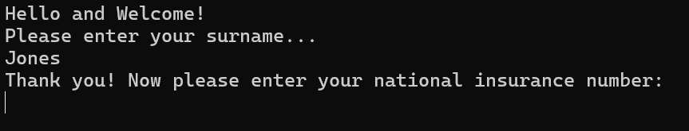
Result: Did the programme behave as expected ie syntactically and logically correct?
YES
If NO, what went wrong?
If YES, comment on what happened
The code validated the surname and asked the next question being the national insurance number

Test:
Surname ii Leave blank

Screenshot(s) of output:
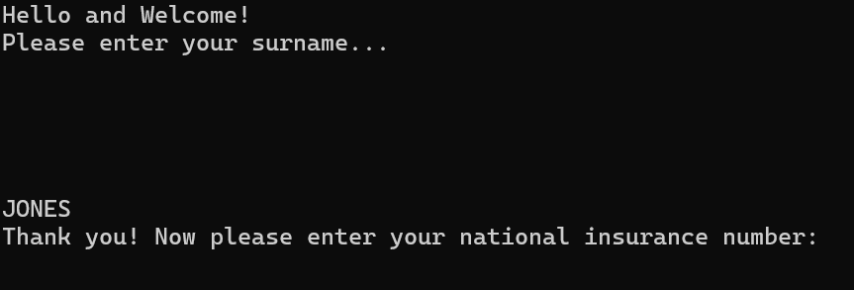
Result: Did the programme behave as expected ie syntactically and logically correct?
YES
If NO, what went wrong?
If YES, comment on what happened

Response is left blank until a surname is entered as expected

Test: Surname iii Enter A

Screenshot(s) of output:
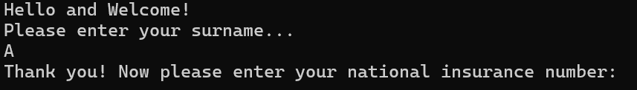
Result: Did the programme behave as expected ie syntactically and logically correct?
YES
If NO, what went wrong?
If YES, comment on what happened
A was accepted. Although this works as intended, some surnames do only contain 1 letter but are usually a vowel e.g. A, E, I, O, U.

Test: Surname iv Enter 123

Screenshot(s) of output:
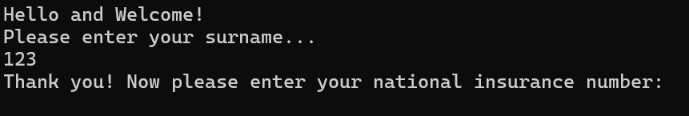
Result: Did the programme behave as expected ie syntactically and logically correct?
NO

If NO, what went wrong?
Integers are not supposed to be accepted however “123” was accepted
If YES, comment on what happened

Test: National Insurance Number i Enter PE534121B

Screenshot(s) of output:
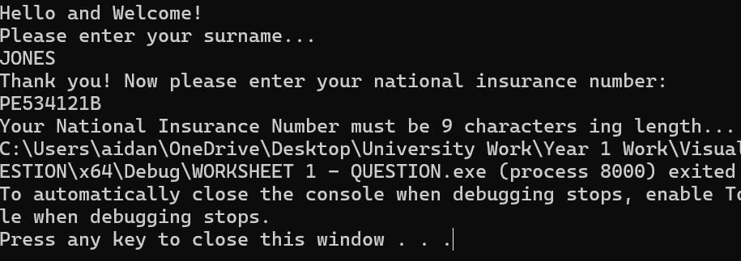
Result: Did the programme behave as expected ie syntactically and logically correct?
YES
If NO, what went wrong?
If YES, comment on what happened
The entered NIN was not accepted as a national insurance number must be 9 characters in length.
Therefore the validation prevented the entry.

Test: National Insurance Number ii Enter BLANK

Screenshot(s) of output:
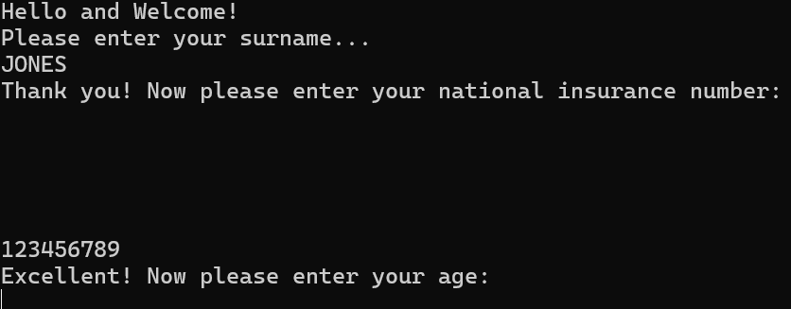
Result: Did the programme behave as expected ie syntactically and logically correct?
YES
If NO, what went wrong?
If YES, comment on what happened
The program continued to make a new line until a value was entered.

Test: National Insurance Number iii Enter AB11223344556677

Screenshot(s) of output:
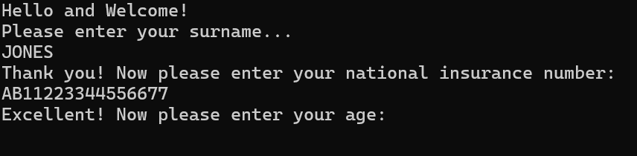
Result: Did the programme behave as expected ie syntactically and logically correct?
NO
If NO, what went wrong?
If YES, comment on what happened
The program accepted the entered value however it is over the limit of a national insurance number.

Test: Age i Enter 34

Screenshot(s) of output:
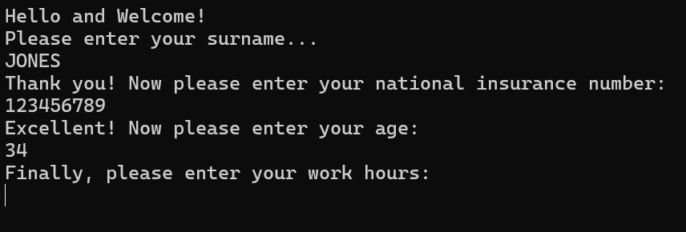
Result: Did the programme behave as expected ie syntactically and logically correct?
YES
If NO, what went wrong?
If YES, comment on what happened
Program accepts 34 and continues to the work hours

Test: Age ii Enter 150

Screenshot(s) of output:
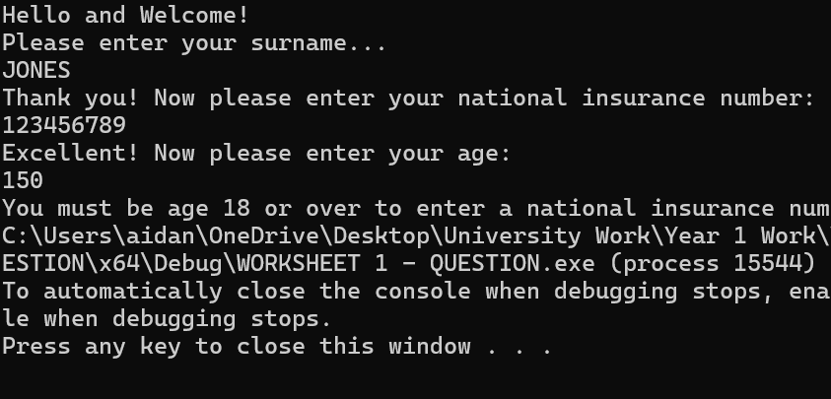
Result: Did the programme behave as expected ie syntactically and logically correct?
YES
If NO, what went wrong?
If YES, comment on what happened
Program does not accept 150 as the oldest person alive is less than 116 years of age. Therefore, the program denies access.

Test: Age iii Enter -4

Screenshot(s) of output:
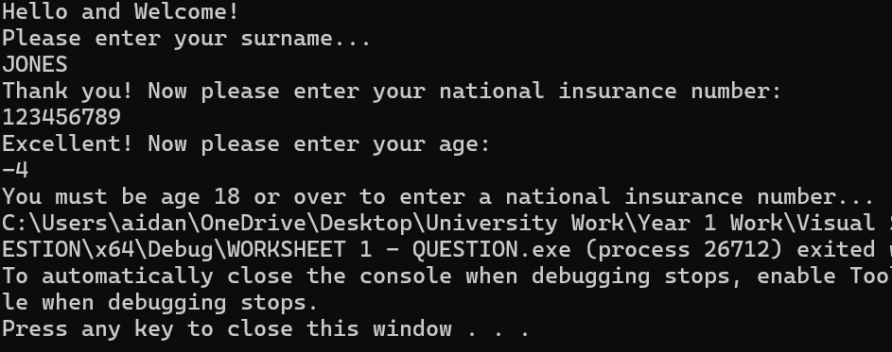
Result: Did the programme behave as expected ie syntactically and logically correct?
YES
If NO, what went wrong?
If YES, comment on what happened
The program does not accept -4 as an age as a person can not have an age below 0 but must be over 18 to enter a national insurance number.

Test: Age iv Enter a letter

Screenshot(s) of output:
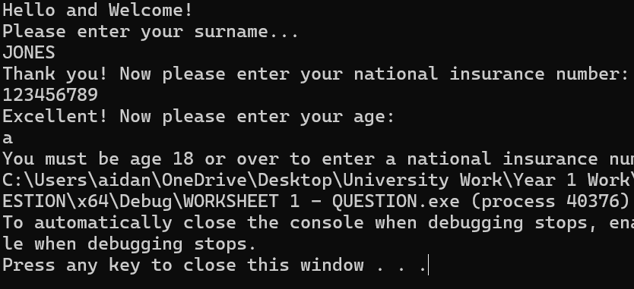
Result: Did the programme behave as expected ie syntactically and logically correct?
YES
If NO, what went wrong?
If YES, comment on what happened
The program does not accept a letter as an age therefore the program provides the error message of 18+ required.

Test: Working hours i Enter 37.5

Screenshot(s) of output:
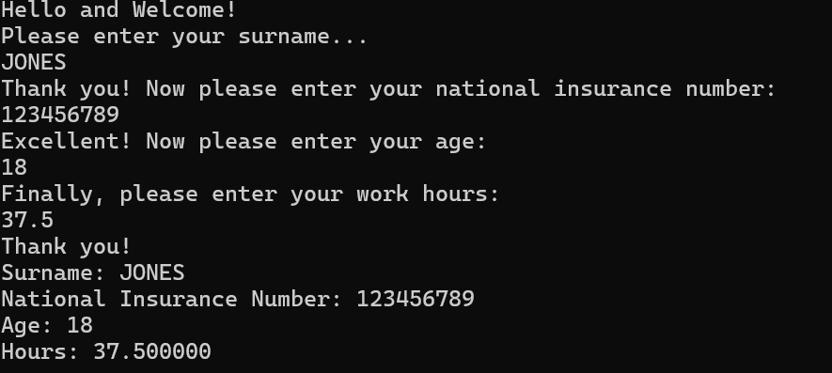
Result: Did the programme behave as expected ie syntactically and logically correct?
YES
If NO, what went wrong?
If YES, comment on what happened
The program accepts 37.5 and provides all entered information. However, the printed hours could be improved by rounding the working hours to 1 decimal place.

Test: Working hours ii Enter 105

Screenshot(s) of output:
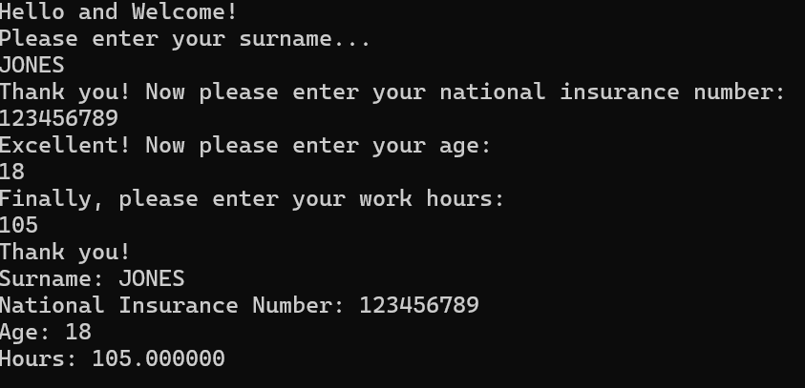
Result: Did the programme behave as expected ie syntactically and logically correct?
YES
If NO, what went wrong?
If YES, comment on what happened
The program accepts 105 as it is between the parameters of 0 and 168 hours

Test: Working hours iii Enter 0

Screenshot(s) of output:
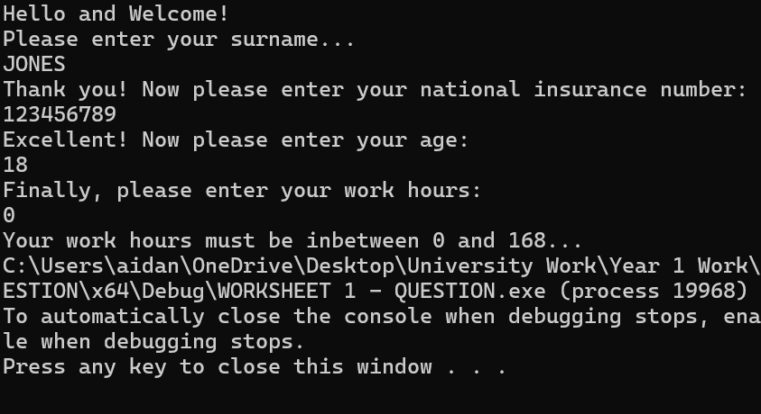
Result: Did the programme behave as expected ie syntactically and logically correct?
YES
If NO, what went wrong?
If YES, comment on what happened
The program does not accept 0 as it is not between the work hour parameters of 0 and 168. It must be greater than 0 and less than 168

Test: Working hours iii Enter -2

Screenshot(s) of output:
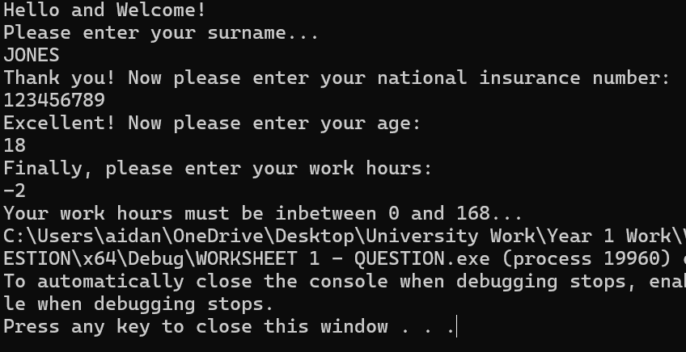
Result: Did the programme behave as expected ie syntactically and logically correct?
YES
If NO, what went wrong?
If YES, comment on what happened
The program does not accept -2 as it is not between the work hour parameters of 0 and 168. It must be greater than 0 and less than 168

- Consider the results of the above tests and revisit your code in order to solve the problems. (Note: you may not be able to solve all of them, but solve as many as you can.)

Paste your revised code here:

#define _CRT_SECURE_NO_WARNINGS
#include <stdio.h>
#include <string.h>

void main()
{
int theLength;
char Surname[30];
char NIN[10];
int Age;
float Hours;

Age = 0;

printf("Hello and Welcome!\n");
printf("Please enter your surname... \n");
scanf("%s", &Surname);
if (strlen(Surname) > 0 && strspn(Surname, "abcdefghijklmnopqrstuvwxyzABCDEFGHIJKLMNOPQRSTUVWXYZ '-") == strlen(Surname))
{
printf("Thank you! Now please enter your national insurance number: \n");
scanf("%s", &NIN);
theLength = strlen(NIN);
if (theLength == 9)
{
printf("Excellent! Now please enter your age: \n");
scanf("%d", &Age);
if (Age < 116 && Age >= 18)
{
printf("Finally, please enter your work hours: \n");
scanf("%f", &Hours);

if (Hours < 168 && Hours > 0)
{
printf("Thank you!\n");
printf("Surname: %s\n", Surname);
printf("National Insurance Number: %s\n", NIN);
printf("Age: %d\n", Age);
printf("Hours: %f\n", Hours);
}
else
{
printf("Your work hours must be inbetween 0 and 168...");
}
}
else
{
printf("You must be age 18 or over to enter a national insurance number...");
}
}
else
{
printf("Your National Insurance Number must be 9 characters ing length...");
}
}
else
{
printf("Invalid surname: only letters, space, hyphen, and apostrophe allowed.\n");
}
}

