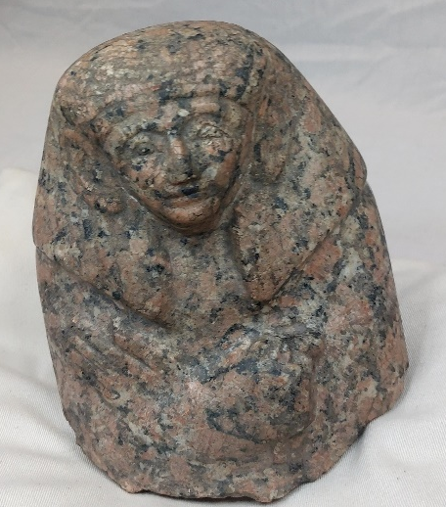
My plan for creating a social media advertisement would initially be a series posts on internet platforms such as Facebook and Instagram, while also utilising the advertisement feature on those platforms due to their high site traffic. By doing my advertising campaign this way, my advertisement has a higher possibility of attracting a higher volume of a potential audience. The main reasoning for using this method of advertisement is that these social media platforms have an incredibly large user base with Facebook having an estimated 44 million users within the United Kingdom alone, Although it is safe to assume that the maximum audience will not be this size it can lead to estimates on how many potential visitors will be able to have the advertisement appear on their feed. The target audience for this exhibition that the advertisements would be aimed towards the common person, somebody who does not have a particular background with Ancient Egypt, or more specifically the Old Kingdom Period which ranged from 2055 BCE until 1650 BCE. However, the advertising could also potentially be promoted within academic circles as it is still a useful tool for those studying the Old Kingdom specifically or just the greater field of Ancient Egyptian history. Any advertising done will include at least a single imagine of the Fragmented Statue like the image shown on the left. The advertisement will also contain some basic information about the artifact but not too much as to make a visit to view it irrelevant, the advertisement will also include references to its age as it estimated to be within the region of 3500 years to a significant 4000 years old. It will also be given any relevant hashtags on the posts, although this is most useful on Instagram as you can follow individual tags, and as a result of this the advertisement will have an increased chance of appear one the feed of a person who is interested within the subject matter or other factors such as museums etc.
For my advertisement the wording will be presented as the following: “Come and see the top half of an Ancient Egyptian statue hailing from the Old Kingdom period at [Location/Venue]. This statue is a must see for anyone with the slightest interest in Ancient Egyptian craftsmanship or history as the object is anywhere between 3500 years old to 4000 years old. So come along as see this magnificent piece of history from one of the oldest civilisations in our collective history.” The hashtags for this post will include relevant hashtags such as: #Statue, #OldKingdom, #AncientEgypt, #Hieroglyphics, #Museum and #Exhibit, to name a few. However, this method only works for platforms like Instagram and Twitter, while on Facebook the posts would most likely be posted in certain groups that relate to Museums, Ancient Egypt and the Old Kingdom of Ancient Egypt. Also, for further advertising opportunities the ad could be put on the venue or organisations website to have the event being advertised for people who visit the website to see what is upcoming.

Shepherd, Jack. https://thesocialshepherd.com/blog/facebook-statistics#:~:text=Out%20of%20the%20total%20estimated,of%20the%20total%20UK%20population. 30 Essential Facebook Statistics You Need To Know In 2022. 05/10/2022

