SHIVKUMAR GIRISHBHAI RANA
2321276

HOW DOES THE HRM FUNCTION IMPACT THE BUSINESS HEALTH OF ORGANIZATIONS?

Table of Contents
Introduction 4
Research Background 4
Research rationale 6
Literature review 8
Analysis of the impact of HRM function on business health in an organization 8
Relationship between HRM practices and employee engagement to enhance organizational outcome 10
Analysis of the different challenges faced by HRM in the business organization. 12
Recommendation of some suitable suggestions to mitigate HRM challenges for developing an organization's business health. 14
Theoretical framework 15
Literature gap 17
Discussion of the research, aim, objective, and research question 17
Research aim 17
Research objective 17
Research Questions 18
Paradigm and Methodology 18
Research Paradigm 18
Research Philosophy 19
Research Approach 21
Research strategy 22
Research Design 22
Methodology 24
Data collection method 24
Data analysis method 25
Sampling 27
Significance of the Study 27
Discuss resource implications and needs 28
Time plan for the research process 28
Ethical considerations 29
Limitations 29
References List 31

List of figures
Figure 1: “Human resources professionals' strategies” to accelerate employees' “skill development” globally in 2021 6
Figure 2: Challenges faced by the HRM during the Covid-19 8
Figure 3: Role of “HR analytics” 10
Figure 4: Relationship between HRM practices and employee engagement 12
Figure 5: Challenges of HR Manager 14
Figure 6: Leadership characteristics on Human resource development 16
Figure 7: AMO theory 17
Figure 8: “Advantages of interpretivism research philosophy” 21
Figure 9: “Advantages of Inductive approach” 22
Figure 10: “Advantages of explanatory research design” 24
Figure 11: Advantages of “secondary data collection method” 26
Figure 12: “Advantages of qualitative data analysis technique” 27
Figure 13: Research Timeline 30

Introduction
HR functions play a vital role in improving the performance level of the employees in a business organization. Through “enhancing communication and promoting the culture”, HR reduced the workplaces workplace and increased employee morale and satisfaction. This study also identified the “relationship between the HRM and employee engagement”. The rationale of the study justified the different issues of the HRM practices and on the other hand, this study also recommended the different strategies to mitigate the HRM challenges in an organization.

Research Background
The HR function plays a vital role in improving performance by motivating employees, managing their demands, and creating processes to improve and measure performance by offering various development opportunities for an organization. (Paul and Singh, 2023) Along with that, HRM is fully responsible for addressing areas within organizations and creating a positive image of an organization. HRM is responsible for attracting, recruiting, and retaining top talent within organizations. Moreover, effective retention and recruitment strategies can ensure that organizations have the right people in the right positions that directly impact innovation, competitiveness, and productivity (Tanova and Bayighomog, 2022). HRM is directly engaged with the organizational business changing process and influences the organizational performance.
In the healthcare sector, HR plays a vital role in improving the organization's health by adopting various types of strategies (Ncbi.nlm.nih.gov, 2023). This is essentially stated that HRM establishes a “performance management system” that can align with organizational objectives and individual goals. HRM boosts employees' engagement and motivation which can lead to improved performance outcomes and productivity. Moreover, HRM also plays a vital role in managing employee relations and building a positive work environment (Harney and Alkhalaf, 2021). At the same time, by enhancing communication and promoting a culture of respect and fairness, human resources help to reduce workplace disruptions as well as employee morale and satisfaction.
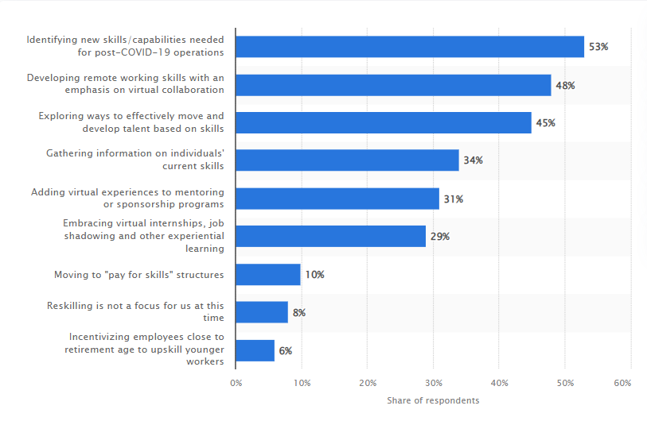

Figure 1: “Human resources professionals' strategies” to accelerate employees' “skill development” globally in 2021
(Source: Statista.com, 2023)
From the above image, it can be observed that in 2021, “human resources professionals” plan to address and enhance the skill development of employees globally. 53% of employees and people have stated that HR mostly focuses on new skill development after the pandemic and they also develop working skills for remote workers (Statista.com, 2023). However, HR provides sufficient training to their employees to improve the working performance of an organization and it aids in enhancing the sales revenue and sales growth of an organization. It is necessary to note that HRM contributes to strategic planning by offering recommendations on workforce planning, the organization’s development initiatives, and talent management as well (Podgorodnichenko et al. 2020). It helps an organization to achieve long-term success in the competitive market.
HRM enhances the organization’s productivity and makes good relations with its employees. The core function of “human resources management” is to identify an organization's future needs. It can be stated that staff development and career planning are crucial functions of HRM. HRM are selecting suitable candidates for their organization through various processes and it is a vital procedure for the organization and company’s working growth fully depends on employees' working growth (Kerdpitak and Jermsittiparsert, 2020). Moreover, performance management is another significant function of HRM and it helps to create an “environment” where workers are motivated and encouraged to provide their best and make “high-quality work.”

Research rationale
HRM faces different challenges that can significantly impact the business health condition and impact on the business operation. Most of the business organizations faced difficulties in funding, which also led to an increase in recruitment costs. The lack of skilled employees negatively impacted the business operations. HRM also faces different compliances and legal challenges that can negatively impact the business operation. It is considered the major issue of HRM in the business organization (Sindhura, 2022). The “compliance law and the regulation” are not only related to the hiring process but also to the staff benefits, payment, and other different aspects of the employees. This act and the legislation create difficulties for the HR manager.
Most of the organizations faced “high turnover rates” due to poor job satisfaction, and ineffective management which also created disruptions in productivity and increased training and recruitment costs (Kiran et al. 2023). HR also faced the challenges of the integration of the new technology, which also increased the data security risk.
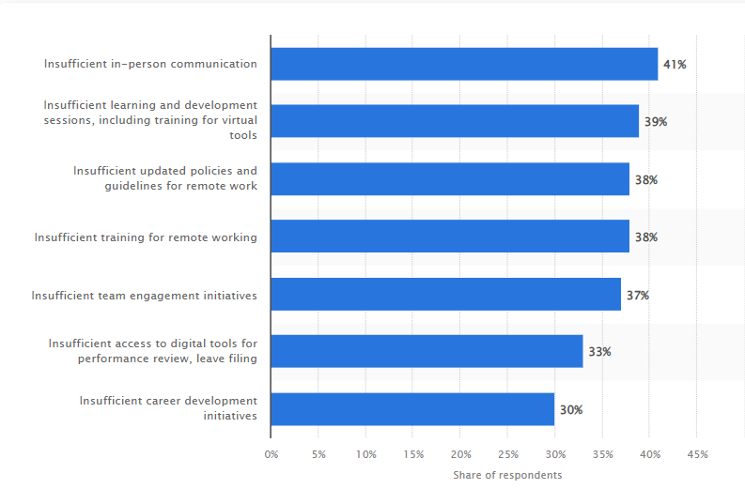

Figure 2: Challenges faced by the HRM during the Covid-19
(Source: Statista Research Department, 2022)
During the pandemic situation, the HR manager faced different challenges. Based on the above image, it has been seen that 38% of the people stated that the HR manager provided insufficient training for remote working (Statista Research Department, 2022). 37% of the people believe that “insufficient team engagement initiatives” by the HR manager are the major challenges of the business organization. On the other hand, other people stated that HR faced challenges regarding “communication, insufficient learning, and development sessions” while working from home in a pandemic situation. Due to the “globalization budget constraints, HR managers” faced the challenge (Hamouche, 2023). Over recent years, the HR manager faced difficulties during the implementation of “diversity initiatives in retail organizations” in the UK. By addressing the challenges, the HR manager contributed to the organizational success and enhanced the positive business outcome (Opatha, 2020). This study shed light on the different functions of the HRM and identified the different challenges of the HRM and their implications for the success of the organization. Determining the different complexities of the HR manager helps to explore the different strategies, which can help to enhance the HR practices and positive impact on the business health condition.

Literature review

Analysis of the impact of HRM function on business health in an organization
Creating a healthy workplace culture, offering chances for professional development, rewarding and recognizing top performance, and identifying issues can contribute to employee engagement. Hence. It can be stated that HR plays a crucial role in motivating employee engagement. As per the view of Hamouche (2023), during “covid 19”, most organizations faced a huge challenge, and at that time, HR helped to recover organizations by implementing various strategies and enhancing employee engagement. In the healthcare sector, the health crisis was raised for several reasons but HR identified issues and provided proper training to improve the working environment that was essential for an organization. Adula et al. (2022), stated that “human sources management” and an organization’s health are related to each other. Moreover, HR uses various types of innovative strategies for staff empowerment and faculty and promotes a positive culture. Therefore, HRM practices such as fair compensation, effective communication, recognition programs, and growth opportunities contribute to higher levels of employee morale and employee engagement. In an organization, engaged employees are more innovative, productive and committed to organizational goals.
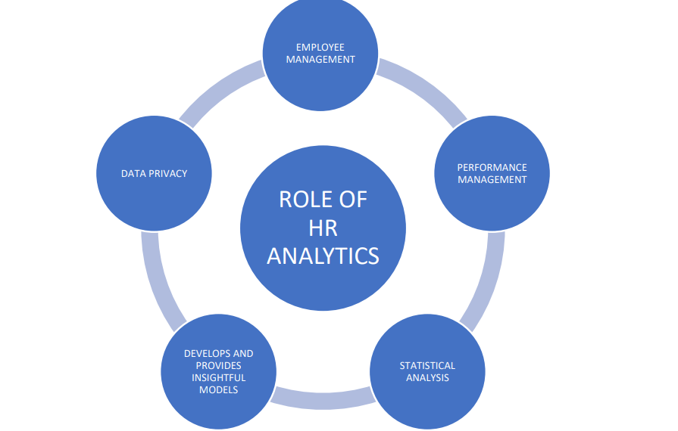

Figure 3: Role of “HR analytics”
(Source: Tomar and Gaur, 2020)
Based on this image, it can be seen that HR analytics also plays a vital role in improving an organization's business health. As per the presumptions of Tomar and Gaur (2020), HR analytics engages in the data privacy and statistical analysis process. Moreover, enhancing employee management and performance management are crucial responsibilities of HR analytics. HR analytics aids in engaging in the recruitment process by addressing the most potential candidates and their success based on historical data. By utilizing data insights. HR teams can create informed decisions in order to attract top talent. In addition, HR analytics helps organizations measure organization's engagement levels and address various factors that can contribute to retention and job satisfaction. HR teams develop business strategies to develop employee engagement, decrease turnover, and boost employee experiences as well. Thus, HR analytics can improve the business health condition of an organization. As per the words stated by Kerdpitak and Jermsittiparsert (2020), HRM is connected with hierarchical execution and they can improve employee behavior by engaging the employees. Besides, HRM invests in employee development and training programmes in order to increase knowledge and competencies. HRM plays a significant role in enhancing positive employee relations and resolving conflicts effectively. This can be stated that a positive and supportive work environment has been promoted by enhancing trust, and open communication that positively impacts business operations.

Relationship between HRM practices and employee engagement to enhance organizational outcome
HRM practices are crucial to drive “employee engagement.” Engagement defines the willingness of employees to provide their best for organizational success. As per the opinion of Van and Nafukho (2020), HR motivates and engages employees with the help of the leaders of an organization. Engaged employees are more committed and motivated to their work, which leads to high productivity. HRM practices such as recognition programs, and employee development contribute to enhancing employee engagement and can lead to developed organizational productivity. In addition, there is a “U-shaped” relationship between employee engagement and HRM practices.
If any HR is more engaged with an organization and enhances employee engagement, business growth, and job performance would also increase. On the other hand, Satata (2021), stated that employee engagement is a both psychological and physical condition related to work emotionally and aids to gain the organizational goals. Engaged employees offer high-quality service and meet the customer needs. It helps to create a stronger business health of an organization. Moreover, HRM practices focus on employee engagement that directly impacts the customer satisfaction level and enhances customer retention and loyalty as well.
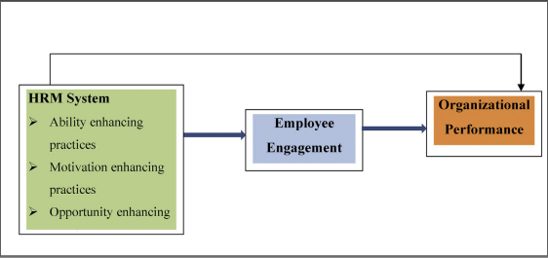

Figure 4: Relationship between HRM practices and employee engagement
(Source: Tensay and Singh, 2020)
Based on this image, it can be stated that HRM systems, employee engagement, and organizational performance are related to each other. Tensay and Singh (2020), the HRM system helps to increase employee engagement and employee engagement aids in boosting organizational performance. Employee engagement is crucial in the business environment. With the help of AMO theory, this article explained the performance appraisal, and employee engagement that can lead to enhanced organization’s productivity. Rodjam et al. (2020), stated that in this modern era, employee performance is a crucial aspect of the organization’s prosperity and growth.
Therefore, employee performance boosts the organization’s productivity and develops the workforce. The business strategies related to HRM make satisfaction among the organization's employees by using cutting-edge technologies and strategies. Moreover, engaged employees promote a positive organizational culture by enhancing shared values, trust, and collaboration. At the same time, HRM practices emphasize building strong relationships and contributing fairness and transparency to make an inclusive and supportive work culture that leads to enhancing organizational outcomes in the global competitive market.

Analysis of the different challenges faced by HRM in the business organization.
HRM faces different challenges in the business organization. Due to the increase in the “competition level, and skill shortages”, HRM faced difficulties which led to an “increase in turnover rates” and decreased organizational productivity. As opined by Tomar and Gaur, (2020), attracting top talent is the major challenge in HR practices. As per this author, HR analytics faced “data quality challenges” For the HR manager, it is not easy to collect a huge amount of data on the employees in a business organization. This organization also faced the lack of the support of the top management in a business organization. Traditional processes of the technology lead to a lower production level, which can negatively impact the HR manager. On the other hand, Hamouche, (2023), stated that the HR manager faced difficulties during the COVID-19 situation. During the pandemic situation, HR managers provide insufficient training to their employees for remote working. It also negatively impacted the employees and affected the organizational productivity and business operations. Due to insufficient team engagement initiatives and the lack of communication between the employees and the HR, it created challenges for the business organization. The “COVID-19 pandemic, globalization, and the economic crisis situation” create a complex and challenging environment for the HR manager. As stated by Hasan et al. (2021), for employee engagement, in the workplace, the HR manager faces a lot of challenges. It also decreased the rate of productivity and negatively impacted “innovation and the organizational culture”.
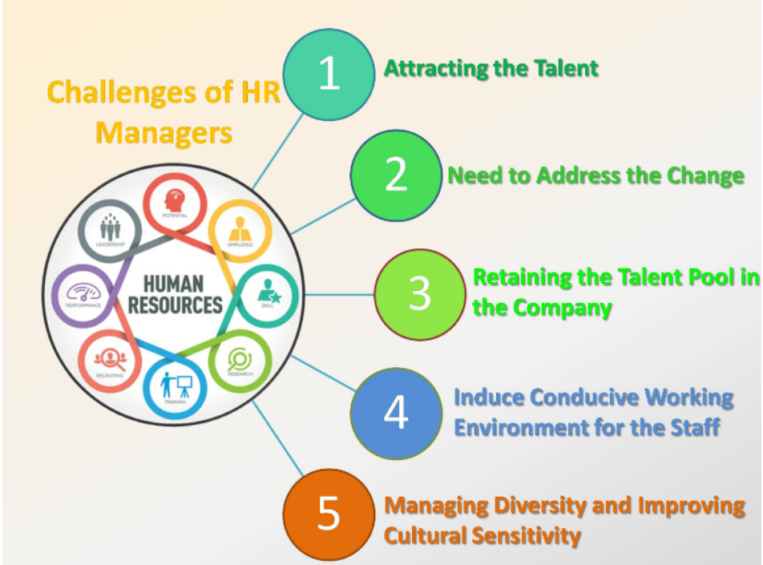

Figure 5: Challenges of HR Manager
(Source: Muktamar et al. 2023)
For “managing diversity and improving cultural sensitivity” HR also faced difficulties in a business organization. As stated by Muktamar et al. (2023), Human resources also faced “environmental challenges”. The rapidly changing environment led to the threat to the human resource management of the business organization. For this reason, the “HR manager” should adopt different policies to make the workforce more diverse. “Technological changes, legal changes, and environmental changes” affected the organizational structure and the managing styles of the business organization. But there is a lack of technical skill in the employees. It created big challenges for the HRM to train the employees regarding advanced technology to become efficient workers.

Recommendation of some suitable suggestions to mitigate HRM challenges for developing an organization's business health.
Due to the “environment, and technological changes”, the HR manager faces different difficulties, which can negatively impact the business operation. As opined by Chapman et al. (2023), the implementation of the “robust compliance management process” helps to monitor the changes in the “environmental laws and the regulations”. These strategies help to provide the training of the employees and enhance the development opportunities for the HR staff, which can help to increase the innovation process in a business organization. Due to the “lack of leadership approaches”, employees face different conflicts in a business organization. The “conflict between the HR and the employees” creates an unhealthy working environment.
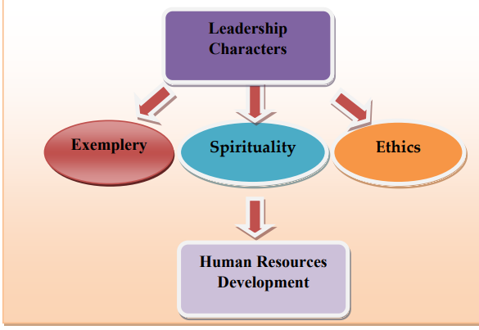

Figure 6: Leadership characteristics on Human resource development
(Source: Widyatmoko et al. 2020)
Widyatmoko et al. (2020), stated that the HR manager should develop leadership, which is considered the learning and the development strategy. The successful planning of the leaders increases employee satisfaction and affects employee morale. Good leadership practices to mitigate the challenges of HR in a business organization. As opined by Reis et al. (2021), enhanced recruitment is considered one of the important strategies that can attract top talents and provide a lot of benefits to employees. These strategies help to mitigate the “challenges of the HR manager” in a business organization. On the other hand, due to the integration of the technology, the employees faced the skill gap and it created a challenge for the HR manager to train the employees. For this reason, the HR manager provides the training and development of the HR staff, which can help to increase data-driven decision-making.
The organization should be more invested in the HR analytics tools and the technology for the data collection, which can help to improve the accuracy of the HR data. In addition, Yadav et al. (2022), stated that “implementing employee engagement initiatives” is considered one of the important strategies that can help to mitigate the HRM challenges for developing the business health condition. As per this author, the “employee engagement” positively impacted on the organizational effectiveness. During the pandemic situation, HR faced communication challenges. For this reason, the organization should develop a communication channel between the HR and the employees. Through the implementation of these strategies, the organization mitigated the HRM challenges and increased employee engagement and productivity in the workplace.

Theoretical framework
AMO Theory
AMO theory indicates the three different components such as “ability, motivation and opportunities”, which can help to indicate “organizational behaviours”. These three components help to shape “employee characteristics” and contribute to the overall success of the business organization (Bos‐Nehles et al. 2023). This theory helps to portray the “human resources management system” in a business organization. HR managers used this theory to describe the complex relationship between the “employees in the workplace and their outcomes” in the business organization.
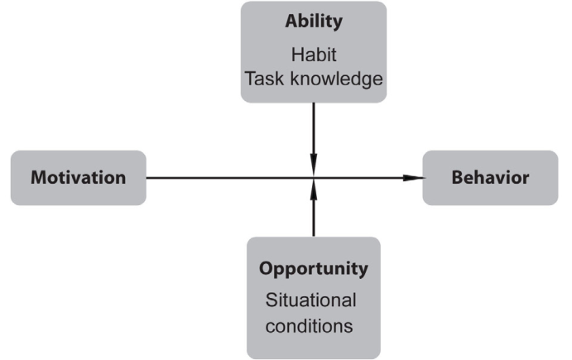

Figure 7: AMO theory
(Source: Researchgate.net, 2023).
Through the application of this theory, an HR manager enhances the employee's ability. The different training and development programs help the employees to gather the different skills in a business organization. Developed the performance management system to help to increase the ability of the employees in a business organization (Xintong, 2023). This theory helps to enhance the engagement level of the employees in a business organization. Through the application of the different strategies, the HR manager motivated the employees and fulfilled the goals of the business organization. The opportunities also indicated the different external conditions. The main aim of HRM practices is to increase employee opportunities in the business organization (Astudillo-Rodas and Riccucci, 2021). “Developing communication, and collaboration” between employees can help to increase employee opportunities. This model helps leaders to improve employee performance and aids in meeting the strategic objective of the organization.

Literature gap
This study described the relationship between HRM practices and the employee engagement in the business organization but does not cover the financial performances and the business operations in the business organization. It is considered the major gap of the literature review. On the other hand, this study has limited exploration of the HRM practices. This study does not describe the specific leadership styles on the HRM effectiveness and the employee engagement and there is a lack of the data on the HRM practices, which is considered the major gap of the study.

Discussion of the research, aim, objective, and research question

Research aim
This study aims to analyze the ways in which HRM function impacts the “business health of the organization.”

Research objective
- To analyze the impact of HRM function on business health in an organization.
- To establish a relationship between HRM practices and employee engagement to enhance organizational outcome
- To identify challenges faced by HRM in the business organization.
- To recommend some suitable suggestions to mitigate HRM challenges for developing an organization's business health.

Research Questions
- How does the “HRM function impact the business health of organizations?”
- What is the relationship between HRM practices and employee engagement to enhance organizational outcomes?
- What are the challenges faced by HRM in the business organization?
- What are effective suggestions to mitigate HRM challenges for developing an organization's business health?

Paradigm and Methodology

Research Paradigm
“Pragmatism” is an important concept of the research methodology and it is considered one of the “philosophical movements” that can help to investigate real-world problems. Through the use of different multi-source data, this “research paradigm” answered the different research questions of the study (Muzari et al. 2022). The “pragmatist research” indicated that most importantly “research design, research approach, and philosophy”. It can help to identify the research problem and help to solve the research question (Saunders et al 2023). “Paradigm” is considered one of the “important philosophical approaches” that focuses on the “theoretical understanding of the research”. It primarily focuses on “problem-solving orientation” and prioritizes the potential solutions of the research.

Research Philosophy
“Research philosophy” is the important layer of the research onion. The “research philosophy” helped to make decision-making about the “research approach, strategy, and data collection method” and indicate the different procedures and techniques to answer the research question (Saunders et al. 2023). There are different types of research philosophy but the philosophy is mainly divided into “ontology, epistemology, and axiology”.
This study will be based on “secondary qualitative research”. For this reason, this study will select the “interpretivism research philosophy”. The “interpretivism research philosophy” will be suitable for determining the HRM functions in a business organization (Al Harahsheh and Pius, 2020). The main aim of this research philosophy is to “increase the general understanding of the reality” of HRM practices, which can impact on the business health condition in a business organization. This research philosophy will help to fulfil the research objective. This philosophy provides a detailed “contextual understanding of the HRM practices” and it can help to explore the organizational culture that can help to shape the effectiveness of the HRM practices in the business organization.

Figure 8: “Advantages of interpretivism research philosophy”
(Source: Created by Author)
This research philosophy will help to explore the relationship between “HRM practices and employee engagement in business operations. For the development of the qualitative findings of the “HRM function on the organizational health condition”, this research will select the “interpretivism research philosophy” (Primecz, 2020). On the other hand, this study will avoid the “positivism philosophy” because this philosophy helps to identify the “quantitative data on the research” and it is based on a large number of sample sizes. It is considered the major disadvantage of the “positivism philosophy”. For this reason, the researcher will avoid the “positivism philosophy”.

Research Approach
This research will select the “inductive research approach”. The “inductive research approach” will be based on the “interpretivism philosophy”. For the development of the “secondary qualitative research”, this study will select the “inductive research approach” (Zhang et al. 2021). The researcher will use the “inductive research approach” to establish the relationship between “HRM practices and financial performances and business operations”. It is considered the major advantage of this research approach. “The inductive theory of this research” will help to the overall development of the research strategy. It can help to develop a “grounded Theory for Research”.

Figure 9: “Advantages of Inductive approach”
(Source: Created by Author)
This approach also helps to provide flexibility through analysis of the “HRM function in the organizational context”. For this reason, this study will accept the “inductive research approach” and will avoid the “deductive approach” because the “deductive approach” helps to describe the “descriptive analysis” of the study. This approach also provides incorrect conclusions on the study and it helps to “interpret the statistical method” of the study (Niaz et al. 2023). For this reason, this approach will create disadvantaged for the qualitative study and will accept the “inductive approach”. This approach will contribute to the “theoretical generation” in the context of the “HRM function in the business organization”.

Research strategy
There are different forms of the “research strategy such as the survey. case study, thematic analysis, interview analysis”, and others (Wisker, 2009). For the development of the research, this study will select the thematic analysis research strategy. This research strategy helped to develop qualitative research in the context of the functions of the HRM, which impacted the business health of the organization. This research strategy will be suitable for meeting the research objective. The researcher will select 15 articles for the development of the thematic analysis of the research. “Thematic analysis research strategy” provides a deep understanding of different perceptions of HRM practices (Nuraini et al. 2024). This research strategy helps to develop the “relationship between the different themes”. Through the “data collection, coding, and the development of thematic analysis”, this study will improve the qualitative findings of the research.

Research Design
Research design is an important concept for data collection. There are different types of “research designs” such as “explanatory, descriptive”, and others. This study will select the “explanatory research design”, because, this research design helps the researcher to gain an “understanding of the concept of the HRM functions” (Bentouhami et al. 2021). It can impact the organization’s health. In the context of this research, this research design provides a lot of advantages. This research design helps to the development of “qualitative funding” and helps to identify the “different challenges of the HRM function”, which can negatively impact on the business operation. Through conducting this “explanatory research design”, the researcher will predict the cause behind the challenges of HRM practices (Sidharth, 2023). This approach will help to predict the future directions of the functions of the HRM.

Figure 10: “Advantages of explanatory research design”
(Source: Created by Author)
This research design will help to explore the complex situation in the context of the study. On the other hand, “descriptive research design” helps to evaluate the “primary quantitative study”. The main disadvantage of the “descriptive research design” is that the research design has limited depth analysis (Taherdoost, 2022). “Lack of contextual understanding” is one of the limitations of the “descriptive research design”. This research design only provides valuable insights into quantitative funding. As this study will follow the “secondary qualitative research”, the researcher will select the “explanatory research design”.

Methodology

Data collection method
“Data collection method” is a crucial process in the overall research process because it will help to collect data and information about the research topic. Moreover, the “data collection method” is divided into two sections such as, “primary and secondary method.” For analyzing the role of HRM in business health, the researcher will take “secondary qualitative data.” It can be stated that the analysis of secondary data is a comparably cheaper and time effective method than the primary study (Feng et al. 2021). The researcher will collect authentic data regarding HRM contribution in various organizations by collecting information from various sources including journals, articles, websites, and so on. At the same time, accessing secondary data about HR practices and organizational performance metrics can provide significant insights into the research study.

Figure 11: Advantages of “secondary data collection method”
(Source: Created by Author)
A total of 15 articles will be collected from Google Scholar and ProQuest. The “secondary study” will save money, time, and energy while conducting this research. It is a quicker process than the “primary study” and it will help to provide detailed insights into employee engagement and the HR process in an organization (Cutchin et al. 2020). By obtaining “secondary sources” from various journals and articles, the researcher will collect data about workplace culture to understand the HRM practices that contribute to developing the business health of any organization. For this reason, the researcher will choose the “secondary data” and reject the “primary data collection method” for this research study.

Data analysis method
After data collection, “data analysis” is vital to conduct the research paper. There are two types of “data analysis techniques” such as “qualitative and quantitative.” For evaluating this research topic, the “qualitative technique” will be used in this paper. However, with the help of this technique, a detailed, holistic, and deeper view of HRM practices will be provided in this study (Mezmir, 2020). Moreover, this technique will help to capture various aspects of HRM practices and their impact on the talent acquisition process within an organization. For the analysis of this study, the researcher will conduct a thematic analysis based on 15 articles. All 15 articles will be peer-reviewed and must be published after 2020.

Figure 12: “Advantages of qualitative data analysis technique”
(Source: Created by Author)
All articles and journals will be collected from Google Scholar and ProQuest which will provide authentic information about the research topic. Moreover, with the aid of this particular technique, the researcher will be able to reveal the primary causes of research problems (Vindrola-Padros and Johnson, 2020). The quantitative technique cannot find the root causes of the research problems and will not be effective for secondary studies. Besides, the “qualitative technique” will help to analyze the HRM practices and their impacts on the business organization in a scientific manner that cannot be possible for the “quantitative study” (Taherdoost, 2022). Thus, the qualitative thematic analysis” will be considered and the “quantitative technique” will be rejected for this study.

Sampling
Sampling is a process that helps to choose random articles from a wide range of population sizes. The “purposive sampling size” will be selected for this research study (Berndt, 2020). With the help of this sampling, a total of 15 articles will be taken from Google Scholar and ProQuest regarding the research topic. However, “purposive sampling” will help to save both time and money in the “data collection process.” Again, it will also help to provide an in-depth analysis with the help of the “qualitative research design” (Makwana et al. 2023). The “purposive sampling” tends to be high-quality information that can be specific to analyze the research topic.

Significance of the Study
HRM is a significant topic that plays a significant role in this study. In any organization, HRM has played a vital role in improving the business health of an organization. Moreover, effective HRM practices lead to higher employee satisfaction and performance. By understanding how HRM influences these factors, organizations can improve productivity (Makwana et al. 2023), decrease turnover, and increase employee engagement. This study is significant because HRM practices positively impact financial performance. Human resources help an organization to gain sustainable competitive advantages and influences on organizational culture.
At the same time, HRM practices not only influence organizational outcomes but also affect the employee's well-being. Research in this area can shed light on how HRM practices impact employee engagement and employee satisfaction as well. HRM not only benefits the companies but also develops employee productivity, employee engagement, and business growth (Podgorodnichenko et al. 2020). Besides, HRM helps to develop an organization’s strategic approach to training, and recruitment of HR. HRM is a crucial function in every organization. Without HRM, organizations would not be able to “recruit and retain employees” develop and increase organization. For this reason, this study will be significant and HRM is also crucial for any organization’s development.

Discuss resource implications and needs
For conducting this study, the researcher will take approximately 9 For the topic selection and analysis, the researcher will take time around 7 days to generate research aims and objectives within the next 14 days or two weeks. After that, the researcher will take week 4 and week 5 to conduct the literature review. After that, the data collection and analysis process will be completed within 21 days and the final file will be submitted in week 9. For evaluating this research, the researcher will not spend a huge amount of money on resources because the “Secondary study” will be very cost-efficient and time-effective.

Time plan for the research process
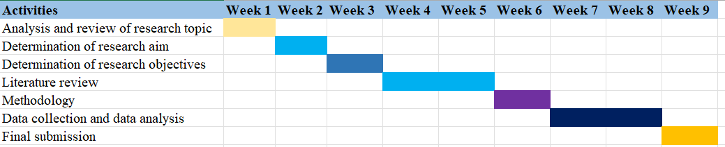

Figure 13: Research Timeline
(Source: Created by Author)

Ethical considerations
“Ethical consideration” is significant in the research to ensure a respectful and responsible usage of existing data. Therefore, in order to evaluate this study, the researcher will follow and maintain all ethics and rules. The researcher will obtain proper permissions to copyright laws while using any copyrighted material (Gostinska, 2022). The researcher must maintain the integrity and accuracy used in the secondary research. Plagiarism must be avoided to analyze this research and all data must be handled securely.

Limitations
This study will be based on the secondary qualitative data but the primary research will be more effective. With the help of the primary study, the researcher can collect authentic primary data about the HRM practices of the business organization through surveys (Podgorodnichenko et al. 2020). But in order to analyze this study, the researcher will collect only secondary sources which are only partially reliable for this study. However, lack of time and resources, the researcher will not get proper time to analyze this study effectively. It will be considered one of the major limitations of this research.

References List
Adula, M., Kant, S. and Birbirsa, Z.A., 2022. Systematic Literature Review on Human Resource Management Effect on Organization Performance. Annals of Human Resource Management Research, 2(2), pp.131-146.
Alharahsheh, H.H. and Pius, A., 2020. A review of key paradigms: Positivism VS interpretivism. Global Academic Journal of Humanities and Social Sciences, 2(3), pp.39-43.
Astudillo-Rodas, M. and Riccucci, N.M., 2021. Personnel management: improving employee and organizational performance. Handbook of Theories of Public Administration and Management, pp.167-178.
Bentouhami, H., Casas, L. and Weyler, J., 2021. Reporting of “theoretical design” in explanatory research: A critical appraisal of research on early life exposure to antibiotics and the occurrence of asthma. Clinical Epidemiology, pp.755-767.
Berndt, A.E., 2020. Sampling methods. Journal of Human Lactation, 36(2), pp.224-226.
Bos‐Nehles, A., Townsend, K., Cafferkey, K. and Trullen, J., 2023. Examining the Ability, Motivation and Opportunity (AMO) framework in HRM research: Conceptualization, measurement and interactions. International Journal of Management Reviews, 25(4), pp.725-739.
Chapman, M., Xu, L., Lapeyrolerie, M. and Boettiger, C., 2023. Bridging adaptive management and reinforcement learning for more robust decisions. Philosophical Transactions of the Royal Society B, 378(1881), p.20220195.
Cutchin, G.M., Plexico, L.W., Weaver, A.J. and Sandage, M.J., 2020. Data collection methods for the voice range profile: a systematic review. American Journal of Speech-Language Pathology, 29(3), pp.1716-1734.
Feng, Y., Duives, D., Daamen, W. and Hoogendoorn, S., 2021. Data collection methods for studying pedestrian behaviour: A systematic review. Building and Environment, 187, p.107329.
Gostimskaya, I., 2022. CRISPR–cas9: A history of its discovery and ethical considerations of its use in genome editing. Biochemistry (Moscow), 87(8), pp.777-788.
Hamouche, S., 2023. Human resource management and the COVID-19 crisis: Implications, challenges, opportunities, and future organizational directions. Journal of Management & Organization, 29(5), pp.799-814.
Harney, B. and Alkhalaf, H., 2021. A quarter‐century review of HRM in small and medium‐sized enterprises: Capturing what we know, exploring where we need to go. Human Resource Management, 60(1), pp.5-29.
Hasan, H., Nikmah, F., Nurbaya, S., Fiernaningsih, N. and Wahyu, E., 2021. A review of employee engagement: Empirical studies. Management Science Letters, 11(7), pp.1969-1978.
Kerdpitak, C. and Jermsittiparsert, K., 2020. The influence of organizational culture, employee commitment and organization citizen behaviour on the HRM practices: Mediating role of perceived organization support. Systematic Reviews in Pharmacy, 11(1), pp.407-415.
Kiran, P.R., Chaubey, A. and Shastri, R.K., 2023. Role of HR analytics and attrition on organisational performance: a literature review leveraging the SCM-TBFO framework. Benchmarking: An International Journal.
Makwana, D., Engineer, P., Dabhi, A. and Chudasama, H., 2023. Sampling Methods in Research: A Review. Int. J. Trend Sci. Res. Dev, 7, pp.762-768.
Mezmir, E.A., 2020. Qualitative data analysis: An overview of data reduction, data display, and interpretation. Research on humanities and social sciences, 10(21), pp.15-27.
Muktamar, A., Wahdiniawati, S.A., Fatmawati, F. and Mardikawati, B., 2023. Challenges and Opportunities in HRM Research in the Era of Globalization: A Bibliometric Analysis of the Effects of Cultural Diversity and Innovation in Organizations. West Science Interdisciplinary Studies, 1(11), pp.1177-1186.
Muzari, T., Shava, G.N. and Shonhiwa, S., 2022. Qualitative research paradigm, a key research design for educational researchers, processes and procedures: A theoretical overview. Indiana Journal of Humanities and Social Sciences, 3(1), pp.14-20.
Ncbi.nlm.nih.gov, (2023). The Link between HRM Practices and Performance in Healthcare: The Mediating Role of the Organizational Change Process. Available at: https://www.ncbi.nlm.nih.gov/pmc/articles/PMC10178150/ [Accessed on 17-04-2024]
Niaz, S., Salam, T. and Nazir, S., 2023. Statistical Methods in Computer Science: A Comparative Review of Inductive and Deductive Approaches. VAWKUM Transactions on Computer Sciences, 11(1), pp.204-216.
Nuraini, N., Basalamah, I., Hanadelansa, H. and Murniati, S., 2024. Examining the Impacts of Human Resource Management HRM-Financial Management Alignment: A Qualitative Review of Accounting Literature. Atestasi: Jurnal Ilmiah Akuntansi, 7(1), pp.442-458.
Opatha, H.H.D.P.J., 2020. HR analytics: a literature review and new conceptual model. International Journal of Scientific and Research Publications, 10(6), pp.130-141.
Paul, P. and Singh, B., 2023. Healthcare employee engagement using the Internet of things: A systematic overview. The Adoption and Effect of Artificial Intelligence on Human Resources Management, Part A, pp.71-97.
Podgorodnichenko, N., Edgar, F. and McAndrew, I., 2020. The role of HRM in developing sustainable organizations: Contemporary challenges and contradictions. Human Resource Management Review, 30(3), p.100685.
Primecz, H., 2020. Positivist, constructivist and critical approaches to international human resource management and some future directions. German Journal of Human Resource Management, 34(2), pp.124-147.
Reis, I., Sousa, M.J. and Dionísio, A., 2021. Employer branding as a talent management tool: A systematic literature revision. Sustainability, 13(19), p.10698.
Researchgate.net, (2023). The motivation-opportunity-ability model Available at: https://www.researchgate.net/figure/The-motivation-opportunity-ability-model-19_fig3_254463912[Accessed on: 4/17/2024]
Rodjam, C., Thanasrisuebwong, A., Suphuan, T. and Charoenboon, P., 2020. Effect of Human Resource Management Practices on Employee Performance Mediating by Employee Job Satisfaction. Systematic Reviews in Pharmacy, 11(3).
Satata, D.B.M., 2021. Employee engagement as an effort to improve work performance: literature review. Ilomata International Journal of Social Science, 2(1), pp.41-49.
Saunders, M., Lewis, P. & Thronhill, A. (2012). Research Methods for Busdiness Students (4th ed.). Harlow: Pearson Education Ltd.
Sidharth, G., 2023. Research Designs for Contemporary Social Science Research: An Overview. International Research Journal of Management, Sociology & Humanities, 14(1), pp.381-392.
Sindhura, K., 2022. Talent Management Strategies in Human Resource Management: Critical for Business-A Systematic Review. Journal of Positive School Psychology, 6(3), pp.3396-3409.
Statista Research Department, (2022). Major HR challenges while working remotely during COVID-19 APAC 2020. Available at: https://www.statista.com/statistics/1306659/apac-hr-challenges-while-working-remotely-during-covid-19/ [Accessed on: 4/17/2024]
Statista.com, (2023). Human resources professionals strategies to accelerate employees' skill development worldwide 2021. Available at: https://www.statista.com/statistics/1235402/hr-professionals-plans-to-accelerate-skill-development/ [Accessed on 17-04-2024]
Taherdoost, H., 2022. What are different research approaches? Comprehensive Review of Qualitative, quantitative, and mixed method research, their applications, types, and limitations. Journal of Management Science & Engineering Research, 5(1), pp.53-63.
Tanova, C. and Bayighomog, S.W., 2022. Green human resource management in service industries: the construct, antecedents, consequences, and outlook. The Service Industries Journal, 42(5-6), pp.412-452.
Tensay, A.T. and Singh, M., 2020. The nexus between HRM, employee engagement and organizational performance of federal public service organizations in Ethiopia. Heliyon, 6(6).
Tomar, S. and Gaur, M., 2020. HR analytics in business: role, opportunities, and challenges of using it. Journal of Xi’an University of Architecture & Technology, 12(7), pp.1299-1306.
Van, H.T.M. and Nafukho, F.M., 2020. Employee engagement antecedents and consequences in Vietnamese businesses. European Journal of Training and Development, 44(2/3), pp.89-103.
Vindrola-Padros, C. and Johnson, G.A., 2020. Rapid techniques in qualitative research: a critical review of the literature. Qualitative health research, 30(10), pp.1596-1604.
Widyatmoko, W.F., Pabbajah, M. and Widyanti, R.N., 2020. The character of leadership in human resources development: A critical review. International Journal of Management, Innovation & Entrepreneurial Research, 6(2), pp.1-9.
Wisker, G. (2009). The undergraduate research handbook. New York: Palgrave Macmillan.
Xintong, T., 2023. Review of Research on Employee Innovation with AMO Theory. In Proceedings of the 6th International Conference on Economic Management and Green Development (pp. 1005-1013). Springer, Singapore.
Yadav, A., Pandita, D. and Singh, S., 2022. Work-life integration, job contentment, employee engagement and its impact on organizational effectiveness: a systematic literature review. Industrial and Commercial Training, 54(3), pp.509-527.
Zhang, Y., Xu, S., Zhang, L. and Yang, M., 2021. Big data and human resource management research: An integrative review and new directions for future research. Journal of Business Research, 133, pp.34-50.

