Luke Evans

BIT

Business Information Systems

Due 17/05/2019

Contents
Luke Evans 1
BIT 1
Business Information Systems 1
Due 17/05/2019 1
ETL Plan – UKAEA Data Warehouse – Initial Build 3
Introduction 3
Existing Source System 3
Data Warehouse 5
Changes Made to the data 5
Data Warehouse prototype 5
Data Warehouse Reports 6
Top five expense types 6
Top five expense areas 6
Suppliers who received the most money from each department 7
Data Warehouse Dashboard 7
Data Warehouse Implementation 8
Data Warehouse Final Product 9
Schema Diagram 11
Bibliography 18

ETL Plan – UKAEA Data Warehouse – Initial Build

Introduction
In this task, a data warehouse prototype will be designed and created for the company UKAEA; this will be done using the data that they have collected from their first quarter of 2018 which is from April to June. Throughout the document all aspects of the creation process will be touched upon such as data that had to be cleaned, what features would be implemented for the final version or potential limitations of the data warehouse.

Existing Source System
The Existing source system was an excel spreadsheet and it’s from these the data will be extracted to then fill the data warehouse. These data sheets were provided by UKAEA themselves for each month of their first quarter and the screenshots below show them after data cleaning has been completed.
April:
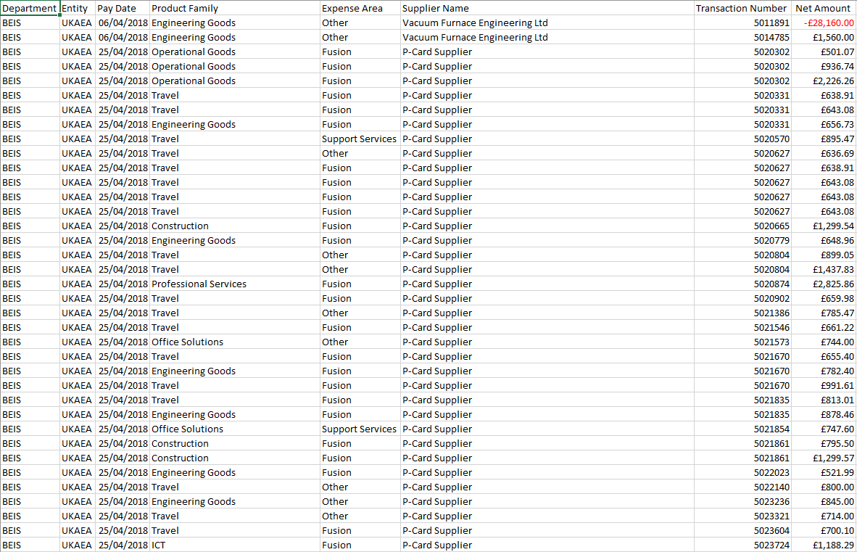

May:
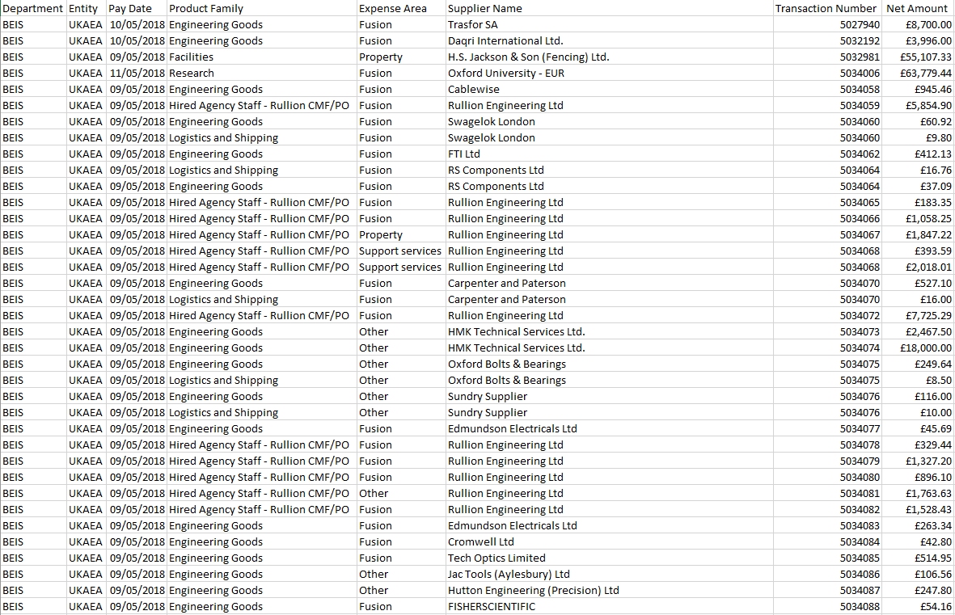

June:
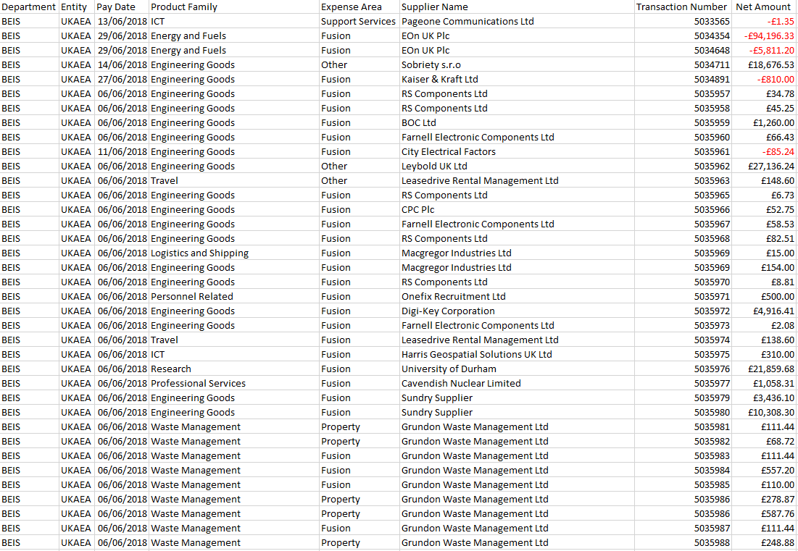

Data Warehouse
A Data Warehouse is a system that collects and stores a large amount of data of an organisation from different sources. Standard Databases can act as the sources that the data warehouse will eventually collect from. Reports can are created from the data within the data warehouse to allow the organisation to make business decisions. The data collected for the data warehouse will be from all aspects of the organisation. Organisation will typically upgrade to data warehouses due to their need to store large amounts of historical data; a normal database will allow quick access to specific transactions [1].

Changes Made to the data
Due to no contact with UKAEA, certain assumptions have to be made regarding the current data set. There could be issues with the data that haven’t been checked already and these issues would need to be sorted and altered before starting the build of the data warehouse. The changes would be made in excel before transferring to the data warehouse in Access.
Undiscovered errors were looked for throughout the UKAEA data to ensure no future issues would occur. Data cleaning involved deleting data sets with no information in them due to them being completely irrelevant. There were a number of fields that had no data other than ‘Department’ so they could easily be deleted with no repercussions; these blank records may have become a potential error once moved to access if they weren’t dealt with. Fixing the wording for the title of some fields was another way to avoid future errors. Access may not have accepted a few of them due to spaces between and before words.
It also turned out that looking for any duplicate data was very helpful; disposing of the duplicate data was a simple process that Microsoft Excel could run before the being moved over the Access.
An anomaly record was found in the data for April; a record was logged for February which was not part of this particular quarter. The assumption was that the anomaly was down to human error and someone had simply typed in the wrong number. The record was left alone to refer to staff later on just in case.

Data Warehouse prototype
A data warehouse would be used by UKAEA to create reports and quickly analyse the data stored. Within this task, a prototype data warehouse will be created to simulate how it would work. The data used for this prototype will be taken from provided sources that are during the first quarter for 2018; this will be from April to June. Microsoft Access is the software package that will be used to create this particular prototype because it can be used to create reports to display key data.
This prototype would only involve the basic functions of Access and would not include the working code required for the final version. The final version shall be discussed, mentioning the missing functions and how it would work.

Data Warehouse Reports
Reports have been created to show specific data; the data required is ‘top five expense types’, ‘top give expense areas’ and ‘supplier who received the most money from each department’. Each report was created using the queries made to detect the data set needed. The queries were created for all April, May, June and the quarter as a whole. These reports were easily created using the ‘Report’ option in Access which allowed the data that the report stored to be chosen from an interface.

Top five expense types
The data from this statistic will be solely taken from the quarter as a whole to have the highest on average. A large number of results appear in this specific report (‘ProductFamilyQuarter’) and it clearly shows the top five expense areas. These expense areas are ‘Engineering Goods’, ‘Professional Services’, ‘Hired Agency Staff – Rullion CMF/PO’, ‘Facilities’ and ‘ICT’. The screenshot below shows the report results for ‘ProductFamilyQuarter’.
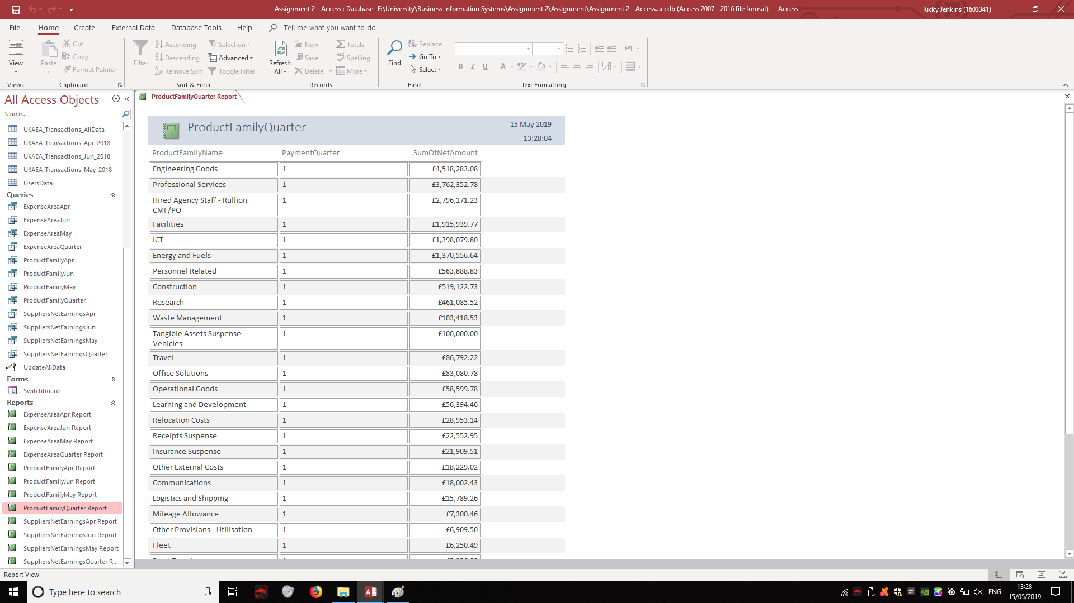

Top five expense areas
The data from this statistic will be solely taken from the quarter as a whole to have the highest on average. Only four expense areas showed in the final report but it still clearly showed them in order based on highest “SumOfNetAmount”. The top four are “Fusion”, “Other”, “Property” and “Support services”. The screenshot below shows the report results for ‘ExpenseAreaQuarter’.

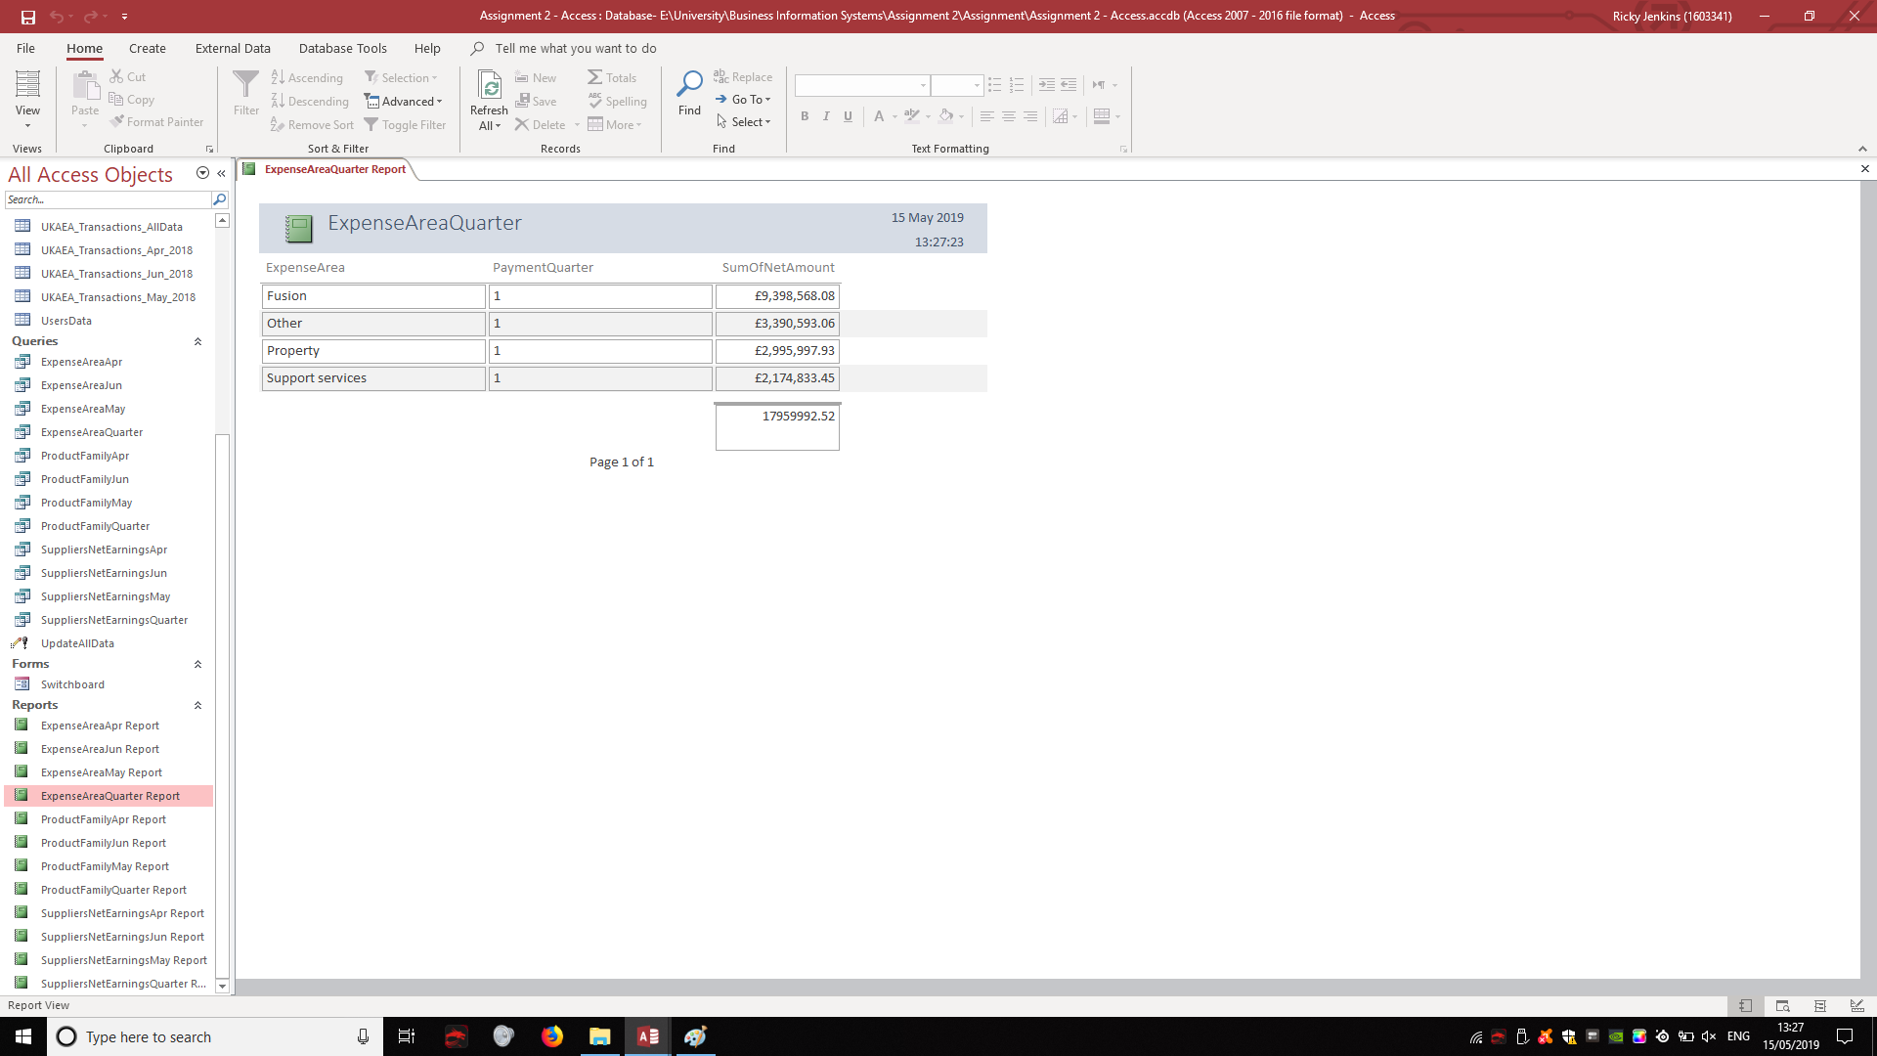

Suppliers who received the most money from each department
The data from this statistic will be solely taken from the quarter as a whole to have the highest amount of money received on average. Plenty of results appear in this specific report and it clearly shows the top five suppliers who receive the most money from each department. These suppliers include ‘Rullion Engineering Ltd’, ‘Morson International’, ‘EDF Energy’, ‘South Oxfordshire District Council’ and ‘Marsh Ltd’. The screenshot below shows the report results for “SuppliersNetEarningsQuarter’.

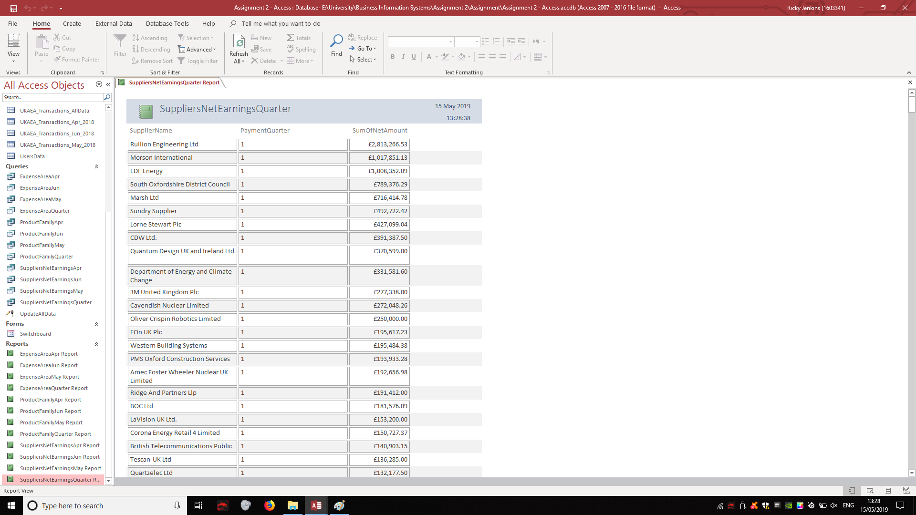

Data Warehouse Dashboard
The screenshot below shows the working dashboard within the data warehouse. The data warehouse dashboard was created as a user interface which allows any user to navigate through it finding any reports they need. Each report has a button which can take the user back to the home dashboard page and from there they can navigate where they please. The prototype allows the user to access data quickly through the dashboard. Only the necessary reports were created to answer the current key questions above and the available switchboards to access are “ExpenseArea”, “ProductFamily” and “SuppliersNetEarnings”.
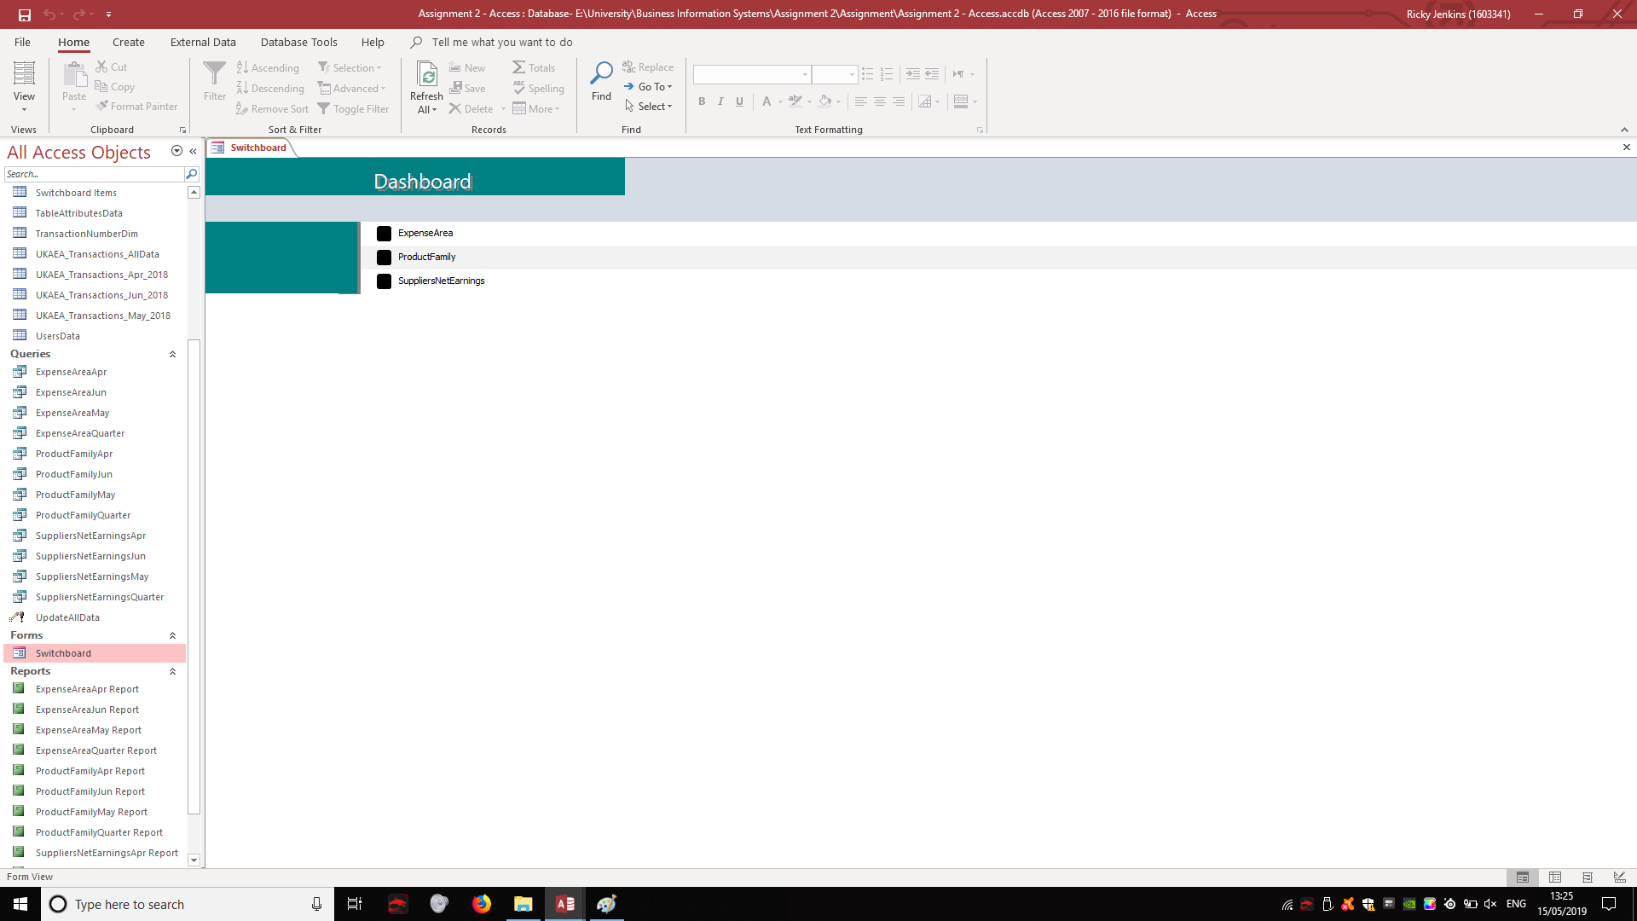

Data Warehouse Implementation
The implementation process involved migrating all of the altered data from the original data sheets into an Access where the data warehouse prototype is created. There was an issue with many of the data types such as ‘Data/Time’ due to no code being implemented in the prototype. To fix these issues, the majority of data types had to be changed to ‘Short Text’ so that they would run in the queries. With the addition of the required code, ‘Data/Time’ and other data types would be viable but this would be an addition made for the final product.
The table’s primary keys had the dim ID’s in them and they had to be changed manually in parts due to errors with Access. The screenshot below shows an example of the ‘DepartmentDim’ table which has an appropriate ID and organised fields.
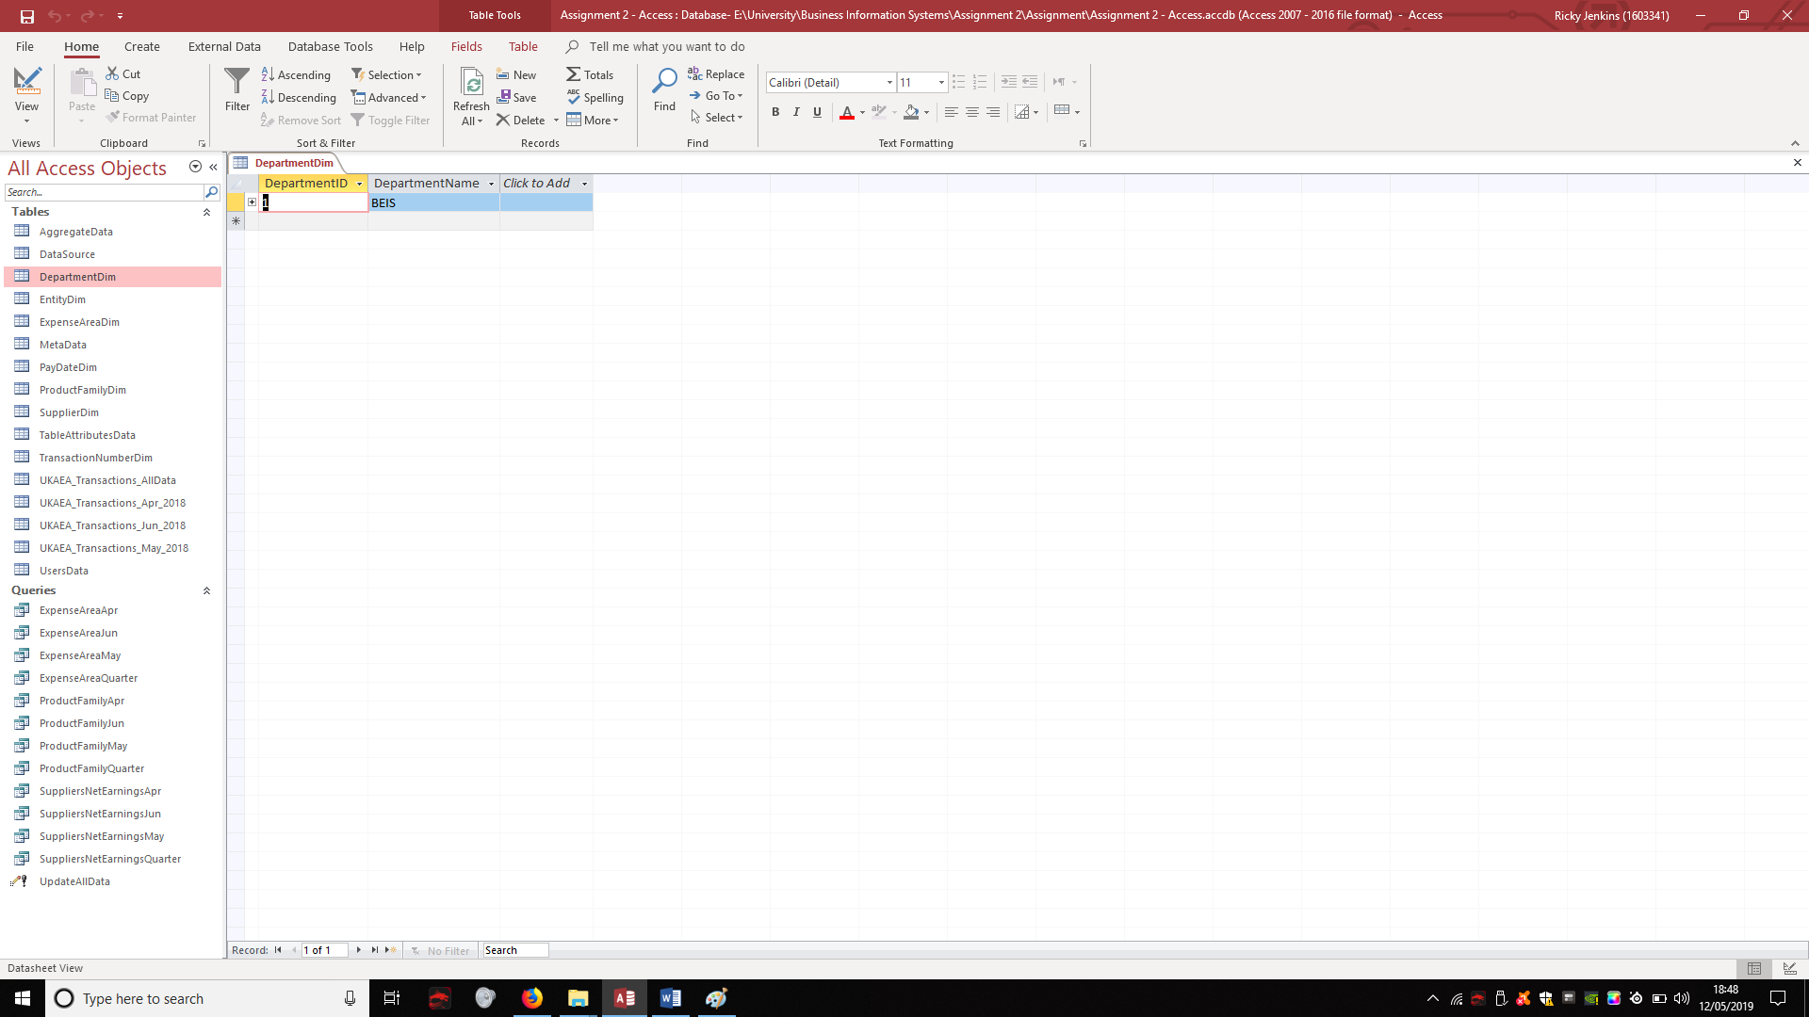
In the final version there would be a way, using code, to implement a way for users to create queries without going through the Access process. The screenshot below shows an example query created for ‘ExpenseArea April’.
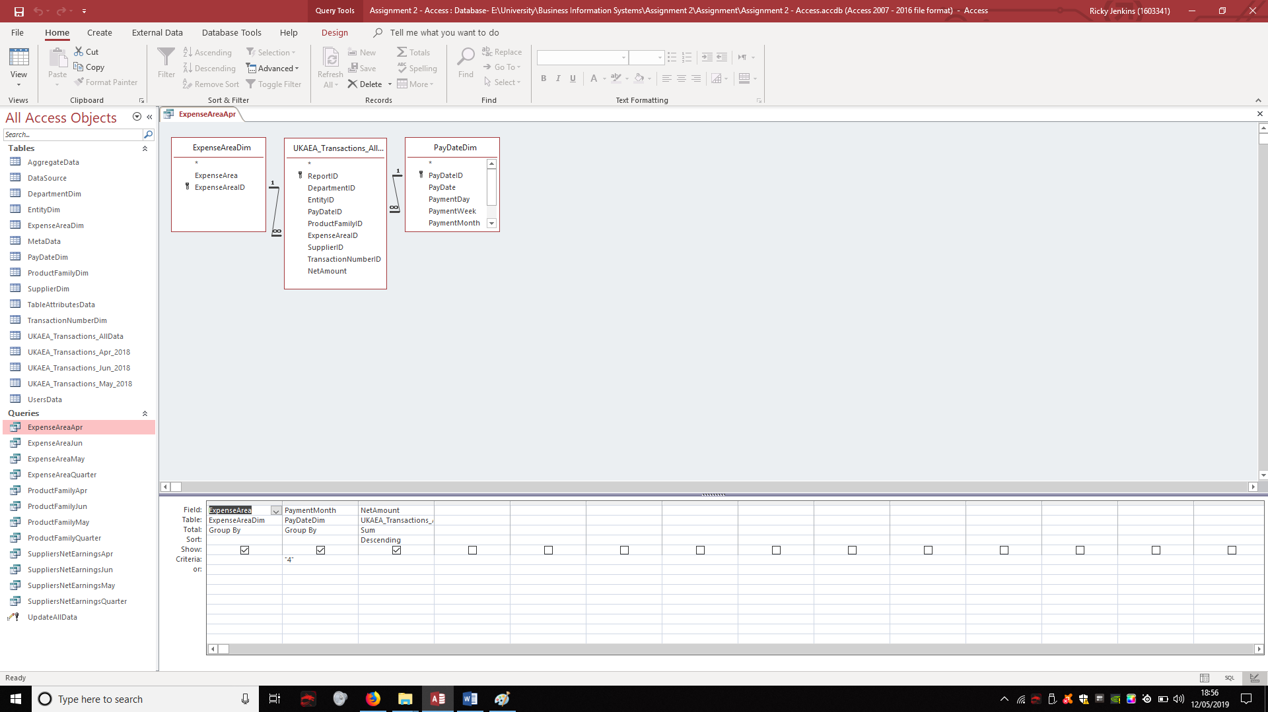
Unfortunately, when a query was made for the ‘UKAEA_Transactions_AllData’ table, it wouldn’t run for some reason. This then meant that each month would have to stay separate and a lot more queries had to be made to accommodate this.
The relationships were set up assuming that the ‘All data’ table would be working when it came to the queries. Each table was correctly linked with the table and Access still couldn’t run the query. The screenshot below shows the relationships for the data warehouse.
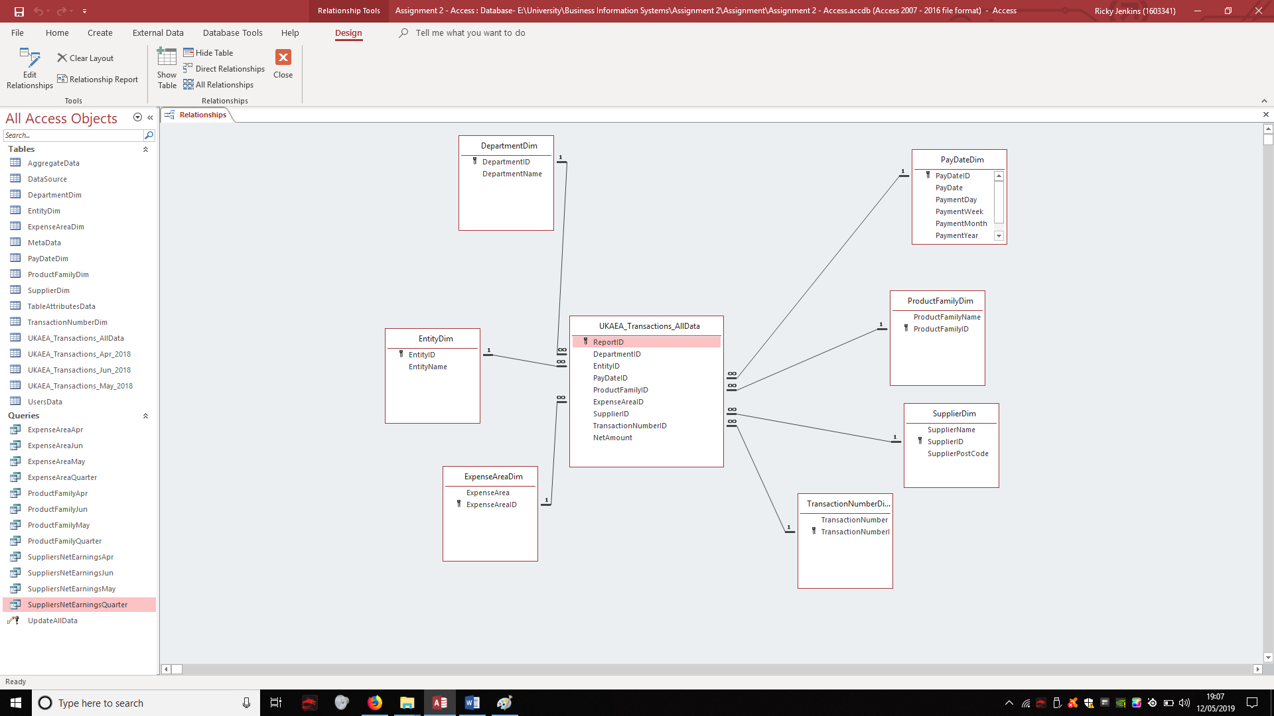

Data Warehouse Final Product
Now the final version of the data warehouse will be discussed and the features required by UKAEA to make it efficient for the organisation to justify using it. An example of this is that currently the data from the excel spreadsheets were collected and transferred manually into the data warehouse. The final product would need to have an implemented automation system which updates the new data as often as UKAEA want.
The dashboard would eventually require a log in system for users to ensure that not just anyone would be able to access the organisations entire data records. The interface would include boxes to enter ‘Username’ and ‘Password’; this would log them in if they were both correct and the user was recognised. These would be included in the user data table and could be altered if they wanted.
The user data table will store all information involving the users of the data warehouse; this is who is using it at any given point, what changes they have made, whether a new user needs to be added (New staff member) or perhaps removed to relieve access to them. If any changes were manually made to any data then it would be recorded by the system to then show which user made the alteration.
The Meta data table is also blank but will eventually hold the information of each cell of data stored in the entire data warehouse. The Meta data is what would be checked if specific data had changed and no one knew why; this table stores when data is created, edited, who by and where it originally came from (existing source systems). Meta data is known as “data that describes other data” and that is needed if UKAEA would like to analyse their data [2].
The aggregate data is currently blank but would work towards allowing a user to analyse the data in a structured format.

The table attributes data table is also currently blank but would be used to identify which data is in which table.
The data warehouse as a final product would be automated but still allows manual changes by authorised staff/users. The prototype is an example of how the data warehouse would work and how they could use the new interface within the company. The prototype should be considered a success because it shows the functions of the data warehouse without the addition of code.

Schema Diagram
The design for the new data warehouse can be seen in the diagram below which shows the general layout when it’s applied the Microsoft Access. A diagram such as this one can be very beneficial in the initial design on Access as it gives something to go off when creating it; if someone is creating one from scratch then some tables may be left out and forgotten. The diagram also looks very similar to the relationships for the data warehouse.
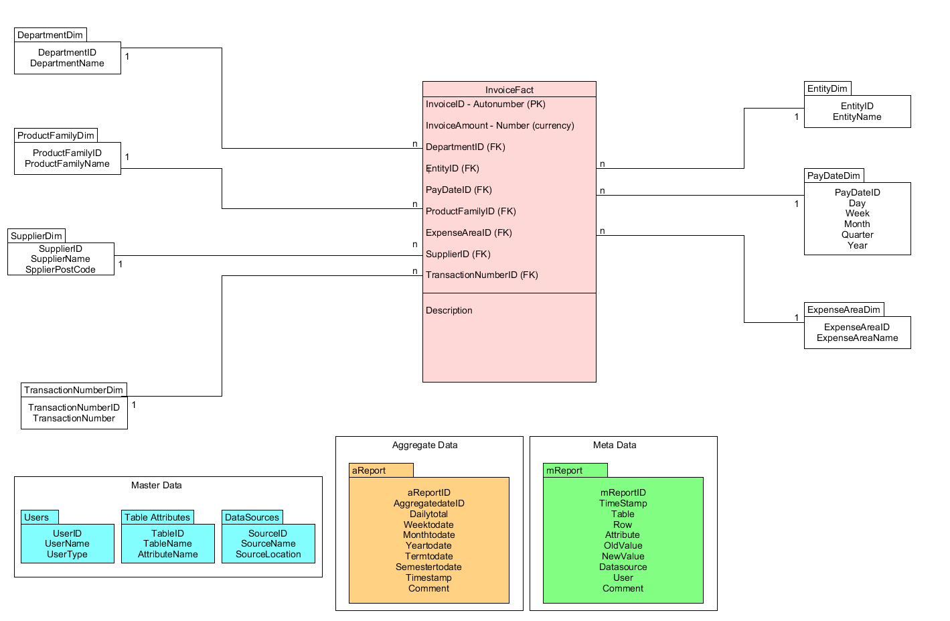

Database to data warehouse table mapping:

DATABASE TABLES | DATA WAREHOUSE TABLE
Comes from Spreadsheet | InvoiceFact
DB.Department | DepartmentDim
DB.Entity | EntityDim
DB.ProductFamily | ProductFamilyDim
DB.PayDate | PayDateDim
DB.ExpenseArea | ExpenseAreaDim
DB.Supplier | SupplierDim
DB.TransactionNumber | TransactionNumberDim
DB.Department, DB.Entity, DB.Paydate, DB.ProductFamily, DB.ExpenseArea  DB.Supplier, DB.Transaction | ME_Meta
Not Applicable – This table needs to be generated from Fact | A_Aggregate
Not Applicable – This table needs to be generated from scratch | MA_Users

Database to data warehouse attribute mapping

ReportFact
ATTRIBUTE | SOURCE(S) | PROCESSING REQUIRED | MISSING VALUE? | INCORRECT VALUE?
ReportID | Generated | None | Shouldn’t happen | Refer to staff member
DepartmentID | DB.Department | Link to DepartmentFamilyDim | Shouldn’t happen | Refer to staff member
EntityID | DB.Entity | Link to EntityDim | Set to “Unknown” value | Refer to staff member
PayDateID | DB.PayDate | Link to PayDateDim | Set to “Unknown” value | Refer to staff member
ProductFamilyID | DB.ProductFamily | Link to ProductFamilyDim | Shouldn’t happen | Refer to staff member
ExpenseAreaID | DB.ExpenseArea | Link to ExpenseAreaDim | Set to “Unknown” value | Refer to staff member
SupplierID | DB.Supplier | Link to SupplierDim | Set to “Unknown” value | Refer to staff member
TransactionNumberID | DB.TransactionNumber | Link to TransactionNumberDim | Set to “Unknown” value | Refer to staff member
NetAmount | From Spreadsheet | From Spreadsheet | Shouldn’t happen | Refer to staff member

DepartmentFamilyDim
ATTRIBUTE | SOURCE(S) | PROCESSING REQUIRED | MISSING VALUE? | INCORRECT VALUE?
DepartmentID | Generated | None – Primary key | Shouldn’t Happen | Refer to staff member
DepartmentName | DB.Department | None | Refer to staff member | Refer to staff member

EntityDim
ATTRIBUTE | SOURCE(S) | PROCESSING REQUIRED | MISSING VALUE? | INCORRECT VALUE?
EntityID | Generated | None – Primary key | Shouldn’t happen | Refer to staff member
EntityName | DB.Entity | None | Refer to staff member | Refer to staff member

ProductFamilyDim
ATTRIBUTE | SOURCE(S) | PROCESSING REQUIRED | MISSING VALUE? | INCORRECT VALUE?
ProductFamilyID | Generated | None – Primary key | Shouldn’t happen | Refer to staff member
ProductFamilyName | DB.ProductFamily | None | Refer to staff member | Refer to staff member

PayDateDim
ATTRIBUTE | SOURCE(S) | PROCESSING REQUIRED | MISSING VALUE? | INCORRECT VALUE?
DateID | Generated | None – Primary key | Shouldn’t happen | Refer to staff member
Day | Generated / DB.PayDate | None | Shouldn’t happen | Refer to staff member
Week | Generated / DB.PayDate | None | Shouldn’t happen | Refer to staff member
Month | Generated / DB.PayDate | None | Shouldn’t happen | Refer to staff member
Year | Generated / DB.PayDate | None | Shouldn’t happen | Refer to staff member

ExpenseAreaDim
ATTRIBUTE | SOURCE(S) | PROCESSING REQUIRED | MISSING VALUE? | INCORRECT VALUE?
ExpenseAreaID | DB.ExpenseArea | None – Primary key | Shouldn’t happen | Refer to staff member
ExpenseAreaName | DB.ExpenseArea | None | Refer to staff member | Refer to staff member

SupplierDim
ATTRIBUTE | SOURCE(S) | PROCESSING REQUIRED | MISSING VALUE? | INCORRECT VALUE?
SupplierID | DB.Supplier | None – Primary key | Shouldn’t happen | Refer to staff member
SupplierName | DB.Supplier | None | Refer to staff member | Refer to staff member
SupplierPostCode | DB.Supplier | None | Refer to staff member | Refer to staff member

TransactionNumberDim
ATTRIBUTE | SOURCE(S) | PROCESSING REQUIRED | MISSING VALUE? | INCORRECT VALUE?
TransactionNumberID | DB.TransactionNumber | None – Primary key | Shouldn’t happen | Refer to staff member
TransactionNumber | DB.TransactionNumber | None | Refer to staff member | Refer to staff member

ME_Meta
ATTRIBUTE | SOURCE(S) | PROCESSING REQUIRED | MISSING VALUE? | INCORRECT VALUE?
MReportID | Generated | None – Primary key | Generated | Refer to staff member
TimeStamp | Generated (current time) | On Insert / Update | Generated | Refer to staff member
Table | Table Name | On Insert / Update | Shouldn’t happen | Refer to staff member
Row | Row Index / Row Name | On Insert / Update | Shouldn’t happen | Refer to staff member
Attribute | Changed record | On Insert / Update | Shouldn’t happen | Refer to staff member
OldValue | Generated | On Insert / Update | Shouldn’t happen | Refer to staff member
NewValue | Generated | On Insert / Update | Shouldn’t happen | Refer to staff member
Datasource | Generated | On Insert / Update | Shouldn’t happen | Refer to staff member
User | MA_User | On Insert / Update | Shouldn’t happen | Refer to staff member
Comment | Generated | On Insert / Update | Shouldn’t happen | Refer to staff member

A_Aggregate
ATTRIBUTE | SOURCE(S) | PROCESSING REQUIRED | MISSING VALUE? | INCORRECT VALUE?
AReportID | Generated | Requested – Primary key | Generated | Refer to staff member
AggregatedateID | Generated | Requested | Shouldn’t happen | Refer to staff member
Dailytotal | Generated | Requested | Shouldn’t happen | Refer to staff member
Weektodate | Generated | Requested | Shouldn’t happen | Refer to staff member
Monthtodate | Generated | Requested | Shouldn’t happen | Refer to staff member
Yeartodate | Generated | Requested | Shouldn’t happen | Refer to staff member
Termtodate | Generated | Requested | Shouldn’t happen | Refer to staff member
Semestertodate | Generated | Requested | Shouldn’t happen | Refer to staff member
Timestamp | “Current Time” | Requested | Generated | Refer to staff member
Comment | Generated | Requested | Shouldn’t happen | Refer to staff member

MA_Users
ATTRIBUTE | SOURCE(S) | PROCESSING REQUIRED | MISSING VALUE? | INCORRECT VALUE?
UserID | MA_User | None – Primary key | Generated | Refer to staff member
UserName | MA_User | None | Generated | Refer to staff member
UserType | MA_User | None | Generated | Refer to staff member

MA_DataSource
ATTRIBUTE | SOURCE(S) | PROCESSING REQUIRED | MISSING VALUE? | INCORRECT VALUE?
SourceID | MA_DataSource | None – Primary key | Generated | Refer to staff member
SourceName | MA_DataSource | None | Generated | Refer to staff member
SourceLocation | MA_DataSource | None | Generated | Refer to staff member

MA_TableAttributes
ATTRIBUTE | SOURCE(S) | PROCESSING REQUIRED | MISSING VALUE? | INCORRECT VALUE?
TableID | MA_TableAttributes | None – Primary key | Generated | Refer to staff member
TableName | MA_TableAttributes | None | Generated | Refer to staff member

Bibliography

[1] | “The Difference Between a Data Warehouse and a Database,” panoply, [Online]. Available: https://panoply.io/data-warehouse-guide/the-difference-between-a-database-and-a-data-warehouse/. [Accessed 13 April 2019].
[2] | M. Rouse, “metadata,” techtarget, [Online]. Available: https://whatis.techtarget.com/definition/metadata. [Accessed 15 April 2019].

