

Assessment 1 – Reading Task Template
PART 1: Upload your photo of your A3 in-class notes here:
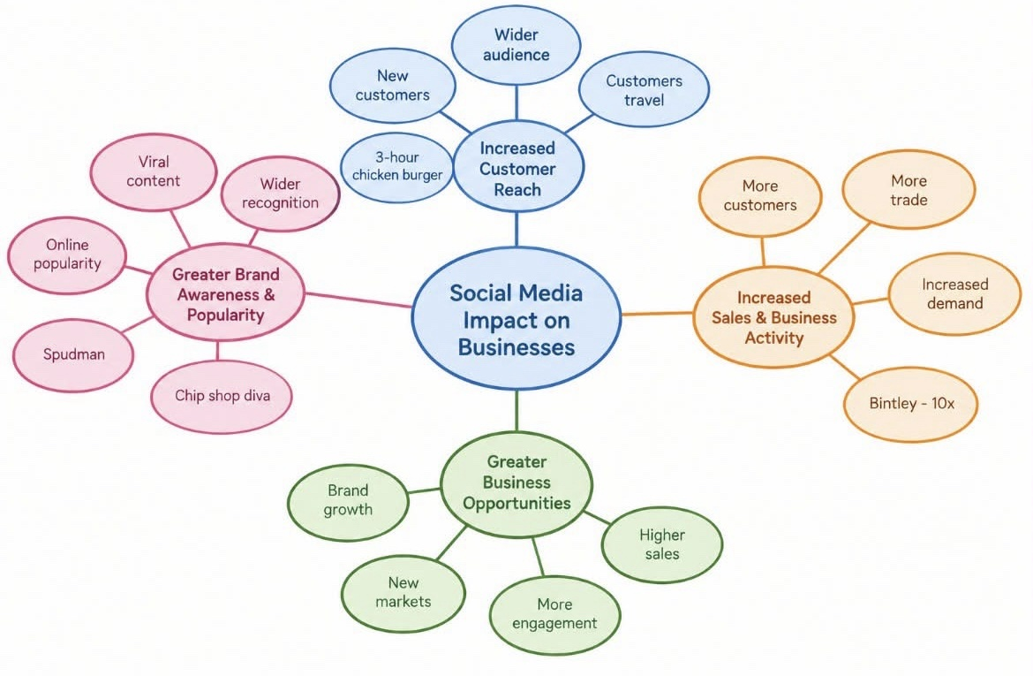

PART 2:
- Answer every question below in 1-3 full sentences.
- Use your own words. Do not use generative AI to answer these questions.
- Include a specific detail from the text when asked.
REMINDER
- The main idea is the overall message of the whole text.
- A key point helps to explain the main idea.
- A specific detail or example from the text shows that the key point is true.

- What is the main idea of the whole text?

The main idea is that social media, particularly tiktok, can have a significant positive impact on small businesses by increasing their visibility, attracting new customers and increasing sales. The article shows that businesses do not necessarily need large advertising budgets to gain attention, because customer generated videos and viral content can introduce a business to a much wider audience. The examples in the text demonstrate how social media attention can turn relatively local businesses into destinations for customers who are willing to travel long distances to try their product.

- What is one key point that supports the main idea, and which specific example from the text shows this?

One key point supporting the main idea is that viral social media content can attract customers from outside a business’s normal local area. When customers share their experiences online, the business can reach people who may never have heard of it before. A specific example is Honeywood Sandwich Shop. The owner Murat Mutlu explains that customers began travelling long distances after one of his regular customers posted about the shop online. The article states that one customer had travelled three hours specifically to try the shops chicken burger. This shows how social media exposure can turn a local food business into a destination for customers from much further away, potentially increasing sales and expanding its customer base.

- What is a different key point that supports the main idea, and which specific example from the text shows this?
A different key point is that social media can create rapid increases in demand and business activity when content becomes viral. This demonstrates that the effect of social media can go beyond simply making people aware of a business it can lead to increase in customers. A specific example from the text is Binley Mega Chippy, which reportedly experienced a tenfold increase after videos about the business became popular on social media. This example supports the main idea because it shows the potential commercial impact of viral content. A small business can receive a level of attention that would be difficult to achieve through its normal local customer base alone.

- Which part of the text do you think is most important, and why?
I personally think the most important part of the text is the example of Honeywood Sandwich shop, particularly the statement that customers travelled “three hours to try its chicken burger”. This is important because it provides a clear example of how social media can directly influence customer behaviour. From a business perspective the example also shows that social media can change a small business’s potential market from mainly local customers to customers from much further away. It also shows the importance of customer generated content. The shop did create its own tiktok videos, but the article explains that content posted by its customers was what helped increase the shops business. This is significant because it suggests that a business’s online reputation is not controlled entirely by the business itself. Customers can create content that reaches a much larger audience and can influence other people’s purchasing decisions. This shows the connection between social media engagement and brand awareness and customer demand.

Reflection:
- What did you find difficult in this task (including in-class components), and why was it difficult?
The main idea of the article because it included several different examples of businesses benefiting from social media. For example, the article mentioned Binley mega chippy, Spudman, and Honeywood sandwich shop and a few more. At first, I found it difficult to decide whether the main idea should focus on viral videos, Tiktok, increased sales or attracting new customers. I had to look at the whole article rather than focusing on just one example and recognise what the different examples had in common.

- What helped you with this difficulty, and how did it help you?
What helped me was reading the article carefully and looking for the main point that connected all the examples. I focused on what happened to the businesses after they received attention on social media. This helped me recognise that the different examples were all showing how social media can increase a small business’s visibility and exposure, attract new customers. Looking at specific evidence, such as the customer who travelled three hours to Honeywood sandwich shop and Binleys mega chippy reported in increase in trade, it helped understand the main idea and select relevant points to support my answers.

