

Title of dissertation: Policing mental health: Should police be attending mental health calls and do they have the required training?

Name of student: Tim Gibson
Student number: 2016569
Degree title: BSc (HONS) professional Policing Practice

Acknowledgements

I would like to thank all the university staff members who have helped me through the initial training process and then the following two years. I would also like to thank the police staff in training as well as my colleagues who have supported me throughout this process.
Finally, I would like to thank my family who have provided me with support throughout the process.

Declaration
This work has not previously been accepted in substance for any degree and is not being concurrently submitted in candidature for any degree.
Signed: 
Date: 03/07/2023

STATEMENT 1
This dissertation is being submitted in partial fulfilment of the requirements for the degree of BA.
Signed: 
Date: 03/07/2023

STATEMENT 2
This dissertation is the result of my own independent work/investigation, except where otherwise stated.
Other sources are acknowledged by footnotes giving explicit references. A bibliography is appended.
Signed: 
Date: 03/07/2023

STATEMENT 3
I hereby give consent for my dissertation, if accepted, to be available for photocopying and for interlibrary loan, and for the title and summary to be made available to outside organisations.

Signed: 
Date: 03/07/2023

STATEMENT 4
I hereby give consent for my dissertation, if accepted, to be available on the university’s IT system to those who have consent to use the system.

Signed: 
Date: 03/07/2023

Abstract

The aim of this dissertation is to explore opinions around police officers attending mental health calls and if so, do they have the required training. The researcher has looked at how other agencies use the police and if the agencies work together. The researcher will also examine if police attending mental health calls has an adverse effect on a person in crisis, and if their attendance is just because there is no one else.
The researcher has carried out extensive research in relation to the topic of mental health and police and has drawn on literature surrounding the topic of policing mental health. The researcher has also conducted their own private research including a questionnaire to gather data and opinions of current officers.
The findings from the research will be documented and the results will be examined, and they will hopefully assist in finding the right balance to deal with a person in a crisis. It’s hoped that through the results it will lead to police gaining the training needed to deal with mental health situations and a better experience for the person in crisis.

Contents page

Chapter 1 -Introduction……………………………………………………………………………………………………… 7
  - – Background……………………………………………………………………………………………………………… 7-8
  - – Aims and objectives……………………………………………………………………………………………………. 8

Chapter 2 - Literature review………………………..……………………………………………………………………. 9
2.1 – Introduction…………………………………………………………………………………………………………………9
2.2 – Police training and mental health……………………………………………………………………………9-10
2.3 – Should police be attending mental health calls?......................................................10-12
2.4 – Police use of the Mental Health Act…………………………………………………………….…………….12
2.5 - Discussion: Are police failing people with mental health issues…………………….………12-13
2.6 - The Crisis Care Concordat………………………………………………………………………….………….13-14
2.7 - Police failing leading to the death of Kelly Hartigan-Burns………………………………………….14

Chapter 3 - Methodology………………………………….…………………………………..……………………………15
3.1 – Introduction……………………………………………………………………………………………………………….15
3.2 – Research onion…………………………………………………..…………………………………………………15-16
3.3 – Research philosophy…………………………………………………………………………………………….16-17
3.4 – Research approach…………………………………………………………………………………………………….17
3.5 – Ethical considerations………………………………………………………………………………………………..18
3.6 – Research strategy and choice…………………………………………………………………………………….18

Chapter 4 – Results chapter…………………………………………………………………..………………………..…19
4.1 – Introduction……………………………………………………………………………………………………………….19
4.2 – Participants……………………………………………………………………………………………………………..…19
4.3 – Interactions…………………………………………….…………………………………….……………………………19
4.4 – Appropriate training…………………………………………………………………………….……………….19-20
4.5 Police use of section 136 of the Mental Health Act…………………………………………………….…20
4.6 – Working with other agencies………………………………………………………………………………..20-21
4.7 – Is the current system failing people with mental health issues…………………………………21
4.8 – Conclusion of the results gathered……………………………………………………………………………21

Chapter 5 - Conclusion and recommendations………………………………………………………………….22
5.1 – Objectives………………………………………………………………………………………………………………..22
5.2 - To explore the likelihood that someone suffering with mental illness has involvements with the Criminal Justice System……………………………………………………………………………………….22
5.3 - To explore incidents highlighted by the media where the police have had dealings with someone suffering with mental health……………………………………………………………………………..22
5.4 - To explore the need for proper training for police officers when dealing with mental health………………………………………………………………………………………………………………………………..23
5.5 - Questionnaire evaluation…………………………………………………………………………………………..23

Chapter 6 – Final thoughts………………………………………………………………………………………………….24

Chapter 7 – Bibliography……………………………………………………………………………………………………25

Appendix

1.0 Chapter One: Introduction
1.1 Background

This dissertation will look at the subject of policing mental health, it will look at the current system of policing mental health and if it ultimately leads to a person receiving the help they need. It will also look at the training that officers get at dealing with a person who is in crisis and if the police are all to often used as a first port of call.
Research suggests that the system is currently failing when it comes to dealing with a person is crisis. A police officer has limited options when dealing with a person in crisis this dissertation will look at section 136 of the mental health act and how that is utilised by police.
The subject was chosen by the researcher as it is something that they have first-hand experience with, and they feel that people are being let down by the current system. The researcher feels like it is an important subject no person is immune from struggling with mental health issues and everyone deserves the correct help. Mental health problems are no specific to a gender and it does not discriminate it affects all persons.
Mental health is an important topic and one that seems to be increasing, particularly in the last few years as people lived through the Covid pandemic and now the cost-of-living crisis. Health and Social Care Secretary Sajid Javid spoke at the Global Mental Health Summit 2021, and he stated that 1 in 5 adults in the UK suffered with some form of mental health in 2021 a figure that had doubled of the last three years (Javid, 2021).
Mental health calls are now a huge part of policing its very rare as a response officer you can finish a shift on the beat without coming across someone with mental health issues. Due to the amount of incident police must attend the researcher feels it’s important to make sure that the police are trained in dealing with mental health situations which doesn’t seem to be the case now. The current system allows police to utilise section 136 of the mental health act however the researcher will also examine what happens after that and how long a person must wait to see a professional.
Unfortunately, at one stage in a person’s life they will struggle with a form of mental health issues and in extreme cases they may require assistance from a mental health professional. Mental health refers to a person’s mental well-being and their ability to combat the stresses and tribulations of life it can affect how a person’s relationship and their employment, as well as shape the world they live in. Mental health issues include psychosocial impairments, mental illnesses, and other mental states linked to high levels of suffering, functional limitations, or risk of self-harm. Although this is not always or necessarily the case, people with mental health disorders are more likely to have lower levels of mental well-being (World Health Organisation , 2022).
Since 1948, the paths taken by physical and mental health have diverged significantly. The two have just recently begun to achieve greater parity in the world of health and social care. Methods and procedures were antiquated, and stigma pervaded mental health in general. In the strict Victorian asylums where they were treated, those with mental illnesses and impairments were kept hidden from the public and separated from their communities. Official acts of Parliament that dealt with mental illness and disabilities used wording that reflected the stigma. The terms "lunacy" and "mental deficiency" were frequently employed (Natiomnal institue for health and care exellence , 2022).

  - Aims and objectives.

- Explore the training that police officers have on dealing with a person in a mental health situation.
- Review the effects that police interaction can have on a person in a crisis, and to examine that if police are needed at every incident they attend. Examine if police have to respond to incidents as there is no one else to go.
- Review how the police work with other agencies to trat people with mental health.
- Explore the views of police officers when it comes to dealing with a person in a mental health crisis.
- Are people with mental health issues being failed.

Chapter 2: Literature review
2.1 Introduction

This literature review will examine and analyse the literature already available about mental health and how the Police deal with someone who is in a crisis, it will also analyse if a police officer has an adverse effect on the situation and if they should attend. The review will look at the training that an officer receives to deal with someone in a crisis and whether it is sufficient. There are many authors about mental health within policing. This review will focus on the work of (Adnapoz, 1995), (Heidi S. Vermette, 2005), (John McDaniel, 2020), (Lane, 2019) and (NIHR , 2021). The literature offers different viewpoints around policing mental health and the struggles officers face dealing with certain situations.
The closing of the large asylums was one of the most important mental health measures of the previous 50 years. De-institutionalization is the term typically used to describe this programme. Police encounters with mentally ill people increased because of the inability to offer adequately funded community mental health services (Teplin, 1984). From this point forward, police involvement in this area grew steadily (Cummins, 2013) (John McDaniel, 2020).
This issue has existed for quite some time. In his historic examination of the jails in England and Wales in 1780, John Howard remarked that there were too many "idiots and lunatics" incarcerated. He also mentioned how this had a negative effect on how people with mental illnesses were treated (John McDaniel, 2020).

2.2 Police training and mental health
The police are duty bound to care for the public however Rhiannon Lane who wrote an article in the journal of Community and Applied Social Psychology states that the police do not receive the appropriate training to deal with someone in a crisis (Lane, 2019). Rhiannon Lane argues that Police officers receive very little mental health training, despite estimates showing that 15% of UK police events involve persons with a mental health condition. Concerns have been raised that Police are being forced to play a primary role in providing mental health care because of the UK's underfunded and fragmented mental health services and the high-profile criticisms the police have received for their handling of incidents involving mental health. It is crucial to investigate how specific organizations function to defend the boundaries of their respective professional responsibilities in a period of austerity and extensive public service cuts.
When dealing with people suffering from mental illness on the scene, police officers have a lot of discretion, but sadly, arrest is the most frequent case outcome. As state mental institutions and inpatient treatment alternatives have drastically declined, the criminal justice system has emerged as the major method of mental health care. A major concern for police officers often is how to effectively de-escalate mental health situations involving agitated and at times aggressive people when appropriate procedures are unknown to them (Wilcox, 2015).
In the US it has been highlighted that the police are dealing with a growing number of calls involving people with mental health, and they have not undergone the training to assist them. Thousands of police departments across the US have now implemented a Crisis Intervention Team (CIT). According to CNN, about 15 percent of police jurisdictions in the U.S. have CIT programs. That’s about 2,800 programs, and the number is growing. CIT programs involve 40 hours of training to educate officers about mental health issues. The sessions are often led by mental health professionals. The training involves educating officers in spotting the signs and symptoms of dealing with a person in crisis. It also allows officer to meet with victims of mental health when they are not in a crisis to discuss how to police them. Studies have already shown that CIT training improves an officer’s attitude around mental health and reduces the risk of injury to an officer and the subject (Neogov, 2022).

2.3 Should police be attending mental health calls?

The police have always dealt with people with mental health incidents however recently they seem to be attending more incidents. BBC Radio 5 live conducted research into the police attendance at mental health incidents and the figures show that police attend more incidents each year. While there were 385,206 incidents flagged as mental health-related in 2014, in 2018 that figure was 494,159, a rise of 28%. This has led to police chiefs saying that there are less police officers available to fight and prevent crime as they are tied up with mental health calls. The Home Office said it is working to "relieve the burden on officers" (BBC Radio five live , 2021).
In recent months, concern has grown about how much time police spend responding to calls regarding mental health. In certain forces, the number of requests to deal with mental health crises more than tripled between 2019 and 2021, according to data obtained by the Labour Party through a freedom of information request in February. In that time, there was an increase of 342% in Suffolk Constabulary, 260% in Norfolk, 90% in Northamptonshire, and 54% in Leicestershire. A representative of the National Police Chiefs' Council responded by stating that mental health callouts had a substantial influence on the resources that were available: "Policing is often seen as the service of last resort, but chiefs must make decisions balancing ever-growing demands." (Future Care Capital, 2023)
Chief Constable Mark Collins, who is the lead for mental health and policing at the National Police Chiefs Council, told 5 Live: "Police are not dealing with crime and investigations when called out to mental health incidents. "The public would rather we spent our time on crime. If there is a crisis in the community, it should be dealt with by NHS specialist staff and not the police."

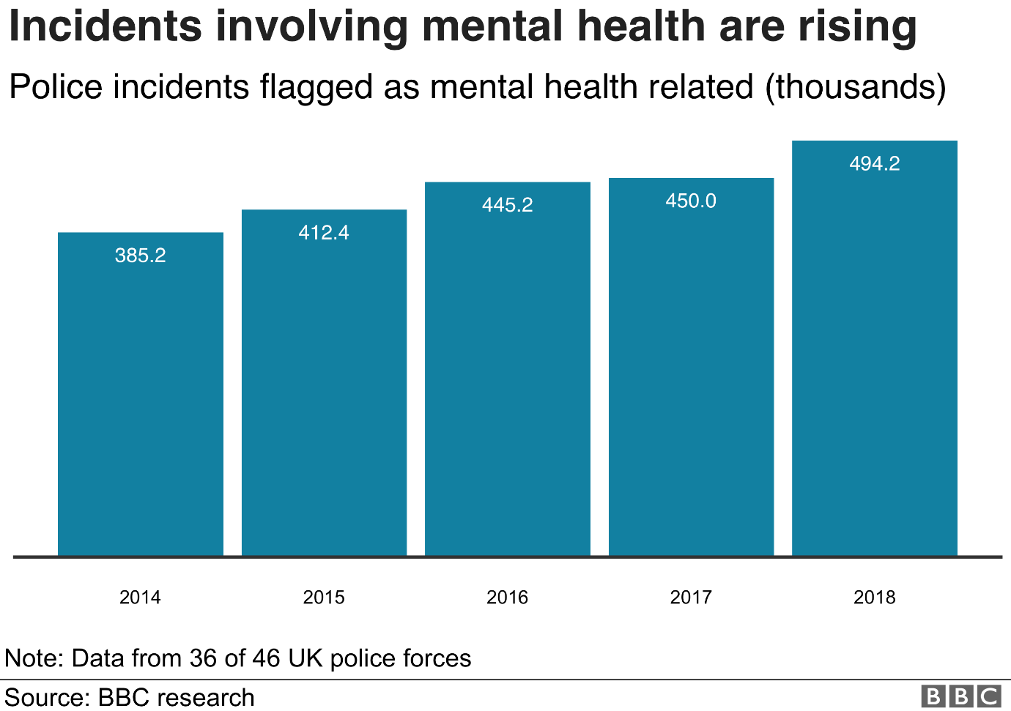

Whilst researching for this dissertation the crime and policing minister Chris Philip stated the following should not be a “stopgap” for other agencies. He added: “Police officers are of course often first responders, problem solvers and investigators, but they are not for example, mental health specialists. In my view the police should not be expected to fill in for other emergency services where there is no risk to life or safety and where no criminal offence has been committed.”
Philp said that since his appointment, numerous people, including Mark Rowley, the Metropolitan Police commissioner, had raised the issue of mental health callouts with him. “The concern was cases that were basically medical, a mental health crisis, where there was no threat to life or safety, either to the individual themselves or the public more widely, were getting passed to policing, rather than being dealt with as a medical or social services incident and taking up a huge amount of police time,”
A new approach is to be put in place through a National Partnership Agreement between policing, the Home Office, the NHS, the Ambulance Trust and the Department of Health and Social Care. The model would focus on the Right care Right person approach that is already used in Humberside. The model is believed to have saved the police in Humberside around 15,000 hours of work a year and has since been adopted by forces in Hampshire and North Yorkshire. The approach is essentially to make sure that the agency that tends to the call is best equipped to help the person. The police are only required should there be an immediate risk to life or serious harm (Future Care Capital, 2023).

2.4: Police use of section 136 of the Mental Health Act
When a person appears to be experiencing a mental disorder, the police have the authority under Section 136 to take them away from a public area and deposit them in a safe location. Police will determine that the person needs care and control right away because of their worrying behaviour. It is crucial to note that when the choice is made to take a person to a secure location, they are not in custody. The role of the police is to support assessments of an individual's health, wellness, and the safety of others around them (NHS, 2021).
For 60 years, Section 136 has been in effect. The identical Section 136 was present in the MHA 1959 before the MHA 1983. The use of this police authority, the related legal restrictions, and the police documentation of its usage have all drawn criticism since the 1970s (John McDaniel, 2020).
The case of MS VS UK highlights the potential difficulties that can arise when section 136 is used. MS assaulted his aunt and was escorted to the police station under Section 136, but the FME determined he was unfit for an interview. He needed a medium security unit, according to the local psychiatric intensive care centre, but for a variety of reasons, his transfer there took longer than expected. The delay led to detention beyond the 72-hour limit of section 136, but he did not make any claim under Article 5. His claim was instead in negligence and breach of Article 3 and, as the case was summarily dismissed in the domestic proceedings, the Article 3 aspect of the case proceeded to the European Court of Human Rights. The initial s136 imprisonment in a police station, the authorities' demeanour, or the physical confinement conditions (food and drink) received no objection from the ECtHR. It did, however, come to the conclusion that the conditions the applicant was forced to endure were an insult to human dignity and crossed the line into degrading treatment for the purposes of Article 3 because MS was in a state of great vulnerability throughout his detention, as evidenced by the squalor to which he quickly descended inside his cell, and because he was in urgent need of appropriate psychiatric treatment (Mental Health Law , 2022).

2.5: Discussion - Are police failing people with mental health issues?

Dr Adrian James, president of the Royal College of Psychiatrists, said: "Too many people with mental disorders who get involved with criminal justice are being failed by a system that overlooks the use of Mental Health Treatment Requirements. "Thousands of people could benefit from structured, formally supervised care and treatment in the community, but mental health services don't have the resources they need to deliver mental health treatment requirements at scale. The government must give mental health services the funding they need."
According to a thorough multi-inspectorate assessment, the criminal justice system failed thousands of mentally ill people who were imprisoned. According to six regulatory agencies, people in England and Wales who are suspected of having mental health problems receive inadequate treatment if they are detained, charged with a crime, imprisoned, or given a probationary period. A third of those detained by the police, as well as 48% of men and 70% of women in prison, struggle with their mental health in some way (The guardian, 2021).
The 107-page report was compiled by inspectors who looked at more than 300 instances from six different regions, spoke with 550 professionals, and heard from 67 people with mental health issues who had previously dealt with the criminal court system. Justin Russell, the chief probation inspector, commented on the findings and claimed that not enough progress had been made since the last joint examination by the bodies 12 years prior (The guardian, 2021).

Commenting on the report, the chief inspector of probation, Justin Russell, said not enough progress had been made since the last joint inspection by the bodies 12 years ago.
“Police forces, prosecutors, prisons, and probation services all assess individuals in different ways, which leads to gaps and inconsistencies. Even when mental health needs are identified, the information is not always recorded fully or used to make effective decisions. There are significant problems in the exchange of information in every agency and at every stage of an individual’s journey in the criminal justice system. This part of the system is broken and needs to be fixed urgently,” he said (Justice Inspectorates , 2021).

2.6: The Crisis Care Concordat (2014).

The Crisis Care Concordat is a document that sets out the principles and good practice that should be followed by health staff, police officers and approved mental health professionals when working together to help people in a mental health crisis (GOV.uk, 2014).
The document stated that to be able to detect risk and vulnerability as well as the need for medical care, police personnel need have the proper training. This training will assist the police in determining whether people need to be detained in accordance with section 136 or if there are other ways to assist them. The obligations of affiliated organisations should also be covered in training ( Department of Health and Concordat signatories, 2014 ).

The document also mentions the case study of the street triage car in Leicestershire. The street triage car reduced the section 136 detention rate by 33%. In operation since 2013 the car driven by a police officer and a mental health triage nurse aimed to improve the experience of persons suffering with mental health issues.
The mental health nurse provides the training and experience of a registered nurse and can conduct on the spot mental health assessments they also have mobile access to mental health services and information systems. ( Department of Health and Concordat signatories, 2014 ).

2.7: Police failings leading to the death of Kelly Hartigan-Burns

An inquest heard how 35-year-old Kelly Hartigan-Burns died after being detained in a police cell at Blackburn’s Greenbank police station in December 2016 (Beaney, 2022). It is stated in the Bolton newspaper Jurors spent two days conferring before reaching an open conclusion, while considering that “significant and serious” failings by the police contributed to Kelly’s death.
The jury highlighted issues with lack of training for the police, the absence of police national computer markers, lack of communication between a senior attending officer and the transportation team, and management in the custody suite contributed to Kelly’s death.
The jury’s conclusion said: “If officers of Lancashire Constabulary involved in this incident had shown more compassion, acted diligently, practised common sense, followed guidance and procedure from the moment they found Kelly in the church yard and throughout her detention there may have been a different outcome.”
This was a clear failure by the police that were involved in this incident and again one of the primary reasons highlighted is the lack of training provided to police officers when dealing with mental health.

Chapter 3: Methodology
3.1: Introduction

The previous chapter of the dissertation looked at the current literature available on Policing mental health. This chapter the researcher will explain to the reader how the study will be carried out. The literature review currently suggests that policing mental health in Britain especially requires in depth and specific training to help understand a persons need. It may also suggest that the police force would benefit from a designated team to police mental health. There is a lack of literature that supports police not attending mental health calls however opinions seem to be changing in more recent times.

3.2 Research Onion

There are many research skills and methodology’s available to a researcher for this dissertation the research onion will be used. The research onion was developed by Saunders et al in 2007. In essence the research onion reflects all the different decisions that a researcher has made whilst developing their methodology. Essentially you work from the outside of the onion towards the centre, as you reach the centre it will describe a more thorough level of research.

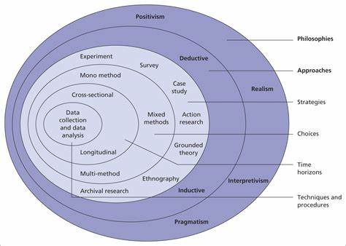
Fig 1. Diagram of research onion (Saunders 2007)

Whilst Saunders research onion is not perfect it is a commonly used tool as it is simple and reliable. At a minimum, it helps you understand what decisions you need to make in terms of your research design and methodology.
The onion is made up into 6 layers they are as follows:
1.Research philosophy
2.Research approach
3.Research strategy
4.Choices
5.Time horizon
6.Techniques & procedures

3.3 Research Philosophy

There are three different philosophies that are significant when planning and carrying out research. The three philosophies are Ontology, Epistemology as well as Axiology. For this dissertation the researcher has chosen to use the epistemology philosophy. This was chosen as Epistemology is the theory of a person’s knowledge. The theory is in about the mind’s relation to reality.

The research philosophy that will be used for this dissertation is called Interpretivism which is also closely linked with realism. The influence that social and cultural influences can have on a person is emphasised by interpretivism. This point of view emphasises how people think and see the world in relation to its sociocultural context. According to the interpretivist theory, the researcher actively participates in the study since it's important to develop a comprehensive understanding of the participant, as well as their behaviours, thoughts, and meanings.

3.4 Research approach

There are two types of research approach this is the second layer of the research onion developed by Saunders. Research approach is a broader method used by the researcher and it is spilt into two inductive or deductive. The inductive approach means to generate your theories from the research that has been conducted, however the deductive approach always starts with a theory and will then build on it or test it through research. The researcher for this study has opted for the deductive approach the aim being to collect data and then to generate theories based on the data findings. This will help prove or disprove some of the questions that surround policing mental health, for example are police trained or best equipped in dealing with a person in crisis.
Also linked with research approaches are quantitative and qualitative research. Graphs and numbers are used to represent quantitative research. It is used to validate or put to the test beliefs and presumptions. A topic's generalizable facts can be established through this kind of study.
Experiments, observations that are quantified, and surveys with closed-ended questions are examples of common quantitative procedures (Streefkerk, 2019).
The results of qualitative research are written up. It aids in understanding ideas, experiences, or concepts. You can gain comprehensive knowledge about poorly understood subjects by the type of research you are doing. Common qualitative techniques include open-ended interview questions, written descriptions of observations, and literature reviews that examine ideas and theories (Streefkerk, 2019).
The researcher has compiled a questionnaire and will record the findings later in the dissertation this is an example of how quantitative research has been utilised in this study.

3.5 Ethical considerations.
This study will not include anyone has suffered with mental health or had any dealings with the police whilst in crisis, this is due to the delicate matter of the subject. It can also be unfair to ask someone to draw on experiences when they were not in the right mind frame. It was made clear by the researcher that anyone who participated in the study was voluntary and no one was forced to answer any questions, participants were also made aware of the subject matter before they were involved in the study. It was also explained that anyone who chose to participate would be completely anonymous and no personal information or data would be shared as a result of their participation in the study.

3.6 Research strategy and choice.
The researcher has opted for the strategy of conducted a questionnaire on the subject on policing mental health, the questionnaire was formed on surveplanet.com. The questionnaire was made accessible by a hyperlink and posted on social media websites. The researcher was aware that asking current serving police officers their opinion on current strategies with the job would be difficult for them to answer, this is why a questionnaire was the chosen strategy, the researcher felt like the fact the questionnaire gave the participant the chance to answer questions anonymously would provide a more truthful response.
Furthermore, the questionnaire was by far the most cost-effective method of achieving a large volume of quantitative data. This method was also the easiest to encourage participants.
The only difficulties envisaged by the researcher in using the questionnaire method would be the time it would take to analyse the data.

Chapter 4: Results chapter

4.1: Introduction
This section of the dissertation will be utilised to examine and analyse the data from the questionnaire. The questionnaire was sent to current serving officer within South Wales police force, and they were all informed that it would not take them longer then 5 minutes to complete.

4.2: Participants
Other than the participants having to be a current serving officer in South Wales police there were no other restrictions put on the questionnaire. The subject of poling mental health is something that all police officers must deal with, so the researcher wanted many contrasting opinions. The first question asked was about the level of service that the officer has. This question was asked to see if there would be any correlation into an officer with more experience and how they find dealing with mental health incidents. The majority of participants at 59% had less than five years’ service however that is not uncommon on response shifts these days interestingly the second highest to participate was officers with over 20 years’ service. I think the range in participants will be good for the questionnaire as it will not just be focusing on officers with recent dealings. Only one participant chose not to answer this question.

4.3: Interactions

The next question asked participants how often they deal with a mental health call on an average shift. The average here being twice a shift, as mentioned earlier in the study the demand that mental health has on a police officers shift is large and it can be argued that this is taking away from police officers time to fight crime engage in more proactive policing. Every participant chose to answer this question, seven participants stated that they do not attend mental health calls on a shift. An additional question that could have been asked before could have been are you currently an officer on a response shift as there are many departments within the force which are officer based.

The third question again centred around an officer’s interaction to a mental health call. The question asked if in their opinion does a police officer have an adverse effect on a person in a mental health crisis. This was probably the most interesting answer as out of the thirty-three persons who participated not one answered no to this question. The majority of participants 58% here answered yes. This clearly shows that an officer attending a call believes that they are not helping the situation and are in some cases making it worse. I think it would have been interesting here to have the view of a person who has suffered a mental health crisis and see if they had the same opinion as the officers. As mentioned previously however due to the subject being sensitive, I did not want to as anyone who has suffered to recount their experiences.

4.4: Appropriate training.

Question four asked the officers participating in the questionnaire do they think they have had the appropriate training to deal with someone in a mental health crisis. This question was the most alarming and had the largest majority vote with 91% of the officers stating that they did not think that they had the appropriate training. This gives a massive indication that the current training falls below what is required and when you analyse the response to question two where it was found that officers tend to mental health calls on average two times a shift this is concerning. Even though earlier in the study research has shown that the police are making an effort to move away from attending mental health calls it important to be realistic, almost every call an officer attends they will deal with someone with mental health difficulties even if not the primary reason for the call. I think the findings here clearly show that police officers are not appropriately trained to deal with mental health.
Perhaps a question that could have been included in the questionnaire here would be to ask the officers participating if they could think if any specific training that would assist them.

4.5: Police use of section 136 of the Mental Health Act.

The next section of the questionnaire asked about section 136 of the Mental Health Act and how police use it and what officers think should happen after an they section a person. There was a wide and varied response to the question, how often do you utilise section 136 of the Mental Health Act however the most common answer being only when a person is in danger.
The question that asked what you believe should happen when a person is conveyed to a place of safety for example a hospital was a lot more one sided. Was a police officer has conveyed them to a place of safety 79% of participants believe that is when the police officers’ role in the incident should end and a healthcare professional should take over the researcher know from experience that is not the case. An officer will often spend their entire shift with a person that has been sectioned under 136 of the Mental Health Act.
The College of policing states that the ambulance team will execute a handover protocol based on the patient's medical needs once they arrive at the health-based place of safety. The person will subsequently be turned over by officers along with a written explanation of the s. 136 detention. In cases when the ABCDE/VAF instrument for vulnerability assessment has been used, a framework for this transfer may be provided.
Until a handover is complete, officers should remain in the health-based place of safety. In general, police should not be expected to stay with a detainee for more than an hour (Royal College of Psychiatrists Guidance). However, the amount of time that officers spend with the detainee depends depend on the circumstances and hazards associated with the individual. During this transitional period, the health-based place of safety should be able to hire the right personnel (College of policing , 2022).

4.6: Working with other agencies.
This section of the questionnaire asked the officers if in their opinion that the police force and other agencies worked well together to achieve best results when dealing with mental health. It was not a shock to the researcher when looking at the data gathered so far and the response to some of the previous questions the majority with 85% of the vote was no. Its clear that the police are used as a first port of call to attend these incidents often because there is no one else. The data collected shows that officers often attend these calls not suitably trained and on behalf of other agencies.

4.7: Is the current system failing people with mental health issues?
The answers provided for this question were again a landslide majority and is a real eye opener for not only the police force however all agencies that deal with mental health. Overall, 91% of participants believe that the current system is failing people with mental health issues. Perhaps the another question should have asked participants the main reason they believed the system is failing, is it lack resources inadequate training or maybe something else.

4.8: Conclusion of results gathered.
By analysing all the responses from current police officers its clear to see that there is a lack of training in relation to dealing with someone with mental health. Officers are being sent to calls that they are not trained for and often because there is no one else to go. Its also clear looking at the data that there is no cohesion between the police and other services again it appeared the police are being used as a first port of call and then often being left to deal with the fall out. The most worrying findings from analysing the data is that there is a strong belief that people are being let down by the current system and this needs to change.
A copy of the questionnaire will be included in the appendix of the dissertation as well as the results.
Chapter 5: Conclusion and recommendations.
5.1: Objectives.

The below are the objectives that were at the forefront of this study. The researcher hopes that by focusing on the following objectives and recommendations that knowledge can be gained by the police in how to best deal with a person with mental health. By reviewing the existing literature and conducting a study with South Wales police hopefully this study can be examined and used to provide a better service for those suffering with mental health.
The objectives:
- To explore the likelihood that someone suffering with mental illness has involvements with the Criminal Justice System.
- To explore the need for proper training for police officers when dealing with mental health.
- To explore incidents highlighted by the media where the police have had dealings with someone suffering with mental health.

5.2: To explore the likelihood that someone suffering with mental illness has involvements with the Criminal Justice System.

The Criminal justice System and those who suffer from mental health issues and disorders have a complicated relationship. Despite the fact that it is widely acknowledged that they are more frequently the victims than the perpetrators of crime, 40% of them experience arrest at least once in their lifetime (Mental Health Commission of Canada, 2020). With such a high likelihood of someone suffering with mental health coming into contact with the police it is important that police are trained appropriately.
A major inspection has found poor support for people with mental health issues as they make their way through the criminal justice system in England and Wales.

5.3: To explore incidents highlighted by the media where the police have had dealings with someone suffering with mental health.
As previously highlighted in the literature review the case of Kelly Hartigan-Burns was a clear failing by the police due to lack of training surrounding mental health. There are very little incidents where the police are praised by the media for they work around mental health. When you analyse the data from the questionnaire it is clear that the police do not have the training to deal with these incidents and in the case of Kelly Hartigan-Burns is sadly led to her death.

5.4 To explore the need for proper training for police officers when dealing with mental health.
Of all the research conducted for this study whether it be current literature or ne quantitative data found by the result of this study, it all points to the fact that police need better training to deal with an individual in a mental health crisis. The literature review highlighted the opinions of the media for the need for further training however most notably the officers on the beat today feel they are under trained to deal with mental health situations. Recent decisions seem to be leading towards the police not attending mental health calls however that’s not to say they won’t be dealing with people with issues every shift they are on. The training needs to be specific and should work in tandem with other mental health services.

5.5 Questionnaire evaluation.
The questionnaire was constructed to achieve both qualitative and quantitative data from the officers that participated. There is clear evidence from the results of the questionnaire that police are not receiving appropriate training when it comes to mental health incidents. Its also evident that this is not just the feeling of new inexperienced officers but that of officers who have over 20 years’ service.
Whilst the questionnaire provided valuable insight into police officers opinions when it can to police mental health there are recommendations that could have improved the quality of the data. Whilst I made an attempt to distribute the questionnaire to as many officers as possible, I did not ensure the questionnaire was active for that long. This meant that officers that may have been on free time on annual leave did not have a chance to participate.
One of the main takeaways from the questionnaire was that I should have made the questions more specific when asking about the officer’s service. Whilst information from all officers was appreciated by the researcher it would have been benefitable to ascertain if the questionnaire was being completed by front line police officers.

Chapter 6: Final thoughts.
This study has utilised literature conducted by others as well as gathering data from South Wales police officers. The literature review showed that policing and mental health have been intwined for years and will continue to be. Police have a duty of care and will always respond to a person n in a crisis. However the literature did emphasise the need for change the BBC report showed the demand on resources is taking police away from being proactive and fighting crime (BBC Radio five live , 2021).
It is evident now after the study that there is a need for training to help assist police officers when dealing with a person in mental health crisis. The data gathered by the researcher through the questionnaire is damming and cannot be overlooked there has to be more training provided for police officers. The questionnaire however showed that the police are willing to attend call and are open to receiving any training that will assist them.
The incidents documented by the media are not good and portray police officers often in a negative light particularly in the Kelly Hartigan-Burns case (Beaney, 2022), with appropriate training this could benefit police and victims of mental health.
Despite the negativity surrounding policing mental health there are signs that different approaches are being trialled such as the introduction of the mental health triage car in Leicestershire which has seen positive change ( Department of Health and Concordat signatories, 2014 ).

7.0 Bibliography.

Bibliography
Department of Health and Concordat signatories, 2014 . Mental Health Crisis , London: GOV.uk.

Adnapoz, J., 1995. The Police-Mental Health Partnership. s.l.:Yale University Press.

BBC Radio 5 live , 2019. www.bbc.co.uk. [Online]
Available at: https://www.bbc.co.uk/news/uk-49317060
[Accessed 12 January 2023].

BBC Radio five live , 2021. www.bbc.co.uk. [Online]
Available at: https://www.bbc.co.uk/news/uk-49317060
[Accessed 14th December 2022].

Beaney, A., 2022. www.theboltonnews.co.uk. [Online]
Available at: https://www.theboltonnews.co.uk/news/20053186.serious-police-failures-contributed-death-kelly-hartigan-burns/
[Accessed 8th March 2023].

College of policing , 2022. www.college.police.uk. [Online]
Available at: https://www.college.police.uk/app/mental-health/mental-health-detention
[Accessed 4th Febuary 2022].

Future Care Capital, 2023. futurecarecapital.org.uk. [Online]
Available at: https://futurecarecapital.org.uk/latest/police-no-longer-required-to-attend-mental-health-call-outs/
[Accessed 23rd May 2023].

GOV.uk, 2014. www.gov.uk. [Online]
Available at: https://www.gov.uk/government/publications/mental-health-crisis-care-agreement
[Accessed 4th March 2023].

Heidi S. Vermette, M. D. A. P. M. a. P. S. A. M., 2005. Mental Health Training for Law. The Journal of the American Academy of Psychiatry and the Law, Volume 33, pp. 42 - 46 .

Javid, S., 2021. www.gov.uk. [Online]
Available at: https://www.gov.uk/government/speeches/mental-health-a-decade-of-change-in-just-2-years
[Accessed 15 January 2023].

John McDaniel, K. M. K. P., 2020. Policing and Mental Health. 1st Edition ed. London : s.n.

Justice Inspectorates , 2021. www.justiceinspectorates.gov.uk. [Online]
Available at: https://www.justiceinspectorates.gov.uk/cjji/media/press-releases/2021/11/mentalhealth2021/
[Accessed 5th May 2023].

Lane, R., 2019. “I'm a police officer not a social worker or mental health nurse”. Community and Applied Social Psychology , 29(5), pp. 429 - 442.

McDaniel, J. L., 2018. Reconciling mental health, public policing and police accountability. The Police Journal: Theory, Practice and Principles, 92(1).

Mental Health Commission of Canada, 2020. Mental Health and the , Ottawa: National Library of Canada.

Natiomnal institue for health and care exellence , 2022. indepth.nice.org.uk. [Online]
Available at: https://indepth.nice.org.uk/mental-health-and-the-nhs/index.html
[Accessed 7th May 2023].

Neogov, 2022. www.powerdms.com. [Online]
Available at: https://www.powerdms.com/policy-learning-center/policing-the-mentally-ill
[Accessed 22nd April 2023].

NHS, 2021. www.lscft.nhs.uk. [Online]
Available at: https://www.lscft.nhs.uk/about-us/mental-health-act/understanding-mental-health-act/what-section-136-mental-health-act
[Accessed 3rd June 2023].

NIHR , 2021. evidence.nihr.ac.uk. [Online]
Available at: https://evidence.nihr.ac.uk/alert/closer-links-between-police-and-health-services-can-improve-experiences-for-people-in-mental-health-crisis/#:~:text=Tighter%20working%20partnerships%20between%20health%20professionals%20and%20police,danger%20to%20themselv
[Accessed 14 January 2023].

Streefkerk, R., 2019. www.scribbr.com. [Online]
Available at: https://www.scribbr.com/methodology/qualitative-quantitative-research/
[Accessed 23rd June 2023].

The guardian, 2021. www.theguardian.com. [Online]
Available at: https://www.theguardian.com/society/2021/nov/17/every-part-of-justice-system-fails-mentally-ill-people-inspectors-find
[Accessed 22nd April 2023].

Wilcox, N., 2015. leb.fbi.gov. [Online]
Available at: https://leb.fbi.gov/articles/featured-articles/the-importance-of-mental-health-training-in-law-enforcement
[Accessed 22 April 2023].

World Health Organisation , 2022. www.who.int. [Online]
Available at: https://www.who.int/news-room/fact-sheets/detail/mental-health-strengthening-our-response
[Accessed 7th April 2023].

Appendix
Results of questionnaire

Question 1
How long have you been a police officer?
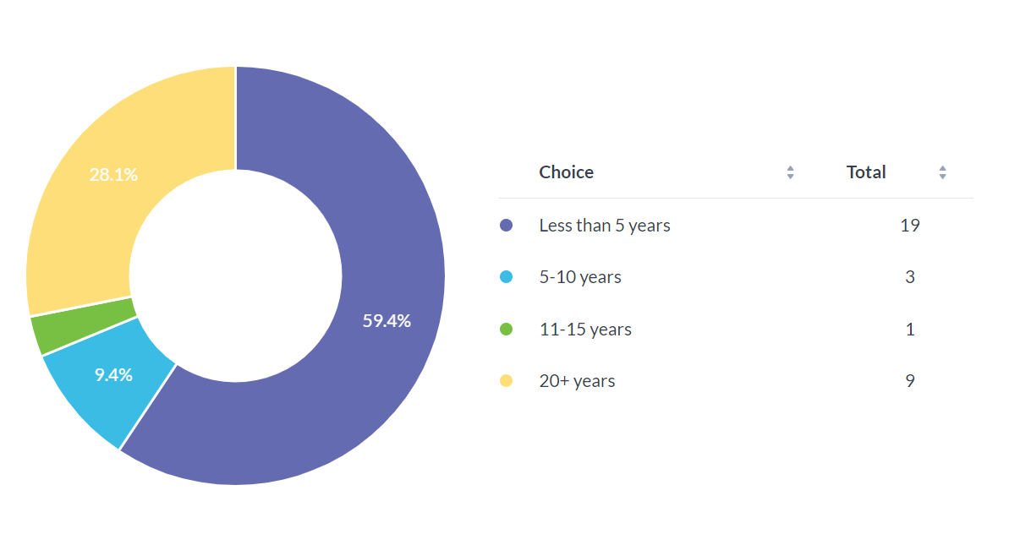
Question 2
On average how many times a shift will you attend a mental health call?
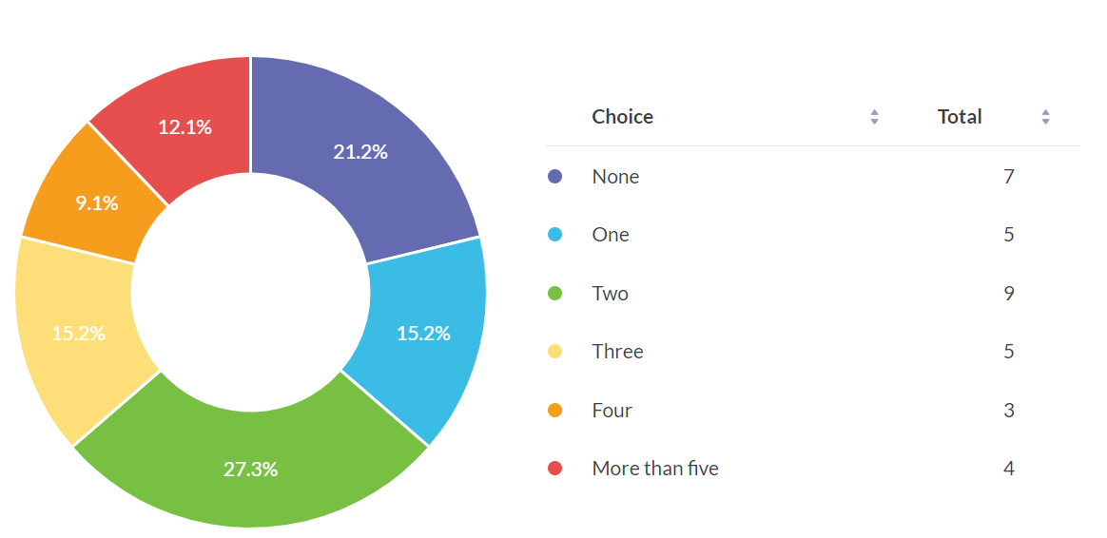

Question 3
In your opinion does a police officer have an adverse effect on a person in a mental health crisis?
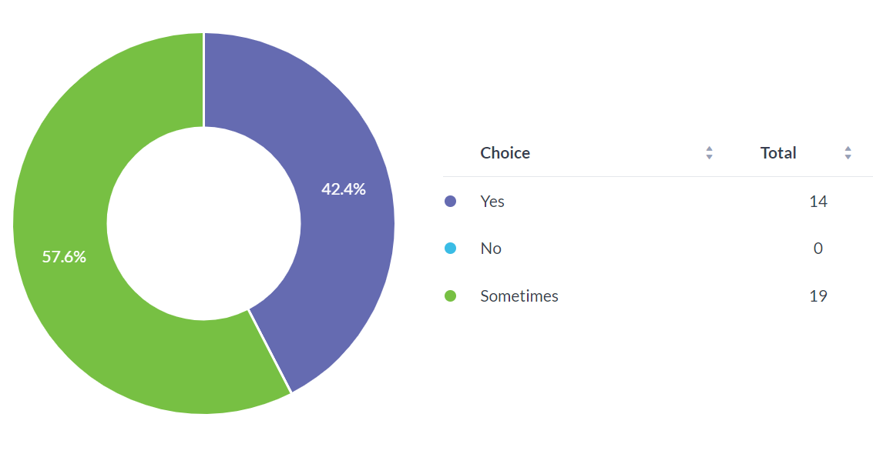
Question 4
In your opinion do you think that you have received the appropriate training to deal with someone in a mental health crisis?

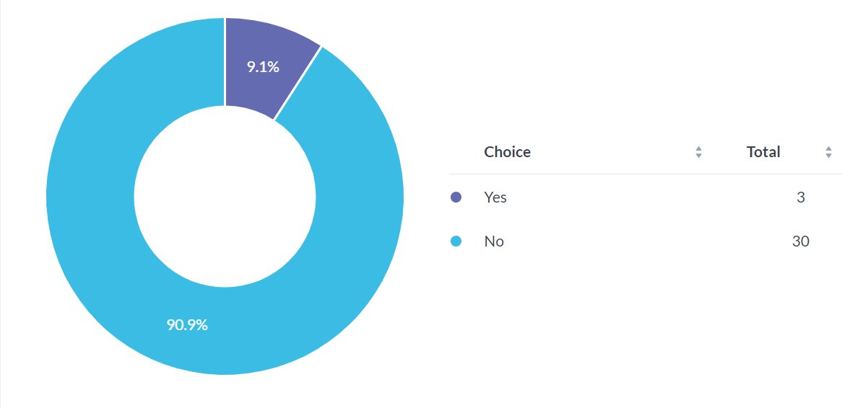

Question 5
When dealing with someone with mental health how often do you utilise section 136 of the Mental Health Act?
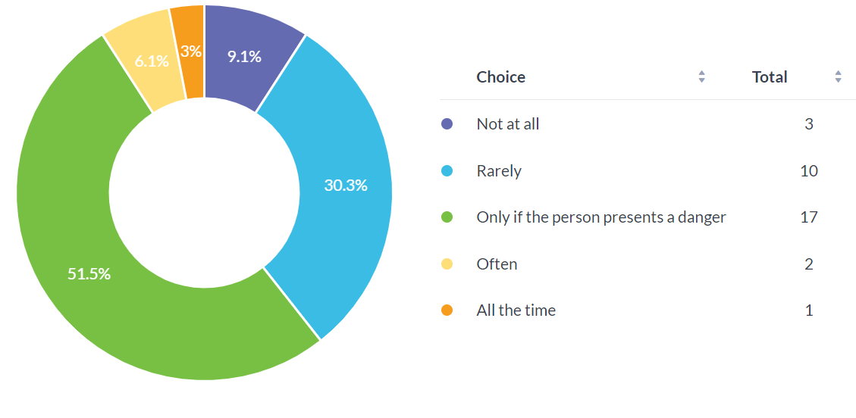

Question 6
Do you think that once a person is sectioned under 136 of the Mental Health Act and conveyed to hospital officers should be allowed to leave?

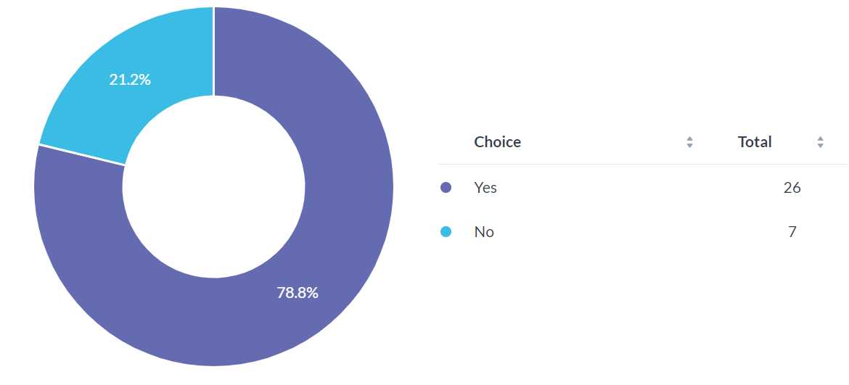

Question 7
Do you think that the police and other agencies work well together in dealing with someone suffering from mental health?
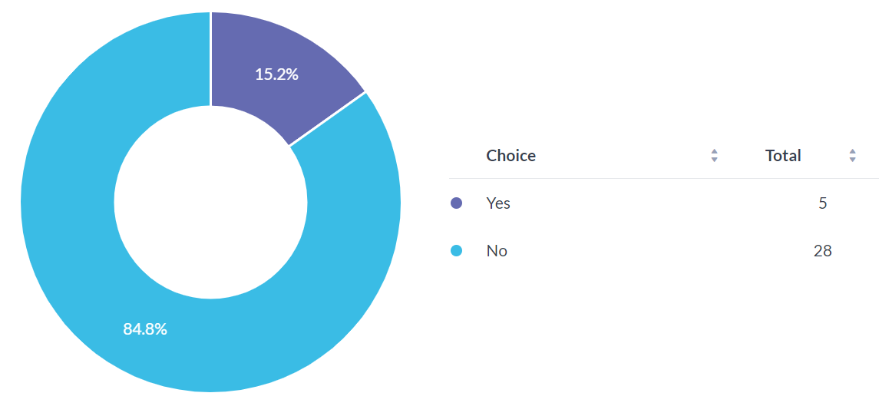
Question 8
Do you believe the current system is achieving the best results for s a person in a mental health crisis?

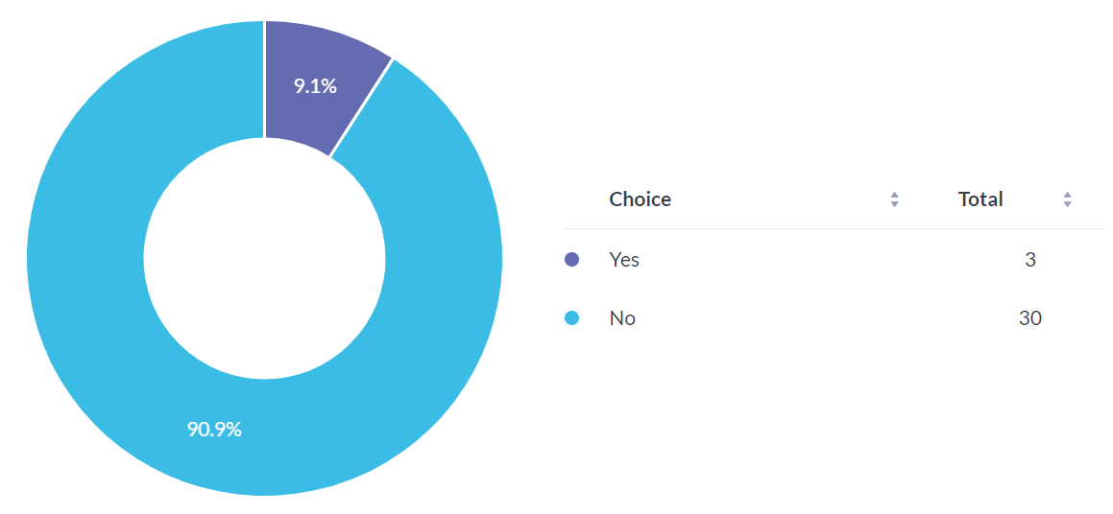

Question 9
Do you think police officers should be attending mental health calls if there is no immediate risk?

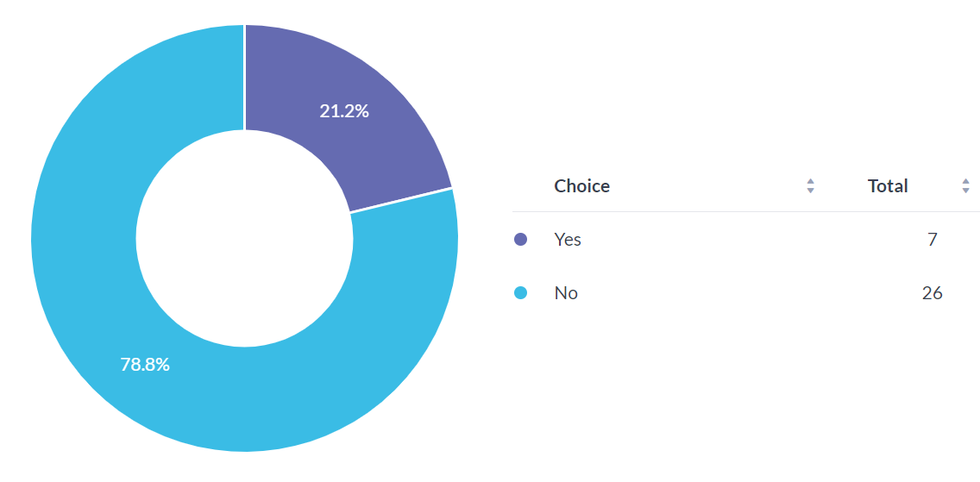

APPLICATION FOR ETHICAL APPROVAL

In order for research to result in benefit and minimise risk of harm, it must be conducted ethically. A researcher may not be covered by the University’s insurance if ethical approval has not been obtained prior to commencement.

The University follows the OECD Frascati manual definition of research activity: “creative work undertaken on a systematic basis in order to increase the stock of knowledge, including knowledge of man, culture and society, and the use of this stock of knowledge to devise new applications”. As such this covers activities undertaken by members of staff, postgraduate research students, and both taught postgraduate and undergraduate students working on dissertations/projects.

The individual undertaking the research activity is known as the “principal researcher”.

Ethical approval is not required for routine audits, performance reviews, quality assurance studies, testing within normal educational requirements, and literary or artistic criticism.

Please read the notes for guidance before completing ALL sections of the form.

This form must be completed and approved prior to undertaking any research activity. Please see Checklist for details of process for different categories of application.

Delete the Guidance Notes at the end of the form BEFORE submitting your application

SECTION A: About You (Principal Researcher)
Full Name: |  | Timothy James Gibson
Tick all boxes which apply: |  | Member of staff: | ☐ | Honorary research fellow: | ☐
Undergraduate Student | ☒ | Taught Postgraduate Student | ☐ | Postgraduate Research Student | ☐

Institute/Academic Discipline/Centre: | IMH
Campus: | Swansea
E-mail address:
Contact Telephone Number:
For students:
Student Number: | 2016569
Programme of Study: | BSc (HONS) professional Policing Practice
Director of Studies/Supervisor: | Jane Thomas

SECTION B: Approval for Research Activity
Has the research activity received approval in principle?  (please check the Guidance Notes as to the appropriate approval process for different levels of research by different categories of individual) |  | YES | ☒ | NO | ☐
 |  |  |  | Date
If Yes, please indicate source of approval (and date where known): Approval in principle must be obtained from the relevant source prior to seeking ethical approval | Research Degrees Committee |  | ☐
 | Institute Research Committee |  | ☐
 | Other (write in) Jane Thomas |  | ☒

SECTION C: Internal and External Ethical Guidance Materials
Please list the core ethical guidance documents that have been referred to during the completion of this form (including any discipline-specific codes of research ethics, and also any specific ethical guidance relating to the proposed methodology). Please tick to confirm that your research proposal adheres to these codes and guidelines.
UWTSD Research Ethics & Integrity Code of Practice | ☒
UWTSD Research Data Management Policy | ☒
 | ☐

SECTION D: External Collaborative Research Activity
Does the research activity involve collaborators outside of the University? |  | YES | ☐ | NO | ☒
If Yes, please provide the name of the external organisation and name and contact details for the main contact person and confirmation this person has consented to their personal data being shared.as part of this collaboration.
Institution
Contact person name
Contact person e-mail address

Has this individual consented to sharing their details on this form? |  | YES | ☐ | NO |  |  | ☐
Are you in receipt of a KESS scholarship? |  | YES | ☐ | NO |  |  | ☐
Is your research externally funded |  | YES | ☐ | NO |  |  | ☐
Are you specifically employed to undertake this research in either a paid or voluntary capacity? | Voluntary | YES | ☐ | NO |  | ☐
 | Employed | YES | ☐ | NO |  | ☐
Is the research being undertaken within an existing UWTSD Athrofa Professional Learning Partnership (APLP) | If YES then the permission question below does not need to be answered. | YES | ☐ | NO |  |  | ☐
Permission to undertake the research has been provided by the partner organisation | (If YES attach copy)  If NO the application cannot continue | YES | ☐ | NO |  |  | ☐

Where research activity is carried out in collaboration with an external organisation
Does this organisation have its own ethics approval system? | YES | ☐ | NO | ☐
If Yes, please attach a copy of any final approval (or interim approval) from the organisation

SECTION E: Details of Research Activity
Indicative title: | Policing – Mental health.
Proposed start date: | 28/09/2022 | Proposed end date: | 03/07/2023
Introduction to the Research (maximum 300 words)
Ensure that you write for a Non-Specialist Audience when outlining your response to the three points below:

Purpose of Research Activity

The purpose of the research is to determine if Police are given the appropriate training in dealing with mental health incidents. It will also attempt to answer that if Police presence has a positive or negative effect on someone in crisis. The research will also look at if other agencies use the Police to attend mental health incidents even if they are not necessarily required.

This dissertation will look in detail about a Police Officer’s role when dealing with mental health incidents and the powers and procedures that an officer can utilise. The dissertation will also assess that if a Police Officers presence is always helpful in dealing with someone if they are experiencing a mental health episode. The dissertation will look at how the Police work with other agencies in relation to mental health and if the Police are used by other agencies in the right way.

The Police must attend mental health calls every day, and they are often the first contact that someone in a crisis will have. Given that mental health incidents seem to be on the rise research will be conducted to look at the training that an officer for dealing with a mental health incident. There will also be research into the aftermath of a mental health incident and the duty Police have when a person is conveyed to a place of safety.

The question that this dissertation will answer is that do Police need to attend all mental health incidents and do they always have a positive effect.

This research is justified as Police now deal with mental health calls every day often on behalf of other agencies.

(this box should expand as you type)
Research Question

Are the Police force utilised correctly when dealing with mental health situations?

(this box should expand as you type)
Aims of Research Activity

(this box should expand as you type)
Objectives of Research Activity

(this box should expand as you type)
Proposed methods (maximum 600 words)
Provide a brief summary of all the methods that may be used in the research activity, making it clear what specific techniques may be used. If methods other than those listed in this section are deemed appropriate later, additional ethical approval for those methods will be needed.
I will conduct research for the dissertation by using the internet and looking at research that has already been conducted about Policing mental health. I have already completed initial research and have seen that there is a lot or information already out there on the subject.

As well as using the internet I will read journals and articles available to the public to structure my writing. I will utilise the library provided by the university to gather further information to further my points throughout the dissertation.

Another method I will utilise is to construct a questionnaire that will ask opinions of current Police Officers and seek their views on the current training provided to officers regarding mental health. I will also ask if they feel that other agencies work with them in dealing with someone in a crisis or if other agencies make it more difficult.

(this box should expand as you type)

Location of research activity
Identify all locations where research activity will take place.
Swansea

(this box should expand as you type)
Research activity outside of the UK
If research activity will take place overseas, you are responsible for ensuring that local ethical considerations are complied with and that the relevant permissions are sought. Specify any local guidelines (e.g. from local professional associations/learned societies/universities) that exist and whether these involve any ethical stipulations beyond those usual in the UK (provide details of any licenses or permissions required). Also specify whether there are any specific ethical issues raised by the local context in which the research activity is taking place, for example, particular cultural and/or legal sensitivities or vulnerabilities of participants.
NA

(this box should expand as you type)
Use of documentation not in the public domain: Are any documents NOT publicly available? | NO | ☒
 | YES | ☐
If Yes, please provide details here of how you will gain access to specific documentation that is not in the public domain and that this is in accordance with prevailing data protection law of the country in question and England and Wales.

(this box should expand as you type)

SECTION F: Scope of Research Activity
Will the research activity include: | YES | NO
Use of a questionnaire or similar research instrument? | ☒ | ☐
Use of interviews? | ☐ | ☒
Use of diaries? | ☐ | ☒
Participant observation with their knowledge? | ☐ | ☒
Participant observation without their knowledge? | ☐ | ☒
Use of video or audio recording? | ☐ | ☒
Access to personal or confidential information without the participants’ specific consent? | ☐ | ☒
Administration of any questions, test stimuli, presentation that may be experienced as physically, mentally or emotionally harmful / offensive? | ☐ | ☒
Performance of any acts which may cause embarrassment or affect self-esteem? | ☐ | ☒
Investigation of participants involved in illegal activities? | ☐ | ☒
Use of procedures that involve deception? | ☐ | ☒
Administration of any substance, agent or placebo? | ☐ | ☒
Working with live vertebrate animals? | ☐ | ☒
Other primary data collection methods, please explain in this box  For example, ‘focus groups’. Please indicate the type of data collection method(s) in this box and tick the accompany box. | ☐ | ☒
Details of any other primary data collection method:  (this box should expand as you type) | ☐ | ☒
If NO to every question, then the research activity is (ethically) low risk and may be exempt from some of the following sections (please refer to Guidance Notes).

If YES to any question, then no research activity should be undertaken until full ethical approval has been obtained.

SECTION G: Intended Participants
Who are the intended participants: | YES | NO
Students or staff at the University? | ☒ | ☐
Adults (over the age of 18 and competent to give consent)? | ☒ | ☐
Vulnerable adults? | ☐ | ☒
Children and Young People under the age of 18? (Consent from Parent, Carer or Guardian will be required) | ☐ | ☒
Prisoners? | ☐ | ☒
Young offenders? | ☐ | ☒
Those who could be considered to have a particularly dependent relationship with the investigator or a gatekeeper? | ☐ | ☒
People engaged in illegal activities? | ☐ | ☒
Others (please identify specifically any group who may be unable to give consent) please indicate here and tick the appropriate box. | ☐ | ☒
Other – please indicate here:  (this box should expand as you type) | ☐ | ☒

Participant numbers and source
Provide an estimate of the expected number of participants. How will you identify participants and how will they be recruited?
How many participants are expected? | 10-15  (this box should expand as you type)
Who will the participants be? | Fellow students and colleagues I will ask them to participate in completing a questionnaire.  (this box should expand as you type)
How will you identify the participants? | I have worked alongside them.  (this box should expand as you type)

Information for participants: | YES | NO | N/A
Will you describe the main research procedures to participants in advance, so that they are informed about what to expect? | ☒ | ☐ | ☐
Will you tell participants that their participation is voluntary? | ☒ | ☐ | ☐
Will you obtain written consent for participation? | ☐ | ☒ | ☐
Will you explain to participants that refusal to participate in the research will not affect their treatment or education (if relevant)? | ☒ | ☐ | ☐
If the research is observational, will you ask participants for their consent to being observed? | ☒ | ☐ | ☐
Will you tell participants that they may withdraw from the research at any time and for any reason? | ☒ | ☐ | ☐
With questionnaires, will you give participants the option of omitting questions they do not want to answer? | ☒ | ☐ | ☐
Will you tell participants that their data will be treated with full confidentiality and that, if published, it will not be identifiable as theirs? | ☒ | ☐ | ☐
Will you debrief participants at the end of their participation, in a way appropriate to the type of research undertaken? | ☒ | ☐ | ☐
If NO to any of above questions, please give an explanation
Will not need written consent as I will only ask people over 18.

(this box should expand as you type)

Information for participants: | YES | NO | N/A
Will participants be paid? | ☐ | ☒ | ☐
Is specialist electrical or other equipment to be used with participants? | ☐ | ☒ | ☐
Are there any financial or other interests to the investigator or University arising from this study? | ☐ | ☒ | ☐
Will the research activity involve deliberately misleading participants in any way, or the partial or full concealment of the specific study aims? | ☐ | ☒ | ☐
If YES to any question, please provide full details
(this box should expand as you type)

SECTION H: Anticipated Risks

Outline any anticipated risks that may adversely affect any of the participants, the researchers and/or the University, and the steps that will be taken to address them.

If you have completed a full risk assessment (for example as required by a laboratory, or external research collaborator) you may append that to this form.
Full risk assessment completed and appended? |  | Yes | ☒
 |  | No | ☐
Risks to participants
For example: emotional distress, financial disclosure, physical harm, transfer of personal data, sensitive organisational information
Risk to Participant:  No risk  (this box should expand as you type) | How will you mitigate the Risk to Participant  NA  (this box should expand as you type)
If research activity may include sensitive, embarrassing or upsetting topics (e.g. sexual activity, drug use) or issues likely to disclose information requiring further action (e.g. criminal activity), give details of the procedures to deal with these issues, including any support/advice (e.g. helpline numbers) to be offered to participants. Note that where applicable, consent procedures should make it clear that if something potentially or actually illegal is discovered in the course of a project, it may need to be disclosed to the proper authorities
(this box should expand as you type)
Risks to investigator
For example: personal safety, physical harm, emotional distress, risk of accusation of harm/impropriety, conflict of interest
Risk to Investigator:  No risk.  (this box should expand as you type) | How will you mitigate the Risk to Investigator:  NA  (this box should expand as you type)
University/institutional risks
For example: adverse publicity, financial loss, data protection
Risk to University:  No risk.  (this box should expand as you type) | How will you mitigate the Risk to University:  NA  (this box should expand as you type)

Disclosure and Barring Service
If the research activity involves children or vulnerable adults, a Disclosure and Barring Service (DBS) certificate must be obtained before any contact with such participants. | YES | NO | N/A
Does your research require you to hold a current DBS Certificate? | ☐ | ☐ | ☒

SECTION I: Feedback, Consent and Confidentiality
Feedback
What de-briefing and feedback will be provided to participants, how will this be done and when?
I will offer participants what will happen with the research that I have gathered and also inform them that if they wanted a copy they could have one.
(this box should expand as you type)
Informed consent
Describe the arrangements to inform potential participants, before providing consent, of what is involved in participating. Describe the arrangements for participants to provide full consent before data collection begins. If gaining consent in this way is inappropriate, explain how consent will be obtained and recorded in accordance with prevailing data protection legislation.
Consent is given by participating in the questionnaire.

(this box should expand as you type)
Confidentiality / Anonymity
Set out how anonymity of participants and confidentiality will be ensured in any outputs. If anonymity is not being offered, explain why this is the case.
NA

(this box should expand as you type)

SECTION J: Data Protection and Storage
In completing this section refer to the University’s Research Data Management Policy and the extensive resources on the University’s Research Data Management web pages (http://uwtsd.ac.uk/library/research-data-management/).
Does the research activity involve personal data (as defined by the General Data Protection Regulation 2016 “GDPR” and the Data Protection Act 2018 “DPA”)? | YES | NO
“Personal data” means any information relating to an identified or identifiable natural person (‘data subject’). An identifiable natural person is one who can be identified, directly or indirectly, in particular by reference to an identifier such as a name, an identification number, location data, an online identifier or to one or more factors specific to the physical, physiological, genetic, mental, economic, cultural or social identity of that natural person. | ☐ | x
If YES, provide a description of the data and explain why this data needs to be collected:
(this box should expand as you type)
Does it involve special category data (as defined by the GDPR)? | YES | NO
“Special category data” means sensitive personal data consisting of information as to the data subjects’ –  (a) racial or ethnic origin,  (b) political opinions,  (c ) religious beliefs or other beliefs of a similar nature,  (d) membership of a trade union (within the meaning of the Trade Union and Labour Relations (Consolidation) Act 1992),  (e) physical or mental health or condition,  (f) sexual life,  (g) genetics,  (h) biometric data (as used for ID purposes), | ☐ | x
If YES, provide a description of the special category data and explain why this data needs to be collected:
(this box should expand as you type)
Will the research activity involve storing personal data and/or special category data on one of the following: | YES | NO
Manual files (i.e. in paper form)? | ☐ | ☒
University computers? | ☐ | ☒
Private company computers? | ☐ | ☒
Home or other personal computers? | ☐ | ☒
Laptop computers/ CDs/ Portable disk-drives/ memory sticks? | ☒ | ☐
“Cloud” storage or websites? | ☐ | ☒
Other – specify: | ☐ | ☒
For all stored data, explain the measures in place to ensure the security of the data collected, data confidentiality, including details of password protection, encryption, anonymisation and pseudonymisation:
(this box should expand as you type)
All Data Storage
Will the research activity involve any of the following activities: | YES | NO
Electronic transfer of data in any form? | ☐ | ☒
Sharing of data with others at the University? | ☐ | ☒
Sharing of data with other organisations? | ☐ | ☒
Export of data outside the European Union or importing of data from outside the UK? | ☐ | ☒
Use of personal addresses, postcodes, faxes, emails or telephone numbers? | ☐ | ☒
Publication of data that might allow identification of individuals? | ☐ | ☒
Use of data management system? | ☐ | ☒
Data archiving? | ☐ | ☒
If YES to any question, please provide full details, explaining how this will be conducted in accordance with the GDPR and DPA (and/or any international equivalent):
(this box should expand as you type)
List all who will have access to the data generated by the research activity:
(this box should expand as you type)
List who will have control of, and act as custodian(s) for, data generated by the research activity:
(this box should expand as you type)
Give details of data storage arrangements, including security measures in place to protect the data, where data will be stored, how long for, and in what form. Will data be archived – if so how and if not why not.
(this box should expand as you type)
Please indicate if your data will be stored in the UWTSD Research Data Repository (see https://researchdata.uwtsd.ac.uk/ ). If so please explain. (Most relevant to academic staff)
(this box should expand as you type)
Confirm that you have read the UWTSD guidance on data management (see https://www.uwtsd.ac.uk/library/research-data-management/) | YES | ☒
 | NO | ☐
Confirm that you are aware that you need to keep all data until after your research has completed or the end of your funding | YES | ☒
 | NO | ☐

SECTION K: Declaration
The information which I have provided is correct and complete to the best of my knowledge. I have attempted to identify any risks and issues related to the research activity and acknowledge my obligations and the rights of the participants.

In submitting this application I hereby confirm that I undertake to ensure that the above named research activity will meet the University’s Research Ethics and Integrity Code of Practice which is published on the website: https://www.uwtsd.ac.uk/research/research-ethics/
Signature of applicant: |  | Date:

For STUDENT Submissions:
Director of Studies/Supervisor: |  | Date:
Signature: |  | Date:

For STAFF Submissions:
Academic Director/ Assistant Dean: |  | Date:
Signature: |  | Date:

Checklist: Please complete the checklist below to ensure that you have completed the form according to the guidelines and attached any required documentation:
☒ | I have read the guidance notes supplied before completing the form.
☒ | I have completed ALL RELEVANT sections of the form in full.
☒ | I confirm that the research activity has received approval in principle
☒ | I have attached a copy of final/interim approval from external organisation (where appropriate)
☒ | I have attached a full risk assessment (and have NOT completed Section H of this form) (where appropriate) ONLY TICK IF YOU HAVE ATTACHED A FULL RISK ASSESSMENT
☒ | I understand that it is my responsibility to ensure that the above named research activity will meet the University’s Research Ethics and Integrity Code of Practice.
☒ | I understand that before commencing data collection all documents aimed at respondents (including information sheets, consent forms, questionnaires, interview schedules etc.) must be confirmed by the DoS/Supervisor, module tutor or Academic Director.
☒ | I have deleted the guidance notes before submitting the PG2 for consideration

RESEARCH STUDENTS AND STAFF ONLY
All communications relating to this application during its processing must be in writing and emailed to pgresearch@uwtsd.ac.uk , with the title ‘Ethical Approval’ followed by your name.
You will be informed of the outcome of your claim by email; therefore it is important that you check your University and personal email accounts regularly.

STUDENTS ON UNDERGRADUATE OR TAUGHT MASTERS PROGRAMMES should submit this form (and receive the outcome) via systems explained to you by the supervisor/module leader.

This form is available electronically from the Academic Office web pages: https://www.uwtsd.ac.uk/academic-office/appendices-and-forms/

Application Process

All staff research projects and all research students must submit the Ethical Approval Form to the University Research Ethics Committee via the Academic Office (pgresearch@uwtsd.ac.uk). Staff research directly in relation to personal study for taught undergraduate or Masters programmes should be submitted via the Institute procedures explained below.

Taught masters and taught undergraduate research Ethical Approval Forms are considered within Institutes. Institutes will provide details of the specific processes for this. Where the Ethical issues within any single ethical application are of particular concern the Institute will refer these to the University Research Ethics Committee. Any student activity that involves the collection of primary data needs to undergo Ethical approval, this includes assignment work as well as dissertations.

Notes for guidance in completion of this form

Section A: About You
Please complete all relevant sections

Section B: Approval for research activity
Research proposals must be approved in principle before applying for Ethical Approval. The proposal approval only becomes final when the ethical approval is received.

The process for proposal approval varies according the individual and programme of study:
- Research students, by application on form PG1 to the Research Degrees Committee
- Taught students by review of research proposal within Institutes (Institutes provide specific details of these processes)
- Staff, by agreement by the Academic Director/Assistant Dean

Section C: External Ethical Guidance materials
Many discipline areas are required to operate with the discipline specific codes of research ethics (for example health, psychology, education etc.), any such codes must be listed and you must tick to confirm that you have consulted with these.

Section D: External Collaborative Research Activity
Provide details of the external collaborative partners, where appropriate you might want to submit a copy of the external collaboration agreement with the Ethical Approval Form. If the partner requires the research to be subject to its own internal Ethical approval process then please provide details of that process and a copy of any final (or interim) approvals received from the organisation.

Section E: Details of Research Activity
Remember that the individuals reviewing this Ethical Approval Form may not have seen your research proposal, and also may not be experts in the specific area of your research. The information provided should therefore be jargon free and clearly stated.
Indicative Title: please use the same title as used on the research proposal.
Purpose: the Ethical approval process will want to ensure that the methods you propose are adequate and appropriate to address the research aims and objectives. Excessive additional data collection can be seen as unethical.
Proposed Methods: the Ethical approval process seeks to ensure that you understand the methods that are intended, and that the implementation of those methods will be appropriate and without unnecessary impact on respondents. This section must explain how the methods described will lead to the collection of necessary and sufficient data, but not excessive data. Please be specific.
Location: this needs to mention geographical location and also local situation (for example, within Local Authority Offices in Cardiff, using a private room but close to other individuals). If you are collecting data within an organisational setting then you need to explain the permissions that you have obtained to do this.
Research Activity outside of the UK: please complete this section in detail, and note any guidance you have received. Also describe your own familiarity (or not) with the location that you will be utilising.

Section F: Scope of Research Activity
Please tick ALL of the research activities that might be undertaken. If any additional types of activity are intended then please add an extra box and describe these.
If you have answered no to all questions in F then sections G and J do not need to be completed. Section H should be considered, and may be completed. Signatures are still required in section K.

Section G: Intended Participants
Please tick all categories that might apply.
Numbers & Source: if you are using a series of different methods or research activities please list numbers for each stage/phase. Be clear about how you will find respondents. Will you use intermediaries, and if so how? How will you ensure compliance with your sampling strategy?
Information for participants: all participants should be appropriately informed about the research, what is expected of them and what will happen to the information that they provide. The Ethical review process does not ask to see this documentation, but requires this to be reviewed and approved by the Director of Studies in the case of research students, the supervisor/module tutor in relation to students on taught programmes and the Academic Director/Assistant Dean in relation to staff research.

Section H: Anticipate Risks
All research carries some level of risk. The answers you provide to questions in this section will be reviewed to ensure that you have an appropriate understanding of the type of risks involved and how you can mitigate against these risks. If you have completed a full risk assessment, as required for example for laboratory work, field work, clinical tests, diving operations, or by a collaborative partner, you may append that to this form. In that case, please tick the box indicating this has been provided. You will not then be required to complete Section H.
Risk to participants Think very carefully about how your actions/questions/discussions might affect the people you are involving as participants. You might identify the risk as small but it would still be a risk. Many types of question have the potential to make respondents less content with their life / job; you need to recognise and try to ameliorate any such effects
If these are business owners, time with you may reduce profit.
In some locations physical risk is very real to both participants and yourself, please consider this.
Risk to you, the researcher Think about where you will meet people, if there are any dangers involved in the location. If you are meeting people as individuals think about using a public place. In general do not visit people in their own homes or remote locations. If you are talking to individuals about certain issues think about how their responses might affect you emotionally. What about the risk of collecting insufficient data?
Risk to the University When undertaking your research, you are acting as a member of the University (student or staff). Professionalism is important, so it is important to be well organised and well prepared. Punctuality, clarity etc. are all part of this. What will you do to ensure this? You must ensure you do not harm the good name of the University in any way and do nothing to undermine the reputation of the research it conducts and sponsors. Upholding high standards of conduct and integrity are vital in this regard. You must also conduct the research in such a way to minimise the potential for claims of negligence made against the University, its researchers and any collaborating individual or organisation. In this respect you should always comply with ethical, legal and professional frameworks, obligations and standards as required by statutory and regulatory authorities, as well as the university’s Research Integrity and Ethics Code of Practice. Research misconduct in this respect can take many forms, including:
- fabrication: making up results or other outputs (eg, artefacts) and presenting them as if they were real
- falsification: manipulating research processes or changing or omitting data without good cause
- plagiarism: using other people’s material without giving proper credit
- failure to meet ethical, legal and professional obligations: for example failure to declare competing interests; misrepresentation of involvement or authorship; misrepresentation of interests; breach of confidentiality; lack of informed consent; misuse of personal data; and abuse of research subjects or material
- improper dealing with allegations of misconduct: failing to address possible infringements such as attempts to cover up misconduct and reprisals against whistle-blowers

Adverse Outcomes. Think carefully about the possibilities, and cover here

Section I: Feedback, Consent and Confidentiality
Feedback to participants: outline your approach. Will interview transcripts be shared with respondents to check accuracy? Will summaries of questionnaire analysis be made available to respondents in some way? Will an overview report be provided? How and when?
Informed consent: Draft letter / e-mail / or heading (or footer) section of questionnaire must be approved by DoS/supervisor (if research student), supervisor/module tutor if taught student, or Academic Director / Assistant Dean if a member of staff.
Confidentiality/Anonymity. Explain clearly how you will ensure confidentiality and anonymity.

Section J: Data Protection and Storage
Before completing this section it is necessary to read the University’s Research Data Management information. The questions that follow are designed to ensure compliance with the Data Protection Act as well as established research protocols.

Many research activities will involve electronic transfer of data and use of data management systems in the summarisation and analysis of data. You will need to explain these in relation to compliance with the Data Protection Act.
Think carefully about who will have access to your data, this will include supervisors and examiners. Also that a thesis will be made available via the University library and the British Library system. If you are seeking an access bar for a period of time after completion then mention it here. If you will provide a copy of your findings, or intend to give a presentation, to a facilitating/ supporting/accessing organisation then explain that in this section. But also think about the general principle of data sharing, as explained in the Research Data Management information.
In terms of storage of data please ensure security, and also mitigate against loss of data.

Section K: Declaration
Ensure the appropriate countersignatures have been provided
Look carefully at the checklist and ensure that you comply with and tick all that are relevant to your research.

