

Management Economics

Contents
Introduction 2
Task 1 3
a) Fundamental Economic Problems that Affected the UK’s Demand & Supply Chain 3
b) Solving the Economic Problems 5
(a) Relevancy of Demand and Supply in the Case Study 9
(b) Difference between elasticity and inelasticity of demand with reference to price changes in the cost of fuel. 12
(c) Laws of Supply and Demand 13
Conclusion 17
References 18

Introduction
The case study delves into the intricate economic challenges triggered by the aftermath of the Covid-19 pandemic, particularly focusing on the disruptions in global supply chains and their impact on the demand-supply equilibrium. Fundamental economic problems have emerged, including labor shortages, disruptions in international supply chains, and consequential fluctuations in fuel availability and pricing. These disruptions have led to a scarcity of drivers, fuel shortages, and a surge in consumer demand, exacerbating the supply-demand imbalance. Understanding the relevance of demand and supply dynamics becomes crucial in comprehending the root causes of shortages and price fluctuations in the fuel market. Additionally, the concepts of elasticity and inelasticity of demand concerning fuel price changes highlight consumers' responsiveness to price shifts and the laws of supply and demand governing the relationship between price and quantity demanded or supplied. Addressing these multifaceted economic issues requires strategic interventions across industries, policy frameworks, and innovation to restore stability and resilience in supply chains.

Task 1

Fundamental Economic Problems that Affected the UK’s Demand & Supply Chain
The global outbreak of COVID-19 has significantly altered the rhythm of the world. The economic and commercial sectors are perhaps the most impacted. The abrupt implementation of quarantine measures and trade restrictions has necessitated a shift in business operations to comply with COVID-19 guidelines. This has resulted in a series of supply and demand disruptions in the marketplace. Many businesses have experienced a supply shortage due to the quarantine of their workforce. Thus, In the premise of the pandemic countries like the UK faced the following economic problems,
- Shortage of demand due to an increase of demand the concept of ‘Shortages of demand due to an increase in demand’ during the COVID-19 pandemic (Shokouhifar and Ranjbarimesan, 2022) refers to the imbalance caused by a sudden change in consumer behavior. Restrictions led to a surge in goods demand, but suppliers couldn’t keep up, causing shortages. The situation in the UK was exacerbated by its exit from the European Union (Sanders, 2020), adding more trade barriers and restrictions to the existing supply shortages due to the pandemic.

- Shortage of Supply (Shortage of Drivers): The COVID-19 trauma led to a significant shortage of lorry drivers in the UK, disrupting supply chains. This was due to a backlog in HGV driver tests and travel restrictions causing many European drivers to return home. Brexit further exacerbated the situation, with new immigration rules and changes in tax regulations making the UK less appealing for EU nationals. The Road Haulage Association guessed a shortage of over 100,000 drivers, leading to severe supply chain issues affecting the delivery of various commodities (Aday and Aday, 2020).

- The Effects of the BREXIT on the Demand and Supply Chain Facilities Brexit, the UK’s 2021 exit from the EU’s single market and customs union, had a significant impact on the country’s demand and supply chain during the pandemic. It led to initial trade disruptions with the EU, reducing UK exports (Badiani, 2019), and supply chain issues due to changes in border customs, administrative errors, and pandemic-related staff shortages. New immigration rules and pound depreciation made the UK less attractive to EU nationals, exacerbating labor shortages (Kierzenkowski et al., 2016). Despite new trade agreements, the shift to non-EU trading partners in 2021 saw a decrease in overall trade volume relative to the UK’s economy size (Baier and Bergstrand, 2007).
- Panic Buying of Scarce Resources During the COVID-19 pandemic, the UK experienced a surge in panic buying, particularly of storable goods like food and household supplies. This behavior, driven by pandemic-induced uncertainty and fears about Brexit-related supply chain disruptions, led to temporary store shortages. Interestingly, the panic buying was more due to an increase in households buying storable products rather than large quantity purchases. Despite supermarkets urging moderation, panic buying continued, causing concern (Naeem and Ozuem, 2022).
- Shortage of Fuel Supply and High Price of Fuel In 2021, The UK’s fuel crisis was primarily due to panic buying and supply chain issues, not an actual fuel shortage. Triggered by media coverage of a leaked government document discussing a shortage of HGV drivers, attributed to Brexit and the COVID-19 pandemic (Welfens, 2020), panic buying and driver shortages led to petrol stations running out of fuel. Despite high fuel stocks, temporary shortages occurred due to panic buying and supply chain problems (BBC News, 2021). The demand drop in spring 2020 led to lower gas prices, but the fuel crisis likely caused a price increase (Upton and Nuttall, 2014).
- The End of Furlough and Redundancies the UK government’s furlough scheme, helped employers pay the wages of workers who were unable to work due to the pandemic, ending on 30 September 2021. The scheme supported more than 11 million jobs and reduced the number of redundancies but did not prevent them entirely (Plummer and Palumbo, 2020). Some industries, such as hospitality and manufacturing, were more affected by redundancies than others. The end of the furlough scheme has raised concerns about a possible increase in unemployment, as some employers may not be able to keep their workers or face low demand. The government has introduced other support measures, but some experts doubt their effectiveness.
- Bankruptcies due to lack of funds and high borrowings, During the COVID-19 pandemic, UK businesses grappled with financial challenges due to a drop in demand for goods and services and an increase in the cost of living (Chiu, Kokkinis and Miglionico, 2021). To manage the financial strain, many businesses resorted to high levels of borrowing. However, the combination of reduced revenue and increased costs made loan repayment difficult, leading to a liquidity crisis. This lack of cash or assets that could be easily converted to cash resulted in widespread defaults and even bankruptcies.
- Shift in Consumer Appetite from Services to Goods. During the COVID-19 pandemic, consumer behavior significantly shifted from services to goods due to various factors. Government-imposed lockdowns and social distancing measures led to increased home time, reducing service-based activities like travel and dining out, and increasing spending on durable goods. This also led to an increase in purchasing durable goods. The change in work and lifestyle patterns, with many working from home and reducing social activities, created a greater need for products like home improvement, entertainment, and fitness items (Sturm, 2004). Additionally, the uncertainty and fear caused by the pandemic led to stockpiling of goods, particularly storable products like food staples and household supplies.

Solving the Economic Problems
The UK government had to adopt policies to solve the above-mentioned policies swiftly. In the following discussion policies taken by the government and additional suggestive policies are presented from both the government and the organizational point of view,

Government Intervention
The Government of the UK has and can utilize the following economic tools to overcome the above-mentioned predicaments caused by the COVID19 pandemic and related phenomena.
Fiscal Policy Measures: The government took a series of financial measures to cope up with the impact of restrictions. These included support schemes for individuals and businesses, which totaled £169bn since 2020. Most of the additional spending went to individuals, at £100bn, with the rest £69 bn spent on business support schemes (POPE and HOURSTON, 2022).
Monetary Policy Measures: The Omicron variant has dampened the Bank of England’s outlook for the economy in the near future. To curb the high inflation rate of 5.1% in November 2021, the Bank of England has increased the interest rate from 0.1% to 0.25% (Lea, 2021).
Financial Support: The government launched a historic support package for people in March 2020, when the crisis began. The main sources of support for workers were the furlough scheme, officially called the Coronavirus Job Retention Scheme (CJRS), and the Self-Employment Income Support Scheme (SEISS). Universal Credit was boosted by £20 a week to help the poorest and jobless. (PEOPLE, 2021).
Support Regarding the Lack of Driver Issue: The government offered temporary visas for 5,000 overseas HGV drivers, including 300 immediate visas for tanker drivers. However, only 127 European Union fuel drivers applied for the scheme. The government also deployed military personnel to help deliver fuel to forecourts in the hardest-hit areas (GOV.UK, 2021).
Some more notable programmes from the UK government are- the Kickstart scheme, the Recovery Loan Scheme and the Job Entry Targeted Support programme.

Relaxing the COVID19 Restrictions
Relaxing COVID-19 restrictions had several positive impacts on the UK economy, particularly in terms of addressing supply chain issues.
Resumption of Business Operations: As restrictions were lifted, businesses were able to resume operations, which helped to restore supply chains. This was particularly beneficial for sectors like retail and hospitality, which had been heavily impacted by lockdown measures.

Increased Consumer Spending: The easing of restrictions also led to an increase in consumer spending, as people were able to go out and spend more on goods and services². This increased demand helped to stimulate economic growth (Magableh, 2021).
Improved Labor Market: With the lifting of restrictions, many people were able to return to work, alleviating labor shortages that had been exacerbating supply chain issues.
Boost to Manufacturing and Trade: The easing of restrictions also allowed for a resumption of manufacturing activities and trade, helping to address supply chain disruptions (Magableh, 2021).

Organizational Decision making
To battle the aftermath of the covid pandemic and the supply chain dilemma an organization can develop some key strategies. Some of it are explained briefly in the following section,
- Developing a Shortage Management Team: A shortage management team strategy can help an organization tackle supply chain issues caused by the COVID-19 pandemic. The strategy involves understanding the pandemic’s impact on the organization and its supply chain, improving communication within the organization and with external partners, increasing the organization’s flexibility to adapt to changes in demand or supply, building resilience into the supply chain, and monitoring and adjusting the strategy as necessary. This approach can help an organization navigate pandemic-related challenges and enhance its supply chain resilience (Saitbaeva, Ganaeva and Muratov, 2022).
- Creating and Improving Supplier Corroborations Network: Enhancing supplier collaborations can significantly aid in addressing supply chain issues caused by the COVID-19 pandemic. This involves creating a transparent view of the supply chain by identifying critical components, diversifying suppliers to reduce reliance on a single source, maintaining regular communication with suppliers to identify potential issues early, working with suppliers to develop contingency plans for disruptions, and investing in technologies that improve supply chain visibility. These measures can play a vital role in overcoming supply chain challenges during a pandemic (Dyer, 1996).
- Assessing and improving own supply chain: Evaluating and enhancing an organization’s supply chain can significantly assist in tackling supply chain problems triggered by the COVID-19 pandemic. This includes establishing a clear understanding of the supply chain, broadening the supplier base to decrease dependence on a single provider, keeping consistent communication with suppliers, formulating contingency strategies for potential disruptions, and investing in technologies that enhance supply chain transparency. These actions can be crucial in navigating supply chain difficulties during a pandemic (Soni and Kodali, 2010).
- Keep Stakeholders Informed and up to Date: Keeping stakeholders up to date with the issues regarding supply chain and inventory will build up loyalty among them.

Working to Reduce Waste and Developing Alternative Ways:
Waste management strategies can address supply chain issues in the UK by reducing environmental damage, increasing efficiency and resilience, and enhancing competitiveness and innovation. Key benefits include reduced greenhouse gas emissions and pollution, improved operational flexibility and resilience, and increased competitive advantage and innovation. These benefits can be achieved by adopting a comprehensive approach to waste management and leveraging technologies like the Internet of Things, 5G, blockchain, artificial intelligence, and advanced analytics (Ahmed et al., 2022).
Task 2

(a) Relevancy of Demand and Supply in the Case Study
The case study highlights the substantial impact of the COVID-19 pandemic on global supply chains, particularly in the UK, leading to shortages in demand and supply, especially in the fuel industry. Understanding the relevance of demand and supply in this scenario is crucial for several aspects:

1. Pricing Strategy to Manage Demand and Supply Pressure:
Adjustment of prices: Understanding demand and supply helps in adjusting fuel prices to manage the imbalance between high demand and constrained supply. This can aid in stabilizing the market and avoiding extreme price fluctuations (Nelson, 2019).
Fuel stations observing a sudden increase in demand due to shortages might implement dynamic pricing strategies. They can raise prices slightly during peak hours or high-demand periods to manage demand by discouraging excessive purchases and encourage more balanced consumption.

2. Competition and Price Management:
Competitive pricing: Knowledge of demand and supply dynamics allows companies to competitively price their products (fuel in this case) while ensuring profitability. It helps in strategizing to keep prices low while maintaining operational efficiency (Baker, 2002).
Fuel retailers could strategically set their prices lower than competitors to attract more customers while ensuring the price remains profitable. This competition helps in stabilizing prices within a reasonable range, preventing drastic increases due to heightened demand.

3. Business Productivity and Expansion:
Supply chain optimization: Managing demand and supply effectively aids in maintaining the flow of goods, like Amazon's online platform management, enhancing business productivity, and potentially expanding market reach (Turban, Pollard and Wood, 2018).
Online retail platforms like Amazon could streamline their delivery operations during fuel shortages. They might optimize their delivery routes or invest in alternative energy vehicles to maintain operational efficiency, ensuring timely deliveries despite fuel supply constraints.

4. Marketing Strategies:
Tailored marketing: Understanding consumer demand helps in developing targeted marketing strategies. In this case, promoting fuel conservation or alternative modes of transportation during shortages could be effective.
Fuel companies might focus their marketing efforts on promoting fuel-efficient driving practices or public transport usage during periods of supply shortage. This aims to manage demand by encouraging more efficient fuel consumption.

5. Inventory Management Strategies:
Just-in-time systems: Balancing inventory based on demand fluctuations becomes essential, especially in times of supply constraints. Managing inventory efficiently becomes crucial for uninterrupted operations (Chen, Wu and Yao, 2009).
Fuel suppliers employing a 'just-in-time' inventory strategy might adjust their inventory levels based on real-time demand fluctuations. They'd maintain minimal stock without risking shortages or excess inventory during uncertain times.

6. Financial Attraction and Investment:
Attracting investments: A clear understanding of demand and supply dynamics can attract investors, like an IPO, by showcasing the potential for high returns due to high demand and limited supply, driving investment interest.
A fuel company experiencing high demand due to shortages might decide to go public through an IPO. They showcase their demand-supply dynamics to potential investors, attracting high capital investments due to the perceived potential for profit in a market with limited fuel supply.

7. Worker Retention and Risk Management:
Employee satisfaction: Properly managing demand and supply allows businesses to maintain stability, potentially offering higher salaries or bonuses, leading to better worker retention and satisfaction.
Risk mitigation: Analyzing demand and supply helps in identifying and mitigating risks associated with shortages or excess inventory.
Fuel companies experiencing increased demand due to shortages might offer temporary incentives such as higher wages or bonuses to retain drivers or workers handling distribution. This helps in maintaining workforce stability during challenging times.

8. Managing Shortages and Market Shifts:
Market alignment: Understanding demand and supply enables businesses to forecast shortages, strategize solutions, and adapt to shifting market demands. It assists in matching supply to demand more effectively.
Fuel suppliers use demand forecasting models to predict shortages and adjust their supply accordingly. They might redistribute fuel resources to areas experiencing severe shortages, effectively matching supply to localized demand.

In essence, demand and supply management in the context of the fuel shortage due to the pandemic is pivotal. It empowers businesses to navigate the challenges, maintain equilibrium, optimize operations, and employ strategies to cope with sudden market shifts and shortages. Understanding demand and supply dynamics is crucial for businesses to strategize and manage their operations during times of market uncertainty, such as the fuel shortages caused by the COVID-19 pandemic. Such an understanding allows for informed decision-making, ensuring resilience and adaptability in the face of supply chain disruptions.

(b) Difference between elasticity and inelasticity of demand with reference to price changes in the cost of fuel.
Elasticity and inelasticity of demand refer to how responsive the quantity demanded of a good or service is to changes in its price. In the context of fuel prices:

1. Elasticity of Demand:
Elasticity of demand for fuel in the UK refers to the degree to which consumers alter their quantity demanded when there are changes in the price of fuel.
Elasticity Aspect:
If the demand for fuel is elastic, it means that consumers are highly responsive to changes in fuel prices. For instance, if the price of fuel increases, elastic demand would lead to a significant reduction in the quantity of fuel demanded. People might cut back on driving, opt for public transportation, or seek alternative energy sources.
Effect of the Pandemic on Fuel Costs in Elastic Demand Scenario:
During the pandemic, when restrictions were in place, and people worked from home more often, there was a substantial decrease in the demand for fuel. Elastic demand meant that even a slight change in the price of fuel had a noticeable impact on the overall quantity demanded.
Advantages:
Setting an optimum price: Understanding elasticity helps in determining the ideal price point that maximizes revenue.
Lower taxes: Goods with elastic demand may be taxed without significantly impacting overall revenue because consumers are more responsive to price changes.
Increasing sales: By adjusting prices according to demand elasticity, businesses can attract more customers and increase sales.

Disadvantages:
Continuous competitive monitoring: In an elastic market, competitors' pricing strategies need constant observation to adjust prices effectively.
Time dependency: Elasticity measurements are relevant for a specific period, but consumer preferences and behaviors change over time, impacting demand elasticity
2. Inelasticity of Demand:
Inelasticity of demand for fuel in the UK means that changes in the price of fuel have a relatively minor impact on the quantity demanded by consumers.
Inelasticity Aspect:
If the demand for fuel is inelastic, consumers tend to continue buying fuel despite changes in its price. They might reduce consumption slightly, but the overall quantity demanded doesn't significantly decrease in response to price hikes.
Effect of the Pandemic on Fuel Costs in Inelastic Demand Scenario:
Even during the pandemic, when fuel prices might have fluctuated due to changes in demand and supply dynamics, the inelastic demand for fuel could have resulted in a relatively steady quantity demanded. For instance, essential services, delivery vehicles, and certain industries might have continued to rely on fuel, regardless of price changes.

Advantages:
Revenue boost through price increase: With inelastic goods, a price increase can lead to a considerable boost in revenue since demand remains relatively stable.

Disadvantages:
Limited flexibility in pricing: While increasing prices may boost revenue, this advantage is limited, as consumers are less responsive to price changes.

It's important to note that the advantages and disadvantages of elasticity and inelasticity of demand can vary based on specific market conditions, product types, and other external factors. The application of these concepts requires a nuanced understanding of the market dynamics and consumer behavior.

(c) Laws of Supply and Demand
The laws of supply and demand are the basic principles that determine the price and quantity of a good or service in a market.

The law of demand
The law of demand says that when everything else stays the same, people buy less of a good or service when its price goes up, and more when its price goes down. The demand curve is a graph that shows how the price and the amount people buy of a good or service are related, assuming other things do not change. The demand curve goes down from left to right, showing that price and the amount people buy have an opposite relationship (Osadiya, 2023).

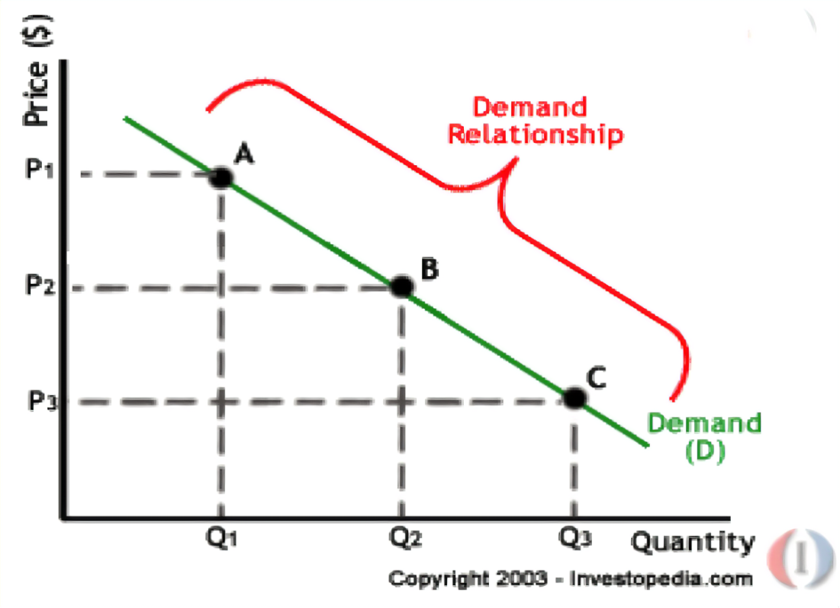

Point A, B and C are on the demand curve which shows the correlation between the quantity demanded (Q) and the price (P). According to point A, the quantity is Q1 and the price is P1, and point B and point C are so on. The higher price will get lower quantity and the lower price will get higher demand.

Figure 1: Ordinary downward sloping demand curve (Osadiya, 2023)

The law of supply asserts that, under constant conditions, the quantity of a good or service provided rises with an increase in its price, and conversely decreases as the price drops. The supply curve visually depicts this connection between the price and quantity supplied of a product or service, assuming other variables remain unchanged (Osadiya, 2023). It shows an upward slope from left to right, illustrating the direct correlation between price and quantity supplied.
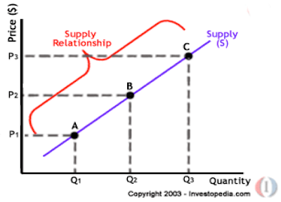
The points of A, B and C are which shows the correlation between quantity supplied (Q) and price (P). According to point A, the quantity supply is the Q2 and the price is the P2, and point B and point C are so on.

Figure 2: Ordinary upward sloping supply curve (Osadiya, 2023)

The market equilibrium
The point where the demand curve and the supply curve meet is called the market equilibrium. It means that the amount of a good or service that people want to buy and the amount that sellers want to sell are the same at that price. The price and the amount that make the market equilibrium are found by looking at how supply and demand affect each other in the market. If the price is higher than the equilibrium price, sellers will have more of the good or service than buyers want, and the price will go down. If the price is lower than the equilibrium price, buyers will want more of the good or service than sellers have, and the price will go up. The market will try to reach the equilibrium point unless something changes the demand or supply curves. In the graph, the equilibrium price is P1. The equilibrium amount is Q1.
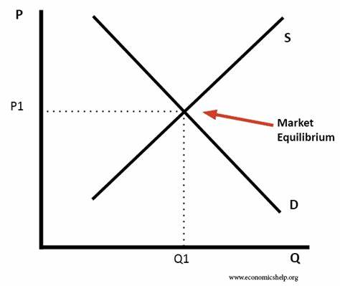

Figure 3: The market equilibrium curve (Osadiya, 2023)

Conclusion
The complex economic challenges presented in the case study demand a comprehensive approach to stabilize disrupted supply chains. Short-term solutions should focus on addressing driver shortages through improved incentives and working conditions. Embracing technological integration and diversifying supply sources can enhance resilience. Collaboration among stakeholders and policymakers is pivotal in crafting sustainable strategies and promoting innovation in transportation. To manage consumer behavior during price fluctuations, understanding demand-supply dynamics, including elasticity, is essential. Investing in alternative energy sources and promoting efficient usage can relieve pressure on conventional resources. Ultimately, a concerted, multifaceted effort across sectors is necessary to restore stability and fortify global supply chains' resilience.

References
Aday, S. and Aday, M.S. (2020). Impact of COVID19 on the food supply chain. Food Quality and Safety, 4(4), pp.167–180.
Ahmed, I., Zhang, Y., Jeon, G., Lin, W., Khosravi, M.R. and Qi, L. (2022). A blockchain‐and artificial intelligence‐enabled smart IoT framework for sustainable city. International Journal of Intelligent Systems, 37(9), pp.6493–6507.
Badiani, R. (2019). Outlook on UKEU Brexit negotiations and possible economic risks. International Economics and Economic Policy, 16, pp.5–16.
Baier, S.L. and Bergstrand, J.H. (2007). Do free trade agreements actually increase members’ international trade? Journal of international Economics, 71(1), pp.72–95.
Baker, J.B. (2002). Competitive Price Discrimination: The Exercise of Market Power Without Anticompetitive Effects. Antitrust LJ, 70, p.643.
Chen, H., Wu, O.Q. and Yao, D.D. (2009). On the Benefit of Inventory-Based Dynamic Pricing Strategies. Production and Operations Management, 19(3), pp.249–260. doi:https://doi.org/10.1111/j.1937-5956.2009.01099.x.
Chiu, I.H., Kokkinis, A. and Miglionico, A. (2021). Debt Expansion as" Relief and Rescue" at the Time of the Covid19 Pandemic: Insights from the Legal Theory of Finance. Ind. J. Global Legal Stud., 28, p.29.
Cigliano, J. (1980). Price and income elasticities for airline travel: the North Atlantic market. Business Economics, pp.17–21.
Dyer, J.H. (1996). Specialized supplier networks as a source of competitive advantage: Evidence from the auto industry. Strategic management journal, 17(4), pp.271–291.
GOV.UK. (2021). More support to help people to become HGV drivers among package of government measures to ease risk of shortages. [online] Available at: https://www.gov.uk/government/news/more-support-to-help-people-to-become-hgv-drivers-among-package-of-government-measures-to-ease-risk-of-shortages.
Kierzenkowski, R., Pain, N., Rusticelli, E. and Zwart, S. (2016). The economic consequences of Brexit: a taxing decision.
Lea, R. (2021). Bank raises Bank Rate, after CPI inflation jumps to 5.1% in November. Arbuthnot Banking Group, 20.
Magableh, G.M. (2021). Supply Chains and the COVID‐19 Pandemic: A Comprehensive Framework. European Management Review, [online] 18(3). doi:https://doi.org/10.1111/emre.12449.
Naeem, M. and Ozuem, W. (2022). Understanding misinformation and rumors that generated panic buying as a social practice during COVID19 pandemic: evidence from Twitter, YouTube and focus group interviews. Information Technology & People, 35(7), pp.2140–2166.
Nelson, P. (2019). Advertising as Information. Journal of Political Economy, 82(4), pp.729–754. doi:https://doi.org/10.1086/260231.
PEOPLE, B. (2021). BUDGET 2021.
Petrol station stocks back to normal. (2021). BBC News. [online] 21 Oct. Available at: https://www.bbc.co.uk/news/business-58991951 [Accessed 15 Nov. 2023].
Plummer, R. and Palumbo, D. (2020). Covid: What Impact Has the Furlough Scheme had? BBC News. [online] 30 Oct. Available at: https://www.bbc.co.uk/news/business-54601117.
POPE, T. and HOURSTON, P. (2022). Coronavirus: what support did government provide for individuals and businesses? [online] Institute for Government. Available at: https://www.instituteforgovernment.org.uk/explainer/coronavirus-economic-support-individuals.
Saitbaeva, E., Ganaeva, E. and Muratov, A. (2022). Management approaches to solving the problem of personnel shortage in the education system. Perspectives of Science & Education, 60(6).
Sanders, K.B. (2020). British government communication during the 2020 COVID19 pandemic: learning from high reliability organizations. Church, Communication and Culture, 5(3), pp.356–377.
Sgouridis, S., Bonnefoy, Philippe A and John, H.R. (2011). Air transportation in a carbon constrained world: Longterm dynamics of policies and strategies for mitigating the carbon footprint of commercial aviation. Transportation Research Part A: Policy and Practice, 45(10), pp.1077–1091.
Shokouhifar, M. and Ranjbarimesan, M. (2022). Multivariate timeseries blood donation/demand forecasting for resilient supply chain management during COVID19 pandemic. Cleaner Logistics and Supply Chain, 5, p.100078.
Soni, G. and Kodali, R. (2010). Internal benchmarking for assessment of supply chain performance. Benchmarking: An International Journal, 17(1), pp.44–76.
Sturm, R. (2004). The economics of physical activity: societal trends and rationales for interventions. American Journal of Preventive Medicine, 27(3), pp.126–135.
Turban, E., Pollard, C. and Wood, G. (2018). Information technology for management: Ondemand strategies for performance, growth and sustainability. John Wiley & Sons.
Upton, E. and Nuttall, W.J. (2014). Fuel panics: Insights from spatial agentbased simulation. IEEE Transactions on Intelligent Transportation Systems, 15(4), pp.1499–1509.
Welfens, P.J. (2020). Trump’s trade policy, BREXIT, corona dynamics, EU crisis and declining multilateralism. International Economics and Economic Policy, 17, pp.563–634.

