BA (Hons) LEADERSHIP AND MANAGEMENT SKILLS FOR THE WORKPLACE

DEVELOPING WORKPLACE CRITICAL THINKING
BMSW 5101



TITLE:
PART A - Individual Business Report – A Case study of Starbucks Management System

PART B - Reflective Journal
STUDENT: NEH NATACH CHE

STUDENT NUMBER: 2018139

LECTURER: AKINSEYE ALUKO

WORD COUNT: PART A: 2555
PART B: 1991

CONTENT
PART A
Executive Summary ……………………………………………………………………3
Brief Introduction ………………………………………………………………………..4
Overview …………… …………………………………………………………………..6
Scientific Management Theory …………………………………………………….…6
Systems Management theory …..…………………………………………………….9
Starbucks as a Systems Management Theory ...………………………………….12
Recommendations …………………………………………………………..……….14
Summary ………………………………………………………………………………15
Reference List ………………………………………………………………………..15
PART B
REFLECTIVE JOURNAL
Description…………………………………………………………………………….18
Feeling …………………………………………………………………………………20
Evaluation ……………………………………………………………………………..22
Analysis ………………………………………………………………………………..23
Conclusion …………………………………………………………………………….25
Reference List………………………………………………………………………….26

EXECUTIVE SUMMARY
Management in business has evolved as a result of various theoretical lenses. Several theoretical contributions from socialists, psychologists, modernists, and scientific theorists have been highlighted in the quest to define the best systems for organisations to remain productive in various eras of societal development. The most notable ones have described hourly wages and assisted employees with specific tasks. On the other hand, some have encouraged managers to use employee empowerment in exchange for productive output for the organisation's benefit. The paper introduces Starbucks as the chosen organisation and develops two different management types similar to Starbucks.
The paper discusses both management models' various characteristics, benefits, and drawbacks. Furthermore, the report selects and elaborates on the management with the most managerial resemblance to Starbucks. Finally, the report discusses how the management concept has aided the company's recovery from the Covid-19 pandemic.

1.0 BRIEF INTRODUCTION OF STARBUCKS
Starbucks is a leading global coffee company founded in 1971 in Seattle by three San Francisco University students, Jerry Baldwin, Zev Siegl, and Gordon Bowker. Since its initial sale to an American businessman, Howard Schultz, the company has grown significantly, amassing several business acquisitions under its belt, including Torrefazione Italia (Parker, 2005, p118), The Coffee Connection, and Seattle's Best Coffee. The company has network partnerships and stores spread across Europe, Africa, Asia, the Americas, and Oceania that operate under a franchise and license model but are governed by its headquarters in Seattle, Washington.
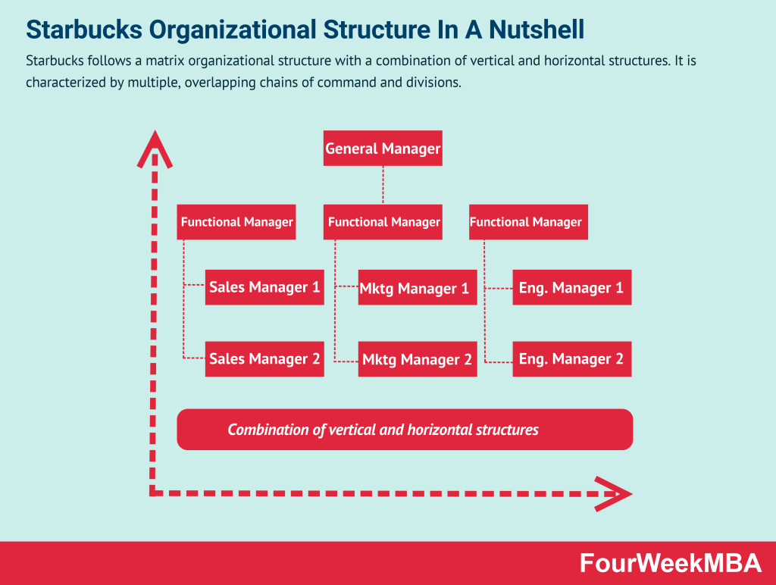
Fig. 1. A picture illustrating the systems management of Starbucks. (Source: Cuofano, 2022)
According to Forbes (2021), the hospitality industry is currently valued at around $139 billion, with over $23 billion in sales, $30 billion in assets, and $664 million in profit, earning several accolades for brand loyalty, fair market share, and company value in the economic sector. Starbucks (2022) recognises employees as critical components of the organisation, transforming them into partners through rigorous training and resourceful measures to improve its diversity, pay, and inclusion structure while maintaining a sustainable and ethical position in the environment.
Starbucks is an example of a systems management firm with multiple functions collaborating and coordinating across the globe to broaden the company's vision through product and service differentiation for a better market position (Nykiel, 2007, p213).

2.0 OVERVIEW
According to Cole and Kelly (2015, p13), several management theories for businesses from various perspectives and originators are appropriate for multiple organisations. However, as illustrated in fig. 1, the primary goal of each approach is to harness resources for higher yields. Management encompasses traditional scientific management, administrative management, human relations, social-psychological management, organisational behaviour, strategic perspective, positioning perspective, resource-based view, contingency, and systems theories. The paper focuses on two types that have played a significant role in most firms' growth: scientific management and systems theories.
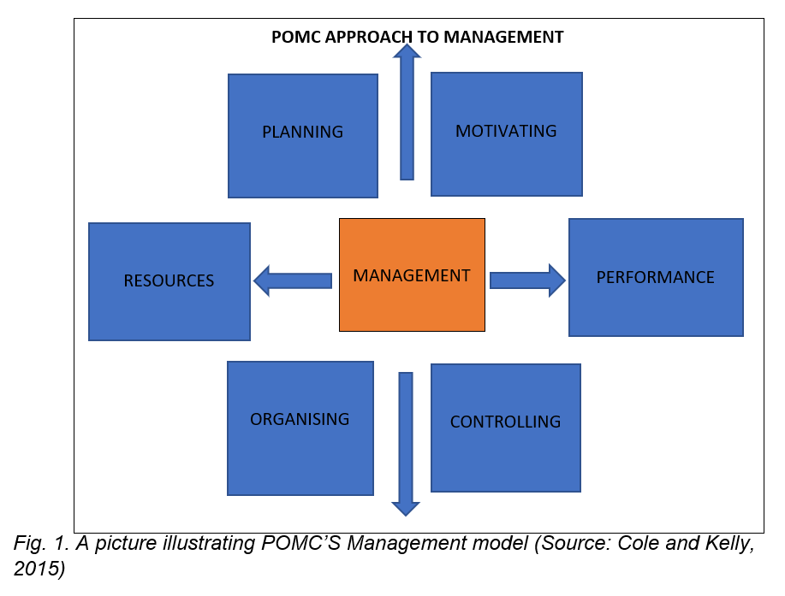
2.1 SCIENTIFIC MANAGEMENT THEORY
In the quest to satisfy enterprises' production at rewarding profits while employing managerial tactics with well-crafted job roles for individual workers in the past, precisely, the industrial age, an American practical manager-theorist called Fredrick Winslow Taylor proposed a scientific management theory. According to Cole and Kelly (2015, p26), Taylor sought to revolutionise the operational procedures, initially identified as problems for attaining higher efficiency on the shop floor. There was no clear definition of job roles and tasks associated with individual workers and their job roles, ultimately inviting personal interpretation to production with minimal supervision and control by management. Thus, posing a significant threat to production and profits to most industries sprouting at the time.
Holzer and Schwester (2015, p46) highlight that, to resolve the issue, Taylor established a scientific approach to a profitable organisational model embedded in four management principles, involving:
- Developing a science of each element of work – Taylor asserts in his proposition that each role is to be entitled to specific rules and norms defining each process. According to Sannigrahi (2011, p107), the first scientific management principle entrusts each role to be sub-divided into several processes and analysed over a specific time deemed measurable by the end.
- Organise and instruct specific tasks to specific tasks to specific roles – The theory determines an accurate boundary for functions from the scientific backdrop of time and methods for the particular job. The principle overrides natural human reluctance to pressure called 'soldiering' and aligns individuals to the mindset of demanding tasks and responsibilities associated with specific roles. Hanna (2009, p260) supports that the principle enables enterprises to attain profit without any extra effort.
- Cooperation between Management and the workers – The part of Taylor's philosophy translates workers to work in unison with the management through a resounding scientific platform where each part directly relies on another for overall productivity. Thus, Taylor's assertion would eventually benefit the organisation's production and profitability.
- Work sharing – The principle outlines the effects of sharing work knowledge on a broader scale, encouraging a collective idea for managers to identify who and what to be done at every given period. The principle supervises individual workers to commit to every given time, ultimately translating to predictable production of an organisation for investment and profitability purposes.

2.2 ADVANTAGES OF SCIENTIFIC MANAGEMENT
- IPL (2022) asserts that Taylor's scientific management theory encourages a standardised approach to work yield with nest practices. Cole and Kelly (2015, p30) support that the measurement detailing attached to the process provides resourceful information, rigours enough to produce a significant level of accuracy.
- The theory stimulates managers to outline productive tasks to specified roles to produce organisational efficiency while enhancing the leadership skills required for the flexibility of diverse situations (Jeswal, 2021, p142).
- The theory benchmarks the current work structure, emphasising wage entitlement per time spent at each functional role accompanied by defined knowledge about the role acquired through minimum training (Fajardo, 1997, p86).
- The theory encourages high work ethics to yield enhanced cooperation with collaborative teamwork amongst workers and managers to adapt to changes in working culture while taking advantage of higher wages and incentives.
- The theory opens organisations to better planning and decision-making processes with more considerable control over respective workers.

2.3 DRAWBACKS OF SCIENTIFIC MANAGEMENT
- The systems open to a lack of motivation amongst workers due to over-reliance on pay to work stigma and incentives.
- The theory appears to be practically challenging for larger organisations while admonishing the effectiveness of small-scale enterprises.
- The theory sets out a friction frame where managers may easily trip in making decisions which may affect production.
- The theory elevates managers to upper levels of planning and decision-making while crippling the creativity of individual workers due to restrictive tasks aligned to their respective roles, drawing intense pressure.

3.0 SYSTEMS MANAGEMENT THEORY
Systems theory is defined by Sullivan and Atlas (1998, p2) as a set of holistic parts of an organised whole with a specific purpose and interaction with the environment. Some authors describe management as a simplified human body with a common goal of existence; however, it detects and reacts to the environment when any part fails. In terms of organisations, it is worth noting that individual departments or branches work together to achieve the company's overall goal. One example is Lloyds Banking Group, which has acquired several businesses, including Halifax Bank, Scottish Widow, and Bank of Scotland. Another example is Dyson PLC, where departments such as Suppliers, Procurement, Operations, Marketing and Sales, and R&D work together to achieve a single goal for the company. CFI (2022) identified the two types of system management: open and closed systems.
3.1 TYPES OF SYSTEMS MANAGEMENTS
Open systems appear to be system management with regular interaction with the environment, according to Cole and Kelly (2015, p96). Any external environmental factors can significantly impact the function and the organisation. Some factors can include government policies and regulations, customer behaviour, and strategic management planning to counteract the organisation's surface effect. On the other hand, closed systems management does not directly interact with the environment. The accounting department is a classic example of a closed system; thus, any change in the background has no significant impact on the course of operation.
In systems management, the individual components or parts that comprise the more prominent organisation are sub-systems (Ferreira et al. 2020, p22). Although some organisational systems may be classified as closed management and others as open management, they all appear interconnected to produce a typical corporate value. Nonetheless, management encourages thin boundaries between each function, known as interfaces, and a defined process in each sub-system, defining their roles. According to Cole and Kelly (2020, p96) and Ferreira et al. (2020, p22), some sub-systems, such as accounting, budgetary control, and planning, operate within the organisation's confines and are referred to as internal interfaces. Alternatively, other sub-systems are regularly involved in the external operations within the environment, such as the R&D, procurement, and after-sales departments.
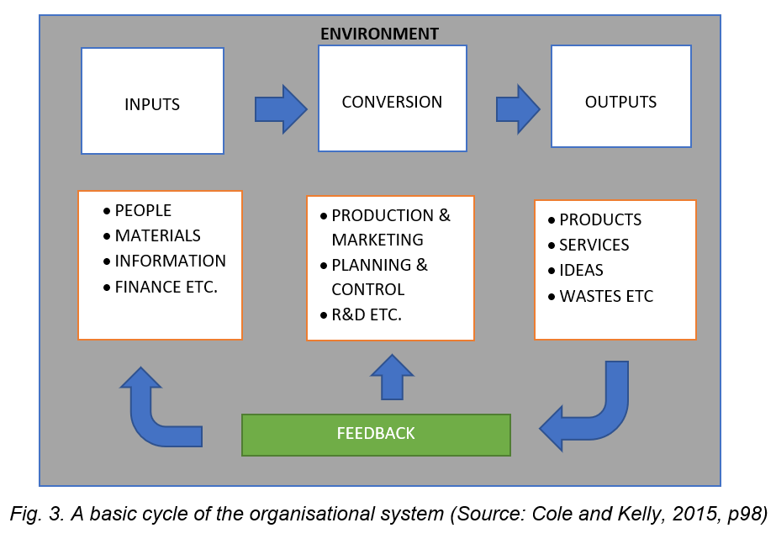
3.2. CHARACTERISTICS OF A SYSTEM
Systems recognise that all respective functions need a holistic collaboration under individual elementary boundaries by defined roles in fig to achieve the ultimate purpose. 3. Systems consist of;
- Inputs – the character that assembles all system parts indirect interactions with the environment, such as the people, raw materials, information, and finance.
- Conversion/transformation – the character that comprises production and marketing, planning and organisation, control and assurance teams, and R&D functions of the organisation or systems
- Outputs – the character that encapsulates finished products, services, ideas or wastes into the environment.
- Feedback – Typically, this character streams sustainable responses from the environments and helps managers at departments steer their production course for better value positioning. Feedback exists in diverse forms, including market competition, product, and service response from customers for better delivery and market fair share. Sullivan et al. (1998, p10) posit that, feedback plays a significant contribution to the performance of systems through better evaluation of employee salary, diversity and inclusion, ethical consideration in operations and outputs and sustainable sourcing of raw materials.

3.3 ADVANTAGES OF SYSTEMS THEORY
- The system encourages management with respective detailing to produce better results for the company's overall vision while positioning the firm at an advantageous market position.
- The theory centralises operations around the core individuals of the company, raising bars for salaries, diversity and inclusion, ethical behaviour and all the resource support for the output of individual make-up.
- The management model's feedback element enables management to centralise attention to trends and patterns and predict future returns for investment and corrective measurements for mistakes.
- The management model is practical, especially in the modern logistics and direct customer services companies like Starbucks and Tesco, and encourages a systemic synergy required for all functions of the organisational system.
- The system models efficient and effective platforms for better resource allocation and best policy strategies and opens up for corrective approach relative to scientific management, which appears rigid and task-oriented.

3.4 DRAWBACKS OF THE SYSTEMS MANAGEMENT THEORY
- The model's environmental impact steers the company's direction in situ for newer strategies, delaying plans to reach the overall system purpose. Such is an example of the recent COVID-19 pandemic's impact on several companies.
- Companies adopting this management model appear to sync diverse contingency plans for future environmental happenings, drawing a summary of an expensive model in practicality.

4.0 STARBUCKS’ SYSTEMS MANAGEMENT THEORY
Starbucks has achieved success in the coffee industry through a series of business model evolutions to the current organisational structure. Although modern businesses do not foster a strict management style for long-term success due to unforeseen changes and their associated consequences, Flamholtz and Randle (2016, p43) contends that Starbucks has featured a specific management style in the name of systems management throughout the firm's existence. Starbucks, like systems management, has diverse functions around the world that work in a hierarchical structure to achieve a common goal despite different roles and responsibilities. According to the authors, companies with clear directions and strong corporate acumen have the flexibility to meet challenging situations with diverse tactics to successful platforms and present future opportunities.
Recent challenges for businesses have included the 2008 economic crisis, Brexit
with newer regulations and trade policies, and the COVID-19, not to mention the
ongoing Russia/Ukraine war. Starbucks operates under several functions to produce an unprecedented global expansion through a series of functions classified as
follows:
Planning – The company's function is to strategise the business's long-term viability through policies, mission statements, values, and tactics. The component deconstructs complex programs into simpler parts for consumption by various general and area managers across the world's dispersed operational provinces. Diversity, inclusion, ethics, corporate culture, values, and functional dimensions are all part of the planning.
Sourcing – The organisation's function is responsible for all purchases and relationships with the supply chain. Surprisingly, one of the firm's critical functions is sourcing, which centralises procurement, supplier management, and minute contract detailing to engage all suppliers within the legal chain.
Making – The function of the firm is in charge of the company's transformation through a variety of positions, including human resources, finance, information technology, marketing, legal, operations (including all barristers and trainers), and Research and Diversity. Although not directly affected by the environment, the overall function of the business's making element has a significant impact on delivery.
Deliver – The critical function of the business that sustains customers through various forms of experience, such as physical stores, third-party delivery partnerships, and digital marketing.

5.0 RECOMMENDATIONS
The fate of many businesses is hanging on a thin thread, leading most companies to the brink of liquidation, owing to the financial losses accrued during the COVID-19 pandemic. Through tactics, most firms have strategised new ways of adapting business operations to recover from remnants of severe economic challenges. Some companies have long-term partnerships with third-party logistics for last-mile deliveries and investments in advanced technology for customised customer experiences and newer modes of customer engagement. On the contrary, some companies, such as Starbucks, have closed thousands of stores while heavily investing in redesigning existing stores to accommodate customers' newer working styles. Rogers et al. (2022) believes that retail industries must create a critical operational environment that is flexible but agile enough to meet the growing consumer behaviour of remote customers as companies encourage employees to work from home.
It is recommended that, for Starbucks to lean toward newer growth following the pandemic, corrective attention be focused on the employee culture through mental well-being and financial incentives as the core of a change in their campaign to regain strengths for newer tactics. According to Deloitte (2017), the human element serves as a fulcrum for change through positive attitude and corporate belief.
Through the importance of technology in bringing about change in an organisation, it is suggested that Starbucks take advantage of the opportunity of digitalisation and enhance its digital presence in its quest to offer loyalty flexibility through Artificial intelligence and establish a significant foothold in the coffee industry. According to Brewer (2020), despite Starbucks' recent surge in digital innovation, the company is poised to deploy the platform to entice customers at premium convenience for a fair market share and value positioning.

Furthermore, more sustainable transparency that complements business ethics through customer visibility from the supply chain, including farmers, can be automated to engage customers at the core of the business operating model. It is common to gradually improve the transparency network that has been built over time to help add value and loyalty to the business amid the societal cry for a sustainable environment.
6.0 SUMMARY
The report concludes with an account of the types of management theories from the traditional days to the present days and how some of them have moulded the success of businesses, typifying Starbucks as an ensemble of systems management theories. The report highlighted the characteristics and drawbacks of scientific and systems management theories with recommendations to the company in gear to remain successful as before the pandemic with strengthened beliefs and value proposition.

REFERNCE LIST

Brewer R. (2020). How Starbucks is using AI to fuel its growth, deepen customer relationships. Yahoofinance.com [online] Available at https://finance.yahoo.com/news/starbucks-to-use-ai-at-the-drive-thru-151414041.html?guccounter=1&guce_referrer=aHR0cHM6Ly93d3cuZ29vZ2xlLmNvLnVrLw&guce_referrer_sig=AQAAAJVUvffdkBpB4VDhNLR5KZ9dOY1juaFI5K26if1gUtwlMDs3LtiE5k1-uMR9jOMnh7iiYPdXmY6oUzlNqbkqO3mPx0yxyYzdDtuW-YX4FA8ifq75fuEq__4w0wRIWfnFP9W6FecbRCujXz1xXu1Y9PJ0HYbTq3z-bF1E0tdNDsDu [Accessed on 30 April 2022].

CFI (2022). Management Theories. CFI.com [online]. Available at https://corporatefinanceinstitute.com/resources/careers/soft-skills/management-theories/ [Accessed on 30 April 2022].
Cole G. E., Kelly P. (2015). Management Theory and Practice 8th ed. Andover, Cengage Learning. pp.13, 26, 30 98, 96.
Cuofano G. (2021). Starbucks organisational structure in a nutshell. Fourweekmba.com [online]. Available at https://fourweekmba.com/starbucks-organizational-structure/ [Accessed on 30 April 2022].
Deloitte (2017). Global Capital Human Trend. Deloitte.com [online] Available at https://www2.deloitte.com/content/dam/Deloitte/global/Documents/About-Deloitte/central-europe/ce-global-human-capital-trends.pdf [Accessed on 30 April 2022].
Fajardo F., R. (1997). Management. 1st ed. Manilla. Rex Book Store. pp.86.
Ferreira E. J., Erasmus A. W., Groenewald D. (2009). Administrative Management. 2nd ed. Cape Town, Juta and Company Ltd. Pp. 22.

Flamholtz E. G., Randle Y. (2016). Growing Pains: Building Sustainably Successful Organizations. 1st ed. Hoboken, New Jersey. John Wiley and Sons Inc. pp.43.
Forbes (2021). Starbucks. Forbes.com [online]. Available at https://www.forbes.com/companies/starbucks/?sh=4648006628ac [Accessed on 30 April 2022].
Hanna N., K. (2009). Enabling enterprise transformation: Business and grassroots innovation for the knowledge economy. 1st ed. New York. Springer International. Pp260.
Holzer M., Schwester R. W. (2015). Public Administration – An introduction. 2nd ed. Abingdon, Routledge Publishing. pp46.
Jeswal N. (2021). Business Organisation. 1st ed. Agra. India. pp.106.
Nykiel R. (2007). Handbook of Marketing Research Methodologies for Hospitality and Tourism.1st ed. New York. The Howarth Hospitality and Tourism Press. pp.213.
Parker B. (2005). Introduction to Globalisation and Business: Relationships and Responsibilities. 1st ed. London. Sage Publications. pp.118.

Rogers S., Waelter A., Hatfield S., Pieters L. (2022). How remote work is influencing what we buy. Deloitte.com [online] Available at https://www2.deloitte.com/us/en/insights/industry/retail-distribution/consumer-behavior-trends-state-of-the-consumer-tracker/how-remote-work-influences-spending.html [Accessed on 30 April 2022].

Sannigrahi A., K. (2011). Human Resource Development. 1st ed. New Delhi. New India Publishing Agency. pp.106.
Starbucks (2022). Our Company. Starbucks.com [online]. Available at https://www.starbucks.com/about-us/ [Accessed on 30 April 2022].
Sullivan C. F., Atlas C. (1998). Healthcare Food Services Systems Management 1st ed. Maryland, Aspen Publishers Inc. pp.2 and 10.

1.0 PART B - REFLECTIVE JOURNAL (GIBB’S REFLECTIVE CYCLE)
1.1 Description
It is fair to mention that stepping into the class, my overall thoughts of the module were just the definition and dynamics of management as bear-minimum. Although I suffered a few technical glitches with the online platform, the experience, and the intake from the first week's onset captivated my attention once that was resolved. During the first week, the class was introduced to management theories underlying various organisations from ancient times to the current business environment. According to Hearn and Louvrier (2015), multiple theorists from multiple backgrounds have proposed management theories to society, including scientists, psychologists, socialists, and modernists.
Among the theories covered during the week, some have received significant recognition over time due to their extensive coverage, such as scientific management and work definition per minimum wages. Throughout the week, the class encountered prominent personalities such as Fredrick Taylor and Max Webber, who were attracting significant changes within the workplace. Their contributions established effective boundaries between managers and employees, with defined roles and responsibilities to supplement the week's deeper logical reasoning.
The second week began with a reflection on the previous week, particularly my colleagues discovering their workplace managerial styles. The week's goal was to highlight the value of critical thinking in the workplace and the power of analysis. Gino and Staats (2020) agree that critical thinking is a tool for organisational decision-making in managerial positions, with various benefits and consequences for failures. The class paused for a thinking discussion deeply rooted in our routine decisions with the least attention, no matter how obscure the concept appears. Williams (2002, p53) added that critical thinking can be deduced but has a more significant impact on a corporate decision, thus shop floors or board rooms.
The third week of the class saw a broader expansion of critical thinking with various examples and analogies to add to the initial image previously drawn to the style. Aside from the importance to the public, the benefits to an organisation range from economic contribution to team creativity and are a necessary skill set for career success. Another goal for the week was to introduce management theory to the Human Relations approach.
Following the last week's recap, the class was tasked with researching the business environment and how it has evolved during the meeting. Although the tone was set by management theories, critical thinking, and delving deeper into the various types of management and their applications, the prevalence of business evolution was enterprising to our managerial quest. Throughout the week, the class was tasked to compare and contrast the complementary contrast employed by each management theory type in problem-solving, decision-making, and inductive and deductive approaches in current management.
Max Weber's bureaucratic management in organisations and Edward de Bono's six thinking hats were introduced to the class. Bureaucracy, as an organisational structure founded in the 18th century, is still visible in today's business environment and is a widely used template. According to Bono (2017), people can vision as thinkers when they use a broader perspective on situations to have positive experiences. He identified colours as a perfect representation of personality in his assertion; managers tend to adapt to situations for solutions, including white, red, black, yellow, green, and blue.
Although the remaining weeks of six to nine were disrupted by festive periods, final report output, and bank holidays, the class managed to sail through other critical topics such as contingency theory in management, systems theory, innovations, organisational controls, and task management. In the interest of the course, the class was ready to identify the management style that best suited each member's workplace rather than the existing regime that was already in place.

2.0 FEELINGS
The PowerPoint slides were exciting and informative for further reading on the topics for the coming week. The experience appears to be more informative and felt very sharp and applicable to my personal and professional dealing with situations with deeper logical lenses.
During the second week, my feeling had grown from underpinning the management theories of the previous week to the everyday decisions made at the workplace. The experience was indeed a beneficiary, although the complexity was harder to define as it always appears. During the week, I realised that every time I was faced with a decision in the past, I went for contingency measures without evaluating, analysing or even taking time to stop, think or even learn and develop arguments.
The week provided an open platform for analysis with various scopes, including additional critical thinking and human approach management theory. Within a week, the experience revealed a deeper connection with more relativity to understanding the best skill set to deploy in every situation, particularly when employing a human approach theory in management. As a result of its adaptability concerning technology in the form of AI, the human component of an organisation is critical to decision making and value proposition.
The fourth week's experience appeared slightly overloaded; however, applying critical thinking at each task stage simplified every concept to an understandable form to digest. Throughout the experience, I extensively related subtopics such as Gantt charts and scientific and human approach management to comprehend how businesses have evolved. While the Gantt chart can assist a manager in gaining control of a schedule, scientific management establishes firm task boundaries between workers, allowing managers to award employees at specific times.
A sense of discontinuity and adaptability marked the week to the two topics. The majority of the class was drawn to the six thinking hats concepts and their relevance to everyday life, such as creativity creation, honesty, and unconscious decision-making bias. Whereas bureaucratic management discourages quick decisions, delays progress obstructs modern changes to business improvement and ultimately appears to be a barrier to organisational productivity for dynamic progression.
The class's final experience accumulated over the remaining weeks broadened the overall thinking scope. I was able to create a real personality and relate to it on various levels, including judgment, management, planning, decision-making, the inevitable changes in today's society, and the drive for organisational productivity.

3.0 EVALUATION
According to George Bernard Shaw, “progress is impossible without change”, which I learned from the PowerPoint slides in week one. The resonation from the start portrayed my motivation for taking this module, as my primary reason was to advance on my career ladder. As a result of broadening my managerial perspective, a shift in priorities necessitates devoting time and effort to each decision.
In my second week's evaluation, I emphasised the importance of critical thinking; however, the concept also allows for beliefs, values, and emotions associated with situations. According to McKee et al. (2012, p290), critical thinking is a managerial tool that empowers decision making at all levels of an organisational structure.
My third-week experience provided a solid foundation for setting goals, especially when working in groups. The assertion for the week is reasonable because it employs a socio-centric bias analysis, which I previously used to deploy in most cases rather than taking a universal approach. Control over decision-making processes is recognised as a result of the universal method.
The fourth-week experience is more important to the module because the class was designed to engage in decision-making from a broader context, especially when individuals' past backgrounds appear to underpin specific pathways. It is worth noting that management can produce practical results by prioritising logical reasoning and critical thinking over strict control measures.
In my fifth-week evaluation, I stated that the lesson assisted me in carrying out a self-assessment of my critical thinking abilities because we had to do a class exercise representing managers and making decisions. The class exercise helped me assess myself using the most rigorous parameters to bring myself up to speed on the principles of business application and decision making.
Because of the broader perspective of information accumulated over the period, the concepts used throughout the module represented a high value for career development and an asset to self-assessment.

4.0 ANALYSIS
The first week's lessons taught me what critical thinking is and related questions and a series of workplace scenarios, which honestly changed my perspective on how I used to look at situations. My curiosity was to marry management theories to my workplace's management style. The aim was to conclude which part has been modernised to suit the needs and complexities of the company.
During the second week, the class participated in an exercise in which we examined a dialogue approach to critical thinking. It shaped my understanding of teamwork and my tolerance for other people's opinions with appropriate attention and space for deeper reflection.
During the third week, I quickly grasped the concept of management as an umbrella of several skill sets with varying degrees of importance at any given time. The management theory videos produced qualities that can be used in the future for better evaluation at a given time. The human relations approach and Hawthorne's studies (1924-1982) assisted me in understanding how minor changes in life and the workplace will benefit my workplace productivity.
The fourth week's production of a Gantt chart in scheduling meetings and projects and defining individual timelines orchestrated a refined understanding of the class for analysing situations. In the interest of making sense, the week emphasised priorities as a key to business evolution, much like theorists, scientists, modernists, and socialists did in their respective eras.
The fifth week featured a fascinating presentation as the class had to marry our routine workplace decision-making process to Bono's hat, thinking to our advantage. Regardless of the level of expertise, decision-making experience in any situation can be critical to a business's overall goal. Although the class gained more from the six thinking hats compared to the bureaucratic management style, it was clear that most participants in the class knew less about it than the typical bureaucracy in our workplaces. The colours included;
White hat – indicates neutrality and objectivity (matters concerned with objective facts and figures)
Red hat – represents emotions expressed in anger and rage
Black hat – shows seriousness to situations or weakness to views and opinions.
Yellow hat – illustrates optimism in opinions and experiences.
The green hat – highlights creativity and ingenuity.
Blue hat – shows the level of control employed in situations.
Although, in general, the module appeared to be a challenge with a few technical glitches, it can be deduced as a practical reference point for analysis in various ways. Management theories, critical thinking, Gantt charts, logical reasoning, business evolution, and the six thinking hats have all made me a better manager from every angle than before.

5.0 CONCLUSION
In a nutshell, week one piqued students' interest in the course. I was eager to learn about my co-workers' perspectives and their organisational resemblance to the management types.
In honour of the second week, I can conclude that, while situations vary, the inclusion of critical thinking in any form or shape outweighs any hurried solutions.
Finally, the third week enlightened me on the importance of critical thinking in pursuing management, particularly when implementing a humanistic approach in an organisation.
The week summarises how business evolution has been a continuous revolution and a symbolic shift to accommodate changing environmental conditions and consumer behaviours. In this era, it can be stated that society approaches businesses from ecological factors, defining business directions, such as the COVID-19 pandemic, BREXIT, and even the Russia/Ukraine war.
Looking back on the week, I agree that the adaptability of the six colours of Bono's thinking hats is directly related to critical thinking. It encourages analysing facts from gut feelings to data from an objective standpoint. Furthermore, Bono's concept aids in the exploration of potentials that are highly required in the managerial world of today's business environment.
Finally, the reflection has struck a chord with my managerial nerves from various perspectives over the next few weeks. It has significantly aided my advancement in my administrative career, providing accounts for better management in any organisation I am or will ever be employed to manage.

6.0 REFERENCE LIST
de Bono, E. (2017). Six Thinking Hats: The Multi-million Bestselling Guide to Running Better Meetings and Making Faster Decisions. United Kingdom: Penguin Books Limited.
Francesca G., Staats B. (2015). Why Organizations Don’t Learn. Hbr.com [online] Available at https://hbr.org/2015/11/why-organizations-dont-learn [Accessed on 30 April 2022].
Hearn J., Louvrier J. (2015). Theories of difference, Diversity and Intersectionality: What do they bring to diversity management? Oxfordhandbooks.com [online]. Available at https://www.oxfordhandbooks.com/view/10.1093/oxfordhb/9780199679805.001.0001/oxfordhb-9780199679805-e-28 [Accessed at 30 April 2022].
McKee A., Kemp T., Spence G. (2013). Management – A focus on leaders 1st ed. Australia. Pearson Publications. pp.290.
William S. (2002). Making better business decisions – Understanding and improving critical thinking and problem-solving skills. 1st ed. California. Sage Publications Inc. pp.53.

