

The Global Business Environment

Student Name: Nicolae-Alexandru Voinea
Student ID: 2119833
Lecturer: Alfred Mensah
Module code: LCBB4005
Deadline: 12/05/2022

Table of Contents
Introduction 3

Analyzing the megatrends such as external and internal environment impacts the automobile industry due to pandemic 4

Conducting internal analysis to know how the pandemic has impacted the automobile industry 6
Evaluating competitive context in the automobile industry by applying porter’s five forces analysis 8

Measuring survival and success factors due to pandemic in the automobile industry 9

Conclusion 11

References 12

Introduction
This research discusses the way the Covid-19 pandemic has impacted the automobile industry. During the pandemic, the manufacturers and suppliers that are interrelated with the automobile industry had to shut their activities. It has considered megatrends such as both internal and external analysis in terms of understanding complex situations. It impacts identifying the survival and success factors that have affected the automobile industry. The UK has consisted of several renowned automobile companies such as Jaguar, Bentley, Lotus, Rolls-Royce, Aston Martin, etc. This automobile industry is not only manufacturing premium cars but also exporting different automotive parts to different countries. Around 2400 suppliers are available in the UK regarding the material distribution as well as comprising 20 R&D centers for exploring innovations. In 2019, the UK has exported UK-built vehicles to more than 150 countries.

2.Analyzing the megatrends such as external and internal environment impacts the automobile industry due to pandemic
Applying PESTEL analysis
2.1Political
In the UK, the local govt. has declared the rules and regulations regarding the manufacturing process of automobile parts. It is generally used towards assuring fair market policy and ensuring the safety of passengers. The administrative bodies are promoting less usage of fossil fuels because of excessive pollution.
2.2Economic
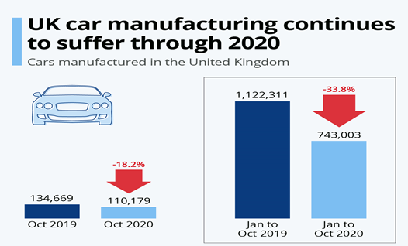
Figure 1 UK car manufacturing scenario (Kaitwade, 2021)
Based on the stability of income among the customers, the automobile companies would think of increasing the supply of cars. If the tax rate is high on imported cars, then it influences the customers to think of purchasing locally produced cars (Kaitwade, 2021). Companies that are manufacturing automobiles in the UK have been facing a downfall in the year 2019-2020 due to Covid-19. From Jan to Oct 2019, they have manufactured 1.1 million cars but from Jan to Oct 2020, they have produced 700k cars. It indicates around 33.8% downfall of manufactured cars in the UK automobile industry. The downfall in car manufacturing industry has occurred due to the impact of the pandemic because it has created barriers to completing the regular supply chain process. Several decisions of the govt. regarding the lockdown and strike have pushed the automobile companies to face such situations.
2.3 Social
In the UK, people have prioritized the purchase of cars not only for the need for transportation but also considering fashion statements. Around 7 major premium and sports car manufacturers have been established in the UK. On the other hand, 60 specialist car manufacturers are working on the customization of cars based on personal choices and interests. Due to the pandemic, people have shifted their choices to the purchase of necessary items regarding lifestyle items. As per modern trends, they had to change their perceptions regarding the consumption of luxurious products.
2.4 Technological
Due to the advancement in technologies, the automobile industry has expanded its logistic support and distribution system (Wormald, 2020). It has focused on using different technologies such as artificial intelligence, the internet of things, electrification, and additive manufacturing. These are contributing to fostering the growth of the automobile industry in the UK and it also promotes green technology for reducing emissions. The requirement for the new cars has been reduced because of the less movement of people. People have been conducting their meetings and shopping from the online platform without visiting places physically.
2.5 Environmental
While manufacturing automobile parts in the UK, they have concentrated on cutting emissions. Different environmental policies are followed in the UK such as fuel consumption law, greenhouse gas limitations, and recycled use of materials. Even, electric car production initiatives have been taken by UK-based car manufacturers such as Rolls Royce that would encourage other competitors to be concerned about environmental protection. Pandemic has influenced the automobile companies to launch programs that would support protecting the environment such as low-carbon taking engines. It has also enabled the car manufacturers to survive these complex issues as well as create a good reputation with the customer.

2.6 Legal
It has identified several laws and regulations regarding the design, production, marketing, selling, and developing of automobiles. Due to digitalization, it remains significant for an automobile company to ensure the practice of intellectual property rights, balancing the number of vehicle supply, authentic forensic tests of the cars, and customer protection rights. Due to Covid-19, automobile companies are forced to limit the number of employees towards avoiding physical interaction in different sections.

Conducting internal analysis to know how the pandemic has impacted the automobile industry

3.1 Applying SWOT Analysis
3.1.1 Strengths
- The UK has consisted of a variety of automobile companies that have been running the business since 1904 like Rolls Royce.
- They have introduced globally recognized car companies such as Rolls Royce, Land Rover, Jaguar, and Bently.
- Manufactured cars in the UK have been exported to more than 150 countries around the globe.
- More than 2400 suppliers are available from different countries regarding the regular supply of materials to manufacture cars.
- In the case of innovating new technologies and designs of automobiles, they have been operating 20 R&D factories (Zhang, and Li, 2020).
- Strong technological capacities and automation process has facilitated the company to deal with pandemic problems.
- Due to capital effectiveness for the long years, they have supported the victims who such as employees have suffered economically due to the pandemic.

3.1.2 Weaknesses
- Car manufacturers in the UK are highly reliant on different factors such as fuel prices, and the validity of the registration period. It is impacting the market demand for cars negatively because customers are reluctant to face such legal complexities.
- On the other hand, the automobile industry in the UK has a high dependency on the supply of materials from China. Due to Covid-19, they are not able to get the desired amount of materials to deliver expected cars around the world.
- The increasing competition has indicated obstacles for the companies because of low-bargaining power in the pandemic situation.
- Small and medium companies are not capable enough to use advanced technologies in the manufacture of automobile parts and it can affect the risk of errors during a pandemic.

3.1.3 Opportunities
- The UK market automobile industry is now trying to prioritize the OEMs such as original equipment manufacturers and it would support the company towards reducing the dependency on other countries (Hoeft, 2021). It can ensure the country’s sustainability regarding the production of automobile parts and commercially demanded cars.
- They can even adopt advanced technologies such as ERP technology, 3D technology, electrification, and artificial intelligence to facilitate the production and assembly of cars.
- The lifestyle of the customers has been changing after Covid-19 as they are now more concerned about environmental protection. It also aids in organizational production by promoting the use of renewable energy and recycled materials to cut excessive costs.

3.1.4 Threats
- Due to the established companies, new automobile companies cannot sustain themselves in the competitive market. Renowned organizations have a loyal customer base and a strong influence on social media regarding the purchase of cars.
- Companies are frequently facing changes in the design of cars and it pushes them to bring out innovative designs as compared to rivals.
- On the other hand, volatility of fuel prices has also limited the purchasing level of cars as high-consumed fuel cars can be expensive in maintenance.
- In the UK, the automobile industry has made 15 years ahead projects and plans such as developing the Giga factory which indicates high fixed cost and investment.
- Pandemic has shown the vulnerability of the automobile industry and they need to be prepared for any kind of disaster.
- It increases the risk of low inventory, failed supply chain process, and manufacturing cars that should be concerned to deal with future issues in terms of not repeating like a pandemic.

Evaluating competitive context in the automobile industry by applying porter’s five forces analysis

4.1 Supplier’s bargaining power
The automobile companies in the UK are not producing cars but also exporting automotive parts to different countries. It has been indicating a stable and strong relationship with suppliers to get desired materials. In that case, the UK has faced moderate bargaining power of suppliers due to the balanced number of available suppliers in the local market.
4.2 Buyer’s bargaining power
The automobile industry has been introducing a variety of companies that facilitate customers to get desired cars within range. It increases the bargaining power of buyers against car manufacturers. On the other hand, the import facility in the UK has decreased the chance of bargaining for the manufacturers.
4.3 The threat of New Entrants
Due to the existence of established organizations in the UK market, the automobile companies are not facing a high threat to the entrants of new companies (Harris, et al., 2020). Renowned organizations like Jaguar, McLaren, and Rolls Royce have large market share and loyal customer value in the local market creates obstacles for the new companies in the automobile industry. They can think of approaching high customer demand at low manufacturing cost which indicates the low threat of new entrants in the market.
4.4 Substitution threat
The risk of substitution has arisen due to the launch of innovative products and services. But automobile industry cannot be substituted with other products like air or water vehicles. Moreover, it can improve the process of operations and manufacturing cars in the company. It defines the low risk of substitution in the UK automobile industry as well as encourages the way of adding value for ensuring sustainability like electric cars.
4.5 Competition
Available companies in the automobile industry are facing tough competition due to commercialization, digitalization, and globalization. In the UK, there have fair market operations regarding the business of automobiles. When a company like Rolls Royce, Jaguar, Bentley has introduced new products and quality in the cars, then it pushes competitors to adapt to changes. They have focused on high investment in the research and development section for innovating new automobile parts like an airbag, low emission engines, and unique designs.

Measuring survival and success factors due to pandemic in the automobile industry
Due to Covid-19, automobile companies have identified low demand for luxury and commercial cars. In that case, companies are focused on reducing excessive costs by cutting employment, shutting down regional branches, and following a defensive approach to secure investment. Based on the impact of Covid-19, the global supply chain system of automobile parts has been damaged and they cannot think of expanding business without generating support and materials from China. The UK has announced strikes and lock-downs several times that lower business transactions. These physical parts cannot even be shipped from one place to another without human interaction such as export guidance and regulations. In that case, several factors have been identified which support the automobile industry to survive and achieve desired success even after the impact of Covid-19.
5.1 Extensive distribution system: In the case of selling new vehicles, the car manufacturers in the UK have identified a few pooling locations to conduct test drives (Handfield, Graham, and Burns, 2020). It allows the customers to purchase cars with a digital financial system such as cryptocurrency. By expanding branches in different urban areas, companies can interact with target customers along with offering repair services to the customers. It also helps the customers to get quick delivery of different parts from the nearby locations. Commission-based sale has also pushed organizational sales in different countries and it focuses on engaging customers from different corners of the world.
5.2 Trending innovation: UK-based automobile companies have focused on following innovative trends in the market that fosters the company’s growth. It includes applying electrification and artificial intelligence which is highly used by Tesla. It has been applied in the production of the upcoming Rolls Royce Spectre car. On the other hand, 3D printing is used in the design system of cars along with developing vehicle connectivity. It also indicates following trending technologies like big data analytics for solving complex problems and allowing the manufacturing of autonomous vehicles.
5.3 Cutting excessive expenditure: While manufacturing cars, the companies can think of cutting excessive costs that would indicate getting high profits. Several organizations have survived during Covid-19 by lowering the cost of marketing, and operations. Companies like Bently and Aston Martin in the UK have reduced the number of salespeople, used technologies to influence purchasing decisions, and promoted the use of recycled materials. Due to Covid-19, the management has been used to arranging seminars and meetings online frequently which decreases the cost of physical seminars and meetings. They can even take suggestions regarding the design and planning from experts in different countries through the digital communication system.
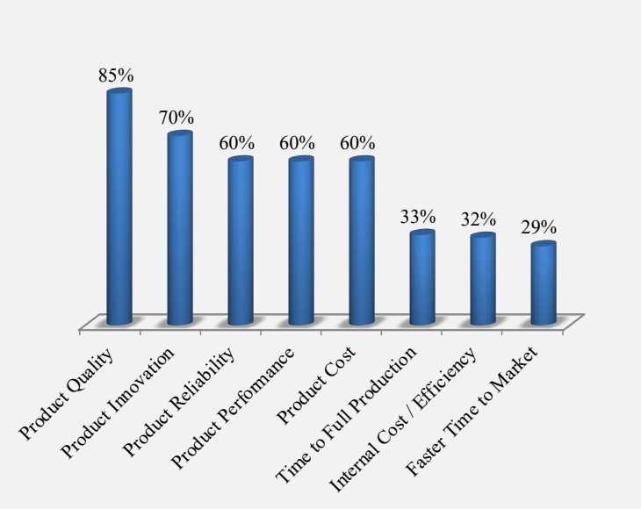
Figure 2 Survival and success factors for the automobile industry
According to this chart, it has that automobile customers are highly preferring quality products and it differs a company from others. Based on the innovative products and services, 70% of organizational success is assured. In this industry, customers are changing their choices as per the social trends because they purchase cars to express their fashion sense and social status (Arribas-Ibar, Nylund, and Brem, 2021). The automobile companies like Jaguar and Rolls Royce are only manufacturing limited editions of cars which increases higher demand among global customers. They even require making pre-booking to get their customized and personalized cars. To sustain in the competitive market, automobile companies are trying to assemble parts in a faster way so that they can reduce the gap between order and distribution time. They have also prioritized the use of modern technologies towards reducing the range of errors and increasing efficiency to get desired effectiveness.

Conclusion
To summarize the impact of COVID-19 on the automobile industry, this research has measured the survival factors and success factors. By analyzing value chain analysis, it can determine the way an organization can add value to the company. While manufacturing and exporting automotive parts to different countries, the UK govt. has facilitated local businesses through developing rules and regulations. It has also examined the competitive forces that are creating obstacles for companies with similar products and services. Social and economic factors have highly affected the automobile industry of the UK in terms of getting the work done along with distributing final products. It concludes the competitive forces that have been pushing an organization to change its policies and infrastructure to overcome barriers and sustain itself in the market.

References
Arribas-Ibar, M., Nylund, P.A. and Brem, A., 2021. The risk of dissolution of sustainable innovation ecosystems in times of crisis: the electric vehicle during the COVID-19 pandemic. Sustainability, 13(3), p.1319.
Handfield, R.B., Graham, G. and Burns, L., 2020. Corona virus, tariffs, trade wars and supply chain evolutionary design. International Journal of Operations & Production Management.
Harris, J.L., Sunley, P., Evenhuis, E., Martin, R., Pike, A. and Harris, R., 2020. The Covid-19 crisis and manufacturing: How should national and local industrial strategies respond?. Local Economy, 35(4), pp.403-415.
Hoeft, F., 2021. The case of sales in the automotive industry during the COVID‐19 pandemic. Strategic Change, 30(2), pp.117-125.
Kaitwade, N., 2021. COVID-19 shatters global automotive industry; sales of metal powder take a nosedive amid wavering demand. Metal Powder Report, 76(3), pp.137-139.
Wormald, J., 2020. The UK Automobile: Post-Brexit.
Zhang, H. and Li, Y., 2020, October. Optimal Design of Carrying Auxiliary Fixtures in an Automobile Production Line Based on Static Analysis Method. In Proceedings of the 2nd International Conference on Artificial Intelligence and Advanced Manufacture (pp. 422-427).

