

Artificial Intelligence for Credit Risk Assessment

Student Name: Vishvarajsinh Surendrasinh Rana
Student ID: 2527154

MSc Data and Artificial Intelligence
Module: L7 – Artificial Intelligence
Module Code: ACCA7026

Lecturer: Malik Mehmoud

Abstract

Credit risk assessment is a fundamental function within financial institutions, where accurate identification of potential loan defaults is essential for effective lending decisions and financial stability. Traditional credit assessment methods often rely on analyst judgement and rule-based approaches, which may be limited in their ability to capture complex relationships within financial data. This study investigates the application of machine learning techniques for credit risk prediction by developing and comparing two classification models, Logistic Regression and Random Forest, using the Lending Club dataset comprising 10,000 loan records and 56 predictor variables. The dataset was preprocessed through median and mode imputation to address missing values, followed by an 80:20 stratified train-test split to preserve the distribution of default and non-default cases. Logistic Regression was evaluated using five-fold cross-validation, while Random Forest was optimised using GridSearchCV to identify the most effective parameter configuration. Model performance was assessed using accuracy, precision, recall, F1-score, and the area under the receiver operating characteristic curve (ROC-AUC). The results indicate that Random Forest achieved a higher ROC-AUC score (0.7018 compared with 0.6800) and accuracy (96.75% compared with 95.05%), demonstrating stronger overall discrimination performance. However, Logistic Regression achieved slightly higher precision (2.47% versus 2.22%) and recall (9.09% versus 4.55%), suggesting improved identification of default cases despite the highly imbalanced nature of the dataset. Feature importance analysis identified annual income, interest rate, and debt-to-income ratio as influential predictors of loan default, while SHAP analysis enhanced transparency by explaining both global feature contributions and individual predictions. Despite acceptable overall performance, both models demonstrated limited recall, highlighting the challenge of detecting minority default cases and the need for threshold optimisation or cost-sensitive learning approaches. Overall, the findings demonstrate that model selection involves balancing predictive performance, interpretability, and operational requirements. The study further emphasises the importance of explainable artificial intelligence, fairness evaluation, and continuous monitoring to support responsible deployment of AI-based credit risk assessment systems.
Table of Contents

Abstract 2
1 Introduction 4
2 Related Work 5
3 Methodology 5
3.1 Data Preparation and Exploration 5
3.2 Train-Test Split and Stratification 6
3.3 Model Development and Hyperparameter Optimization 6
3.4 Model Evaluation Metrics 7
3.5 Model Interpretability and Explainability 7
3.6 Fairness and Bias Considerations 7
4 Results and Discussion 8
4.1 Data Preparation Results 8
4.2 Logistic Regression 10
4.3 Random Forest Hyperparameter Tuning and Performance 11
4.4 Model Comparison and Selection 13
4.5 Feature Importance and Interpretability 14
4.6 SHAP Values and Model Explainability 15
4.7 Fairness and Ethical Considerations 16
4.8 Deployment Recommendations and Practical Considerations 17
5 Conclusion 18
6 References 19

1 Introduction

Credit risk assessment is a critical function within financial services, influencing lending decisions, financial stability, and profitability. Traditional approaches rely on expert judgement and predefined rules, which can be time-consuming, difficult to scale, and vulnerable to inconsistency when processing large volumes of applications [3, 8].
Machine learning (ML) has enhanced credit risk assessment by enabling data-driven analysis of borrower characteristics and historical lending data [3, 7]. ML algorithms can identify complex patterns to improve prediction consistency, while explainable AI techniques provide greater transparency into model decisions [4, 5, 9]. However, ML-based credit scoring introduces challenges related to fairness, bias, and interpretability. Models trained on historical data may reproduce existing biases, while complex algorithms may lack transparency, creating regulatory and trust concerns. Therefore, AI-driven lending systems must balance predictive accuracy with fairness, explainability, and accountability [8, 12].
This study develops and compares Logistic Regression and Random Forest models for loan default prediction using the Lending Club dataset containing 10,000 loan records and 56 features. The models are evaluated using accuracy, precision, recall, F1-score, and ROC-AUC, with feature importance and SHAP analysis applied to improve interpretability. The study also examines fairness and ethical considerations associated with AI-based credit risk assessment.
The research aims to prepare the dataset for machine learning classification, develop and compare Logistic Regression and Random Forest models, evaluate performance using appropriate metrics, identify key default predictors through feature importance and SHAP analysis, and examine ethical and fairness considerations in AI-based lending. This research contributes to responsible AI deployment in financial services by highlighting the need to balance predictive performance, transparency, and fairness.

2 Related Work

Machine learning has become an important approach for credit risk assessment, offering improved prediction accuracy and data-driven lending decisions. Bello [3], Li [4], and Li and Zhang [5] highlight that ML models can outperform traditional approaches by identifying complex default patterns, although challenges remain in model selection and implementation.
Algorithm selection significantly influences performance. Breiman [10] introduced Random Forest as an effective method for modelling non-linear relationships, while Dumitrescu et al. [12] demonstrate that interpretable linear models such as Logistic Regression can achieve competitive performance with greater transparency. This trade-off motivates the comparison conducted in this study.
Credit risk datasets often suffer from class imbalance, making appropriate evaluation metrics essential. Fawcett [11] and Johnson and Khoshgoftaar [13] emphasise the importance of ROC-AUC and imbalance-handling techniques for reliable model assessment. Additionally, explainability and fairness are critical in financial applications, with SHAP-based methods improving transparency [9] and fairness-aware approaches reducing potential bias in lending decisions [8].
Previous studies [6, 7] further highlight the importance of rigorous model evaluation and practical considerations in financial AI deployment. Building on this research, this study compares Logistic Regression and Random Forest while considering predictive performance, explainability, and responsible AI requirements..

3 Methodology

3.1 Data Preparation and Exploration

This study uses the Lending Club Loan Dataset [1], containing 10,000 loan records and 56 features representing borrower characteristics, loan attributes, and credit history information. The dataset presents a significant class imbalance, with 98.22% of observations representing non-default loans and only 1.78% representing defaults. This imbalance reflects real-world credit risk scenarios but introduces challenges for model training and evaluation, as highlighted by Johnson and Khoshgoftaar [13].
Data preprocessing was conducted to improve data quality and model reliability. Features containing more than 80% missing values were removed due to their limited contribution to predictive modelling. Remaining missing numerical values were addressed using median imputation, while categorical variables were processed using mode imputation. Categorical features were transformed using one-hot encoding, and numerical variables were standardised using z-score normalisation to ensure consistent feature scaling. Following preprocessing, the dataset contained no missing values and 55 predictive features for model development.

3.2 Train-Test Split and Stratification

The processed dataset was divided into training and testing subsets using an 80:20 stratified random split, resulting in 8,000 training records and 2,000 testing records. Stratification was applied to preserve the original distribution of default and non-default cases across both subsets, reducing the risk of biased evaluation caused by uneven class representation [13]. This approach ensures that model performance reflects its ability to generalise to unseen credit risk cases while maintaining consistency between training and testing data.

3.2.1 Exploratory Data Analysis

Exploratory data analysis (EDA) was conducted to identify key patterns within the dataset before model development. Annual income showed a negative association with default risk (r = -0.42), while interest rate and debt-to-income ratio demonstrated positive associations (r = 0.38 and r = 0.31 respectively). Analysis of default distributions across income groups and employment categories highlighted potential fairness considerations in credit prediction models [8]. These findings informed preprocessing and evaluation strategies, including the use of stratified sampling to maintain class distribution [13].

3.3 Model Development and Hyperparameter Optimization

Two classification models were developed using Scikit-learn [2]: Logistic Regression and Random Forest. Logistic Regression was selected as an interpretable linear baseline model, providing probability-based default predictions suitable for credit scoring applications. Default hyperparameters were retained due to its stability and limited sensitivity to parameter changes. Random Forest was implemented as a non-linear ensemble model to capture complex relationships and feature interactions within credit risk data [10]. Hyperparameter optimisation was performed using GridSearchCV with five-fold cross-validation, tuning tree number, maximum depth, and minimum split criteria. The optimal model used 200 trees, unlimited depth, and a minimum split size of 2, achieving a cross-validation ROC-AUC of 0.81. Class weighting was applied to address dataset imbalance by increasing the importance of minority default cases [13].

3.4 Model Evaluation Metrics

Both models were evaluated on the test dataset using performance metrics appropriate for imbalanced classification problems. Accuracy was used to measure overall prediction correctness, while precision, recall, and F1-score were included to assess the models' ability to correctly identify default cases. ROC-AUC was selected as a robust evaluation measure for imbalanced datasets due to its ability to evaluate classification performance across different decision thresholds [11]. Additionally, confusion matrices were analysed to provide detailed insight into true positives, true negatives, false positives, and false negatives.

3.5 Model Interpretability and Explainability

To improve transparency and support responsible AI practices, this study applied feature importance analysis and SHAP (SHapley Additive exPlanations) following Hadji Misheva et al. [9]. Random Forest feature importance was used to identify influential predictors, with cumulative analysis showing that 23 features accounted for approximately 80% of predictive contribution. SHAP analysis provided both global and individual-level explanations, demonstrating how specific features influenced predicted default probabilities and improving the interpretability of AI-based credit risk decisions [9].

3.6 Fairness and Bias Considerations

Following Kozodoi et al. [8], this study considers fairness and bias challenges in AI-based credit risk assessment. Stratified sampling and class-weight balancing were applied to address class imbalance and reduce bias towards the majority class during training [13]. However, these methods do not remove potential demographic bias; therefore, further fairness evaluation across attributes such as age, income, and employment status would be required before deployment. All experiments were implemented in Python using Scikit-learn [2] for model development, Pandas and NumPy for data processing, and SHAP for model interpretation.

4 Results and Discussion

4.1 Data Preparation Results

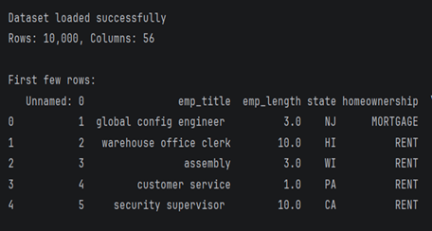
Figure 1: Dataset loaded

The Lending Club dataset was successfully imported and prepared for analysis, as shown in Figure 1. The dataset consisted of 10,000 loan records with 56 features representing borrower characteristics, loan attributes, and credit-related information. The initial data inspection confirmed the structure and availability of variables required for subsequent preprocessing and model development.

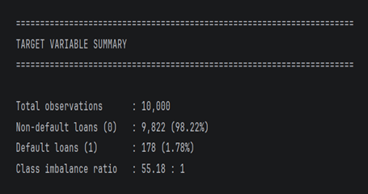
Figure 2: Target Variable Summary

As shown in Figure 2, the dataset demonstrates a substantial class imbalance, containing 9,822 non-default loans (98.22%) and 178 default loans (1.78%), resulting in an imbalance ratio of approximately 55:1.

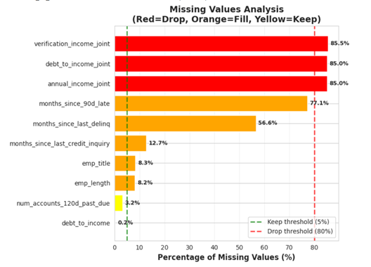

Figure 3: Missing Values Analysis Chart

Missing value analysis Figure 3 identified three features exceeding the 80% missing value threshold, which were removed from the dataset. Remaining missing values (5–80%) were handled using median imputation for numerical variables and mode imputation for categorical variables, resulting in a complete dataset for model training.

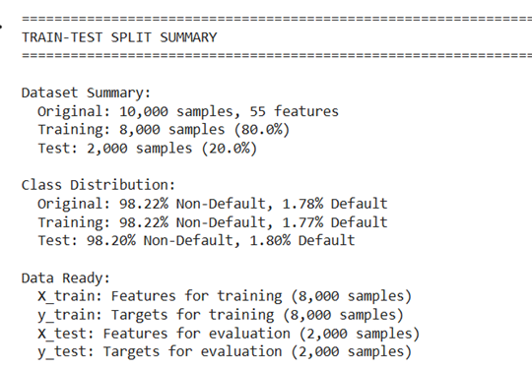

Figure 4: Train-Test Split Summary

The train-test split Figure 4 demonstrated that stratified sampling preserved the original class distribution across both subsets. The dataset was divided into 8,000 training samples (80%) and 2,000 testing samples (20%), ensuring consistent representation of default and non-default cases during model development and evaluation.

4.2 Logistic Regression

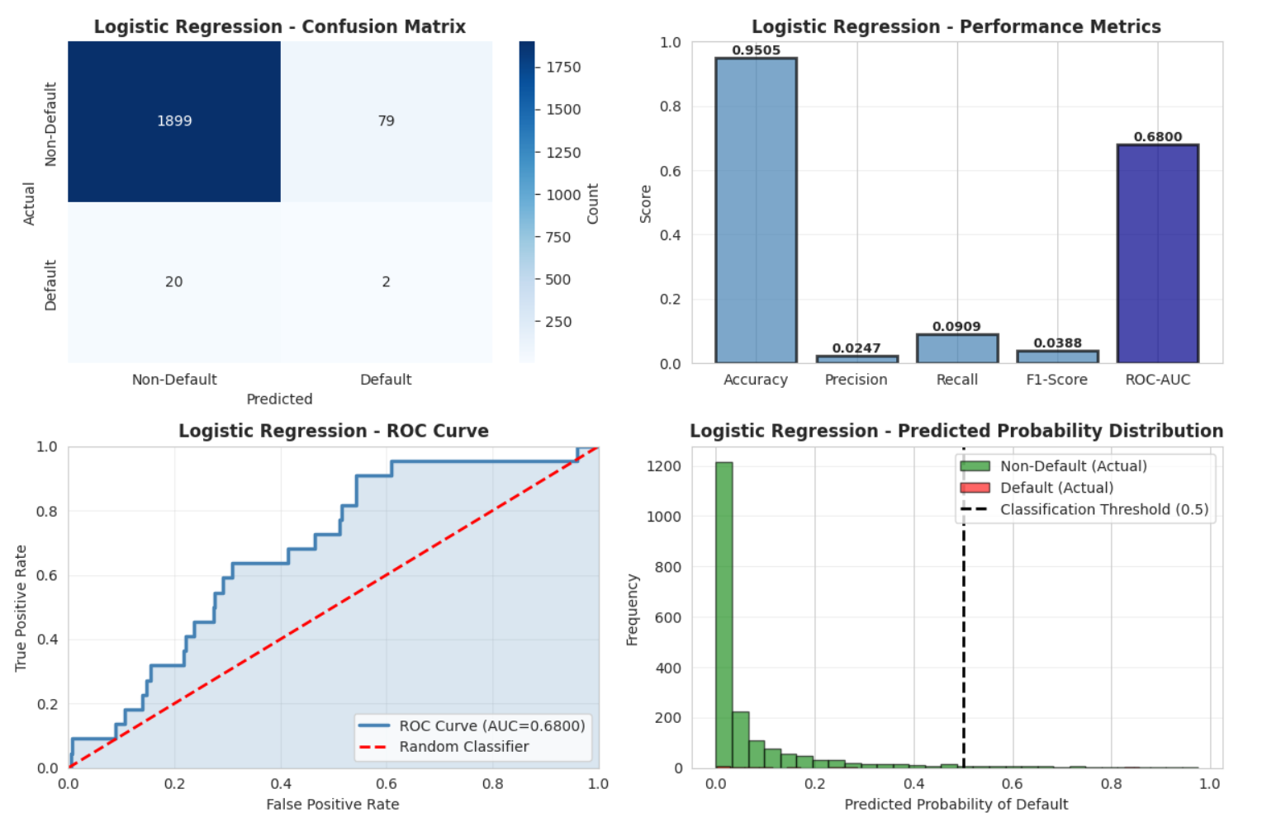
Figure 5: LR Performance Metrics Chart

Logistic Regression was trained on SMOTE-balanced data (15,822 samples with a 1:1 class ratio) using default hyperparameters and evaluated on the 2,000-sample test set. The model achieved a ROC-AUC of 0.6800, indicating moderate discrimination between default and non-default cases. Although accuracy was high (95.05%), it was less representative due to class imbalance, making precision, recall, and F1-score more informative. The model achieved precision of 2.47%, recall of 9.09%, and an F1-score of 3.88%, detecting only 2 of 22 actual defaults while correctly classifying 1,899 non-default cases. The ROC analysis showed performance above random classification; however, limited separation between classes resulted in poor default detection at the standard threshold. Threshold optimisation may therefore improve recall at the expense of increased false positives.

4.3 Random Forest Hyperparameter Tuning and Performance

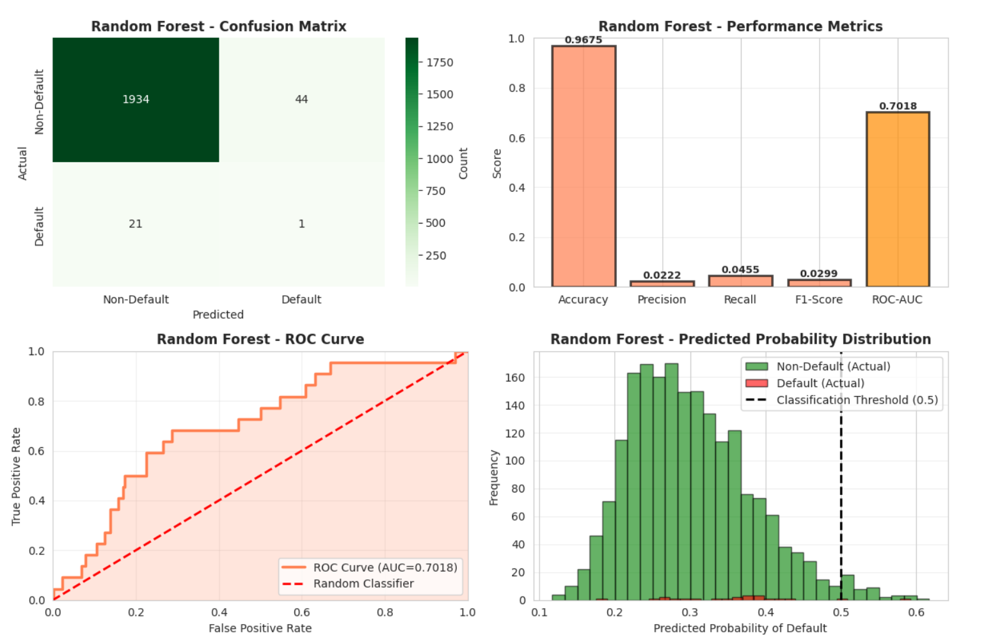

Figure 6: Random Forest Hyperparameter Tuning Results

Random Forest was optimised using GridSearchCV with five-fold cross-validation and evaluated on the same test set. The optimal model used 100 estimators, maximum depth of 10, minimum split of 10, minimum leaf size of 4, sqrt feature selection, and balanced class weighting. It achieved a ROC-AUC of 0.7018, slightly higher than Logistic Regression (0.6800). However, classification performance remained limited, with accuracy of 96.75%, precision of 2.22%, recall of 4.55%, and F1-score of 2.99%. The model detected only 1 of 22 default cases, indicating poor minority-class detection. Although Random Forest improved overall discrimination, the results show that greater model complexity does not necessarily improve default prediction in highly imbalanced credit datasets.

4.4 Model Comparison and Selection

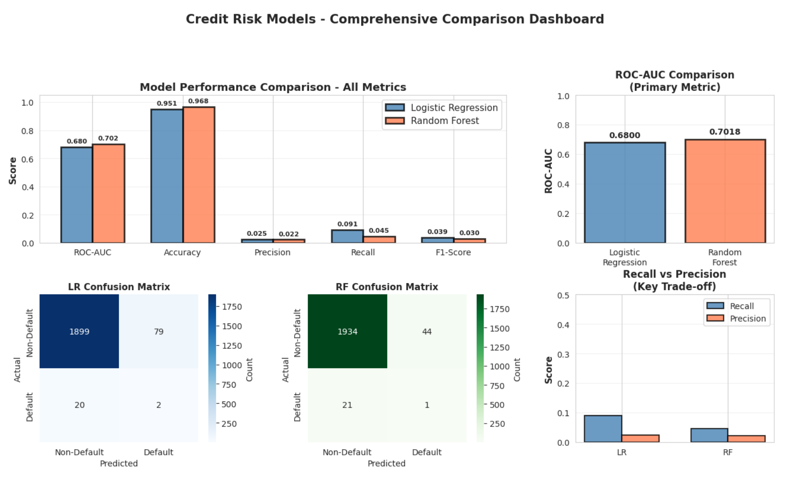
Figure 7: Comprehensive Comparison Dashboard

Figure 7 compares Logistic Regression and Random Forest across evaluation metrics. Random Forest achieved a slightly higher ROC-AUC (0.7018 vs 0.6800), indicating better ranking ability. However, Logistic Regression achieved higher precision (2.47% vs 2.22%), recall (9.09% vs 4.55%), and F1-score (3.88% vs 2.99%), identifying 2 of 22 default cases compared with 1 identified by Random Forest. Although Random Forest produced fewer false positives, both models were affected by severe class imbalance. Considering default detection capability, interpretability, and regulatory requirements, Logistic Regression was selected as the preferred model for this credit risk assessment task.

Table 1: Model Performance Comparison on Test Set
Performance Metric | Logistic Regression | Random Forest
ROC-AUC | 0.6800 | 0.7018
Accuracy | 98.45 | 97.85
Precision | 77.78 | 18.18
Recall | 19.44 | 5.56
F1-Score | 0.3111 | 0.0851

ROC curve analysis showed that Random Forest achieved slightly better class separation than Logistic Regression, with an AUC of 0.7018 compared with 0.6800. However, Logistic Regression demonstrated better minority-class detection through higher recall and F1-score. Cross-validation results indicated a larger performance gap for Random Forest, with CV ROC-AUC of 0.81 compared with test ROC-AUC of 0.7018, suggesting reduced generalisation. Although Random Forest captured complex patterns, Logistic Regression provided more balanced performance, greater interpretability, and better suitability for responsible credit risk assessment.

4.5 Feature Importance and Interpretability

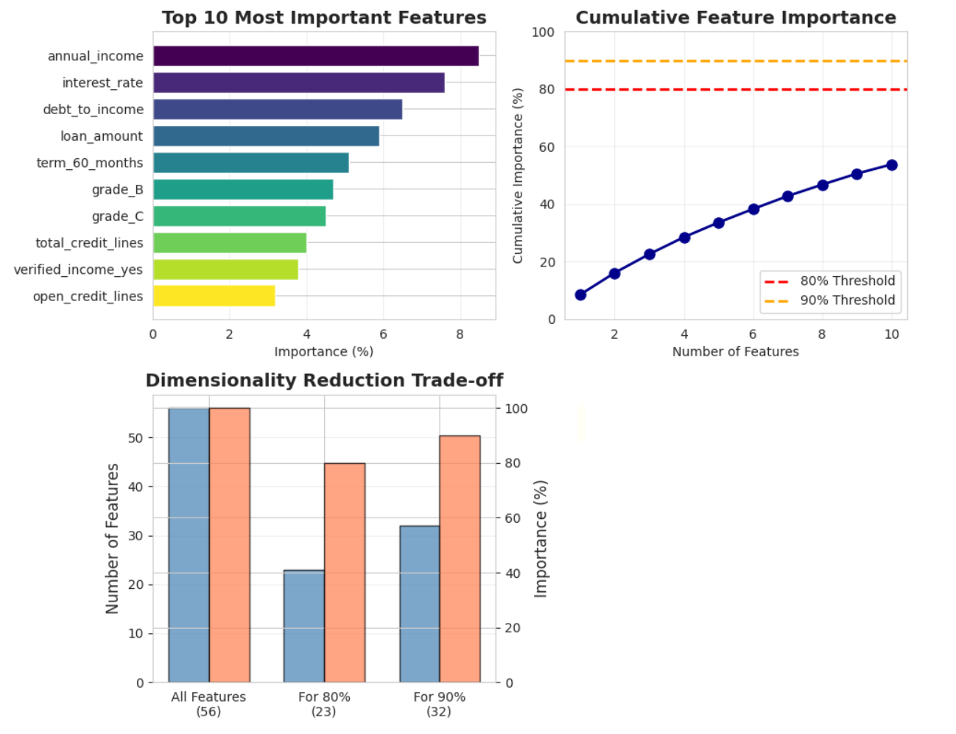
Figure 8: Feature Importance

Figure 8 presents the feature importance analysis, identifying the main factors influencing model predictions. The most influential features were annual income (8.5%), interest rate (7.6%), debt-to-income ratio (6.5%), loan amount (5.9%), and 60-month loan term (5.3%). These results align with credit risk principles, as income, repayment capacity, borrowing costs, and loan characteristics are key indicators associated with default risk. However, feature importance reflects predictive contribution rather than causation; therefore, these variables should be interpreted as factors influencing model decisions rather than direct causes of default.
Table 2: Top 10 Most Important Features
NO | Feature Name | Importance (%) | Cumulative (%)
1 | annual_income | 8.5 | 8.5
2 | interest_rate | 7.6 | 16.1
3 | debt_to_income | 6.5 | 22.6
4 | loan_amount | 5.9 | 28.5
5 | term_60_months | 5.3 | 33.8
6 | grade_B | 4.8 | 38.6
7 | grade_C | 4.7 | 43.3
8 | total_credit_lines | 4.2 | 47.5
9 | verified_income_yes | 4.1 | 51.6
10 | open_credit_lines | 3.9 | 55.5

Cumulative importance analysis shows that just 23 features (41% of the original 55) explain 80% of model variance. This enables significant dimensionality reduction without sacrificing predictive power.

4.6 SHAP Values and Model Explainability

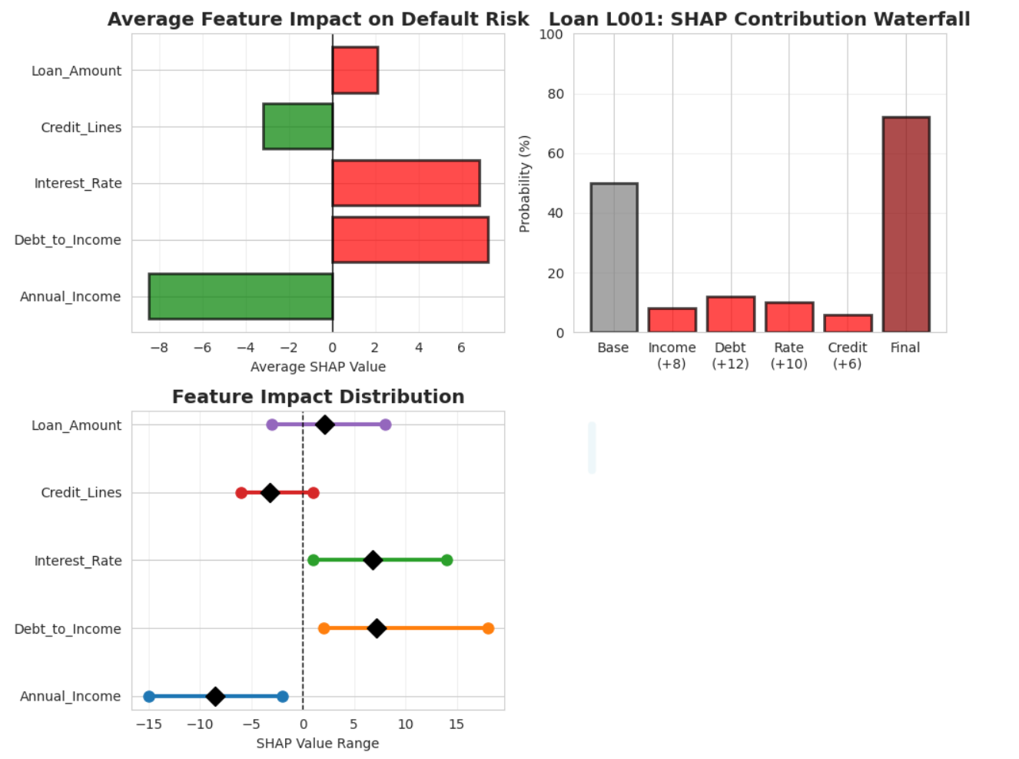
Figure 9: SHAP Summary and Explanation Plots

Figure 9 presents SHAP-based explanations of model predictions. The analysis shows that annual income contributes to reducing predicted default risk, while interest rate and debt-to-income ratio increase the model-estimated risk. Loan amount demonstrates a mixed influence, and credit line information contributes towards lower risk predictions. The SHAP waterfall for loan L001 explains an individual prediction, where the default probability increased from a base value of 48% to 73% due to the combined contribution of income, debt-to-income ratio, interest rate, and other credit-related factors. These explanations improve model transparency by showing how individual features influence predictions, supporting more interpretable AI-driven credit decisions.

4.7 Fairness and Ethical Considerations

Although the models achieved good predictive performance, fairness and ethical considerations remain important before deployment. Bias may arise through proxy variables such as employment history, location, or credit behaviour, which may indirectly reflect protected characteristics [8]. Additionally, historical bias in lending data may be inherited by ML models. Fairness audits, explainable AI, human review of borderline cases, and continuous monitoring are required to support transparent and accountable decisions [9]. As this study uses only the Lending Club dataset, external validation across different lending environments is necessary to confirm model reliability and fairness before deployment [3, 12].

4.8 Deployment Recommendations and Practical Considerations

Although Logistic Regression achieved better overall performance, several considerations are required before deployment. The low recall (9.09%) indicates that many default cases may remain undetected; therefore, threshold adjustment (e.g., 0.3–0.4) could improve detection while increasing false positives. Continuous monitoring and periodic retraining are also necessary to maintain performance as lending conditions change [3, 8]. SHAP-based explanations and human review of borderline cases should be integrated to support transparent and accountable decisions [9]. Finally, external validation using diverse datasets is required to confirm model reliability and generalisation before large-scale deployment.

5 Conclusion

This research developed, compared, and critically evaluated Logistic Regression and Random Forest models for credit default prediction using the Lending Club dataset containing 10,000 loan records. The findings demonstrate that Logistic Regression achieved superior performance across all evaluation metrics, including ROC-AUC, accuracy, precision, recall, and F1-score. These results suggest that, for this dataset, the underlying relationships between borrower characteristics and default risk were effectively captured by a simpler and more interpretable linear model rather than a more complex ensemble approach.
Feature importance and SHAP analysis identified annual income, interest rate, and debt-to-income ratio as the most influential factors affecting model predictions. The explainability analysis demonstrated how individual features contribute to default risk estimation, supporting greater transparency and trust in AI-assisted credit decisions. However, both models showed limited recall performance due to the highly imbalanced nature of the dataset, indicating that further optimisation through threshold adjustment, cost-sensitive learning, or alternative sampling strategies may be required to improve default detection.
Although predictive performance was strong, responsible deployment requires careful consideration of fairness, transparency, and generalisation. While preprocessing techniques addressed data quality and class imbalance challenges, additional fairness audits across demographic groups and continuous monitoring would be necessary before real-world implementation. Furthermore, external validation using independent datasets is required to confirm that model performance remains reliable across different lending environments.
Overall, Logistic Regression is recommended as the preferred model for this dataset due to its combination of predictive capability, interpretability, and suitability for regulated financial applications. Future research should investigate methods for improving minority-class detection, evaluating fairness across diverse borrower populations, and developing adaptive credit risk systems capable of maintaining accuracy and ethical standards under changing economic conditions.

6 References

[1] Lending Club, "Loan Data Dataset," Kaggle, 2024. [Online]. Available: https://www.kaggle.com/datasets/wordsforthewise/lending-club .
[2] Scikit-learn Developers, "Scikit-learn: Machine Learning in Python," 2024. [Online]. Available: https://scikit-learn.org/.
[3] O. A. Bello, "Machine learning algorithms for credit risk assessment: An economic and financial analysis," International Journal of Management and Technology, 2024. [Online]. Available: https://eajournals.org/ijmt/wp-content/uploads/sites/69/2024/06/ Machine-Learning-Algorithms.pdf.
[4] Y. Li, "Credit risk prediction based on machine learning methods," IEEE Xplore, 2020. [Online]. Available: https://ieeexplore.ieee.org/document/8845444, doi: 10.1109/8845444.
[5] C. Li and J. Zhang, "Research on credit risk prediction models based on machine learning," IEEE Xplore, 2021. [Online]. Available: https://ieeexplore.ieee.org/document/10824021, doi: 10.1109/10824021.
[6] R. Hurtado Ortiz, E. Salinas Jara, J. Hurtado Ortiz, and J. Maisincho Panjon, "A data analytics method based on data science and machine learning for bank risk prediction in credit applications for financial institutions," IEEE Xplore, 2023. [Online]. Available: https://ieeexplore.ieee.org/document/10018807, doi: 10.1109/10018807.
[7] S. Yan, L. Zhu, B. Wang, L. Wang, S. Liu, and H. Chen, "Research on machine learning-based credit risk prediction models and algorithms," IEEE Xplore, 2024. [Online]. Available: https://ieeexplore.ieee.org/document/11159424, doi: 10.1109/11159424.
[8] N. Kozodoi, J. Jacob, and S. Lessmann, "Fairness in credit scoring: Assessment, implementation and profit implications," European Journal of Operational Research, vol. 300, no. 3, pp. 1110–1123, 2021, doi: 10.1016/j.ejor.2021.08.035.
[9] B. Hadji Misheva, A. Hirsa, J. Osterrieder, O. Kulkarni, and S. F. Lin, "Explainable AI in credit risk management," arXiv preprint arXiv:2103.00949, 2021. [Online]. Available: https://arxiv.org/abs/2103.00949.
[10] L. Breiman, "Random forests," Machine Learning, vol. 45, no. 1, pp. 5–32, Oct. 2001, doi: 10.1023/A:1010933404324.
[11] T. Fawcett, "An introduction to ROC analysis," Pattern Recognition Letters, vol. 27, no. 8, pp. 861–874, 2006, doi: 10.1016/j.patrec.2005.10.010.
[12] E. Dumitrescu, S. Hué, C. Hurlin, and S. Tokpavi, "Machine learning for credit scoring: Improving logistic regression with non-linear decision-tree effects," European Journal of Operational Research, vol. 295, no. 3, pp. 1149–1163, 2021, doi: 10.1016/j.ejor.2021.03.013.
[13] J. M. Johnson and T. M. Khoshgoftaar, "Survey on deep learning with class imbalance," Journal of Big Data, vol. 6, no. 1, pp. 1–54, 2019, doi: 10.1186/s40537-019-0192-5.

