University of Wales Trinity Saint David
Information Engineering
Documentation

5/3/2018
Priyankkumar Patel
1704831

Screen Capture from the Relationship Diagram
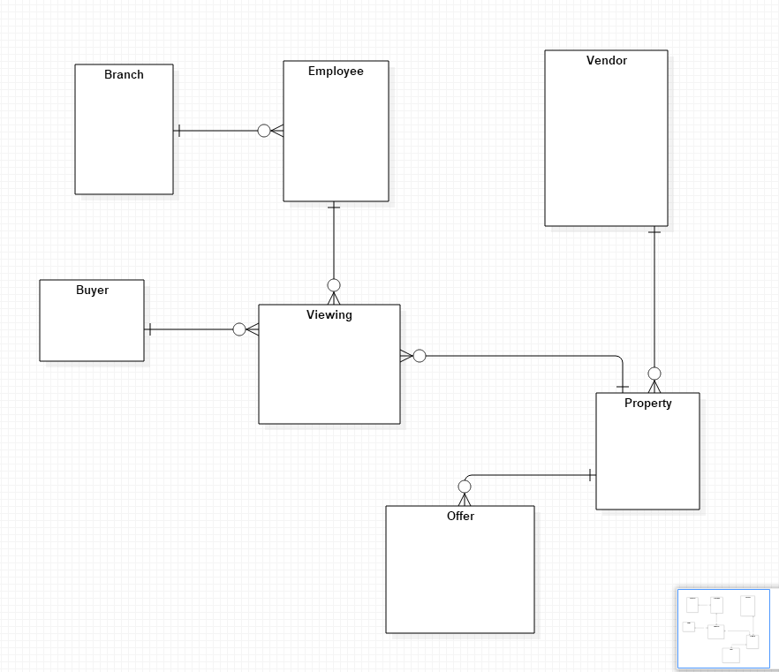

(Figure of Entity Relationship for Home From Home)

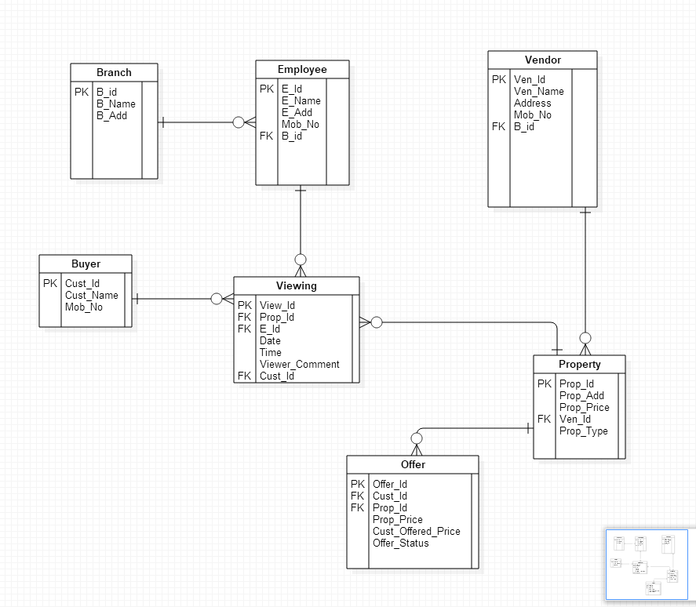

(Figure of Entity Relationship Diagram with Attributes for Home From Home System)

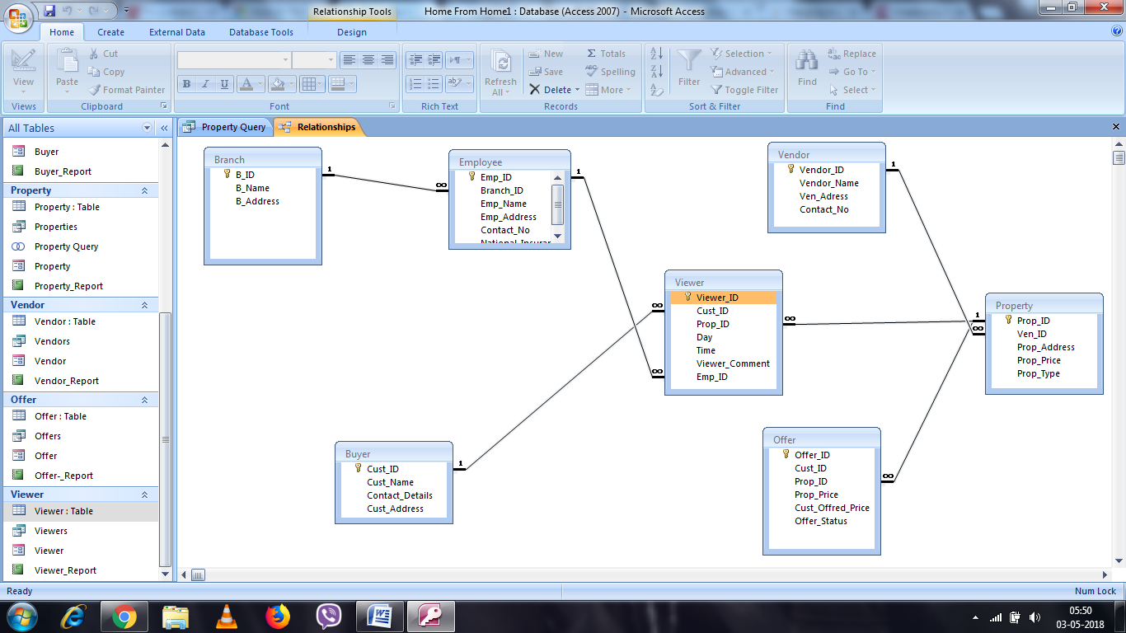

Output from all reports

Output of Branch Report:
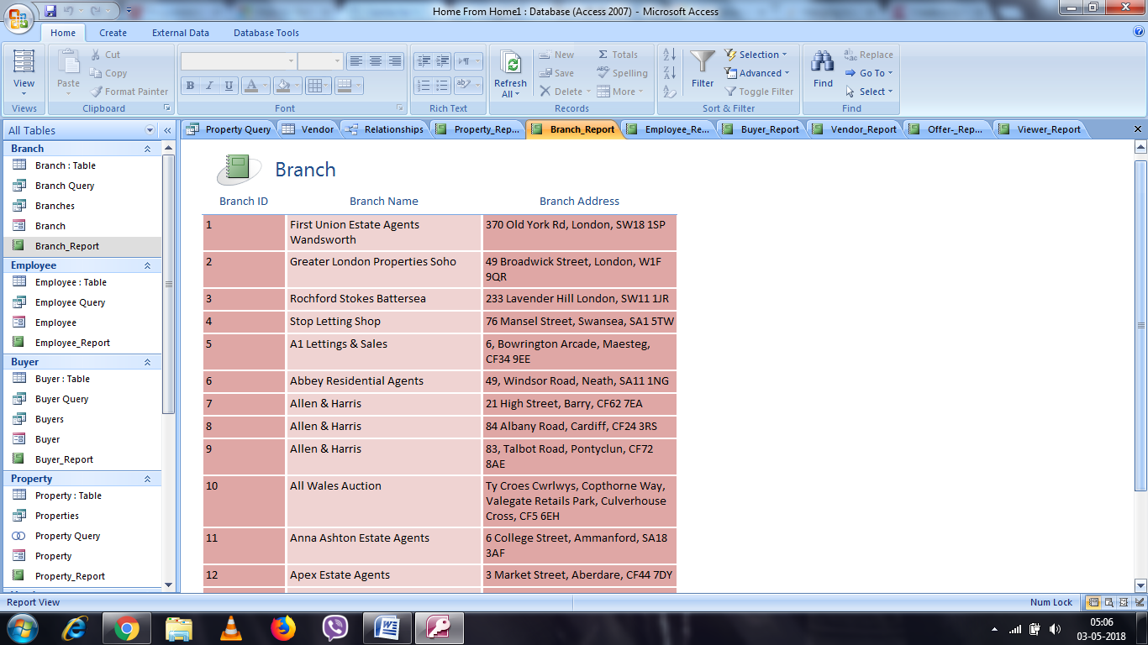

Output of Employee Report:

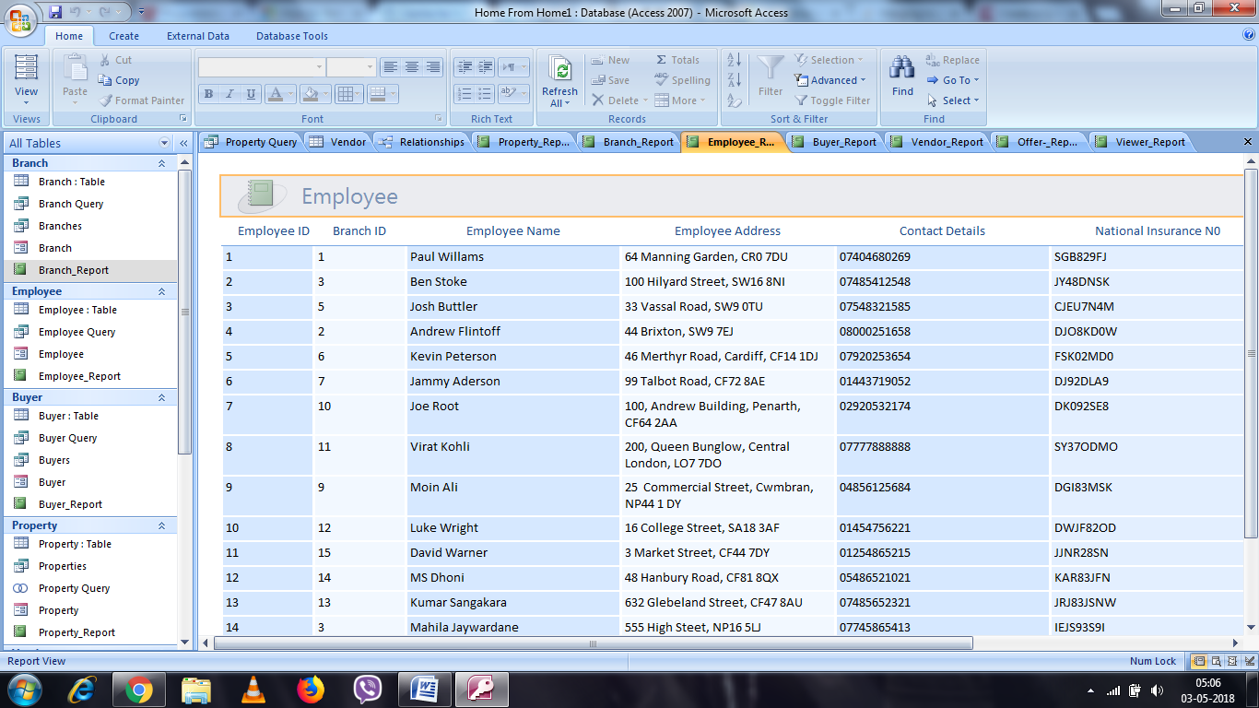

Output of Buyer Report:
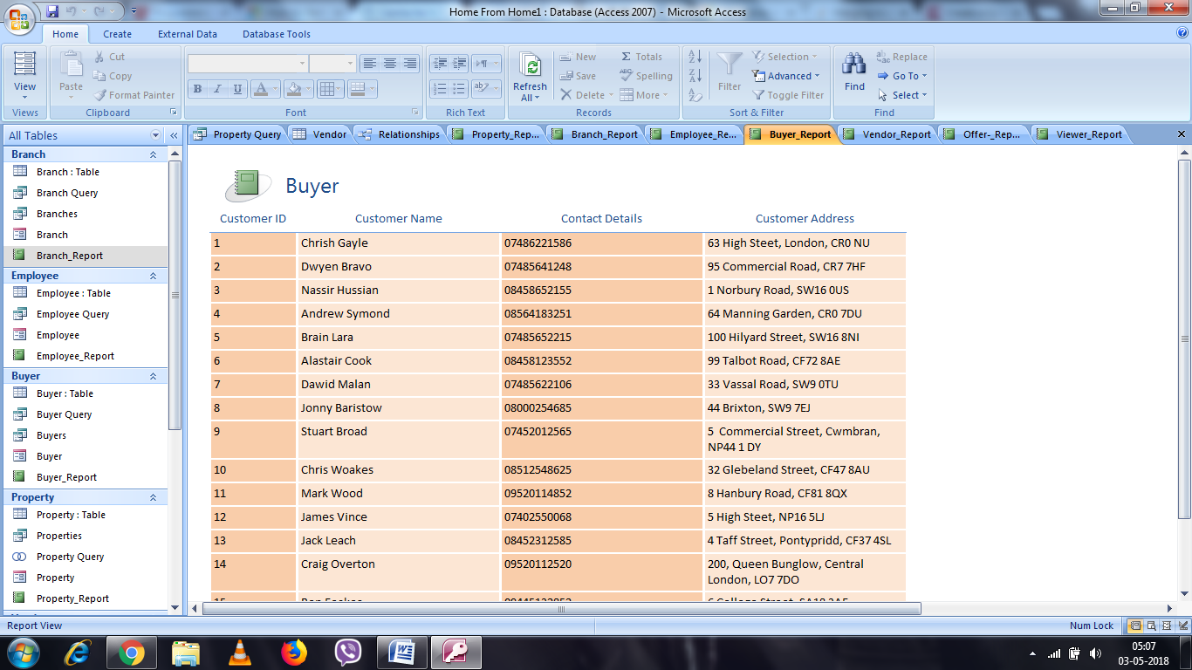

Output of Property Report:
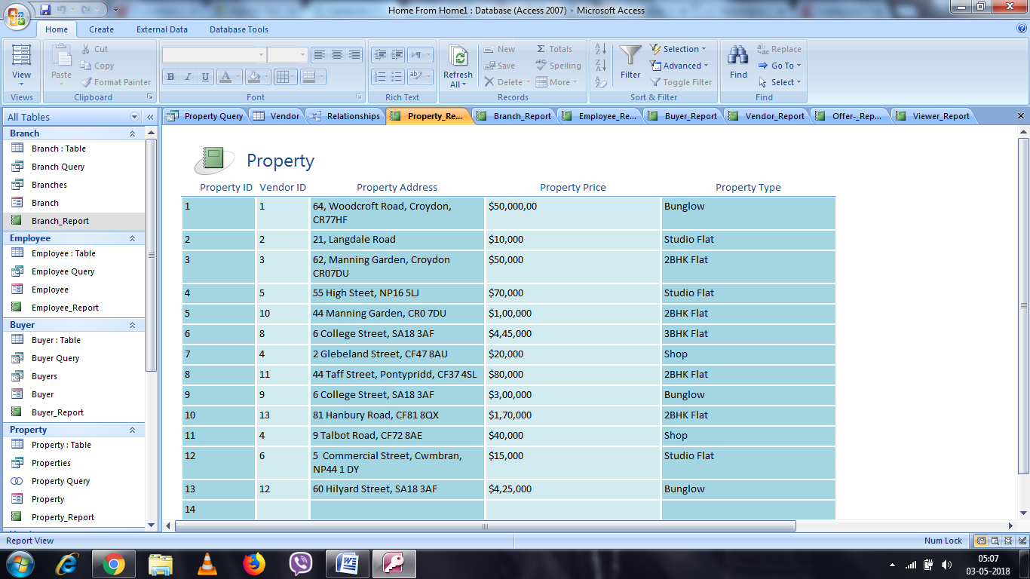

Output of Vendor Report:
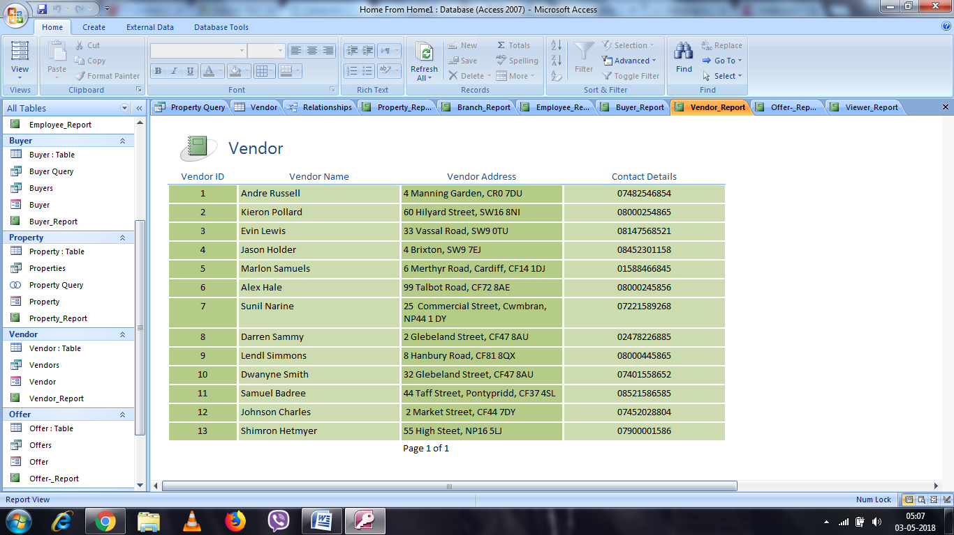

Output of Offer Report:
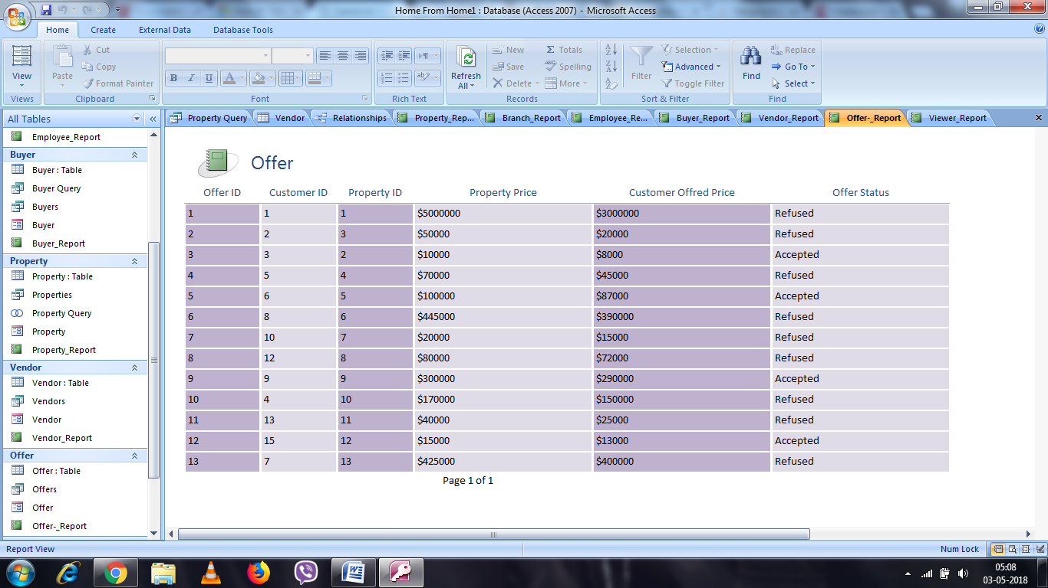

Output of Viewer Report:
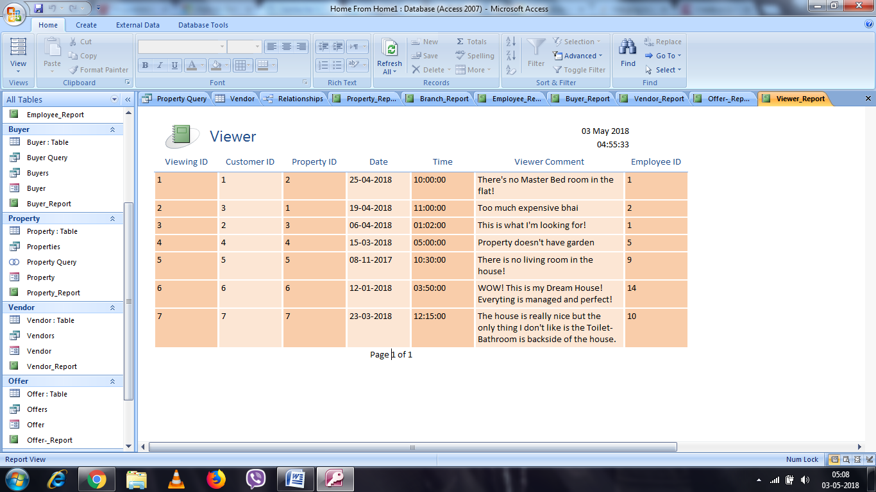

Screen Capture for each form used
Branch form:
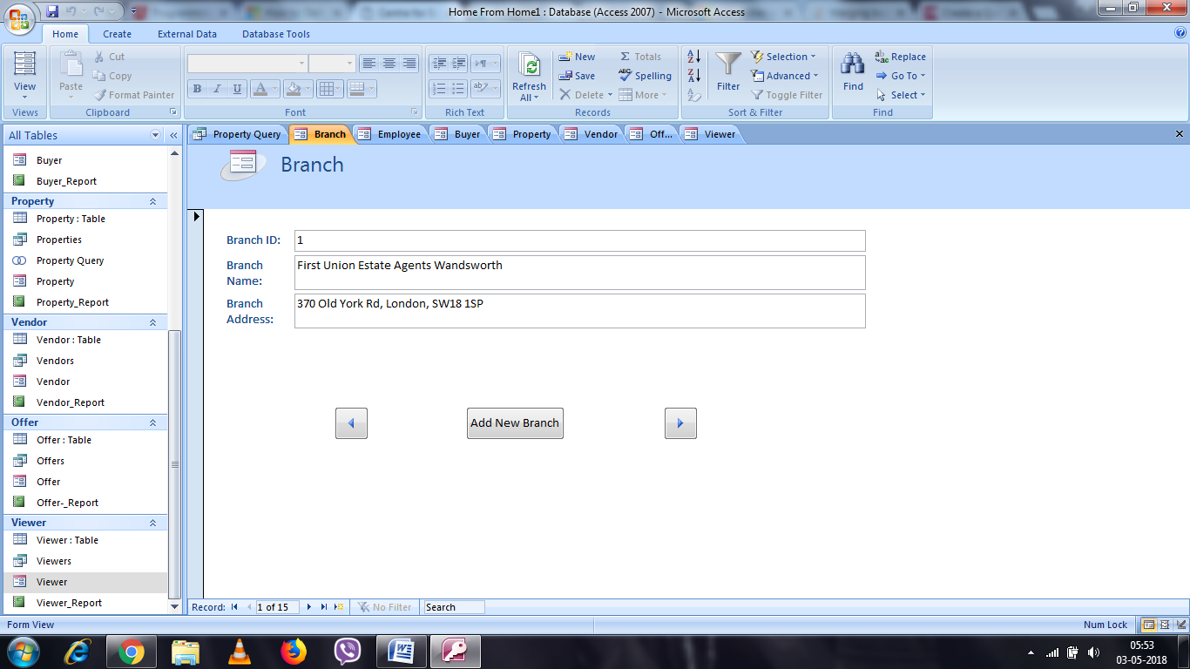

Employee Form:
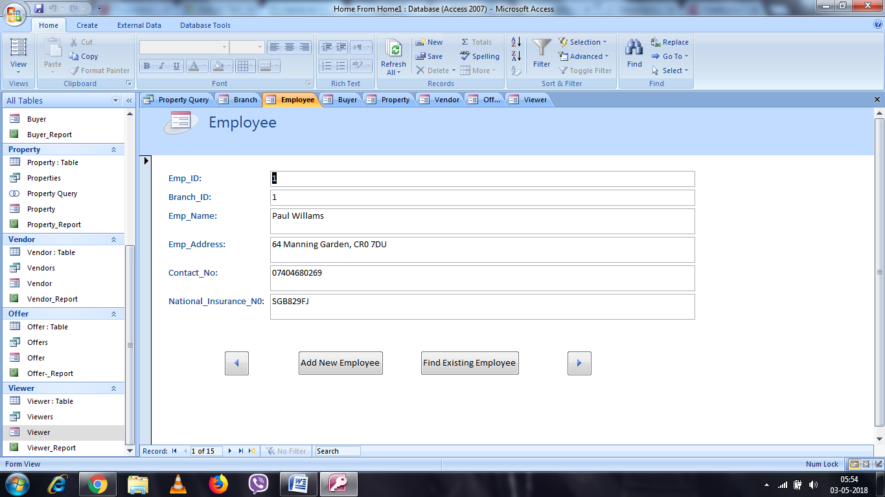

Buyer Form:

Form of Property:
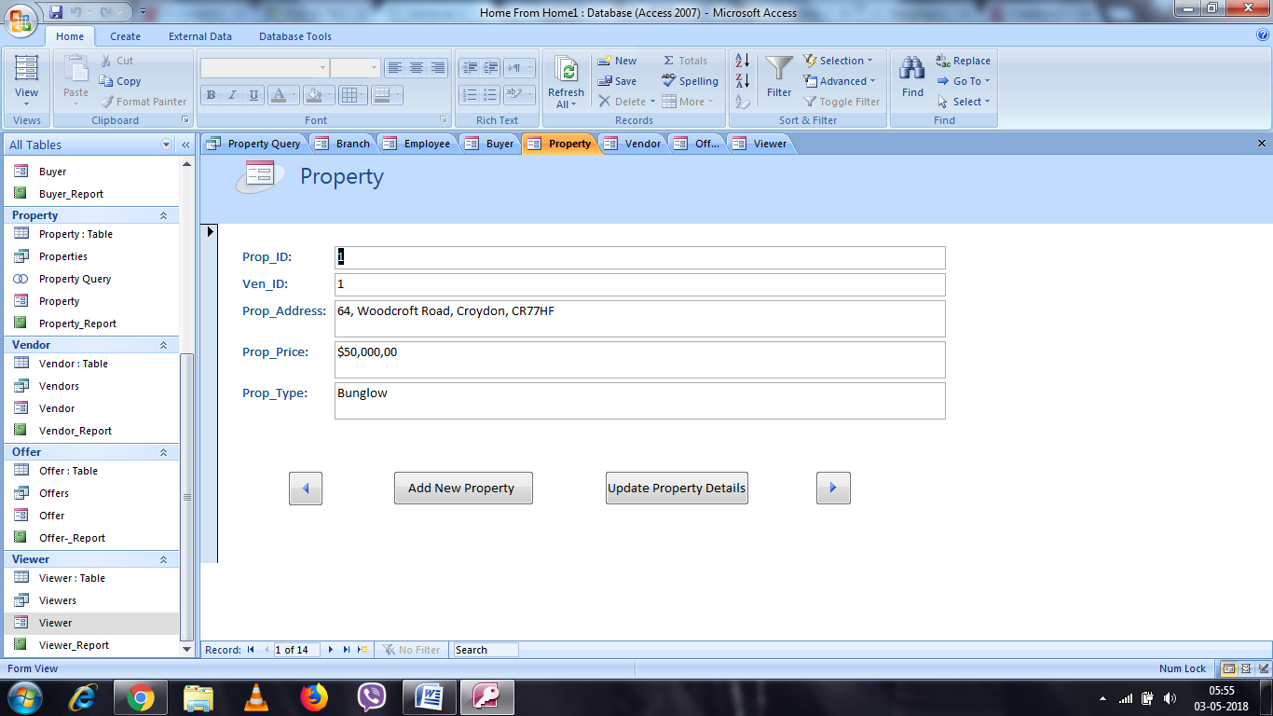

Form of Vendor:

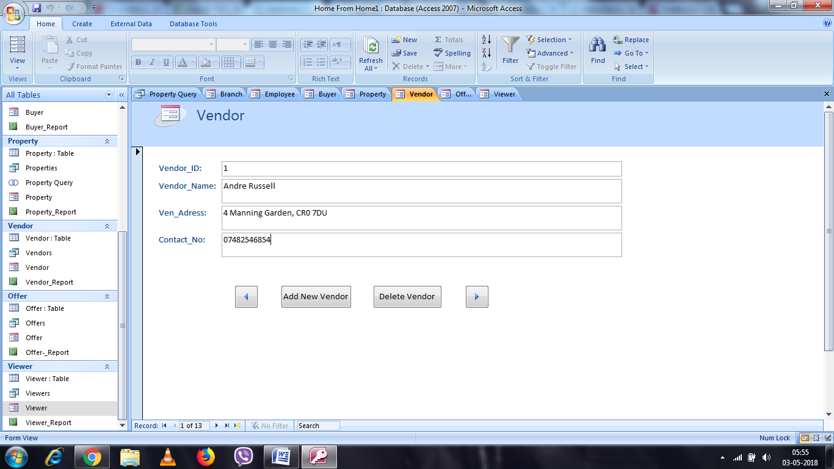

Form of Offer:
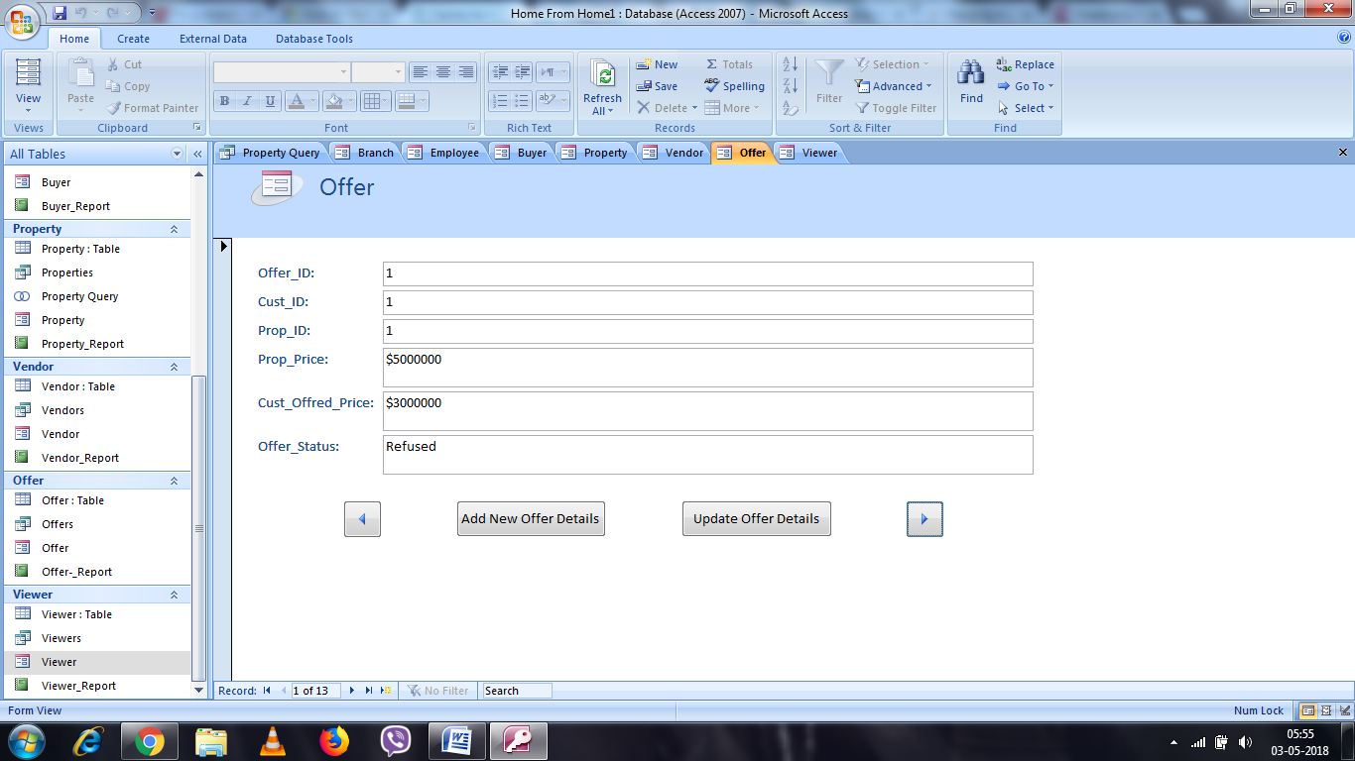

Form of Viewer:
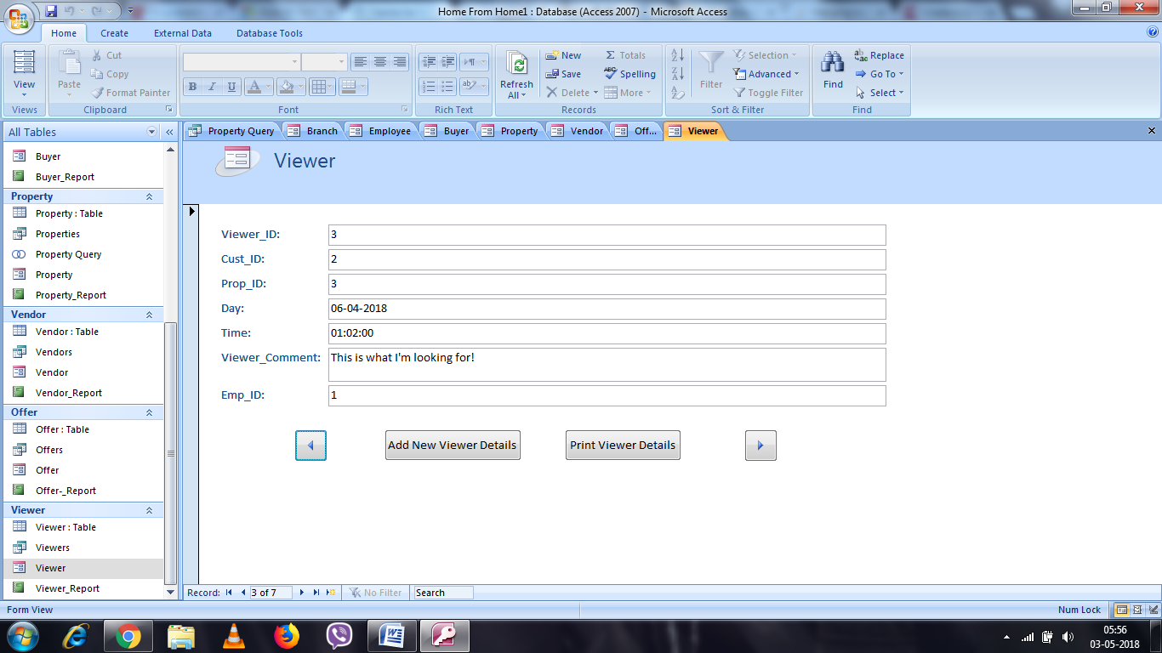
Evidence of SQL
Offer and Property Merge Table:
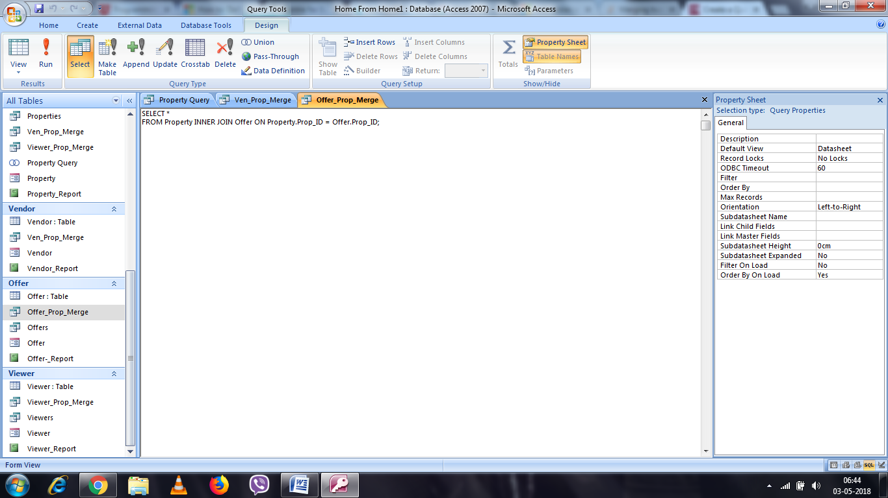

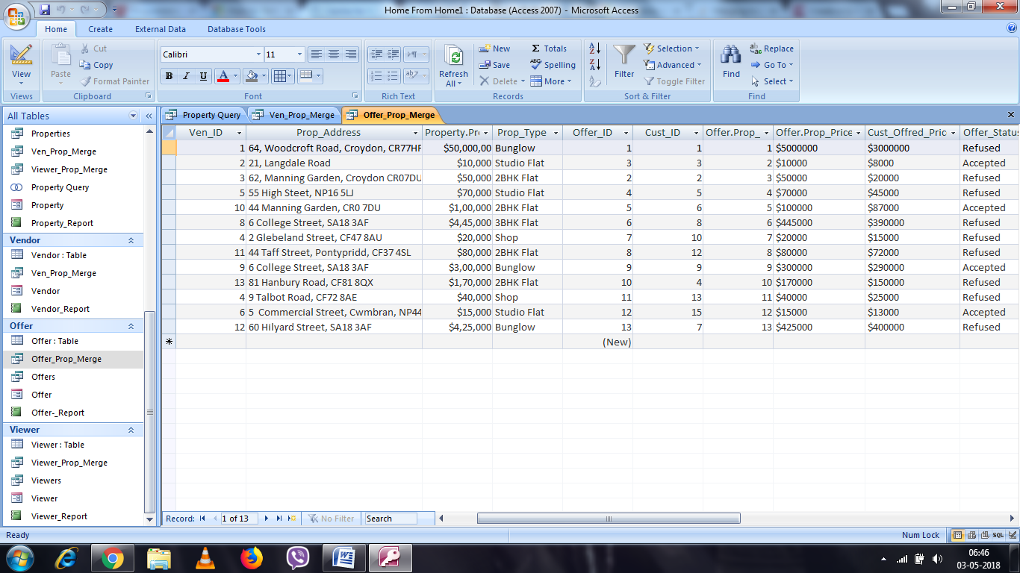

Employee and Branch Merge Table:
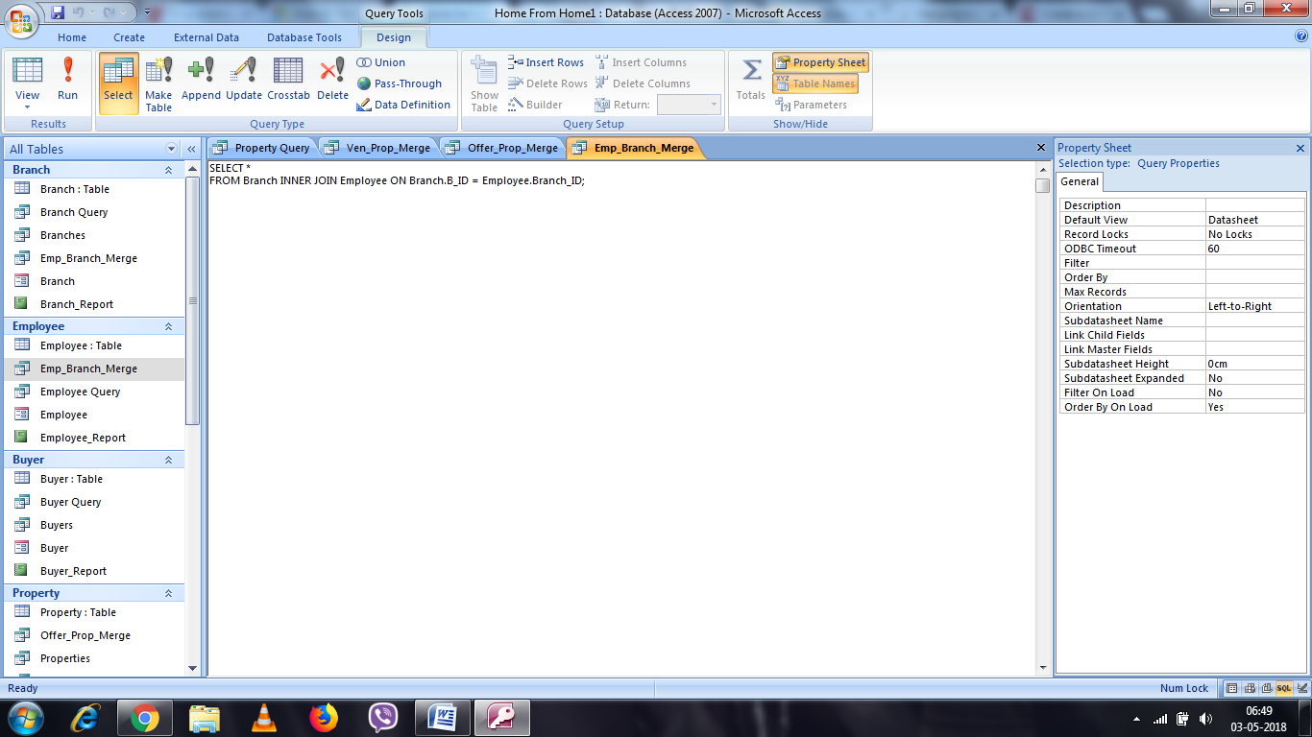

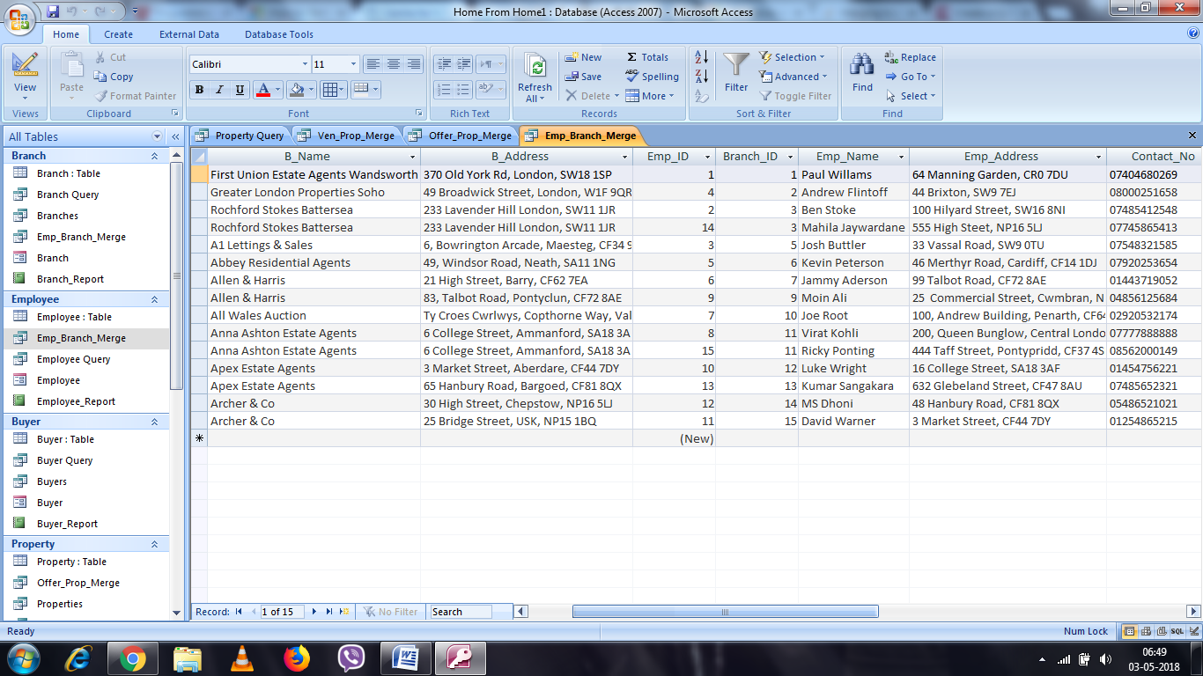

User Guide:

Branch
B_ID PK | Unique ID number of the Branch
B_Name | Name of the particular branch
B_Address | Address of the branch

Branch
Field Name | Compulsory? | Data Type | Validation Rule
B_ID PK | Yes | AutoNumber | Primary Key
B_Name | Yes | Text | Name of the branch
B_Address | Yes | Text

Employee
Emp_ID PK | Unique ID number of the Employee
Branch_ID | Unique Branch ID to identify particular employee belongs to which branch
Emp_Name | Name of the Employee
Emp_Address | Address of the Employee
Contact_No | Mobile number of the Employee
National_Insurance_No | National Insurance number of the Employee to rights to work and to pay legal Gov Tax.

Employee
Field Name | Compulsory? | Data Type | Validation Rule
Emp_ID PK | Yes | AutoNumber | Primary Key
Branch_ID | Yes | Number | Foreign Key
Emp_Name | Yes | Text | Value in A to Z
Emp_Address | Yes | Text | Value in A to Z & 0 to 9
Contact_No | No | Text | Value
National_Insurance_No | Yes | Text | Value in A to Z & 0 to 9

Buyer (Customer)
Customer_ID | Unique ID number of the Customer
Cust_Name | Name of the customer
Contact_Details | Mobile number of the customer
Cust_Address | Address of the customer

Buyer
Field Name | Compulsory? | Data Type | Validation Rule
Cust_ID | Yes | AutoNumber | Primary Key
Cust_Name | Yes | Text | Value A to Z
Contact_Details | Yes | Text | Value 0 to 9
Cust_Address | No | Text | Value A to Z & 0 to 9

Property
Prop_ID (PK) | Unique ID number of the Property
Ven_ID (FK) | Vendor ID number to identify the particular property belongs to which vendor or who is the owner of property
Prop_Address | Address of the Property
Prop_Price | Selling price of the property
Prop_Type | Type of the property

Property
Field Name | Compulsory? | Data Type | Validation Rule
Prop_ID (PK) | Yes | AutoNumber | Primary Key
Ven_ID (FK) | Yes | Number | Foreign Key
Prop_Address | Yes | Text | Value A to Z & 0 to 9
Prop_Price | Yes | Text | Value 0 to 9
Prope_Type | Yes | Text | Value A to Z & 0 to 9

Vendor (Owner)
Vendor_ID | Unique ID number of the Vendor
Vendor_Name | Name of the Vendor (Owner)
Ven_Address | Address of the Vendor
Contact_No | Mobile number of the vendor

Vendor
Field Name | Compulsory? | Data Type | Validation Rule
Vendor_ID | Yes | AutoNumber | Primary Key
Vendor_Name | Yes | Text | Value A to Z
Ven_Address | No | Text | Value A to Z & 0 to 9
Contact_No | Yes | Text | Value 0 to 9

Offer
Offer_ID | Unique ID number of the Offer
Cust_ID | Foreign key of the table which is Primary key of Buyer Table, with the help of that we can easily find out customer name and details whoever has give the offer.
Prop_ID | Foreign key of the table which is Primary key of Property Table, with the help of that we can easily find out on what property customer has made an offer
Prop_Price | Actual price of the property
Cust_Offered_Price | Price which is offered by customer after visiting particular property
Offer_Status | Based on offered price by customer we can make a decision on that price which is Acceptable or Not

Offer
Field Name | Compulsory? | Data Type | Validation Rule
Offer_ID | Yes | AutoNumber | Primary Key
Cust_ID | Yes | Number | Foreign Key
Prop_ID | Yes | Number | Foreign Key
Prop_Price | Yes | Text | Value 0 to 9
Cust_Offered_Price | Yes | Text | Value 0 to 9
Offer_Status | Yes | Text | Value A to Z

Viewer
Viewer_ID | Unique number of the viewer
Cust_ID | Foreign key of the table which is primary key of Customer Table, with the help of that its easy to know what customer viewing the property.
Prop_ID | Foreign key of the table which is primary key of Property Table, with the help of that its easy to find on what property has been visited by the customer.
Emp_ID | Foreign key of the table which is Primary Key of Employee Table, with the help of that we can know which employee serving or dealing with particular customer and on what property he/she handling.
Day | Date of the day
Time | Time of the meeting or visiting on property
Viewer_Comment | Review of the customer after visiting the property.

Viewer
Field Name | Compulsory? | Data Type | Validation Rule
Viewer_ID | Yes | AutoNumber | Primary Key
Cust_ID | Yes | Number | Foreign Key
Prop_ID | Yes | Number | Foreign Key
Emp_ID | Yes | Number | Foreign Key
Day | Yes | Date/Time | ##-##-####
Time | No | Date/Time | ##-##-####
Viewer_Comment | No | Text | Value A to Z

Description of Entity Relationship Diagram:
- There are mainly seven Entities represented in the system, such as:
-Branch
-Employee
-Vendor
-Property
-Offer
-Viewing
-Buyer

-Each entity has different types of field or attributes as shown in below figure.

-Branch (B_ID, B_Name, B_Address)
Where B_ID is the unique ID number which every branch should have to differentiate themselves.

-Employee(Emp_ID, Emp_Name, Emp_Address, Contact_No, B_ID)
Where Emp_ID is the primary key of the table and B_ID is the Foreign key of the table to identify the what employee belongs to which branch.

-Vendor(Vendor_ID, Vendor_Name, Ven_Address, Contact_No)
This table contains the details of vendors or owners.

-Property(Prop_ID, Ven_ID, Prop_Address, Prop_Price, Prop_Type)
Table of Property having the details of all the property to sell with vendor id so its easy to find who is the owner of particular property.

-Offer(Offer_ID, Cust_ID, Prop_ID, Prop_Price, Cust_Offered_Price, Offer_Status)
This table contains the details about the offers which is made by customer on each property and based on this we can easily come to know how far we are to get out price and what is customer’s expectations so, basically this table will help us to analysis about the property price and customer offered price.
-Viewer(Viewer_ID, Cust_ID, Prop_ID, Day, Time, Viewer_Comment)
This table plays very important role in the system. This table helps to avoid Data Redundancy and it follows the Rules of 3NF, with the help of this table I have removed Many to Many Relationships in the system.
-Also, its helps to know about the customer’s review by using Viewer_Comment attribute.

