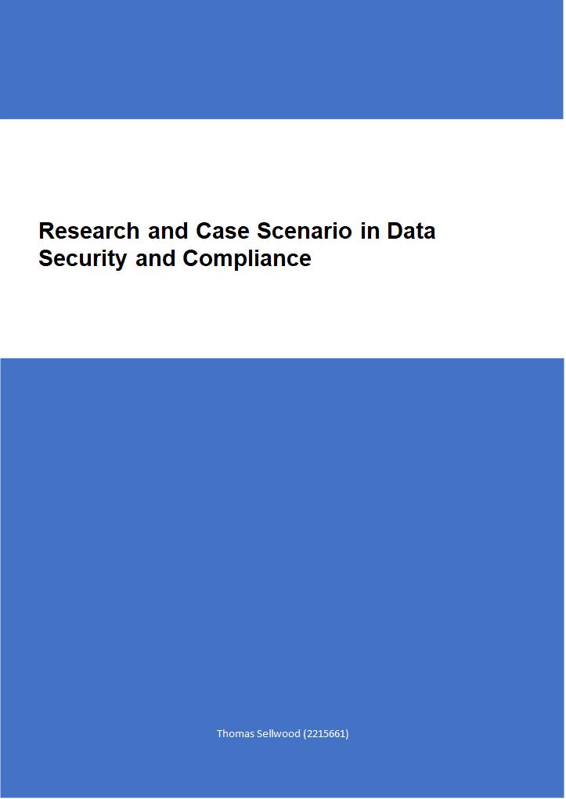

Research in Data Security and Compliance
Thomas JE Sellwood
Student University of Wales Trinity St David, Swansea, Wales
2215661@student.uwtsd.ac.uk

Abstract
In a time of escalating cyber threats and stringent regulatory standards, data security and compliance are critical priorities for modern organizations. This research examines the necessity for organizations in the UK to establish robust frameworks that protect, detect, react, and safeguard sensitive information within their IT systems and infrastructure. It emphasizes the pivotal role of cryptography in securing data at rest and in transit, alongside tools like encryption, digital signatures, and hash functions to ensure confidentiality, integrity, and authenticity.
The research further explores advanced security measures, including Intrusion Detection and Prevention Systems, Security Information and Event Management systems, and penetration testing, emphasizing their role in detecting and mitigating threats.
Additionally, it addresses the importance of compliance with UK regulatory frameworks, such as the General Data Protection Regulation (GDPR), Data Protection Act 2018, and NIS Regulations 2018, emphasizing the legal and financial implications of non-compliance.
The research highlights by adopting a holistic approach grounded in the principles of protect, detect, react, and safeguard, organizations can proactively address cybersecurity challenges, ensure regulatory adherence, and build a resilient security posture. This comprehensive strategy not only secures sensitive data but also strengthens organizational resilience against evolving threats and reputational risks.

- Introduction
In today's interconnected digital landscape, data security and compliance have become paramount concerns for modern organizations. As cyber threats evolve and become increasingly sophisticated, safeguarding sensitive information and ensuring adherence to regulatory standards are critical for maintaining data integrity, confidentiality, and availability. The below research will examine the necessity for organizations in the UK to create robust environments that protect, detect, react, and safeguard applications within their IT systems and infrastructure. It explores the roles of cryptography in achieving these goals.
Organizations manage vast amounts of sensitive data, including personal information, financial records, intellectual property, and proprietary business information. The unauthorized access, theft, or manipulation of this data can have severe repercussions, such as financial losses, legal penalties, operational disruptions, and reputational damage [1]. Thus, ensuring data security is not merely a technological necessity but also a critical business imperative.
Data breaches and cyber-attacks have become increasingly common, affecting organizations of all sizes and across all industries. Capital One data breach involved the disclosure of 100 million customers details after a web application firewall was hacked [2]. In addition to the immediate impact of data breaches, organizations must also contend with the long-term effects on their reputation.

- Cryptography
Cryptography is integral to protecting data both in transit and at rest. Cryptography is a practice of developing and utilizing algorithms to protect and obscure data [3]. In practice cryptography transformed into an unreadable format making use of algorithms to achieve it. transforming readable data into an unreadable format using algorithms [3].
Cryptography ensures that only those parties that are authorized can access the information [3]. This is a crucial aspect for maintaining confidentiality and integrity and will form a fundamental part of many data security strategies.

- Uses of Cryptography
- Encryption
Data encryption is a process that will convert data into a secure format that can only be decrypted using a specific key. For example, Transport Layer Security (TLS) encrypts data transmitted over networks, this prevents the interception of the data by unauthorized parties [4].
Once the data is encrypted if it is intercepted during transmission or accessed without authorization, it remains in a state which unreadable and unusable to the attacker that has intercepted it. Modern encryption algorithms, such as Advanced Encryption Standard (AES) and RSA (Rivest-Shamir-Adelman), provide robust security and are widely used to protect sensitive data [4]. Other methods such as DES and Triple DES are now deprecated as they are both considered insecure [4].
- Digital Signatures
Digital signatures aid in the verification of the authenticity and the validity of data, they can assure that the data has not been tampered [5].
Digital signatures are important particularly for legal documents and transactions, as it provides a means of non-repudiation, ensuring that the sender cannot deny having sent the message [5].
Digital signatures make use of cryptographic techniques to attach the identity of the signer to the document, providing an assurance that the document has not been altered since it was signed [6].
- Hash Functions
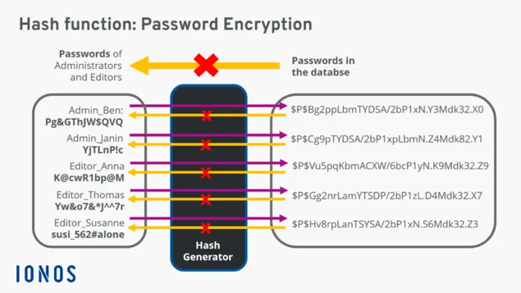Figure 1 Demonstrating a hash function [7].
The purpose of hash functions is to create a unique digital signature of data. This enables organizations to verify the integrity of files and provide assurance that they have not been altered as if the two hash values match the data has not been tampered with during transmission to the receiver from the sender [7]. As can be seen in Fig1 this demonstrates how passwords are taken from plain text and a hash is generated and stored in the database.
There are many hash functions such as SHA-1, SHA-2, SHA-3 and MD-5. SHA-1 has been disallowed for use in digital signature by NIST based on the Wang et al attack and there is also the potential for modern computers to brute force it [8].
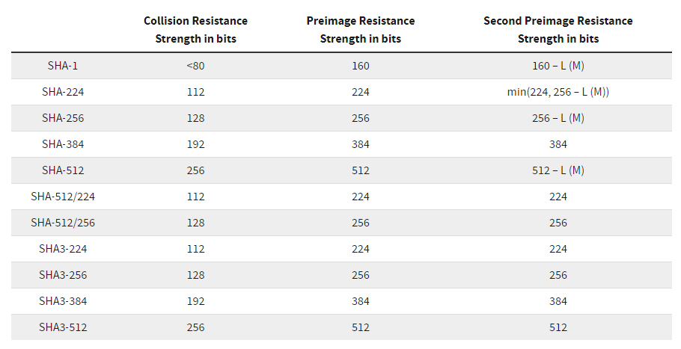Figure 2: table of hashing algorithms and associated strengths from NIST [8].

Above figure 2 demonstrates the strength of each of the algorithms as categorised by NIST, where the higher the values for collision resistance, preimage resistance and second preimage resistance the stronger the algorithm.
- Intrusion Detection and Prevention Systems and Other Security Tools
While cryptography aims to secure data, organizations must also detect and respond to threats that breach their defences.
This is where Intrusion Detection and Prevention Systems (IDPS) play their part. IDPS technologies monitor network traffic and system activities for signs of malicious behaviour and respond accordingly. This provides an additional layer of security [9].
- Intrusion Detections Systems
IDS tools analyse network and system activities for suspicious patterns that may indicate a security breach They can be broadly split into two types; network intrusion detection systems, these monitor incoming network traffic [10]. The other type is host-based intrusion detection systems these are a system that monitors the files of the operating system [10].
IDS’s can be signature-based, detecting known threats by comparing against a database of attack patterns, or anomaly-based, identifying deviations from normal behaviour [10].
Signature-based IDS are effective at detecting known threats, these can utilize byte sequences in network traffic or know instruction sequences utilized by malware. Utilizing this method is impossible to detect new attacks as no pattern is available [10].
Anomaly-based IDS are better at identifying new and unknown threats by detecting unusual activity that deviates from established norms. These then compare this behaviour against a trust model which is created using machine learning, any behaviour which does not fit against the trust model will flag as a potential exploit. This sometimes can lead to false positives as previous unknown legitimate activity can be flagged as malicious [10].
- Intrusion Prevention Systems (IPS)
IPS tools not only detect threats but also take proactive measures to block or mitigate them. These tools are placed in line with the flow of traffic on the network between the source of the information and destination. These will usually sit behind the firewall [11].
Once the IPS detects malicious activity, it can take various actions this could include dropping malicious packets, resetting connections, and alerting administrators [11]. Occasionally an IPS could also be configured with a honeypot or decoy data, to distract and attract bad actors into accessing this instead of their intended target [11].
Many modern networks deal with extremely high volumes of traffic, by having an IPS employing automation and actively responding to detected threats, attacks can be stopped from succeeding and reduce the potential impact on the organization's systems and data [11].
IDPS are essential components of an organization's security infrastructure, providing real-time monitoring and response capabilities and often catching threats that the firewall cannot catch on its own [11].
- Scrutiny Tools for Enhanced Security
Beyond IDPS, there are other scrutiny tools that enhance the security posture of organizations by providing deeper insights into potential vulnerabilities and threats. These tools have the potential to help organizations identify and address security weaknesses before they can be exploited, ensuring a proactive approach to security is taken.
- Security Information and Event Management (SIEM)
SIEM systems assist organizations in the detection, analysis and ultimately response to security threats that have the potential to harm the business. They help identify and correlate events that may signify an ongoing attack [12].
SIEM systems collect data from a wide range of sources and use advanced analytics to detect patterns and anomalies that may indicate a security incident [12].
By providing centralized visibility and analysis, SIEM systems help organizations quickly detect and respond to threats [12].
- Vulnerability Scanners
Vulnerability scanning is a broad term that is used to describe an automated process that scans systems and networks for known vulnerabilities, providing organizations with actionable insights to patch and secure their infrastructure [13].
Vulnerability scanners identify weaknesses in software, configurations, and network devices that could be exploited by attackers [13].
By regularly scanning for vulnerabilities, organizations can prioritize remediation efforts and reduce the risk of successful attacks [13].
- Penetration Testing
Penetration testing involves simulating cyber-attacks to identify weaknesses in the organization's defences. Using this proactive approach helps organizations understand their vulnerabilities and address them before they can be exploited, providing assurances in the organization’s vulnerability assessment [14].
Penetration testers use a variety of techniques and tools that would be bad actors would utilize to identify and exploit vulnerabilities, providing a realistic assessment of the organization's security posture. The results of penetration tests can help organizations improve their security controls, policies, and procedures [14].
- Creating a Secure environment: Protect, Detect, React and Safeguard
To effectively safeguard applications and IT infrastructure, organizations must adopt a multi-faceted approach that encompasses protection, detection, reaction, and safeguarding, these aspects form part of NIST’s cybersecurity framework [15]. Utilizing these functions can provide a holistic strategy ensures that all aspects of data security are addressed, providing comprehensive protection against a wide range of threats [15].
- Protect
Implementing robust safeguards that ensure the delivery of critical infrastructure such as firewalls, encryption, and access controls to prevent unauthorized access and data breaches [15].
Protection involves deploying a range of security technologies and practices to defend against threats. This can includes using strong authentication and authorization mechanisms to control access to sensitive data and systems, empowering staff within the organization through role and privilege-based user training and managing protective technology to ensure that systems are secure and resilient [15].
- Detect
This area focuses on detecting suspicious activities and potential threats in real-time and enabling the timely discovery of cybersecurity events [15]. Detection involves continuously monitoring for signs of malicious behaviour, ensuring anomalous events re detected and the impacts of these events are understood [15]. By detecting threats early, organizations can respond quickly to mitigate their impact and prevent further damage.
- React
This function focuses on how to formulate plans to swiftly address, mitigate and contain the impact of cybersecurity incidents [15]. This can include isolating affected systems, conducting forensic analysis, and restoring normal operations. Reaction involves having a well-defined and tested incident response plan in place that can be implemented and executed during an incident, ensuring that the organization can respond effectively to security incidents [15].
Incident response plans should include procedures for identifying and containing the incident to prevent expansion of the event, resolution of the incident, and conducting post-incident analysis such as lesson learned sessions to learn from the event and improve future response efforts and forensic analysis [15].
- Safeguard
This function concerns itself with the continuous improvement of security practices through regular audits, vulnerability assessments, and updates to security policies and technologies [15].
Safeguarding involves ongoing efforts to enhance the organization's security posture. This includes identifying asset vulnerabilities, identifying cybersecurity policies internal to the organization and legislation which impacts on the organization, performing vulnerability assessments to discover and remediate weaknesses, and identifying a risk management strategy for the organization which will include its risk tolerances [15]. By continuously improving security practices, organizations can stay ahead of emerging threats and ensure that their defences remain effective.

- The Role of Compliance in Data Security in the UK
Compliance with regulatory standards is a critical aspect of data security for modern organizations in the UK. Regulatory frameworks such as the General Data Protection Regulation (GDPR) [16], the Data Protection Act 2018 [1], and the Network and Information Systems (NIS) Regulations 2018 [17] impose strict requirements on how organizations handle, protect, and manage sensitive data. Failure to comply with these regulations can result in significant legal and financial penalties, as well as damage to the organization's reputation.
- General data Protection Regulation (GDPR)
The GDPR is a comprehensive data protection regulation that applies to organizations that process the personal data of individuals in the European Union (EU), including the UK [16].
It sets out principles for that form the general data protection regime and mandates stringent requirements for data protection, including obtaining explicit consent for data processing, ensuring data accuracy and security, and providing individuals with rights to access, correct, and delete their data [16]. Organizations that fail to comply with the GDPR principles can face substantial fines, up to 4% of their annual global revenue or £17.5 million, whichever is higher [16].
- Data Protection Act 2018
The Data Protection Act 2018 is the UK's implementation of GDPR, providing a legal framework for data protection in the UK [1]. The Data Protection Act 2018 reinforces GDPR requirements and provides additional guidance and clarity for organizations operating in the UK [1].
- NIS Regulations 2018
The NIS Regulations 2018 apply to operators of essential services and digital service providers in the UK, requiring them to implement appropriate security measures and report significant incidents [17]. The regulations aim to improve the security and resilience of the UK's critical infrastructure, ensuring that essential services such as energy, transport, and healthcare are protected from cyber threats [17]. Non-compliance with the NIS Regulations can result in significant fines and regulatory action [17].
Compliance with these and other regulatory frameworks requires organizations to implement robust data security practices and controls. This includes conducting regular risk assessments, implementing security technologies, and maintaining detailed records of data processing activities. Organizations must also stay informed about changes to regulatory requirements and adapt their security practices accordingly to ensure ongoing compliance.
- Conclusion
In conclusion, as the landscape of cybersecurity and data threats are ever changing, this necessitates that modern organizations establish comprehensive data security and compliance strategies [15].
Organizations leveraging cryptography, intrusion detection and prevention systems, and other scrutiny tools, organizations can create environments that protect, detect, react, and safeguard their IT systems and applications as demonstrated above. This holistic approach not only ensures the security of sensitive information but also supports compliance with regulatory requirements such as GDPR [16], NIS Regulations 2018 [17] and the data protection act [1].
The importance of data security and compliance cannot be overstated, as organizations face increasing risks from cyber threats and regulatory pressures. In quarter 1 of 2024 2970 data breaches were reported to the information commissioner’s office [18]. By organizations adopting best practices, implementing advanced security technologies, and fostering a culture of security awareness, organizations can build a robust security posture that protects their data and ensures compliance.

Case Scenario – Design of an Information Security Unit

Introduction
This report outlines an approach to establishing a new information security unit within the organization. The information security unit will address critical needs in protecting the company's sensitive data, complying with regulations, and safeguarding the digital infrastructure of the organization. This report details how the information security unit will address key areas.

Organization Structure
This will establish a clear reporting structure and defined roles & responsibilities for the unit.

Policies and Procedures
Developing comprehensive policies and procedures that address data security, user behaviour, and incident response for the whole organization.

Data Protection Compliance
Ensuring compliance with relevant data protection regulations like GDPR, Data protection Act and NIS Regulations as an example.

Security Standards
Description of the security standards that the unit will work and measure themselves against

Contingency Planning
Developing and testing a robust plan for responding to security incidents and ensuring business continuity.

Governance and Strategic Planning for Security
Defining clear ownership and accountability for security across the organization.

Risk Management
Implementing a systematic approach for identifying, assessing, and mitigating security risks.

Organization Structure
This section will demonstrate the team structure that should be established a dedicated information security unit with a clear reporting line to senior management.
The ISU will be structured with a clear hierarchy to ensure accountability and efficiency, the roles are broadly described below.
Chief Information Security Officer (CISO)
This role sits at the top-level management for the organization and is the top of the information security unit. This role is the link between the executive board and the information security unit, this person should be acting as the guide for the organization for information security [19].
This role will determine the policies appropriate to information security unit, ensure that risk assessments for the organization are carried out and then implement appropriate risk mitigation plans. They must understand the internal and external information security risks of the organization, covering the IT environments and physical environments. They must liaise with other departments and external stakeholders to successfully implement the organizations information security strategy [19].
Information Security Specialists
The role of the information security specialists to assist the chief information security officer, they should be motivated to discuss and raise potential upcoming issues and report these to chief information security officer [19].
In their capacity the information security specialists should make advisal’s for technologies and products that relate to the information security of the organization [19].
Data Owners
Data owners ultimately have control of who accesses the data. Within their role they should be conducting regular reviews of users who have been granted access to data and whether this access is still applicable for their role and still applicable to the business requirements [19].

Data Custodians
This role performs a custodial role of the data, they will not own the data but have access to entirety of the data. The key part of this role is to ensure the integrity, confidentiality and availability of the data so that only authorized persons have access. This role will link up with the data owner and provide access to data based on requests and approvals of the data owner [19].
The ISU will collaborate with other departments, such as IT, legal, and HR, to integrate security practices into all business processes. Regular meetings and inter-departmental committees will facilitate this collaboration.
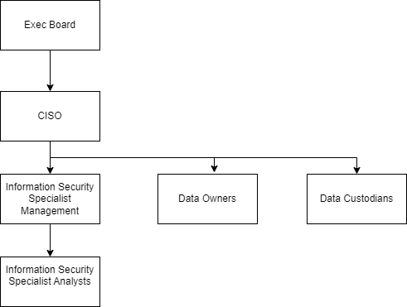
Figure1. Organizational chart
As can be seen from the organizational structure chart demonstrated in Figure1 this demonstrates that the Chief Information Security Officer has direct report up to the executive board of the organization. It also demonstrates how the information security analysts report into the Chief Information Security Officer and the proposed organizational structure of the unit for the organization.
This team structure will ensure clear ownership, efficient communication, and focused expertise for the team.

Policies and Procedures
The information security unit will be key in developing a suite of comprehensive security policies and procedures for the organization, they key areas that policies are required is described below. These policies cover key areas for policy development as defined in ISO/IEC 27001 [19].

Acceptable Use of Company Technology (AUP)
This policy will outline the acceptable use of corporate equipment, this will cover areas such as password management, safe use of wi-fi, defining the applications that can or cannot be installed, what types of devices can connect to the internet and what and how personal data can be communicated [20] [21] .
This document plays a key role in maintaining the integrity and security of the organization’s infrastructure. The acceptable use of company technology policy should clearly define what is permissible for staff in terms of, hardware, software, networks and data access. By explicitly stating the rules around these areas, the risks will be minimised with the physical devices [21].
The key to implementing a successful acceptable use policy is to make it interactive, relevant and regularly updated and ensure that training is reinforced [21]. Data Classification and Handling
This policy defines the rules that employees should follow when handling data [22].
The policy should include the methodology for the categorization of data, to identify the sensitivity and corresponding level of risk, for example data that is publicly available is extremely low risk, whereas data such as credit card or national insurance number is classified as high risk [22].
This policy should also cover, who has access to what data, where it is stored and how this data can be transported outside the network [22].
This policy is important in assisting with regulatory compliance to regulations such as GDPR [22].

Access Control and Identity Management
This refers to a collection of processes procedures and systems which should be in place which support the binding of an individual to a set of permissions within a system [23].
This policy for access control should cover areas such as who has access to systems or data and why they have access to those systems, the circumstances under which access is revoked or granted, what actions in systems are recorded, and how these audit records are obtained and how they are to safeguard against tampering [23].
The identity management aspect then should incorporate strong procedures around how users’ identity is obtained the more privileged the users access the more stringent and robust the verification their identity should be [23].

Incident Response Procedures
This procedure will detail the processes which must be followed if a cyber security incident was to occur [24].
This policy should outline key areas such as key contacts or where to find this information, the criteria for escalation, and guidance on legal and regulatory requirements [24].
The policy may contain play books or run books that focus on a specific type of incident that can encountered be encountered the national cybersecurity centre recommends 3-5 high risk incidents that could be encountered [24]. These playbooks are required to be written in a way so that the first few hours can be managed as efficiently as possible, these should contain information on who should be contacted, how to triage the incident, how to record data for further investigation and analysis and how the incident should be mitigated, and the impact reduced [24] .

Security Awareness Training
Training is one of the key areas that needs to be covered with a robust policy. This policy should seek to foster a workforce with a culture of awareness and safety of cyber threats [25]. This policy must define the training required that staff must undertake, it is important that this training is relevant and continually updated to encompass new threats and the policy must be written in a way to include this a key section [25]. It is important to also measure and review the policy periodically this ensures the policy is relevant and effective [25].
These policies will need to be clearly communicated to all employees, and regular training will need to be conducted to ensure awareness and compliance by all staff members of the organization to maintain the cyber security of the organization. The information security unit will be key in developing, maintaining and supporting these policies.

Data Protection Compliance
The information security unit will conduct a thorough assessment of applicable data protection regulations like GDPR and assess and implement this for the organization.
As described above the information security unit will produce policies and procedures relating to data protection.
A key part of the information security units work will be with compliance with the security requirements of the UK GDPR. The security principle is obligatory for both data controllers and data processors [26].
The information security unit will be key in determining which security measures to implement, it is important to consider the latest technological advancements and the costs of implementation. The selected measures must be appropriate for the specific circumstances and proportionate to the risks posed by the data processing activities [26].
The information commissioner’s office recommends using techniques such as pseudonymisation and encryption where applicable. These measures help in protecting the confidentiality, integrity, and availability (known as the CIA triad) of personal data, as well as the systems and services used to process this data [26].
It is essential to have mechanisms in place to restore access to and availability of personal data promptly in the event of a physical or technical incident. This ensures business continuity and data resilience [26].
Regular testing of the effectiveness of these security measures is also a key requirement. This involves having processes to assess, test, and evaluate the security measures regularly, making necessary improvements based on the outcomes. This testing can be done internally or externally often organizations will opt for a mix of the two [26].
Encompassing these roles into the information security unit will ensure compliance with data protection regulations, minimize legal risk and financial penalties to the organization, and build trust with customers.

Security Standards
The information security unit will be key in adopting key security industry standards to implement industry recognised security. These standards include are described below.
ISO/IEC 27001
ISO/IEC 27001 offers a framework for establishing, implementing, maintaining, and continuously improving an information security management system. This standard, paired with the guidance from ISO/IEC 27002, focuses on understanding security issues within both external and internal organizational contexts, addressing the needs and expectations of interested parties [19].
One of the core components of this standard is the risk assessment process. This involves understanding and quantifying the risks faced by the organization, comparing them with acceptable levels, and identifying the appropriate treatment options. Although the standard does not prescribe a specific risk assessment methodology, it will allow the organization to choose or develop their approach [19].
The standard outlines various control clauses that provide a structured approach to information security management, covering areas such as [19]:
- Information Security Policies
- Organization of Information Security
- Human Resources Security
- Asset Management
- Access Control
- Cryptographic Controls
- Physical and Environmental Security
- Operations Security
- Communications Security
- System Acquisition, Development, and Maintenance
- Supplier Relationships
- Information Security Incident Management
- Information Security Aspects of Business Continuity Management
- Compliance
ISO/IEC 27001 includes 35 control objectives and 114 controls, detailed in ISO/IEC 27002, to guide effective information security management. By applying these controls and comprehensive risk management at the organizational level, organizations can significantly enhance their resilience against information security threats [19].
NIST Cybersecurity Framework
NIST Special Publication 800-39, Managing Information Security Risk: Organization, Mission, and Information System View, offers comprehensive guidance on integrated, organization-wide risk management. Chapter Two outlines the below components and multi-tiered approach of risk management, focusing on [19]:
- Organization-level risk management (Tier 1)
- Mission/business process-level risk management (Tier 2)
- Information system-level risk management (Tier 3)
- Risk related to trust and trustworthiness
- The impact of organizational culture on risk
- Relationships among key risk management concepts
Chapter Three details a life cycle-based process for the management of information security risks, this chapter covers [19]:
- An overview of the risk management process
- Establishing the context for risk-based decisions
- Risk assessment
- Risk response
- Continuous risk monitoring
This process emphasizes managing risk across three specific layers or tiers as they are described. Organization level (Tier 1), mission/business process level (Tier 2), and information system level (Tier 3) [19].
NIST Special Publication 800-53 Revision 4, "Security and Privacy Controls for Federal Information Systems and Organizations," provides guidance on assigning effective security controls within the multi-tiered risk management approach. Chapter Two discusses the below [19]:
- Multi-tiered risk management concepts
- Structure and organization of security controls into families
- Security control baselines for tailoring
- Use of common controls and security capability inheritance
- External environments and service providers
- Assurance and trustworthiness
- Revisions and extensions to security controls and baselines
Chapter Three of SP 800-53 further describes the process of selecting and specifying security controls for organizational information systems, including [19]:
- Selecting appropriate security control baselines
- Tailoring baseline controls, including developing specialized overlays
- Documenting the security control selection process
- Applying the selection process to new and legacy systems
The combination of SP 800-39 and SP 800-53 provide a solid foundation for organizations for managing information security risks [19].
Utilizing the combination of these two industry standards, will set the information security unit in securing the data of the organization.

Contingencies Planning
As part of the incident response plan described above the organization should have appropriate business continuity planning and know how to enact this if required to enter a state of business continuity.
As part of its role the information security unit will contribute towards the development of this plan. The plan should include strategies such as back-up and recovery methods, whether there is any off-site storage, will the organization provision hot/cold/warm sites [19]. Also, consideration needs to be given for any alternative systems and back up equipment from vendors, this should be added into plan and for these service level agreements with defined timelines must be agreed by the suppliers so that the organization has effective timely support [19].
The information security unit must use a cost versus benefit analysis to incorporate and create an appropriate business continuity strategy [19].

Governance and Strategic Planning for Security
Successful implementation of effective security management program is high on the list of problems for many organizations. The work of aligning information security to the organization’s strategy is a challenging and constant work which requires defining capabilities that are strategically vital to organization [27].
The key to an organization of applying good governance and strategic planning for security involves recognizing capabilities that are strategically vital to the organization. This is where the information security unit will ensure those vital capabilities remain protected by ensuring that the organization employs a sound security governance framework [27].

Risk Management
The information security unit will be key in developing risk management for data security within the organization.
As part of the information security units’ function in risk management, they will need to assist in proactively managing the data security risks of the organization [19].
The first part of this process will be to identify the risks presented to the organization such as theft of laptops or potentially a bad attacker tapping into the network. These will then need to be analysed to assess the probability of these once this happens a risk level will be decided. Once this risk level has been decided the organization must decide on how this risk is to be managed, whether they are accepted, avoided, transferred or mitigated [19].
The information security unit will be key to achieving the organizations aims in data security risk management.

Conclusion
This report outlines the approach for establishing a new information security unit within the organization. The unit will focus on protecting sensitive data, complying with regulations, and implementing sound security governance and policies to safeguard digital infrastructure. The information security unit will ensure the organization's data and systems are well-protected.

References
[1] (). Data Protection. Available: https://www.gov.uk/data-protection.
[2] (). Top Cybersecurity Threats in 2024. Available: https://onlinedegrees.sandiego.edu/top-cyber-security-threats/.
[3] (). What is Cryptography. Available: https://www.ibm.com/topics/cryptography.
[4] (). What Is Encryption?. Available: https://cloud.google.com/learn/what-is-encryption#.
[5] (). Digital Signatures and Certificates. Available: https://support.microsoft.com/en-gb/office/digital-signatures-and-certificates-8186cd15-e7ac-4a16-8597-22bd163e8e96.
[6] (). Digital Signature. Available: https://www.techtarget.com/searchsecurity/definition/digital-signature.
[7] (). What is a hash function? Definition, usage, and examples. Available: https://www.ionos.co.uk/digitalguide/server/security/hash-function/.
[8] (). Hash Functions. Available: https://csrc.nist.gov/projects/hash-functions.
[9] K. Scarfone and P. Mell. K. Scarfone and P. Mell. "Intrusion detection and prevention systems," in Handbook of Information and Communication Security, P. Stavroulakis and M. Stamp, Eds. 2010, Available: https://doi.org/10.1007/978-3-642-04117-4_9. DOI: 10.1007/978-3-642-04117-4_9.
[10] (). What is an Intrusion Detection System?. Available: https://www.barracuda.com/support/glossary/intrusion-detection-system.
[11] (). What is an Intrusion prevention System?. Available: https://www.vmware.com/topics/intrusion-prevention-system#.
[12] (). What is SIEM?. Available: https://www.microsoft.com/en-gb/security/business/security-101/what-is-siem.
[13] (19/01/). Vulnerability scanning tools and services. Available: https://www.ncsc.gov.uk/guidance/vulnerability-scanning-tools-and-services.
[14] (). Penetration Testing. Available: https://www.ncsc.gov.uk/guidance/penetration-testing.
[15] (). The CSF 1.1 Five Functions. Available: https://www.nist.gov/cyberframework/getting-started/online-learning/five-functions.
[16] (). A guide to the data protection principles. Available: https://ico.org.uk/for-organisations/uk-gdpr-guidance-and-resources/data-protection-principles/a-guide-to-the-data-protection-principles/.
[17] (). The NIS Regulations 2018. Available: https://www.legislation.gov.uk/uksi/2018/506.
[18] (). Data Security Incident Trends. Available: https://ico.org.uk/action-weve-taken/data-security-incident-trends/.
[19] U. Nayak and U. H. Rao. U. Nayak and U. H. Rao. The InfoSec Handbook : An Introduction to Information Security The InfoSec Handbook : An Introduction to Information Security (1st ed.) 2014. DOI: 10.1007/978-1-4302-6383-8.
[20] (). How To Make an Acceptable Use Policy – Example with Free Template. Available: https://www.cyberpilot.io/cyberpilot-blog/how-to-make-an-acceptable-use-policy#:~:text=An%20AUP%20for%20security%20provides%20specific%20rules&text=For%20example%2C%20it%20can%20include,equipment%2C%20like%20laptops%20and%20smartphones.
[21] (). Security Awareness Training: Why You Need a Corporate Acceptable Use Policy. Available: https://www.comptia.org/blog/security-awareness-training-corporate-acceptable-use-policy.
[22] (). A COMPREHENSIVE GUIDE TO DATA HANDLING POLICIES – WHAT THEY ARE AND HOW TO IMPLEMENT THEM. Available: https://www.consilien.com/news/a-comprehensive-guide-to-data-handling-policies-what-they-are-and-how-to-implement-them#:~:text=A%20Data%20Handling%20Policy%20is,and%20manage%20an%20organization's%20data.
[23] (). Introduction to identity and access management. Available: https://www.ncsc.gov.uk/guidance/introduction-identity-and-access-management#:~:text=An%20identity%20and%20access%20management,joiners%2C%20leavers%20and%20movers%20process.
[24] (). Incident management. Available: https://www.ncsc.gov.uk/collection/incident-management/cyber-incident-response-processes.
[25] (). 6 Sections Every Security Awareness Training Policy Needs. Available: https://cybeready.com/awareness-training/sections-security-awareness-training-policy-needs.
[26] (). A guide to data security . Available: https://ico.org.uk/for-organisations/uk-gdpr-guidance-and-resources/security/a-guide-to-data-security/.
[27] G. Jackson Jr and S. Rahman. G. Jackson Jr and S. Rahman. Security Governance, Management and Strategic Alignment Via Capabilities Security Governance, Management and Strategic Alignment Via Capabilities 2017. DOI: 10.1109/CSCI.2017.8.

