Secure the Network from common threats and attacks
Networks and cyber security essentials
Sean garrington gar19847608
Contents
1. Possible Breaches 2
2. Review of Breaches 3
Threats 3
Vulnerabilities 3
Attacks 3
Possible Security Implementation 4
3. Implementation 4
4. References 6

Possible Breaches

Possible Security Breach 1: Internal actors
Internal actors is the possibility that employees excluding the ones that lost their job, acted maliciously against the business. Some employees may have had access to data they may not need or may be acting off an external factor. In turn, the employee(s) could have logged onto the network and install ransomware onto the workstation.

Possible Security Breach 2: Disgruntled employees
In the scenario, it was mentioned that after losing their job, one of the Sales Heads thought about disrupting the business and later on the workstations was found have its contents encrypted with a “.rekt” file. This could have happened if Alfred or the person managing the network’s user permissions forgot to or did not revoke the Sales Head’s access to the network, potentially allowing them still have access the network and encrypt the files after losing their job.

Possible Security Breach 3: Phishing
In the scenario, it is stated that the network for the “Complimentary” Wi-Fi for the customers was not segregated, this means that someone using the “Complimentary” Wi-Fi, could have clicked on a malicious link while on the network that could have infected it. Furthermore, the employees also could have accidentally clicked on a malicious phishing link that was sent to one of their emails, which downloaded the ransomware onto the workstation an encrypted the important files.

Review of Breaches

Threats

A threat to a network is “any attempt to breach (a) network and obtain access to your data” [1]. This can be for a number of reasons such as monetary gain, disrupting a business or organisation or just for fun.Types of threats include but are not limited to malware, phishing, brute force attacks, denial of service or DOS attacks and people. If any threat gets into a network, it can cause many major issues, such as the whole network going down in a DOS or DDOS attack, DOS being a single PC and DDOS being a network of PCs flood a network with request that eventually overwhelm the network causing it to crash [2]. Important files being encrypted and locked unless the organisation or person pays the ransom such as in this case with the important files being encrypyted by a “.rekt” file. In particular, the “.rekt” files originate from the “REKTLocker” ransomware, for more information on REKTLocker see [3].

Vulnerabilities

Attacks

Possible Security Implementation

Implementation

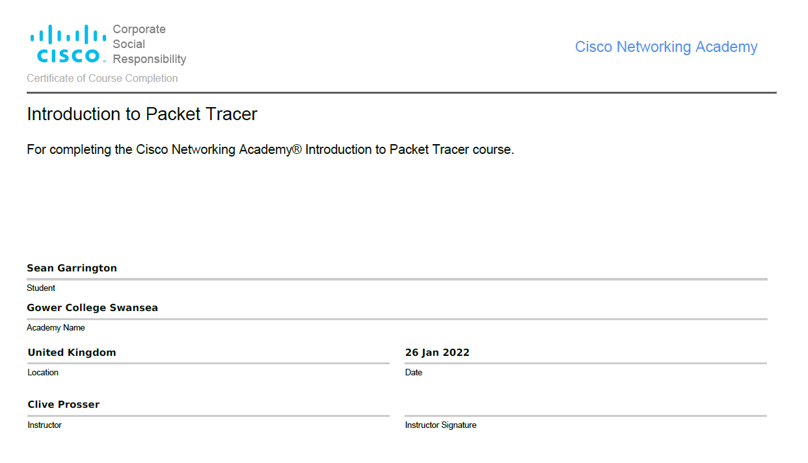

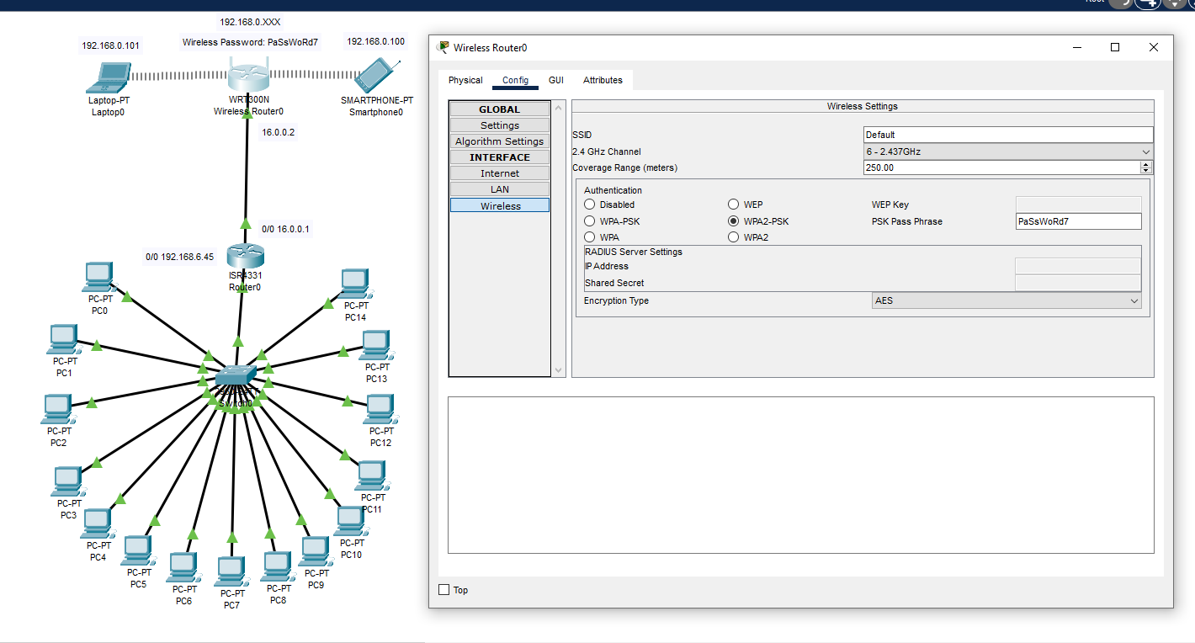

Bibliography

[1] | SecurityScorecard, "How to Identify Network Security Threats and Vulnerabilities," 26th May 2021. [Online]. Available: https://securityscorecard.com/blog/identify-network-security-threats-and-vulnerabilities#:~:text=A%20network%20security%20threat%20is,data%20is%20a%20network%20threat.&text=Other%20threats%2C%20like%20malware%20or,aimed%20at%20stealing%20your%20data.. [Accessed 25 January 2022].
[2] | Checkpoint, "What is DDoS?," N/A. [Online]. Available: https://www.checkpoint.com/cyber-hub/cyber-security/what-is-ddos/#:~:text=DDoS%20(Distributed%20Denial%20of%20Service,intended%20users%20on%20the%20Internet.. [Accessed 25 January 2022].
[3] 1 | T. Meshauskas, "REKTLocker Ransomware," PCRisk, 9th December 2021. [Online]. Available: https://www.pcrisk.com/removal-guides/10351-rektlocker-ransomware. [Accessed 25th January 2022].

