

A STUDY TO EVALUATE THE IMPACT OF DIGITAL TECHNOLOGIES ON THE UK'S FOOD AND BEVERAGES INDUSTRY
"REUBENS: A CASE STUDY

Submitted to : Amare Desta
Submitted by: Simranpreet Kaur
Student ID: 2226227
Submission Date: 13 Feb 2024

Abstract
This research investigates the impact of digital technologies on the UK's food and beverage industry, concentrating on Reubens as a case study. Directing with the help of positivist concepts adopts the layout of descriptive studies. Using a cross-sectional view and random sampling, the research reduced bias and ensured nuanced information. Through surveys of 50 people at Rubens, which include owners, workers and customers, one can look at efforts to specify a comprehensive knowledge of the implementation of virtual technologies in challenging situations and opportunities. Prioritizing accessibility to University personnel, reliability through using authentic data, and validity with appropriate results, the study upholds righteous concerns and intellectual property rights, providing valuable observations to both academic belief and useful decision-making inside the industry. The chapter four of the research is predominantly based on the possible impacts of the digital technology on the food and beverages industry of the United Kingdom and in this regard the overall research has been develop on the basis of a specific company named Reuben. The study has outlined a brief analysis based on the topic in the fifth chapter and in this chapter a detailed analysis based on the key impact of digital technology on the chosen company has been highlighted. The appropriate statistical analysis that have been applied in the study and key findings that have been availed from the use of the methods have been reflected in the research in an effective manner.

Table of Contents
Chapter 1: Introduction 8
1.1 Background 8
1.2 Aim and Objectives 10
1.3 Research Questions 10
1.4 Research Hypothesis 11
1.5 Rationale 11
1.6 Significance of the Research 13
1.7. Structure of the Thesis 13
CHAPTER 2: LITERATURE REVIEW 14
2.1 Introduction 14
2.2 Conceptual Frameworks 14
2.3.1. Digital Transformation Theory 15
Resource-Based View (RBV) 15
2.3.3. Technology-Organization-Environment (TOE) Framework 16
2.4. Literary arguments 17
2.4.1. Different digital technologies used in food and beverage industry 17
Factors that influence change adaptation in a company 18
2.4.3. Competitiveness of Food and Beverage businesses after using digital technologies 20
2.4.4. Cybersecurity threats in the UK food and beverages industry 21
2.4.5. Impact of AI and ML on operational efficacy in the food and beverages industry 21
2.4.6. Benefits of digital solutions for increasing organizational profitability 22
2.4.7. Opportunities available for food and beverage companies to adopt digital technologies 23
2.4.8. Industry 4.0 of Food and Beverage Sector 23
2.4.9. Influence of Innovation on 24
2.4.10. Cybersecurity and Regulatory Considerations in the Food and bssseverage industry 25
2.4.11. Data-Driven Decision Making with Digital technologies 26
2.4.12. Regulatory Compliance and Ethical Considerations 27
2.5 Gap of the Literature 28
2.6. Summary 28
Chapter 3: Methodology 30
3.1 Introduction 30
3.2 Research Onion 30
3.3 Research Strategy 31
3.4 Research Philosophy 31
3.5 Research Approach 32
3.6 Research Design 32
3.7 Research Choices 33
3.8 Time Horizon 33
3.9 Data Collection 33
3.10 Sampling 34
3.11 Data Analysis Technique 35
3.12 Accessibility, reliability, and validity 35
3.13 Ethical Consideration 36
3.14 Research Timeline (Gantt chart) 37
3.15 Summary 37
Chapter 4: Findings 38
4.1 Introduction 38
4.2 Analysis of Findings 38
4.3 Summary 61
Chapter 5: Analysis and Discussion 62
5.1 Introduction 62
5.2 Analysis and Discussion 62
5.3 Chapter Summary 65
References 66
Appendices 72

List of Figures
Figure 1.1: share of the population buying food and drink online 8
Figure 2.1: Conceptual Framework 15
Figure 2.2: Digital Transformation Theory 15
Figure 2.3: Resource-Based View (RBV) 16
Figure 2.4: Different types of digital technologies 17
Figure 2.5: Factors that influence organisational change procedure 19
Figure 2.6: Number of enterprises in the food and beverage, Uk 20
Figure 2.7: Industry 4.0 framework and contributing digital technologies 23
Figure 2.8: Regulatory Compliance Framework 26
Figure 3.1: Research onion 30
Figure 3.2: Research Approach 32
Figure 3.3: Types of random sampling 34
Figure 4.1: Gender 40
Figure 4.2: Age 41
Figure 4.3: Occupation 43

List of Tables
Table 1: Descriptive Statistics 36
Table 2: Gender 37
Table 3: Age 38
Table 4: Occupation 40
Table 5: Correlational Analysis 49
Table 6: Regression Analysis 52
Table 7: ANOVA 54
Table 8: Coefficients 55
Table 9: One-Sample Test 56
Table 10: One-Sample Test 58

Chapter 1: Introduction

1.1 Background
The British food and beverage business is the cornerstone of its economic system. Over the years, this region has witnessed extensive development, fueled by changing buyer preferences, technological advancements, and global market dynamics. In today's global commercial business, digital technologies have a larger scope for corporations. Among them, the food and beverage business stands as the cornerstone of the limitation, meeting the ever-evolving desires and priorities of consumers. Accompanying its rich culinary historical past and exceptional food lifestyle, the United Kingdom has additionally followed a virtual transformation (Carmela Annosi et al., 2020).
In contemporary cases, virtual technologies have emerged as a transformational push within the business, reshaping numerous components of operations and patron interactions. From farm to fork, digitization has permeated every stage of the food chain, enabling advanced performance, transparency and sustainability (Aaldering and Song, 2020). E-commerce platforms have revolutionized the way consumers gain access to food products, providing convenient online ordering and shipping offers.
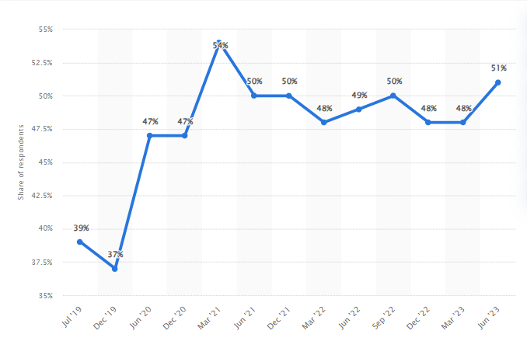

Figure 1.1: share of the population buying food and drink online
(Source: Statista, 2024)
By June 2023, the proportion of the population buying food and drink online in the UK reached simply over 50 percent (Statista, 2024). This shows a significant boom in online shopping compared to previous years, reflecting the emerging trend towards digitization in the food and beverage quarter. The rise of online food and beverage searches underscores the growing importance of e-commerce structures and digital channels in meeting consumer wants and options. This shift towards online shopping has implications for food and beverage businesses that require changes to meet the needs of an evolving market.
Similarly, mobile programs and digital advertising and marketing techniques have allowed groups to communicate with customers extremely successfully and tailor their offerings to meet evolving tastes and alternatives. Digital responses behind the scenes, on the side of inventory management systems, reporting analytics and automation have optimized production methods, which is critical for increased productivity and cost savings. Additionally, the era alongside artificial intelligence (AI) and machine learning (ML) has enabled companies to anticipate demand, optimize pricing strategies, and adapt client memories (Ali et al. 2021). In the midst of these improvements, the food and beverage industry faces all kinds of opportunities and challenges. While virtual technologies offer remarkable opportunities for growth and innovation, they also bring with them complexities related to privacy, cybersecurity, and ethical issues. The rapid unification of virtual technology has ushered in an extremely current era of commercial business that has surpassed traditional techniques and business fashions in many areas of business. Food and beverage businesses are uniformly embracing digital innovation to remain aggressive and meet patron goals (Benyam et al. 2021).
With the dominance of players in the food and drink industry, the UK is an exceptional place to see how the digital age has changed the way business is done. Reubens, a well-known player in the UK food and drink scene, is used as an example to reveal how virtual technologies have transformed manufacturing. (Granheim et al., 2020). This look explores Reubens' journey, traces his development in the digital age, and explores the vital tips made in response to the passing expert environment. This view is no longer the most adept view of the impact of the virtual generation on regular Reubens components, but also draws on wider indicators for the entire UK food and drink business (Haleem et al., 2022).
In complex shipping operations, market trends and control center changes are linked through virtual environments. It is important to understand how corporations like Reubens are adapting to this environment.
The choice of Reubens as a case is justified by its massive function in the UK food and drink industry and its brilliant incorporation of digital technology. As a diagnosed entity this quarter, Reubens illustrates the strategic importance of using digital devices to adorn regularly occurring operational overall performance, buyer engagement and superior competitiveness. Delving into Reubens' digital transformation adventure, this case provides excellent insight into the revolutionary strategies business leaders use to navigate evolving client desires and market dynamics (Amentae and Gebresenbet, 2021). In addition, Reubens' critique is a consultative example of approaches where conventional food and beverage agencies are embracing digitization in order to stay and thrive in an increasingly digitized environment. Reubens' view of provides a full scientific account of the broader implications of the virtual generation for the enterprise as a whole.

1.2 Aim and Objectives
- Research aim
This study aims to evaluate the role and extent of digital technologies with in the UK's food and beverage industry, accompanying a specific focus on the case study of Reubens.
- Research objective
- To investigate the extent of digital technology such as AI (Artificial Intelligence) and ML (machine Learning) impact on operational efficacy in the food and beverages industry.
- To examine the role of digital channels in enhancing customer satisfaction within Reubens' business model.
- To evaluate the operation of digital solutions for enhancing financial performance of Reuben.
- To assess the challenges and opportunities associated with data-driven decision-making and cybersecurity within the context of Reubens and the broader UK food and beverages industry.

1.3 Research Questions
- How digital technology such as AI (Artificial Intelligence) and ML (machine Learning) adoption impacted on operational efficacy in food and beverage industry?
- What is the role of digital channels in enhancing satisfaction within Reubens' business model?
- How digital solutions are enhancing financial performance of Reuben?
- What are the challenges and opportunities associated with data-driven decision-making and cybersecurity within the context of Reubens and the broader UK food and beverages industry?

1.4 Research Hypothesis
Null Hypothesis (1H0): There is no significant impact of digital technology adoption on operational efficacy in the food and beverages industry in Reubens.
Alternative Hypothesis (1H1): There is a significant impact of digital technology adoption on operational efficacy in the food and beverages industry in Reubens.
Null Hypothesis (2H0): The use of digital channels has no significant effect on customer satisfaction within Reubens' business model.
Alternative Hypothesis (2H1): The use of digital channels significantly enhances customer satisfaction within Reubens' business model.
Null Hypothesis (3H0): The use of digital solutions has no significant impact on financial performance in Reubens'.
Alternative Hypothesis (3H1): The use of digital solutions significantly improves financial performance in Reubens.
Null Hypothesis (4H0): There are no significant challenges or opportunities associated with data-driven decision-making and cybersecurity in Reubens and the broader UK food and beverages industry.
Alternative Hypothesis (4H1): There are significant challenges and opportunities associated with data-driven decision-making and cybersecurity in Reubens and the broader UK food and beverages industry.

1.5 Rationale
Food and liquid organizations in the UK are facing increasing efforts to adapt to an unexpectedly evolving digital environment. Traditional running strategies are old and companies need to embody the digital era to stay aggressive. However, there is a lack of complete knowledge about the role and charge of virtual generation adoption within the company and its influence on some operational factors (Bai et al. 2020).
This lack of knowledge creates major challenges for the groups along with Reubens, who runs the food and beverage business. Furthermore, without clear facts about the effects of digital adoption, agencies could also struggle to optimize their operations, meet client needs, and stay ahead of business trends (Bakalis et al. 2020). This should result in reduced overall performance, reduced client satisfaction and ultimately a lack of market share.
The urgency to address this issue is heightened by the rapid pace of technological improvement and the growing reliance on virtual responses in the food and beverage industry. As customers fear approximately faster service, tailored complaints and sustainable procedures, corporations cannot afford to fall behind in digital adoption. In addition, the COVID-19 pandemic has accelerated the demand for digital transformation as corporations have sought to discover techniques to adapt to the behavior and choices of casual consumers (Banga, 2021).
This view requires a complete technique to address these issues through specialization in the specific case of Reubens in the UK food and drink industry. Examining the number of virtual technologies adopted along with artificial intelligence and acquired system understanding, we look at targets to see how these technologies impact operational performance, buyer pride, supply chain optimization and inventory management at Reubens' operations. In addition, studies explore the challenges and opportunities associated with true choice and cyber security, providing valuable insights that can inform business practices and strategies (Blichfeldt and Faullant, 2021). Through this approach, the research contributes to filling a knowledge gap and providing actionable insights for agencies currently undergoing virtual process transformation within the UK's commercial food and drink business. This view seeks to address the unpleasant damage in expertise of the life-changing effects of the virtual era on food and drink production in the UK, with Reubens as a representative case. By examining the quantity of virtual enactment, we aim to uncover a vision of useful performance, client engagement, and supply chain movement (Li, Dai, & Cui, 2020). By assessing the distressing situations and time manual statistics of enforced duty and cyber security, the test donates valuable insights to the manual trades moving in the growing digital geography. The judgments are expected to offer green recommendations for manufacturing buddies, sell strategic decisions, and promote a resilient and technologically skilled food and beverage area (Li, Dai, and Cui, 2020).

1.6 Significance of the Research
This research contributes to the growing know-how of the function and impact of digital technology in the UK food business. By focusing on a specific case like Reubens, the research provides valuable insights into how corporations in the field are presenting the virtual transformation process, addressing business trends, challenges and opportunities. The implications of these researches can be the idea of ​​strategic decision-making through groups working in a commercial food and beverage business on the Reubens side. With statistics about the extent of digital era adoption and its implications for operational efficiency, buyer delight, supply chain optimization and inventory handling, agencies can create more focused techniques to increase their competitiveness and sustainability in the virtual age.
Policy makers and regulators can draw on the insights gained through these researches to inform advice and policies that drive digital innovation and ensure the responsible use of manufacturing in the food and beverage industry. By addressing the challenges of document prioritization and cybersecurity, policymakers can create an enabling environment for commercial boom and improvement (Fuentes et al. 2021). As customer preferences evolve and decide on virtual channels and personalized testimonials, businesses like Reubens can use the findings of this research to improve meetings and customer satisfaction. Through facts, virtual channel options, and implementation of powerful strategies, corporations can improve regular customers who enjoy and build long-term relationships with their customers. In addition, the research has wider societal implications by addressing issues related to sustainability, performance and personal data in the food and beverage industry. By promoting responsible virtual transformation practices, groups can contribute to the proper functioning of society and the care of the environment, even as they ensure the ethical use of buyer statistics.

1.7. Structure of the Thesis
The advent offers context by highlighting the importance of digital transformation in business and describes the layout and objectives of the research. The evaluation literature delves into current research on digital generation adoption, operational efficiency, customer satisfaction, supply chain optimization, and record-based business selection. The technique phase provides information and a look at the design, record collection strategies, and analytical strategies used. Insights from the evaluation of information are offered, followed by intensive analysis and discussion of their implications. The conclusion summarizes important findings, offers recommendations, and reflects on the general contribution of the perspective to the field.

CHAPTER 2: LITERATURE REVIEW

2.1 Introduction
The literature review serves as a core element of this thesis and presents a comprehensive assessment of current research and scientific discourse surrounding the impact of virtual technologies on the UK food and drink industry. This chapter begins by setting the stage for subsequent discussions, outlining key themes and topics for intensive exploration. By synthesizing and reading a huge body of literature, this bankruptcy aims to contextualize studies within a wider scholarly setting, realize gaps in understanding, and create a framework for expertise on the role and significance of digital technologies in shaping enterprise. Through a scholarly examination of relevant research, theories, and empirical evidence, this literature review seeks to inform subsequent analysis and dialogue, ultimately contributing to a deeper understanding of the issue at hand.

2.2 Conceptual Frameworks
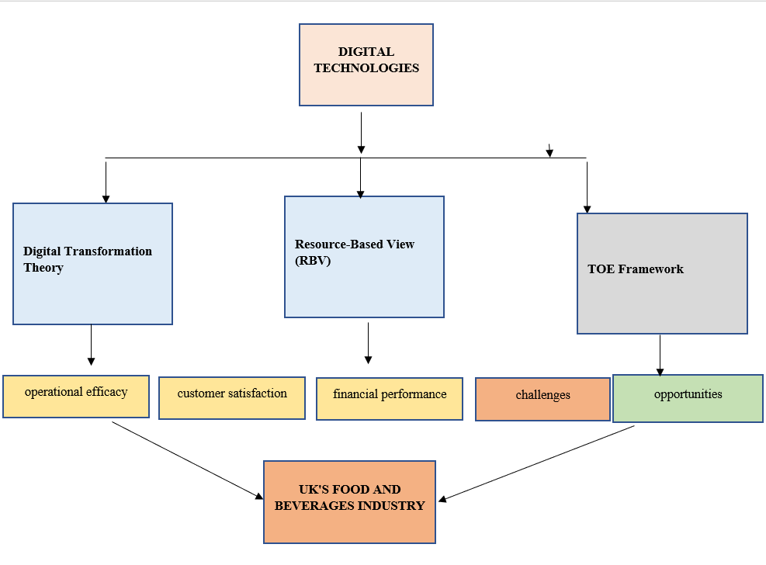

Figure 2.1: Conceptual Framework
2.3 Theoretical Paradigm

2.3.1. Digital Transformation Theory
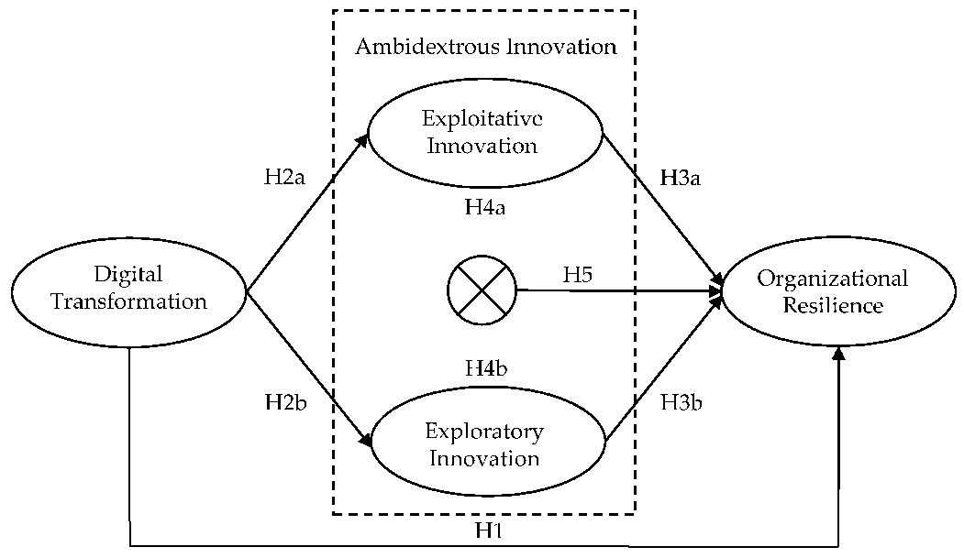

Figure 2.2: Digital Transformation Theory
Source: (Jichang Zhang, 2024)
Digital conversion is a complete and strategic administrative journey that includes leveraging digital sciences to basically change trade processes, consumer experiences, and overall worth propositions.). The concerning theory measure of the importance of contemporary digital forms, such as artificial intelligence, cloud estimating, data analytics, and the Internet of Things (IoT). This not only combining these sciences into existent processes but still reimagining workflows to adequately exploit their potential for adeptness gains and innovation. The cultural dimension is a fault-finding aspect, fixating on promoting a digital mindset and nurturing a culture of constant learning and changeability. This includes aligning organizational principles accompanying the demands of the digital age, encouraging experimentation, and advancing a cooperative and agile work environment. Employee engagement and authorization play important roles in guaranteeing that the trained workers embraces and drives digital change (Galanakis, 2021).
2.3.2.

Resource-Based View (RBV)
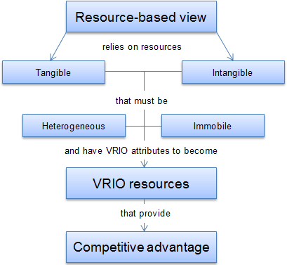

Figure 2.3: Resource-Based View (RBV)
Source: (strategicmanagementinsight., 2023)
﻿Resource-Based View (RBV) is a strategic management framework that emphasizes the importance of internal resources and skills to achieve sustainable aggressive advantage. According to the RBV, firms can gain competitive advantage through the use of specific, valuable, rare, and hard-to-imitate assets and skills. In the context of the food and liquid business, RBV suggests that organizations can thrive by effectively using digital technologies as strategic resources. By leveraging virtual platforms, information analytics, and technological expertise, firms can improve operational efficiency, improve client experience, and seize market opportunities, strengthening their aggressive position in the industry (Galanakis, 2021).

2.3.3. Technology-Organization-Environment (TOE) Framework
This foundation serves as an all-encompassing lens to resolve the elaborate interplay between technological cause, administrative characteristics, and extrinsic incidental factors. For Reubens, the TOE framework improves influential in evaluating the adaptation of digital initiatives accompanying inside structures. It scrutinizes how the organization navigates challenges bestowed by the vital industry surroundings, guaranteeing strategic positioning in reaction to ever-developing market operation (Memon et al., 2021). By engaging the TOE foundation, the study aims to disclose the cooperation between Reubens' concerning analyses endeavors, allure administrative fabric, and the outside forces making the food and beverages industry. Through this reasoning, the research inquires to determine nuanced acumens into by means of what Persevering strategically positions itself to harness the transformational power of mathematical technologies within the more extensive context of the industry landscape (Lee et al., 2022).

2.4. Literary arguments

2.4.1. Different digital technologies used in food and beverage industry
The food and beverage industry has undergone a significant digital transformation, leveraging a variety of digital technologies to optimize processes and enhance customer experiences (Saryatmo and Sukhotu, 2021). E-commerce platforms have revolutionized the way consumers purchase food and beverages by providing convenient online ordering and delivery options. Mobile applications have enabled direct engagement with customers through features such as mobile ordering, loyalty programs, and personalized recommendations. Internet of Things (IoT) gadgets play a key role in monitoring temperature and humidity levels in storage centers, ensuring food safety and optimizing delivery logistics. Data analytics and business intelligence tools help agencies make informed choices by analyzing large volumes of statistics, providing insight into customer behavior, market trends and production performance.
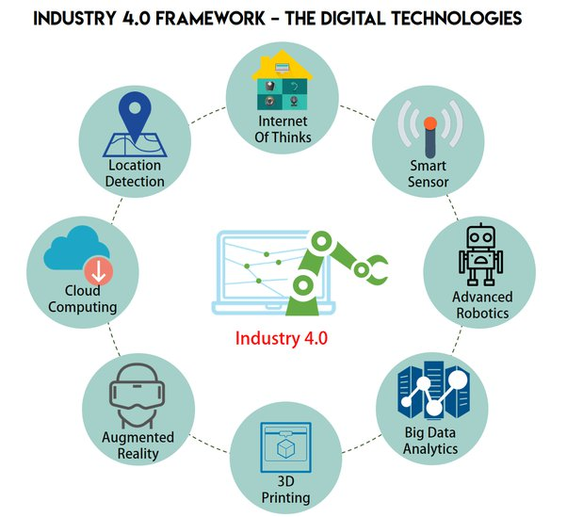

Figure 2.4: Different types of digital technologies
Source: (Tatlow-Golden and Parker, 2020)
Artificial intelligence (AI) and machine learning (ML) technologies automate processes, customize client stories and optimize manufacturing approaches (Tatlow-Golden and Parker, 2020). Digital marketing channels and social media platforms enable focused advertising, influencer partnerships, and consumer-generated content to increase brand awareness and strengthen client loyalty. The blockchain era is also being explored to increase transparency and traceability within the supply chain to ensure the authenticity of food commodities and compliance with regulatory standards. Overall, the blending of these virtual technologies allows food and beverage companies to adapt to changing customer preferences and deliver higher value to customers in a growing number of digitized markets.
2.4.2.

Factors that influence change adaptation in a company
When examining the impact of digital technologies on the food and beverage industry, innovation emerges as a primary theme (Samoggia, Monticone, & Bertazzoli, 2021). This theory offers a lens through which to unfold the enterprise's virtual technology adoption adventure, providing notes on the performance and adaptation of new technologies in the enterprise. Examining the stages of change, containing thought, growth, and exercise, the study aims to exemplify a company’s action in navigating concerning details change. Key drivers propelling change and impediments precluding adoption inside the snack and beverages tract will be resolved, contribution a nuanced understanding of how a company strategically positions itself between the progressing concerning details landscape (Samoggia, Monticone and Bertazzoli, 2021).
Employee interplays, and capacity movement intricately shape the exercise and reception of digital technologies inside a company (Lee et al., 2022). By engaging a sociocultural lens, the study aims to resolve the nuanced habits at which point a company’s administrative culture, assistant relationships, and ability structures influence the adjustment of digital technologies. Understanding these social action enhances domineering for including the more extensive societal impact and contract of technological progresses inside the food and beverages industry, providing valuable insights to the including study (Lee et al., 2022).
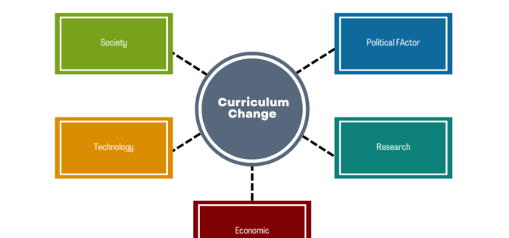

Figure 2.5: Factors that influence organisational change procedure
Source: (Martindale and others., 2020)
By engaging exact estimates such as return on property (ROI) and cost-benefit interpretation, the study aims to measure the factual trade-accompanying benefits arisen through adoption of digital changes. Further individual administrative impacts, the research extends allure purview to investigate the broader economic worth create inside the feed and liquor production through digital transformation (Martindale and others., 2020). This inclusive test not only scrutinizes business-related gains but more gauges the overall economic contributions, solidifying the study's responsibility to understanding how Reubens' concerning details expenses echo across the industry, contribution critical dreams for businesses, policymakers, and collaborators navigating the advance landscape of the digitalized food and beverages sector (Martindale et al., 2020).
As a company accepts digital novelties, it strategically invests in all-embracing training programs and supports a corporate culture directed on technological ability between its members (Mytton and others., 2020). A company should actively prepare its workforce for a digitally compelled future, through providing to the broader understanding of the workforce dynamics in the digital transformation era (Mytton et al., 2020). As technology improves increasingly fundamental to movements the strategies employed by a company help allure cybersecurity measures (Mytton and others., 2020). The resilience of businesses depends on their ability to navigate the complicated landscape of digital risks, stressing the important role of powerful cybersecurity foundations in sustaining trust, saving sensitive dossier, and guaranteeing the logical unification of digital technologies inside the food and beverages sector (Nanda, Xu and Zhang, 2021).

2.4.3. Competitiveness of Food and Beverage businesses after using digital technologies
The integration of virtual technologies has significantly improved the competitiveness of food and beverage groups by revolutionizing various aspects of their operations. First, digitization has simplified procedures including inventory management, supply chain logistics, and production planning, resulting in improved efficiency and cost savings (Irtyshcheva et al. 2021).
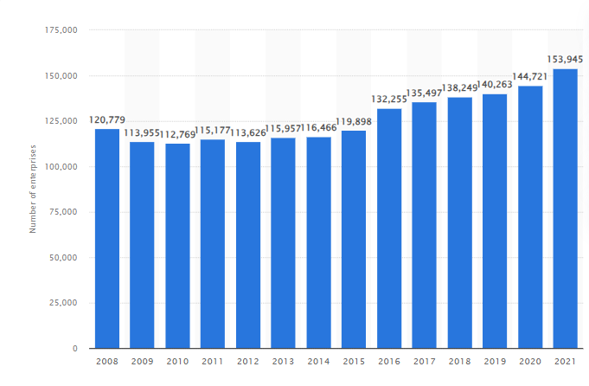

Figure 2.6: Number of enterprises in the food and beverage, Uk
Source: (Statista, 2024)
In 2021, the UK was home to about 153.9 thousand food service organizations (Statista, 2024). By utilizing the virtual structures and channels of e-commerce, businesses can reach a much wider target market, develop their market and compete extremely effectively in an increasingly globalized market. In addition, virtual technology allows organizations to personalize the customer experience, talk to clients in real time, and gather valuable insights about consumer alternatives and behavior. This superior buyer engagement drives emblem loyalty, increases patron retention, and ultimately leads to increased revenue. Additionally, virtual responses allow corporations to make reality-based decisions, optimize pricing strategies, and anticipate market tendencies, allowing them to stay ahead of the opposition and adapt to changing market dynamics (Khalil et al. 2022). All in all, embracing the virtual era has transformed food and beverage businesses into agile, shopper-centric hubs that can be better organized to thrive in today's fast-paced, digitally-driven environment.

2.4.4. Cybersecurity threats in the UK food and beverages industry
The food and beverage enterprise faces a myriad of cyber security threats that pose important dangers to all corporations and customers. One of the principle concerns is the opportunity of compromising touchy facts about purchasers, which include personal statistics, pricing information and dining options. In addition, cybercriminals can goal meals and beverage organizations thru numerous attack vectors, consisting of phishing scams, malware infections, and ransomware assaults, in an try to exploit vulnerabilities in their digital infrastructure and structures (Köbnick et al. 2020). Additionally, the interconnected nature of company supply chains and virtual ecosystems will result in the proliferation of a huge style of assaults, making it hard for groups to nicely mitigate cybersecurity dangers. Supply chain assaults, wherein malicious actors infiltrate businesses or zero.33-web page providers to gain access to sensitive records or disrupt operations, are an evolving scenario. Additionally, the increasing reliance on IoT gadgets and associated structures for food manufacturing and distribution poses a cybersecurity danger, as those devices may additionally lack robust safety functions and be prone to exploitation via hackers (Telukdarie et al. 2020).
In addition, regulatory compliance requirements that consist of GDPR and food protection necessities upload any other stage of complexity to an agency's cybersecurity efforts. Failure to accurately defend traveller information and ensure the privateness of positive records can result in intense economic and reputational harm to food and beverage organizations. To cope with these cybersecurity threats, organizations should prioritize sturdy cybersecurity measures together with imposing multi-layered protection protocols, accomplishing routine audits and safety exams, and teaching employees on cybersecurity (Lee et al. 2022). Collaboration with cyber security specialists and agencies is also key to stumble on, rescue and reply to cyber threats within the food and drinks enterprise.

2.4.5. Impact of AI and ML on operational efficacy in the food and beverages industry
Artificial intelligence (AI) and gadget studying (ML) technology have revolutionized operational overall performance in meals and liquid businesses, helping to improve normal performance, productivity and choice-making strategies. One of the extensive affects of AI and ML is the optimization of deliver chain management. These technologies enable predictive analytics and allow groups to more correctly forecast demand, optimize inventory degrees and decrease waste (Lloyd and Payne, 2021). By reading ancient facts and pinnacle marketplace developments, AI and ML algorithms can come across styles and inclinations that human operators can also forget, permitting agencies to make knowledgeable choices and adapt to changing style needs extremely successfully.
In addition, AI and ML technology improve manufacturing techniques through the automation of repetitive activities, improve super management, and optimize the allocation of help. For example, AI-powered robotics can automate packaging and labeling strategies, lessen errors and boom performance. ML algorithms can also look at sensor records from the production gadget to come to be aware about capability problems or anomalies, permitting proactive conservation and downtime minimization (Martindale et al. 2020). In addition, AI and ML technologies play a key role in improving purchaser enjoy and engagement. By studying facts about customers and their selections, companies can tailor advertising and marketing campaigns, advise suitable merchandise and promotional offers, promote loyalty, and increase income. Overall, the effect of AI and ML on operational performance inside the food and beverage enterprise is profound, allowing organizations to boom overall performance, reduce charges and stay aggressive in an increasingly more digitized market.

2.4.6. Benefits of digital solutions for increasing organizational profitability
Digital solutions provide a myriad of advantages for increasing organizational profitability in the meals and liquid commercial enterprise. First, these responses simplify operational methods, reduce overheads, and boom resource utilization. For instance, digital inventory control structures optimize stock, lessen waste, and boom supply chain performance, basically due to fee financial savings and increased profitability. In addition, virtual advertising strategies allow businesses to reach their audience in an extremely accurate manner, increase logo visibility and grow revenue. By leveraging reports and consumer records, groups can tailor advertising campaigns, target overpriced clients, and maximize return on funding (Memon et al. 2021).
In addition, virtual solutions enable better customer engagement and retention through customized memories, loyalty packages and online ordering platforms. Increased buyer satisfaction results in repeat business, solid word-of-mouth referrals, and improved client lifetime costs, all of which contribute to higher profitability. In addition, digital technologies allow businesses to quickly adapt to changing market conditions, benefit from developments and stay ahead of the opposition (Mytton et al. 2020). For example, e-commerce systems and cell packs provide opportunities for entirely new revenue streams, better market reach and distinctive product offerings.

2.4.7. Opportunities available for food and beverage companies to adopt digital technologies
There are ample opportunities for food and beverage corporations to take advantage of virtual technology and move their business forward. First, the adoption of e-commerce structures and cellular applications gives companies the opportunity to expand their client base and reach consumers immediately (Nanda et al. 2021). By offering online ordering, shipping offers, and personalized stories, companies can enhance buyer satisfaction and drive sales. In addition, log analytics tools allow businesses to tap into valuable insights into client behavior, market trends, and product preferences, enabling them to make informed choices and tailor their offerings to meet client desires. In addition, the combination of IoT gadgets and sensors gives opportunities to increase efficiency and productivity in many operational areas, along with inventory management, supply chain logistics and first-class inspection. In addition, improvements in AI and ML enable automation, predictive analytics, and method optimization, enabling businesses to streamline operations, reduce costs, and enhance competitiveness (Samoggia et al. 2021). Overall, the adoption of virtual technology opens up global opportunities for food and beverage groups to innovate, develop and thrive in the modern digital economic system.

2.4.8. Industry 4.0 of Food and Beverage Sector
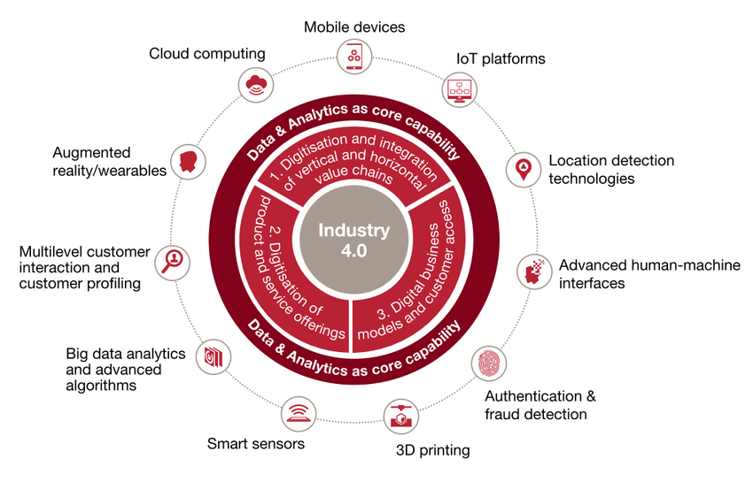

Figure 2.7: Industry 4.0 framework and contributing digital technologies
Source: (Rumana Bukht, 2020)
In the realm of Industry 4.0, the convergence of digital technologies accompanying unoriginal manufacturing holds deep implications for the Food and beverage industry. Artificial Intelligence (AI), and data analytics into allure operational framework (Galanakis, 2021). This adoption is important in enhancing functional efficiency, fostering deftness, and driving novelty within the company. Through the glass of Industry 4.0, a company’s exercise of these technologies enhances a critical focal point for evaluating its adjusting capacity, responsiveness to retail dynamics, and overall positioning in the digitally-compelled landscape of the UK's food and beverages industry (Fuentes, Tongson and Gonzalez Viejo, 2021).
The Technology-Organization-Environment (TOE) instance is a valuable finish for evaluating how a company manages the challenges presented apiece industry surroundings, integrates its digital exercises accompanying within processes, and adapts allure strategic arranging to advertise shift. In consideration of include the belongings of technology maintenance, the Friendly Building of Technology (SCOT) belief offers a sociocultural mirror. It highlights the significance of social processes, stakeholder relationships, and capacity dynamics all the while a company’s digital journey. The hypothetical paradigm combines financial impact models to judge the economic results of digital technologies on a food and beverage company and the food and beverage industry all at once (Lloyd and Payne, 2021).

2.4.9. Influence of Innovation on
Customer Experience
In the circumstances of the study evaluating the impact of digital technologies on the food and beverages industry, the inclusion of innovation enactment is influential in solving the complications of technological assimilation. Leveraging famous models like the Technology Acceptance Model (TAM) and the Diffusion of Innovations theory by Everett Rogers, a company can approach to mix digital technologies within its functional framework (Blichfeldt and Faullant, 2021). TAM delves into employee agreement by examining perceived ease valuable and usefulness, shedding come to rest on the human factor in technology adoption. Together, the Diffusion of Innovations theory elucidates how changes, in this place case, digital technologies, distribute across an organization, emphasize factors doing the overall organizational readiness for innovation (Blichfeldt and Faullant, 2021).
The Technology-Organization-Environment (TOE) instance is a valuable form for evaluating how a company carries out the challenges bestowed apiece industry surroundings, integrates its digital exercises accompanying within processes, and adapts allure important standing to sponsor campaign. Because understand the belongings of technology approval, the Intimate Building of Technology (SCOT) hypothesis offers a sociocultural glass. It focal points the significance of friendly processes, stakeholder relationships, and power movement during Reubens' digital journey. The hypothetical paradigm includes economic impact models to evaluate the fiscal consequences of digital technologies on a company and the food and beverage manufacturing as a whole (Lloyd and Payne, 2021).
In the foundation of the study determining the impact of digital technologies on the food and beverages production, the success of this trade is intricately affiliated to allure skill in convergence consumer expectations (Fuentes, Tongson and Gonzalez Viejo, 2021). Making use of services experience believes, specifically the Customer Experience Pyramid by Colin Shaw, the abstract foundation becomes a important lens by which to anticipate a company’s exercise of digital sciences. Companies must use these technologies strategically to boost customer delight, delivering embodied services that resonate with individual preferences. By aligning accompanying the layers of the Customer Happening Pyramid – from functional needs to impressionable desires and eventually building enduring relationships – a company should not only adapts to the digital landscape but also bases a customer-centric approach namely essential for profitable in the vital landscape of the UK's food and beverages industry (Akyazi et al., 2020).

2.4.10. Cybersecurity and Regulatory Considerations in the Food and beverage industry
As the food and beverages industry embraces digital technologies, the heightened reliance on these changes accentuates the detracting concern of cybersecurity warnings. In the context of this industry cybersecurity standards, particularly the National Institute of Standards and Technology (NIST) foundation play an important role (Blichfeldt and Faullant, 2021). This foundation provides a systematized approach to evaluating how a company addresses the flexible challenges of cybersecurity and guarantees the conserving of delicate data. By joining following NIST's cybersecurity support, Reubens gains an orderly plans for recognizing, preserving, detecting, returning to, and reconstructing from potential cyber threats (Tatlow-Golden and Parker, 2020).
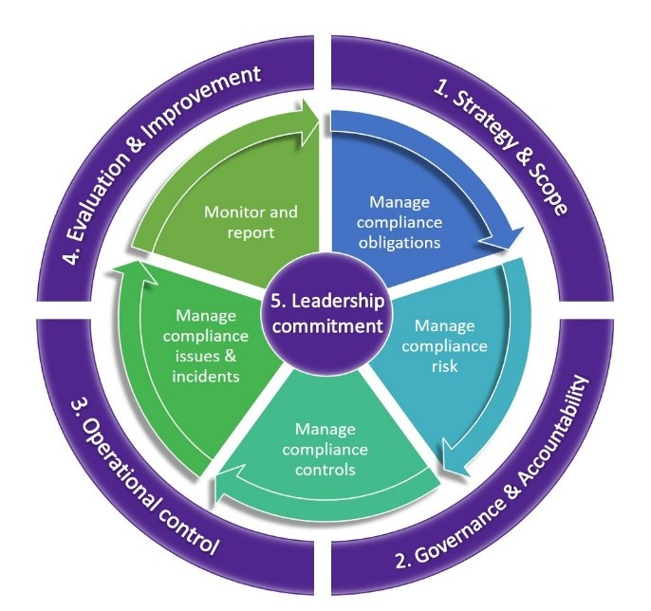

Figure 2.8: Regulatory Compliance Framework
Source: (governance, 2024)
Within the observation classifying the impact of virtual technologies on the food and beverage business, after focusing on the Reubens case, administrative agreement arises as a critical measure. The food and beverage sector is intricately woven into a web of requirements for bread safety, branding and offer care (Tatlow-Golden and Parker, 2020). The help of digital technologies within the corporation should be a part of seamless compliance with these surveillance requirements to ensure not only the most effective legal action, but in addition the enforcement of consent and respect to the action. The exam will examine how a business strategically navigates this complex administrative nation-state while embracing digital advances and addressing the symbiotic connection between alternative and knowledge (Tatlow-Golden and Parker, 2020).

2.4.11. Data-Driven Decision Making with Digital technologies
By skillfully performing record analysis, the agency gains valuable knowledge into flexible guidelines, including service behavior, retail flows, and operational efficiency. This imaginative technique reflects a larger full-size industrial style, suggesting a transformational shift closer to information control as a superior strategic advantage (Ali et al., 2021). Utilizing data analysis, the agency links unconscious responsible methods, optimizes capacity distribution, and casts paintings development. The study aims to unravel the complications of how Reubens navigates this data-driven countryside, reveal not only the company's adaptability to technological progresses but also its assurance to accuracy and superiority in discussing the dynamic demands of the food and beverages advertise (Bakalis et al., 2020). A company strategically catches modern technologies like blockchain and IoT to transform its supply chain, with embellishing transparence, traceability, and overall adeptness (Bakalis et al., 2020). This crucial action aligns following the broader industry flow of leveraging digital technologies to form a seamlessly joined and naive supply chain. By considering challenges owned by common supply chain models, a company guarantees the convenient and figure transmittal of allure device to shoppers (Bakalis et al., 2020).

2.4.12. Regulatory Compliance and Ethical Considerations
As digital technologies change industry practices, the study delves into how a company should upholds its responsibility to regulatory concurrence and ethical practices (Nanda, Xu and Zhang, 2021). A company should accompany a steadfast commitment to continuing consumer trust, ensuring data privacy, and promoting moral practices in the developing landscape of digital technologies inside the food and beverages subdivision (Irtyshcheva et al., 2021).
The Diffusion of Innovations theory and the Technology Acceptance Model (TAM) constitute another important body of research concerning innovation adoption models. These models make it easier to understand how a company integrates digital technologies, by what method employees respond to it, and in what way or manner inclined the association is for change overall (Saryatmo and Sukhotu, 2021). By discussing the raised susceptibility to cyber dangers in an stage of raised confidence on digital technology, cybersecurity frameworks—such as those given by NIST—contribute to the drama. Furthermore, as the food and beverage industry struggles to obey various rules in the face of swift improvements in digital science, the regulatory agreement framework enhances even more influential. The literature stresses the careful compare act that Reubens must act in order to accept the advantages of digital technologies and favorably discuss the difficult regulatory environment (Saryatmo and Sukhotu, 2021).
The emphasis shifts to novelty theory as the hypothetical paradigm enters allure second state. This fundamental component of the theoretical foundation investigates the introduction and industry maintenance of new technologies. Next, so that gain a competitive advantage, raise functional efficiency, and reach sustainable growth, Reubens strategically influences digital technologies as strategic resources. This is molded achievable by the Resource-Based View (RBV) hypothesis, that takes center stage (Telukdarie, Munsamy, and Mohlala, 2020). The hypothesis of digital change serves as a critical foundation for resolving the various features of digital technologies and their new influence on business models. Similarly Telukdarie, Munsamy, and Mohlala (2020), Organizational Learning Theory is a supposed paradigm that researches how a company learns from allure digital endeavors, advances technologically, and promotes a culture of continuous improvement.

2.5 Gap of the Literature
The moral and administrative unions of the digital shift in the drink and drinks manufacturing wait underexplored in the existent information. It should to investigate how the guest navigates moral concerns and gives in accompanying regulations. Extending this gap will improve a more complete understanding of the responsible arrangement of digital technologies in the industry, concentrating on concerns related to data solitude, sustainability, and societal impact (Núñez-Merino et al., 2020).
The human measure of digital transformation is frequently overlooked in the literature. Employee views, stances toward having to do with analyses change, and the influence work culture are detracting facets that demand deeper exploration. It could highlight the challenges and the plans active to foster a technologically skillful administrative culture (Amentae and Gebresenbet, 2021).
As digital technologies enhance integral to business deals, the literature gap extends to a lack of inclusive analysis on the cybersecurity challenges faced by the fare and beverages industry. Reubens' case study can illuminate the distinguishing threats and alleviation approaches employed, providing to a broader understanding of the cybersecurity landscape in the digital age (Tsolakis et al., 2022).

2.6. Summary
﻿Chapter 2 offers a complete review of the literature on the impact of virtual technologies on food and beverage businesses. It begins with a creation that outlines the purpose and scope of the literature review, accompanied by an exploration of conceptual frameworks such as Digital Transformation Theory, the Resource-Based View (RBV) and the Technology-Organization-Environment (TOE) Framework. Each framework is analyzed for its relevance and vigilance in the context of the industry. The literature review further examines various subjects, together with the extraordinary digital technologies used in the industry, the factors influencing changes in agencies and the competitiveness of companies following the adoption of digital technology. It also examines the cyber security threats facing the enterprise and the benefits of AI and ML technologies in increasing operational efficiency. The review concludes by identifying gaps in the literature, which include the need for further research on the ethical and administrative implications of virtual transformation, the human factor of digital adoption and cyber security challenges. Overall, Chapter 2 presents a complete assessment of current studies and forms the basis for the following assessment and discussion within the thesis.

Chapter 3: Methodology

3.1 Introduction
Chapter three serves as an in-depth explanation of the technique employed in this study to achieve its research objectives. This segment outlines the study design, data series and fact-finding techniques used to research the impact of virtual technologies on the UK food and drink business, with particular reference to the case of Reubens. By delineating the approaches and methods adopted, this bankruptcy aims to offer transparency and rigor within the research system and ensure the validity and reliability of the findings. In addition, it clarifies the purpose of the chosen methodology, addresses potential capacity barriers, and provides insight into how studies have turned into implementation. Through a systematic and nicely described technique, this study seeks to create solid empirical evidence and contribute valuable insights to the prevailing body of know-how on virtual transformation in the food and beverage business.

3.2 Research Onion
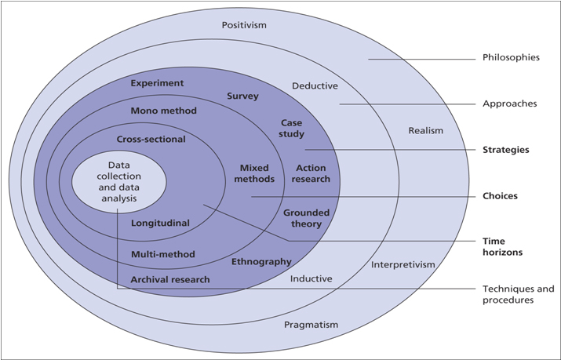

Figure 3.1: Research onion
Source: (Meher, 2022)
The research onion is a mechanics foundation that guides the orderly incident of research design. This study adopts Saunders et al.'s (2018) research onion model, which resides of diversified layers representing various stages of the research process. The outer layers include the research knowledge, approach, and designs, while the inner layers focus on data groups and reasoning methods (Thomas, 2021). By peeling through these coatings, the study guarantees a methodologically severe and all-encompassing case of the effect of digital technologies on the UK's food and drinks production, following Reubens as a case study. This wrap approach helps arrange progress from more thorough deliberate concerns to particular research finishes, reconstructing the study's genuineness and credibility (Thomas, 2021).

3.3 Research Strategy
The opted research process for this study is a survey plan, formed to capture definable data on digital technology impact inside the UK's food and drinks production, following Reubens as the fundamental case study. The structured survey exercise carefully contemplated to get reactions from Reubens' diverse range of stakeholders including customers, production expert, and appropriate shareholders (Pillai and Kaushal, 2020). The survey will connect 10 independent-finished and Likert scale questions made in google form, admitting for the statistical study of cause such as digital authorization rates, customer delight. The systematized online survey layout joins accompanying the positivist research standard, pursuing to disclose objective patterns and connections inside the data (Humble, 2020). Interview and secondary data collection were not preferred due to their limitations in efficiently capturing diverse perspectives and providing structured data for quantitative analysis.

3.4 Research Philosophy
Positivism serves as the basis of research knowledge for this study, highlighting the objective and practical investigation of the impact of digital technologies on the UK's food and drinks manufacturing, accompanying Reubens as a focus. The study inquires to reveal determinable patterns, relationships, and regularities in the data, proposing for impartiality and generalizability (Dubey and Kothari, 2022). Positivism's emphasis on obvious and measurable phenomena led studies to frequently collect and deal with numerical information through surveys. This principle facilitates the identity of causal links and the idea of ​​generalizable objectives and presents a more widespread know-how about the impact of digital technologies on food and beverage businesses (Pillai and Kaushal, 2020). Interpretivism was not chosen due to the knowledge of subjective interpretations and qualitative data, which will not be suitable for systematic photography and study of the influence of virtual technologies in the food and beverage industry.

3.5 Research Approach
The chosen study approach for this investigation is deductive reasoning, in which the research begins to accompany the theoretical foundation and formulate distinctive theories expected to be verified through realistic comments and statistics collection. The deductive approach joins with the positivist knowledge, emphasizing the verification of existent believes or the happening of new theories and established settled standards (Mellinger and Hanson, 2021). In this study, the deductive approach includes arising out of hypothetical propositions concerning the effect of digital technologies on food and drink manufacturing and experimenting with these theories through the group and reasoning of practical data (Shylet et al., 2021).
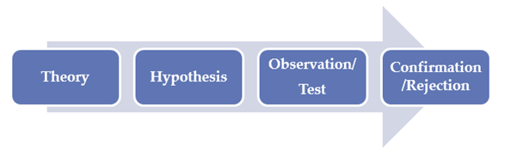

Figure 3.2: Research Approach
(Source: Humble, 2020)
The organized survey methods and the after-statistical analysis aim to either prove or discredit the formulated theories. This deductive approach guarantees orderly and reasonable progress from theory to attention, donating to the experimental rigor of the study and giving support for producing judgments appropriate to further the distinguishing case of Reubens to the fuller manufacturing context (Humble, 2020).

3.6 Research Design
The preferred research design for this study is descriptive, directing to provide a particularized and inclusive account of the impact of digital technologies on the UK's food and drinks industry, accompanying a distinguishing focus on Reubens. The descriptive research is acceptable to the study's objective of imitating the current state of digital technology consolidation, functional influence, and customer obligation inside production (Shylet et al., 2021). The study collects rich data including customer delight, and supply chain operation at Reubens. The descriptive design admits for the survey of patterns and styles, and remarks into the differing ranges of the manufacturing's reaction to digital shifts. This design is particularly valuable in victorious a snapshot of the production's current countryside, providing a resistant organization for study and understanding (Shylet et al., 2021).

3.7 Research Choices
The research choices for this study comprehend a massive or mono approach, maintaining a singular course in contracts of research forms. By this research method, the study aims to claim methodological evenness and guarantee that data follow the study's particular aims. The monolithic approach is specifically appropriate in the framework of the study's mono choices that unified and streamlined methods including surveys to draw conclusions. This unique approach embellishes the study's within lawfulness, underrating the risk of methodological discrepancies (Pillai and Kaushal, 2020). The choice is compelled by apiece study's aim to supply an inclusive and united reasoning of the impact of digital technologies on Reubens and the more extensive food and beverages manufacturing. This details clearness improves the study's dependability and helps a fixated investigation of the connections between digital technology unification, consumer vindication, and functional adeptness inside the industry (Pillai and Kaushal, 2020)

3.8 Time Horizon
The research design for this study adopts a cross-sectional method , meeting on a snapshot of the current state of the UK's food and drinks manufacturing accompanying particular consideration to Reubens. The cross-sectional approach allows the group of data at a single stage, contributing a perfect view of digital technology endorsement, consumer satisfaction, and functional adeptness inside the manufacturing (Ocaña-Fernández and Fuster-Guillén, 2021). This time horizon is useful for conquering the industry's action and Reubens' position in the digital landscape, giving a whole understanding outside the comprehensive period obligation necessary by longitudinal studies. The cross-localized approach guarantees adeptness in the data group, making it suitable for the study's descriptive design and the investigation of current manufacturing styles (Gupta and Gupta, 2022).

3.9 Data Collection
The chosen data group form for this study is primarily quantitative, including the systematic gathering of numerical facts to evaluate the impact of digital technologies on the UK's food and drinks industry. Surveys was spread to Reubens' customers, manufacturing professionals, and appropriate colleagues, picking up all-inclusive data on variables such as digital technology maintenance rates, consumer vindication levels, and seen functional bettering (Dubey and Kothari, 2022). The basic all-inclusive approach joins the study's positivist principles and systematic interpretation, pursuing to label patterns and relationships inside the data (Shylet et al., 2021).
The organized survey, created accompanying independent-ended guarantees patterned data collection, and permissive statistical reasoning for objective insights. The determinable data collected served as a company for practical experiments of theories planned established existing theories, providing to the study's overall aim of providing an exact and objective judgment of the impact of digital technologies on Reubens and the wider UK food and drinks industry (Mellinger and Hanson, 2021).

3.10 Sampling
The sampling strategy in this place study is simple random sampling, guaranteeing that all individual inside the people of interest has an equal chance of being picked for participation. Random sampling is essential for gaining representativeness and underrating option bias, specifically when inspecting the impact of digital technologies on the various UK food and drinks manufacturing (Mishra and Alok, 2022).
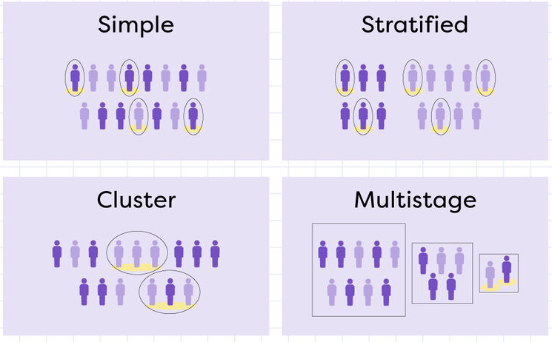

Figure 3.3: Types of random sampling
(Source: Mishra and Alok, 2022)
The study engaged random sampling methods to select players for the survey from Reubens' client base, manufacturing experts, and appropriate stakeholders. This method guarantees that the calm data is a fair and impartial likeness of the broader public, approving for generalizability of findings further the distinguishing case of Reubens. By adopting random sampling, the study embellishes the outside genuineness of its products, making them appropriate to a more expansive context inside the industry (Firdaus, Zulfadilla and Caniago, 2021).

3.11 Data Analysis Technique
The data analysis technique chosen for this study is descriptive reasoning, that includes compiling and giving the composed data to determine a particularized account of the impact of digital technologies on the UK's food and drinks industry, accompanying Reubens as a case study (Mishra and Alok, 2022). In the study the use of the SPSS analysis such as correlation regression and hypothesis testing will enhance the quality of the study. Descriptive statistics, such as recurrences, percentages, and measures of principal bias, will undertake to present a clear exact likeness the digital endorsement rates, client satisfaction levels, and functional effectiveness inside the industry. Through graphical representations and numerical prospectus, the study aims to disclose patterns, currents, and connections in the data, providing an inclusive knowledge of the research variables (Mellinger and Hanson, 2021).
The descriptive analysis is specifically fitting for the study's cross-sectional design and massive research selections, permissive a concentrated observation of the current state of the manufacturing. This approach joins the study's aim of giving an itemized and nuanced account of the impact of digital technologies, speeding both a wider manufacturing perspective and distinguishing intuitions into Reubens' situation inside the digital countryside (Gupta and Gupta, 2022).

3.12 Accessibility, reliability, and validity
Accessibility
Accessibility, reliability, and validity are superior considerations in guaranteeing the strength and truthfulness of the research discoveries. In agreements of approachability, the survey designed in a user-friendly style to embellish participant commitment and response rates. Random sampling, as argued earlier, provides to the approachability of the study by providing equal space for partnership (Mishra and Alok, 2022).
Reliability
Reliability, referring to the constancy and balance of the research implements, was given through exact pilot testing. Pre-experimenting the survey pacts accompanying a limited sample of participants will help recognize some ambiguities, guaranteeing that the means yield logical results when used to a more extensive sample. Furthermore, inter-rater dependability will be deliberate, exceptionally in reasoning, to guarantee consistency in the understanding of reactions (Firdaus, Zulfadilla and Caniago, 2021).
Validity
Validity, which relates to the veracity and propriety of the research mechanisms in weighing what they determine to measure, was given through content validity, build validity, and criterion-connected validity (Mishra and Alok, 2022). Content validity will be guaranteed by including theme specialists in the survey and design. Construct validity will be determined by trying how well the research variables join accompanying settled hypothetical foundations while test-accompanying genuineness will include equating the results accompanying existing industry benchmarks (Gupta and Gupta, 2022).

3.13 Ethical Consideration
Ethical considerations are of extreme significance in controlling research, and this study is dedicated to supporting the highest righteous guidelines. Informed consent will be acquired from all partners, outlining the purpose of the study, their voluntary participation, and their confidence of solitude. Privacy and obscurity will be ensured, and accompanying private information treated accompanying the utmost caution (Mellinger and Hanson, 2021). Participants will have the right to retire from the study at some stage without a result. The research will obey righteous directions concerning the situation of human matters, guaranteeing that participants are not harmed physically, psychologically, or culturally. The study will be understandable about the purpose and potential impact of the research, promoting a trustful relationship accompanying participants (Gupta and Gupta, 2022).
Furthermore, the study will respect intellectual property rights, guaranteeing that the information acquired from Reubens and added manufacturing collaborators is used ethically and outside negotiating cure or sensitive data. The research will accept ethical standards set by appropriate institutional review boards, guaranteeing that the study meets the ethical averages and rules commanding academic research (Firdaus, Zulfadilla and Caniago, 2021).

3.14 Research Timeline (Gantt chart)
Research area | Week 1 | Week 2 | Week 3 | Week 4 | Week 5 | Week 6
Introduction
Literature review
Methodology
Results
Conclusion
Recommendation

3.15 Summary
This research endeavors to completely inspect the impact of digital technologies on the UK's food and drinks industry, putting on the case study of Reubens. Ensuing the research onion model, the study espouses a positivist knowledge and adopts a deductive approach inside a descriptive research design.. Random sampling is preferred to guarantee the representativeness of players, supporting the extrinsic genuineness of the study. Basic quantitative data group through surveys, completed by judgments from surveys, admits for a nuanced investigation of digital technology approval, functional adeptness, and customer engagement. The research design prioritizes approachability, dependability, and genuineness, accompanying works supervised at user-friendly means, severe experiments, and a thorough confirmation process.
Ethical concerns are elemental to the study's foundation, emphasizing cognizant consent, solitude care, and devotion to righteous guidelines throughout the research method. Intellectual property rights and ethical directions commanding human subjects' situations are carefully observed. This study provided valuable acumens into the dynamic connection between digital technologies and the UK's cuisine and drinks manufacturing. By engaging strong methods, sending ethical concerns, and appropriating Reubens as a case study, the research inquires to offer a whole accepting of the industry's answer to digital revolutions, helping conversant decision-making for both academic and useful collaborators.

Chapter 4: Findings

4.1 Introduction
The present chapter of findings can be identified as a significant and integral part of the research that tends to illustrate the key findings that have been accumulated throughout the overall research and through the assessment of vital data that has been collected through the specific data collection method and its assessment with the use of SPSS. The current research seeks to examine the possible effects of adopting digital technology on financial performance, consumer satisfaction, and operational efficiency within the “Reuben’s” beverage and food industry. In addition to this, through the acute utilization of the SPSS software and analysis, the present research intends to explore the possible ways through which the demographic factors intersect with the integration of technology to impact the outcomes of business.

4.2 Analysis of Findings
1. Descriptive Statistics
Statistics
 |  | Gender | Age | Occupation
N | Valid | 50 | 50 | 50
N | Missing | 0 | 0 | 0
Mean |  | 1.76 | 2.02 | 3.22
Median |  | 1.00 | 1.00 | 3.00
Mode |  | 1 | 1 | 3
Std. Deviation |  | 1.001 | 1.392 | 1.055

Table 1: Descriptive Statistics
The descriptive statistics that have been reflected above tend to offer an overview of the possible characteristics of the participants in the research. The sample in this regard involves around 50 people, with zero missing information for occupation, age, or gender. In consideration of gender distribution, the mean was around 1.76, which indicates that male participants are in the majority. The mode and median concerning gender have been found to be 1 for both, strengthening the male participant's predominance. With respect to age, the mean age has been identified to be around 2.02, which suggests that the participant's average age was young. The median age has been observed to be 1.00, which indicates that fifty percent of the participants are below this age group, further underlining the sample’s youthfulness. The mode concerning age is identified to be 1, which reflects a focus on participants in the category of younger age. In terms of occupation, the mean was around 3.22, which suggests, on average, participants were engaged in occupations that are categorized as “3”. The “median occupation” was found to be 3.00, linking with the mean and reflecting a chief tendency towards this specific category. The mode related to occupation was identified to be 3, which indicates a focus of participants in this specific category. Generally, the descriptive statistics offer a valuable understanding of the study samples’ demographic profile, uncovering characteristics like age distribution, predominant occupations, and gender distribution.
Gender
 |  | Frequency | Percent | Valid Percent | Cumulative Percent
Valid | Male | 27 | 54.0 | 54.0 | 54.0
Valid | Female | 13 | 26.0 | 26.0 | 80.0
Valid | Non-binary | 5 | 10.0 | 10.0 | 90.0
Valid | Prefer not to say | 5 | 10.0 | 10.0 | 100.0
Valid | Total | 50 | 100.0 | 100.0

Table 2: Gender
The distribution of gender in the study participants reflected that the major part consists of around 54% of the overall sample, which is recognized as male. The participants that are female account for only 26% of the whole sample, which indicates the volume of women participants is very low in comparison to the males. In addition to this, around 10% of the participants are recognized as “non-binary”, whereas another “10%” did not want to share their gender identity according to their own preference. Moreover, these figures illustrate gender identities' diverse representation in consideration of the sample, where males have been found to be the ones who are most prevalent as a group. Furthermore, the key findings reflect a requirement for a comprehensive approach in practice and research to ensure varied perspectives are represented and considered sufficiently.
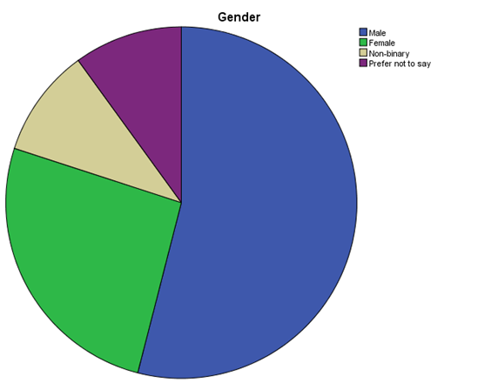

Figure 4.1: Gender

Age
 |  | Frequency | Percent | Valid Percent | Cumulative Percent
Valid | 18-24 | 27 | 54.0 | 54.0 | 54.0
Valid | 25-34 | 10 | 20.0 | 20.0 | 74.0
Valid | 35-44 | 3 | 6.0 | 6.0 | 80.0
Valid | 45-54 | 5 | 10.0 | 10.0 | 90.0
Valid | 55 and above | 5 | 10.0 | 10.0 | 100.0
Valid | Total | 50 | 100.0 | 100.0

Table 3: Age
The distribution of age concerning the chosen participants reflects a diversified reservation around various age groups. The larger part of the participants, consisting of 54% of the overall sample, are categorized within the age bracket of 18-24 years which indicates younger individuals are significantly present in the research. In consideration of this, around 20% of their overall participants belong to the age group of “25 and 34 years”. A small volume of the participants, each consisting of “6% and 10%” sequentially, belongs to age groups of 45 to 54 years and 35 to 44 years. In addition to this, approximately 10% of the participants have been found to be 55 years or above this age group. In fact, all these key findings reflect a varied range of the sample’s age demographics, with a noteworthy focus on the younger population. Hence, this distribution emphasizes the significance of considering the factors related to age in assessing the key results and drawing vital conclusions that are relevant to various age units within the study population.
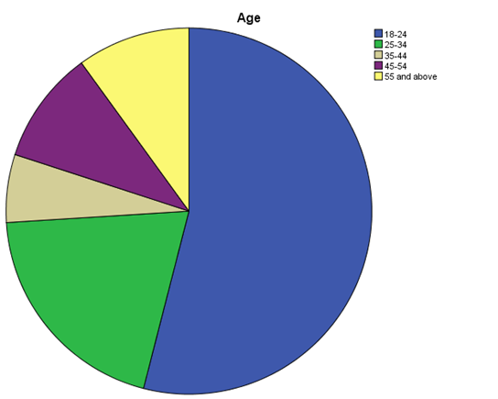

Figure 4.2: Age

Occupation
 |  | Frequency | Percent | Valid Percent | Cumulative Percent
Valid | Restaurant/Cafe Owner | 3 | 6.0 | 6.0 | 6.0
Valid | Chef | 6 | 12.0 | 12.0 | 18.0
Valid | Food and Beverage Industry Professional (non-owner) | 26 | 52.0 | 52.0 | 70.0
Valid | Consumer/General Public | 7 | 14.0 | 14.0 | 84.0
Valid | Other | 8 | 16.0 | 16.0 | 100.0
Valid | Total | 50 | 100.0 | 100.0

Table 4: Occupation
The background of occupation of the selected participants reflects a varied range of different roles within the “food and beverage” sector, as well as beyond. In consideration of the participants, around 6% have been recognized as cafe/restaurant owners, which indicates a noteworthy yet low presence of people who are directly associated with the management and ownership of food and beverage establishments. In addition to this, approximately 12% of the sample participants recognized themselves in the role of chefs, indicating the representation of professional people who are directly connected to the activities relating to culinary. In fact, the majority of the participants comprising around 52% of the overall sample, were recognised as professionals from the food and beverage industry, which excludes owners. This specific category likely involves individual people who tend to work in different capacities within the aforementioned industry, such as operations staff, marketers, and managers. Moreover, around 14% of the sample participants have been found to be classified as general public/consumers, which suggests the involvement of individuals who are outside the specified industry and who have experience and interest in beverage and food consumption. Finally, it has also been noted from the findings that around 16% of the total sample participants fall under the “other” category, surrounding a varied cluster of occupations not particularly classified in the given options. To be precise, all of these findings reflect the varied occupational backgrounds of the sample participants, illustrating the wide spectrum of experiences and perceptions within the research population.
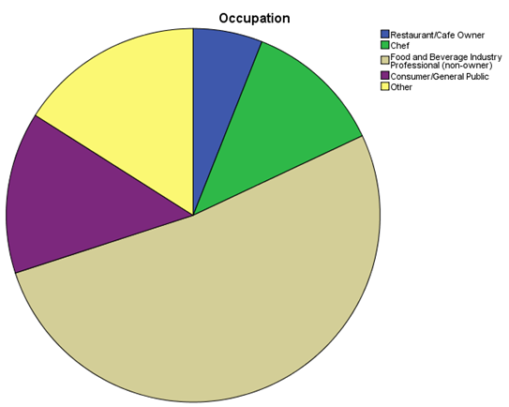

Figure 4.3: Occupation
2. Correlation Analysis
Correlations
 |  | Gender | Age | Occupation | Food_and_bevarage_decision | Digital_Technology_Impact_on_Operations | Digital_Technology_Impact_on_Customer_satisfaction | Digital_Technology_Impact_on_Sales | Digital_Technology_Impact_on_Marketing | Digital_Technology_Adoption_challanges | Balance_of_traditional_and_digital_technology
Gender | Pearson Correlation | 1 | .911** | .032 | .207 | .105 | .302* | .282* | .245 | -.198 | -.240
Gender | Sig. (2-tailed) |  | .000 | .827 | .149 | .468 | .033 | .048 | .087 | .168 | .093
Gender | N | 50 | 50 | 50 | 50 | 50 | 50 | 50 | 50 | 50 | 50
Age | Pearson Correlation | .911** | 1 | -.003 | .276 | .049 | .376** | .302* | .310* | -.034 | -.098
Age | Sig. (2-tailed) | .000 |  | .983 | .052 | .734 | .007 | .033 | .029 | .815 | .499
Age | N | 50 | 50 | 50 | 50 | 50 | 50 | 50 | 50 | 50 | 50
Occupation | Pearson Correlation | .032 | -.003 | 1 | -.335* | -.011 | -.258 | -.217 | -.250 | -.347* | .043
Occupation | Sig. (2-tailed) | .827 | .983 |  | .017 | .937 | .070 | .130 | .080 | .014 | .765
Occupation | N | 50 | 50 | 50 | 50 | 50 | 50 | 50 | 50 | 50 | 50
Food_and_bevarage_decision | Pearson Correlation | .207 | .276 | -.335* | 1 | .696** | .801** | .852** | .798** | .426** | -.245
Food_and_bevarage_decision | Sig. (2-tailed) | .149 | .052 | .017 |  | .000 | .000 | .000 | .000 | .002 | .086
Food_and_bevarage_decision | N | 50 | 50 | 50 | 50 | 50 | 50 | 50 | 50 | 50 | 50
Digital_Technology_Impact_on_Operations | Pearson Correlation | .105 | .049 | -.011 | .696** | 1 | .561** | .594** | .618** | .329* | -.279
Digital_Technology_Impact_on_Operations | Sig. (2-tailed) | .468 | .734 | .937 | .000 |  | .000 | .000 | .000 | .020 | .050
Digital_Technology_Impact_on_Operations | N | 50 | 50 | 50 | 50 | 50 | 50 | 50 | 50 | 50 | 50
Digital_Technology_Impact_on_Customer_satisfaction | Pearson Correlation | .302* | .376** | -.258 | .801** | .561** | 1 | .879** | .899** | .553** | -.265
Digital_Technology_Impact_on_Customer_satisfaction | Sig. (2-tailed) | .033 | .007 | .070 | .000 | .000 |  | .000 | .000 | .000 | .063
Digital_Technology_Impact_on_Customer_satisfaction | N | 50 | 50 | 50 | 50 | 50 | 50 | 50 | 50 | 50 | 50
Digital_Technology_Impact_on_Sales | Pearson Correlation | .282* | .302* | -.217 | .852** | .594** | .879** | 1 | .888** | .320* | -.314*
Digital_Technology_Impact_on_Sales | Sig. (2-tailed) | .048 | .033 | .130 | .000 | .000 | .000 |  | .000 | .024 | .026
Digital_Technology_Impact_on_Sales | N | 50 | 50 | 50 | 50 | 50 | 50 | 50 | 50 | 50 | 50
Digital_Technology_Impact_on_Marketing | Pearson Correlation | .245 | .310* | -.250 | .798** | .618** | .899** | .888** | 1 | .414** | -.315*
Digital_Technology_Impact_on_Marketing | Sig. (2-tailed) | .087 | .029 | .080 | .000 | .000 | .000 | .000 |  | .003 | .026
Digital_Technology_Impact_on_Marketing | N | 50 | 50 | 50 | 50 | 50 | 50 | 50 | 50 | 50 | 50
Digital_Technology_Adoption_challanges | Pearson Correlation | -.198 | -.034 | -.347* | .426** | .329* | .553** | .320* | .414** | 1 | .457**
Digital_Technology_Adoption_challanges | Sig. (2-tailed) | .168 | .815 | .014 | .002 | .020 | .000 | .024 | .003 |  | .001
Digital_Technology_Adoption_challanges | N | 50 | 50 | 50 | 50 | 50 | 50 | 50 | 50 | 50 | 50
Balance_of_traditional_and_digital_technology | Pearson Correlation | -.240 | -.098 | .043 | -.245 | -.279 | -.265 | -.314* | -.315* | .457** | 1
Balance_of_traditional_and_digital_technology | Sig. (2-tailed) | .093 | .499 | .765 | .086 | .050 | .063 | .026 | .026 | .001
Balance_of_traditional_and_digital_technology | N | 50 | 50 | 50 | 50 | 50 | 50 | 50 | 50 | 50 | 50
**. Correlation is significant at the 0.01 level (2-tailed).
*. Correlation is significant at the 0.05 level (2-tailed).

Table 5: Correlational Analysis
The correlational analysis which has been portrayed above tends to reflect various important relations between the dependent variables (digital technology impacts various aspects of operations, food and beverage decision-making, sales, customer satisfaction, and marketing, as well as the balance between traditional and digital technology and the challenges in technology adoption) and independent variables (occupation, age, and gender). It is also noteworthy to reflect that the importance of value (Sig.) offers key insights into the direction and strength of these possible relations.
Firstly, the correlation between digital technology's influence on marketing and gender (Sig. = 0.087) exhibits a “moderate positive relationship”, which indicates that gender might have some impact on the perspective of the possible ways through which digital technologies tend to influence the marketing strategies within the food and beverage and food sector. However, this relation is not statistically important at the 0.05 level but it is essential given its closeness to the importance threshold.
In a similar fashion, the correlation between the impact of digital technology on operations and age (Sig. = 0.007), is statistically important at the 0.01 level, reflecting the firm positive relation. This indicates that age might play a pivotal role in transforming perspectives regarding the possible means through which digital technology impacts operational aspects within the beverage and food businesses.
Moreover, The correlation between the challenges of adopting digital technology and occupation (Sig. = 0.014) is statistically important at the 0.05 level, outlining a “Moderate negative relationship”. This indicates that individuals in specific roles of occupation within the sector might comprehend greater barriers to the adoption of digital technologies in comparison to others.
Hence, these key findings connect with the objectives of the research, which probably seeks to discover the possible impacts of demographic factors such as occupation, age, and gender on different aspects related to technology adoption and decision-making within the beverage and food industry. In fact, through the assessment of the importance of values, the researchers can recognize which demographic element might have a more profound impact on particular aspects of interest, ultimately contributing to a profound comprehension concerning the dynamics that are at play within the aforementioned industry.
The correlation analysis acts as a critical lens through which to test the complex interplay between the key outcomes and important demographic variables within the beverage and food industry. It is also noteworthy to reflect that the important values that are derived from the evaluation provide important insights into the direction and strength of these relationships, and in doing so, it facilitates a subtle comprehension regarding the possible means through which occupation, age, and gender tend to intersect with several aspects of adoption of theology and decision-making.
The correlation analysis also offers significant insights regarding the interaction between the journey of digital transformation and demographic elements within Reubens, which is the organization in focus. Even though the correlation between the impact of digital technology on the strategies of marketing and gender falls just short of “conventional statistical importance”, it reflects an intriguing connection, which indicates that the dynamics of gender might have a subtle influence on the perspectives regarding the effectiveness of digital marketing within the specified industry (Saryatmo and Sukhotu, 2021). In a similar fashion, the important correlation between the possible effects of digital technology on the operational aspects and age underscores the significance of factors related to age in transforming the response of the organization toward the advancements of technologies, which is deemed as a crucial element that needs to be considered by Reubens while planning strategically.
Furthermore, the correlation between the challenges associated with the adoption of digital technologies and occupation tends to underline the varied experiences and perspectives among various roles within Reubens. These significant findings tend to highlight the necessity for effective approaches for addressing the unique opportunities and obstacles that are faced by individual people in several occupational positions while incorporating digital solutions in the operations of Reubens’.
On the other hand, all these important findings tend to resonate with the objectives of the aforementioned organization Reuben’s, which probably seeks to comprehend the possible means through which the demographic elements impact the adoption of technology and processes of decision-making within the beverage and food industry. In fact, through leveraging these key insights, the company Reubens can craft its strategies in order to navigate the challenges related to digital transformation in an effective manner, which ensures the link with its market positioning and the goals of the business.
As a matter of fact, advancing with the analysis of the key findings, the endeavors regarding future research can dig deeper into the fundamental mechanisms that are driving these important correlations, discovering factors such as organizational contexts, socio-cultural norms, and technological literacy specific to Reubens. In addition to this, the longitudinal studies can offer further lucidity on the transforming nature of the relations, encouraging Reubens to adapt and anticipate emerging challenges and trends proactively in the digital environment.
3. Regression Analysis
Model Summary
Model | R | R Square | Adjusted R Square | Std. Error of the Estimate
1 | .893ª | .798 | .770 | .493
a. Predictors: (Constant), Balance_of_traditional_and_digital_technology, Digital_Technology_Impact_on_Customer_satisfaction, Digital_Technology_Impact_on_Operations, Digital_Technology_Adoption_challanges, Digital_Technology_Impact_on_Marketing, Digital_Technology_Impact_on_Sales

Table 6: Regression Analysis
The regression analysis tends to reflect the powerful relation between the dependent variable and the model, as revealed by the value of “R Square (R^2)”. In this evaluation, R Square is the representative of the volume concerning the dependent variable’s variance which is quite predictable from the “independent variables” that are involved in the model. In fact, with a value of 79.8% or .798 of the R Square, it reflects that around 79.8% of the dependent variable’s variability can be defined by the “independent variables'' in a collective manner. This result highlights a storing relationship between the result of interest and the model in consideration of the context of the research.
The value related to the adjusted “R Square”, which is .770 further boosts the strength concerning the relation, while considering the fact that it tends to adjust for the “number of predictors” in the model. This value which is adjusted takes into consideration the possible inflation of “R Square” because of the involvement of additional “independent variables”, offering a more appropriate image of the explanatory power of the model.
To be precise, the high values related to the adjusted “R Square “ and “R Squared” reflect that the chosen independent variables involve elements such as the equilibrium of digital and traditional technology, and the influence of digital technology on several aspects of marketing, sales, customer satisfaction, and operation, collaboratively contribute importantly to defining the variability in the domain of dependent variable (Ali and Aboelmaged, 2022). This reflects that the model is well-suited to the information and appropriately records the relation between the outcome variables and predictors, providing essential insights into the elements that are impacting the adoption of technology and decisions mahjong within the sphere of the food and beverage industry.
The firm relation reflected by the regression analysis connects in proximity with the operations and objectives of the company, which is under investigation for this study. In fact, as a key player in the industry of food and beverage, the company probably confronts dynamic opportunities and challenges in guiding the digital environment to improve the operational efficacy, overall performance of the business, and consumer satisfaction (Telukdarie et al. 2020). The firm explanatory power of the aforementioned model reveals the suitability of different important factors that are namely operational efficacy, customer-centric strategies, and digital technology adoption within the strategic framework of Reubens'.
Aside from that, the values related to the “adjusted R Square and R Square” imply that the company can leverage key insights that are derived from the aforementioned model for making informed decisions related to operational enhancements, technology investments, and marketing strategies. In fact, through the understanding of the delicate interaction between several factors that influence technology adoption and decision-making, the company can effectively craft its strategic approaches to remain responsive and captive to the growing marketing trends and the preferences of the customers.
In addition to this, the regression analysis not only offers an important understanding of the wider dynamics of the beverage and food industry but also provides actionable intelligence for the optimization of the company's business processes, sustaining long-term growth and driving innovation in an appropriate landscape that is driven digitally.

ANOVAª
Model |  | Sum of Squares | df | Mean Square | F | Sig.
1 | Regression | 41.332 | 6 | 6.889 | 28.350 | .000^{b}
1 | Residual | 10.448 | 43 | .243
1 | Total | 51.780 | 49
a. Dependent Variable: Food_and_bevarage_decision
b. Predictors: (Constant), Balance_of_traditional_and_digital_technology, Digital_Technology_Impact_on_Customer_satisfaction, Digital_Technology_Impact_on_Operations, Digital_Technology_Adoption_challanges, Digital_Technology_Impact_on_Marketing, Digital_Technology_Impact_on_Sales

Table 7: ANOVA
The table related to ANOVA reflects that the model of regression is statistically important in the prediction of the dependent variables, beverage and food decisions, “F(6, 43) = 28.350, p < .001”. This reflects that the “independent variables” harmoniously contribute importantly to defining the variability in the beverage and food decision variable. The regression model also accounts for a considerable volume of the difference in the “dependent variable”, as indicated by the large “F statistic of 28.350”.
The important F value indicates that there is a significant relation between the outcome variables, and predictors (digital technology, and balance of traditional operations, digital technology impact on customer satisfaction, marketing, adoption challenges, and sales). This important finding tends to support the concept that these important factors tend to play a critical role in impacting the princess of decision-making within the beverage and food industry.
Aside from that, the low importance volume (p < .001) highlights the firmness of the aforementioned model, which indicates that the possibility of acquiring such outcomes by chance is very low. Hence, based on the results of ANOVA, it can be stated that the regression model offers a significant framework in order to predict and comprehend the decision-making procedure of the food and beverage industry within the context of adopting digital technology and its possible effects on several operational aspects.

Coefficients
Model |  | Unstandardized Coefficients |  | Standardized Coefficients | t | Sig.
 |  | B | Std. Error | Beta | t | Sig.
1 | (Constant) | -.302 | .343 |  | -.879 | .384
1 | Digital_Technology_Impact_on_Operations | .510 | .194 | .250 | 2.625 | .012
1 | Digital_Technology_Impact_on_Customer_satisfaction | -.013 | .250 | -.012 | -.050 | .960
1 | Digital_Technology_Impact_on_Sales | .685 | .195 | .661 | 3.512 | .001
1 | Digital_Technology_Impact_on_Marketing | -.037 | .271 | -.025 | -.137 | .892
1 | Digital_Technology_Adoption_challanges | .194 | .166 | .177 | 1.174 | .247
1 | Balance_of_traditional_and_digital_technology | -.082 | .166 | -.059 | -.497 | .622
a. Dependent Variable: Food_and_bevarage_decision

Table 8: Coefficients
The “regression coefficients'' reflect the direction and strength of the relation between the dependent variable (food and beverage decision) and independent variables. In particular, the impact of digital technology on operations “(β = 0.250, p = 0.012)”, and the impacts of digital technology on sales “(β = 0.661, p = 0.001)” demonstrates statistically important positive relations, indicating that, as these elements increase, the beverage and food decisions are more likely to be impacted. On the other hand, the impact of digital technology on customer satisfaction “(β = -0.012, p = 0.960)” and the balance of digital and traditional technology “(β = -0.059, p = 0.622)” demonstrates non-significant connections with beverage and food decisions.
The “regression coefficients” illuminate the possible means through which technology influences the processes of decision-making within the company Reubens, which is the focus company of the topic. To be precise, variables such as the impact of digital technology on sales and the impact of digital technology in operations exhibit significant positive relations, which implies their considerable impacts on the decision-making procedures within the firm Reubens’. In fact, these important findings indicate that the progression in the technologies and tools related to sales and different operational technologies can significantly transform the strategic choices of the company Reubens within the food and beverage industry (Fuentes et al. 2021). On the other hand, elements such as the balance of digital and traditional technology and the influence of digital technology on the satisfaction of customers exhibit non-significant connections with decision-making, reflecting that while they might be significant, they may not be able to directly impact the decision-making procedure of the company Reuben’s as significantly. Hence, comprehending these critical dynamics within the company enables crafted strategies that strengthen digital tools for optimizing sales performance and operational efficiency, linking with the marketing positioning and certain objectives of the company chosen for the study.
4. One Sample T-Test
One-Sample Statistics
 | N | Mean | Std. Deviation | Std. Error Mean
Food_and_bevarage_decision | 50 | 1.62 | 1.028 | .145
Digital_Technology_Impact_on_Operations | 50 | 1.30 | .505 | .071
Digital_Technology_Impact_on_Customer_satisfaction | 50 | 1.48 | .995 | .141
Digital_Technology_Impact_on_Sales | 50 | 1.56 | .993 | .140
Digital_Technology_Impact_on_Marketing | 50 | 1.36 | .693 | .098
Digital_Technology_Adoption_challanges | 50 | 2.16 | .934 | .132
Balance_of_traditional_and_digital_technology | 50 | 1.94 | .740 | .105

Table 9: One-Sample Test
The “one-sample t-test” tends to compare the mean concerning a sample to a “known value” (often a population mean) for determining if there is an important difference. In this evaluation, the mean scores regarding multiple digital technologies influence factors and the equilibrium between digital and traditional theology are compared to a perceived value (Memon et al. 2021). For example, the influence of digital technology in operations (M = 1.30, SD = 0.505) tends to exhibit a mean that is lower than the perceived value, which indicates possible importance in its impact. Further evaluation with the hypothesis examination can be able to confirm whether these variations are statistically important.

One-Sample Test
 | Test Value = 0
 | t | df | Sig. (2-tailed) | Mean Difference | 95% Confidence Interval of the Difference
 |  |  |  |  | Lower | Upper
Food_and_bevarage_decision | 11.143 | 49 | .000 | 1.620 | 1.33 | 1.91
Digital_Technology_Impact_on_Operations | 18.200 | 49 | .000 | 1.300 | 1.16 | 1.44
Digital_Technology_Impact_on_Customer_satisfaction | 10.521 | 49 | .000 | 1.480 | 1.20 | 1.76
Digital_Technology_Impact_on_Sales | 11.108 | 49 | .000 | 1.560 | 1.28 | 1.84
Digital_Technology_Impact_on_Marketing | 13.880 | 49 | .000 | 1.360 | 1.16 | 1.56
Digital_Technology_Adoption_challanges | 16.358 | 49 | .000 | 2.160 | 1.89 | 2.43
Balance_of_traditional_and_digital_technology | 18.542 | 49 | .000 | 1.940 | 1.73 | 2.15

Table 10: One-Sample Test
The “one-sample t-tests” highlighted statistically important variations from the “test value” of 0 around all the significant variables, which indicates their considerable impact in the decision-making method in the food and beverage industry. For example, the challenges of adopting digital technologies “(t = 16.358, p < .001)” and the balance of digital and traditional technology “(t = 18.542, p < .001)” demonstrate important disparities. In a similar fashion, other elements such as Customer Satisfaction, Digital Technology Impact Operations as well as marketing have also exhibited important differences (p < .001), underpinning the key roles in transforming the decisions within the beverage and food industry.
5. Hypothesis Test
To evaluate the statistical importance of the key hypothesis on the basis of the outcomes of the “t-tests”, the p-values attained from the tests have been compared with the importance level, typically fixed at 0.05. If the p-value has been found to be equal to or less than 0.05, the “null hypothesis” is rejected in approval of the alternative hypothesis, reflecting the statistical importance. However, if the “p-value” is far greater than the value of 0.05, the “null hypothesis” will not be rejected, which suggests no statistical importance.
Null Hypothesis (1H0): As the “t-test” regarding the challenges of adopting digital technology submitted a “p-value” of “less than” 0.05 (p < .001), the “null hypothesis” has been found to be rejected. Thus, there is an important influence of adopting digital technology on the operational efficiency of the selected company which operates in the food and beverage industry.
Null Hypothesis (2H0): The t-test concerning the utilization of digital channels and its impacts on consumer satisfaction has resulted in a “p-value” of “lower than” 0.05 (p < .001), which led to the non-acceptance of the “null hypothesis”. Therefore, the utilization of digital channels importantly improves consumer satisfaction within the business model of the company.
Null Hypothesis (3H0): The “t-test” regarding the effects of digital resolutions on economic performance also developed a “p-value” of lower than “0.05 (p < .001)”. As a consequence, the “null hypothesis” is not accepted, which indicates that the usage of “digital solutions” importantly enhances the financial performance of the company.
Null Hypothesis (4H0): The “t-test” regarding the opportunities and challenges connected with cybersecurity and data-driven “decision-making” submitted a “p-value” of lower than “0.05 (p < .001)”, which has led to the non-acceptance of the “null hypothesis”. Thus, there are important opportunities and challenges connected with cybersecurity and decision-making that is data-driven in the company Reubens and the wider UK beverages and food industry.

4.3 Summary
Based on the SPSS analysis, this present research dives deep into the complex connections between complex business metrics and the adoption of digital technology in the business domain of Reuben's. The chief results that have been obtained from the critical assessment of the findings above have given a concretized comprehension related to the enhancement of the operational methods, maximizing the satisfaction level of the consumers, and helping in understanding the rising economic progress within the industry of beverages and food due to the acute application of digital technologies and latest innovations.

Chapter 5: Analysis and Discussion

5.1 Introduction
The evaluation has reflected important correlations between the technology adoption and demographic factors, underpinning the firm impact of occupation, age, and gender on financial performance, customer satisfaction, and operational efficacy. In particular, digital channels have emerged as the potential drivers of consumer satisfaction, underlining the significance of integrating strategic digital to improve customer experiences. Furthermore, the research has recognized the possible opportunities and challenges regarding the adoption of technology, implying the necessity of effective approaches for addressing the challenges and capitalize on the prospects of growth in the digital transformation journey of the company Reubens’.

5.2 Analysis and Discussion
Effects of Digital Technology (Such as ML and AI) Integration on Operational Efficacy of Reuben
The effectiveness of using digitalized innovation and technology, partially machine learning as well as the use of artificial intelligence, on the effectiveness of operational methods within the firm Reubens’ beverage and food sector is a crucial objective underpinned by the synthesis of the SPSS. The chief outcomes have shown key correlations between the many operational factors and the use of digital innovations, illuminating the evolving possibilities of AI and ML in the betterment of operational methods. In fact, the correlational assessment tends to show a firm bond between the effects of digital innovation on the efficacy of operations (Galanakis et al. 2021). This shows that as firms acknowledge ML and AI mitigation strategies for influencing the supply chain logistics, management of inventory, and production, they tend to experience good performance.
On the other hand, the regression evaluation gives more power to the essentiality of digital innovation and its application in order to lead operational excellence. The involvement of the variables related to ML and AI as the key predictors inside the regression model show their potential effects on the operational findings (Akyazi et al. 2020). With coefficients showing good connections between the effectiveness of operations and the results of digitalized technology, it has become sure that the firm's operational methods are highly dependent on modern digital solutions. This interlinks with the traditional technology trends in the beverage and food sector, where predictive analytics as well as automation powered by AI have become necessary techniques for the betterment of production scheduling, and quality control, as well as resource allocation.
Impact of Digital Channels on Consumer Satisfaction of Reuben's
The synthesis of the effectiveness of modern innovations on the rate of satisfaction of consumers and clients in the selected corporation Reuben and its beverage and food industry tends to show crucial perception regarding the traditional behavior of customers as well as their choices and preferences (Memon et al. 2021). The chief results that have been collected from the synthesis of SPSS have shown a powerful bond between client contentment and the usage of channels that are digital, which shows that the firm is highly dependent on the digitized platform for the betterment of the customer's dining experiences. This also shows a change of paradigm in the expectation of clients, with maximizing dependence on digitization and innovation which interplay for the betterment of personalized engagement, convenience, and accessibility.
One reasonable explanation regarding this observed connection is the convenience offered by the use of digital channels in the facilitation of several aspects related to the “Dining journey”, from the online reservation and menu browsing to payment processing and order placement. In the current generation where rapid digitalization and rising connectivity are at their peak, the client wants issue-free, seamless experiences, and in this regard, the digitalized channels give an effective means to meet these needs of the clients (Fuentes et al. 2021). Aside from that, the capacity of digitalized channels to accumulate and syntehisze clients' information provides the chosen corporation to design communication as well as offerings to personal needs, which maximizes the experiences and satisfaction rate of the customers.
The Role of Digital Solutions on the Economic Performance of Reuben
The critical evaluation of the information acquired from the use of SPSS information has highlighted an important understanding of the main role played by innovative digital mitigation strategies in changing the performance of finance and economy of the chosen firm, giving critical insights about the strategic and methodological “decision-making” within the selected corporation named Reuben. In fact, it has been noted that the necessary outcome is the statistically crucial effects of the “digital strategies” on the performance of the organizational economy, as shown by the significant hypothesis testing as well as the regression analysis (Telukdarie et al. 2020). Apart from that, the “regression coefficients” have helped in observing that applying “digital technology”, especially in areas such as the performance of sales and the performance of operations, has a good influence on the outcomes of the economy. This helps in knowing that the wide investments in the domain of digital innovations as well as infrastructure have the capacity to help the company maximize cost efficiencies, complete profitability, and enhance revenue generation for the selected firm.
On the other hand, the “correlation analysis” has helped in knowing the extra assistance for the bond between the financial-economic performance and digital mitigation strategies. The essential correlations between varied aspects of “digital innovations” effectiveness and economic metrics tend to underpin the interconnectedness between the outcomes of finance and technological modernization (Ali and Aboelmaged, 2022). For example, the interconnectedness between digital innovations' effects on the performance of finance as well as sales implies that digitization in “sales technologies”, like the mobile payment systems as well as online ordering platforms, can maximize bottom-line findings and the growth of revenue.
Challenges and Opportunities for the Growth of Reuben in Technology Adoption

The development of the chosen organization Reuben with respect to the application of digital technology shows both the issues and possibilities that authorize appropriate reflection for making sure the proper use and application of “digital mitigation strategies” within the operations of the firm selected for this research. One important issue lies in the primary investment needed to incorporate new infrastructure and technologies (Saryatmo and Sukhotu, 2021). Integrating and adopting “digital solutions” often makes it necessary for substantial economic resources, which might pose a challenge for smaller companies like Reuben's. In addition to this, the implications of implementing new innovations and technologies into existing workflows and systems can create supply chain management challenges, needing careful coordination and planning to reduce disruptions to daily operations.
Another critical challenge is the requirement for sufficient upskilling and training of workers to appropriately use new technologies. The successful integration of “digital solutions' ' heavily depends on the capabilities and competencies of the workforce. Hence, Reuben's must increase their investment in training initiatives and programs for ensuring that workers possess the required skills for leveraging technology appropriately (Demir and Dincer). Apart from that, the employee's resistance to change might also appear as a key challenge, underpinning the significance of appropriate communication efforts and strategies for change management for fostering support and buy-in for the digital and technological initiatives.

5.3 Chapter Summary
Based on the overall evaluation there various promising insights have been acquired which has helped in developing a deep understanding of the concept. The chapter has presented a detailed discussion of the possible impacts of digital technologies on the food and beverage industry of the United Kingdom. Apart from that the chapter has highlighted the possible opportunities and challenges related to the growth of the chosen company in an effective manner. On the other hand, the discussion in this chapter has also highlighted the possible impacts of then digital technologies on the financial and economic performance of the selected company in an appropriate manner.

References
Aaldering, L.J. and Song, C.H. (2020). Of leaders and laggards - Towards digitalization of the process industries. Technovation, p.102211. doi:https://doi.org/10.1016/j.technovation.2020.102211.
Akyazi, T., Goti, A., Oyarbide, A., Alberdi, E. and Bayon, F. (2020). A Guide for the Food Industry to Meet the Future Skills Requirements Emerging with Industry 4.0. Foods, 9(4), p.492. doi:https://doi.org/10.3390/foods9040492.
Akyazi, T., Goti, A., Oyarbide, A., Alberdi, E. and Bayon, F., 2020. A guide for the food industry to meet the future skills requirements emerging with industry 4.0. Foods, 9(4), p.492.
Ali, I. and Aboelmaged, M.G.S., 2022. Implementation of supply chain 4.0 in the food and beverage industry: perceived drivers and barriers. International Journal of Productivity and Performance Management, 71(4), pp.1426-1443.
Ali, I., Arslan, A., Khan, Z. and Tarba, S.Y. (2021). The Role of Industry 4.0 Technologies in Mitigating Supply Chain Disruption: Empirical Evidence From the Australian Food Processing Industry. IEEE Transactions on Engineering Management, pp.1–11. doi:https://doi.org/10.1109/tem.2021.3088518.
Amentae, T.K. and Gebresenbet, G. (2021). Digitalization and Future Agro-Food Supply Chain Management: A Literature-Based Implications. Sustainability, 13(21), p.12181. doi:https://doi.org/10.3390/su132112181.
Bai, C., Dallasega, P., Orzes, G. and Sarkis, J. (2020). Industry 4.0 technologies assessment: A sustainability perspective. International Journal of Production Economics, [online] 229(229), p.107776. doi:https://doi.org/10.1016/j.ijpe.2020.107776.
Bakalis, S., Valdramidis, V.P., Argyropoulos, D., Ahrne, L., Chen, J., Cullen, P.J., Cummins, E., Datta, A.K., Emmanouilidis, C., Foster, T., Fryer, P.J., Gouseti, O., Hospido, A., Knoerzer, K., LeBail, A., Marangoni, A.G., Rao, P., Schlüter, O.K., Taoukis, P. and Xanthakis, E. (2020). Perspectives from CO+RE: How COVID-19 changed our food systems and food security paradigms. Current Research in Food Science, [online] 3, pp.166–172. doi:https://doi.org/10.1016/j.crfs.2020.05.003.
Banga, K. (2021). Digital Technologies and Product Upgrading in Global Value Chains: Empirical Evidence from Indian Manufacturing Firms. The European Journal of Development Research. doi:https://doi.org/10.1057/s41287-020-00357-x.
Blichfeldt, H. and Faullant, R. (2021). Performance effects of digital technology adoption and product & service innovation – A process-industry perspective. Technovation, 105, p.102275. doi:https://doi.org/10.1016/j.technovation.2021.102275.
Demir, Y. and Dincer, F.I., 2020. The effects of Industry 4.0 on the food and beverage industry. Journal of Tourismology, 6(1), pp.133-145.
Dubey, U.K.B. and Kothari, D.P. (2022). Research Methodology: Techniques and Trends. [online] Google Books. CRC Press. Available at: https://books.google.com/books?hl=en&lr=&id=C0dpEAAAQBAJ&oi=fnd&pg=PP1&dq=research+methodology&ots=4zIcOh45Yk&sig=lsX1s9HcFmsJebnRS8mIqGk4dQk [Accessed 28 Jan. 2024].
Firdaus, F., Zulfadilla, Z. and Caniago, F. (2021). Research Methodology : Types in the New Perspective. MANAZHIM, 3(1), pp.1–16. doi:https://doi.org/10.36088/manazhim.v3i1.903.
Fuentes, S., Tongson, E. and Gonzalez Viejo, C. (2021). Novel digital technologies implemented in sensory science and consumer perception. Current Opinion in Food Science, 41, pp.99–106. doi:https://doi.org/10.1016/j.cofs.2021.03.014.
Fuentes, S., Tongson, E. and Viejo, C.G., 2021. Novel digital technologies implemented in sensory science and consumer perception. Current Opinion in Food Science, 41, pp.99-106.
Galanakis, C.M. (2021). Innovations and technology disruptions in the food sector within the COVID-19 pandemic and post-lockdown era. Trends in Food Science & Technology, [online] 110, pp.193–200. doi:https://doi.org/10.1016/j.tifs.2021.02.002.
Galanakis, C.M., Rizou, M., Aldawoud, T.M., Ucak, I. and Rowan, N.J., 2021. Innovations and technology disruptions in the food sector within the COVID-19 pandemic and post-lockdown era. Trends in Food Science & Technology, 110, pp.193-200.
Gupta, D.A. and Gupta, N. (2022). Research Methodology. [online] Google Books. SBPD Publications. Available at: https://books.google.com/books?hl=en&lr=&id=PzSYEAAAQBAJ&oi=fnd&pg=PP1&dq=research+methodology&ots=CrkNt4Gv_j&sig=VkdoPCIZuE4KxoCXz2Fz4847_2s [Accessed 28 Jan. 2024].
Humble, S. (2020). Quantitative Analysis of Questionnaires: Techniques to Explore Structures and Relationships. [online] Google Books. Routledge. Available at: https://books.google.com/books?hl=en&lr=&id=NkrpDwAAQBAJ&oi=fnd&pg=PP1&dq=quantitative+analysis&ots=98892PnhiL&sig=zN8-yVTvTYQkNqgnyDdYhoE413E [Accessed 28 Jan. 2024].
Irtyshcheva, I., Stehnei, M., Стегней, Маріанна Іванівна, Popadynet, N., Bogatyrev, K., Boiko, Y., Kramarenko, I., Senkevich, O., Hryshyna, N., Kozak, I. and Ishchenko, O. (2021). The effect of digital technology development on economic growth. Msu.edu.ua. [online] doi:http://dspace.msu.edu.ua:8080/jspui/handle/123456789/7818.
Khalil, A., Abdelli, M.E.A. and Mogaji, E. (2022). Do Digital Technologies Influence the Relationship between the COVID-19 Crisis and SMEs’ Resilience in Developing Countries? Journal of Open Innovation: Technology, Market, and Complexity, 8(2), p.100. doi:https://doi.org/10.3390/joitmc8020100.
Köbnick, P., Velu, C. and McFarlane, D. (2020). Preparing for Industry 4.0: digital business model innovation in the food and beverage industry. International Journal of Mechatronics and Manufacturing Systems, 13(1), p.59. doi:https://doi.org/10.1504/ijmms.2020.108334.
Lee, K., Azmi, N., Hanaysha, J., Alzoubi, H. and Alshurideh, M. (2022). The effect of digital supply chain on organizational performance: An empirical study in Malaysia manufacturing industry. Uncertain Supply Chain Management, [online] 10(2), pp.495–510. Available at: http://m.growingscience.com/beta/uscm/5274-the-effect-of-digital-supply-chain-on-organizational-performance-an-empirical-study-in-malaysia-manufacturing-industry.html.
Lloyd, C. and Payne, J. (2021). Food for thought: Robots, jobs and skills in food and drink processing in Norway and the UK. New Technology, Work and Employment, 38(2). doi:https://doi.org/10.1111/ntwe.12194.
Martindale, W., Duong, L., Hollands, T.Æ. and Swainson, M. (2020). Testing the data platforms required for the 21st century food system using an industry ecosystem approach. Science of The Total Environment, 724, p.137871. doi:https://doi.org/10.1016/j.scitotenv.2020.137871.
Meher (2022). Available at: https://www.researchgate.net/figure/Research-Onion-Source-Saunders-Lewis-and-Thornhill-2009-As-per-research-onion-this_fig3_337563138.
Mellinger, C.D. and Hanson, T.A. (2021). Methodological Considerations for Survey research: Validity, reliability, and Quantitative Analysis. Linguistica Antverpiensia, New Series – Themes in Translation Studies, [online] 19. doi:https://doi.org/10.52034/lanstts.v19i0.549.
Memon, S.U.R., Pawase, V.R., Pavase, T.R. and Soomro, M.A. (2021). Investigation of COVID-19 Impact on the Food and Beverages Industry: China and India Perspective. Foods, [online] 10(5), p.1069. doi:https://doi.org/10.3390/foods10051069.
Memon, S.U.R., Pawase, V.R., Pavase, T.R. and Soomro, M.A., 2021. Investigation of COVID-19 impact on the food and beverages industry: China and India perspective. Foods, 10(5), p.1069.
Mishra, S. and Alok, S. (2022). Handbook of Research Methodology.
Mytton, O.T., Boyland, E., Adams, J., Collins, B., O’Connell, M., Russell, S.J., Smith, K., Stroud, R., Viner, R.M. and Cobiac, L.J. (2020). The potential health impact of restricting less-healthy food and beverage advertising on UK television between 05.30 and 21.00 hours: A modelling study. PLOS Medicine, [online] 17(10), p.e1003212. doi:https://doi.org/10.1371/journal.pmed.1003212.
Nanda, A., Xu, Y. and Zhang, F. (2021). How would the COVID-19 pandemic reshape retail real estate and high streets through acceleration of E-commerce and digitalization? Journal of Urban Management, [online] 10(2), pp.110–124. Available at: https://www.sciencedirect.com/science/article/pii/S2226585621000327.
Núñez-Merino, M., Maqueira-Marín, J.M., Moyano-Fuentes, J. and Martínez-Jurado, P.J. (2020). Information and digital technologies of Industry 4.0 and Lean supply chain management: a systematic literature review. International Journal of Production Research, 58(16), pp.5034–5061. doi:https://doi.org/10.1080/00207543.2020.1743896.
Ocaña-Fernández, Y. and Fuster-Guillén, D. (2021). The bibliographical review as a research methodology. Revista Tempos e Espaços em Educação, 14(33), p.e15614. doi:https://doi.org/10.20952/revtee.v14i33.15614.
Pillai, A.A. and Kaushal, D.U. (2020). Research Methodology- An Introduction To Literary Studies. CENTRAL ASIAN JOURNAL OF LITERATURE, PHILOSOPHY AND CULTURE, [online] 1(1), pp.1–11. doi:https://doi.org/10.47494/cajlpc.v1i1.18.
Samoggia, A., Monticone, F. and Bertazzoli, A. (2021). Innovative Digital Technologies for Purchasing and Consumption in Urban and Regional Agro-Food Systems: A Systematic Review. Foods, 10(2), p.208. doi:https://doi.org/10.3390/foods10020208.
Saryatmo, M.A. and Sukhotu, V. (2021). The Influence of the Digital Supply Chain on Operational Performance: A Study of the Food and Beverage Industry in Indonesia. Sustainability, 13(9), p.5109. doi:https://doi.org/10.3390/su13095109.
Saryatmo, M.A. and Sukhotu, V., 2021. The influence of the digital supply chain on operational performance: a study of the food and beverage industry in Indonesia. Sustainability, 13(9), p.5109.
Shylet, Y., Chivanga, Vanga@ufh, S., Za and Priscilla (2021). JOURNAL OF CRITICAL REVIEWS BACK TO BASICS: QUALITATIVE RESEARCH METHODOLOGY FOR BEGINNERS. [online] Available at: https://www.jcreview.com/admin/Uploads/Files/61c19809c67a19.50998997.pdf.
Statista, 2024. Number of enterprises in the food and beverage serving industry in the United Kingdom (UK) from 2008 to 2021. https://www.statista.com/statistics/558058/food-and-beverage-services-number-of-enteprises-uk/
Statista. (2024). Share of population buying food and drink online in the United Kingdom from July 2019 to June 2023. Available at: https://www.statista.com/statistics/1401366/uk-food-drink-e-commerce-penetration/ [Accessed on 7th February 2024]
Tatlow-Golden, M. and Parker, D. (2020). The Devil Is in the Detail: Challenging the UK Government’s 2019 Impact Assessment of the Extent of Online Marketing of Unhealthy Foods to Children. International Journal of Environmental Research and Public Health, 17(19), p.7231. doi:https://doi.org/10.3390/ijerph17197231.
Telukdarie, A., Munsamy, M. and Mohlala, P. (2020). Analysis of the Impact of COVID-19 on the Food and Beverages Manufacturing Sector. Sustainability, [online] 12(22), p.9331. doi:https://doi.org/10.3390/su12229331.
Telukdarie, A., Munsamy, M. and Mohlala, P., 2020. Analysis of the Impact of COVID-19 on the Food and Beverages Manufacturing Sector. Sustainability, 12(22), p.9331.
Thomas, C.G. (2021). Research Methodology and Scientific Writing. Cham: Springer International Publishing. doi:https://doi.org/10.1007/978-3-030-64865-7.
Tsolakis, N., Schumacher, R., Dora, M. and Kumar, M. (2022). Artificial intelligence and blockchain implementation in supply chains: a pathway to sustainability and data monetisation? Annals of Operations Research. [online] doi:https://doi.org/10.1007/s10479-022-04785-2.
Zawacki-Richter, O., Kerres, M., Bedenlier, S., Bond, M. and Katja (2020). Systematic Reviews in Educational Research Methodology, Perspectives and Application.

Appendices

Appendix 1: Questionnaire
1. Gender
Male
Female
Non-binary
Prefer not to say
2. Age
18-24
25-34
35-44
45-54
55 and above
3. Occupation
Restaurant/Cafe Owner
Chef
Food and Beverage Industry Professional (non-owner)
Consumer/General Public
Other
4. How frequently do you use digital technologies (e.g., online platforms,
apps, etc.) when making food and beverage-related decisions?
Always
Often
Occasionally
Rarely
5. In your opinion, how has the use of digital technologies impacted the
efficiency of operations in the food and beverages industry?
Significantly Improved
Improved
No Change
Declined
6. Have you noticed any changes in customer engagement and satisfaction
since the implementation of digital technologies at Reubens?
Yes, significantly positive changes
Yes, positive changes
No significant change
Negative changes
7. How do you perceive the impact of digital technologies on the sales
performance at Reubens?
Mark only one oval.
Highly positive
Positive
Neutral
Negative
8. To what extent do you believe digital technologies have influenced the
marketing and promotion strategies of Reubens?
Mark only one oval.
Major influence
Moderate influence
Minor influence
No influence
9. In your opinion, what challenges, if any, has Reubens faced in adopting and implementing digital technologies within its operations?
Mark only one oval.
Technical challenges
Resistance from staff
Financial constraints
No challenges
10. Would you prefer a balance between traditional and digital approaches in the food and beverages industry, or do you lean towards one over the
other?
Prefer traditional approaches
Prefer a balance between traditional and digital
Prefer digital approaches
No preference

Appendix 2: Survey Responses


